Catastrophic Illness in Children Relief Fund

Income Documentation
Eligibility for reimbursement is calculated by comparing your medically related expenses for your child to annual household income for the same 12-month period. You will be asked to list all sources of income (including earned, public benefits and unemployment) for your household for the past 24 months. There will be spaces on the online application for you to upload proof of your income.

Type of Income | Proof of Income
Adoption/foster subsidy | Bank statements or CICRF can help you get this from state website (VendorWeb)
Child Support/alimony | Divorce court order, Dept of Revenue payment history or letter signed by non-custodial parent
Dept of Transitional Assistance (DTA) | Completed DTA release form and CICRF can request on your behalf
Employer | Federal tax returns with W-2(s) for the past 2 years and most recent paystubs for the parents/guardians who worked
Paid Family Medical Leave (PFML) | PFML payment history report
Pension/retirement income | Federal tax return with 1099(s)
Rental income | Federal tax return with 1099(s) and Schedule C
Self-employment income | Federal tax return with 1099(s) and Schedule C
Short-/Long-term Disability | Federal tax return with 1099(s)
Social Security or Social Security Disability (SSDI) | Annual award letter, Social Security or SSDI 1099 statement for all household members receiving benefits
Supplemental Security Income (SSI) | Annual award letters for all household members receiving SSI
Unemployment | Federal tax return with 1099(s), award letter from Dept. of Workforce Development
Workers’ Compensation | Worker’s Compensation award letter specifying the weekly compensation amount

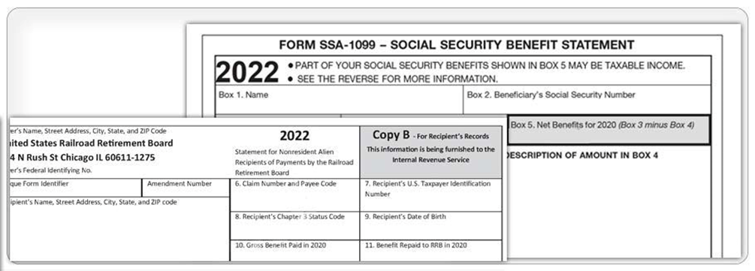
Social Security Benefit Statement:
A social security benefit statement is a tax form that shows the total amount of benefits you received from Social Security in the previous year. It is mailed out each January to people who receive benefits and tells you how much Social Security income to report to the IRS on your tax return.

- Noncitizens who live outside of the United States receive the SSA-1042S instead of the SSA-1099.
- The forms SSA-1099 and SSA-1042S are not available for people who receive Supplemental Security Income (SSI).
- A replacement SSA-1099 or SSA-1042S is typically available for the previous tax year after February 1.
- If you don’t have access to a printer, you can save the document on your computer or laptop and email it.
- For information about requesting a replacement SSA-1099 or getting another copy, visit https://www.ssa.gov/myaccount/replacement-SSA-1099.html

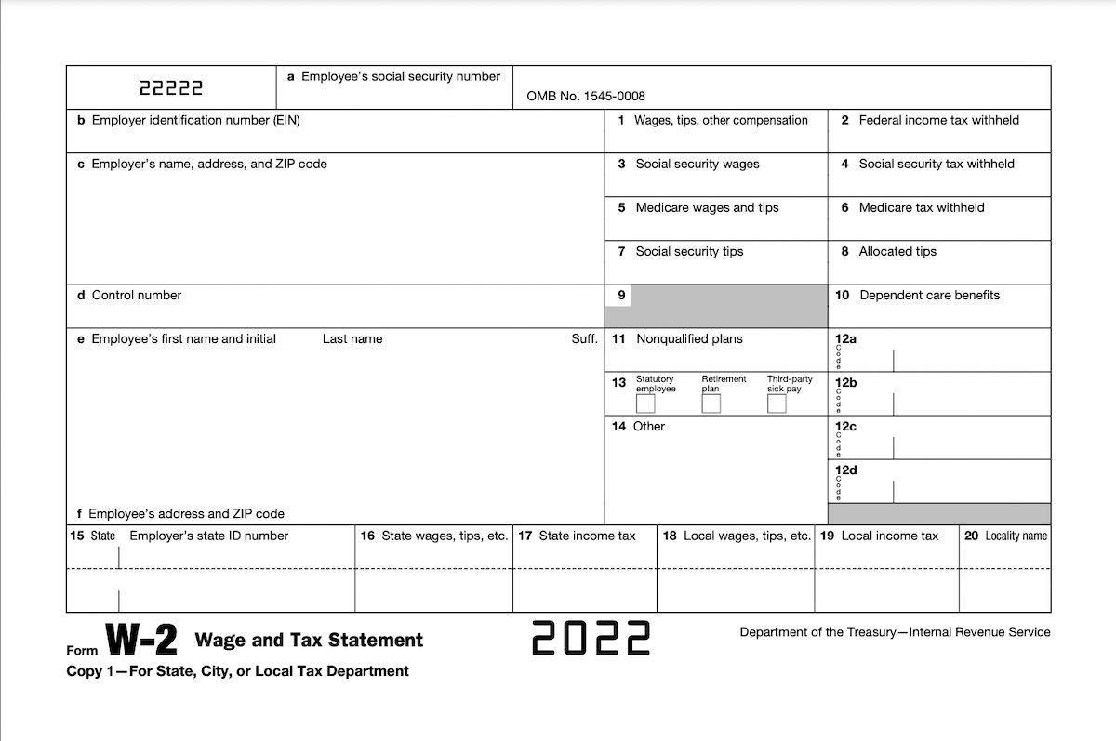
Form W-2:
Every employer engaged in a trade or business who pays remuneration, including noncash payments of $600 or more for the year (all amounts if any income, social security, or Medicare tax was withheld) for services performed by an employee must file a Form W-2 for each employee (even if the employee is related to the employer) from whom:
- Income, Social Security, or Medicare tax was withheld.
- Income tax would have been withheld if the employee had claimed no more than one withholding allowance or had not claimed exemption from withholding on Form W-4, Employee's Withholding Allowance Certificate.
- For more information, visit the IRS’ website at https://www.irs.gov/forms-pubs/about-form-w-2

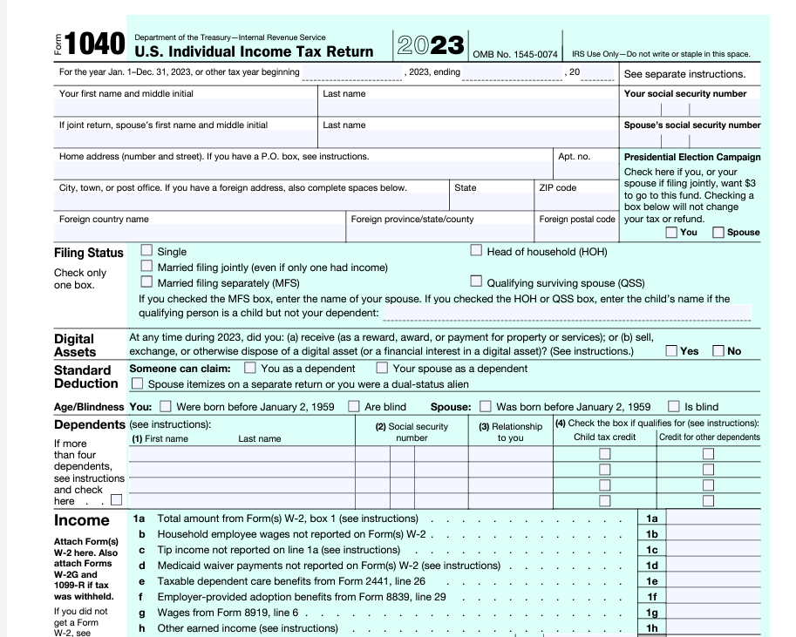

Form 1040 (Tax Return filing form):
The IRS 1040 form is one of the official documents that U.S. taxpayers use to file their annual income tax return. The 1040 form is divided into sections where you report your income and deductions to determine the amount of tax you owe or the refund you can expect to receive. Depending on the type of income you need to report, it may be necessary to attach additional forms, also known as schedules. Taxpayers use the federal 1040 form to calculate their taxable income and tax on that income.

For more information about the IRS 1040 form, visit https://turbotax.intuit.com/tax-tips/irs-tax-return/what-is-an-irs-1040-form/L4aOys6cI and refer to the IRS’ official website at https://www.irs.gov/forms-pubs/about-form-1040
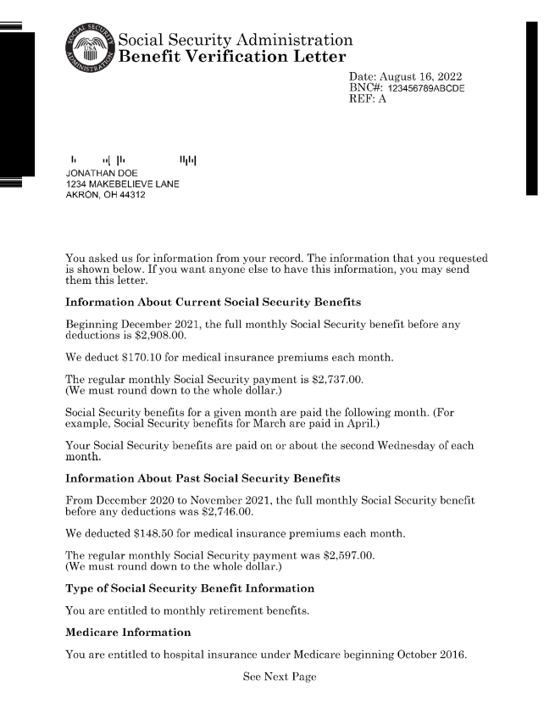
Social Security Benefits Letter:
The benefit verification letter, sometimes called a "budget letter," a "benefits letter," a "proof of income letter," or a "proof of award letter,”
serves as proof that you either:

- Get Social Security benefits, Supplemental Security Income (SSI), or Medicare.
- Have never received benefits or SSI.
- Have applied for benefits.
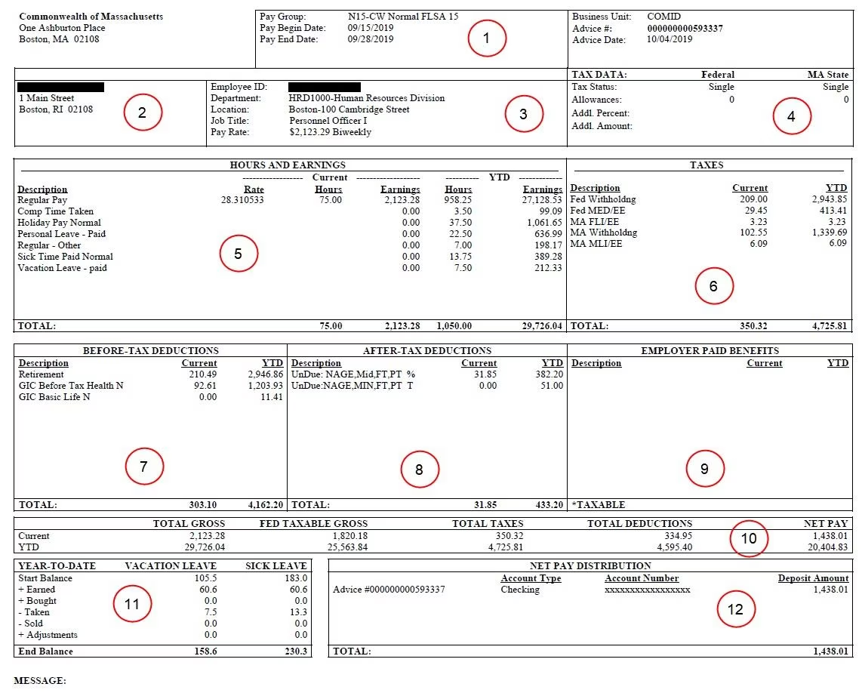
Paystub or payroll record (Format may vary by employer):

Note: The example above shows a paystub for an employee of the Commonwealth of Massachusetts (someone employed by the state of MA).

Employers must give workers a statement with their pay that says:
- the name of the employer and worker
- the date of payment (month, day and year)
- the number of hours worked during the pay period
- the hourly rate
- all deductions and increases made during the pay period.

Payroll records include the worker’s name, address, job/occupation, amount paid each pay period, and hours worked (each day and week). Employers may not charge workers for paystubs. Paystubs may be given out electronically as long as the employer provides a way for the worker to print out the information.

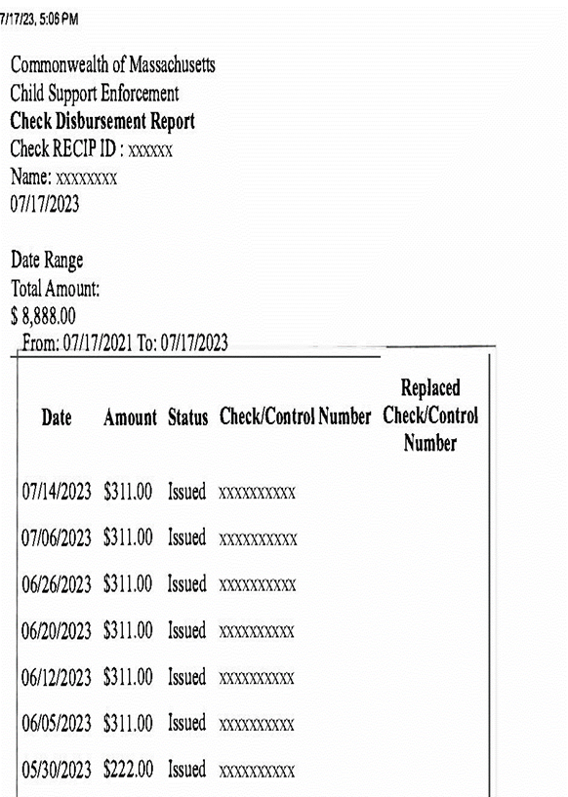

Commonwealth of Massachusetts Child Support Payments:
The image above shows a sample of a report of payments a family receiving child support may see. If you receive child support payments and would like to request your payment history, visit https://www.mass.gov/how-to/get-your-child-support-payment-history

