CICRF REDCap Follow-up Survey Guide
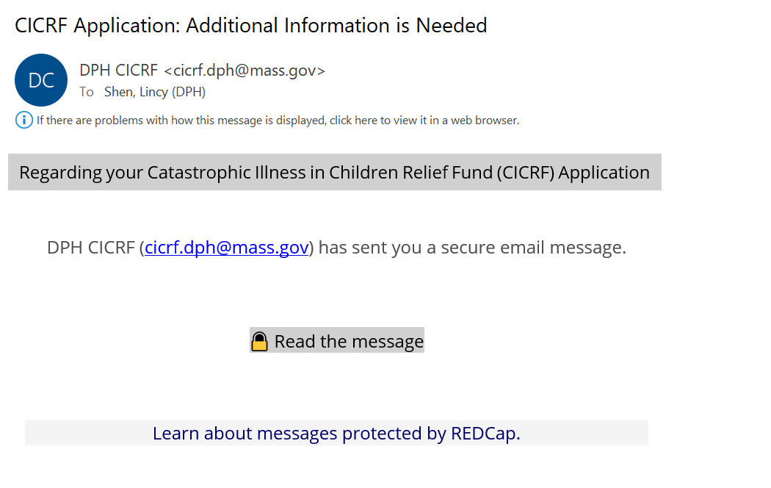
Click here to read the secure message
Your-email-address
- After submitting your application to CICRF through our REDCap Online application (https://redcap.ehs.mass.gov/redcap/surveys/?s=9RRDDWXC9AJ8HRLX), CICRF staff will review your application to determine what additional information is needed from you before your application is assigned to a Program Coordinator.
- CICRF will send a “follow-up survey” to the email address associated with your REDCap Online application. The email you’ll receive will look like the image shown above. Click on “Read the message” next to the lock icon.
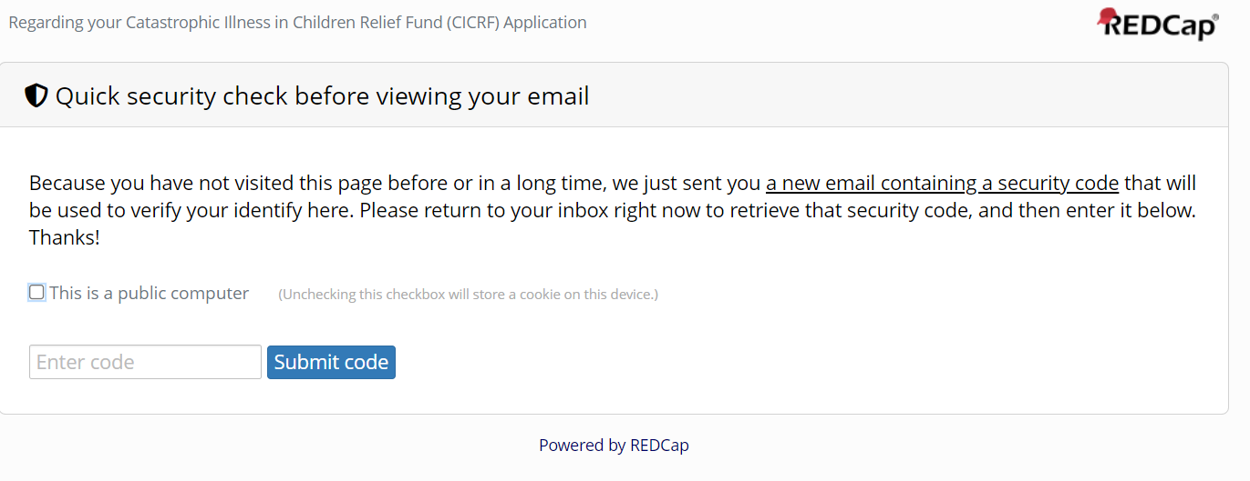
- After you click on Read the Message, you’ll be prompted to enter in a 6-digit security code, which will be sent as an email to your inbox immediately after opening the page above. Before entering your code, make sure the checkbox next to “This is a public computer” is unchecked.
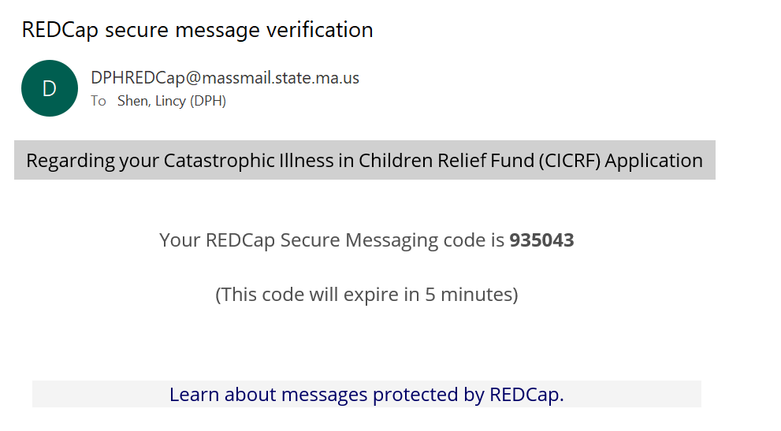
Your-email-address
Note: The code you’ll be required to enter to access your Follow-up survey will be sent to you in an email as shown above.

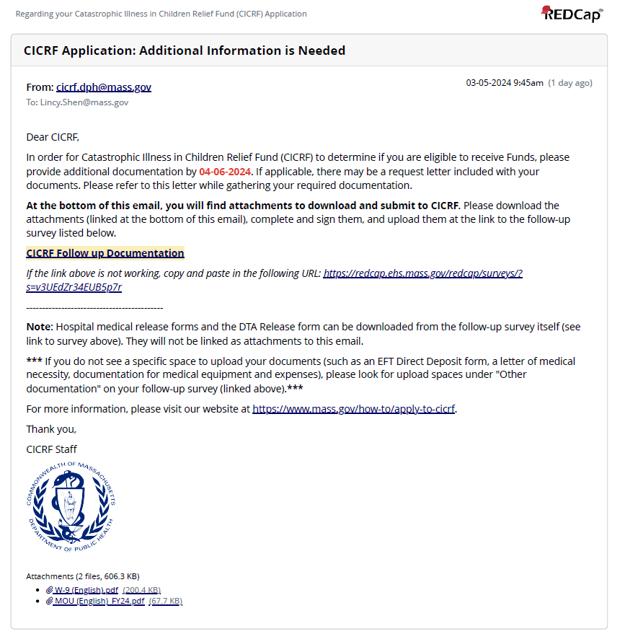
Download documents to sign, initial (when applicable), and submit in your follow-up survey
Link to follow-up survey
Your-email-address
Your FirstName

- After submitting the security code, you’ll be able to access the message above, which contains a link to your follow-up survey. The deadline for you to submit additional documents requested by CICRF staff will appear in red text. At the bottom of the message, you’ll find files that you should download, sign, then save as PDF documents. Click on the link that says “CICRF Follow up Documentation” once you’re ready to submit your documents to CICRF.

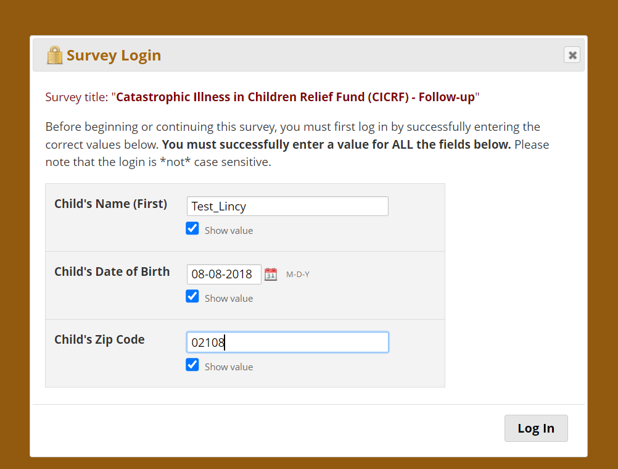
- Before accessing the follow-up survey to upload and submit documentation CICRF staff are requesting from your family, you’ll be asked to verify your child’s basic information. Please enter your child’s first name, their date of birth (month/date/year – for example, 12/10/2020), and your 5-digit zip code.
  - Note: To make it easier to enter in your child’s information, you can check off the “Show value” box underneath each field.

Note: If you enter any of the three pieces of information incorrectly 3 times, you’ll receive the following message shown in the image below.
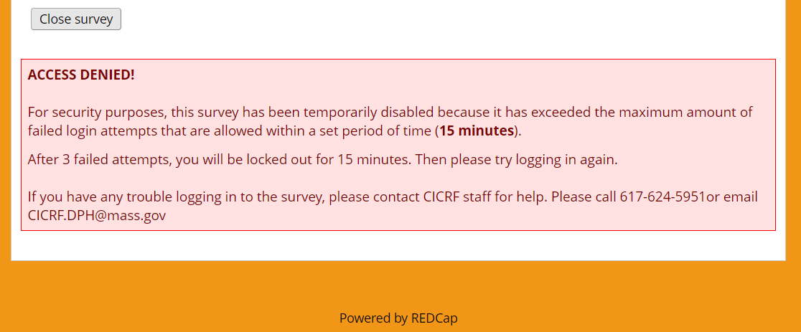

If you’re not able to access your survey despite entering in your information correctly, please contact CICRF at CICRF.DPH@mass.gov. Someone from our team will get back to you during our regular business hours (Monday – Friday, 9AM – 5PM).
If you’re able to login and access your follow-up survey, you should see a form like the images shown below.
Your follow-up survey may look a bit different depending on what documents CICRF is requesting from you.

For example, you may be asked to upload expense documentation for a vehicle purchase, home modification, medical expenses, medical equipment, health insurance premiums, funeral expenses, lodging costs, or for other expenses you’re applying for reimbursement for. You may also be asked to upload additional income documentation including tax returns, social security benefits letters, a signed DTA release form, official documentation showing child support or alimony received, disability income, paid family medical leave income, or other forms of income.

CICRF will provide as much information as possible regarding documentation we’re requesting to be uploaded.
---------------------------------------------------------------------------------------------------------------------------------------------------------------
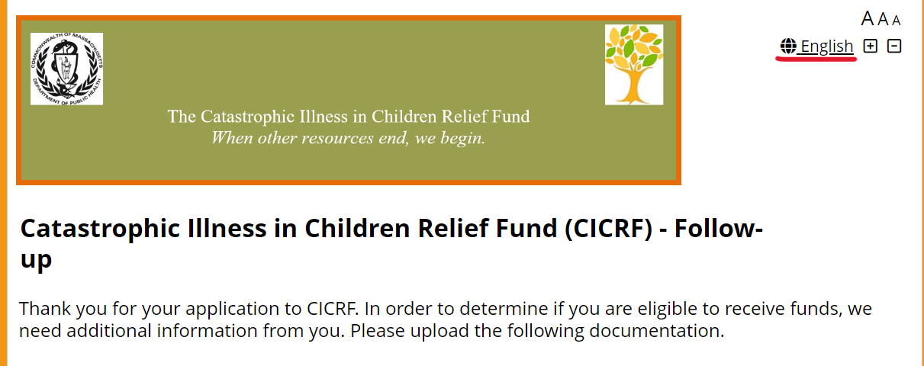
- When you first open the follow-up survey, you’ll see the following message at the top of the screen. “Thank you for your application to CICRF. To determine if you are eligible to receive funds, we need additional information from you. Please upload the following documentation.”

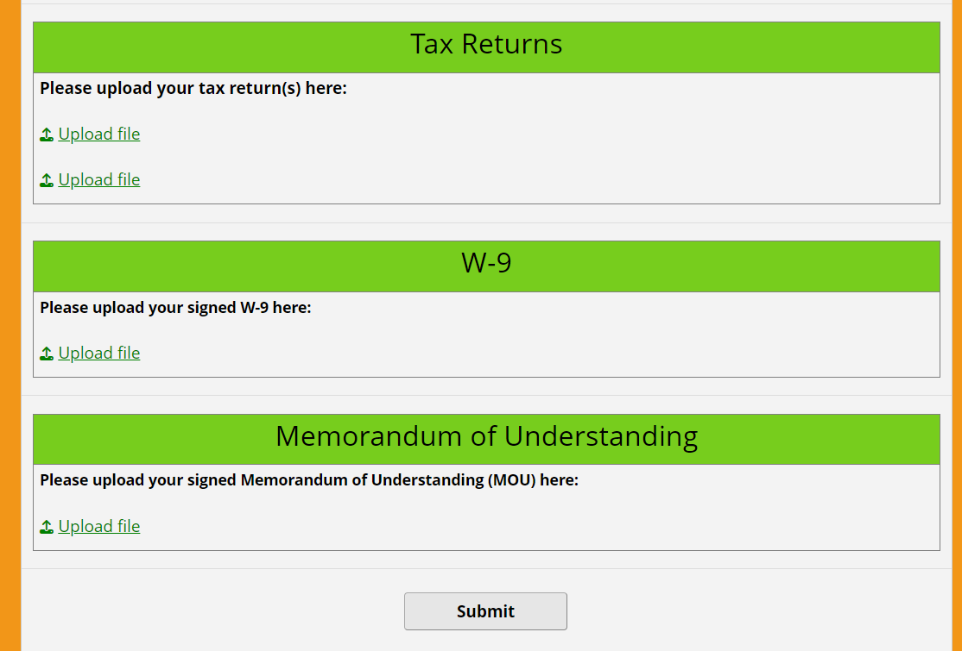
Note: The image above is just an example of what types of documents CICRF Staff may request from your family. You may be asked to provide more or fewer documents than what’s shown above.

- You should have downloaded the attachments from the secure email sent from cicrf.dph@mass.gov (see Step #4). Make sure you’ve signed them and that you have the signed versions of your documents (if a signature is needed) as a file on your computer. Then, click on the “Upload file” buttons to upload files that correspond to the document being requested.
  - Note: Each “Upload file” space must contain a file as your follow-up survey was custom tailored to request a specific number of each kind of document from you.

- Once you’ve finished uploading all required documents in the upload spaces provided, hit the “Submit” button.
  - Note: You cannot save and return to your follow-up survey in the same way that you can with your online application.

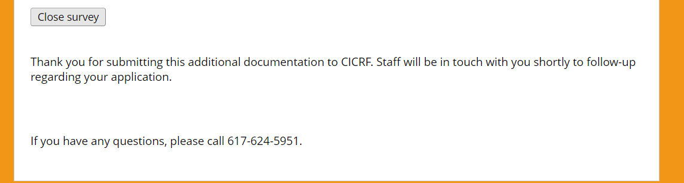
- You should receive the message shown in the image above.
- Depending on what forms and documentation are being requested of you, your follow-up survey may also contain a section titled “Other Documentation” (see image below). If you see this section on your follow-up survey, there will be between 1-6 upload spaces (6 max).
  - You should upload the following types of documents into this section: EFT Direct Deposit form, an Accessible Vehicle statement, Home Modification statement, medical expense documentation and proof of payment, and letters of medical necessity for expenses other than vehicles and home modifications
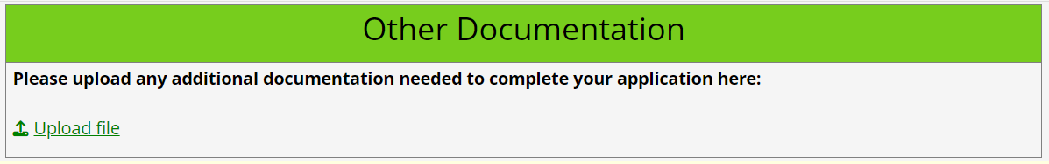
- If you have multiple files that you’d like to upload (such as two W-2’s or more than one SSI letter) and there’s only one upload space, we recommend that you merge these files into one document.
  - To combine your files into a single document, you can use a tool such as this one: https://www.adobe.com/acrobat/online/merge-pdf.html. You can also use the built-in file combining and file converting features if you have Adobe Acrobat.
  - Another option is that you can save anything you combine in a word document as a PDF. For example, you might insert images, scans, or screenshots of your W-2’s into a word document. To save this document as a PDF, go to File > Save As > PDF.

If you don’t complete CICRF’s request for follow-up documentation within 7 days, you will receive a reminder email. If after 7 days (1 week), you still do not complete the request for follow-up documentation, you will receive 2 more reminders. In total, you will receive 3 emails from CICRF regarding your follow-up survey: 1 initial email and 2 reminders.

The reminder email you will receive will appear as shown in the images below.
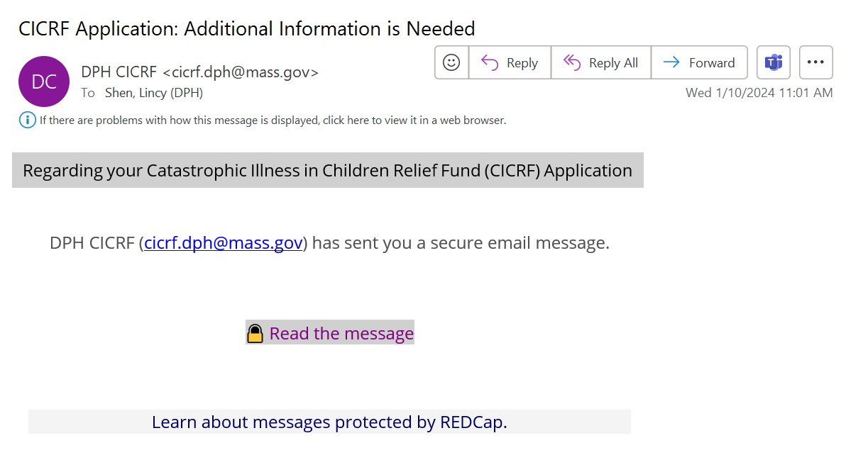
Click here to read the secure message
Your-email-address

Your Email
Your Name
The message you’ll receive will appear as shown above. The follow up documentation request email you receive as a reminder will look the same as the initial email you received.

If you do not complete the request for follow up documentation by the deadline (in bold red text) and you do not contact CICRF at CICRF.DPH@mass.gov or by phone at (617) 624-5951 before the deadline, you will be asked to re-apply to CICRF by submitting a new application.

