# **Accessing MOSES & other EOLWD resources using Citrix and the Internet**

Updated July, 2014

Safeguard your passwords and follow rules for Personally Identifiable Information (PII) to protect customer information.

## URL for Non-EOLWD Employees Off State Network

<HTTPS://CC-CITRIX.DETMA.ORG>

## URL for EOLWD Employees Off State Network

<HTTPS://STAFF-CITRIX.DETMA.ORG>

## URL for both Non-EOLWD and State Employees On State Network

<HTTP://CITRIX.DETMA.ORG>

## If you have a previous version of Citrix receiver on the computer:

You must use a Citrix Clean-up utility to remove the old version before you install the new version. You can download the utility from <http://support.citrix.com/article/CTX137494>

Using Mozilla Firefox or Google Chrome for your internet browser:   
You don’t have to change Firefox or Chrome settings.

If you are using Internet Explorer for your internet browser and you are not on the state network:   
You must add https://*.detma.org to your trusted sites in Internet Explorer before you go to the Citrix website. To do that, open Internet Explorer, click Tools, then Internet Options, then the Security tab, then Trusted Sites, then the Sites button. Type https://*.detma.org where it says “Add this website” and then click Add. You should have a checkmark in the box for Require server verification (https:) for all sites in this zone. Apply the change, then close Internet Explorer and reopen Internet Explorer again.

If you are using Internet Explorer for your internet browser and you are on the state network:   
You must add *.detma.org to your trusted sites in Internet Explorer before you go to the Citrix website. To do that, open Internet Explorer, click Tools, then Internet Options, then the Security tab, then Trusted Sites, then the Sites button. Type *.detma.org where it says “Add this website” and then click Add. You must uncheck the box for Require server verification (https:) for all sites in this zone. Apply the change, then close Internet Explorer and reopen Internet Explorer again.

Here’s a screen shot of what it looks like after you click Add, when you’re off the state network:

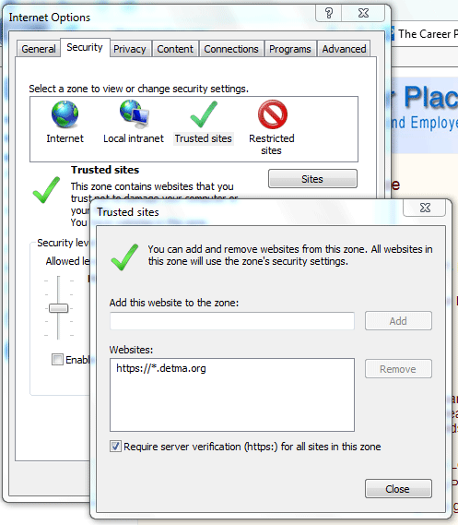

## Website:

Go to the appropriate website:

* OFF STATE NETWORK, NON-EOLWD EMPLOYEES: <https://cc-citrix.detma.org>
* OFF STATE NETWORK, EOLWD EMPLOYEES: <https://staff-citrix.detma.org>
* ON STATE NETWORK, ALL: <http://citrix.detma.org>

You’ll be prompted to install the Citrix Receiver. Please do so and accept all the defaults, using the following instructions:

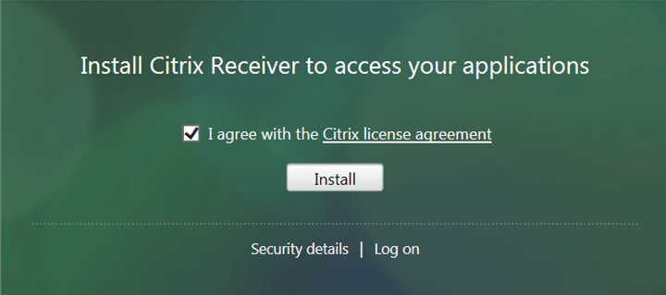

Check off License agreement and click Install.

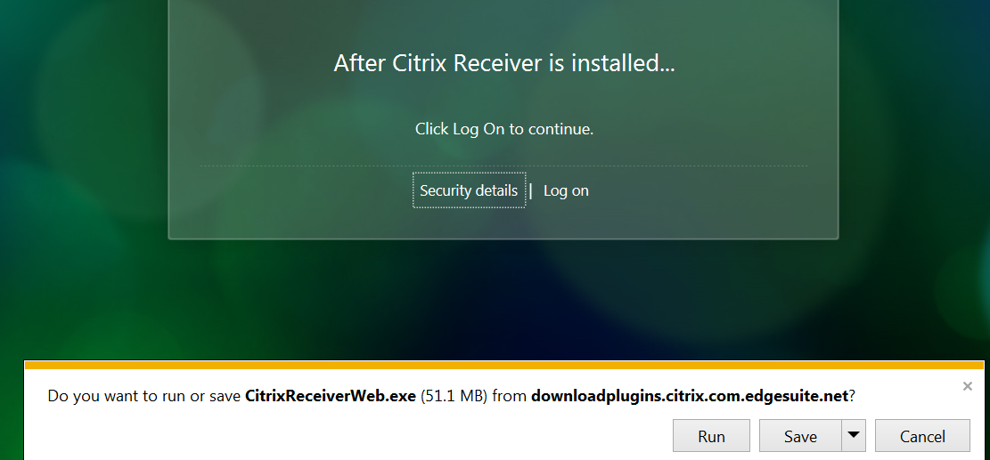

Click Save and save the executable to your local desktop. Right-click the executable and Run as Administrator.

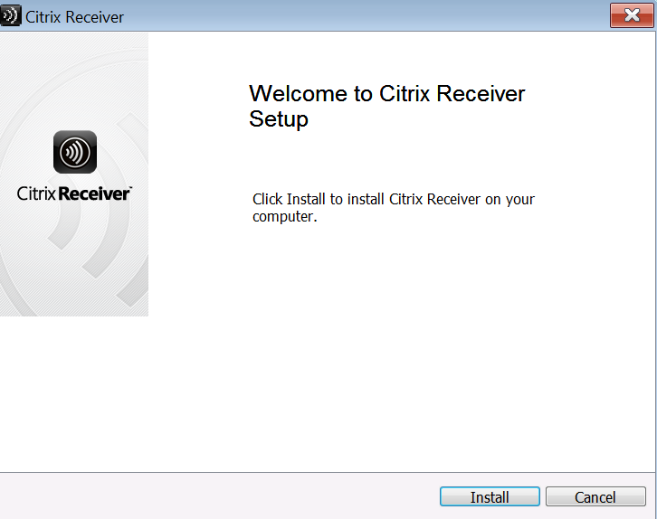

Click Install.

That completes the installation, and you can delete the CitrixReceiverWeb.exe file from the desktop.

## Launching Applications

When you open your applications for the first time, you’ll be prompted for permission to allow access. Click Permit Use and check the box for “Do not ask me again for this site.”

