**INDOOR AIR QUALITY**

**WATER DAMAGE ASSESSMENT**

**Clara Barton Elementary**

**25 Depot Road**

**Oxford, MA**

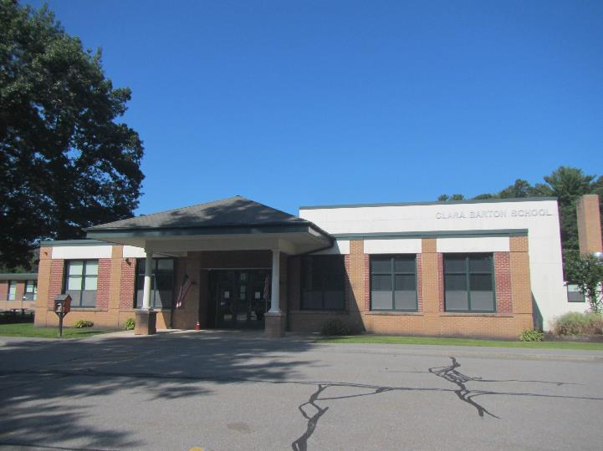

Prepared by:

Massachusetts Department of Public Health

Bureau of Climate and Environmental Health

Indoor Air Quality Program

September 2024

# BACKGROUND

|  |  |
| --- | --- |
| Building: | Clara Barton Elementary (CBE) |
| Address: | 25 Depot Road, Oxford, MA |
| Requestor: | Anonymous complaint received via email |
| Reason for Request: | Concerns about mold in the school |
| Date of Assessment: | August 23, 2024; note this assessment occurred over summer break. |
| Massachusetts Department of Public Health/Bureau of Climate and Environmental Health (MDPH/BCEH) Staff Conducting Assessment: | Thomas Murphy, Environmental Analyst, Indoor Air Quality (IAQ) Program |
| Building Description: | CBE is a one-story, red-brick building constructed in the 1950s. According to facility staff, renovations/additions to the school were made in the early 2000s. The gymnasium and the main entrance have a peaked roof and the rest of the school has a flat roof. |
| Windows: | Openable in most areas |

# EXECUTIVE SUMMARY

The MDPH/IAQ Program received a complaint of water damage/mold growth at CBE. IAQ staff visited CBE along with a health inspector from the town of Oxford. During a discussion with CBE staff, it was reported that one classroom had previously experienced mold growth but was cleaned/remediated. No visible mold was observed during an inspection of the room. The library was also an area of concern, and water-damaged ceiling tiles were found there. According to CBE staff, the water damage was due to roof leaks, allowing water infiltration into the school.

Based on observations made during this assessment and discussions with CBE staff, a number of recommendations were made; the highlights include:

* Have the roof repaired to prevent continued water infiltration.
* Replace all water-damaged ceiling tiles and other building materials. Disinfect areas of water leaks with an appropriate antimicrobial, as needed.
* Regularly clean dust and debris from supply/exhaust vents and univents which can be a source for mold growth.
* Any necessary mold remediation should be conducted following the US EPA’s “Mold Remediation in Schools and Commercial Buildings” <http://www.epa.gov/mold/mold-remediation-schools-and-commercial-buildings-guide>.
* Refer to the following document “Preventing Mold Growth In Schools During Hot, Humid Weather” <https://www.mass.gov/info-details/preventing-mold-growth-in-massachusetts-schools-during-hot-humid-weather> which can be used to minimize the impact of such weather on classroom materials.

In addition, the IAQ Program has offered to conduct a general IAQ assessment of CBE to identify any other conditions that impact the indoor environment.

# METHODS

Please refer to the IAQ Manual for methods, sampling procedures, and interpretation of results (MDPH, 2015).

**RESULTS AND DISCUSSION**

The following is a summary of indoor air testing results (Table 1):

* ***Temperature*** was within or close to the MDPH recommended range of 70°F to 78°F in areas tested on the day of the assessment.
* ***Relative Humidity*** was within/slightly above the MDPH recommended comfort range of 40 to 60% in all areas tested. Relative humidity outdoors was 65%. All indoor relative humidity measurements were below outdoor measurements. The US Environmental Protection Agency (US EPA) recommends keeping indoor relative humidity between 30 and 50% to prevent mold growth, which presents a unique challenge in regions with high relative humidity in the outdoor environment (Center for Green Schools, 2024).

## Ventilation

A heating, ventilating, and air conditioning (HVAC) system has several functions. First it provides heating and, if equipped, cooling. Second, it is a source of fresh air. Finally, an HVAC system will dilute and remove normally occurring indoor environmental pollutants by not only introducing fresh air, but by filtering the airstream and ejecting stale air to the outdoors via exhaust ventilation. Even if an HVAC system is operating as designed, point sources of respiratory irritation may exist and cause symptoms in sensitive individuals.

Fresh air in most classrooms is supplied by unit ventilators (univents) (Picture 1). Univents draw air from the outdoors through a fresh air intake located on the exterior wall of the building (Picture 2) and return air through an air intake located at the base of the unit. Fresh and return air are mixed, filtered, heated, or cooled, and provided to rooms through an air diffuser located in the top of the unit (Figure 1). Ceiling-mounted univents were observed in a small number of rooms and operate in similar manner. Exhaust ventilation is provided by unit exhaust ventilators or vents on the wall (Picture 3).

In some rooms, the top and/or front of univents were blocked by classroom items (Picture 4). For univents to provide fresh air as designed, intakes/returns must remain free of obstructions. Importantly, these units must remain on and be allowed to operate while rooms are occupied.

It should be noted that univents at CBE do not have air conditioning (AC) capacity, which would be useful in reducing relative humidity conditions over the summer. In a majority of classrooms, window mounted ACs (WACs) are used for cooling during the warm season. WACs are equipped with filters that need to be cleaned periodically. In at least one classroom the “check filter” light was on (Table 1; Picture 5). During filter cleaning, examine cooling fins for dust/debris and clean/vacuum as needed to ensure efficient operation and to prevent mold growth and associated odors. Ductless air conditioners were observed in other classrooms. These systems are effective at cooling but do not provide air exchange.

Other locations such as the library, hallways, and administration offices have mechanical ventilation which is provided by rooftop air handling units (AHUs). Air is drawn in through air intakes, filtered, heated, cooled (unlike classroom univents) and distributed via ceiling or wall-mounted diffusers (Picture 6). Air is drawn back to AHUs via ceiling or wall-mounted return vents (Picture 7). According to CBE staff, the library’s AHU was recently installed (Picture 8).

To maximize air exchange, the MDPH recommends that both supply and exhaust ventilation operate continuously during periods of occupancy. In order to have proper ventilation with a mechanical supply and exhaust system, the systems must be balanced to provide an adequate amount of fresh air to the interior of a room while removing stale air from the room. It is recommended that HVAC systems be re-balanced every five years to ensure adequate air systems function (SMACNA, 1994).

## Microbial/Moisture Concerns

### Mold issues due to high humidity

Hot humid summers are becoming more frequent due to climate change. Massachusetts has experienced hot, humid, and rainy summers in 2018, 2021, 2023, and August 2024. July of 2021 was the wettest ever recorded in Massachusetts, and the three-month period from June through August, known as the meteorological summer, was the fourth wettest on record, according to the National Oceanic and Atmospheric Administration’s (NOAA) Centers for Environmental Information (NOAA, 2021). The summer of 2023 was also hot, and wet, being measured as the second rainiest on record (WBUR, 2023). And the summer of 2024 has also had significant stretches of hot, humid weather. These conditions are challenging for buildings, particularly those without central air conditioning.

Under these weather conditions, public buildings such as schools experienced extended periods of water vapor exposure from high relative humidity. When exposed to these conditions, porous materials such as gypsum wallboard, cardboard, and other materials may become moistened and colonized with mold, particularly if located in areas that are prone to developing condensation, such as floors and walls in contact with the ground (e.g., below grade space).

A key concept in dealing with condensation-related water damage is that of “dew point.” The dew point temperature is the temperature at which air with a given amount of water becomes saturated with water and water begins to condense out as a liquid. For example, at 75°F and 70% relative humidity, the dew point temperature would be 64°F. That means that any surface at or below that temperature in contact with that air will start to generate condensation. In very humid conditions, surfaces do not have to be cooled much below ambient temperature to go below the dew point. Dehumidification, either through air conditioning or through stand-alone dehumidifiers, can reduce the chances of condensation. Monitoring areas of the building that may be colder than the rest of the room (e.g., floors, exterior walls in shade, and chilled plumbing and HVAC components) can lead to discovery of the areas that are most likely to be a problem during humid weather.

As previously mentioned, according to CBE staff, a classroom (B10) had experienced areas of mold but all affected areas including the carpet, chairs and baseboard vent area had been extensively cleaned/remediated prior to the IAQ program visit. A dehumidifier was placed in the room. No evidence of visible mold or mold odor was observed during the visit.

The guideline “Preventing Mold Growth In Schools During Hot, Humid Weather” <https://www.mass.gov/info-details/preventing-mold-growth-in-massachusetts-schools-during-hot-humid-weather> should be used to minimize the impact of such weather on classroom materials. This includes use of air conditioning and dehumidifiers, ensuring exhaust vents are on and operable, keeping windows closed, and ensuring air can circulate around porous materials.

The US Environmental Protection Agency (US EPA) and the American Conference of Governmental Industrial Hygienists (ACGIH) recommend that porous materials (e.g., ceiling tiles, carpet) be dried with fans and heating within 24 to 48 hours of becoming wet (US EPA, 2008; ACGIH, 1989). If not dried within this time frame, mold growth may occur. Once mold has colonized porous materials such as cardboard, books or ceiling tiles, they are difficult to clean and should be removed. Frequently solid/non-porous items can be cleaned to remove water stains and microbial growth.

### Other sources of moisture

Plants were noted in some classrooms (Table 1). Plants, soil, and drip pans can serve as sources of mold/bacterial growth. Plants should be properly maintained, over-watering of plants should be avoided, and drip pans should be inspected periodically for mold growth. In addition, plants should not be placed on top of or in the airstream of HVAC equipment such as univents (Picture 9).

In order for building materials to support mold growth, a source of water exposure is necessary. Identification and elimination of the source of water moistening building materials is necessary to control mold growth. Water-damaged ceiling tiles can indicate current/historic roof/plumbing leaks or other water infiltration. They can also provide a source of mold and should be replaced after a water leak is discovered and repaired. At the time of the assessment several water-damaged ceiling tiles were observed, in classrooms, the library, the main hallway, the cafeteria and other locations. (Table 1; Pictures 10 through 14).

A water-damaged ceiling tile was noted above a ductless air conditioner (Picture 15). Ductless ACs are equipped with tubing and sometimes a pump to drain the condensation generated through operation. Leakage of water can occur when the condensate line is blocked or damaged, or the pump malfunctions. Ductless AC tubing and pumps should be checked regularly to ensure proper drainage and repaired/cleaned when necessary.

The drains of sinks, showers, and other water fixtures have traps to prevent sewer gas from entering occupied spaces. These traps consist of a u-shaped pipe which collects water, forming a seal. Schools such as CBE are particularly vulnerable to dry drain traps due to the extended summer vacation when the building is unoccupied, since sinks in classrooms are not in use. Wetting drain traps regularly to maintain the airtight water seal is particularly important when heavy rains occur. As large amounts of water enter storm/sewer pipes, air and other water vapor/odors/pollutants can be forced up drainpipes, which would be prevented from entering the occupied space by a wet drain trap.

### Building envelope concerns

At least one area on the roof had more water accumulation than other locations (Picture 16); this appeared to be over the main hallway. According to CBE staff, the library and hallways are susceptible to water damage from roof leaks. Additionally, both the library and hallway have skylight windows which are vulnerable to water penetration. These conditions can lead to water damage of building materials. An active leak was observed in the C wing girl’s restroom. The gym reportedly experiences a leak from the roof whenever there is a heavy rain. According to CBE staff, water-damaged ceiling tiles have been previously replaced on more than one occasion indicating ceiling tiles/building materials will continue to suffer water damage until the roof has been permanently fixed.

Trees were noted very close to the building (Pictures 17 and 18). The presence of large trees is likely enhancing water retention, preventing drying of the exterior (Picture 19), and affecting drainage as well as overhanging the roof. These trees pose several hazards:

* Leaves and other debris accumulate around gutters, which inhibits rainwater drainage. Clogged gutters and/or ineffective drains can lead to water moistening exterior walls.
* Trees prevent sunlight from drying walls and soil.
* The trees are a possible danger due to the distance from exterior walls:
  + The recommended safe distance that any tree should be planted is the minimum of the expected maximum growth height of the species from the exterior of a building (BI, 2015).
  + Soil subsidence may also be caused by tree roots, which can undermine the structure of a building to cause wall and floor cracking and related damage. To prevent subsidence, a sufficient distance appropriate for the tree species is recommended (Williams, 2006).
  + Severe weather may result in the tree falling onto the building or the tree roots damaging the foundation. Due to the height of the trees, each is likely located closer than recommended distances.
* In general, a tree root system will spread out in all directions from its trunk. In some cases, tree roots can extend for over 100 feet from its trunk. Any structure disrupting the root structure may make the tree unstable if subjected to high winds from a certain direction. Based on the location, the foundation walls likely disrupt the roots of several trees.
* The Federal Emergency Management Agency (FEMA) provides several recommendations in order to prepare for severe thunderstorms. Of note FEMA recommends “Cut down or trim trees that may be in danger of falling on your [building]” (FEMA, 2018).

## Other Conditions

## *HVAC equipment*

In some areas such as the library, main hallway and classrooms, exhaust vents, supply diffusers and personal fans had accumulated dust/debris (Pictures 20 and 21). This dust can be reaerosolized under certain conditions and can also be a medium for mold growth. Univent cabinets can also accumulate dust and debris which should be cleaned when filters are changed (e.g., 2 to 4 times/year).

### *Carpeting*

Some areas, such as the library, had wall-to-wall carpeting. The service life of carpeting in schools is approximately 10-11 years (IICRC, 2002). Aging carpet can produce fibers that can be irritating to the respiratory system. In addition, lifting carpet can create tripping hazards. Area rugs were also observed in the school. Carpets should be cleaned annually (or semi-annually in soiled/high traffic areas) in accordance with Institute of Inspection, Cleaning and Restoration Certification (IICRC) recommendations, (IICRC, 2012). Regular cleaning with a high efficiency particulate air (HEPA) filtered vacuum in combination with an annual cleaning will help to reduce accumulation and potential aerosolization of materials from carpeting. Area rugs too worn to be effectively cleaned should be replaced. Area rugs should be rolled up and stored in a clean, dry place when rooms are not occupied during the summer months to prevent moistening due to condensation.

### *Other conditions*

In classrooms and other locations, items were on floors, windowsills, tabletops, counters, bookcases and desks, which provide a source for dusts to accumulate. These items (e.g., papers, folders, boxes) make it difficult for custodial staff to clean. Items should be relocated and/or be cleaned periodically to avoid excessive dust build up. In addition, dust and debris can accumulate on flat surfaces (e.g., desktops, shelving and carpets) in occupied areas and subsequently be re-aerosolized causing further irritation.

Damaged ceiling tiles and holes in the ceiling were observed in some classrooms. Damaged ceiling tiles and holes in the ceiling can allow dust and debris to fall into occupied areas. All openings and damaged areas should be repaired.

Air purifiers were observed in some classrooms and other rooms (Picture 22). These should be maintained, including filter changes, in accordance with manufacturer’s instructions. Air purifiers that may produce ozone should not be used in any occupied areas (EPA, 2003).

# CONCLUSIONS/RECOMMENDATIONS

The following are recommendations to improve and maintain IAQ:

## Ventilation Recommendations

1. Implement the following methods to promote increased airflow:
   * Limit outside air intake during periods of elevated relative humidity (>70%) for extended periods of time. Operate HVAC systems not equipped with chilling components (e.g., unit ventilators, or univents) with the fresh air intake vents *closed*.
   * Operate general exhaust ventilation system normally.
2. Operate the HVAC system (supply/exhaust) to provide for *continuous* fresh air ventilation during occupied hours.
3. Continue with regular filter changes for HVAC equipment using MERV 8 filters or the best quality/highest MERV-rating that can be used. During filter changes, vacuum debris from univent and air handling unit (AHU) cabinets.
4. Ensure that the appropriate size filters are used in univents. Ensure filters fit flush in their racks with no spaces in between allowing bypass of unfiltered air into the unit.
5. Remove all items blocking the top of the univents.
6. Use openable windows to supplement fresh air during temperate weather. Ensure all windows are closed tightly at the end of each day. *Do not* use windows while AC system is operating in its chilling mode to prevent condensation/mold growth.
7. Keep all doors closed between rooms with an operating AC system (library) and without to prevent condensation where colder and warmer, more humid air meet.
8. Clean filters in AC units prior to and as needed during the cooling season. During filter cleaning examine cooling fins for dust/debris and clean/vacuum as needed to ensure efficient operation and to prevent mold growth and associated odors.
9. Consider adopting a balancing schedule of every 5 years for all mechanical ventilation systems, as recommended by ventilation industrial standards (SMACNA, 1994).

## Water Damage Recommendations

1. Management of buildings in extreme relative humidity and rain can be challenging. The following documents can provide guidance that can be used to reduce the impact of hot, humid weather in buildings: “Mold Growth Prevention During Hot, Humid Weather” <https://www.mass.gov/service-details/preventing-mold-growth-in-massachusetts-schools-during-hot-humid-weather> and “Remediation and Prevention of Mold Growth and Water Damage in Public Schools” <https://www.mass.gov/service-details/remediation-and-prevention-of-mold-growth-and-water-damage-in-public-schools-and>.
2. Have the roof repaired to prevent continued water infiltration.
3. Replace all water-damaged ceiling tiles and other building materials. Disinfect areas of water leaks with an appropriate antimicrobial, as needed.
4. If porous items (e.g., books, papers, cardboard) are colonized with mold and the mold does not easily wipe off, the items should be discarded. Non-porous/smooth, solid items can be cleaned.
5. Any necessary mold remediation should be conducted following the US EPA’s “Mold Remediation in Schools and Commercial Buildings” <http://www.epa.gov/mold/mold-remediation-schools-and-commercial-buildings-guide>.
6. Conduct regular walkthroughs to observe conditions in the building, paying close attention to walls, ceiling tiles, and flat surfaces for signs of moisture and/or mold growth.
   * Monitor weather through extended forecasts to determine if hot, humid weather for more than two days is predicted. Many web-based weather services will provide a dew point listing.
   * Consider installing/using indoor air sensors. As indoor air sensors become more sophisticated and less expensive, they can be placed in classrooms to measure and provide accurate, real-time information via an application or web-based dashboard, eliminating the need for personnel to take measurements with hand-held equipment.
   * Monitor temperature of condensation-prone building components with a laser thermometer. If the temperature of the building component is below the dew point during hot, humid weather, steps should be taken to decrease humidity levels.
7. Avoid storing porous materials in contact with the floors, particularly during periods of high humidity.
8. Use dehumidifiers in combination with fans and ACs during summer months/periods of elevated relative humidity.
9. Clean and maintain portable dehumidifying units in accordance with manufacturers’ recommendations or drain into sinks to reduce daily maintenance.
10. The following measures can be used to reduce fungal growth on porous materials:
    * Avoid placing wall-to-wall carpeting or other porous materials on slab in contact with soil or on floors in below-grade areas.
    * Avoid placing porous materials on temperature bridges such as floor/wall junctions that are below grade. A temperature bridge is a structure that allows cooler temperatures to transfer between two areas. Furniture made of metal is more likely to be susceptible to temperature fluctuations. Avoid storing porous materials on metal objects that are low and in contact with floor or foundation walls.
    * Store porous materials in airtight, hard plastic containers.
    * Avoid placing porous materials between fresh air supply vents and exhaust vents. The air between this equipment is likely to hold moisture since these systems are used to remove water vapor from a building interior.
    * Move furniture such as bookcases and file cabinets at least 1-inch from walls to create airflow and prevent trapping moisture that can lead to mold growth on walls.
    * Roll up and remove area rugs over the summer.
11. Keep classroom/office plants in good condition, avoid overwatering, and keep them away from the airstream of ventilation equipment.
12. Ensure that condensation from AC equipment is draining properly. Check collector pans, piping and any associated pumps for clogs and leaks and clean periodically to prevent stagnant water build-up and remove debris that may provide a medium for microbial growth.
13. Ensure that all sink drains are wetted regularly (once a week) to prevent water vapor backup into classrooms.
14. Trim back trees from overhanging the roof and ensure all plants/shrubs are located at least five feet away from exterior walls.

## Other Recommendations

1. Clean supply/exhaust vents, univents and personal fans regularly to remove accumulated dust/debris. Replace surrounding ceiling tiles that cannot be adequately cleaned.
2. Clean carpeting regularly in accordance with The Institute of Inspection, Cleaning and Restoration Certification (IICRC) recommendations (IICRC, 2012).
3. After repairing holes in ceiling tiles, conduct a thorough cleaning of furniture and other items, including wet wiping of all surfaces.
4. Maintain air purifiers in accordance with manufacturer's instructions. Avoid using any air purifiers that may produce ozone (e.g., ionizers). Consider locating air purifiers so the outlet of the units is in the breathing zone of occupants.
5. Refer to resource manual and other related IAQ documents located on the MDPH’s website for further building-wide evaluations and advice on maintaining public buildings. These documents are available at: <http://mass.gov/dph/iaq>.

# Long Term Recommendations

1. Remove trees in close proximity to the building that are closer than their maximum growth height.

# REFERENCES

ACGIH.1989. Guidelines for the Assessment of Bioaerosols in the Indoor Environment. American Conference of Governmental Industrial Hygienists, Cincinnati, OH.

BI. 2015. A List of Trees and the Recommended Safe Distance from Buildings. Bickers Insurance, Littlehampton, West Sussex, UK. <https://www.bickersinsurance.co.uk/about-us/latest-news/property-owners-news/a-list-of-trees-and-the-recommended-safe-distance-from-buildings/>

Center for Green Schools. 2024. U.S. Green Building Council, Inc. [School mold prevention programs help keep schools healthy | U.S. Green Building Council (usgbc.org)](https://www.usgbc.org/articles/school-mold-prevention-programs-help-keep-schools-healthy). Lauren Bolton, Aug 22, 2024.

FEMA. 2018. How to Stay Safe When a Thunderstorm Threatens. Federal Emergency Management Agency, Washington, DC. FEMA V-1009/May 2018.

HG. 2021. Mold keeps South Hadley High School shuttered. Hampshire Gazette. <https://archive.gazettenet.com/South-Hadley-High-School-still-closed-amid-mold-remediation-42413519>.

IICRC. 2002. Institute of Inspection, Cleaning and Restoration Certification. A Life-Cycle Cost Analysis for Floor Coverings in School Facilities.

IICRC. 2012. Institute of Inspection, Cleaning and Restoration Certification. Carpet Cleaning: FAQ. Retrieved from <https://iicrc.org/>.

MDPH. 2015. Massachusetts Department of Public Health. Indoor Air Quality Manual: Chapters I-III. Available at: <https://www.mass.gov/lists/indoor-air-quality-manual-and-appendices#indoor-air-quality-manual->.

NOAA. 2021. Summer 2021 neck and neck with Dust Bowl summer for hottest on record. National Oceanic and Atmospheric Administration, 1401 Constitution Avenue NW, Room 5128, Washington, DC 20230 <https://www.noaa.gov/news/summer-2021-neck-and-neck-with-dust-bowl-summer-for-hottest-on-record>.

SMACNA. 1994. HVAC Systems Commissioning Manual. 1st ed. Sheet Metal and Air Conditioning Contractors’ National Association, Inc., Chantilly, VA.

US EPA. 2003. “Ozone Generators that are Sold as Air Cleaners: An Assessment of Effectiveness and Health Consequences”. United States Environmental Protection Agency, Office of Air and Radiation, Indoor Environments Division, Washington, DC. Last updated September, 2018. <https://www.epa.gov/indoor-air-quality-iaq/ozone-generators-are-sold-air-cleaners>.

US EPA. 2008. “Mold Remediation in Schools and Commercial Buildings”. Office of Air and Radiation, Indoor Environments Division, Washington, DC. EPA 402-K-01-001. September 2008. Available at: <http://www.epa.gov/mold/mold-remediation-schools-and-commercial-buildings-guide>.

WBUR. 2023. “It's been a summer of rain and flooding misery in Mass.” WBUR local news. September 12, 2023. <https://www.wbur.org/news/2023/09/12/summer-flooding-rain-massachusetts>.

Williams, A. 2006. The Distance at Which Trees Can Affect a Building is Quite Significant. The Architects’ Journal. <https://www.architectsjournal.co.uk/home/the-distance-at-which-trees-can-affect-a-building-is-quite-significant/130858.article>.

**Figure 1: Unit Ventilator (Univent)**

**Picture 1**

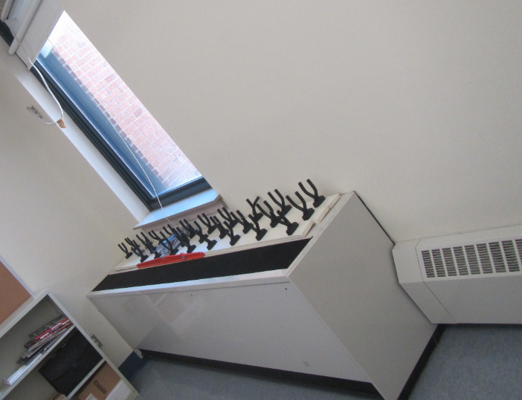

**Classroom univent**

**Picture 2**

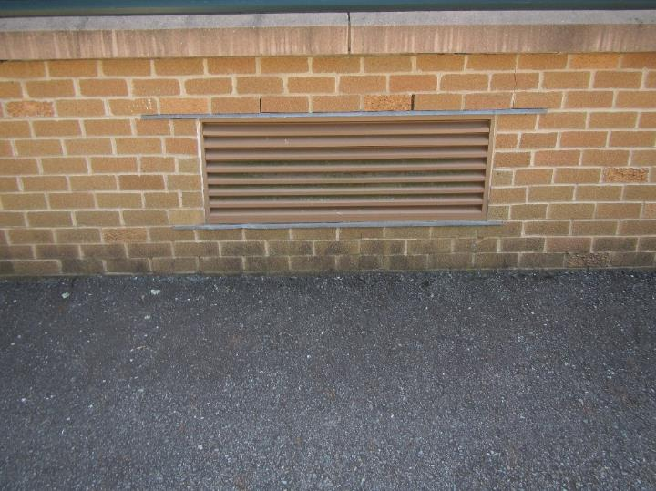

**Univent fresh air intake**

**Picture 3**

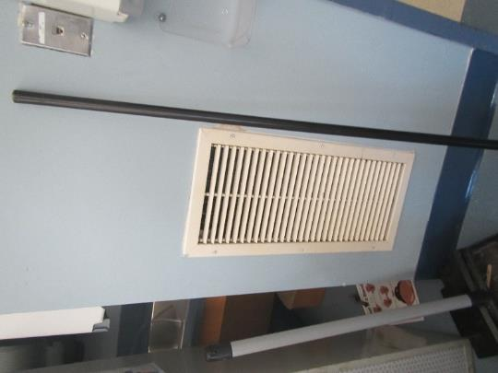

**Exhaust vent on classroom wall**

**Picture 4**

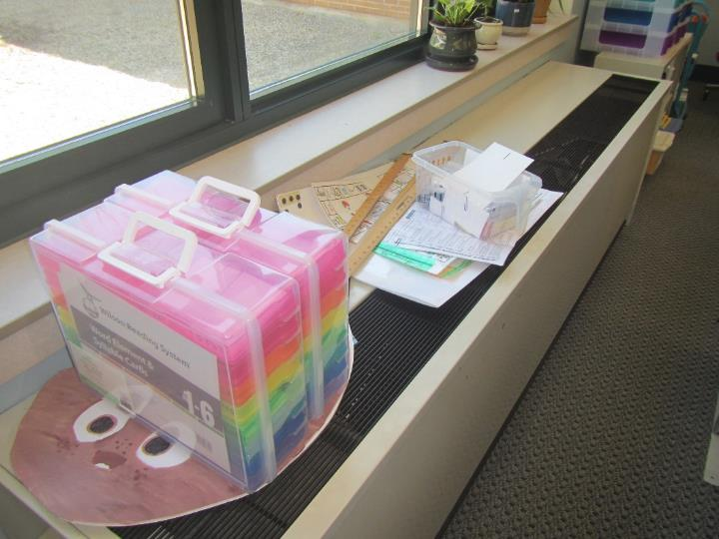

**Top of uninvent blocked by classroom items**

**Picture 5**

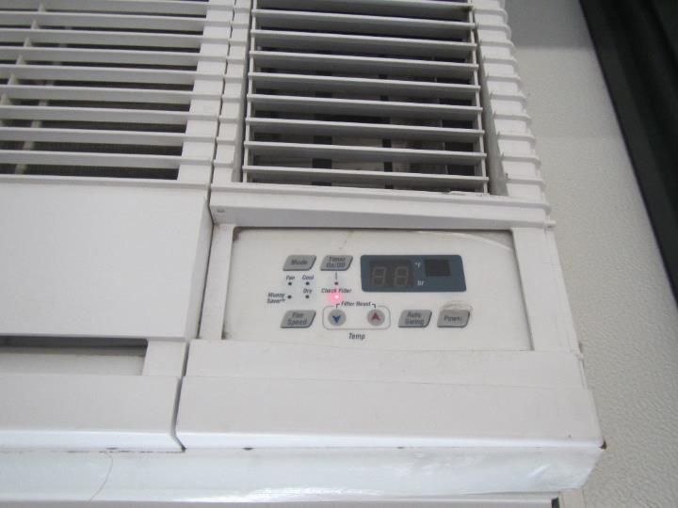

**Check filter light on a window air conditioner**

**Picture 6**

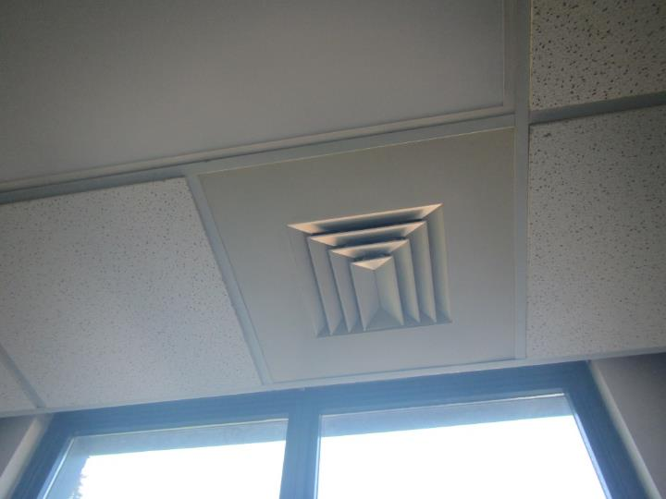

**Supply diffuser in an administration office**

**Picture 7**

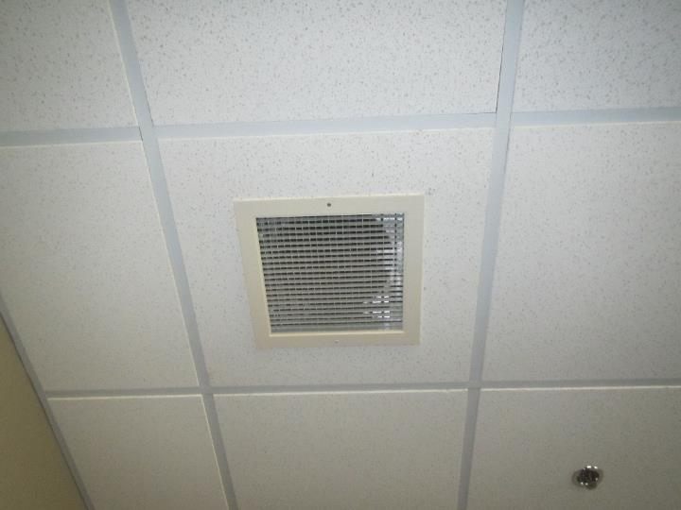

**Return vent in an administration office**

**Picture 8**

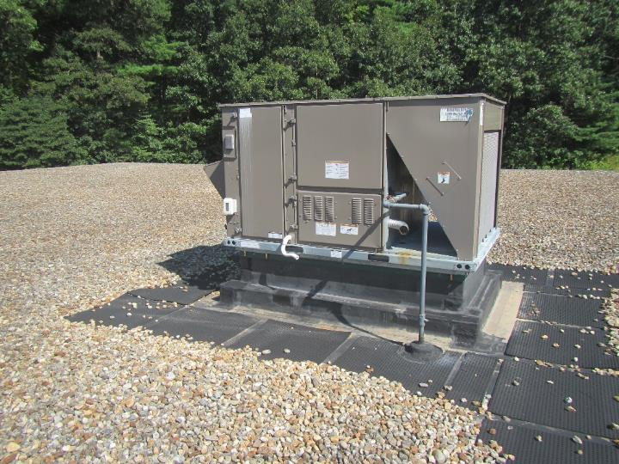

**Air handling unit on roof for library**

**Picture 9**

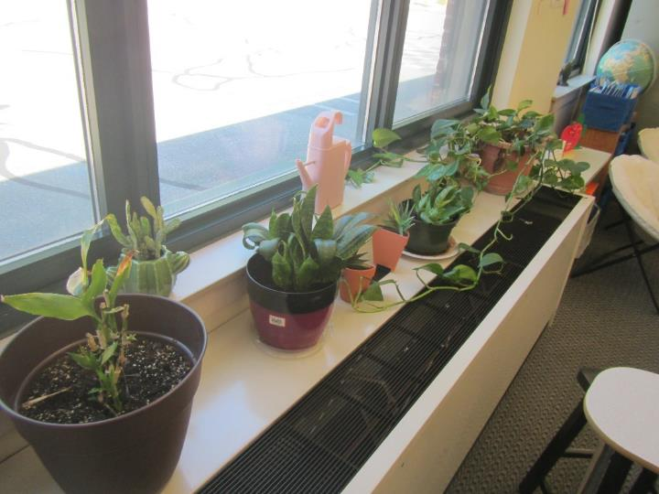

**Plants in classroom hanging over uninvent airstream**

**Picture 10**

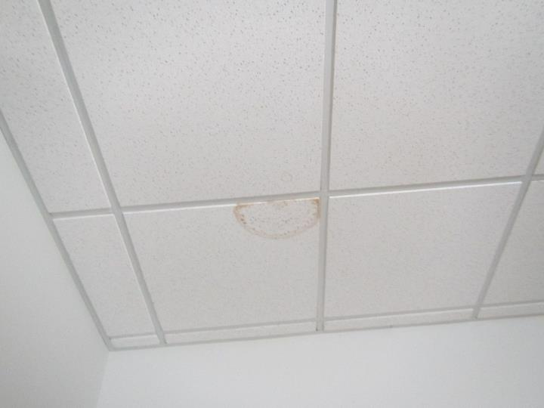

**Water-damaged ceiling tile in a classroom**

**Picture 11**

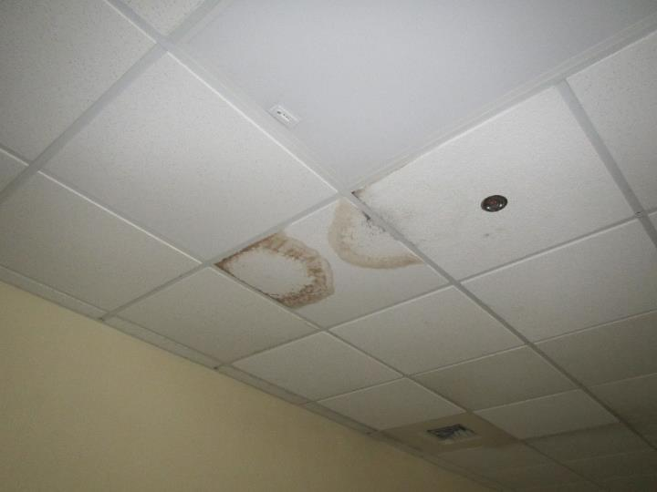

**Water-damaged ceiling tiles in the library**

**Picture 12**

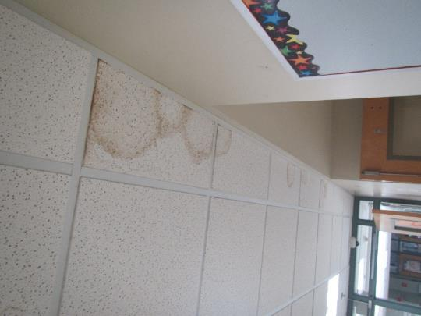

**Water-damaged ceiling tiles in the main hallway**

**Picture 13**

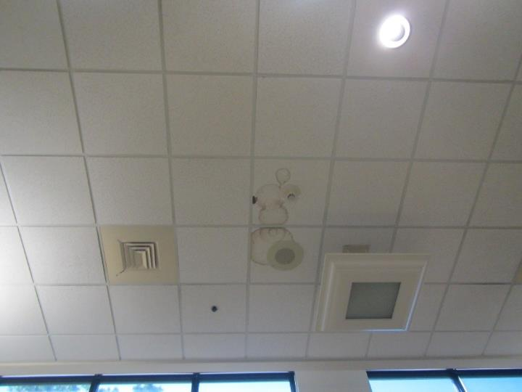

**Water-damaged ceiling tiles in the cafeteria**

**Picture 14**

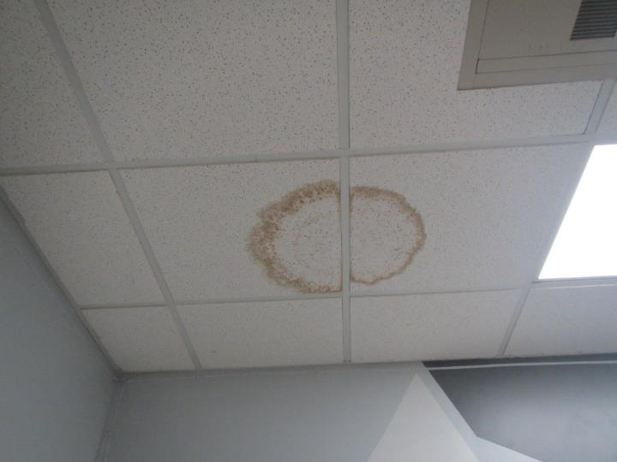

**Water-damaged ceiling tiles in the teacher’s room**

**Picture 15**

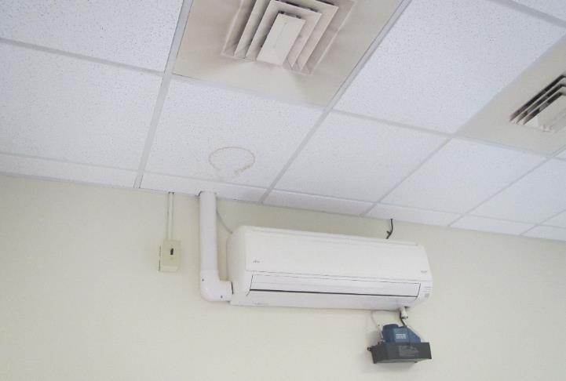

**Ductless air conditioner; note water damaged ceiling tile and dust/debris on supply diffuser**

**Picture 16**

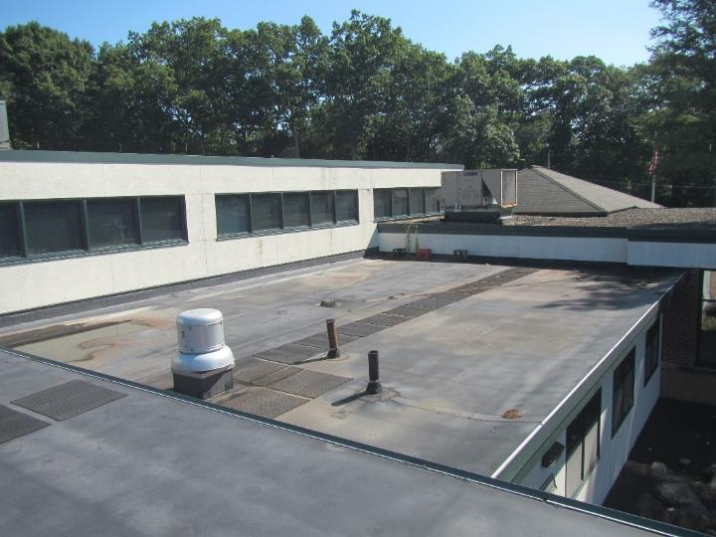

**Accumulation of water on roof (appears to be over main interior hallway)**

**Picture 17**

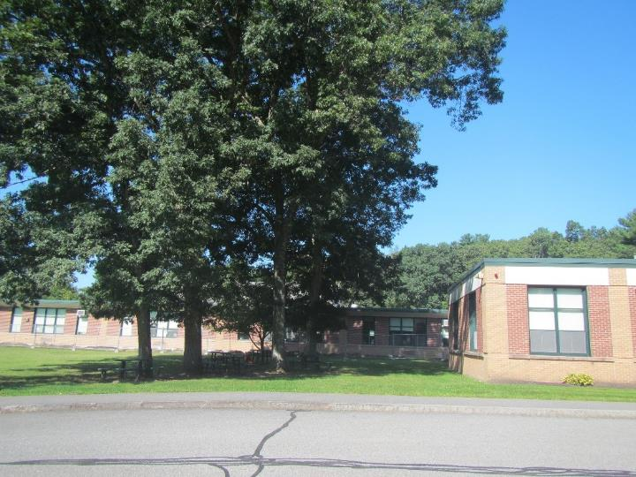

**Large trees close to the school**

**Picture 18**

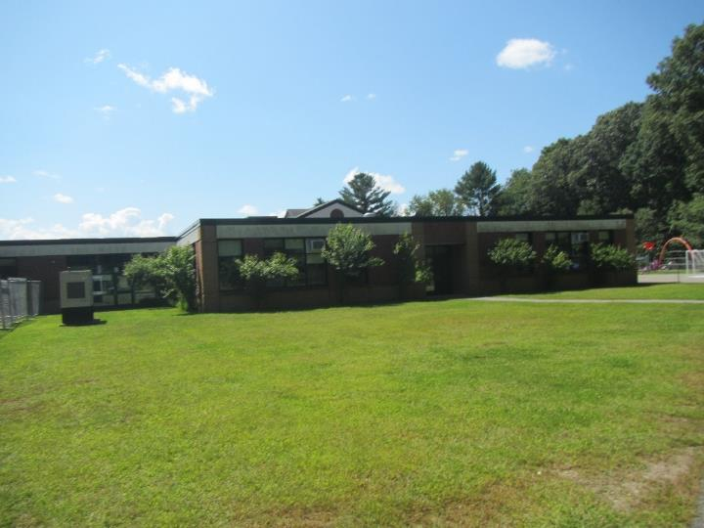

**Additional trees close to the school**

**Picture 19**

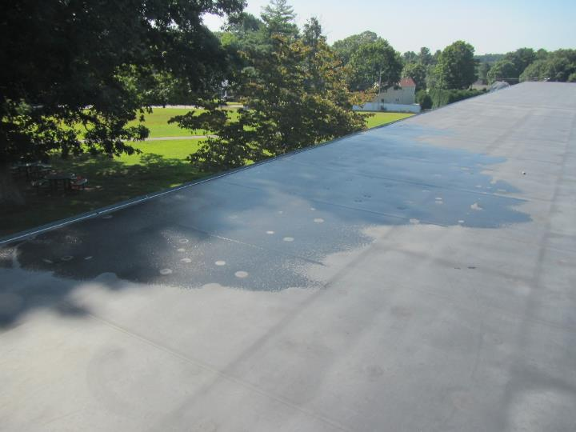

**Tree branches creating shade on roof and wet area on roof**

**Picture 20**

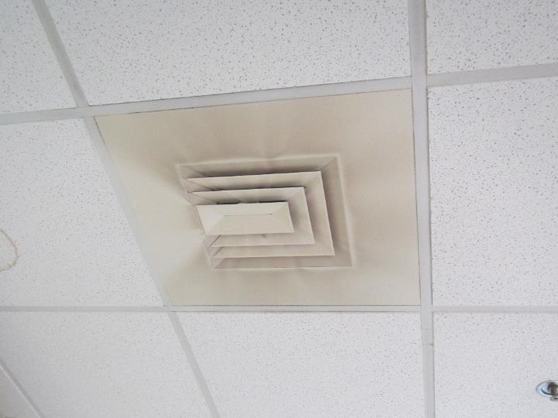

**Dust and debris on a supply diffuser**

**Picture 21**

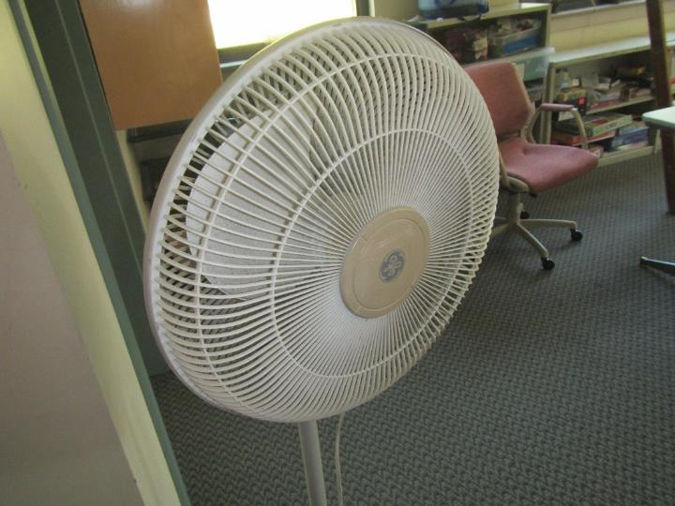

**Dust and debris on a personal fan**

**Picture 22**

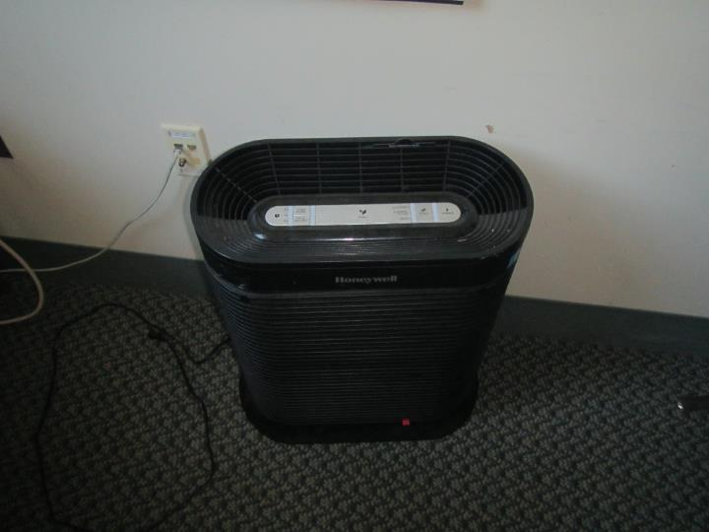

**Air purifier**

| **Location** | **Temp**  **(°F)** | **Relative**  **Humidity**  **(%)** | **Windows**  **Openable** | **Ventilation** | | **Remarks** |
| --- | --- | --- | --- | --- | --- | --- |
| **Supply** | **Exhaust** |
| Background | 71 | 65 |  |  |  | 10:00 AM, sunny |
| B1 | 73 | 59 | Y |  |  | Check filter light on for window AC |
| B2 | 74 | 56 | Y |  |  | Air purifier |
| B3 | 74 | 60 | Y |  |  | Window AC |
| B4 | 74 | 57 | Y |  |  | Window AC, plants, air purifier, water-damaged ceiling tile |
| B5 | 75 | 58 | Y |  |  | Window AC |
| B6 | 74 | 58 | N | Y |  | Ductless AC, water-damaged ceiling tile |
| B7 | 73 | 57 | Y |  |  | Window AC, books on univent |
| B8 | 75 | 57 | Y |  |  | Window AC |
| B9 | 73 | 60 | Y |  |  | Window AC |
| B10 | 73 | 56 | Y |  |  | Window AC, hole in ceiling, dehumidifier |
| B11 | 73 | 61 | Y |  |  | Window AC |
| C12 | 71 | 60 | Y |  |  | Window AC |
| C13 | 70 | 63 | Y |  |  | Window AC |
| C14 | 70 | 62 | Y |  |  | Window AC, art room |
| C15 | 69 | 63 | Y |  |  | Window AC, air purifier, plants |
| C16 | 70 | 62 | Y |  |  | Window AC, air purifier, water-damaged ceiling tile |
| C17 | 69 | 63 | Y |  |  | Window AC, plants |
| C18 | 70 | 63 | Y |  |  | Window AC, personal fan |
| C19 | 70 | 62 | Y |  |  | Window AC, water-damaged ceiling tile |
| D20 | 72 | 61 | Y |  |  | Window AC, water-damaged ceiling tile |
| D21 | 73 | 60 | Y |  |  | Window AC |
| D22 | 72 | 58 | Y |  |  | Window AC, hole in ceiling, plants |
| D23 | 71 | 61 | Y |  |  | Window AC, plants |
| Cafeteria | 73 | 59 | N |  |  | Water-damaged ceiling tiles |
| Counselor | 73 | 57 | Y |  |  |  |
| Gym | 71 | 59 | N |  |  | Reported leak when heavy rain occurs |
| Guidance | 70 | 63 | N | Y | Y |  |
| Library | 72 | 60 | N | Y |  | Water-damaged ceiling tiles, skylight window |
| Library Office | 70 | 63 | N |  |  | Air purifier |
| Main Office | 74 | 59 | Y |  |  |  |
| Nurse | 73 | 59 | Y |  |  |  |
| Principal | 74 | 58 | Y | Y | Y |  |
| Assistant Principal | 73 | 58 | Y | Y | Y |  |
| Teacher’s Room | 73 | 58 | N |  |  | Water-damaged ceiling tile, air purifiers |
| C Wing Girl’s Bathroom | 72 | 61 | N |  | Y | Open ceiling tiles, active water leak from ceiling |