Clarity Overtime Request and Approval Process for Timesheet Users: updated 4/11/2013

As a Timesheet User you currently enter your time into Clarity and it has been requested that you begin to utilize the following process to request and process approval, business and fiscal, to work paid Overtime.

Benefits to You
Building on lessons learned from previous experiences with Overtime Approval at ITD, we hope to greatly simplify the process for requesters and approvers and provide the following benefits:
- Simple approval request process which replaces the previous COMIT approval process for OT.
- Standard display of all pending OT requests on Resource Managers’ Overview page.
- Resource Manager tracks approval process through completion of Budget Approval.
- Payroll Manager enters OT into payroll system when OT posted and approved on a timesheet has matching approval.

Expectations
As a Timesheet User you will be asked to perform several functions in the Clarity tool now, including Overtime request and approval, and each of these tasks will provide increased transparency and visibility into your team’s work. Expect that these tasks may grow and change overtime as we mature and better define how to utilize this new data. Send all questions about this process to Jennifer Magrone at Jennifer.magrone@state.ma.us | Important caveats to this effort include:  - Clarity will never replace traditional communication channels. Continue to talk with your Supervisor and Project Managers about Overtime needs. Clarity is just a tool to support that work.  - This process should not keep you from completing your daily work. If you find Clarity isn’t working don’t stop your business process. Do whatever you need to first complete your work and then inform Jennifer about the issue with the tool.

1 Request Approval in Clarity when Paid Overtime work is being planned.  Frequency: It is expected that you should create a request for each instance of Overtime planned to be worked on a given project in any one to two week period. | 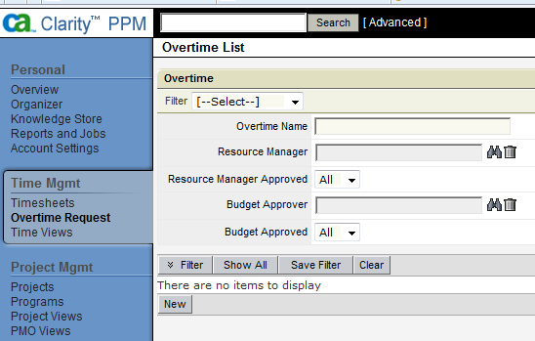  Note: You can search for existing requests using the filter, or click on the “New” button to create a new request.
2Complete all required fields in the OT Request and hit “Submit”  Frequency: It is expected that you should create a request for each instance of Overtime planned to be worked on a given project in any one to two week period. |  | 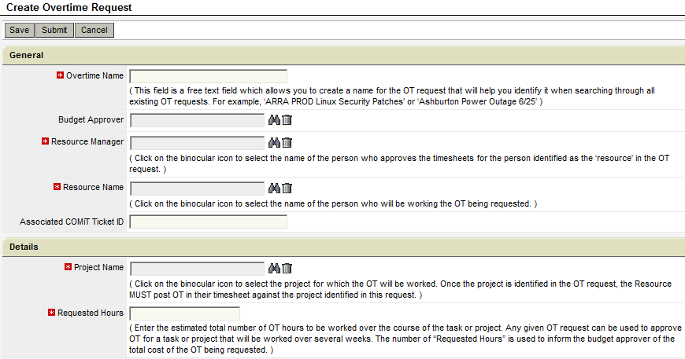 | 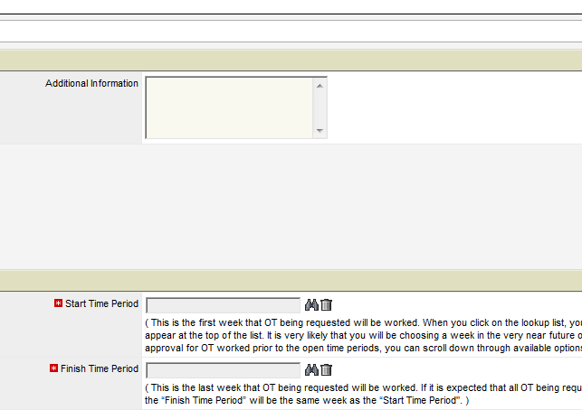
 | Note: Give the Overtime Request a name that you will remember, such as “VG Deployment w/e 9/3”. This name will follow the request to RM and Budget Approvers. Enter the name of the person who will be working the OT in the “Resource Name” field, and enter the supervisor’s name under “Resource Manager. “Project Name” and “Requested Hours” are required fields. If the OT will be for a task within the resource team, choose “Team Tasks” project. “Start Time Period” will be the first week that the OT will be worked. If the requested OT will all be worked within the same week, use the same dates for “Finish Time Period”. Click on “Submit” when you have completed all fields.
3Resource Manager reviews and approves request and submits for Budget Approval.  Frequency: Each request must be reviewed as it is submitted for approval. | 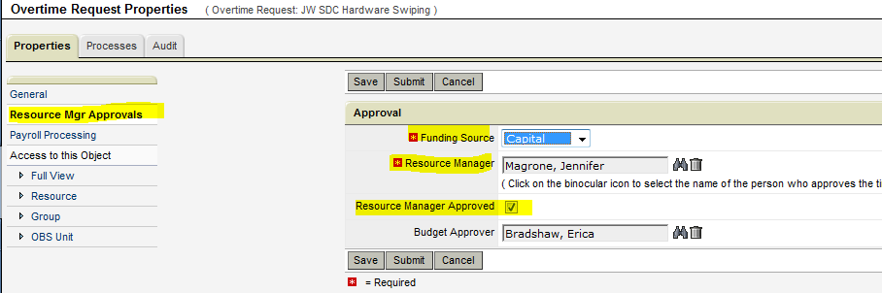
 | Note: Approval request will appear in a portlet on the Resource Managers’ “Overview” screen. Resource Manager opens request and adds Funding Source, Budget Approver, clicks on “Resource Manager Approved” box under RMs name, then clicks on “Submit”.

4 Budget Approver reviews request and completes approval.  Frequency: Each request must be reviewed as it appears in the OT Approval portlet in the RM’s Overview screen. | 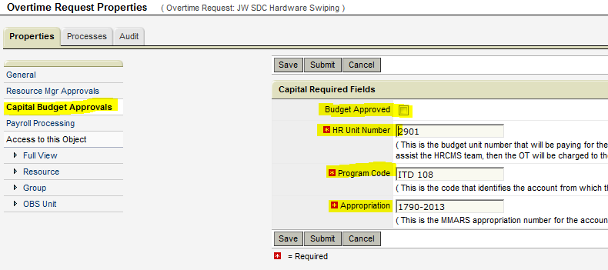
Note: Approval request will appear in a portlet on the Budget Approver’s “Overview” screen. Budget Approver opens request and adds Unit Number for internal requests, or Chargeback code for externally funded requests. Budget Approver clicks on “Budget Approved” box under “Budget Approver” name, then clicks on “Submit”. Request will remain in OT Approval portlet on Resource Managers Overview screen until approved by Budget Approver.
*Budget Approval page may be “Internal”, “Capital” or “Customer Funded” with different information required depending on funding source.
5Payroll Team will see approved request reconciled against OT entered on Timesheet.  Frequency: OT will be entered into HRCMS each pay period, typically on the Monday before payroll runs for timesheets approved for the prior two weeks. | Note: Payroll will enter OT into HRCMS when OT posted to an approved timesheets has a matching, approved OT request. Approval requests must include approval by an approved Budget Approver and all required fields on Budget Approval page must be completed accurately.  In order for Payroll to be able to process OT, the following information must be correct:  - Project identified in approved pre-approval request MUST MATCH project used in timesheet to post OT  - Start date and Finish date identified in approved pre-approval MUST include week of timesheet used to post OT  - OT posted to timesheet MUST be posted with “input type code” of OT

