Class D and M Road Test Sites  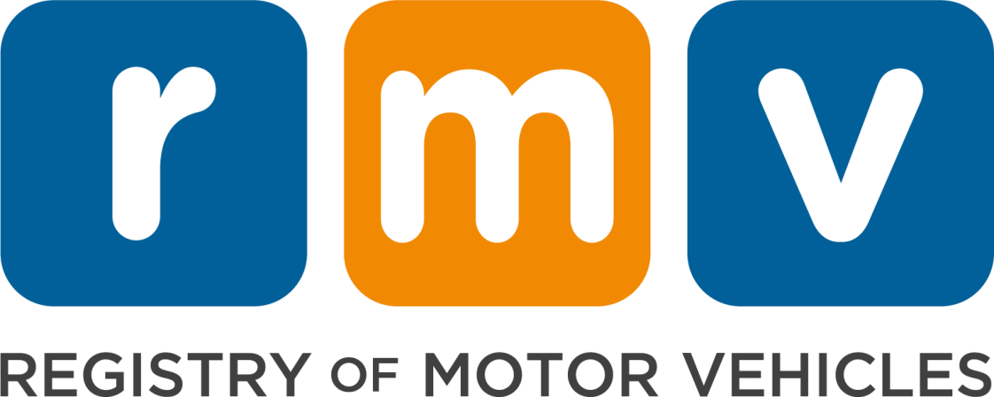 | Address
Avon (CMSC Road Test Site) | 21 Parker Drive  Avon, MA 02322
Boston - Mattapan Riverway Plaza | 90 River St.  Mattapan, MA 02126
Braintree RMV | 10 Plain St.  Braintree, MA 02184
Braintree Granite Plaza | 717 Granite St  Braintree, MA 02184
Brockton RMV | 490 Forest Ave.  Brockton, MA 02301
DCR Asiaf Arena Skating Rink  8:00am - 4:00pm | 702 Belmont Street  Brockton, MA 02301
Cambridge  DCR Simoni Skating Rink  Class D Only Monday - Friday 8:00am - 4:00pm | 155 Gore St.  Cambridge, MA 02141
Fall River RMV  No Motorcycle | 1794 North Main St.  Fall River, MA 02720
Framingham (CMSC Road Test Site) | 5 Edgel Road  Framingham, MA 01701
Greenfield | 18 Miner St.  Greenfield, MA 01301
Haverhill RMV | 229c Lincoln Avenue  Haverhill, MA 01830
Holyoke  DCR Fitzpatrick Arena Skating Rink  Tuesday - Friday Only from 8:00am - 4:00pm | 575 Maple Street  Holyoke, MA 01040
Lawrence RMV  No Motorcycle | 73 Winthrop Ave.  Lawrence, MA 01843
Leominster RMV  No Motorcycle | 500 Research Drive  Leominster, MA 01453
Lowell RMV  No Motorcycle | 77 Middlesex St.  Lowell, MA 01851
Martha’s Vineyard  Tuesdays Only | 11 A Street  Edgartown, MA 02539
Milford RMV  No Motorcycle | 14 Beach St.  Milford, MA 01757
Nantucket RMV  Fridays Only:  Must visit the Nantucket service center to schedule. | 16 Broad St.  Nantucket, MA 02554
New Bedford RMV  No Motorcycle | 212 Theodore H. Rice Blvd  New Bedford, MA 02740
AAA North Andover*  *AAA Members Only | 75 Turnpike St (route 114)  North Andover, MA 01845
Pittsfield RMV | 333 East St.  Pittsfield, MA 01201
Plymouth RMV | 40 Industrial Park Rd.  Plymouth, MA 02360
Revere  DCR Cronin Skating Rink  Class D Only | 870 Revere Beach Parkway  Revere, MA 02151
AAA Rockland*  *AAA Members Only | 900 Hingham St  Rockland, MA 02370
Southbridge RMV  Thursday & Friday Only  No Motorcycle | 6 Larochelle Way  Southbridge, MA 01550
South Yarmouth RMV  Wednesday & Thursday Only | 1084 Route 28  S. Yarmouth, MA 02664
Springfield RMV | 1250 St. James Ave.  Springfield, MA 01104
Taunton RMV  No Motorcycle | 1 Washington St.  Taunton, MA 02780
Watertown RMV | 550 Arsenal St.  Watertown, MA 02472
West Boylston (CMSC Road Test Site) | 186 W. Boylston Street  West Boylston, MA 01583
Wilmington RMV | 355 Middlesex Ave.  Wilmington, MA 01887
Worcester RMV | 50 Southwest Cutoff, Suite 1E  Worcester, MA 01604
AAA Worcester*  *AAA Members Only | 25 Mountain St. East  Worcester, MA 01606
DCR Buffone Arena Skating Rink  8:00am - 4:00pm | 284 Lake Avenue  Worcester, MA 01604

