INDOOR AIR QUALITY ASSESSMENT

Claypit Hill Elementary School
40 Adams Lane
Wayland, MA

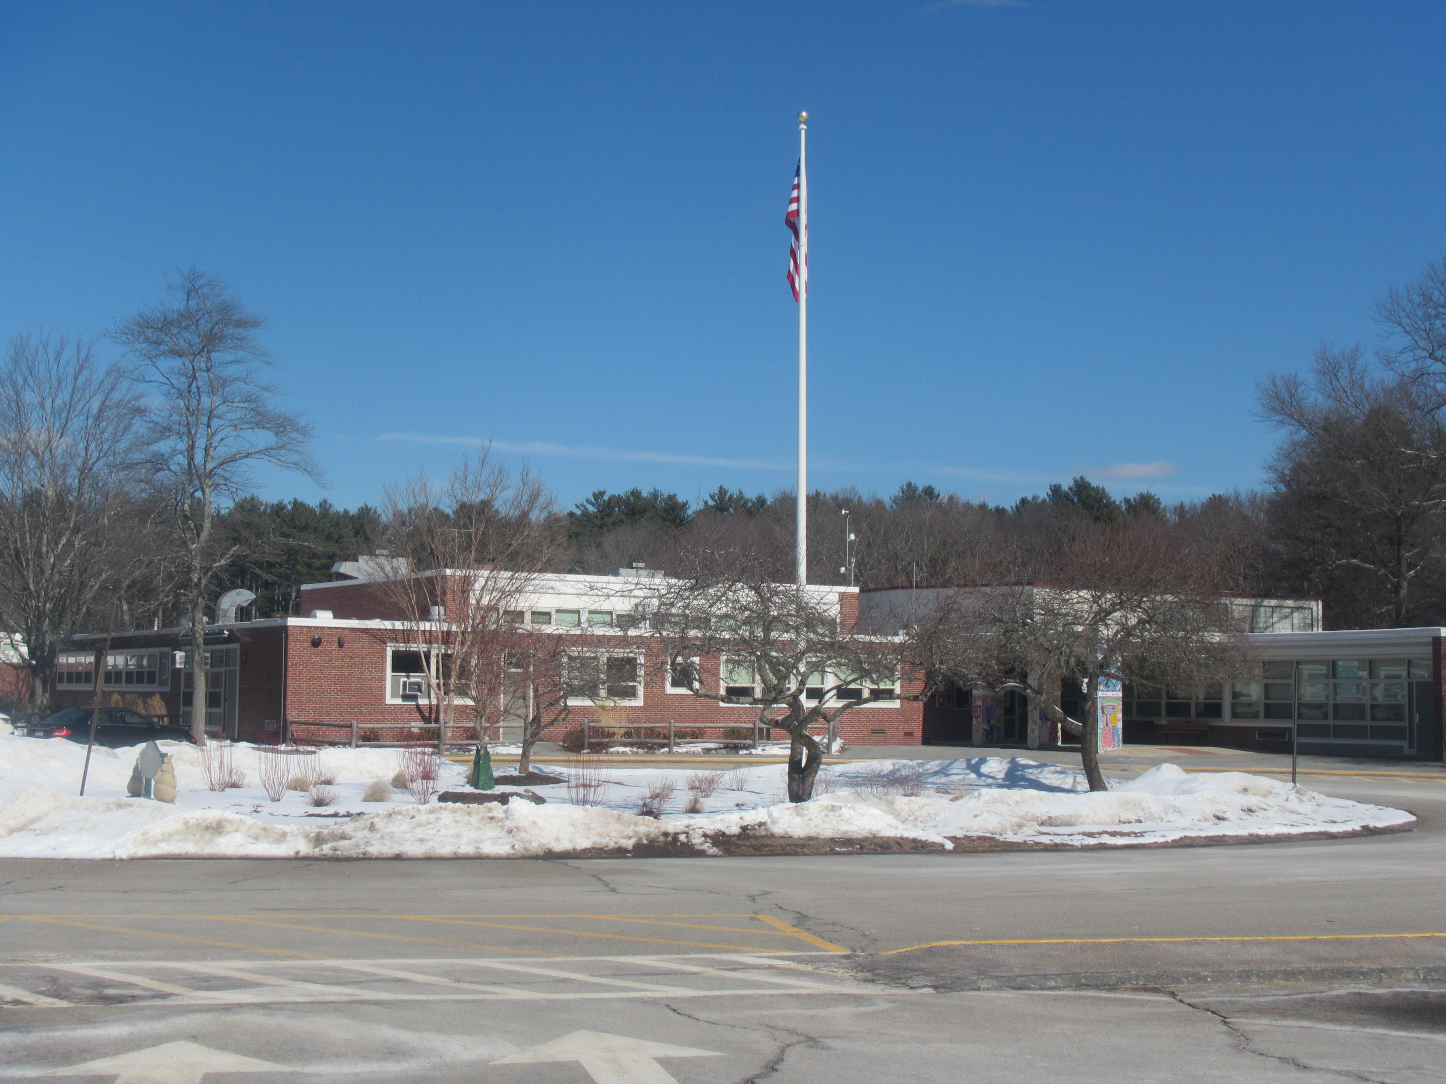

Prepared by:
Massachusetts Department of Public Health
Bureau of Environmental Health
Indoor Air Quality Program
March 2019

BACKGROUND
Building: | Claypit Hill Elementary School (CHES)
Address: | 40 Adams Lane, Wayland, MA
Assessment Requested by: | Susan Bottan, Director of Finance & Operations, Wayland Public Schools
Reason for Request: | General indoor air quality (IAQ)
Date of Assessment: | March 1, 2019
Massachusetts Department of Public Health/Bureau of Environmental Health (MDPH/BEH) Staff Conducting Assessment: | Ruth Alfasso, Environmental Engineer/Inspector and Jason Dustin, Environmental Analyst/Inspector, IAQ Program
Building Description: | The CHES is a single-story building originally built in in the 1950s with several additions including a set of modular classrooms installed in the late 1990s. The building has a brick and concrete block exterior and a flat roof.
Windows: | Openable

METHODS
Please refer to the IAQ Manual and appendices for methods, sampling procedures, and interpretation of results (MDPH, 2015).

RESULTS and DISCUSSION
The following is a summary of indoor air testing results (Table 1).
- Carbon dioxide levels were above the MDPH recommended level of 800 parts per million (ppm) in more than half of the areas surveyed, which indicates a lack of air exchange in many classrooms at the time of assessment.
- Temperature was within or close to the lower end of the MDPH recommended range of 70°F to 78°F in occupied areas apart from one reading of 62°F in a modular classroom.
- Relative humidity was below the MDPH recommended range of 40 to 60% in all areas tested the day of assessment, which is typical of conditions during the heating season.
- Carbon monoxide levels were non-detectable (ND) in all areas tested.
- Particulate matter (PM2.5) concentrations measured were below the National Ambient Air Quality (NAAQS) level of 35 μg/m³ in all areas tested.

A heating, ventilating and air conditioning (HVAC) system has several functions. First it provides heating and, if equipped, cooling. Second, it is a source of fresh air. Finally, an HVAC system will dilute and remove normally-occurring indoor environmental pollutants by not only introducing fresh air, but by filtering the airstream and ejecting stale air to the outdoors via exhaust ventilation. Even if an HVAC system is operating as designed, point sources of respiratory irritation may exist and cause symptoms in sensitive individuals.
Fresh air in most classrooms is supplied by unit ventilators (univents)( Picture 1). Univents draw air from the outdoors through a fresh air intake located on the exterior wall of the building (Picture 2) and return air through an air intake located at the base of the unit. Fresh and return air are mixed, filtered, heated or cooled and provided to rooms through an air diffuser located in the top of the unit (Figure 1).
In many rooms the top and/or front of univents were blocked by classroom items and furniture (Picture 3). In order for univents to provide fresh air as designed, intakes/returns must remain free of obstructions. Importantly, these units must remain on and be allowed to operate while rooms are occupied. It is also important to note that outside air is typically limited (by adjusting intake louvers) during cold/winter months to provide comfort and prevent the freezing of pipes.
Rooftop air handling units (AHU) supply fresh air and exhaust for classrooms in the modular section and many common areas and offices. Air circulation should be on during occupied periods.
In some areas, exhaust vents did not appear to be drawing air (Table 1). This may be due to deactivation by the settings on the HVAC system, broken motors or fan belts. Many exhaust vents in classrooms were obstructed by items and furniture (Picture 4; Table 1). These obstructions should be removed for proper airflow. Also note that in many classrooms, the exhaust vents are located near the classroom doors. When the doors are open, the exhaust vents may draw air from the hallway rather than the classroom. For best operation of the ventilation system, hallway doors should be closed. Lack of exhaust ventilation, particularly in areas where pollutants may be generated such as bathrooms, can allow odors, moisture and pollutants to build up.
To maximize air exchange, the IAQ program recommends that both supply and exhaust ventilation operate continuously during periods of occupancy. In order to have proper ventilation with a mechanical ventilation system, the systems must be balanced after installation to provide an adequate amount of fresh air to the interior of a room while removing stale air from the room. It is recommended that HVAC systems be re-balanced every five years to ensure adequate air systems function (SMACNA, 1994). It is not known when the systems were last balanced.
Temperature control complaints were expressed by some occupants. It is important that occupants have a system to make written requests for adjustments of the HVAC system to address heat, cold and noise complaints without turning off or blocking system components directly.
Some of the univents in the building are beyond their service life. Efficient function of equipment of this age is difficult to maintain, since compatible replacement parts are often unavailable. According to the American Society of Heating, Refrigeration and Air-Conditioning Engineering (ASHRAE), the service life for the various components of the HVAC system is between 20 to 30 years, assuming routine maintenance of the equipment (ASHRAE, 1991).

Microbial/Moisture Concerns
Water-damaged ceiling tiles were observed in a few areas (Picture 5; Table 1) which were attributed to roof leaks. Portions of the roof were repaired recently, meaning some of these damaged tiles are from historic leaks. Water-damaged ceiling tiles can provide a source of mold and should be replaced after a water leak is discovered and repaired. The library had multiple stained ceiling tiles. Library occupants expressed concerns regarding continuing roof leaks that occur during rainstorms. The library is carpeted and contains books and other porous materials that can become moldy if exposed to chronic moistening. Occupants in the library reported that odors occur from carpeting during rainstorms. The US Environmental Protection Agency (US EPA) and the American Conference of Governmental Industrial Hygienists (ACGIH) recommends that porous materials (e.g., wallboard, carpeting) be dried with fans and heating within 24 to 48 hours of becoming wet (US EPA, 2008; ACGIH, 1989). If porous materials are not dried within this time frame, mold growth may occur.
Some classrooms and storage areas have sinks. Some sinks have gaps in the backsplash which can lead to water damage and microbial growth in the material of the cabinet (Picture 6; Table 1). Backsplash gaps should be sealed or replaced with a one-piece unit. Some had large amounts of material stored underneath, including porous materials (Picture 7). The area under sinks can be a damp environment and should be kept clear of porous items which may become mold-colonized. Note that sinks and other drains that are not used regularly (e.g. little-used storage areas, locker rooms) can have the drain traps dry, which can allow sewer odors into the building. Drains should either be moistened periodically to maintain the trap seal, or be capped to prevent the infiltration of sewer odor/gases into occupied areas.
Plants were noted in some classrooms (Table 1). Some plants were on univents or on porous materials. Plants should be well maintained, not overwatered and use non-porous drip pans. They should be kept away from the airstream of ventilation equipment to prevent the distribution of pollen, mold, dirt and odors.
Refrigerators were found in break rooms and some classrooms (Table 1). These appliances should be located in non-carpeted areas and should be kept clean and free from spills and spoiled food that can lead to odors. The gasket of one refrigerator was found stained with mold. Stained gaskets should be cleaned with an antimicrobial solution or replaced if they cannot be cleaned or no longer seal well.
The majority of the building, including the modular classroom area, has a crawlspace below the floor. According to building facility staff, there were significant moisture issues in the modular area crawlspace that were causing odors in the modular classrooms. Building staff examined the crawlspace and identified an inoperable sump pump used for the hand sinks in the modular area which overflowed. The overflow issue was corrected and the area cleaned which has reduced odors in occupied areas. This sump pump should be periodically monitored for function. An alarm to detect pump malfunction or high water level should also be installed to prevent a reoccurrence.
Facility staff reported that increased airflow will be introduced to this portion of the crawlspace through vents in the exterior wall, some of which will be fitted with fans to depressurize the crawls space and remove odors and moisture. This fan will serve to draw air from occupied areas above into the crawlspace. In general, crawl spaces are damp areas with the potential for odors, mold and pests. Isolation of crawl spaces from occupied areas is also necessary, and includes sealing of any pathways between the crawlspace and occupied areas. Gaps around pipes that serve univents can be a frequent pathway between a crawlspace and the occupied areas above. Any such gaps should be sealed with an appropriate fire-rated sealant. Other gaps may include hatchways for utility service and holes around wiring.
The exterior of the building was examined for conditions that may lead to water infiltration or other IAQ concerns. Exterior doors had light visible between the door and the frame (Picture 8) which indicates that weather-stripping needs to be added or replaced to prevent moisture and pests from entering the building. The book storage room was originally a maintenance/storage area with a garage-type roll-up door. This type of door is not weather-tight and may be a source of unconditioned air, moisture and pests (Picture 9).
Some downspouts had been recently extended to direct water away from the base of the building (Picture 10), however a few terminated at the foundation (Picture 11). These should also be extended to drain water away from the building.
In a few areas, plants were observed near or against the exterior of the building (Picture 12). Plants can prevent the building from drying which may lead to damage, and plant roots may damage building foundations. Plants should be trimmed or removed to five feet away from the building.

Other Conditions
Exposure to low levels of total volatile organic compounds (TVOCs) may produce eye, nose, throat, and/or respiratory irritation in some sensitive individuals. BEH/IAQ staff examined rooms for products containing VOCs. BEH/IAQ staff noted hand sanitizers, scented products, cleaners, and dry erase materials in use within the building (Picture 13; Table 1). These products have the potential to be irritants to the eyes, nose, throat, and respiratory system of sensitive individuals.
There are copy machines/printers in the building which can produce waste heat and irritating odors. VOCs and ozone can be produced by photocopiers, particularly if the equipment is older and in frequent use. Ozone is a respiratory irritant (Schmidt Etkin, D., 1992).
The MDPH recommends pleated filters with a Minimum Efficiency Reporting Value (MERV) of 8, which are adequate in filtering out pollen and mold spores (ASHRAE, 2012). Filters should also be changed two to four times a year, or per the manufacturer’s instructions. Some univent cabinets had dust and debris in them (Picture 14). Univent cabinets should be vacuumed out periodically during filter changes to remove dust and debris that may cause odors when heated or aerosolized. Also note that the univent fresh air vents on the outside of the building need to be cleaned periodically to prevent the build-up of debris that can reduce effectiveness and cause odors to be drawn into classrooms.
In many areas, supply vents, exhaust vents and personal fans were dusty (Pictures 15 and 16; Table 1). This dust can be reaerosolized under certain conditions, and can also be a medium for mold growth.
Some areas of the school are carpeted. Carpeting is not recommended for high traffic or instructional areas of schools because it can be hard to keep clean, and may become a source of odors and mold if it gets wet. Carpeting is not recommended in areas subject to chronic moisture/condensation. In addition, carpeting in schools has a service life of approximately 10-11 years (IICRC, 2002).). Carpeting that is beyond its service life becomes increasingly difficult to clean and may release fibers which can be irritating if airborne. School staff reported that some carpeting in the school has already been removed and there is a program plan to remove and replace all the carpeting in classrooms and hallways over the next several years.
Carpets should be cleaned annually (or semi-annually in soiled/high traffic areas) in accordance with Institute of Inspection, Cleaning and Restoration Certification (IICRC) recommendations, (IICRC, 2012). Regular cleaning with a high efficiency particulate air (HEPA) filtered vacuum in combination with an annual cleaning will help to reduce accumulation and potential aerosolization of materials from carpeting. Area rugs were also observed in many classrooms (Table 1). Area carpets too worn to be effectively cleaned should be replaced. Area rugs should be rolled up and stored in a clean, dry place when rooms are not occupied during the summer months to prevent moistening due to condensation.
In many classrooms and particularly in storage areas, large numbers of items were on floors, windowsills, tabletops, counters, bookcases and desks, which provide a source for dusts to accumulate (Picture 17). These items (e.g., papers, folders, boxes) make it difficult for custodial staff to clean. Items should be relocated and/or be cleaned periodically to avoid excessive dust build up and associated irritation.
Note that the Environmental Protection Agency (EPA) conducted a National School Radon Survey in which it discovered nearly one in five schools had “…at least one frequently occupied ground contact room with short-term radon levels above 4 [picocuries per liter] pCi/L” (US EPA 1993). The BEH/IAQ Program therefore recommends that every school be tested for radon, and that this testing be conducted during the heating season while school is in session in a manner consistent with USEPA radon testing guidelines. Radon measurement specialists and other information can be found at www.nrsb.org and http://aarst-nrpp.com/wp, with additional information at: http://www.mass.gov/eohhs/gov/departments/dph/programs/environmental-health/exposure-topics/iaq/radon.

RECOMMENDATIONS
In view of the findings at the time of the visit, the following recommendations are made:
- Operate the HVAC system to provide for continuous fresh air ventilation during occupied hours.
- Remove furniture and items blocking the front and top of univents. Remove furniture and items from in front of exhaust vents.
- Periodically assess whether exhaust vents (classrooms and restrooms) are drawing air and repair as needed.
- Consider closing classroom doors in rooms with exhaust vents near the doors.
- Use openable windows to supplement fresh air during temperate weather. Ensure all windows are closed tightly at the end of each day.
- Work with staff to troubleshoot temperature control problems.
- Utilize a system to report and track maintenance issues so that concerns can be reported by staff and maintenance staff can report when issues have been resolved.
- Consider adopting a balancing schedule of every 5 years for all mechanical ventilation systems, as recommended by ventilation industrial standards (SMACNA, 1994).
- For buildings in New England, periods of low relative humidity during the winter are often unavoidable. Therefore, scrupulous cleaning practices should be adopted to minimize common indoor air contaminants whose irritant effects can be enhanced when the relative humidity is low. To control for dusts, a high efficiency particulate arrestance (HEPA) filter equipped vacuum cleaner in conjunction with wet wiping of all surfaces is recommended. Avoid the use of feather dusters. Drinking water during the day can help ease some symptoms associated with a dry environment (throat and sinus irritations).
- Work with a roofing contractor/building engineer to investigate/repair building envelope leaks. Until this has been completed, avoid storing porous materials in areas of known leaks.
- Consider replacement of library carpeting with non-porous flooring in areas where odors occur, particularly if deep cleaning does not resolve the issue.
- Replace water-damaged ceiling tiles and inspect above them to clean/disinfect any additional moistened material.
- Repair sink backsplashes with appropriate sealant or replace. Avoid storing porous items or large amounts of items under sinks.
- Sinks and other fixtures that are not used regularly should have the drains moistened to ensure the traps function to prevent sewer gas from entering occupied areas. If fixtures are not needed long term, they should be properly sealed or removed and cut/capped.
- Keep plants in good condition, avoid overwatering, and keep them away from the airstream of ventilation equipment.
- Keep refrigerators clean of spills and spoiled food. Clean mold-stained gaskets with an antimicrobial solution or replace.
- Periodically inspect the crawl space sump and pump for overflow and other issues. Consider installing an alarm to detect pump failure and/or water leakage.
- Continue with plans to increase airflow in the crawlspace through ventilation and fans. When deciding where to install fans, consider prevailing wind direction, obstructions, and the location of supply air vents to avoid entraining air from the crawlspace into occupied areas.
- Seal gaps between the crawlspace and occupied areas, including gaps around piping in univents.
- Repair or replace weather-stripping on exterior doors for a tight fit that excludes unconditioned air and pests.
- Seal the garage door in the book room with weather-stripping. Consider plans to replace this with a solid wall if it will continue to be occupied space.
- Ensure downspouts direct water away from the building.
- Trim back plants from the foundation approximately 5 feet, including in the courtyard.
- Reduce or eliminate the use of air fresheners, scented cleaners, hand sanitizers and dry erase materials to reduce irritation. Consult the MDPH guidance “Clean Air is Odor-Free,” attached as Appendix A, for more information.
- Ensure copy machines, laminators and other appliances are used in areas with adequate ventilation and away from occupants.
- Continue to change filters in HVAC units at least twice a year with MERV 8 or higher filters. Clean HVAC and univent cabinets of debris and dust when filters are changed.
- Clean supply and exhaust vents and fans regularly to remove accumulated dust/debris.
- Ensure that screens are installed on univent fresh air intake vents to prevent pest entry or debris accumulation.
- Clean carpeting and rugs at least once per year according to IICRC recommendations (IICRC 2012). Area carpets too worn to be effectively cleaned should be replaced. Roll up and store are rugs in a clean, dry place during the summer.
- Relocate or consider reducing the amount of materials stored in classrooms to allow for more thorough cleaning of classrooms. Plan regular clean-outs to remove and organize items in storerooms, particularly science storage areas. Clean items regularly with a wet cloth or sponge to prevent excessive dust build-up.
- Continue to utilize the US EPA’s (2000), “Tools for Schools”, as an instrument for maintaining a good IAQ environment in the building available at: http://www.epa.gov/iaq/schools/index.html.
- The school should be tested for radon by a certified radon measurement specialist during the heating season when school is in session. Radon measurement specialists and other information can be found at: www.nrsb.org, and http://aarst-nrpp.com/wp.
- Refer to resource manuals and other related IAQ documents for further building-wide evaluations and advice on maintaining public buildings. Copies of these materials are located on the MDPH’s website: http://mass.gov/dph/iaq.

REFERENCES
ACGIH. 1989. Guidelines for the Assessment of Bioaerosols in the Indoor Environment. American Conference of Governmental Industrial Hygienists, Cincinnati, OH.
ASHRAE. 1991. ASHRAE Applications Handbook, Chapter 33 “Owning and Operating Costs”. American Society of Heating, Refrigeration and Air Conditioning Engineers, Atlanta, GA.
ASHRAE. 2012. American Society of Heating, Refrigeration and Air Conditioning Engineers (ASHRAE) Standard 52.2-2012 -- Method of Testing General Ventilation Air-Cleaning Devices for Removal Efficiency by Particle Size (ANSI Approved). 2012.
IICRC. 2002. Institute of Inspection, Cleaning and Restoration Certification. A Life-Cycle Cost Analysis for Floor Coverings in School Facilities.
IICRC. 2012. Institute of Inspection Cleaning and Restoration Certification. Institute of Inspection, Cleaning and Restoration Certification. Carpet Cleaning: FAQ.
MDPH. 2015. Massachusetts Department of Public Health. Indoor Air Quality Manual: Chapters I-III. Available at: http://www.mass.gov/eohhs/gov/departments/dph/programs/environmental-health/exposure-topics/iaq/iaq-manual/.
Schmidt Etkin, D. 1992. Office Furnishings/Equipment & IAQ Health Impacts, Prevention & Mitigation. Cutter Information Corporation, Indoor Air Quality Update, Arlington, MA.
SMACNA. 1994. HVAC Systems Commissioning Manual. 1st ed. Sheet Metal and Air Conditioning Contractors’ National Association, Inc., Chantilly, VA.
US EPA. 1993. Radon Measurement in Schools, Revised Edition. Office of Air and Radiation, Office of Radiation and Indoor Air, Indoor Environments Division (6609J). EPA 402-R-92-014. https://www.epa.gov/sites/production/files/2014-08/documents/radon_measurement_in_schools.pdf
US EPA. 2000. Tools for Schools. Office of Air and Radiation, Office of Radiation and Indoor Air, Indoor Environments Division (6609J). EPA 402-K-95-001, Second Edition. http://www.epa.gov/iaq/schools/index.html.
US EPA. 2008. Mold Remediation in Schools and Commercial Buildings. US Environmental Protection Agency, Office of Air and Radiation, Indoor Environments Division, Washington, D.C. EPA 402-K-01-001. http://www.epa.gov/mold/mold-remediation-schools-and-commercial-buildings-guide.

Picture 1
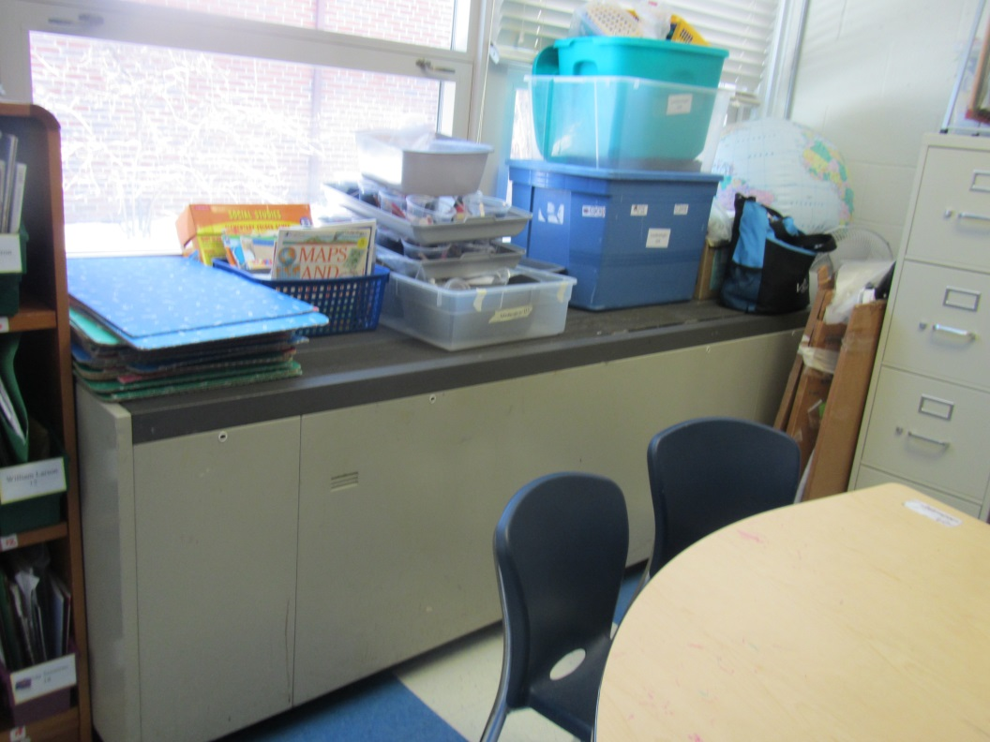
Unit ventilator (univent), note items on top and in front
Picture 2
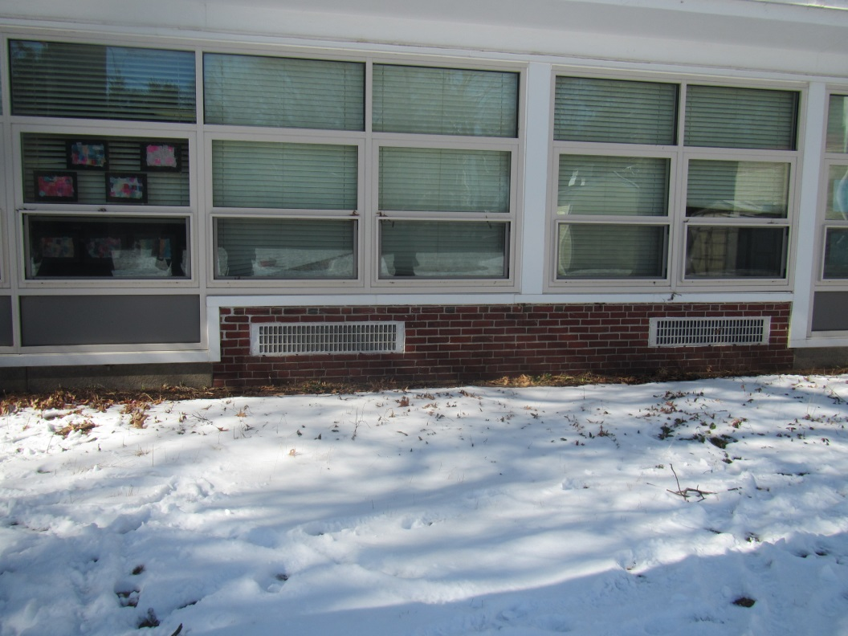
Univent fresh air intakes
Picture 3
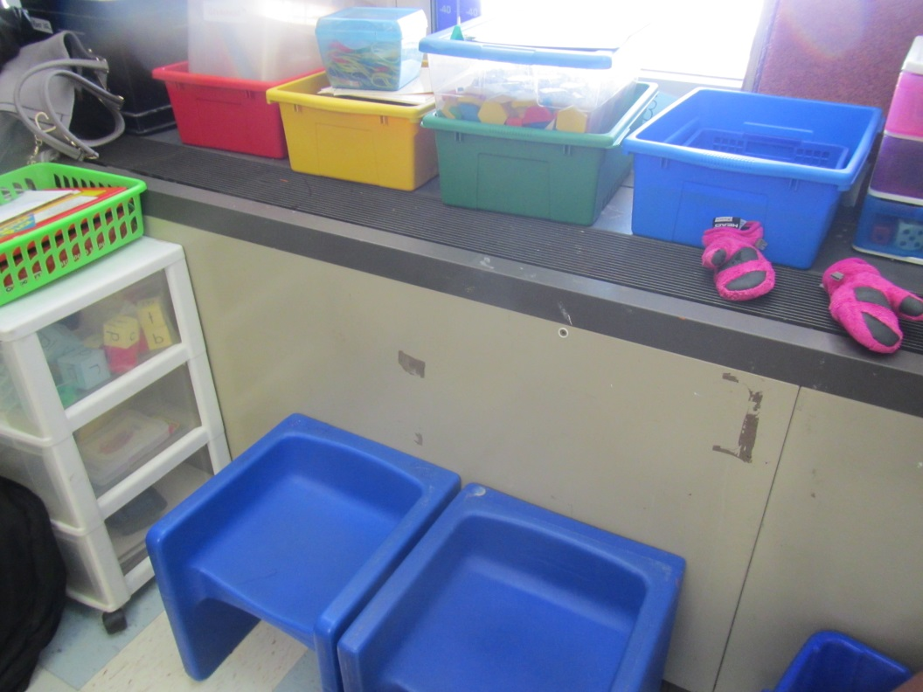
Univent obstructed with items/furniture
Picture 4
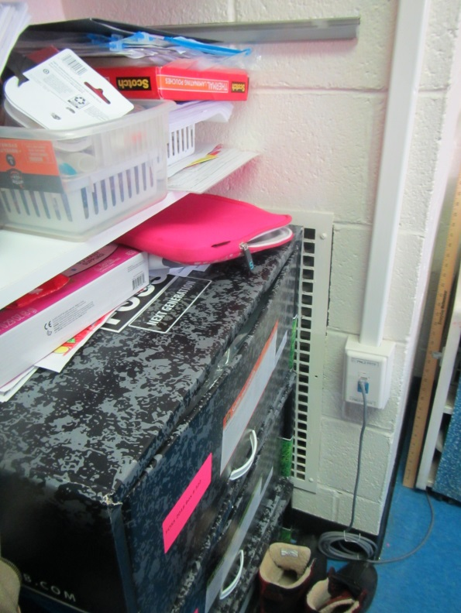
Significantly obstructed exhaust vent
Picture 5
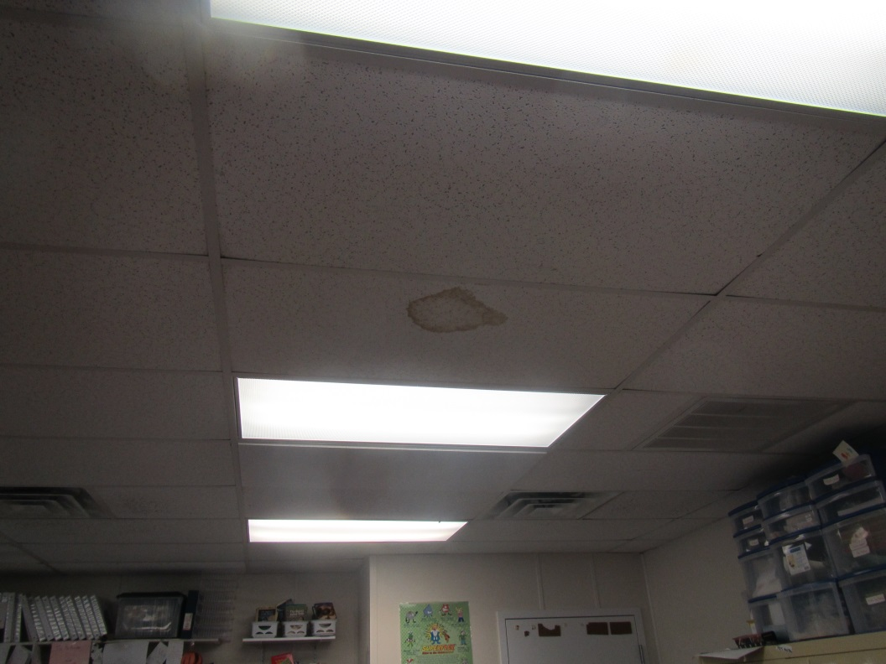
Water-damaged ceiling tile
Picture 6
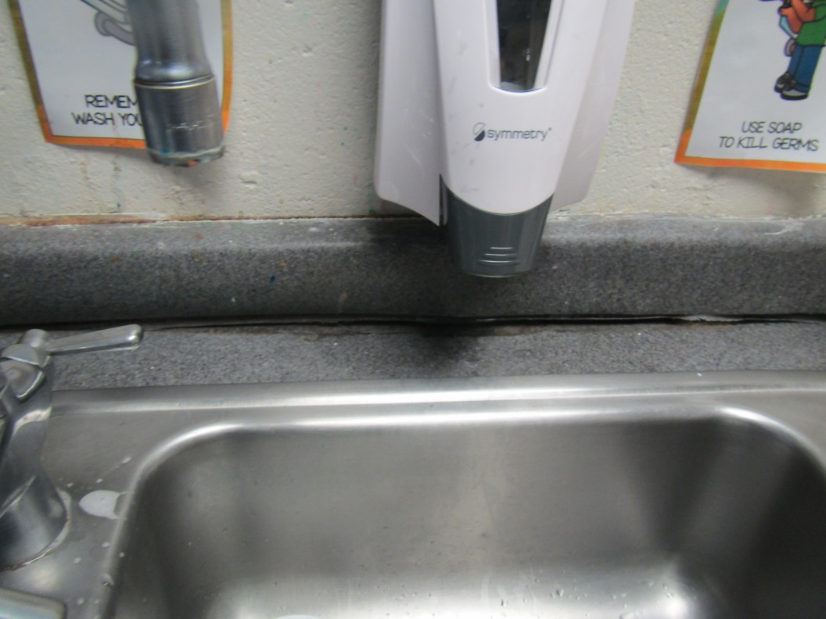
Damaged sealant between bottom and side of backsplash
Picture 7
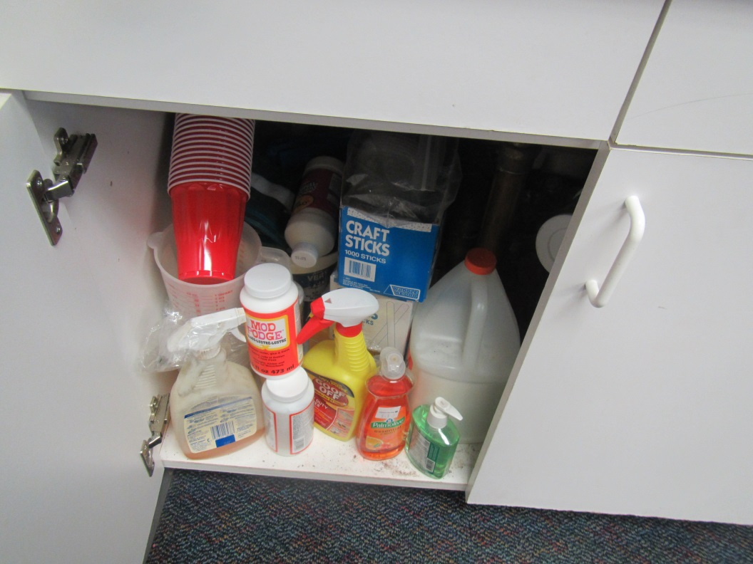
Items, including porous items, under a classroom sink
Picture 8
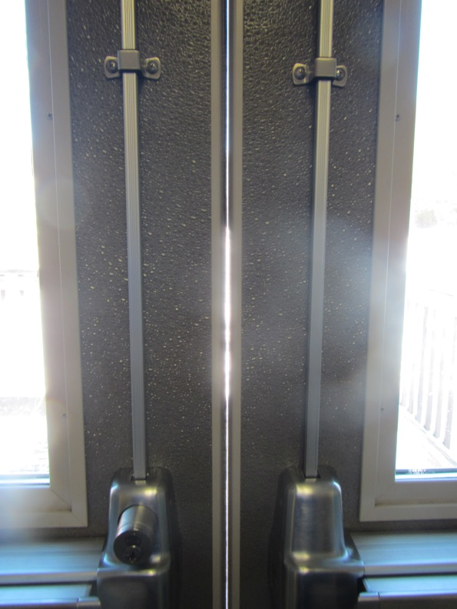
Exterior door missing weather-stripping
Picture 9
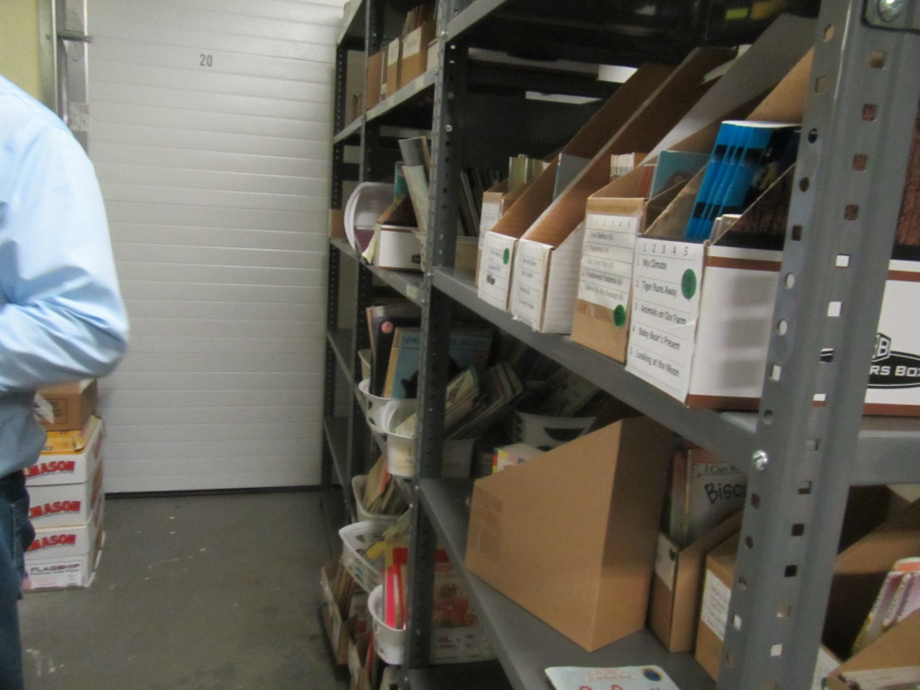
Garage door in book room
Picture 10
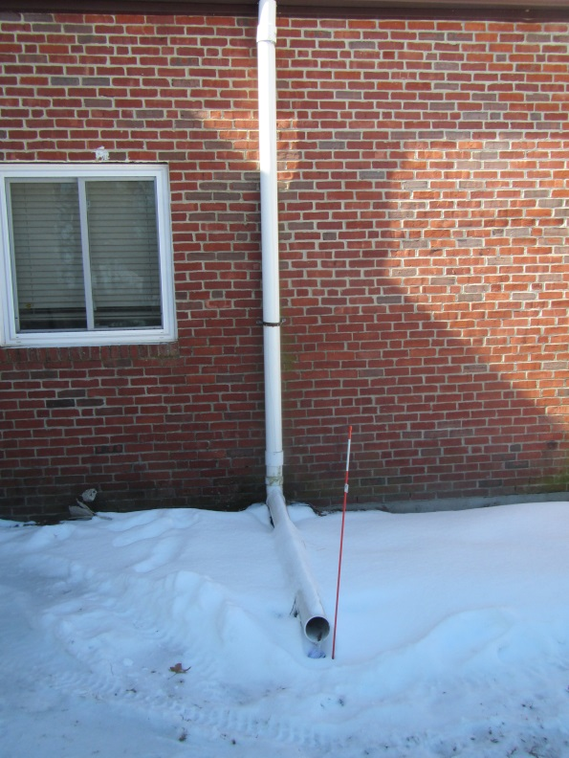
Extended downspout
Picture 11
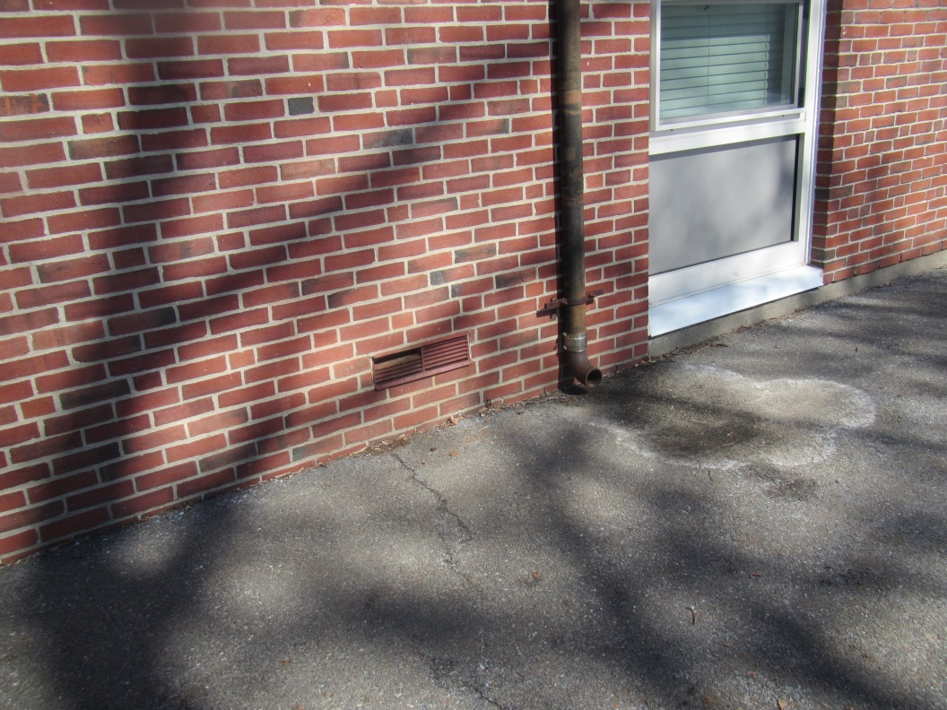
Downspout terminating next to the foundation
Picture 12
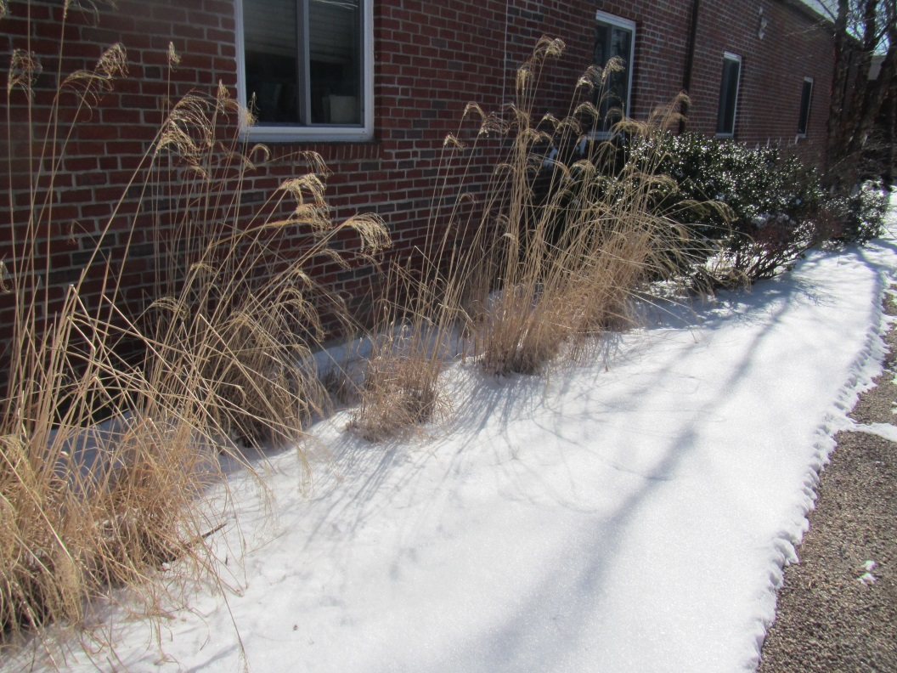
Plants next to the building
Picture 13
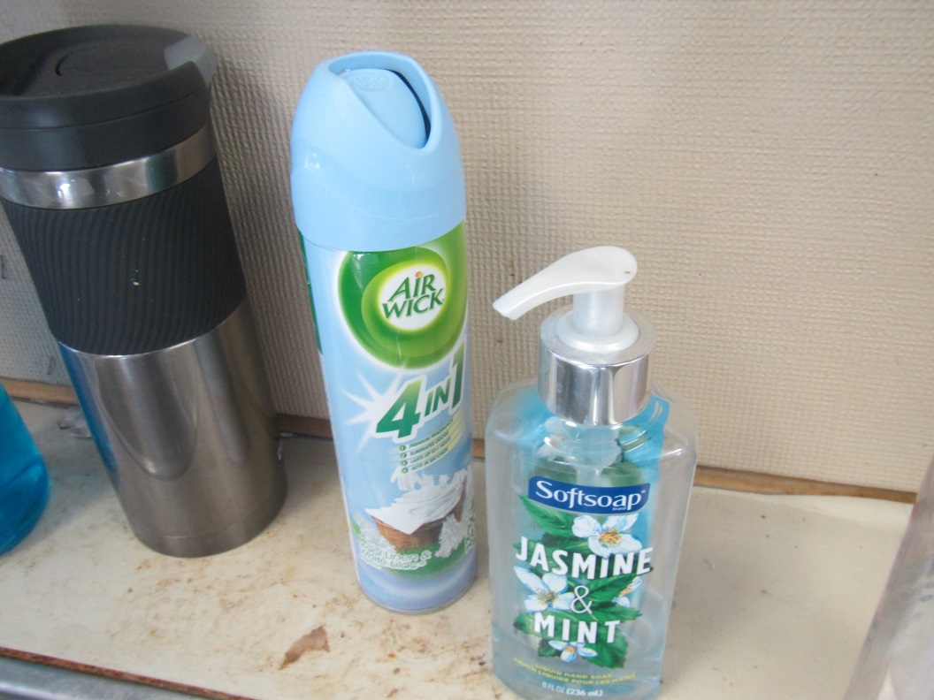
Air freshener and scented hand soap
Picture 14
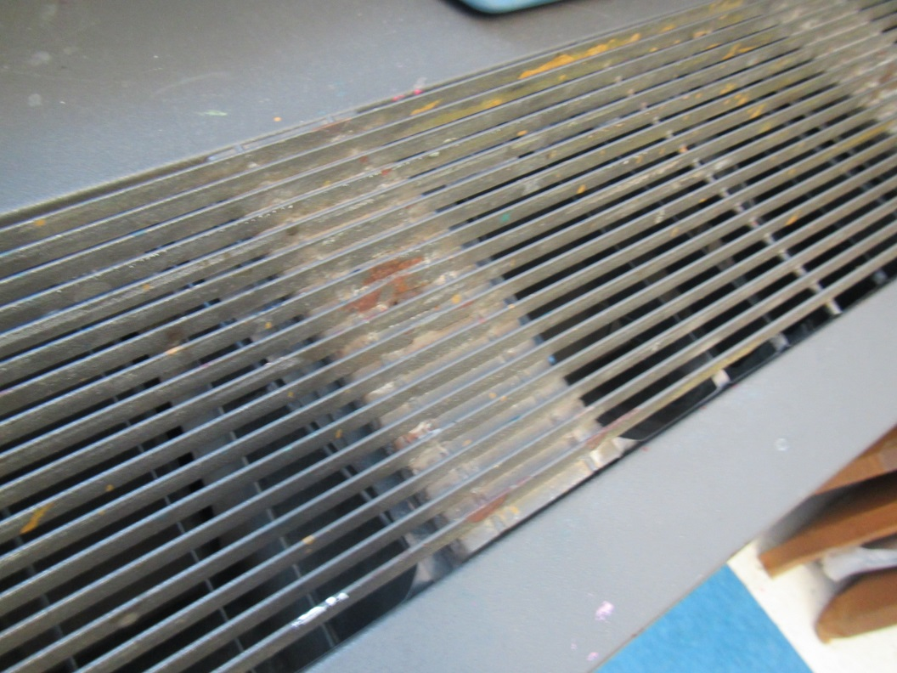
Debris in univent grill
Picture 15
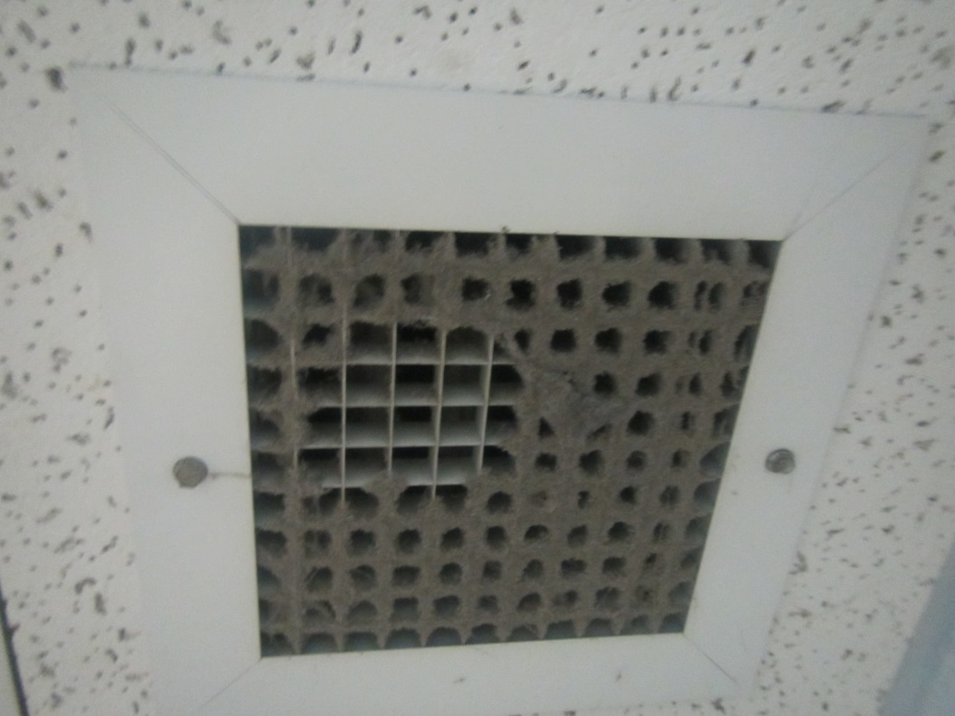
Heavy dust accumulation on exhaust vent
Picture 16
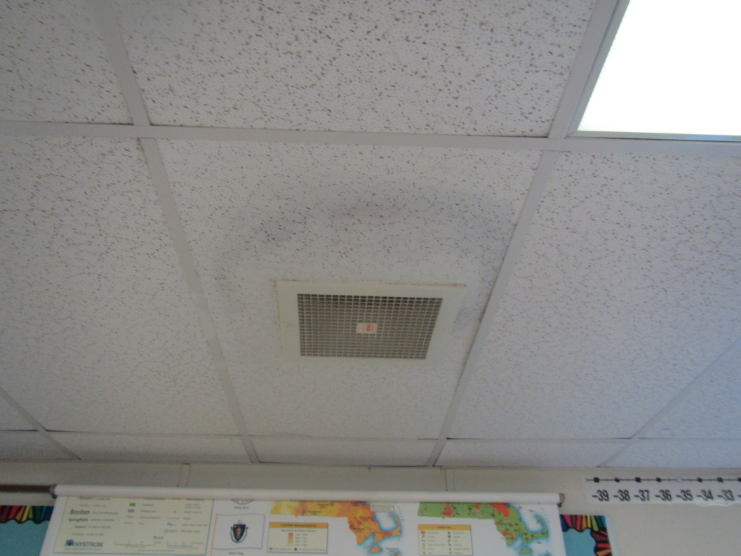
Dusty vent and ceiling tiles in a modular classroom
Picture 17
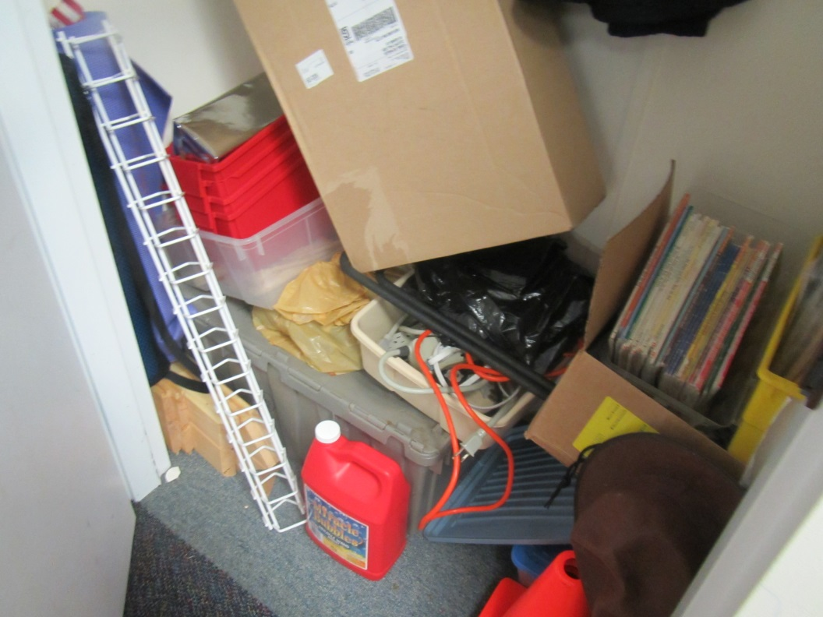
Items in a storage closet

Location | Carbon  Dioxide  (ppm) | Carbon Monoxide  (ppm) | Temp  (°F) | Relative  Humidity  (%) | PM2.5  (µg/m³) | Occupants  in Room | Windows  Openable | Ventilation |  | Remarks
 |  |  |  |  |  |  |  | Supply | Exhaust
Background (outside) | 387 | ND | 46 | 15 | 4 |  |  |  |  | Sunny
BASE room | 719 | ND | 70 | 12 | 5 | 0 | N | Y | Y | Carpet, UF, humidifier
Cooling room | 618 | ND | 70 | 14 | 4 | 0 | N | N | N | Area rug
Gym | 713 | ND | 70 | 19 | 5 | ~30 | Doors to outside | Y | Y | DEM
Music room 1 | 643 | ND | 69 | 16 | 6 | 0 | Y | Y | Y | 3 WD CT, NC
Room 1 | 860 | ND | 69 | 11 | 10 | 1 class just left | Y | Y | Y | Mats, DEM, CP, HS, carpet, sink, WD CT
Room 2 | 805 | ND | 62 | 21 | 6 | 1 | Y | Y | Y | Carpet, DEM, sink, books
Room 3 | 1020 | ND | 70 | 25 | 6 | 0 | Y | Y | Y | Dusty vents, sink with items under, DEM, carpet and area rug, HS, CP,
Room 4 | -- | ND | 70 | -- | 9 | 22 | Y | Y | Y | Carpet and area rug (soiled), DEM, sink, HS
Stage rear | 689 | ND | 69 | 21 | 4 | 0 | N | Y | Y | 2 WD CT, NC
102 | 871 | ND | 71 | 16 | 4 | 18 | Y | Y | Y | Univent on, obstructed, area rug, doors, exhaust very dusty under cover – on but obstructed
103 | 966 | ND | 71 | 19 | 3 | 17 | Y | Y | Y | UV
104 | 922 | ND | 71 | 18 | 4 | 12 | Y | Y | Y | UV blocked
105 kindergarten | 875 | ND | 70 | 16 | 4 | 17 | Y | Y | Y | Exhaust on, dusty, 2 doors, toilet room, sink backsplash gap, NC with area rug, art supplies
106 | 561 | ND | 71 | 16 | 3 | 1 | Y | Y | Y off | UV, DEM, plant, area rug
107 | 1148 | ND | 72 | 18 | 3 | 20 | Y | Y | Y | HS, UV
108 | 1148 | ND | 72 | 16 | 1 | 15 | Y | Y | Y | Area rug, sink, DEM, exhaust on and obstructed
109 | 1154 | ND | 73 | 19 | ND | 0 | y | Y | Y | 2 area rugs, sink with backsplash gap, PF
110 | 1100 | ND | 72 | 16 | 2 | 16 | Y | Y | Y | HS, PF, sink backsplash, exhaust off
111 | 1224 | ND | 72 | 19 | 2 | 15 | Y | Y | Y | HS, AI, UV and exhaust blocked
112 | 1151 | ND | 75 | 16 | 2 | 18 | Y | Y | Y | PF – dusty, exhaust on -- dusty, area rug, door open, items under sink
113 | 1204 | ND | 72 | 20 | 3 | 17 | Y | Y | Y | HS, UV, AI
114 | 965 | ND | 73 | 13 | 1 | 18 | Y | Y | Y | Exhaust off, dusty, area rug, DEM, HS, sink
115 | 940 | ND | 72 | 13 | 1 | 3 | N | Y | Y | Exhaust on
117 | 1028 | ND | 70 | 18 | 3 | 21 | Y | Y | Y | CPs, AF, UV exhaust vent blocked
118 | 943 | ND | 73 | 14 | 1 | 0 | Y | Y | Y | Area rug, exhaust obstructed
120 | 1164 | ND | 70 | 20 | 2 | 18 | Y | Y | Y | Area rug, exhaust off
121 | 1050 | ND | 70 | 17 | ND | 0 | Y | Y | Y | Area rug, TBs (a few), DEM, exhaust off and obstructed
122 | 1188 | ND | 71 | 21 | 4 | 19 | Y | Y | Y off | HS, DEM, UV area rug
123 | 1121 | ND | 69 | 21 | 3 | 1 | Y | Y | Y off | HS, DEM, UV temperature complaints
124 | 737 | ND | 71 | 15 | 6 | 5 | Y | Y | Y | UV blocked, CPs, HS, WD CT
125 | 587 | ND | 71 | 11 | ND | 0 | Y | Y | Y | 1 WD CT, area rug, exhaust on
126 | 743 | ND | 71 | 15 | 4 | 3 | Y | Y | Y | UV, CPs, DEM, WD CT, HS
127 | 588 | ND | 71 | 10 | 1 | 0 | Y | Y | Y | Cleaner odor/AF, univent dust/debris
128 | 1047 | ND | 70 | 15 | ND | 0 | Y | Y | Y | Sink, area rug, DEM, sink backsplash gap
128 | 923 | ND | 70 | 16 | 5 | 0 | Y | Y | Y | DEM, UV, CPs, area rug
129 | 941 | ND | 71 | 18 | ND | 20 | Y | Y | Y | Area rug, sink
Art | 863 | ND | 70 | 19 | 2 | 19 | Y | Y | Y | UV blocked, slight musty odor near kiln/sink area (accumulated dust)
Art Closet |  |  |  |  |  |  | N | N |  | Art supplies – mostly not on floor, damaged flooring
Book room | 1004 | ND | 71 | 15 | 1 | 0 | N | N | N | Garage door, electric garage heater
C | 928 | ND | 72 | 15 | 4 | 7 | N | Y | Y | PF, AI, UV
Cafeteria | 693 | ND | 72 | 13 | 7 | 50+ | N | Y | Y
Colbert tech | 1117 | ND | 72 | 19 | 3 | 22 | N | Y | Y | Computers, area carpet
Conference | 651 | ND | 71 | 15 | 3 | 0 | N | N | Y | NC, area carpet
EL | 573 | ND | 70 | 13 | 3 | 1 | Y | Y | Y on | DEM, plants, UV blocked/off (cold air complaints)
Guidance 2 | 990 | ND | 71 | 19 | 4 | 1 | N | Y | Y | Personal heater
Guidance-McManus | 884 | ND | 69 | 17 | 4 | 6 | N | Y | Y off
Gym office | 808 | ND | 68 | 23 | 1 | 0 | N | N | N | WD CT, HS
Hall near 109 | 1262 | ND | 72 | 21 | 6 | 30+ | N | N | Y
Hehir | 794 | ND | 71 | 15 | 3 | 2 | Y | Y | Y | Plants
Library | 885 | ND | 71 | 14 | 1 | 2 | N | Y | Y | Several WD CT (acoustic type), reported carpet odor when leaks/wet weather, DEM, books
Library OT/PT room | 799 | ND | 71 | 13 | ND | 3 | Y | Y | Y | Area rug and mats, PF, sink
Main Office | 635 | ND | 71 | 14 | 2 | 5 | Y | Y | Y | NC, PC, UV
METCO | 750 | ND | 70 | 12 | ND | 0 | N | N | Y | DEM, exhaust off
Music 2 | 782 | ND | 75 | 12 | 2 | 19 | N | Y | Y | Room has own HVAC, reported temperature issues, DEM, large area rug, DEM, sink backsplash is wooden, HS, CP
Music office 2 | 608 | ND | 66 | 19 | 2 | 1 | N | Y | N | WD CTs x 3
Nurse | 641 | ND | 75 | 11 | 3 | 3 | Y | Y | N | No exhaust vent, sink
OT/PT | 586 | ND | 72 | 11 | 3 | 0 | N | Y | Y | MT and ajar CT
Principal | 662 | ND | 71 | 15 | 3 | 2 | Y | Y | Y | Plants
Reading | 791 | ND | 72 | 17 | 5 | 1 | N | Y | Y | Carpet, pathways in ceiling
Reading resource | 1094 | ND | 71 | 15 | 0 | 0 | N | Y | Y | PF, area rug, makeshift air supply from next room
Server room | - | - | - | - | - | - | - | - | - | WD CTs
SPED Room | 756 | ND | 70 | 13 | 1 | 0 | N | Y | Y | Carpet
Teacher’s lunch | 647 | ND | 74 | 11 | 4 | 1 | Y | Y | Y | Stove, sink backsplash gap, food, 2 ajar CTs, fridge and microwave and toaster, exhaust on
Teacher’s room | 1036 | ND | 71 | 16 | 5 | 2 | N | N | Y | Ceiling fan, door open
Teacher’s work | 1116 | ND | 71 | 17 | ND | 5 | N | N | N | DEM
Tech room | 1053 | ND | 71 | 16 | ND | 0 | N | Y | Y | Area rug, DO, low ceiling, computers
Testing room | 655 | ND | 69 | 16 | 4 | 0 | Y | Y | Y off | MT, Personal heater

The service life is the median time during which a particular system or component of …[an HVAC]… system remains in its original service application and then is replaced. Replacement may occur for any reason, including, but not limited to, failure, general obsolescence, reduced reliability, excessive maintenance cost, and changed system requirements due to such influences as building characteristics or energy prices (ASHRAE, 1991).

