**INDOOR AIR QUALITY ASSESSMENT**

**Clean Water Trust**

**1 Center Plaza Suite 430**

**Boston, MA**

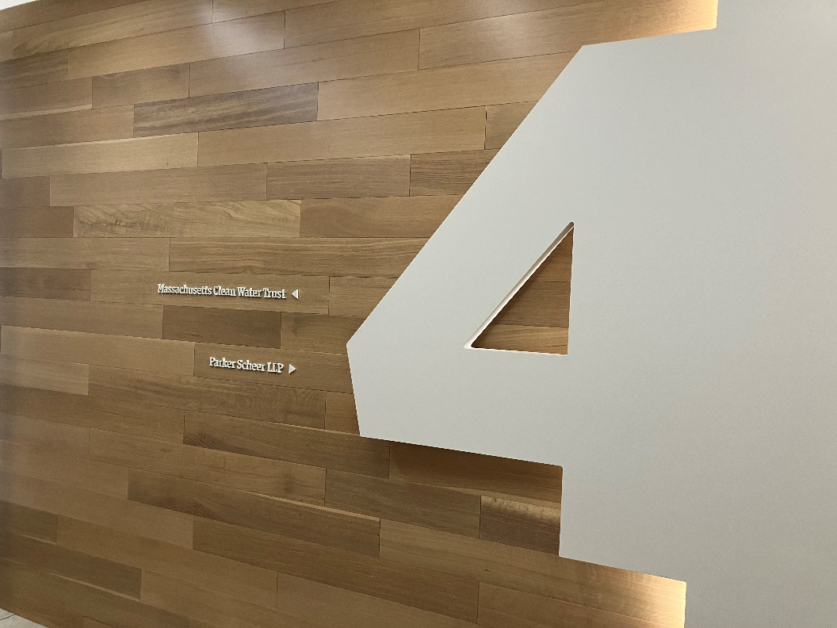

Prepared by:

Massachusetts Department of Public Health

Bureau of Climate and Environmental Health

Indoor Air Quality Program

October 2024

# BACKGROUND

|  |  |
| --- | --- |
| Building: | Clean Water Trust (CWT) offices |
| Address: | 1 Center Plaza, 4th floor, Boston |
| Assessment Requested by: | Kendra Howes, Senior Project Manager, Division of Capital Asset Management & Maintenance (DCAMM) |
| Reason for Request: | Post-occupancy indoor air quality (IAQ) assessment. The space was recently renovated as part of the lease-renewal process. |
| Date of Assessment: | October 2, 2024 |
| Massachusetts Department of Public Health/Bureau of Climate and Environmental Health (MDPH/BCEH) Staff Conducting Assessment: | Ruth Alfasso, Environmental Inspector, IAQ Program |
| Building Description: | The CWT occupies a suite of rooms on the 4th floor of 1 Center Plaza, which is a large, curved, brick, glass, and concrete building located near Government Center in downtown Boston. The building was built in the late 1960s or early 1970s. The CWT suite includes offices, workstations, conference rooms, and a small kitchen area. Interior renovations occurred, including new HVAC installations, paint, and carpeting. |
| Windows: | Windows are not openable in the suite. |

# METHODS

Please refer to the IAQ Manual for methods, sampling procedures, and interpretation of results (MDPH, 2015).

# RESULTS AND DISCUSSION

The following is a summary of indoor air testing results (Table 1).

* ***Carbon dioxide*** measurements were below the MDPH guideline of 800 parts per million (ppm) in all areas tested indicating adequate air exchange at the time of assessment. However, it should be noted that the space was minimally occupied at the time of testing. Carbon dioxide levels would be expected to be higher with increased occupancy.
* ***Temperature*** was within or close to the recommended range of 70°F to 78°F in all areas.
* ***Relative humidity*** was above the recommended range of 40% to 60% in all areas examined. While this is reflective of outdoor conditions, it may also indicate that the HVAC system needs adjustment.
* ***Carbon monoxide*** levels were non-detectable (ND) in all indoor areas tested.
* ***Fine particulate matter (PM2.5)*** concentrations were below the National Ambient Air Quality Standard (NAAQS) level of 35 μg/m3 in all areas tested.
* ***Total Volatile Organic Compounds***were ND in all areas tested.

## Ventilation

A heating, ventilating, and air conditioning (HVAC) system has several functions. First, it provides heating and, if equipped, cooling. Second, it is a source of fresh air. Finally, an HVAC system will dilute and remove normally occurring indoor environmental pollutants by not only introducing fresh air, but also filtering the airstream and ejecting stale air to the outdoors via exhaust ventilation. Even if an HVAC system is operating as designed, point sources of respiratory irritation may exist and affect symptoms in sensitive individuals.

Fresh air is supplied to the CWT offices and common areas through supply vents in the ceiling (Picture 1) and returned through other ceiling-mounted vents. While the vent fixture style for all the vents is a style most typically seen as supply vents, building plans show that there are supply and return vents in all offices.

Offices with windows to the outside were equipped with induction units (Picture 2). These units provide heat and air circulation and may or may not provide fresh air. Items should not be placed on top of or directly in front of these units, as this can impede the free flow of air. In addition, items placed on top will become heated when the system is operating, which may lead to damage or circulation of odors.

The MDPH IAQ program recommends that filters be changed 2-4 times a year (or in accordance with the manufactures recommendations) and be at least minimum efficiency reporting value (MERV) 8, or higher if the equipment can handle them without a degradation in airflow, as these are adequate to filter out pollen, mold, and similar particulates (ASHRAE, 2012). The AHU or AHUs for this office were not assessed during this visit.

It is recommended that HVAC systems be re-balanced every five years to ensure adequate air systems function (SMACNA, 1994). The systems were last balanced in August of 2024 as part of the renovations.

## Microbial/Moisture Concerns

Hot humid summers are becoming more frequent due to climate change. Massachusetts has experienced hot, humid, and rainy summers in 2018, 2021, and 2023. July of 2021 was the wettest ever recorded in Massachusetts, and the three-month period from June through August, known as the meteorological summer, was the fourth wettest on record, according to the National Oceanic and Atmospheric Administration’s (NOAA) Centers for Environmental Information (NOAA, 2021). The summer of 2023 was also hot, and wet, being measured as the second rainiest on record (WBUR, 2023).

The humidity inside the CWT offices ranged from 60-70%, which is higher than the comfort range recommended by the IAQ program for relative humidity. When relative humidity is elevated, the air can feel uncomfortably damp, clammy, or sticky. Excess humidity for a significant period of time can also lead to water damage in porous materials, particularly in areas with a lower temperature, such as ventilation equipment, or exterior windows or walls, due to condensation. In addition, high relative humidity will cause paper to absorb moisture, which in turn cause paper jams in photocopiers and computer printers (Fisher, N., 2024)

Note that the humidity outside on the morning of the assessment was 76% at a temperature of 66ºF, which corresponds to a dew point of 58 ºF. The dew point in indoor areas were similar. This result suggests that the HVAC system is not removing any moisture from the outside air since outdoor air did not require chilling. The IAQ assessment was conducted at the time of year where neither chilling or heating of outdoor air by the HVAC system is necessary to provide for building occupant comfort. Since it is likely that outdoor air drawn into the HVAC system would **not** trigger thermostats to have HVAC system coils to either heat or cool air. In the mode between heating and cooling of outdoors when coils are not activated, the HVAC system would not reduce relative humidity from the air. If signs of high humidity continue during the HVAC system is providing heat, adjustments may be needed to HVAC settings. Helpful adjustments to reduce humidity include temporarily reducing the amount of fresh air into the system during very humid weather, or increasing the setpoint temperature a few degrees. If adjusting the HVAC settings doesn’t work, some other ventilation-engineering solution may be required.

Water-damaged ceiling tiles were noted in several areas (Picture 3; Table 1). Because the CWT suite is on the 4th of 9 floors, and some of the water-damaged tiles were found away from windows, water damage is likely from plumbing or HVAC leaks or condensation on components. Water-damaged ceiling tiles should be replaced when they are found. During replacement, the area above the ceiling tiles should be examined for additional water-damaged materials and sources of water, such as plumbing leaks, uninsulated pipes or ducts, or other issues. None of the water-damaged tiles appeared to be mold-colonized and no musty odors were noted.

## Other IAQ Concerns

Testing was conducted for total volatile organic compounds (TVOCs). All measurements were non-detect (ND). An examination was conducted for products that may be a source of VOCs in indoor air. Products such as dry erase markers, hand sanitizers, and cleaners were noted (Picture 4; Table 1). VOCs from these products can build up and lead to irritation of the mucous membranes.

Staff reported that a few renovation items were still in progress. A can of paint was noted inside the suite (Picture 5). Renovation activities that may produce odors/fumes should preferably be done when the office is not occupied, or in areas away from staff. Use the guidance, [Construction and Renovation Generated Pollutants in Occupied Buildings](https://www.mass.gov/info-details/construction-and-renovation-generated-pollutants-in-occupied-buildings), to reduce the impact of renovations on staff. This should also be used if adjacent office areas in the building are renovated.

Large amounts of papers, boxes, and other storage items were noted in several rooms (Table 1). As the offices are newly occupied, these are likely in transition from storage elsewhere. Large amounts of items in offices and common areas can prevent effective cleaning and may become attractive to pests as harborage.

Some ceiling-mounted vents were dusty (Table 1). This dust can be aerosolized, and can also become a mold growth medium if the vent becomes moistened by condensation. This material should be cleaned periodically. In addition, induction unit cabinets and fins should also be cleaned regularly.

Finally, most areas of the office are carpeted. Carpets should be cleaned regularly in accordance with Institute of Inspection, Cleaning and Restoration Certification (IICRC) recommendations (IICRC, 2012).

# CONCLUSIONS/RECOMMENDATIONS

In view of the findings at the time of the visit, the following recommendations are made:

## Short-term Recommendations

### Ventilation recommendations

1. Consider monitoring humidity and/or dew point periodically, particularly during very humid outdoor weather to ensure the HVAC system can reduce humidity for comfort and to prevent water damage and adjust as needed.
2. Ensure the air handling unit and other HVAC system filters are at least a MERV rating of 8 and are changed at least twice a year.
3. Clean supply and return vents, and the interior of induction units periodically to remove dust.
4. Keep the top and front of induction units free of items and obstructions.
5. It is recommended that HVAC systems be re-balanced every five years to ensure adequate air systems function (SMACNA, 1994).
6. Monitor weather and adjust HVAC set point and fresh air intake percentage as needed to best address weather with high relative humidity (>70%).

### Water damage recommendations

1. Replace water-damaged ceiling tiles. Investigate stained tiles for additional water damage and for sources of water including plumbing leaks, HVAC leaks, or piping/ducts in need of insulation, and repair as needed.

### Other recommendations

1. Use VOC-containing products in areas with good ventilation and keep tightly closed when not in use. Avoid products with strong scents and avoid mixing incompatible products.
2. Follow the guidance in <https://www.mass.gov/info-details/construction-and-renovation-generated-pollutants-in-occupied-buildings> to reduce the impact of any ongoing renovations in the CWT suite or adjacent offices.
3. Ensure paper and boxes are stored in appropriate locations as soon as possible, to make thorough cleaning easier.
4. Clean carpeting in accordance with IICRC recommendations (IICRC, 2012); annually (or semi-annually in soiled/high traffic areas).
5. Refer to resource manual and other related IAQ documents located on the MDPH’s website for further building-wide evaluations and advice on maintaining public buildings. These documents are available at: <http://mass.gov/dph/iaq>.

# REFERENCES

ASHRAE. 2012. American Society of Heating, Refrigeration and Air Conditioning Engineers (ASHRAE) Standard 52.2-2012 -- Method of Testing General Ventilation Air-Cleaning Devices for Removal Efficiency by Particle Size (ANSI Approved).

IICRC. 2012. Institute of Inspection, Cleaning and Restoration Certification. Carpet Cleaning: FAQ.

Fisher, N.  2024.  How Humidity Affects Your Copier and Paper Quality.  Cobb Technologies, Richmond, VA.  <https://www.cobbtechnologies.com/blog/how-humidity-affects-your-copier-and-paper-quality>.

MDPH. 2015. Massachusetts Department of Public Health. Indoor Air Quality Manual: Chapters I-III. Available at: <https://www.mass.gov/lists/indoor-air-quality-manual-and-appendices>.

NOAA. 2021. Summer 2021 neck and neck with Dust Bowl summer for hottest on record. National Oceanic and Atmospheric Administration, 1401 Constitution Avenue NW, Room 5128, Washington, DC 20230 <https://www.noaa.gov/news/summer-2021-neck-and-neck-with-dust-bowl-summer-for-hottest-on-record>

SMACNA. 1994. HVAC Systems Commissioning Manual. 1st ed. Sheet Metal and Air Conditioning Contractors’ National Association, Inc., Chantilly, VA.

WBUR. 2023. “It's been a summer of rain and flooding misery in Mass.” WBUR local news. September 12, 2023. <https://www.wbur.org/news/2023/09/12/summer-flooding-rain-massachusetts>.

**Picture 1**

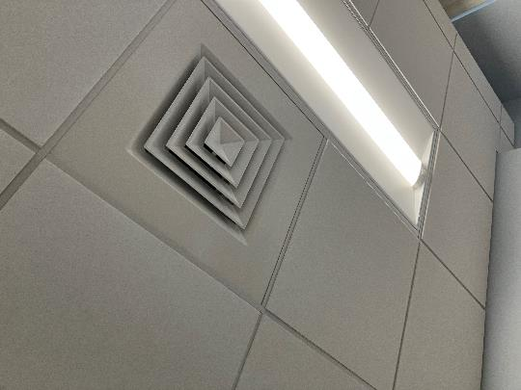

**Ceiling-mounted vent in an office**

**Picture 2**

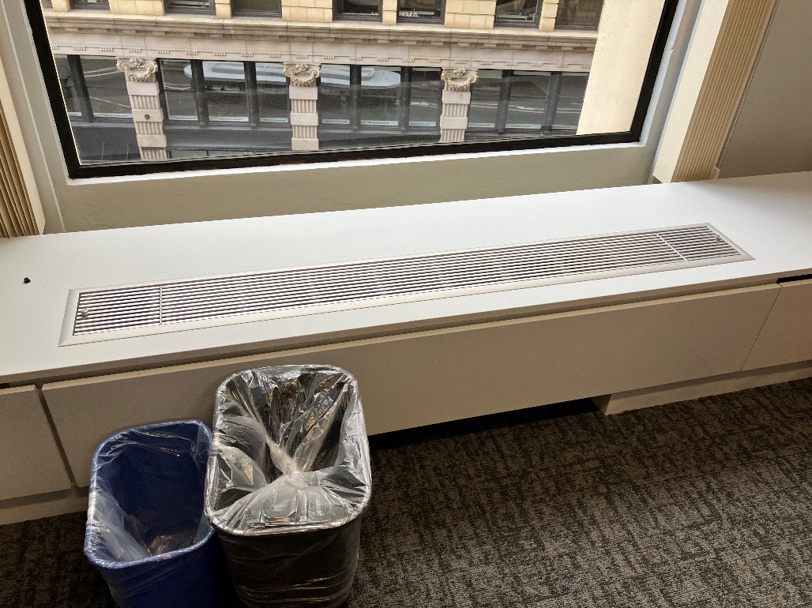

**Induction unit in exterior office**

**Picture 3**

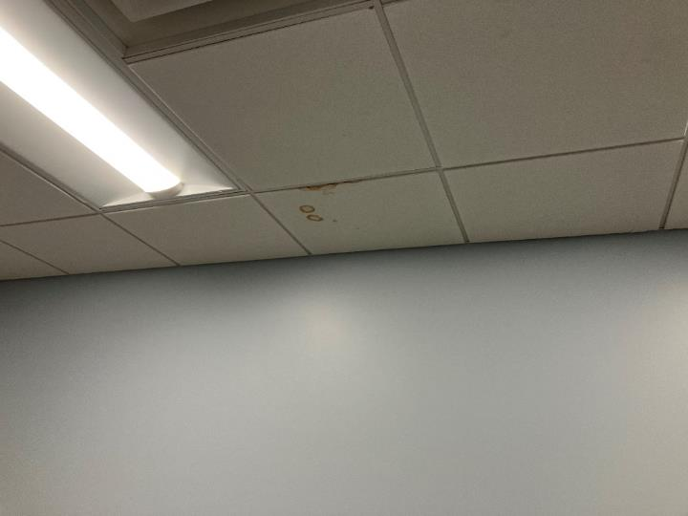

**Water-damaged ceiling tile**

**Picture 4**

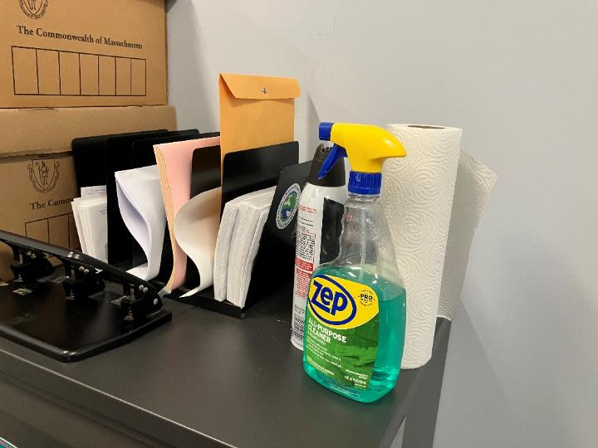

**Cleaning products**

**Picture 5**

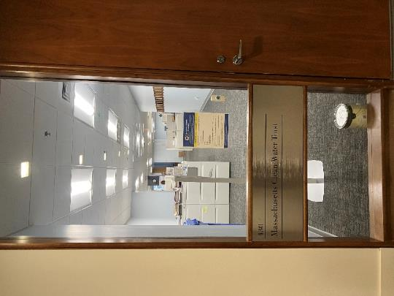

**Paint can inside office suite**

| **Location** | **Carbon**  **Dioxide**  **(ppm)** | **Carbon Monoxide**  **(ppm)** | **Temp**  **(°F)** | **Relative**  **Humidity**  **(%)** | **PM2.5**  **(µg/m3)** | **TVOC**  **(ppm)** | **Occupants**  **in Room** | **Windows**  **Openable** | **Ventilation** | | **Remarks** |
| --- | --- | --- | --- | --- | --- | --- | --- | --- | --- | --- | --- |
| **Supply** | **Exhaust** |
| Background | 386 | ND | 66 | 76 | ND | ND |  |  |  |  | Partly cloudy. Background measurement taken at street level. |
| Larger conference | 427 | ND | 70 | 68 | 2 | ND | 0 | N | Y | Y | 1 MT |
| Front empty room | 427 | ND | 70 | 68 | 1 | ND | 0 | N | Y | Y | 1 WD CT |
| Project manager’s office | 418 | ND | 70 | 68 | 1 | ND | 0 | N | Y | Y | 1 WD CT, DEM, IU |
| Treasurer’s office | 426 | ND | 70 | 68 | 1 | ND | 0 | N | Y dusty | Y | DEM, papers/boxes on floor, IU |
| Department director’s office | 436 | ND | 70 | 68 | 2 | ND | 0 | N | Y | Y | IU with items on top, DEM, HS |
| Small conference room | 426 | ND | 70 | 68 | 1 | ND | 0 | N | Y | Y | Boxes on IU and floor |
| Executive director’s office | 409 | ND | 70 | 68 | 2 | ND | 0 | N | Y | Y | DEM, plant, IU |
| Cube area | 428 | ND | 70 | 68 | 1 | ND | 2 | N | Y | Y |  |
| Cube area center | 425 | ND | 70 | 68 | ND | ND | 2 | N | Y | Y |  |
| Assistant controller’s office | 417 | ND | 70 | 68 | ND | ND | 0 | N | Y | Y | 1 WD CT, IU |
| Office near conference room | 409 | ND | 70 | 68 | ND | ND | 0 | N | Y | Y | IU, HS |
| Office | 401 | ND | 70 | 68 | 1 | ND | 0 | N | Y | Y | IU, HS, cleaning products |
| Office | 421 | ND | 70 | 69 | 2 | ND | 0 | N | Y | Y | IU |
| Small corner office | 421 | ND | 69 | 69 | 2 | ND | 0 | N | Y | Y | IU, boxes, HS |
| Lunchroom | 435 | ND | 70 | 70 | 1 | ND | 1 | N | Y | Y | NC, fridge, microwave, sink |
| Cube area near lunchroom | 425 | ND | 70 | 68 | 1 | ND | 0 | N | Y | Y |  |