INDOOR AIR QUALITY ASSESSMENT

Clifford Marshall Elementary School
200 Moody Street
Quincy, Massachusetts

Prepared by:
Massachusetts Department of Public Health
Bureau of Environmental Health
Indoor Air Quality Program
January 2018

BACKGROUND
Building: | Clifford Marshall Elementary School
Address: | 200 Moody Street, Quincy, MA
Assessment Requested by: | Kevin Segalla, Coordinator of Custodial Services, Quincy Public Schools
Reason for Request: | General indoor air quality (IAQ) with a focus on temperature due to overheating in room in 226 A.
Date of Assessment: | December 8, 2017
Massachusetts Department of Public Health/Bureau of Environmental Health (MDPH/BEH) Staff Conducting Assessment: | Cory Holmes, Environmental Analyst/Inspector IAQ Program
Date of Building Construction: | 1998
Building Description: | The school is a two-story brick, steel frame building.
Building Population: | The school houses pre-school through fifth grade students.
Windows: | Some openable

METHODS
Please refer to the IAQ Manual and appendices for methods, sampling procedures, and interpretation of results (MDPH, 2015).

RESULTS and DISCUSSION
The following is a summary of indoor air testing results (Table 1).
- Carbon dioxide levels were above the MDPH recommended level of 800 parts per million (ppm) in all areas surveyed, likely due to limited fresh air intake by the mechanical ventilation system due to cold weather conditions.
- Temperature was within or close to the MDPH recommended range of 70°F to 78°F in areas tested.
- Relative humidity was below the MDPH recommended range of 40 to 60% in all areas tested and reflective of outdoor (dry) conditions.
- Carbon monoxide levels were non-detectable in all areas tested.
- Particulate matter (PM2.5) concentrations measured were below the National Ambient Air Quality (NAAQS) level of 35 μg/m³ in all areas tested.

Ventilation
The heating, ventilation and air conditioning (HVAC) system for room 226 A consists of a rooftop handling unit (AHU) controlled by a computerized program. The unit supplies conditioned air to occupied spaces via ceiling vents (Picture 1). The room appeared to be equipped with both wall- and ceiling-mounted return/exhaust vents (Pictures 2 and 3). It was reported by Mr. Segalla that a faulty valve had caused overheating in the classroom several weeks prior to the assessment. The valve was reportedly shut off and replaced. As stated previously, at the time of the assessment the temperature in the classroom was within MDPH recommendations and no further complaints were expressed.
Mechanical ventilation in room 006, is provided by a unit ventilator (univent) (Picture 4). Unit ventilators draw fresh air through a vent on the exterior wall. Air is mixed with return air from the room, filtered, heated (if needed) and delivered to the room (Figure 1). The unit was deactivated, therefore no fresh air was being mechanically introduced in the space at the time of assessment. To maximize air exchange, the MDPH recommends that both supply and exhaust ventilation operate continuously during periods of occupancy. Items were also noted on top of and in front of the univent. In order to operate as designed univents should be free and clear of obstructions both on top as well as in front where the return vent is located, as shown in Figure 1.

Microbial/Moisture Concerns
No water-damaged materials were observed in areas surveyed at the time of the assessment.

Other Conditions
Other conditions that can affect IAQ were observed during the assessment. The Library contains wall to wall carpeting and room 006 contains an area rug. Carpets should be cleaned annually (or semi-annually in soiled/high traffic areas) in accordance with Institute of Inspection, Cleaning and Restoration Certification (IICRC) recommendations, (IICRC, 2012). Regular cleaning with a high efficiency particulate air (HEPA) filtered vacuum in combination with an annual cleaning will help to reduce accumulation and potential aerosolization of materials from carpeting.
The univent in room 006 and several supply/return vents were observed to have accumulated dust/debris (Table 1; Pictures 3, 5-7). Univents and supply vents can aerosolize accumulated dust once activated or provide a source for mold growth under moist conditions if not cleaned. In addition, plastic items were seen on top of the heat register, which can give off odors if heated and provide a source of irritation.
Finally, exposure to low levels of total VOCs (TVOCs) may produce eye, nose, throat, and/or respiratory irritation in some sensitive individuals. To determine if VOCs were present, BEH/IAQ staff examined rooms for products containing VOCs. BEH/IAQ staff noted hand sanitizers, spray cleaners, air fresheners and dry erase materials in use within the building (Table 1; Pictures 8 and 9). These products have the potential to be irritants to the eyes, nose, throat, and respiratory system of sensitive individuals.
Note that the Environmental Protection Agency (EPA) conducted a National School Radon Survey in which it discovered nearly one in five schools had “…at least one frequently occupied ground contact room with short-term radon levels above 4 [picocuries per liter] pCi/L” (US EPA 1993). The BEH/IAQ Program therefore recommends that every school be tested for radon, and that this testing be conducted during the heating season while school is in session in a manner consistent with USEPA radon testing guidelines. Radon measurement specialists and other information can be found at www.nrsb.org and http://aarst-nrpp.com/wp, with additional information at: http://www.mass.gov/eohhs/gov/departments/dph/programs/environmental-health/exposure-topics/iaq/radon.

CONCLUSIONS and RECOMMENDATIONS
In view of the findings at the time of the visit, the following recommendations are made:
- Adjust the system to increase fresh air intake as needed/weather permitting.
- Operate all supply and exhaust ventilation equipment continuously during occupied periods.
- Remove any blockages to univents, including items placed on top of the units. Plastic and wax-based materials should not be placed on these units, since heating these items can create odors.
- The MDPH recommends adopting a balancing schedule of every 5 years for all mechanical ventilation systems, as recommended by ventilation industrial standards (SMACNA, 1994).
- For buildings in New England, periods of low relative humidity during the winter are often unavoidable. Therefore, scrupulous cleaning practices should be adopted to minimize common indoor air contaminants whose irritant effects can be enhanced when the relative humidity is low. To control for dusts, a high efficiency particulate arrestance (HEPA) filter equipped vacuum cleaner in conjunction with wet wiping of all surfaces is recommended. Avoid the use of feather dusters. Drinking water during the day can help ease some symptoms associated with a dry environment (throat and sinus irritation).
- Clean univents, supply, return and exhaust vents periodically of accumulated dust/debris.
- Clean carpeting (and area rugs) annually or semi-annually in soiled high traffic areas as per the recommendations of the Institute of Inspection, Cleaning and Restoration Certification (IICRC, 2012).
- Keep chemicals/cleaning products out of reach of children.
- Consider reducing the use of hand sanitizers, air deodorizers, and other scented materials in use within the office since these products have the potential to be irritants to the eyes, nose, throat, and respiratory system of sensitive individuals.
- Consider adopting the US EPA (2000) document, “Tools for Schools,” as an instrument for maintaining a good IAQ environment in the building available at: http://www.epa.gov/iaq/schools/index.html.
- The school should be tested for radon by a certified radon measurement specialist during the heating season when school is in session. Radon measurement specialists and other information can be found at: www.nrsb.org, and http://aarst-nrpp.com/wp/.
- Refer to resource manual and other related indoor air quality documents located on the MDPH’s website for further building-wide evaluations and advice on maintaining public buildings. These documents are available at http://mass.gov/dph/iaq.

REFERENCES
IICRC. 2012. Institute of Inspection, Cleaning and Restoration Certification. Carpet Cleaning: FAQ. Retrieved from http://www.iicrc.org/consumers/care/carpet-cleaning.
MDPH. 2015. Massachusetts Department of Public Health. Indoor Air Quality Manual: Chapters I-III. Available at: http://www.mass.gov/eohhs/gov/departments/dph/programs/environmental-health/exposure-topics/iaq/iaq-manual/.
SMACNA. 1994. HVAC Systems Commissioning Manual. 1st ed. Sheet Metal and Air Conditioning Contractors’ National Association, Inc., Chantilly, VA.
US EPA. 1993. Radon Measurement in Schools, Revised Edition. Office of Air and Radiation, Office of Radiation and Indoor Air, Indoor Environments Division (6609J). EPA 402-R-92-014. https://www.epa.gov/sites/production/files/2014-08/documents/radon_measurement_in_schools.pdf.
US EPA. 2000. Tools for Schools. Office of Air and Radiation, Office of Radiation and Indoor Air, Indoor Environments Division (6609J). EPA 402-K-95-001, Second Edition. http://www.epa.gov/iaq/schools/index.html.
Picture 1
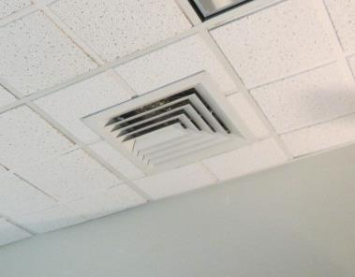
Ceiling-mounted supply vent in room 226 A
Picture 2
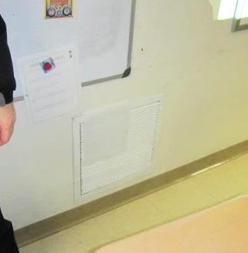
Wall-mounted exhaust vent
Picture 3
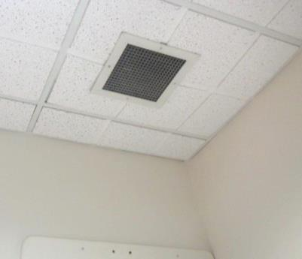
Ceiling-mounted return vent
Picture 4
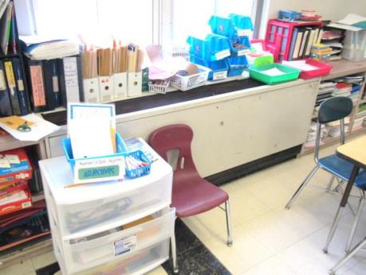
Univent in classroom 006, note plastic items on heat register
Picture 5
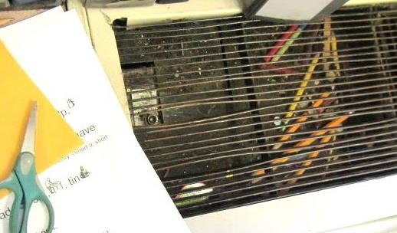
Items/debris in univent air diffuser
Picture 6
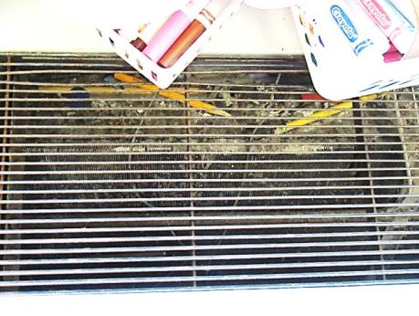
Dust/debris in univent air diffuser
Picture 7
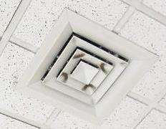
Accumulated dust/debris on supply vent in Library
Picture 8
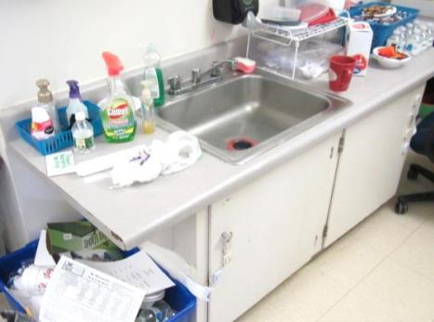
Spray cleaning products on sink countertop in classroom
Picture 9
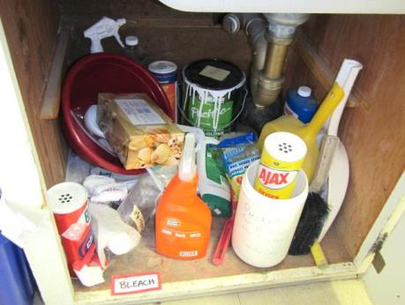
Cleaning products under sink in classroom

Location | Carbon  Dioxide  (ppm) | Carbon Monoxide  (ppm) | Temp  (°F) | Relative  Humidity  (%) | PM2.5  (µg/m³) | Occupants  in Room | Windows  Openable | Ventilation |  | Remarks
 |  |  |  |  |  |  |  | Supply | Exhaust
Background (outdoors) | 407 | ND | 43 | 29 | 9 |  |  |  |  | Cold, overcast
226 A | 839 | ND | 70 | 21 | 6 | 10 | N | Y | Y | PF, dusty vents,
Library | 1235 | ND | 71 | 26 | 14 | 19 | N | Y | Y | Dusty vents, carpeting
006 | 881 | ND | 68 | 23 | 10 | 9 | Y | Y | Y | UV off, items on/front of UV, items/debris in UV air diffuser, area rug, dusty vents, plastic on heater

