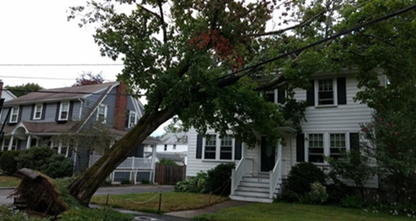

**Massachusetts Department of Public Health**

**CLIMATE HAZARD ASSESSMENT PROFILE**

**EXTREME WEATHER EVENTS**

**CLIMATE HAZARD OVERVIEW**

**Extreme weather events are rare in Massachusetts, but they have occurred more frequently in recent years. Between 1990 and 2019, FEMA recorded 23 weather-related major disaster declarations in Massachusetts (versus 7 between 1960 and 1989). Winter storms have increased in intensity and frequency since 1950, and heavy downpours increased 71% from 1958 to 2010. Climate models predict that continued increases in the intensity and frequency of extreme weather events may damage community infrastructure and threaten populations that are already highly vulnerable to climate hazards and other stressors.**

**HOW WILL CLIMATE CHANGE MAKE THINGS WORSE?**

As warming oceans contribute increasing amounts of energy to weather systems, climate models predict increasing intensity and frequency of tropical storms and major hurricanes (Category 3 and higher). Winter storm intensity and frequency are also likely to continue to increase.

**WHO IS EXPOSED TO EXTREME WEATHER EVENTS?**

Extreme weather events directly expose people to flood water and storm debris. Disruption of infrastructure (e.g., septic/sewage/wastewater treatment facilities, the electric grid, transportation and communication systems) may result in exposures to extreme cold or heat, unsafe food and drinking water, mold in homes and buildings, loss of electrical power for medical equipment, and loss of access to medical services. Individuals may be exposed to waterborne pathogens (e.g., bacteria) or toxic chemicals through contaminated food, drinking water, floodwaters, or soil. Carbon monoxide poisoning can result from improper use of power generators or outdoor appliances (e.g., camp stoves), malfunctioning fireplaces, or blockages to heating equipment vents or vehicle tailpipes.

**WHAT ARE THE HEALTH EFFECTS?**

The most serious health impacts are injury and death caused by storm damage and debris and by automobile accidents. Longer-term health effects include increases in food- and water-borne illness, exacerbation of pre-existing diseases (e.g., asthma), and increases in respiratory illness from exposure to mold. Carbon monoxide poisoning can cause dizziness, blurred vision, confusion, and loss of consciousness, and death. Property damage and displacement of homes and businesses can lead to loss of livelihood and long-term mental stress for those facing relocation. People may also experience post-traumatic stress, anxiety and depression following an extreme weather event.

**Storm Damage, Medford, MA**



**14.7% of MA residents are age 65 or older, and 29.2% of older adults live alone1**

**11.7% of MA residents live below the poverty line1**

**7.9% of MA residents under age 65 are living with a health-related disability1**

**18.2% of MA residents identify as “nonwhite”1**

**WHO IS VULNERABLE TO EXTREME WEATHER events?**

Identifying populations most vulnerable to the health burdens of climate change is an important step in developing state and local adaptation plans. Publicly available data can be used to assess the health-related vulnerability for extreme weather events. Some examples of vulnerability data for Massachusetts are provided below.

**how can we ASSESS VULNERABILITY to climate HAZARDS?**

Climate vulnerability is a function of:

* **Potential impacts** from ***exposure*** (contact with the climate hazard) and ***sensitivity*** (e.g., age, pre-existing health conditions, social disparities) that may increase or decrease health impacts
* **Adaptive capacity** – factors that influence the ability to respond and recover from climate impacts

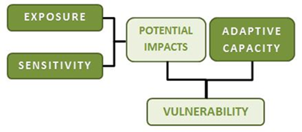

The next page provides information to assess exposure, sensitivity, and adaptive capacity to reduce climate change impacts. This information should be considered when planning actions to reduce health risks from extreme weather events in Massachusetts communities.



**For more information about the public health impacts of climate change in Massachusetts contact:**

Massachusetts DPH | Bureau of Environmental Health | Environmental Toxicology Program

250 Washington Street, Boston, MA 02108

Phone: 617-624-5757 | Fax: 617-624-5183 | TTY: 617-624-5286

Websites: <https://www.mass.gov/climate-and-health>; <https://matracking.ehs.state.ma.us/Climate-Change/index.html>

This work is partially supported by a Climate and Health Cooperative Agreement (5 NUE1EH001322-04) to the Massachusetts Department of Public Health by the U.S. Centers for Disease Control and Prevention. The content does not necessarily reflect the official views of the Centers for Disease Control and Prevention of the Department of Health and Human Services.

**SOCIODEMOGRAPHICOCIODEMOGRAPHICS**

* People over age 65
* People over age 65 and living alone
* Children under age 5
* People of Color
* People who are living below the poverty line
* People experiencing homelessness
* People with limited knowledge of English

**ENVIRONMENT**

* Degraded water quality
* Coastal and stream bank erosion
* Ecosystem damage
* Damage to aquatic and agricultural resources
* Damage to parks and recreational land



**Intervention Strategies for Reducing the Health Impacts of Extreme Weather Events**

* Identify vulnerable populations and health issues in your community using the DPH Community Profiles, and other tools available on the EPHT website: <https://matracking.ehs.state.ma.us/planning_and_tools/index.html>
* Identify critical facilities and infrastructure at risk from flooding, such as drinking water and sewer facilities, and implement modifications that decrease potential flood damage, and/or relocate critical infrastructure from vulnerable areas
* Identify and map vulnerable locations and populations using DPH’s Climate Change Vulnerability Mapping Tool <https://mass.gov/dph/climate-vulnerability-map>
* Assess capability to deploy power generators and water pumps to medical facilities
* Encourage preparedness in the home, in schools, in the workplace, and at healthcare facilities
* Develop communication and outreach plans to raise awareness of evacuation routes, flood zones, and response plans
* Support implementation of DPH’s Mass in Motion and other Wellness programs to increase community resilience <http://www.mass.gov/eohhs/gov/departments/dph/programs/community-health/mass-in-motion/>
* Implement actions to prepare for storms from DPH’s Community Sanitation Program <http://www.mass.gov/eohhs/gov/departments/dph/programs/environmental-health/comm-sanitation>
* Implement actions to prepare for extreme weather from DPH’s Office of Preparedness and Emergency Management’s (OPEM) <http://www.mass.gov/eohhs/gov/departments/dph/programs/emergency-prep/>
* Implement actions to address mold from the aftermath of a storm <http://www.mass.gov/eohhs/gov/departments/dph/programs/environmental-health/exposure-topics/iaq/pollution/mold/>
* Incorporate extreme weather information and storm probabilities into planning, transportation, and public works projects
* Develop campaigns to educate the public on proper generator use and the hazards from combustion appliances
* View the Massachusetts State Hazard Mitigation and Climate Adaptation Plan for information on adaptation strategies <https://www.mass.gov/service-details/massachusetts-integrated-state-hazard-mitigation-and-climate-adaptation-plan>
* View the Massachusetts Climate Change Adaptation Report, Chapter 6: “Human Health and Welfare” for health adaptation strategies <https://www.mass.gov/service-details/2011-massachusetts-climate-change-adaptation-report>

1. 5-Year US Census American Cities Survey, 2018. Data available via <https://mass.gov/dph/climate-vulnerability-map>

**PRE-EXISTNG HEALTH CONDITIONS**

**INFRASTRUCTURE**

* Interruption of utilities (e.g., electric, phone, internet)
* Failure of wastewater treatment systems
* Loss of safe drinking water
* Disruption of transportation and communication systems
* Loss of access to medical services
* Food and supply shortages
* Property damage and displacement of homes, businesses
* Adults with respiratory disease (e.g., asthma, COPD) and/or cardiovascular disease
* Children with respiratory disease (e.g., asthma)
* People using medical equipment that requires electrical power or medications that require refrigeration
* People with physical disabilities or special needs
* People with mental health challenges



**May 2022**

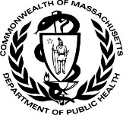

**WHAT ARE THE FACTORS THAT INFLUENCE VULNERABILITY TO EXTREME WEATHER events?**

Assessment of community-specific vulnerabilities will inform adaptation planning efforts. By considering these factors, communities can increase health equity and resilience to climate change impacts. The MA Environmental Public Health Tracking Portal provides helpful tools and community-specific vulnerability data: <https://matracking.ehs.state.ma.us/>.

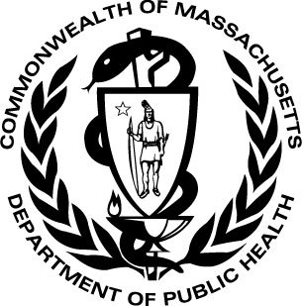

June 2016