**Massachusetts Department of Public Health**

**CLIMATE HAZARD ASSESSMENT PROFILE**

**INLAND FLOODING**

**CLIMATE HAZARD OVERVIEW**

**Inland flooding can occur when the volume of water on land exceeds the capacity of natural and built drainage systems. These flooding events are increasingly common in Massachusetts, due to increases in rainfall. Some floods develop slowly, while flash floods can occur within minutes or hours after a storm. Over 400,000 Massachusetts residents currently live in a 100-year flood zone; meaning there is greater than a 1 in 4 chance that their home will flood during a 30-year mortgage period.**

**HOW WILL CLIMATE CHANGE MAKE THINGS WORSE?**

Many Massachusetts communities are supported by infrastructure that is more than 100 years old. There was a 71% increase in the amount of precipitation that fell on the heaviest precipitation days from 1958 to 2010, and many drainage systems, bridges, culverts, and sewers were designed using outdated precipitation estimates. Projected precipitation levels may exceed the capacity of existing infrastructure. Projections show heavy rainfall events will continue to increase during this century leading to more inland flooding. Predicted increases in the frequency of major hurricanes and stronger storms may also cause severe flooding events.

**WHO IS EXPOSED TO INLAND FLOODING?**

Inland flooding may result in direct exposure to contaminated floodwater and debris. Flooding that disrupts infrastructure (e.g., septic/sewage/wastewater treatment facilities, electrical grids, transportation services, and communication systems) may expose people to extreme cold or heat, unsafe food and drinking water, loss of access to medical services, and mold growth in homes and buildings. People may also be exposed to waterborne pathogens (e.g., bacteria) and/or toxic chemicals in floodwaters that contaminate food, drinking water sources, flooded buildings, and soil.

**WHAT ARE THE HEALTH EFFECTS?**

Physical injury and premature death are the most serious health impacts during a flood. Longer-term health impacts include increases in food- and water-borne illnesses, worsening of pre-existing medical conditions, and respiratory illnesses due to mold exposure. Flooding and roadblocks can hinder emergency vehicle response. Property damage and displacement of homes and businesses can lead to loss of work and long-term mental stress for those facing relocation. Individuals may also experience post-traumatic stress, anxiety and depression following major flooding events.

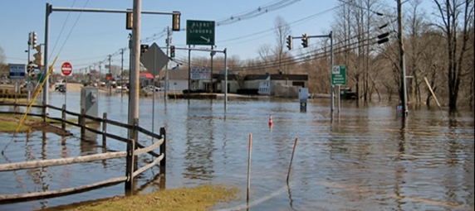



**In 2016, 12.9% of MA children had active Asthma2**

**An average of 21% of residential land in MA cities and towns is in a FEMA 100- or 500-year flood plain.1**

**14.7% of MA residents are age 65 or older, and 29.2% of older adults live alone.2**

**11.7% of MA residents live below the poverty line2**

**Flood water, Taunton, MA**

**Photo Credit: National Weather Service**

**how can we ASSESS VULNERABILITY to climate HAZARDS?**

Climate vulnerability is a function of:

* **Potential impacts** from ***exposure*** (contact with the climate hazard) and ***sensitivity*** (e.g., age, pre-existing health conditions, social disparities) that may increase or decrease health impacts
* **Adaptive capacity** – factors that influence the ability to respond and recover from climate impacts

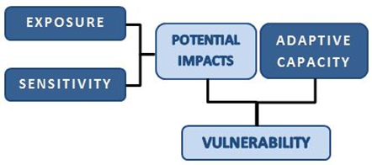

The next page provides information to assess exposure, sensitivity, and adaptive capacity to reduce climate change impacts. This information should be considered when planning actions to reduce health risks from inland flooding events in Massachusetts communities.

**WHO IS VULNERABLE TO INLAND FLOODING EVENTS?**

Identifying populations most vulnerable to the health burdens of climate change is an important step in developing state and local adaptation plans. Publicly available data can be used to assess the health-related vulnerability for inland flooding events. Some examples of vulnerability data for Massachusetts are provided below.

**For more information about the public health impacts of climate change in Massachusetts contact:**

Massachusetts DPH | Bureau of Environmental Health | Environmental Toxicology Program

250 Washington Street, Boston, MA 02108

Phone: 617-624-5757 | Fax: 617-624-5183 | TTY: 617-624-5286

Websites: <https://www.mass.gov/climate-and-health>**;** <https://matracking.ehs.state.ma.us/Climate-Change/index.html>

This work is partially supported by a Climate and Health Cooperative Agreement (5 NUE1EH001322-04) to the Massachusetts Department of Public Health by the U.S. Centers for Disease Control and Prevention. The content does not necessarily reflect the official views of the Centers for Disease Control and Prevention of the Department of Health and Human Services.

**May 2022**



**PRE-EXISTNG HEALTH CONDITIONS**

* Adults with respiratory disease (e.g., asthma, COPD) and cardiovascular disease
* Children with respiratory disease (e.g., asthma)
* People using medical equipment that requires electrical power or medications that require refrigeration
* People with physical disabilities or special needs
* People with mental health challenges

**INFRASTRUCTURE**



* Interruption of utilities (e.g., electric, phone, internet)
* Failure of wastewater treatment systems
* Loss of safe drinking water
* Disruption of transportation and communication systems
* Loss of access to medical services
* Food and supply shortages
* Property damage and displacement of homes and businesses

**SOCIODEMOGRAPHIC**

SOCIODEMOGRAPHICS

* People over age 65
* People over age 65 and living alone
* Children under age 5
* People of Color
* People who are living below the poverty line
* People experiencing homelessness
* People with limited knowledge of English



**ENVIRONMENT**

* Degraded water quality
* River and stream bank erosion
* Ecosystem damage
* Damage to waterways and aquatic resources
* Damage to parks and recreational land



**Intervention Strategies for Reducing the Health Impacts of Inland Flooding Events**

* Identify vulnerable populations and health issues in your community using the DPH Community Profiles, and other tools available on the EPHT website: <https://matracking.ehs.state.ma.us/planning_and_tools/index.html>
* Increase the use of climate and weather information in managing storm water/flood risk and individual events
* Identify and map vulnerable locations and populations using DPH’s Climate Change Vulnerability Mapping Tool <https://mass.gov/dph/climate-vulnerability-map>
* Identify critical facilities and infrastructure at risk from flooding (e.g., drinking water and sewer facilities) and implement modifications that decrease potential flood damage and/or relocate critical infrastructure from vulnerable areas
* Assess capability to deploy power generators and water pumps to medical facilities
* Encourage preparedness in the home, in schools, in the workplace, and at healthcare facilities
* Develop communication and outreach plans to raise awareness of evacuation routes, flood zones, and response plans
* Support implementation of MDPH’s Mass in Motion and other Wellness programs to increase community resilience <http://www.mass.gov/eohhs/gov/departments/dph/programs/community-health/mass-in-motion/>
* Implement actions to prepare for storms from DPH’s Community Sanitation Program <http://www.mass.gov/eohhs/gov/departments/dph/programs/environmental-health/comm-sanitation>
* Implement actions to prepare for extreme weather from DPH’s Office of Preparedness and Emergency Management’s (OPEM) <http://www.mass.gov/eohhs/gov/departments/dph/programs/emergency-prep/>
* Implement actions to address mold from the aftermath of a storm <http://www.mass.gov/eohhs/gov/departments/dph/programs/environmental-health/exposure-topics/iaq/pollution/mold/>
* Incorporate information on projected precipitation increases into planning, transportation, and public works projects
* View the Massachusetts State Hazard Mitigation and Climate Adaptation Plan for information on adaptation strategies <https://www.mass.gov/service-details/massachusetts-integrated-state-hazard-mitigation-and-climate-adaptation-plan>
* View the Massachusetts Climate Change Adaptation Report, Chapter 6: “Human Health and Welfare” for health adaptation strategies <https://www.mass.gov/service-details/2011-massachusetts-climate-change-adaptation-report>

1. FEMA National Flood Hazard Layer 2014 and Q3 flood plains 2005. Data available via <https://mass.gov/dph/climate-vulnerability-map>
2. 5-Year US Census American Cities Survey, 2018. Data available via <https://mass.gov/dph/climate-vulnerability-map>

**WHAT ARE THE FACTORS THAT INFLUENCE VULNERABILITY TO INLAND FLOODING EVENTS?**

Assessment of community-specific vulnerabilities will inform adaptation planning efforts. By considering these factors, communities can increase health equity and resilience to climate change impacts. The MA Environmental Public Health Tracking Portal provides helpful tools and community-specific vulnerability data: <https://matracking.ehs.state.ma.us/>.

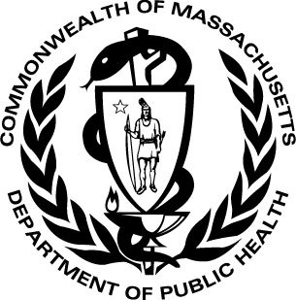

June 2016