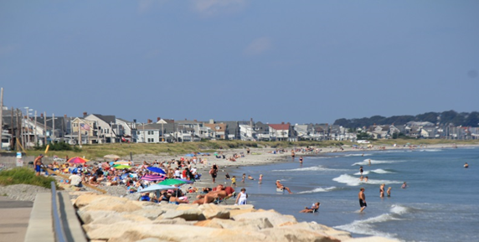

**Massachusetts Department of Public Health**

**CLIMATE HAZARD ASSESSMENT PROFILE**

**WATERBORNE ILLNESS AT RECREATIONAL BEACHES**

**CLIMATE HAZARD OVERVIEW**

**Swimming and other beach activities are the most popular recreational pastimes in Massachusetts. While there are many health benefits from going to the beach, people may be exposed to bacteria that can contaminate beach water, especially after heavy rainfall. Studies have shown that swimming in beach water contaminated by fecal bacteria can have negative public health impacts, including increased risks of acquiring gastrointestinal (GI) and other bacterial illnesses. “Algal Blooms” (otherwise known as “cyanobacterial harmful algal blooms”, or CyanoHABs) can cause illness in humans and their pets that come in contact with contaminated water.**

**HOW WILL CLIMATE CHANGE MAKE THINGS WORSE?**

Climate change is expected to change rainfall patterns in ways that may increase pathogens in beach water and occurrences of CyanoHABs. Flooding can carry contaminated runoff and nutrients into waterbodies and increase the risk of exposure to pathogens and occurrence of CyanoHABs. Increases in water temperature will likely increase the growth and survivability of pathogens and the occurrence of CyanoHABs.

**WHO IS EXPOSED TO CONTAMINATED RECREATIONAL WATER?**

People are exposed to pathogens and other harmful organisms by swimming in contaminated water. Most beach water pathogens come from human or animal waste, which may enter the water from storm water runoff, combined sewer overflows (a release of untreated sewage with rainwater), and poorly functioning septic systems. Cyanobacteria are naturally occurring but may become highly concentrated (i.e., bloom) under certain environmental conditions, particularly during hot weather, and may cause health effects via ingestion, skin contact, and inhalation of contaminated droplets.

**WHAT ARE THE HEALTH EFFECTS?**

Swimming in water contaminated with pathogens can cause gastrointestinal symptoms such as nausea, vomiting, diarrhea, and abdominal pain; respiratory symptoms like sore throat, cough, runny nose, and sneezing; eye and ear symptoms including irritation, earache, and itchiness; dermatological symptoms like skin rash and itching; and flu-like symptoms such as fever and chills. Most of these effects are self-resolving but they can occasionally be more serious, especially in sensitive populations (e.g. children, immunocompromised individuals, and older adults). Cyanobacteria produce toxins that can affect the skin, the liver, and the neurological system.

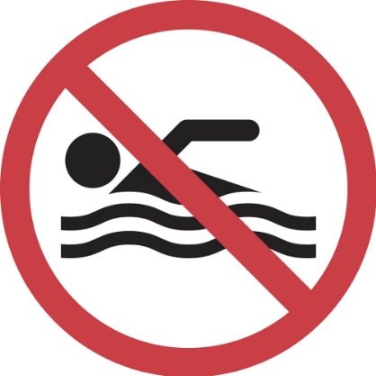

**5.3% of MA residents are under age five2**

**Massachusetts’ beaches are closed hundreds of times each year due to poor water quality1 (exceeding bacteria standards)**

**Massachusetts has 1,100 fresh water and marine beaches in 220 communities1**

**14.7% of MA residents are age 65 or older2**

**Nantasket Beach, Hull, MA**

**how can we ASSESS VULNERABILITY to climate HAZARDS?**

Climate vulnerability is a function of:

* **Potential impacts** from ***exposure*** (contact with the climate hazard) and ***sensitivity*** (e.g., age, pre-existing health conditions, social disparities) that may increase or decrease health impacts
* **Adaptive capacity** – factors that influence the ability to respond and recover from climate impacts

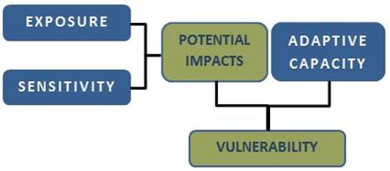

The next page provides information to assess exposure, sensitivity, and adaptive capacity to reduce climate change impacts. This information should be considered when planning actions to reduce health risks from waterborne illness at recreational beaches in Massachusetts communities.

**WHO IS VULNERABLE TO Waterborne Illness?**

Identifying populations most vulnerable to the health burdens of climate change is an important step in developing state and local adaptation plans. Publicly available data can be used to assess the health-related vulnerability for waterborne illness at recreational beaches. Some examples of vulnerability data for Massachusetts are provided below.

**Intervention Strategies for Reducing the Health Impacts of Waterborne Illness**

* Explore current and historical beach water quality test results on the Recreational Water Quality web page <https://matracking.ehs.state.ma.us/Environmental-Data/recreational-water/>
* Identify vulnerable populations and health issues in your community using the DPH Community Profiles, and other tools available on the EPHT website: <https://matracking.ehs.state.ma.us/planning_and_tools/index.html>
* Install pet waste bag dispensers and trash receptacles to reduce trash and pet waste near waterbodies
* Organize community-wide clean-up days
* Develop education materials for homeowners and businesses around the proper use of fertilizers
* Examine potential impacts of rainfall on beach water quality by reviewing historical testing data and rainfall information
* Develop an Adopt-a-Traffic-Island Program that incorporates green practices, such as water retention and low maintenance plantings
* Develop a community storm water management program that includes such activities as illicit discharge detection, construction site runoff control, and street sweeping
* Reduce the quantity of impervious surfaces by incorporating green infrastructure into residential and commercial developments
* Relocate problematic pollutant sources from flood plains
* Modify and enforce watershed protection regulations to take climate change into account
* Evaluate and prioritize implementation of improved controls of agricultural, urban, and storm water runoff to prevent ocean and freshwater contamination, as well as the inadvertent enrichment of nutrients in aquatic areas that offer ideal growth medium for harmful algal blooms
* View the Massachusetts State Hazard Mitigation and Climate Adaptation Plan for information on climate adaptation strategies <https://www.mass.gov/service-details/massachusetts-integrated-state-hazard-mitigation-and-climate-adaptation-plan>
* View the Massachusetts Climate Change Adaptation Report, Chapter 6: “Human Health and Welfare” for health adaptation strategies <https://www.mass.gov/service-details/2011-massachusetts-climate-change-adaptation-report>





**PRE-EXISTING HEALTH CONDITIONS**

* Large areas of landscaped land and/or impervious surfaces near waterways
* Septic systems, sewer overflows, and storm water pipes near waterbodies
* Areas where flooding is frequent
* People with suppressed immune systems
* Pregnant women

**INFRASTRUCTURE**





* People over age 65
* Children under the age of 5

**SOCIODEMOGRAPHIC**

**ENVIRONMENTAL**

* Beaches with a history of elevated bacteria or CyanoHABs
* Beaches near densely populated areas
* Beaches impacted by improper pet waste disposal or nutrient runoff

**WHAT ARE THE FACTORS THAT INFLUENCE VULNERABILITY TO RECREATIONAL WATERBORNE ILLNESS?**

Assessment of community-specific vulnerabilities will inform adaptation planning efforts. By considering these factors, communities can increase health equity and resilience to climate change impacts. The MA Environmental Public Health Tracking Portal provides helpful tools and community-specific vulnerability data: <https://matracking.ehs.state.ma.us/>.

**For more information about the public health impacts of climate change in Massachusetts contact:**

Massachusetts DPH | Bureau of Environmental Health | Environmental Toxicology Program

250 Washington Street, Boston, MA 02108

Phone: 617-624-5757 | Fax: 617-624-5183 | TTY: 617-624-5286

Website: [<https://www.mass.gov/climate-and-health>**;** <https://matracking.ehs.state.ma.us/Climate-Change/index.html>](https://matracking.ehs.state.ma.us/Climate-Change/index.html)

This work is partially supported by a Climate and Health Cooperative Agreement (5 NUE1EH001322-04) to the Massachusetts Department of Public Health by the U.S. Centers for Disease Control and Prevention. The content does not necessarily reflect the official views of the Centers for Disease Control and Prevention of the Department of Health and Human Services.

**May 2022**



1. 2019 Massachusetts Beach Testing Results Annual Report, available at: <https://www.mass.gov/doc/2019-annual-beach-report/download>
2. 5-Year US Census American Cities Survey, 2018. Data available via <https://mass.gov/dph/climate-vulnerability-map>



June 2016