M A S S A C H U S E T T S D E PA R T M E N T O F P U B L I C H E A LT H | B UR E A U OF E N V I R ON M E N TA L H E A LT H
Clinicians’ Experience with Environmental Exposures

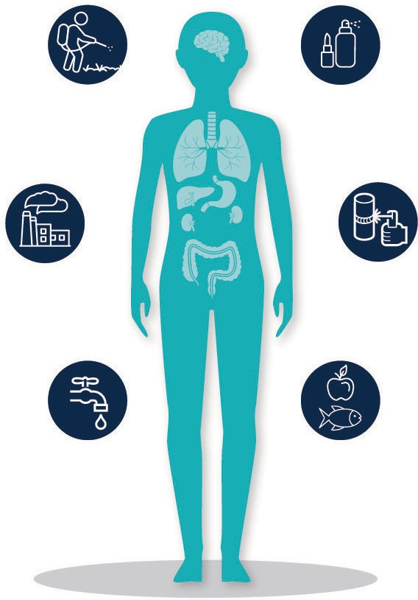
All individuals should enjoy protection from environmental pollution and be able to live in a clean and healthy environment. Nearly 2.3 million Massachusetts residents (46%) live in communities known as environmental justice communities—defined as neighborhoods with low median incomes, a high percentage of minorities, or a significant number of households without English language.1
To improve the health of vulnerable populations and increase health equity in Massachusetts, we are working to equip clinicians with the appropriate knowledge and
tools to assess the role of environmental exposures in their patients’ health, so that they may identify environmental health risks; counsel patients; and prevent, minimize, or treat harmful levels of exposure.
To better understand the current state of environmental health awareness among health care providers, we surveyed actively practicing clinicians in primary care fields such as family medicine, internal medicine, pediatrics,
and reproductive health. This brief summarizes responses from a sample of health care providers. Insights from this survey will inform the development of an environmental health educational campaign program to build awareness of environmental contaminants, their human health effects, and what clinicians can do to help prevent or reduce harmful exposures.
SUMMARY
A survey of 566 primary care clinicians’ experiences in environmental health revealed the following:
- Although clinicians recognized the importance of environmental exposures and their health impacts, 59% did not routinely ask patients about such exposures in the past year.
- Only 7% of clinicians received training on how to discuss environmental exposures with patients in the past year. Time pressure and limited knowledge were the top barriers to having such discussions.
- Exposures because of personal behaviors (smoking, vaping, or marijuana use) were most discussed, and food and drinking water contaminants were least discussed and least familiar to clinicians.
- The survey provides an opportunity to develop tailored educational materials and trainings to meet clinicians’ needs and help them identify harmful environmental exposures and prevention strategies.

1 For more information on environmental justice communities, see https://www.mass.gov/doc/ej2010communitystatisticspdf/download

A diverse sample of actively-practicing Massachusetts clinicians
In the first quarter of 2021, we developed an anonymous online survey of Massachusetts clinicians in collaboration with a scientific advisory panel (SAP) comprised of physicians, health scientists, and nurses. The survey
was reviewed by the MDPH Institutional Review Board, and included 35 questions related to clinical activities, attitudes, and knowledge of environmental exposures; perceived importance of environmental exposures and their health effects; barriers to taking an environmental health history; preferred sources and modes of information on environmental exposures; and demographic characteristics of clinicians and their
practices. The survey drew on an existing questionnaire used by SAP members’ in clinical activities, as well as the literature,2 and was adapted for a general clinical audience. The SAP helped pilot the final instrument and distributed the survey to their professional networks.
After a three-week fielding period in spring 2021, we received survey responses from 727 clinicians, 681 of whom were deemed eligible based on having seen patients on at least a part-time basis in the past year. Because of our intended focus on primary care clinicians, we did not analyze responses from 115 school nurses, leaving 566 clinicians in the final sample, of whom 362 (64%) completed the survey.
The survey captured information from clinicians across the state (Exhibit 1). Consistent with the distribution of our state population, almost 33% of clinicians practiced in Boston, and 60% practiced in an environmental justice community.3
Most clinicians surveyed (85%) identified as female, and most (69%) had been in practice for 10 or more years. Participating clinicians practiced in several primary care and specialty areas (Exhibit 2). Nurses represented 72% of the sample, physicians 23%, and other roles 5%.

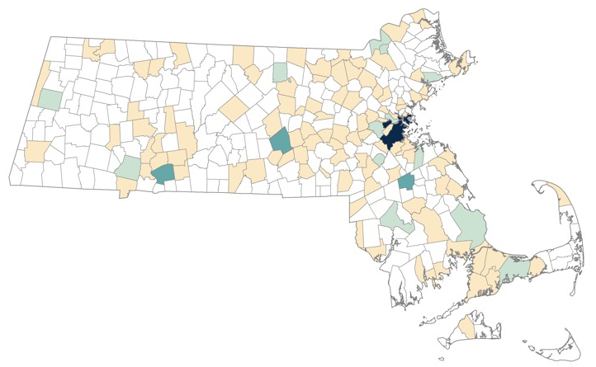Exhibit 1. Practice locations of surveyed clinicians
Number of participants
0
1 to 4 5 to 19 20 to 49 50 to 120

Exhibit 2. Characteristics of Massachusetts clinicians surveyed
Number of clinicians
76
309
195
94
RN
NP
26
MD Other Fam med
Int med
Ped Reprod health
Other
Hospital Public or Private Other
or affiliate
comm practice CHC
Clinical Role
Specialty
Practicing Setting
24
78
74
119
130
40
49
69

RN = registered nurse; NP = nurse practitioner; MD = physician; Fam med = family medicine; Int med = internal medicine or acute care;
Peds = pediatric or adolescent medicine; Reprod = reproductive; comm = community; CHC = clinic or health center.

2 See https://www.ncbi.nlm.nih.gov/pmc/articles/PMC5766221/.
3 For the present analysis, we defined environmental justice communities as those in which at least 50% of the population are underrepresented, underserved people
of color, or people of low socioeconomic status.

Clinicians deem environmental exposures important but infrequently discuss them
Consistent with previous survey findings,4 most Massachusetts clinicians surveyed thought that asking patients about environmental exposures was very important. They also thought that the health impacts of such exposures were very important in the communities where they work, and that clinicians can reduce patients’ environmental exposures through counseling (Exhibit 3). Clinicians in family medicine tended to ascribe greater importance than did clinicians in other primary care areas. Physicians and nurse practitioners also ascribed more importance, as compared with registered nurses. While clinicians working in environmental justice communities ascribed more importance to discussing environmental exposures than did clinicians in other communities, they had less confidence that clinicians can reduce patients’ exposures through counseling.
Despite recognizing the importance of environmental exposures, 59% of clinicians did not routinely ask about such exposures as part of a patient visit in the past year (Exhibit 4). Regular exposure assessments (occurring
at least every few months) were more common among physicians (62%) and nurse practitioners (61%), as compared to registered nurses (24%). They were also more common among clinicians practicing family medicine (62%) and pediatric or adolescent medicine (57%), compared with other primary care areas. The infrequent use of exposure assessments may be related to the fact that
only 7% of clinicians reported receiving recent training on asking about environmental exposures.
Among clinicians who had discussed environmental exposures with patients in the past year, most (65%) were prompted by patients’ symptoms, diagnoses, or risk factors (Exhibit 4). However, among clinicians who worked in reproductive health, exposure discussions were most often embedded into routine practice or screening.
Although patient-initiated discussions were rare among the clinicians surveyed, most clinicians reported receiving some questions from patients about environmental

Exhibit 4. Frequency of discussing environmental exposures with patients
Discussions were prompted by:
- Symptoms or diagnoses (38%)
34%
25%
17%
13%
12%
Never Once or twice Every few Monthly Weekly or
months more

Frequency of asking about exposure to environmental hazards as part of routine patient visit in past year
- Risk factors (27%)
- Routine practice (23%)
Percentage of clinicians
- Patient initiation (4%)
- Other, including COVID-19 (8%)

Exhibit 3. Perceptions about environmental exposures

 | Overall ranking  (out of 5 stars) | Among clinician subgroups
 |  | RN | EJ | Fam med
Perceived importance of asking patients about  environmental exposuresa | 3.7 | 3.6 | 3.8 | 4.1
Perceived importance of health impacts of  environmental exposuresa | 4.0 | 3.8 | 4.2 | 4.2
Agreement that clinicians can reduce patients’ exposures through counselingb | 3.7 | 3.6 | 3.7 | 3.9
a Scale: 1 = of little importance, 3 = of some importance, 5 = of great importance.
b Scale: 1 = strongly disagree, 2 = agree, 3 = neither agree nor disagree, 4 = agree, 5 = strongly agree. EJ = environmental justice community; RN = registered nurse; Fam med = family medicine.

4 See footnote 2 and https://pubmed.ncbi.nlm.nih.gov/16628975/.

exposures (sometimes weekly or more). Exposures because of personal behaviors (smoking, vaping, or marijuana use) rose to the top of discussions with patients—a pattern upheld across clinical roles, specialties, and community types (Exhibit 5).
After personal behaviors, questions about occupational or workplace exposures, followed by exposures because of household chemicals or personal care products were most common. Patients asked least about outdoor air pollution, exposures related to climate change, and food and drinking water contaminants. Clinicians working in
environmental justice communities reported less frequent questions from patients about environmental exposures (across all types) than other clinicians.
The survey also revealed that most clinicians were unfamiliar with several food and drinking water contaminants (e.g. manganese, uranium, and per- and polyfluorinated substances) and certain occupational or workplace exposures (e.g., polychlorinated biphenyls and solvents or volatile organic compounds), and were unlikely to discuss these exposures with patients (Exhibit 5).

Exhibit 5. Percentage of clinicians discussing versus unfamiliar with specific exposures
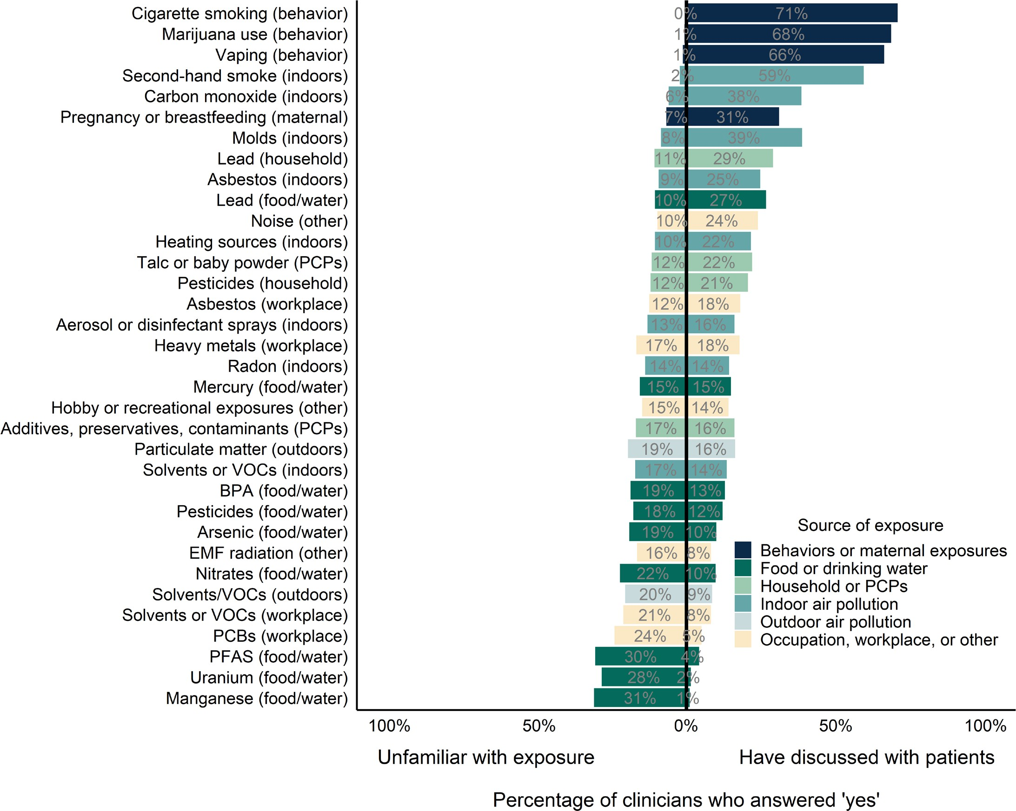

Note: The exposures are ranked by the ratio of “have discussed” to “unfamiliar.”
VOCs = volatile organic compounds; BPA = bisphenol A; EMF = electromagnetic fields; PCBs = polychlorinated biphenyls;
PFAS = per- and polyfluorinated substances.

Clinicians lack training, time, and tools to assess and prevent harmful exposures in patients
Time pressure, limited knowledge, and importance in relation to other issues were the top barriers Massachusetts’ clinicians faced to discussing environmental exposures
with patients (Exhibit 6), consistent with previous survey findings.5 Patients having little ability to control these issues was a more frequent barrier among clinicians working in environmental justice communities (49%) than those working in other communities (31%).
With respect to limited knowledge as a barrier, half the clinicians surveyed reported that they never consulted resources on environmental exposures in the past year. Among clinicians who consulted resources, the top sources of information were government websites (60%), the UpToDate website or app (51%), professional literature (49%), professional societies and associations (46%), and local or state health departments (37%). Clinicians in Massachusetts preferred tip sheets, on-demand or pre-recorded
materials, and online toolkits over live (in-person or virtual) presentations, discussions, or trainings. Preferred modes of delivery differed somewhat by clinical role and specialty.

Exhibit 6. Barriers to discussing environmental exposures
Percentage of clinicians
62%
57%
48%
40%
35%
30%
14%
13%
6%
2%
Time pressure
Limited knowledge Importance in relation
to other issues
Patients have little control of issues
Lack of capacity to treat or refer
Patients are not interested
Limited / contractictory research on impacts
Difficulty communicating
risk to patients
Concern about patients' reaction Population that cannot engage

5 See footnote 2

Creating tailored clinical educational materials on environmental exposures
These findings will be used to tailor educational materials to meet the assessed needs of Massachusetts clinicians. In particular, the survey findings and key informant interviews
will inform the types of educational materials and trainings we develop, with a goal of helping clinicians do the following:
- Recognize health symptoms associated with
environmental exposures
- Take an environmental exposure history to assess the association between environmental contaminants and patients’ health issues
- Counsel patients to prevent or minimize exposure to harmful environmental contaminants
- Refer patients for treatment of health issues caused
or worsened by environmental exposures

This document was made possible, in part, by a federal grant for Capacity Development and Applied Prevention Science from the Agency for Toxic Substances and Disease Registry’s Partnership to Promote Local Efforts to Reduce Environmental Exposure (CDC-RFA-TS20-2001). Its contents are solely the responsibility of the Massachusetts Department of Public Health
and do not necessarily represent the official views of the Agency for Toxic Substances and Disease Registry, or the Department of Health and Human Services.
COLLABORATORS
Mathematica
College of Nursing and Health Science at the
University of Massachusetts Boston
Preventive Medicine Residency at the University of Massachusetts Medical School
Massachusetts Nurses Association
July 2021

For more information on our environmental health capacity building in Massachusetts please contact:
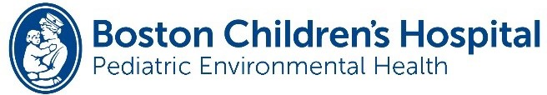
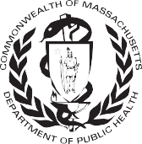
Massachusetts Department of Public Health Bureau of Environmental Health Environmental Toxicology Program
250 Washington Street
Boston, MA 02108 dphtoxicology@mass.gov
Phone: 617-624-5757 | Fax: 617-624-5183 | TTY: 617-624-5286
www.mass.gov/dph/environmental_health

