
Town of Royalston Community Software Consortium

A Cloud-Based Open Source
Integrated Municipal Financial Management System

April 1, 2013

Adams
Alford
Ashby
Ashland
Ayer
Becket
Berkley
Bernardston
Bolton
Brookfield
Charlemont
Cheshire
Chester
Clarksburg
Conway
Cummington
Devens
Dighton
Duxbury
East Brookfield
Egremont
Framingham
Grafton
Great Barrington
Hardwick
Hawley
Heath
Hinsdale
Holliston
Lancaster
Lee
Leyden
Lunenburg
Middlefield
Monroe
Needham
New Braintree
North Andover
North Brookfield
North Reading
Northborough
Oakham
Peru
Plainfield
Princeton
Reading
Richmond
Royalston
Sandwich
Saugus
Seekonk
Sheffield
Shelburne
Somerset
South Shore Tri-Town
Southborough
Tolland
Tyringham
Uxbridge
Warwick
Washington
Wendell
West Brookfield
West Stockbridge
Westhampton
Williamsburg
Williamstown
Windsor

Town of Royalston and the Community Software Consortium (CSC) – a consortium of Massachusetts cities and towns organized under M.G.L. 40, § 4A for interlocal purchasing agreements.
TABLE OF CONTENTS
INTRODUCTORY LETTER 2
EXECUTIVE SUMMARY 4
PARTNER COMMUNITIES 5
GOALS 6
IMPLEMENTATION PLAN 7
Planning 7
Request for Proposal (RFP) Process 7
Specification Documents and Development 7
Agile Development Approach 8
Testing and Feedback 8
General 8
BUDGET 10
CHALLENGES AND SOLLUTIONS 11
Schedule 11
Managing Project Scope Creep 11
High Touch Low Touch 11
OUTCOMES 12
CONTACT INFORMATION 13
REFERENCES 13

INTRODUCTORY LETTER

We would like to take this opportunity to thank the Patrick Administration and the Executive Office for Administration and Finance for their foresight in conceiving of this innovative grant program and the generous funding that we received.

The Town of Royalston, and the Community Software Consortium (CSC) are pleased to report on the success of our Community Innovation Challenge Grant project, completed on time, on budget, and exceeding project expectation deliverables.

Small to middle size towns, many remotely located, are plagued with limited or no Information Technology (IT) support staff; Poor choices for affordable software solutions; and ever increasing demands and expectations from state regulatory agencies, and the general public. Many rural communities have very unreliable and unstable power, frequent outages and frequently damaged computer drives. These towns have no budget or expertise to address these problems individually, on their own. A case in point, one of our beta test towns asked to be included because their server has outlived its life-span, and they do not have the resources to replace it.

CSC previously developed cost effective software to manage the Assessment and Collection processes for communities in Massachusetts. This grant allowed the CSC, with project direction from the Town of Royalston, to move these applications to a cloud environment, and realize significant technical support, operational and usability savings.

In the case of the Assessment side (Real and Personal Property), these applications were brought over intact in ‘terminal emulation’ mode - hosting the existing applications on a virtual desktop. The Collection application was completely rewritten as a cloud based application. The cloud-based software is updated simultaneously and remotely. Local town data is securely available from any local Internet device. And, the cloud stored data it is securely, automatically, and regularly backed up.

We were able to prove the concept - our software would work, as well or better than the personal computer (PC) systems, in a cloud environment, serving multiple communities. All three modules were thoroughly tested, and are now ready for beta testing with select communities, each of whom will operate the system through an entire year cycle.

The response from member communities has been very positive and we decided to expand the number of communities participating in the beta testing phase to accommodate the demand. Beta testing began in April, 2013. .

Having met these short-term objectives, we are now poised to begin the next phase of our project. Our overall long-range goal is to make advanced Municipal financial software IT affordable for all Commonwealth communities, establishing an innovative approach that can be readily shared with other states or regionalized municipal governments.

Sincerely,



Linda Alger Tammy Blackwell
Selectboard Chair Board Chair
Town of Royalston Community Software Consortium

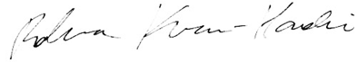
Rebecca Krause-Hardie
Project Manager
Royalston Collector
CSC Board Member

EXECUTIVE SUMMARY

The Town of Royalston, and the Community Software Consortium (CSC) received funding for the purpose of developing and readying for “beta” testing, foundation modules of a “cloud” based integrated municipal financial management system.

The core elements of this system were a set of applications developed by the CSC out of the Commonwealth’s investment in Computer Assisted Mass Appraisal (CAMA) and Tax Administration software in the late 1980’s. This software has been regularly maintained and updated to the latest technology over the years. The CSC had recently commissioned a feasibility study on moving these applications to the Internet in a cost-effective way. Royalston, for example, has been using this software since the mid 1990’s and has a great need for a fully integrated system. It has been struggling with issues of networking between offices miles apart, antiquated computers unable to support a network, as well as a collection of software programs that are inadequate, incomplete, and not integrated.

Phase 1, funded by this grant, proved the concept of small communities using the Internet to centralize applications and data under professional management while defining the requirements for Phase 2 – incorporating other foundation modules for a complete integrated finance system.

Phase 1 (a) successfully placed the CAMA and Personal Property Modules of the system in the cloud using a ‘terminal emulation’ mode utilizing the concept of a remote desktop. (b) The Collection package was completely rewritten in a language called .net as a system native to the cloud. (c) The three modules were completely tested using data from two communities. (d) Each module functioned at the same level or better than its PC equivalent. (e) Feedback from member communities was uniformly positive and (f) we have had to expand the number of communities that will be able to participate in beta testing. (g) Accounting and Treasurer modules from a system developed by the Town of Hanover, and given to the CSC, were documented and reviewed in preparation for moving them to the cloud in Phase 2. (h) A comprehensive testing manual of use cases was developed, (i) as were manuals for system users and software administrators.

Meeting the ambitious timeline was perhaps the most challenging aspect of the project. Flexibility in workload & scheduling was essential. On the outset, we imagined that unforeseen issues would arise. These turned out to include hard-coded programming elements that were designed for desktop use and required additional programming beyond the original scope to work in the cloud. Note: An exceptional collaborative team at Stonewall Solutions Inc., our software vendor, was critical to the project success.

PARTNER COMMUNITIES

The Town of Royalston was the lead partner in this project acting on behalf of itself and the Community Software Consortium (CSC) – a consortium of 68 (sixty-eight) Massachusetts cities and towns organized under M.G.L. 40, § 4A for interlocal purchasing agreements.

The Royalston Collector/IT Manager acted as the project manager, while the CSC Board and member communities provided continuous input and feedback -in real time- on the development and design of the project, through surveys, informal conversations, news updates, monthly board meetings, and the annual meeting of the community membership.

Actual town test data was used from two communities to insure that the applications worked as expected in a multi-community environment. Nine towns will be using the cloud system during the 2013 beta testing phase, which is outside the scope of this project.

CSC member communities:

Adams
Alford
Ashby
Ashland
Ayer
Becket
Berkley
Bernardston
Bolton
Brookfield
Charlemont
Cheshire
Chester
Clarksburg
Conway
Cummington
Devens
Dighton
Duxbury
East Brookfield
Egremont
Framingham
Grafton
Great Barrington
Hardwick
Hawley
Heath
Hinsdale
Holliston
Lancaster
Lee
Leyden
Lunenburg
Middlefield
Monroe
Needham
New Braintree
North Andover
North Brookfield
North Reading
Northborough
Oakham
Peru
Plainfield
Princeton
Reading
Richmond
Royalston
Sandwich
Saugus
Seekonk
Sheffield
Shelburne
Somerset
South Shore Tri-Town
Southborough
Tolland
Tyringham
Uxbridge
Warwick
Washington
Wendell
West Brookfield
West Stockbridge
Westhampton
Williamsburg
Williamstown
Windsor

GOALS

The overall long-range intent of the project is to make advanced integrated municipal financial IT affordable for all Commonwealth communities, establishing an innovative approach that can be readily shared with other states or regionalized municipal governments.

The short-term objective is to prove the concept that an affordable, practical means exist for municipalities, including the smallest in the Commonwealth, to:
- Centralize system administration, security, database administration, and disaster recovery planning in the hands of professionals;
- Create state of the art financial applications which aim at labor-saving integration among modules with flexible and powerful ad hoc reporting;
- Develop full access through any Internet-ready device attached to a broadband connection;
- Support regionalized staffing innovations by making municipal information independent of distance, locations, and office hours;
- Provide municipal data and applications, as appropriate, to all users anywhere who have an Internet connection, making the Internet the town’s network environment;
- Be free of local hardware and software upgrade costs;
- Allow the software modules to benefit from the open-source, free licensing model that generates cost-free highly-relevant enhancements; and
- Provide access to informed and responsive support and training services.

IMPLEMENTATION PLAN

Planning

The implementation process began well before the start of the grant. A detailed analysis of our current collection and assessing applications was undertaken. Moving to the cloud required us to examine which elements could be introduced in ‘terminal emulation mode’, and which needed to be rebuilt from the ground up. As much as possible we needed to anticipate any system changes that might have to be made to work successfully in a virtual environment. We solicited a “white paper” from a vendor who reviewed our applications and recommended the best options for a hosting framework.

We also had numerous discussions at the board level of the CSC to access our readiness to consider a cloud option and the potential benefits and challenges.

Request for Proposal (RFP) Process

Once the project manager was engaged, the top priority was creating a detailed request for proposal. Along with this document, dummy versions of the existing applications were created, as well as access to the extensive system documentation previously created.

RFPs were solicited from companies already on the state contract list to expedite the project. The CSC provided each vendor with extensive material to review and assist them with preparation of their proposals. It may have been a daunting amount of material to review, but was essential for a serious vendor to give a reasonable cost estimate. The number of vendors who gave us proposals was significantly less than the number solicited. We interviewed vendors who provided a proposal, at their offices. Conducting these interviews at their places of business was done intentionally, so as to see the extent of their organization, their level of professionalism, and any other cues that would help us differentiate between vaporware vendors and serious contenders. The request also specifically asked for the names and qualifications of the people who would be working on the project.

Specification Documents and Development

The project team, (including vendor, stakeholders, project manager, IT support staff) created extremely detailed documents that outlined how every button or field on a screen should behave as well as how underlying fields and tables were mapped. A comprehensive set of ‘use cases’ was created so that a tester could walk through for each application function. In every instance, the more specific these were, the better the end results have been. From these the vendor developed a screen validation document that contained their understanding of how each screen functioned. This became the basis for the ‘front-end’ html that drove the user experience. The project team took great care in developing the location of fields, font size, colors, and types of keystrokes that would “optimize the user experience” – delivering “an exceptional customer experience” was a top priority for the project team stakeholders. During the testing, each element was tested side-by-side with the original system to insure the smallest details were correct.

Agile Development Approach

The agile development approach was used during the project. While we did not precisely follow every one of these principles, the overall process was certainly driven by this agile philosophy. Initial meetings were all face-to-face and at least weekly. Further along the development cycle we moved to alternate weeks of in-person and conference calls. Software development ‘sprints’ or ‘timeboxing’ delivered components to test on a weekly basis. Immediate feedback was required from us (within 48 hours) to insure that the project stayed on track. An issue tracking system was employed to clearly identify problems, to clarify ambiguous issues, and to assign responsibility for completion. ‘Omniplan’ and ‘M.S. Project’ software were used to review project status and deliverables. While these project management tools were very important at the outset, they were less and less referred to as the project went on, in part because the priority was on working software as the principal measure of progress.

Testing and Feedback

Quality Assurance (QA) testing was a continuous process of improvement throughout the entire project, as each incremental piece of the overall project was rolled out. At various key moments in the project cycle, the CSC board and users from various communities reviewed project elements. In cases where expertise was required beyond the core project team, other community members were brought in to test and provide critical feedback. The software development team and the CSC stakeholders shared ownership of the process & the data.

General

The vendor development team, Stonewall Solutions Inc., was robust, providing the ability to work on various components simultaneously and progress quickly. Their project ‘team lead’ had a strong background in accounting and business processes, which was essential in their being able to grasp complicated taxation and computational issues.

Our overall schedule was as follows:
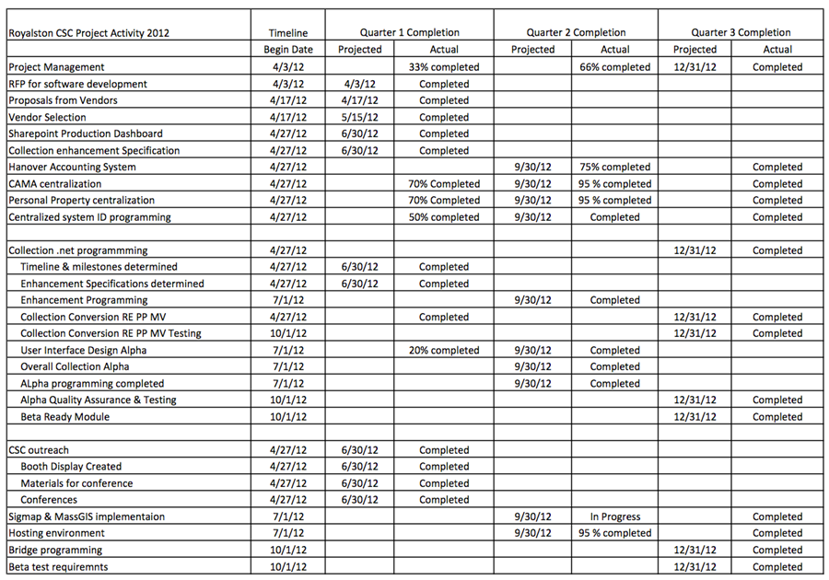

BUDGET

Budgetary Item | Funding Amount
Project oversight and management consultant | $20,000
Programming associated with moving CSC CAMA to multiple-community centralized application and database system | $17,000
Programming associated with moving CSC Collection/Billing to multiple-community centralized application and database system with selected enhancements | $127,500
Enhancements to CSC Collection/ Billing system | $77,310
Programming associated with moving CSC Personal Property Valuation to terminal emulation multiple-community centralized application and database system | $8,500
Programming to adopt identification/ authorization layer covering all modules for multiple community usage | $3,400
Sharepoint Dashboard Development | $1,700
Bridge programming between modules for transfer of appropriate data | $4,250
Hosting development for alpha and small beta testing, including servers, licenses, and colocation | $20,000
Beta test outreach report | $2,550
Conversion programs | $8,500

Total Budget: $290,710

This budget was built based on our prior in-house experience for software development. In addition we did research as well as had informal guidance from several vendors.

CHALLENGES AND SOLLUTIONS

Schedule
Perhaps the most difficult challenge was meeting the very tight schedule imposed by the grant cycle. This required absolute adherence to the project timeline details, and often meant many hours of development and testing ‘when needed’, and not necessarily ‘when convenient’. Weekly meetings with the software vendor were essential to staying on top of the many details and schedule. Often the entire project team put in extended hours beyond what was originally anticipated. Fortunately, the software vendor adhered to the ‘agile’ development methodology insuring that ongoing project ‘releases’ could be tested weekly and adjustments made immediately if necessary.

Managing Project Scope Creep

Moving from a PC based system to the Cloud inevitably brought new issues to the table and new methods to achieve the same or similar results. Numerous choices had to be made to insure that the project stayed on track. In some cases items were deferred or paid for by additional funds directly from the CSC. In other cases the software vendor agreed to make adjustments. For example, the personal property system had hard coded data within it referring to where files were stored and how they were updated. Being cloud based meant that unanticipated programming was required to create more flexibility on the file storage components. Similarly the Real Estate Appraisal system had hard coded authentication methods incorporated into it, which were not compatible with multi-community usage. In the latter case, the original vendor agreed to make changes in their system to address this issue.

High Touch Low Touch

Many of the underlying business ‘use’ cases were new to the programmers and were not easily communicated over conference calls. Consequently it was agreed to meet in person for all the initial meetings. This allowed for better communication, and the ability to work more collaboratively. Having a ‘local’ vendor made this process much more viable.

OUTCOMES

Original Measures of Success
- That the software modules successfully address the design criteria established in the requirements phase with success determined by the Municipal Advisory Committee and members of the associated CSC tier.
- That applications are accessible from any Internet-ready device and that complex reports or forms show acceptable performance service levels.
- That the application has working controls to manage community-specific identification and authorization.
- That data interfaces among software modules and between the software and DLS Gateway accurately and appropriately integrate data and services.
- The ultimate success of the project will be determined by additional communities’ readiness to convert to and adopt the resulting software applications. To the extent that municipalities and other local government units outside of Massachusetts utilize both the software foundation established by this project and replicate the governance model, monetary and programmatic success will measures of success on a national level.
Each of these measures of success has been met. Thorough testing of every aspect of the modules has been completed and the system is now ready for beta testing. The software performs equally as well or better than the current PC based modules.

In regards to point 5 – additional communities’ readiness to convert – we have had outstanding success in this area. At the demonstration of the software to the entire membership in October, there was overwhelming interest in moving to the cloud. We had originally planned on a maximum of six communities beta testing the cloud version. However because of demand and need (e.g. communities that are having server issues and can’t afford a new server) we have extended that to nine communities, and may open it up further after beta testing begins in April 2013.

CONTACT INFORMATION

Rebecca Krause-Hardie
Project Manager, CSC Board Member, Collector – Town of Royalston
978-575-1454 (home office)
978-249-2927 (tax office)
tax@royalston-ma.gov

Tammy Blackwell
CSC Board President, Principal Assessor, Town of Sheffield
413-229-7001 ext. 155
tblackwell@sheffieldma.gov

REFERENCES

For more information about the CSC, visit the Community Software Consortium website.

Project information and references may be found both on this site as well as at the
Town of Royalston’s website.

RESOURCES

White papers and other resources may be found at either the CSC website,
or at the homepage for the Town of Royalston.

