INDOOR AIR QUALITY ASSESSMENT

Clyde Brown Elementary School
5 Park Road, Millis
Millis, MA

Prepared by:
Massachusetts Department of Public Health
Bureau of Environmental Health
Indoor Air Quality Program
March 2016

Background

Building: | Clyde Brown Elementary School (CBES)
Address: | 5 Park Road, Millis, MA
Assessment Requested by: | Nancy Gustafson, Superintendent
Reason for Request: | Mold and general indoor air quality (IAQ) concerns
Date of Assessment: | General IAQ assessment on March 10, 2016
Massachusetts Department of Public Health/Bureau of Environmental Health (MDPH/BEH) Staff Conducting Assessment: | Mike Feeney, Director, Indoor Air Quality Program (IAQP)  Ruth Alfasso, Environmental Engineer, IAQP  Cory Holmes, Environmental Analyst, IAQP
Date of Building Construction: | Original section, 1954; additions in the 1990s
Building Description: | Elementary School, single-story brick construction with peaked roofs
Building Population: | 530 students in grades K through 5 with a staff of approximately 90
Windows: | Mostly openable

METHODS
Please refer to the IAQ Manual for methods, sampling procedures, and interpretation of results (MDPH, 2015).

RESULTS and DISCUSSION
The following is a summary of indoor air testing results (Table 1).
- Carbon dioxide levels were below 800 parts per million (ppm) in about 80% of the areas surveyed, indicating adequate air exchange in most areas.
- Temperature was within the recommended range of 70°F to 78°F in all areas tested.
- Relative humidity was within the recommended range of 40 to 60% in most areas tested, with a few below.
- Carbon monoxide levels were non-detectable in all indoor areas tested apart from the music area where measurements in the main music room and two adjacent offices ranged from 0.7 to 1.5 ppm. Note that this area is adjacent to the door to a loading dock area where vehicles may be parked. When this area was visited again later in the day, readings were all below 0.7 ppm. Background (outside) levels in the front of the building were 0.7 ppm. All levels measured were well below the National Ambient Air Quality Standard (NAAQS) level of 9 ppm.
- Fine particulate matter (PM2.5) concentrations measured below the NAAQS level of 35 μg/m³ in three quarters of all areas tested. Areas above the level of 35 μg/m³ had significant activities (e.g., the cafeteria) that could generate and aerosolize dust. The outdoors PM2.5 measure of 43 μg/m³ was also above the NAAQS level of 35 μg/m³.

This sampling indicates that the ventilation system in the building could provide more fresh air in some areas. Note that the BEH/IAQ Program visited this building for a general IAQ assessment in 2009. The BEH/IAQ Program issued a report detailing conditions observed at the time and provided recommendations to improve IAQ. The 2009 report can be accessed on the MDPH/IAQ website: http://www.mass.gov/eohhs/docs/dph/environmental/iaq/2009/millis-brown-elemty-school-2009.pdf.

Ventilation
A heating, ventilating, and air conditioning (HVAC) system has several functions. First it provides heating and, if equipped, cooling. Second, it is a source of fresh air. Finally, an HVAC system will dilute and remove normally occurring indoor environmental pollutants by not only introducing fresh air, but also filtering the airstream and ejecting stale air to the outdoors via exhaust ventilation. Even if an HVAC system is operating as designed, point sources of respiratory irritation may exist and cause symptoms in sensitive individuals. The following analysis examines and identifies components of the HVAC system and likely sources of respiratory irritant/allergen exposure due to water damage, aerosolized dust, and/or chemicals found in the indoor environment.
Fresh air is provided by a combination of unit ventilators (univents) located in individual classrooms along the outside wall (Picture 1) and air handling units (AHUs) located in mechanical rooms or ceiling-mounted, which serve central areas such as the gym and cafeteria. The unit ventilators draw fresh air through a vent on the exterior wall (Pictures 2 and 3). Air is mixed with return air from the room, filtered, heated (if needed) and delivered back to the room (Picture 3). In some locations, univents were found partly obstructed by items on top or in front, which can impair proper operation (Pictures 1 and 4). Air from the AHUs is filtered, heated, and delivered to rooms via ducted supply vents (Picture 5). Exhaust vents are located on the walls of classrooms, typically near doors (Picture 6) and are ducted to rooftop motors. Note that when classroom doors are open, exhaust vents will tend to pull hallway air into the classroom instead of exhaust vents removing stale air/pollutants from the room and out the building. Many exhaust vents were found blocked by furniture or items (Picture 7; Table 1). Additional exhaust vents are located in toilet rooms and other areas; some of the toilet room exhausts were also found not to be functioning (Table 1), which can allow odors and moisture to build up.

Microbial/Moisture Concerns
Several moisture issues were identified in the building. Stained ceiling tiles were observed in a few areas (Pictures 8 and 9; Table 1). Please note that tiles in the original 1950s portion of the building appear to be adhered directly to the ceiling and are difficult to remove (Picture 8), necessitating the destruction of the tile. As a result they have been left in place and some appear to have been painted over. Areas above suspended ceilings were examined, and no wet or moldy materials were observed; there is a significant air space above the ceiling tile system, which allows drying/reduces the chance of microbial growth. Some of the observed stained tiles were from plumbing and roof leaks that have reportedly been repaired. School officials report that additional areas of leaks existed and that ceiling tiles in several areas were already replaced prior to this MDPH visit.
Many of the leaks reportedly stemmed from roof problems that occurred due to weather conditions during February/March 2015. Due to the heavy snow and cold temperatures, many buildings in Massachusetts experienced ice dams, a condition that occurs when heat rising off a building melts snow, which then refreezes at the edge or gutter of the roof. Ice dams prevent water from draining off the roof, causing water to penetrate the building envelope through roof shingles. This leads to moistened insulation and other building materials in the attic space and occupied spaces below the roof edge. Further, the freeze-thaw action can damage roof materials, gutters, and flashing, leading to additional leaks. A roof that has been subject to ice dams should be thoroughly inspected and repaired to prevent ongoing problems.
BEH/IAQ staff examined the wing containing Classrooms 1 through 11 and noted the roof over Classrooms 5, 6, and 7 is configured to have a flat edge (Pictures 10 and 11), rather than a sloped edge as do the other wings of the building. This configuration would increase the likelihood that ice dams would build up over these rooms since snow would tend to accumulate at the angle where the flat section meets the sloped section of the roof. Other sections of the building without this flat edge can have snow slide off the roof under certain conditions. In order to prevent excess snow buildup on the roof over Classrooms 5, 6, and 7, it is likely that snow would need to be removed manually (e.g., shoveled) by the CBES maintenance staff.
To prevent ice dams on sloped roofs in general, a combination of methods are used. The floor of the attic space is insulated to prevent air movement and heat loss from the occupied space. Ridge vents (installed along the roof ridge) are installed to allow for free exhaust of heat from the attic space. Soffit vents (located beneath the eave in the roof) provide a source of cold outdoor air to replace the heated air that escapes through the ridge vent. This configuration allows for heat to escape so that the attic space has a temperature that is roughly equal to the outdoor temperature, so that the roof materials do not melt snow in contact with the roof. If attic insulation is inadequate, or ridge vents/soffit vents are sealed, then heat can accumulate in the roof peak and start the ice dam creation cycle. This building has soffit vents beneath the roof edge (Picture 12). BEH/IAQ staff could not identify any ridge vents on the peak of the roof. BEH/IAQ staff also noted significant openings in the insulation barrier in the attic floor above Classrooms 5, 6, and 7 (Pictures 13 and 14). These spaces in insulation would readily allow for heat to escape into the attic space, heating the peak of the roof to melt snow which then freezes to form ice dams. In addition, a contributing factor is moistening of insulation resulting from water leaks caused by ice dams. The ability of insulation to prevent temperature transfer is decreased if the material becomes moistened. The loss of temperature control can result in more heat transfer into the attic space, creating larger ice dams and more water penetration. The conditions contributing to the creation of ice dams should be corrected to prevent moisture problems.
At the time of assessment a tarp had been placed over the area of the roof where chronic leaks are occurring (Picture 15). Water-damaged ceiling tiles were replaced in Classrooms 5, 6 and 7.
Many of the sinks in classrooms had backsplashes with a gap (Picture 16; Table 1), which can allow for moistening of the wood material and potential microbial growth. Many sinks also had large amounts of items, including porous items such as paper, wood, and food, stored on or beneath them (Pictures 17 through 20; Table 1), where they could become damaged due to condensation or leaks. Porous items and large amounts of items should not be stored under sinks.
Plants were observed in a few areas (Table 1). Plants can be a source of pollen and mold, which can be respiratory irritants to some individuals. Plants should be properly maintained and equipped with drip pans and should be located away from air diffusers to prevent the aerosolization of dirt, pollen, and mold.
Spaces were observed under/around exterior doors. These doors should be sealed as tight as possible to prevent drafts, moisture, and/or pests from entering the building.

Other IAQ Evaluations
Exposure to low levels of total volatile organic compounds (TVOCs) may produce eye, nose, throat, and/or respiratory irritation in some sensitive individuals. To determine if VOCs were present, BEH/IAQ staff examined rooms for products containing VOCs. BEH/IAQ staff noted air fresheners, hand sanitizers, cleaners, and dry erase materials in use within the building (Pictures 17 to 20; Table 1). All of these products have the potential to be irritants to the eyes, nose, throat, and respiratory system of sensitive individuals.
Pencil sharpeners and pencil shavings were observed in some classrooms, including directly on univents (Picture 21). This material can be irritating if aerosolized. Pencil sharpeners should be located away from sources of air movement, and should be emptied/cleaned regularly.
Some personal fans, supply and exhaust vents were observed to be dusty (Picture 22; Table 1). In some areas, items were observed on the floor, windowsills, tabletops, counters, bookcases, and desks (Table 1), making dust control difficult. Many flat surfaces, univent cabinets, and return vents (bottom front) had dust and debris on/in them as well (Pictures 23 and 24; Table 1).
Some classrooms had area rugs, and some other areas of the school were carpeted (Table 1). Carpeting should be cleaned annually or semi-annually in soiled high traffic areas as per the recommendations of the Institute of Inspection, Cleaning, and Restoration Certification (IICRC, 2012). Area rugs that are worn and/or have become hard to clean should be discarded. Plush items/cushions/pillow, also observed in some classrooms (Picture 25; Table 1), should be cleaned regularly to remove skin cells, oils and debris.
A periodic heating/burning-type odor was reported by the occupant of Classroom 12. BEH/IAQ staff examined the univent and found an oily fluid in the right-hand cabinet (Pictures 26 and 27), which indicates a leak as the likely source of odors.
The day of assessment some areas had missing ceiling tiles (Picture 28), which were reportedly in the process of being replaced. Ceiling tile systems should be intact to prevent exposure to insulation material, dirt, dust/debris that accumulates above the system. In addition, fiberglass insulation can be a source of eye, skin, and respiratory irritation.
Upon entering Classroom 5, BEH/IAQ staff noted a pungent, cat urine-like odor in and around the hallway door and restroom. BEH/IAQ staff traced the source of the odor to a holly bush that was planted in close proximity to the univent fresh air intake for Classroom 5 (Picture 29).

CONCLUSIONS/RECOMMENDATIONS
The following recommendations are made to assist in improving IAQ in the CBES:
- Continue with plans to investigate leaks and repair the roof above Classrooms 5, 6, and 7. Repair leaks as needed in other areas.
- Until roof repairs can be made, continue to be vigilant and encourage staff to report leaks/wet building materials for prompt action/remediation.
- Remove all water-damaged insulation above areas of chronic leaks. Do not replace insulation until roof is repaired. Work should be done during unoccupied periods. Ensure flat surfaces are properly cleaned using a high efficiency particulate arrestance (HEPA) filtered vacuum cleaner and/or wet wiping after removal.
- Consult with a building engineer and/or roofing contractor regarding prevention of ice dams. At minimum, discuss installing a continuous layer of appropriate insulation along the floor of the attic space and providing a means for heat to escape the roof peak.
- Operate all ventilation systems (e.g., univents and AHUs) throughout the building continuously during periods of school occupancy and independent of thermostat control.
- Inspect all exhaust motors and belts periodically for proper function. Repair and replace as necessary.
- Remove all blockages from univents and exhaust vents to ensure adequate airflow. School staff should be encouraged not to deactivate classroom univents; rather, report any complaints concerning temperature control, noise, etc. to the facilities department.
- Close classroom doors to maximize air exchange.
- Make repairs to leaking (oil/fluid) univent in classroom 12 and clean residual material from surfaces.
- Consider adopting a balancing schedule of every 5 years for all mechanical ventilation systems, as recommended by ventilation industrial standards (SMACNA, 1994).
- Use openable windows in conjunction with mechanical ventilation to increase air exchange. Care should be taken to ensure windows are properly closed at night and weekends to avoid the freezing of pipes and potential flooding.
- Consider creating a logbook for staff to submit specific cleaning/maintenance requests. Make logbook available for staff/management in a central location. Cleaning and/ or maintenance requests should include date, requester, a detailed description of where and what the issue is as well as a section for cleaning/maintenance personnel to sign off or document progress of request. Alternatively, an electronic program such as “School Dude” could be used.
- Avoid idling of vehicles in front of the building and at the loading dock area in accordance with M.G.L. c. 90:16A which restricts idling of vehicles to no more than five minutes unless absolutely necessary (MGL, 1986).
- Ensure that doors between the loading dock and occupied areas remain closed whenever possible and that they fit tightly.
- Replace missing/damaged ceiling tiles throughout the building.
- Repair sink backsplashes to render them watertight.
- Refrain from storing porous or significant amounts of materials under sinks.
- Ensure exterior doors close tightly. Install/replace weather-stripping as needed, monitor for light/drafts around doors for proper seal.
- Keep plants in good condition, avoid overwatering, and remove from the airstream of univents and other air sources.
- Inspect and repair the gutter system. Inspect insulation and vents along the edge of the roof to minimize the creation of ice dams and allow the gutters to flow freely.
- Reduce the use of cleaning products, sanitizers and other products containing VOCs. Use only school-issued products, ensure they are properly labeled, and keep material safety sheets on file for each product at the school.
- Keep pencil sharpeners away from air movement sources such as univents, and keep them clean.
- Change filters regularly in univents (2 to 4 times a year), and vacuum the return vents (bottom front) and cabinets of debris each time the filters are changed.
- Clean other supply/exhaust vents and personal fans regularly to prevent aerosolization of debris.
- Clean carpeting and area rugs regularly and discard those that are worn out or too soiled to be cleaned.
- Clean upholstered furniture, cushions/pillows and plush items on a regular basis.
- Relocate or consider reducing the amount of materials stored in classrooms to allow for more thorough cleaning of classrooms. Clean items regularly with a wet cloth or sponge to prevent excessive dust build-up.
- For buildings in New England, periods of low relative humidity during the winter are often unavoidable. Therefore, scrupulous cleaning practices should be adopted to minimize common indoor air contaminants whose irritant effects can be enhanced when the relative humidity is low. To control for dusts, a high efficiency particulate arrestance (HEPA) filter equipped vacuum cleaner in conjunction with wet wiping of all surfaces is recommended. Avoid the use of feather dusters. Drinking water during the day can help ease some symptoms associated with a dry environment (throat and sinus irritations).
- Consider conducting school-wide clutter reduction/cleaning of flat surfaces quarterly, with faculty working in conjunction with maintenance staff to relocate/remove items to facilitate cleaning.
- Consider adopting the US EPA (2000) document, “Tools for Schools”, as an instrument for maintaining a good IAQ environment in the building. This document is available at: http://www.epa.gov/iaq/schools/index.html.
- For more information about mold/remediation consult Mold Remediation in Schools and Commercial Buildings” published by the US Environmental Protection Agency (US EPA, 2008).
- Refer to resource manual and other related IAQ documents located on the MDPH’s website for further building-wide evaluations and advice on maintaining public buildings. These documents are available at: http://mass.gov/dph/iaq.

References
IICRC. 2012. Institute of Inspection, Cleaning and Restoration Certification. Carpet Cleaning: FAQ. Retrieved from http://www.iicrc.org/consumers/care/carpet-cleaning/#faq.
Massachusetts Department of Public Health (MDPH). 2015. Indoor Air Quality Manual: Chapters I-III. Available at: http://www.mass.gov/eohhs/gov/departments/dph/programs/environmental-health/exposure-topics/iaq/iaq-manual/.
MGL. 1986. Stopped motor vehicles; Operation of Engine; Time Limit; Penalty. Massachusetts General Laws. M.G.L. c. 90:16A.
SMACNA. 1994. HVAC Systems Commissioning Manual. 1st ed. Sheet Metal and Air Conditioning Contractors’ National Association, Inc., Chantilly, VA.
US EPA. 2000. Tools for Schools. Office of Air and Radiation, Office of Radiation and Indoor Air, Indoor Environments Division (6609J). EPA 402-K-95-001, Second Edition. https://www.epa.gov/iaq-schools.
US EPA. 2008. Mold Remediation in Schools and Commercial Buildings. US Environmental Protection Agency, Office of Air and Radiation, Indoor Environments Division, Washington, D.C. EPA 402-K-01-001. http://www.epa.gov/mold/mold-remediation-schools-and-commercial-buildings-guide.
Picture 1
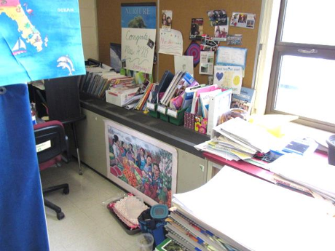
Univent partly obstructed with items on top and in front
Picture 2
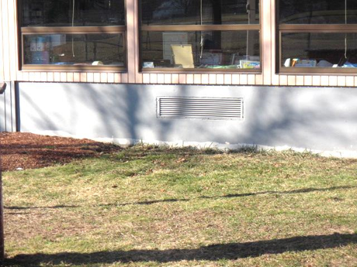
Univent fresh air intake
Picture 3 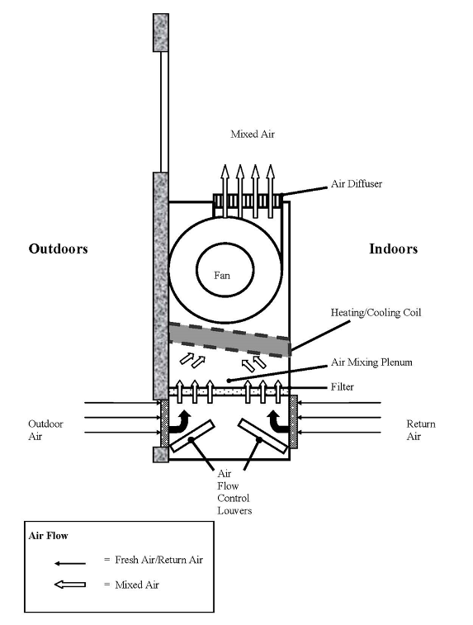
Univent diagram
Picture 4
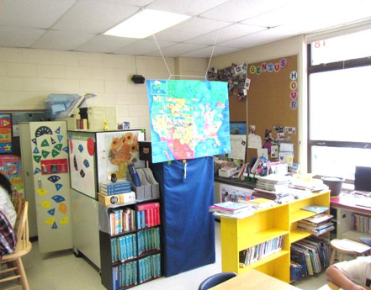
Classroom furniture/items restricting airflow around univent
Picture 5
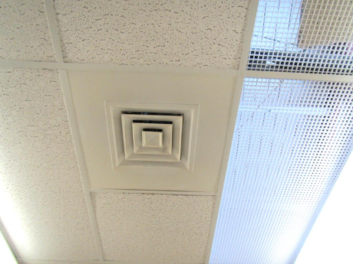
Typical supply vent
Picture 6
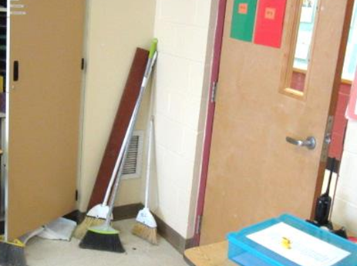
Classroom exhaust vent, note proximity to hallway door
Picture 7
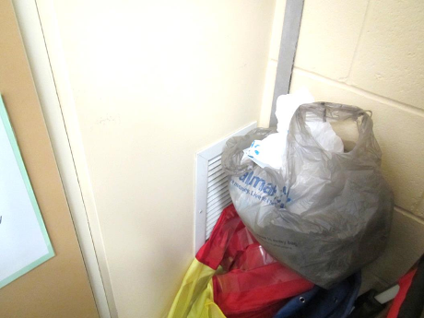
Exhaust vent blocked by items
Picture 8
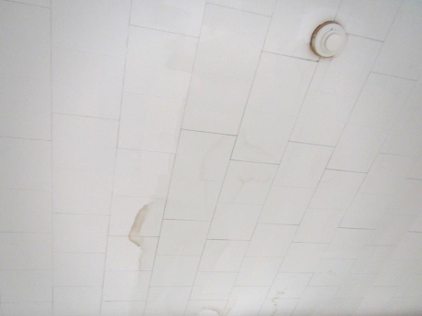
Water-damaged ceiling tiles; note these are the type that attach directly onto the ceiling
Picture 9
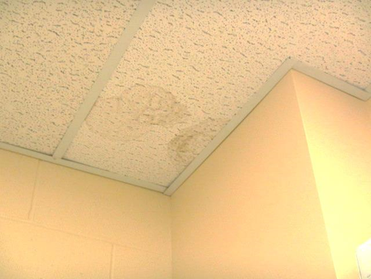
Water-damaged suspended ceiling tiles
Picture 10
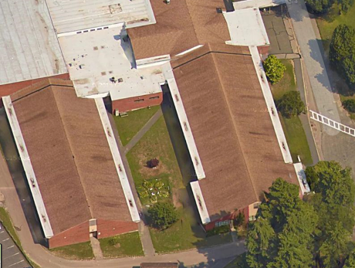
Classrooms 5, 6 and 7 from above; note roof edge jutting (bottom right, white box)
Picture 11
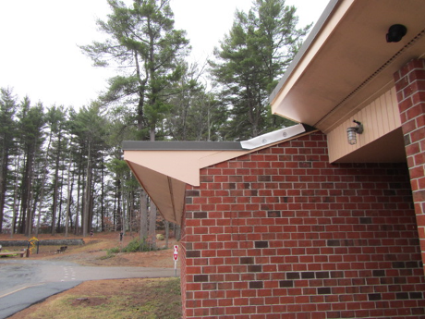
Roof edge jutting
Picture 12
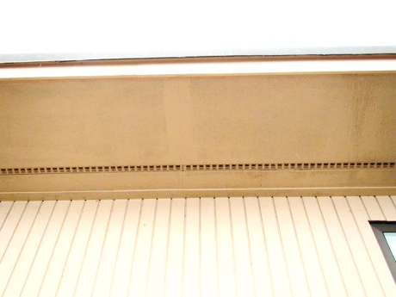
Example of a soffit vent
Picture 13
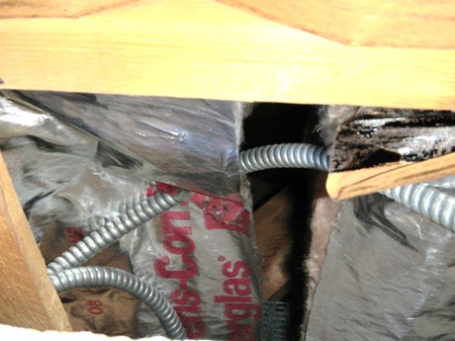
Space between portions of attic floor insulation
Picture 14
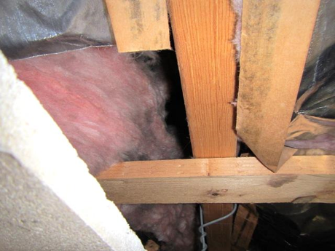
Space between portions of attic floor insulation
Picture 15
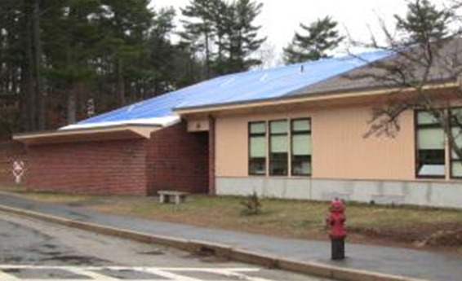
Tarp installed on roof where chronic leaks are occurring
Picture 16
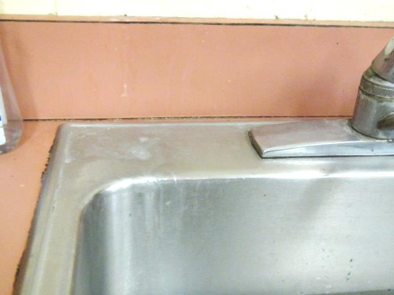
Open sink backsplash and mold staining around edges of sink
Picture 17
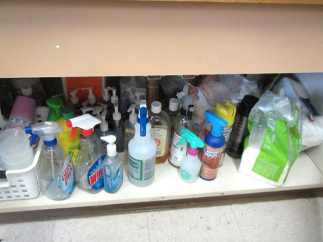
Large amounts of items, including many cleaning products, under a classroom sink
Picture 18
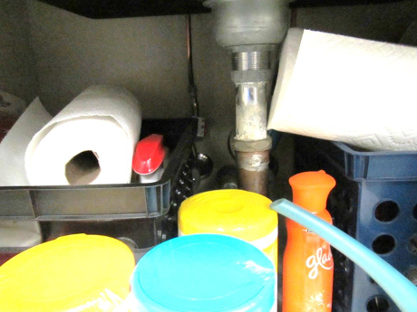
Porous items and cleaning products under a classroom sink
Picture 19
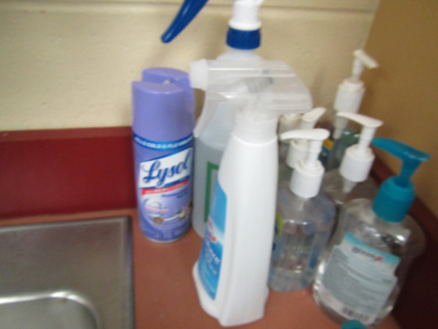
Cleaning products and hand sanitizer in a classroom
Picture 20
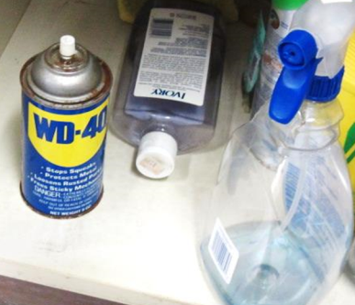
Spray cleaners/materials beneath sink in classroom, note corrosion/rust on WD-40 can
Picture 21
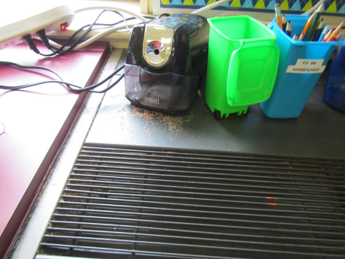
Pencil shavings on/in a univent
Picture 22
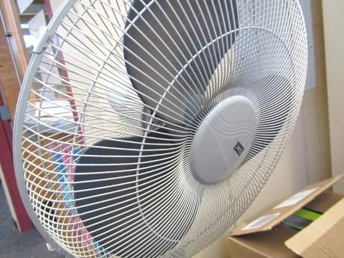
Dusty personal fan
Picture 23
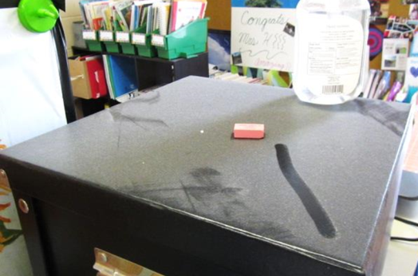
Accumulated dust on flat surface in classroom
Picture 24
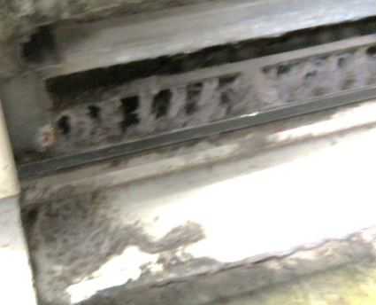
Accumulated dust/debris in univent/along front (return vent)
Picture 25
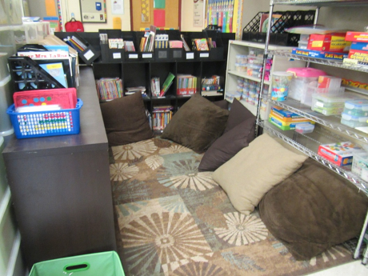
Area rug and plush items in classroom
Picture 26
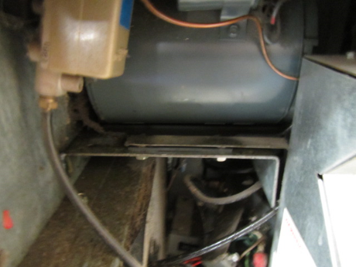
Right side univent cabinet area of leaking fluid Classroom 12
Picture 27
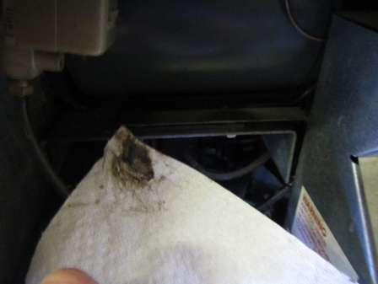
Oily fluid leak in Classroom 12 univent
Picture 28
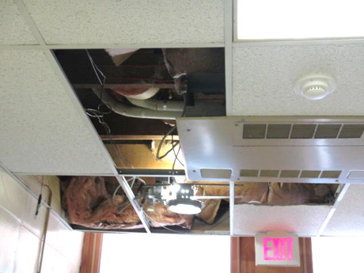
Missing ceiling tiles in hallway, note exposed fiberglass insulation
Picture 29
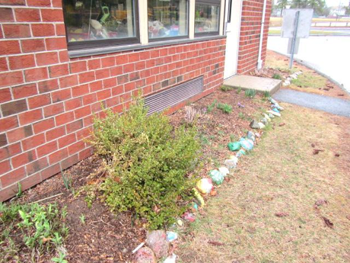
Holly bush outside classroom 5
Location | Carbon  Dioxide  (ppm) | Carbon Monoxide  (ppm) | Temp  (°F) | Relative  Humidity  (%) | PM2.5  (µg/m³) | Occupants  in Room | Windows  Openable | Ventilation |  | Remarks
 |  |  |  |  |  |  |  | Supply | Exhaust
Background | 389 | 0.7 | 68 | 47 | 43 |  |  |  |  | Warm, cloudy, humid
1 | 913 | ND | 75 | 46 | 17 | 19 | Y | Y | Y | File cabinet in front of exhaust
2 | 646 | ND | 76 | 44 | 19 | 1 | Y | Y | Y
3 | 1044 | ND | 77 | 50 | 19 | 19 | Y | Y | Y
4 | 779 | ND | 73 | 48 | 18 | 20 | Y open | Y on | Y | Exhaust blocked, AI, 26 WD CT
5 | 952 | ND | 77 | 53 | 19 | 21 | Y | Y | Y | Odor , Exhaust blocked
5 rest room |  |  |  |  |  |  |  |  | Y off | AF
6 | 800 | ND | 76 | 52 | 17 | 18 | Y open | Y | Y
7 | 742 | ND | 75 | 54 | 21 | 20 | Y | Y | y
8 | 541 | ND | 74 | 52 | 18 | 2 | Y | Y | Y | Exhaust blocked
9 | 732 | ND | 76 | 49 | 21 | 16 | Y | Y | Y
10 | 844 | ND | 77 | 51 | 19 | 20 | Y | Y | Y
11 | 761 | ND | 76 | 51 | 17 | 15 | Y open | Y | Y | DO, File cabinet in front of exhaust
12 | 713 | ND | 74 | 46 | 18 | 19 | Y open | Y | Y | Sink backsplash open, CP, odor complaint from UV-slight oil/fluid leak (right cabinet), dust/debris UV interior/return vent (bottom front)
14 | 652 | ND | 75 | 42 | 39 | 3 some just left | Y | Y UV | Y on | Sink backsplash open, PF, HS, CP, porous items under sink, PS on UV
15 | 730 | ND | 75 | 44 | 34 | 19 | Y 1 open | Y UV | Y | Area rug, sink backsplash open, PS on UV, HS, DEM, CP and porous items under sink
16 | 669 | ND | 74 | 44 | 44 | 20 | Y | Y UV on | Y dusty | DEM, sink backsplash open, CP and porous items under sink, DEM, area rug
17 | 750 | ND | 75 | 43 | 51 | 21 | Y | Y UV | Y on | DEM, PF, HS, plants, PS on UV, NC, sink backsplash open
18 | 754 | ND | 75 | 44 | 20 | 20 | Y | Y UV | Y | Dust/debris-flat surfaces, CP
19 | 741 | ND | 75 | 42 | 34 | 19 | Y | Y UV on | Y on | PF, trash, NC, dirty floor, backsplash on sink open
20 | 634 | ND | 75 | 41 | 32 | 25 | Y 1 open | Y UV | Y on | DEM, area rug, plants, backsplash on sink open
21 | 649 | ND | 77 | 31 | 29 | 17 | Y | Y UV | Y on | NC, sink backsplash open, CP, HS, PF, DEM
22 | 776 | ND | 76 | 43 | 33 | 15 | Y open | Y UV on | Y obst. | DEM, NC, Fridge, area rug and pillows, sink with CP and porous items under, backsplash open
26 | 478 | ND | 73 | 39 | 28 | 2 | Y | Y UV | Y | WAC – on, area rug, DEM, sink
27 | 437 | ND | 74 | 43 | 27 | 0 | Y 2 open | Y UV | Y | Area rug, toilet room exhaust not on, PF, DEM, items under sink
28 | 489 | ND | 75 | 44 | 44 | 15 | Y open | Y UV | Y part obst. | Area rug, fridge, sink, PF, toilet room exhaust not on
29 | 759 | ND | 75 | 43 | 23 | 14 | Y | Y UV | Y | UV-off, DO
30 | 563 | ND | 73 | 48 | 21 | 14 | Y open | Y UV | Y | Exhaust blocked/open door, DO, PF-dusty, area rugs, pillows/cushions
31 | 501 | ND | 75 | 42 | 27 | 0 | Y | Y UV | Y | PF, PS near UV, messy AI under sink
32 | 540 | ND | 75 | 43 | 41 | 0 | Y 2 open | Y UV | Y on dusty | PF, WD CT, area rug, CP under sink
33 | 596 | ND | 74 | 43 | 27 | 2 | Y 1 open | Y UV | Y on | CP under sink
34 | 625 | ND | 75 | 43 | 49 | 0 | Y open | Y UV | Y obst. | Area rug, food, paper and other items under sink, DO, debris in UV, plant, HS
35 technology | 509 | ND | 76 | 42 | 40 | 2 | Y 2 open | Y UV | Y | Area rug, porous items under sink, PCs
36 | 634 | ND | 76 | 40 | 26 | 1 | Y | Y | Y | NC, DEM, DO
CAF | 1144 | ND | 74 | 45 | 59-80 | Many | N | Y | Y | HS, DEM
Copy room | 783 | ND | 76 | 41 | 40 | 1 | N | N | N | DO, 2 PC, storage, WD CT
Gym | 881 | ND | 72 | 43 | 35-44 | Some just left | N | Y | Y | Rubber odor
Gym Storage | 1020 | ND | 72 | 43 | 15 | 0 | N | N | Y
Hallway between classrooms 30/31 |  |  |  |  |  |  |  |  |  | MTs exposed fiberglass insulation
Library main | 695 | ND | 74 | 38 | 37 | 20 | Y 3 open | Y | Y | Carpet tiles, PFs
Main Office | 861 | ND | 76 | 40 | 53 | 2 | Y 2 OPEN | Y | Y | PC, carpet
Mrs. Tocci | 858 | 1.5 | 76 | 41 | 26 | 2 | N | Y | N | Area rug, AI
Ms. Basille | 718 | ND | 74 | 37 | 45 | 2 | N | Y | Y | PF, DO, NC, DEM, HS
Ms. Bernier-Garzon | 779 | ND | 75 | 35 | 41 | 3 | N | N | N | NC, DO – chocked open
Ms. Doherty | 970 | ND | 75 | 35 | 35 | 3 | N | Y | Y obst. | Carpet, AI
Music | 802 | 0.7 | 76 | 41 | 31 | 1 | Y | Y | Y | Plant, WD CT, PF, NC, MT (many)
Nurse | 793 | ND | 76 | 41 | 44 | 1 | Y | Y | Y | WAC, NC, restroom
Other music office | 793 | 1.5 | 76 | 41 | 34 | 0 | N | Y | N | HS, MT, CP, fridge
Principal | 834 | ND | 76 | 39 | 36 | 0 | Y | ? | ?
School Psychologist | 584 | ND | 77 | 42 | 19 | 1 | Y | Y | Y
Special Education  Office 2 | 626 | ND | 75 | 43 | 17 | 0 | N | Y | Y | Areas of leaks (fixed), no current WD issues above CT
Special Education  Office 3 | 622 | ND | 75 | 42 | 15 | 1 | N | Y | Y | 1 WD CT-historic
Special Education  Office 4 | 786 | ND | 76 | 44 | 17 | 3 | N | Y | Y
Special Education  Office 5 | 647 | ND | 75 | 41 | 14 | 1 | N | Y | Y | Plants
Special Education  Office 6 | 645 | ND | 75 | 45 | 14 | 0 | N | Y | Y
Special Education Main | 680 | ND | 75 | 43 | 15 | 2 | N | Y | Y | Areas of leaks (fixed), no current WD issues above CT
Teacher’s lunch | 741 | ND | 76 | 47 | 31 | 9 | N | Y UV | Y | Microwave, CP on sink, vending, fridge, NC

