INDOOR AIR QUALITY ASSESSMENT

Clyde F. Brown Elementary School
5 Park Road
Millis, Massachusetts 02054

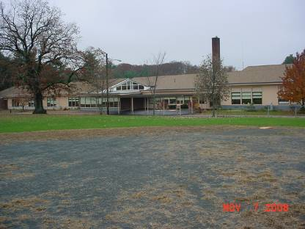

Prepared by:
Massachusetts Department of Public Health
Bureau of Environmental Health
Indoor Air Quality Program
January 2009

Background/Introduction
At the request of Scott Moles, Public Health Director for the Town of Millis, the Massachusetts Department of Public Health (MDPH), Bureau of Environmental Health (BEH) provided assistance and consultation regarding indoor air quality concerns at the Clyde Brown Elementary School (BES), 5 Park Road, Millis, Massachusetts. The request for this assessment was prompted by concerns about the source of tile discoloration and potential health effects that might be associated.
On November 7, 2008, Michael Feeney, Director of BEH’s Indoor Air Quality (IAQ) Program, made a visit to BES to conduct an indoor air quality assessment. The school is a single story brick/concrete building constructed in the 1950s. An addition was built onto the south wall of the building in 1991. The building can be divided into four distinct wings: the 1950s wing; the 1991west wing; the 1991 southwest (SW) wing; and, the 1991 southeast (SE) wing (Map 1, Picture 1). The 1950s wing contains classrooms 25-36, the administrative offices and the library. The 1991 west wing contains the cafetorium, kitchen, gym, and music room. The 1991 SW wing contains classrooms 1-11. The 1991 SE wing contains classrooms 12-22. Windows in the building are openable.

Methods
Air tests for carbon monoxide, carbon dioxide, temperature and relative humidity were conducted with the TSI, Q-Trak, IAQ Monitor, Models 7565. Air tests for airborne particle matter with a diameter less than 2.5 micrometers were taken with the TSI, DUSTTRAK™ Aerosol Monitor Model 8520. MDPH staff also performed visual inspection of building materials for water damage and/or microbial growth.

Results
This school has a student population of approximately 590 and a staff of approximately 50. Tests were taken during normal operations at the school and results appear in Table 1.

Discussion
Ventilation
It can be seen from the Table 1 that carbon dioxide levels were elevated above 800 parts per million parts of air (ppm) in seven of thirty-four areas surveyed, indicating adequate fresh air ventilation in most areas of the school.
Fresh air in classrooms is supplied by a unit ventilator (univent) system. Univents draw air from outdoors through a fresh air intake located on the exterior wall of the building and return air through an air intake located at the base of each unit (Figure 1). Fresh air and return air are mixed, filtered, heated and provided to classrooms through a fresh air diffuser located in the top of the unit. Univents were operating in classrooms throughout the school; however, BEH staff found airflow from these units blocked by papers and books stored on top of diffusers as well as furniture in front of univent returns (Picture 2). In order for univents to provide fresh air as designed, air diffusers and return vents must remain free of obstructions and allowed to operate while rooms are occupied.
Exhaust ventilation for the school is provided by a ducted system and each classroom has a wall-mounted return grille (Picture 3). This exhaust system was operating at the time of assessment, but a weak draw of air was noted in a number of rooms.
To maximize air exchange, the MDPH recommends that both supply and exhaust ventilation operate continuously during periods of school occupancy. In order to have proper ventilation with a mechanical supply and exhaust system, the systems must be balanced to provide an adequate amount of fresh air to the interior of a room while removing stale air from the room. It is recommended that existing ventilation systems be re-balanced every five years to ensure adequate air systems function (SMACNA, 1994). The date of the last balancing of these systems was not available at the time of the assessment.
The Massachusetts Building Code requires that each room have a minimum ventilation rate of 15 cubic feet per minute (cfm) per occupant of fresh outside air or openable windows (SBBRS, 1997; BOCA, 1993). The ventilation must be on at all times that the room is occupied. Providing adequate fresh air ventilation with open windows and maintaining the temperature in the comfort range during the cold weather season is impractical. Mechanical ventilation is usually required to provide adequate fresh air ventilation.
Carbon dioxide is not a problem in and of itself. It is used as an indicator of the adequacy of the fresh air ventilation. As carbon dioxide levels rise, it indicates that the ventilating system is malfunctioning or the design occupancy of the room is being exceeded. When this happens, a buildup of common indoor air pollutants can occur, leading to discomfort or health complaints. The Occupational Safety and Health Administration (OSHA) standard for carbon dioxide is 5,000 parts per million parts of air (ppm). Workers may be exposed to this level for 40 hours/week, based on a time-weighted average (OSHA, 1997).
The MDPH uses a guideline of 800 ppm for publicly occupied buildings. A guideline of 600 ppm or less is preferred in schools due to the fact that the majority of occupants are young and considered to be a more sensitive population in the evaluation of environmental health status. Inadequate ventilation and/or elevated temperatures are major causes of complaints such as respiratory, eye, nose and throat irritation, lethargy and headaches. For more information concerning carbon dioxide, consult Appendix A.
Temperature measurements in the school ranged from 72º F to 77º F, which were within the MDPH recommended comfort guidelines (Table 1). The MDPH recommends that indoor air temperatures be maintained in a range of 70 º F to 78 º F in order to provide for the comfort of building occupants. In many cases concerning indoor air quality, fluctuations of temperature in occupied spaces are typically experienced, even in a building with an adequate fresh air supply.
Measurements of relative humidity ranged from 47 to 68 percent, the majority of which were above the MDPH recommended comfort range (Table 1). The MDPH recommends a comfort range of 40 to 60 percent for indoor air relative humidity. It is important to note, however, that outdoor relative humidity was 77 percent at the time of the assessment. Relative humidity levels in the building would be expected to drop during the winter months due to heating. The sensation of dryness and irritation is common in a low relative humidity environment. Low relative humidity is a very common problem during the heating season in the northeast part of the United States.

Microbial/Moisture Concerns
MDPH staff performed a visual inspection of building materials for water damage and/or microbial growth. Several areas at BES had water damaged ceiling tiles that appear to have remained in place after repairs to the roof. Water-damaged ceiling tiles can indicate sources of water penetration and provide a source of mold growth. The US Environmental Protection Agency (US EPA) and the American Conference of Governmental Industrial Hygienists (ACGIH) recommend that porous materials be dried with fans and heating within 24 to 48 hours of becoming wet (US EPA, 2001; ACGIH, 1989). If not dried within this time frame, mold growth may occur. Once mold has colonized porous materials, they are difficult to clean and should be removed/discarded.
Plants were noted in several classrooms. Plants can be a source of pollen and mold, which can be respiratory irritants for some individuals. Plants should be properly maintained and equipped with drip pans to prevent water damage to porous building materials, which can lead to mold growth. Plants should also be located away from ventilation sources (e.g., air intakes, univent diffusers) to prevent the entrainment and/or aerosolization of dirt, pollen or mold.

Floor Tile Discoloration
Concerns were raised about the dotting of floor tile in various classrooms in the 1991 SW and SE wings (Map 2, Table 1). Floor tiles in classrooms 8-12 have an indentation that appears to be filled with dirt/debris (Pictures 4 and 5). In order for mold to grow, a water source, mold spores and a growth medium is needed. In this instance, no apparent water source exists to moisten this material, limiting its ability to support mold growth. Therefore, the materials in the floor indentation appear to be accumulated dirt and are unlikely to pose a health risk for school occupants (Figure 2).
The source of this material filling the indentation is either material brought into classrooms on occupant’s shoes or airborne debris aerosolized by the classroom univent. Areas around the school are grass, sand and dirt, which will become muddy during wet weather. If tracked-in, this dirt can become a source of airborne particulates once dried. Univents are equipped with filters that provide minimal filtration of respirable particulates that can be distributed by univents. In addition, spaces exist in the univent cabinet that would allow for air to bypass the filter (Picture 6). Univents should be equipped with filters that strain particulates from airflow. In order to decrease aerosolized particulates, disposable filters with an increased dust spot efficiency can be installed in univents. The dust spot efficiency is the ability of a filter to remove particulates of a certain diameter from air passing through the filter. Filters that have been determined by the American Society of Heating, Refrigeration and Air-Conditioning Engineers (ASHRAE) to meet its standard for a dust spot efficiency of a minimum of 40 percent would be sufficient to reduce airborne particulates (Thornburg, 2000; MEHRC, 1997; ASHRAE, 1992). Note that increased filtration can reduce airflow as a result of increased resistance, a condition known as pressure drop. Prior to any increase of filtration, univents should be evaluated by a ventilation engineer to ascertain whether they can maintain function with more efficient filters.

Other Concerns
Indoor air quality can be negatively influenced by the presence of respiratory irritants, such as products of combustion. The process of combustion produces a number of pollutants. Common combustion emissions include carbon monoxide, carbon dioxide, water vapor and smoke (fine airborne particle material). Of these materials, exposure to carbon monoxide and particulate matter with a diameter of 2.5 micrometers (μm) or less (PM2.5) can produce immediate, acute health effects upon exposure. To determine whether combustion products were present in the school environment, BEH staff obtained measurements for carbon monoxide and PM2.5.

Carbon Monoxide
Carbon monoxide is a by-product of incomplete combustion of organic matter (e.g., gasoline, wood and tobacco). Exposure to carbon monoxide can produce immediate and acute health affects. Several air quality standards have been established to address carbon monoxide and prevent symptoms from exposure to these substances. The MDPH established a corrective action level concerning carbon monoxide in ice skating rinks that use fossil-fueled ice resurfacing equipment. If an operator of an indoor ice rink measures a carbon monoxide level over 30 ppm, taken 20 minutes after resurfacing within a rink, that operator must take actions to reduce carbon monoxide levels (MDPH, 1997).
The American Society of Heating Refrigeration and Air-Conditioning Engineers (ASHRAE) has adopted the National Ambient Air Quality Standards (NAAQS) as one set of criteria for assessing indoor air quality and monitoring of fresh air introduced by HVAC systems (ASHRAE, 1989). The NAAQS are standards established by the US EPA to protect the public health from six criteria pollutants, including carbon monoxide and particulate matter (US EPA, 2006). As recommended by ASHRAE, pollutant levels of fresh air introduced to a building should not exceed the NAAQS levels (ASHRAE, 1989). The NAAQS were adopted by reference in the Building Officials & Code Administrators (BOCA) National Mechanical Code of 1993 (BOCA, 1993), which is now an HVAC standard included in the Massachusetts State Building Code (SBBRS, 1997). According to the NAAQS, carbon monoxide levels in outdoor air should not exceed 9 ppm in an eight-hour average (US EPA, 2006).
Carbon monoxide should not be present in a typical, indoor environment. If it is present, indoor carbon monoxide levels should be less than or equal to outdoor levels. On the day of assessment, outdoor carbon monoxide concentrations were non-detect (ND) (Table 1). Similarly, carbon monoxide levels inside the building were also non-detect (Table 1).

Particulate Matter (PM2.5)
The US EPA has established NAAQS limits for exposure to particulate matter. Particulate matter is airborne solids that can be irritating to the eyes, nose and throat. The NAAQS originally established exposure limits to particulate matter with a diameter of 10 μm or less (PM10). According to the NAAQS, PM10 levels should not exceed 150 microgram per cubic meter (μg/m³) in a 24-hour average (US EPA, 2006). These standards were adopted by both ASHRAE and BOCA. Since the issuance of the ASHRAE standard and BOCA Code, US EPA established a more protective standard for fine airborne particles. This more stringent PM2.5 standard requires outdoor air particle levels be maintained below 35 μg/m³ over a 24-hour average (US EPA, 2006). Although both the ASHRAE standard and BOCA Code adopted the PM10 standard for evaluating air quality, MDPH uses the more protective PM2.5 standard for evaluating airborne particulate matter concentrations in the indoor environment.
Outdoor PM2.5 concentrations were measured at 15 μg/m³ (Table 1). PM2.5 levels measured in the school ranged from 7 to 20 μg/m³ (Table 1). Both indoor and outdoor PM2.5 levels were below the NAAQS PM2.5 level of 35 μg/m³. Frequently, indoor air levels of particulates (including PM2.5) can be at higher levels than those measured outdoors. A number of mechanical devices and/or activities that occur in schools can generate particulate during normal operations. Sources of indoor airborne particulates may include but are not limited to particles generated during the operation of fan belts in the HVAC system, cooking in the cafeteria stoves and microwave ovens; use of photocopiers, fax machines and computer printing devices; operation of an ordinary vacuum cleaner and heavy foot traffic indoors.
In an effort to reduce noise from sliding chairs, tennis balls had been spliced open and placed on chair legs (Picture 7). Tennis balls are made of a number of materials that are a source of respiratory irritants. Constant wearing of tennis balls can produce fibers and cause TVOCs to off-gas. Tennis balls are made with a natural rubber latex bladder, which becomes abraded when used as a chair leg pad. Use of tennis balls in this manner may introduce latex dust into the school environment. Some individuals are highly allergic to latex (e.g., spina bifida patients) (SBAA, 2001). It is recommended that the use of materials containing latex be limited in buildings to reduce the likelihood of symptoms in sensitive individuals (NIOSH, 1997).

Conclusions/Recommendations
In view of the findings at the time of this assessment, the following recommendations are made:
- Apply a heavy coat of floor wax over blemished floor tile to create a barrier. Continue with plans to examine options for removing blemishes, which may include replacing floor tiles.
- To reduce tracked-in dirt, consider replacing the hallway carpet with a rubber link mat that can be easily removed for daily wet mopping.
- Consider increasing the dust-spot efficiency of HVAC filters. Prior to any increase of filtration, each piece of air handling equipment should be evaluated by a ventilation engineer as to whether it can maintain function with more efficient filters.
- Remove all blockages from univents and exhaust vents to maximize air exchange. The BEH recommends that both supply and exhaust ventilation operate continuously during periods of school occupancy independent of classroom thermostat control.
- For buildings in New England, periods of low relative humidity during the winter are often unavoidable. Therefore, scrupulous cleaning practices should be adopted to minimize common indoor air contaminants whose irritant effects can be enhanced when the relative humidity is low. Drinking water during the day can help ease some symptoms associated with a dry environment (throat and sinus irritations).
- Move plants away from univents in classrooms. Ensure all plants are equipped with drip pans. Examine drip pans periodically for mold growth and disinfect with an appropriate antimicrobial where necessary. Consider reducing the number of plants.
- Discontinue the use of tennis balls on chairs to prevent latex dust generation.
References
ACGIH. 1989. Guidelines for the Assessment of Bioaerosols in the Indoor Environment. American Conference of Governmental Industrial Hygienists, Cincinnati, OH.
ASHRAE. 1989. Ventilation for Acceptable Indoor Air Quality. American Society of Heating, Refrigeration and Air Conditioning Engineers. ANSI/ASHRAE 62-1989.
ASHRAE. 1992. Gravimetric and Dust-Spot Procedures for Testing Air-Cleaning Devices Used in General Ventilation for Removing Particulate Matter. American Society of Heating, Refrigeration and Air Conditioning Engineers. ANSI/ASHRAE 52.1-1992.
BOCA. , 1993. The BOCA National Mechanical Code/1993. 8th ed. Building Officials and Code Administrators International, Inc., Country Club Hill, IL. Section M-308.1.1.
MDPH. 1997. Requirements to Maintain Air Quality in Indoor Skating Rinks (State Sanitary Code, Chapter XI). 105 CMR 675.000. Massachusetts Department of Public Health, Boston, MA.
MEHRC. 1997. Indoor Air Quality for HVAC Operators & Contractors Workbook. MidAtlantic Environmental Hygiene Resource Center, Philadelphia, PA.
NIOSH. 1998. Latex Allergy A Prevention. National Institute for Occupational Safety and Health, Atlanta, GA.
NIOSH. 1997. NIOSH Alert Preventing Allergic Reactions to Natural Rubber latex in the Workplace. National Institute for Occupational Safety and Health, Atlanta, GA.
OSHA. 1997. Limits for Air Contaminants. Occupational Safety and Health Administration. Code of Federal Regulations. 29 C.F.R 1910.1000 Table Z-1-A.
SBAA. 2001. Latex In the Home And Community Updated Spring 2001. Spina Bifida Association of America, Washington, DC. Http://www.sbaa.org/html/sbaa_mlatex.html
SBBRS. 1997. Mechanical Ventilation. State Board of Building Regulations and Standards. Code of Massachusetts Regulations. 780 CMR 1209.0
SMACNA. 1994. HVAC Systems Commissioning Manual. 1st ed. Sheet Metal and Air Conditioning Contractors’ National Association, Inc., Chantilly, VA.
Thornburg, D. 2000. Filter Selection: a Standard Solution. Engineering Systems 17:6 pp. 74-80.
US EPA. 2001. “Mold Remediation in Schools and Commercial Buildings”. Office of Air and Radiation, Indoor Environments Division, Washington, DC. EPA 402-K-01-001. March 2001. Available at: http://www.epa.gov/iaq/molds/mold_remediation.html
US EPA. 2006. National Ambient Air Quality Standards (NAAQS). US Environmental Protection Agency, Office of Air Quality Planning and Standards, Washington, DC. http://www.epa.gov/air/criteria.html.
Figure 2

Side View of Dirt Accumulation in Floor Tile Wax Below Surface

Dirt

Floor Wax Layer

Tile Layer

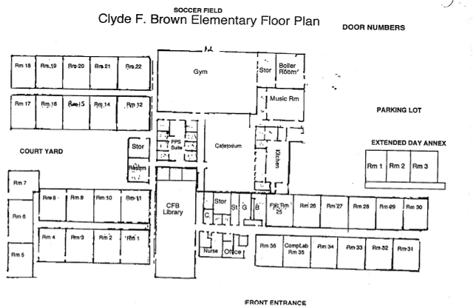

X

X X X X

X denotes location of dents floors
Picture 1

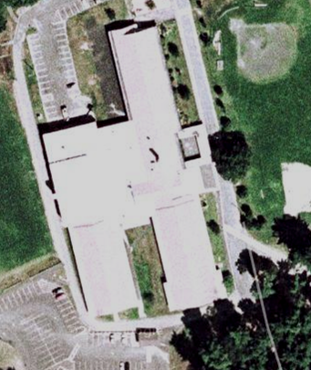
1950s
Wing

1991 Wing
West

1991
- Wing
Wing SE
SW

Picture 2

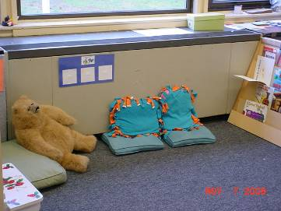

Obstructed Univent

Picture 3

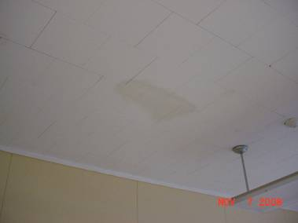

Exhaust Vent

Picture 4

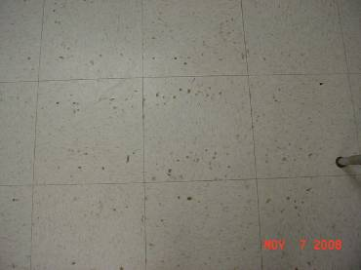

Discolored Indentation of Floor Tile

Picture 5

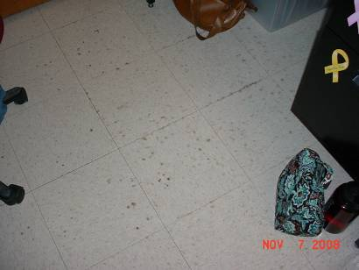

Discolored Indentation of Floor Tile

Picture 6

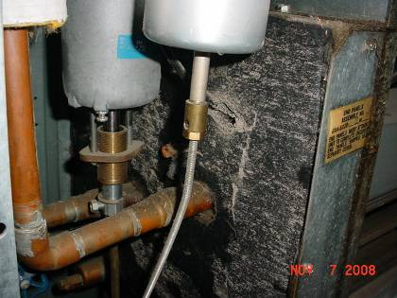

Spaces Exist Is the Univent Cabinet That Would Allow For Air to Bypass the Filter

Picture 7

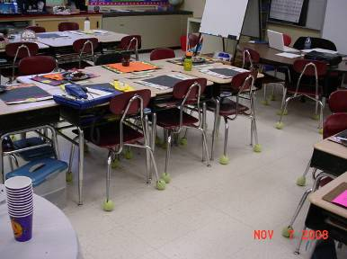

Tennis Balls on Classroom Chairs
Location/ Room | Occupants  in Room | Temp  (°F) | Relative  Humidity  (%) | Carbon  Dioxide  (ppm) | Carbon Monoxide  (ppm) | PM2.5  (µg/m³) | Windows  Openable | Ventilation |  | Remarks
 |  |  |  |  |  |  |  | Supply | Exhaust | Remarks
background |  | 62 | 77 | 378 | 0 | 15
Library | 3 | 73 | 59 | 549 | 0 | 8 | Y | Y | Y | Plants  Peeling paint DO
Cafetorium | 50+ | 73 | 47 | 961 | 0 | 9 | N | Y | Y
1 | 1 | 72 | 67 | 752 | 0 | 13 | Y | Y | Y | TB
2 | 24 | 73 | 65 | 762 | 0 | 14 | Y | Y | Y | TB  1 water damaged ceiling tile
3 | 19 | 74 | 66 | 740 | 0 | 13 | Y | Y | Y | TB
4 | 18 | 73 | 64 | 630 | 0 | 13 | Y | Y | Y | Supply blocked with table  Window open  TB
5 | 30 | 72 | 67 | 771 | 0 | 10 | Y | Y | Y | Restroom vent dusty  Supply blocked with shelf  DO
6 | 0 | 72 | 60 | 717 | 0 | 10 | Y | Y | Y | Supply blocked with shelf  DO
7 | 19 | 73 | 65 | 659 | 0 | 15 | Y | Y | Y | Outdoor door open  TB  4 water damaged ceiling tiles
8 | 1 | 74 | 64 | 620 | 0 | 10 | Y | Y | Y | TB DO  Floor tile indentations
9 | 20 | 74 | 64 | 710 | 0 | 20 | Y | Y | Y | Supply blocked with table  Floor tile indentations
10 | 19 | 74 | 65 | 866 | 0 | 14 | Y | Y | Y | Floor tile indentations  Window open
11 | 19 | 74 | 66 | 854 | 0 | 14 | Y | Y | Y | Floor tile indentations
12 | 2 | 74 | 63 | 731 | 0 | 10 | Y | Y | Y | Floor tile indentations  TB DO
15 | 0 | 75 | 60 | 737 | 0 | 9 | Y | Y | Y | TB
16 | 19 | 73 | 63 | 787 | 0 | 10 | Y | Y | Y | Window open  DO
17 | 21 | 73 | 66 | 840 | 0 | 8 | Y | Y | Y | Supply blocked with table  Plant  TB DO
18 | 20 | 74 | 68 | 1068 | 0 | 11 | Y | Y | Y
19 | 23 | 73 | 68 | 875 | 0 | 10 | Y | Y | Y | TB
20 | 18 | 75 | 66 | 928 | 0 | 12 | Y | Y | Y | Exhaust blocked by shelf  1 Water damaged ceiling tiles  TB
21 | 2 | 74 | 61 | 761 | 0 | 7 | Y | Y | Y | TB DO
22 | 0 | 74 | 61 | 646 | 0 | 10 | Y | Y | Y | Exhaust blocked with paper
25 | 10 | 77 | 58 | 596 | 0 | 8 | N | Y | Y | 8 water damaged ceiling tiles  Laminator  DO
26 | 0 | 75 | 58 | 540 | 0 | 8 | Y | Y | Y | TB DO
27 | 1 | 74 | 61 | 470 | 0 | 9 | Y | Y | Y | Window open  DO
28 | 1 | 72 | 63 | 465 | 0 | 11 | Y | Y | Y | Window open  DO
29 | 2 | 73 | 61 | 501 | 0 | 10 | Y | Y | Y | 6 water damaged ceiling tiles  DO
30 | 0 | 73 | 60 | 472 | 0 | 9 | Y | Y | Y | 2 water damged ceiling tiles  DO
31 | 0 | 73 | 63 | 628 | 0 | 14 | Y | Y | Y | Exhaust blocked by towel  Window open
32 | 0 | 73 | 63 | 536 | 0 | 12 | Y | Y | Y | 6 water damaged ceiling tiles  Window open
33 | 23 | 73 | 65 | 638 | 0 | 9 | Y | Y | Y | Window open  DO
34 | 23 | 76 | 62 | 663 | 0 | 9 | Y | Y | Y | Window open  DO
35 | 0 | 75 | 56 | 458 | 0 | 8 | Y | Y | Y | Window open  Laminator  26 computers
36 | 2 | 75 | 60 | 533 | 0 | 8 | Y | Y | Y | Window open  TB

