MassHealth
Billing Guide
for the CMS-1500
BG-CMS-1500 (Rev.02/21) | Executive Office of Health and Human Services  MassHealth  February 2021

Table of Contents

Introduction 1

General Instructions for Submitting Paper Claims 1
CMS-1500 Claim Form 1
Entering Information on the CMS-1500 Claim Form 2
Time Limitations on the Submission of Claims 2
Claims for Members with Medicare or Other Health Insurance Coverage 2
Provider Preventable Conditions 2
340B Drugs 2
Electronic Claims 3
Where to Send Paper Claim Forms 3
Further Assistance 3

How to Complete the CMS-1500 Claim Form 4

Appendix A: TPL Supplemental Instructions for Submitting Claims on the CMS-1500 for Members with Medicare Coverage 20

Appendix B: TPL Supplemental Instructions for Submitting Claims on the CMS-1500 for Members with Commercial Insurance 22

Introduction
This guide provides detailed instructions for completing the CMS-1500 claim form used in MassHealth billing (including Direct Data Entry on the POSC). Additional instructions on other billing matters, including member eligibility, prior authorization (PA), claim status and payment, claim correction, and billing for members with other health insurance, are located in Subchapter 5 of your MassHealth provider manual. You also can refer to Appendix A of your MassHealth provider manual which is available on the MassHealth website at www.mass.gov/masshealthpubs. Click on Provider Library, and then on MassHealth Provider Manual Appendices.
For information about the resulting remittance advice, see the MassHealth Guide to the Remittance Advice for Paper Claims and Electronic Equivalents.
Please note: Effective January 1, 2012, MassHealth adopted an all-electronic claims-submission policy for greater efficiency. You must now submit all claims electronically, unless you have received an approved electronic claim-submission waiver. You may submit ninety-day waiver requests and final deadline appeals either electronically via the Provider Online Service Center (POSC) or on paper.
Please see All Provider Bulletin 217 (dated September 2011) and All Provider Bulletin 223 (February 2012) for more information about MassHealth’s paper-claims waiver policy. For information on how to submit 90-day waiver requests and final deadline appeals electronically, please also see All Provider Bulletins 220 and 221 (both dated December 2011) and All Provider Bulletin 226 (June 2012). Helpful information is also available in All Provider Bulletins 232 and 233 (February 2013).

General Instructions for Submitting Paper Claims

CMS-1500 Claim Form
The following providers must use the CMS-1500 form when submitting paper claims to MassHealth.

- Abortion clinics
- Acute inpatient hospitals (for professional services provided by hospital-based physicians only)
- Acute, chronic, and psychiatric outpatient hospitals (for professional services provided by hospital-based physicians only)
- Adult day health providers
- Adult foster care providers
- Audiologists
- Chiropractors
- Community health centers (professional services only)
- Day habilitation providers
- Durable medical equipment providers
- Early intervention providers
- Family planning agencies
- Freestanding ambulatory surgery centers
- Group adult foster care providers
- Hearing instrument specialists
- Home-care corporations (elderly waiver)
- Hospital-licensed health centers (for professional services provided by hospital-based physicians only)
- Independent clinical laboratories
- Independent diagnostic testing facilities
- Independent living centers
- Independent nurses
- Independent nurse midwives
- Independent nurse practitioners
- Indian health centers
- Mental health centers
- Municipally based health service providers
- Ocularists
- Opticians
- Optometrists
- Optometry schools
- Orthotics providers
- Oxygen and respiratory therapy equipment providers
- Personal care agencies
- Personal care attendant (PCA) fiscal intermediaries

General Instructions for Submitting Paper Claims (cont.)

- Physicians
- Podiatrists
- Prosthetics providers
- Psychiatric day treatment providers
- Psychologists
- Qualified-Medicare-beneficiaries-only providers (QMB-only) submitting crossover claims
- Rehabilitation centers
- Renal dialysis centers
- Speech and hearing centers
- Sterilization clinics
- Substance-use disorder treatment programs
- Targeted case-management programs
- Therapists
- Transportation providers

Entering Information on the CMS-1500 Claim Form
- Complete a separate claim form for each member to whom you provided services.
- Type or print all applicable information (as stated in the instructions) on the claim form, using black ink only. Be sure all entries are complete, accurate, and legible.
- For each claim line, enter all required information as applicable, repeating if necessary. Do not use ditto marks or words such as “same as above.”
- Attach any necessary reports or required forms to the claim form.
- When a required entry is a date, enter the date in MMDDYY or MMDDYYYY format.
Example: For a member born on February 28, 1960, the entry would be 02281960.

Time Limitations on the Submission of Claims
MassHealth must receive claims within 90 days from the date of service or the date of the explanation of benefits from another insurer. For additional information about the deadlines for submitting claims, please see MassHealth billing regulations (beginning at 130 CMR 450.309).

Claims for Members with Medicare or Other Health-Insurance Coverage
You can find special instructions for submitting claims for services furnished to members with Medicare or health-insurance coverage in Subchapter 5 of your MassHealth provider manual.

Provider Preventable Conditions
See Appendix V of your provider manual for more information on how to bill for Provider Preventable Conditions (PPCs).

340B Drugs
The enactment of the Veterans Health Care Act of 1992 resulted in the 340B Drug Pricing Program, known as Section 340B of the Public Health Service Act. Through this program, providers who qualify as 340B-covered entities are able to acquire drugs at significantly discounted rates. Because of the discounted acquisition cost, these drugs are not eligible for the Medicaid Drug Rebate Program. Accordingly, state Medicaid programs must be able to distinguish between claims for 340B drugs and claims that are not for 340B drugs.
For providers to identify when they are submitting claims for physician-administered 340B drugs in an office or clinic setting, the National Medicaid Electronic Data Interchange HIPAA workgroup has recommended the use of the UD modifier. This will allow Medicaid programs to identify claims for 340B drugs and exclude them from the Medicaid drug rebate collection process.

General Instructions for Submitting Paper Claims (cont.)

MassHealth is implementing the recommended approach. Providers subject to this billing guide who participate in the 340B program must bill using the UD modifier on the CMS-1500, along with the applicable HCPCS code, when submitting claims for physician-administered 340B drugs in an office or clinic setting. Please note that NDC codes are also required on these claims. See Field 24 for instructions.

Electronic Claims
To submit electronic claims, refer to Subchapter 5, Part 3, of your MassHealth provider manual or contact the MassHealth Customer Service Center. Refer to Appendix A of your manual for contact information.

Please Note: Be sure to review this CMS-1500 billing guide, the appropriate companion guides, and our billing-tips flyers to determine the appropriate requirements for submitting electronic files to MassHealth. You can find these documents on the MassHealth website at mass.gov/masshealth.

Where to Send Paper Claim Forms
Appendix A of your MassHealth provider manual describes where to submit paper claims. Keep a copy of the submitted claim for your records. Please note that MassHealth does not accept mail with postage due.

Further Assistance
If, after reviewing the following instructions for completing the CMS-1500 claim form, you need additional assistance, you can contact the MassHealth Customer Service Center. Refer to Appendix A of your MassHealth provider manual for all MassHealth contact information.

How to Complete the CMS-1500 Claim Form
A sample CMS-1500 claim form is shown below. Following the sample are instructions for completing each field on the CMS-1500 claim form. You also may refer to the National Uniform Claim Committee (NUCC) instruction manual available at www.nucc.org. Many types of providers use the CMS-1500 claim form to bill MassHealth for services. In some cases, special instructions have been provided for specific services or situations. Complete each field as instructed in general and follow specific instructions for your provider type or situation, as applicable.
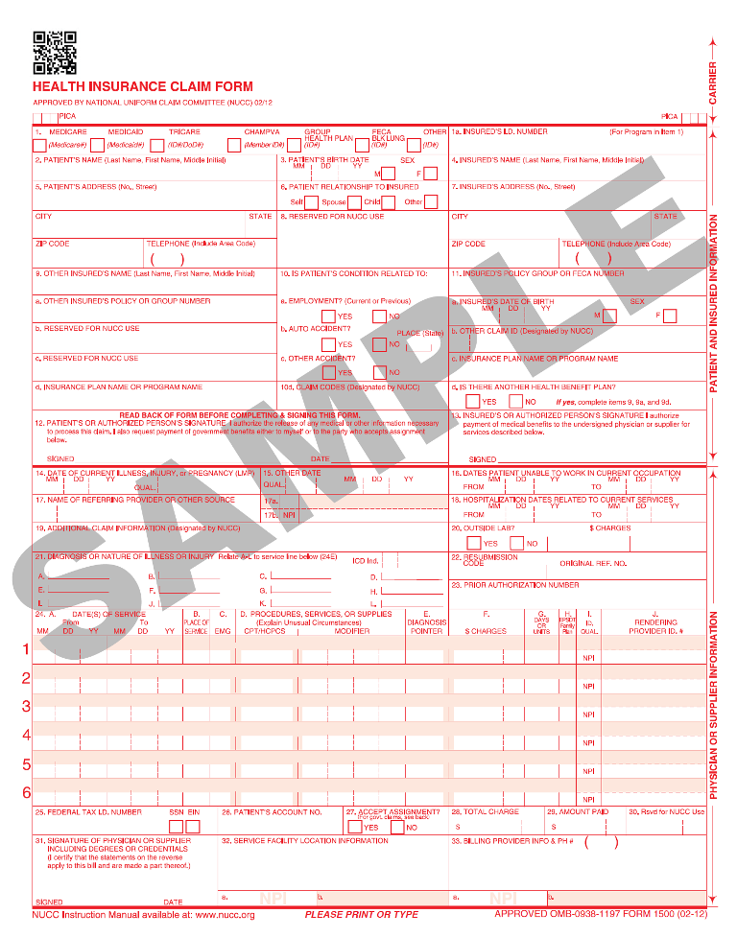
How to Complete the CMS-1500 Claim Form (cont.)
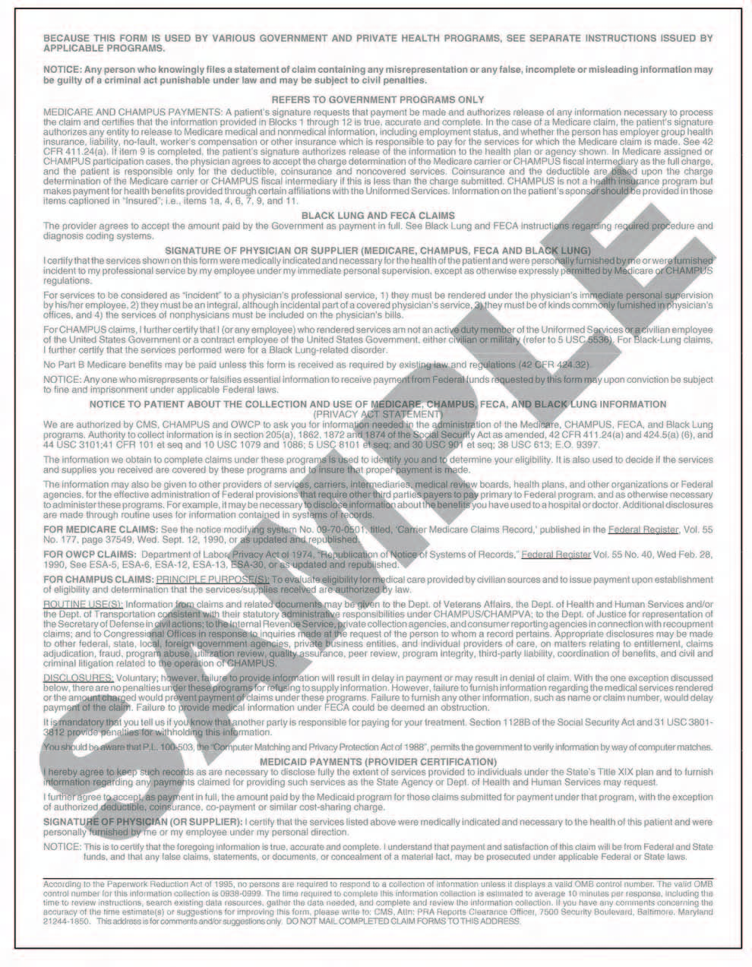
How to Complete the CMS-1500 Claim Form (cont.)
Field No. | Field Name | Description
1 | (Unnamed) | Indicate the type of health insurance coverage applicable to this claim by placing an X in the appropriate box. Only one box can be marked.
1a | Insured’s I.D. Number | Enter the complete 12-character member identification (ID) number that is printed on the MassHealth card.
2 | Patient's name | Enter the name of the MassHealth member receiving services in the following order: last name, first name, middle initial.
3 | Patient’s Birth Date  Sex | Enter the patient’s eight-digit birth date in MMDDYYYY format.  Enter an X in the correct box to indicate the gender of the patient. Only one box can be marked. If gender is unknown, leave this field blank.
4 | Insured’s Name | If the member has other insurance, enter the insured’s name in the following order: last name, first name, middle initial.
5 | Patient's Address | Required
6 | Patient Relationship to Insured | Enter an X in the correct box to indicate the patient’s relationship to the insured. Only one box can be marked.
7 | Insured’s Address | Not required
8 | Reserved for NUCC Use | Not required
9 | Other Insured’s Name | If Field 11d has an entry, complete Fields 9, 9a, and 9d, as applicable. When additional group health coverage exists, enter the name of the other insured in the following order: last name, first name, middle initial.
9a | Other Insured’s Policy or Group Number | Enter the policy or group number of the other insured, if applicable.
9b | Reserved for NUCC Use | Not required
9c | Reserved for NUCC Use | Not required
9d | Insurance Plan Name or Program Name | Enter the seven-digit, MassHealth third-party-liability carrier code. Refer to Appendix C of your MassHealth provider manual for carrier code values.
10a | Is Patient’s Condition Related to Employment? | Enter an X in the appropriate box to indicate whether the condition is employment-related.
10b | Auto Accident?  Place (State) | Enter an X in the appropriate box to indicate the type of accident.  If Yes is marked, also enter the state postal code where the accident occurred.

How to Complete the CMS-1500 Claim Form (cont.)
Field No. | Field Name | Description
10c | Other Accident? | Enter an X in the appropriate box to indicate if the condition is the result of any other type of accident.
10d | Claim Codes (Designated by NUCC) | Not required
11 | Insured’s Policy Group or FECA Number | If applicable, enter the insured’s policy or group number as it appears on the insured’s health-care identification card. If Field 4 is completed, then you must also complete Field 11.
11a | Insured’s Date of Birth  Sex | Enter the insured’s eight-digit birth date in MMDDYYYY format.  Enter an X in the correct box to indicate the gender of the patient. Only one box can be marked. If gender is unknown, leave this field blank.
11b | Other Claim ID (Designated by NUCC) | Not required
11c | Insurance Plan Name or Program Name | Enter the seven-digit MassHealth third-party-liability carrier code.  Refer to Appendix C of your MassHealth provider manual for carrier code values.
11d | Is There Another Health Benefit Plan? | Enter an X in the appropriate box to indicate whether there is another health benefit plan. If Yes, complete Fields 9, 9a, and 9d. Make an entry in only one box.
12 | Patient’s or Authorized Person’s Signature | Enter SOF, Signature on File.
13 | Insured’s or Authorized Person’s Signature | Not required
14 | Date of Current Illness, Injury, or Pregnancy (LMP) | Enter the start date of the present illness, injury, or condition in MMDDYYYY or MMDDYY format.  For pregnancy, use the date of the last menstrual period (LMP). Enter one of the following qualifiers to indicate which date you are reporting.  - 431: Onset of Current Symptoms of Illness  - 484: Last Menstrual Period

How to Complete the CMS-1500 Claim Form (cont.)
Field No. | Field Name | Description
15 | Other Date  Qual | Enter another date related to the patient’s condition or treatment in MMDDYYYY or MMDDYY format.  Enter one of the following qualifiers to identify which date you are reporting.  - 454: Initial Treatment  - 304: Latest visit or Consultation  - 453: Acute Manifestation of a Chronic Condition  - 439: Accident  - 455: Last X ray  - 471: Prescription  - 090: Report Start (Assumed Care Date)  - 091: Report End (Relinquished Care Date)  - 444: First Visit or Consultation  Enter the qualifier between the set of dotted vertical lines on the left.
16 | Dates Patient Unable to Work in Current Occupation | Not required
17 | Name of Referring Provider or Other Source | Enter the name and credentials of the professional who referred, ordered, or supervised the service(s) or supply(ies) on the claim in the following order: first name, middle initial, last name.  If multiple providers are involved, enter one provider using the following priority order.  - Referring Provider  - Ordering Provider  - Supervising Provider  Do not use periods or commas. You may use a hyphen for hyphenated names.  Enter one of the following qualifiers to identify which provider you are reporting.  - DN: Referring Provider  - DK: Ordering Provider  - DQ: Supervising Provider  Enter the qualifier to the left of the dotted, vertical line.
- The Referring, Ordering, and Supervising physician should be actively participating/enrolled with MassHealth at least as a non-billing provider
How to Complete the CMS-1500 Claim Form (cont.)
Field No. | Field Name | Description
17a | (Unnamed) | Enter the other ID number of the referring, ordering, or supervising provider in the shaded area of this field. In the box to the immediate right of “17a,” enter one of the following qualifiers to identify what other ID number is being reported.  - 0B: State License Number  - 1G: Provider UPIN Number  - G2: Provider Commercial Number (MassHealth Provider ID)  - LU: Location Number (for supervising provider only)
17b | NPI | Enter the NPI of the referring, ordering, or supervising provider. If the referring, ordering, or supervising provider does not have an NPI, this field is not required.  The ordering, referring, or supervising provider must be enrolled with MassHealth as a fully participating provider or as a nonbilling provider.

18 | Hospitalization Dates Related to Current Services | If the member has been hospitalized, enter the inpatient hospital admission start date and discharge date (if the patient has been discharged) in MM/DD/YYYY format.  If the patient has not been discharged, leave the discharge date blank.  Psychiatric Day Treatment Providers  Enter the date of the member’s discharge from the program.
19 | Additional Claim Information (Designated by NUCC) | Not required  Previously, this field was used to report information about durable medical equipment repairs. When submitting a claim for a repair that does not require prior authorization (PA), provide the following information in an attachment:  - name of the person who requested the repair;  - date of the request and a specific description of the equipment malfunction;  - list of procedures and parts used to complete the repair;  - cost of each procedure and part; and  - time required to complete the repair.
20 | Outside Lab  $ Charges | Not required

21 | Diagnosis or Nature of Illness or Injury  Relate A–L to service line below (24E) | Between the vertical, dotted lines labeled “ICD Ind.” in the upper right portion of the field, enter one of the following indicators to identify which version/s of ICD codes is/are being reported.  - 9: ICD-9-CM  - 0: ICD-10-CM  Relate lines A through L to the lines of service in Field 24E by line letter. Use the highest level of specificity.  Do not provide a narrative description in this field.

How to Complete the CMS-1500 Claim Form (cont.)
Field No. | Field Name | Description
22 | Resubmission Code  Original Ref. Number | When resubmitting a claim, enter one of the following bill frequency codes left-justified in the left-hand portion of this field.  - 7: Replacement of prior claim  - 8: Void/cancel of prior claim  In the field on the right, enter the 13-character internal control number (ICN) assigned to the paid claim. This ICN appears on the remittance advice the original claim was paid on. Please refer to Subchapter 5, Part 6, of your MassHealth provider manual for detailed billing instructions on claim status and corrections.
23 | Prior Authorization Number | Enter the prior-authorization (PA) number or referral number assigned by MassHealth, if applicable.
24 | (Unnamed Shaded Area ) | Note: Each of the six rows designated for Field 24 contains an upper shaded area and a lower unshaded area. Enter information in these areas as follows.  - Shaded/upper area: drugs; injectable devices; durable medical equipment; oxygen and respiratory therapy equipment; prosthetics and orthotics.  - Unshaded/lower area: date of current illness, injury, or pregnancy; place of service; emergency status; procedures, services, or supplies; diagnosis pointer; charges; days/units; etc.  Enter the following information in the shaded area of Lines 1-6 from the beginning of 24A to the end of 24G for up to 61 characters.  For Drugs or Injectable Devices Administered in the Office or a Clinic Setting  If billing for physician-administered drugs (including 340B drugs) or injectable devices administered in an office or clinic setting, except vaccines, enter the following information.  - Qualifier N4  - 11-digit national drug code (NDC)  - NDC unit of measure  - Quantity of the drug administered  This information is in addition to the Healthcare Common Procedure Coding System (HCPCS) code entered in the unshaded section on the same line. Use the following qualifiers when reporting NDC unit descriptors.  - F2: international unit (for example, anti-hemophilia factor)  - GR: gram (for creams, ointments, and bulk powders)  - ME: milligram (for creams, ointments, and bulk powders)  - ML: milliliter (for liquids, suspensions, solutions, and lotions)  - UN: unit (for tablets, capsules, suppositories, and powder-filled vials)

How to Complete the CMS-1500 Claim Form (cont.)
Field No. | Field Name | Description
24 | (Unnamed Shaded Area) cont. | For Compound Drugs  When billing for compound drugs, use the following qualifiers.  - VY: used to identify that a compound drug is being dispensed; and  - The compound drug association number (a three-digit compound drug association number indicates that the ingredients are part of the same compound drug). This number can be only three digits long, and the submitter must make sure that all ingredients of the compound prescription have the same compound drug association number.  List each drug ingredient that is part of the compound on a separate line with the VY qualifier and a compound drug association number segment. Make sure that all the individual ingredients that make up the compound have the same compound drug association number.  Examples  If billing for a drug administered in a doctor’s office other than a compound drug, enter the following in the shaded area (see below).  - Qualifier N4  - 11-digit national drug code (NDC)  - NDC unit of measure (use one of the following qualifiers when reporting NDC units—F2, GR, ME, ML or UN)  - Quantity of the drug administered, which includes fractions.  If billing for a compound drug administered in a doctor’s office, enter the following in the shaded area.  - Qualifier N4  - 11-digit national drug code (NDC)  - NDC unit of measure (use one of the following unit descriptors when reporting NDC units—F2, GR, ME, ML or UN)  - quantity of the drug administered, which includes fractions  - Reference identification qualifier—Value is VY  - Compound drug association number (a three-digit compound drug association number indicating that the ingredients are part of the same compound drug). This number can be only three digits in length, and the submitter must make sure that all ingredients of the compound prescription have the same compound drug association number.

How to Complete the CMS-1500 Claim Form (cont.)
Field No. | Field Name | Description
24 | (Unnamed Shaded Area) cont. | - Note: Please complete the shaded area for each ingredient that makes up the compound prescription. Use a separate line for each ingredient.  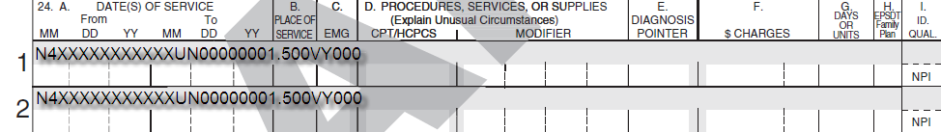  For Durable Medical Equipment, Oxygen and Respiratory Therapy Equipment, Prosthetics and Orthotics  When billing HCPCS service codes that do not require PA, and are payable on an individual consideration (I.C.) basis, enter in the shaded area the acquisition cost in addition to the quantity dispensed. Also, attach a copy of the supplier’s current invoice. Invoices submitted with a claim must be dated no more than 12 months before the date of service. Providers must submit the current invoice and identify on the invoice the item(s) being billed on the claim by circling the item on the invoice and the associated HCPCS service code being billed. Providers should refer to the MassHealth regulations, Subchapter 6 (Service Codes) of their MassHealth provider manual, and the MassHealth Payment and Coverage Guidelines Tool(s) for more information on payment and coverage criteria for service codes that are payable on an individual consideration (I.C.) basis.

How to Complete the CMS-1500 Claim Form (cont.)
Field No. | Field Name | Description
24A | Date(s) of Service  (for lower, unshaded area of form) | Enter the date the service was provided in MMDDYYYY format in the unshaded area.  For a Single Date of Service  In the “From” and “To” columns, enter the date the service was  provided, using the MMDDYYYY format.  For Consecutive Dates of Service  In the “From” column, enter the first date of service. In the  “To” column, enter the last date of service. Billing for consecutive dates of service on a single claim line is allowed only for certain services. For example, a physician may bill for hospital visits on successive days by entering the dates of service in the “From” and “To” boxes, but a physician may not bill for office visits on successive days on a single claim line.  Early Intervention Providers  For Assessments  Enter the date that the assessment was completed in the “From” column. In Field 24G, enter the total number of units spent on the assessment, regardless of the date.  For All Other Early Intervention Services  Follow the instructions given in the general description.  Durable Medical Equipment, Oxygen and Respiratory Therapy Equipment, and Pharmacy providers that have a DME and/or Oxygen specialty  For Monthly Rentals  Enter the last date of the monthly rental period in “From.” Leave “To” blank. Use a separate claim line for each monthly rental period.  For Substitute Rentals  Enter the date of service in “From.” Leave “To” blank. Use a separate claim line for each rental day.  For Purchases and Repairs  Enter the date when the service was furnished in “From.” Leave “To” blank.
24B | Place of Service | Enter the appropriate two-digit code from the place-of-service code list for each item used or service performed. The place-of-service codes are available at http://www.cms.gov/Medicare/Coding/place-of-service-codes/Place_of_Service_Code_Set.html.  Acute Outpatient Hospital billing for professional services where the service is provided by hospital-based physicians only  To help define the type of facility billing for medical services on a professional claim, please use the following place-of-service codes.  21 – Inpatient hospital  22 – Outpatient hospital  23 – Emergency room  99 – Hospital-licensed health center  Durable Medical Equipment, Oxygen and Respiratory Therapy Equipment, Orthotics and Prosthetic Providers  Providers should refer to the MassHealth Payment and Coverage Guideline Tool(s) for the place-of-service codes attached to the HCPCS.  12 – Home  14 - Group Home  31 – Skilled-nursing facility  32 – Nursing facility  33 – Custodial care
24C | EMG | If the service is the result of an emergency, enter Y or leave it blank.
24D | Procedures, Services, or Supplies  CPT/HCPCS  Modifier | Enter the CPT or HCPCS code(s) and modifier(s). This field accommodates up to four two-digit modifiers.  See Subchapter 6 of the applicable MassHealth provider manual for lists of payable or nonpayable service codes and modifiers and their descriptions.  Municipally Based Health Service Providers  Municipally based health service providers should refer to relevant municipally based health service provider bulletins to determine the correct service code.  Transportation Providers  Use modifier “TS” when billing for more than two one-way trips for the same member on the same date of service.  340B-Covered Entities: 340B-Covered Entities (e.g., community health centers, family planning clinics, group practices, and other providers participating in the 340B program).  Use modifier “UD” next to appropriate HCPCS code when billing for a 340B drug.

How to Complete the CMS-1500 Claim Form (cont.)
Field No. | Field Name | Description
24E | Diagnosis Pointer | If applicable, enter the diagnosis code reference letter (pointer) as shown in Field 21 to relate the date of service and the procedures performed to the primary diagnosis. (You must enter ICD-CM diagnosis codes only in Field 21. Do not enter them in Field 24E.)  When multiple services are performed, enter the primary reference for each service first, followed by other applicable services.  The reference number should be a letter A through L or multiple letters as explained in the previous sentence.  Enter letters left justified in the field. Do not use commas between the letters.
24F | $ Charges | Enter the provider’s usual and customary charge or fee (the lowest price that the provider charges or accepts from any payer for the same service, unless otherwise defined in the regulation applicable to the service being billed). Enter the amount right-justified in the dollar area of the field. Do not use commas or dollar signs when reporting dollar amounts. Do not enter negative dollar amounts. Enter “00” in the cents area if the amount is a whole number.  For Durable Medical Equipment, Oxygen and Respiratory Therapy Equipment, Prosthetics, and Orthotics  When billing for DME, oxygen/respiratory therapy equipment, orthotics, or prosthetics products that do not require PA and are listed in Subchapter 6 (Service Codes) of your MassHealth provider manual, and the MassHealth Payment and Coverage Guideline Tool(s), as not requiring individual consideration (IC), enter the provider’s usual and customary charge on the claim.  For Medications and Injectables  Enter the actual acquisition cost and attach a copy of the supplier’s invoice to the claim. Invoices submitted with a claim must be dated no more than 12 months before the date of service.  Personal Care Agencies  For Functional Skills Training  Enter the standard charge per member per month, regardless of the number of skills training sessions provided to the member in the month.  For Initial Evaluations and Reevaluations  Enter the provider’s usual and customary charge or fee.
How to Complete the CMS-1500 Claim Form (cont.)
Field No. | Field Name | Description
24G | Days or Units | Enter the appropriate number of units billed on the claim line for the service date.  For Consecutive Days of Service  Enter the total number of days or units within the billing period.  For Nonconsecutive Dates of Service  Enter “1” for each date of service or unit entered on the claim form.  For Anesthesia  Enter the total number of minutes that make up the beginning and ending clock time for the anesthesia service. One minute equals one unit. See 130 CMR 433.000 for regulations about reporting anesthesia time. If no units are entered, the service is paid at the base rate.
24H | EPSDT  Family Plan | Early and Periodic Screening, Diagnosis, and Treatment  Enter the response in the shaded portion of the field as follows. If there is no requirement (for example, state requirement) to report a reason code for EPSDT, enter “Y” for yes, or “N” for no.  If there is a requirement to report a reason code for EPDST, enter the appropriate reason code as noted below.  - AV: Available–Not Used (Patient refused referral.)  - S2: Under Treatment (Patient is currently under treatment for referred diagnostic or corrective health problem.)  - ST: New Service Requested (Made referral to another provider for diagnostic or corrective treatment/scheduled for another appointment with screening provider for diagnostic or corrective treatment for at least one health problem identified during an initial or periodic screening service, not including dental referrals.)  - NU: Not Used (No EPSDT patient referral was given.)  Family Planning  If the service is for family planning, enter “Y” for yes or “N” for no in the bottom unshaded area of the field.

How to Complete the CMS-1500 Claim Form (cont.)
Field No. | Field Name | Description
24I | ID Qualifier | In the shaded area of Field 24I, enter the appropriate qualifier if the number is a non-national provider identifier (NPI).  If the provider is an atypical provider and does not have an NPI, enter “G2.”  If the provider has an NPI and is providing taxonomy information, enter “PXC.”
24J | Rendering Provider ID # | If applicable, enter the rendering provider ID number. The Rendering provider should be actively participating/enrolled with MassHealth at least as a non-billing provider.  If applicable and if the shaded area of Field 24I is “PXC,” enter the provider taxonomy code in the shaded area of Field 24J. Enter the provider’s NPI in the unshaded area of Field 24J.  If applicable and if the shaded area of Field 24I is “G2,” enter your MassHealth provider ID in the shaded area of Field 24J.
25 | Federal Tax ID Number | Enter the service or supplier federal tax ID (employer identification number) or social security number for the provider.  Enter an X in the appropriate box to indicate which number is being reported. Only one box can be marked.
26 | Patient’s Account No. | Required. Enter the patient’s account number, if one is assigned. Enter the member’s last name if a patient account number is not assigned.
27 | Accept Assignment? Yes or No | For Non-Crossover Claims  Leave this field blank.  For Medicare Crossover Claims  Enter an X in the appropriate box to indicate whether the provider accepts assignment.
28 | Total Charge | Enter the total charges for the services (that is, the total of all charges in Field 24F). Enter the amount in the dollar area of the field.  Do not use commas or dollar signs when reporting dollar amounts. Do not enter negative dollar amounts. Enter “00” in the cents area if the amount is a whole number.  This is a required field.
29 | Amount Paid  $ | Enter the total amount the patient or other payers paid on only the covered services.  Do not use commas or dollar signs when reporting dollar amounts. Do not enter negative dollar amounts. Enter “00” in the cents area if the amount is a whole number.
30 | Reserved for NUCC Use | Not required

How to Complete the CMS-1500 Claim Form (cont.)
Field No. | Field Name | Description
31 | Signature of Physician or Supplier, Including Degrees or Credentials, Date | Enter the legal signature of the practitioner or supplier, signature of the practitioner or supplier representative, “Signature on File,” or “SOF.” Enter either a six-digit date (MM/DD/YY), eight-digit date (MM/DD/YYYY), or alphanumeric date (for example, January 10, 2016) when the form was signed.
32 | Service Facility Location Information | Enter the name, address, city, state, and zip code of the location where the services were provided. Providers of the service (physicians) must identify the supplier’s name, address, zip code, and NPI when billing for purchased diagnostic tests. When more than one supplier is used, use a separate CMS-1500 claim form for each supplier. Enter the name and address information in the following format.  - 1st line: name  - 2nd line: address (The billing provider address must be a street address. Do not use P.O. or lock boxes.)  - 3rd line: city, state, and zip code  Do not use commas, periods, or other punctuation in the address (for example, enter 123 N Main Street 101 instead of 123 N. Main Street, #101). Enter a space between town name and state code; do not include a comma. When entering a nine-digit zip code, include a hyphen.  Do not use P.O. or lock boxes.
32a | NPI | Enter the NPI of the service facility location in Field 32a.
32b | Other ID No. | Enter the appropriate two- or three-character qualifier.  If the provider is an atypical provider and does not have an NPI, enter “G2” followed by the provider’s 10-character MassHealth provider ID.  If the provider has an NPI and is providing taxonomy information, enter “PXC” followed by the taxonomy code.

Field No. | Field Name | Description
33 | Billing Provider Info & Phone # | Enter the billing provider’s or supplier’s name, doing-business-as (DBA) address, zip code, and phone number. Enter the phone number in the area to the right of the field title.  Enter the name and address information in the following format:  - 1st line—name  - 2nd line—address (The billing provider address must be a street address. Do not use P.O. or lock boxes.)  - 3rd line—city, state, and zip code  Field 33 identifies the provider that is requesting to be paid for the services rendered, and should always be completed.  Do not use commas, periods, or other punctuation in the address (for example, enter 123 N Main Street 101 instead of 123 N. Main Street, #101). Enter a space between town name and state code; do not insert a comma.  When entering a nine-digit zip code, include a hyphen. Do not use a hyphen or space as a separator within the telephone number.
33a | NPI | Enter the NPI of the billing provider.
33b | Other ID No. | Enter the appropriate two- or three-character qualifier.  If the provider is an atypical provider and does not have an NPI, enter “G2” followed by the provider’s 10-character MassHealth provider ID.  If the provider has an NPI and is providing taxonomy information, enter “PXC” followed by the taxonomy code.

Appendix A: TPL Supplemental Instructions for Submitting Claims on the CMS-1500 for Members with Medicare Coverage

Please note: On January 1, 2012, MassHealth adopted an all-electronic claims submission policy. You must now submit all claims electronically, unless you have received an approved electronic claim-submission waiver. You may submit 90-day waiver requests and final deadline appeals either electronically via the POSC or on paper.
Please see All Provider Bulletin 217 (September 2011) and All Provider Bulletin 223 (February 2012) for more information about MassHealth’s paper claims waiver policy. For information on how to submit 90-day waiver requests and final deadline appeals electronically, please also see All Provider Bulletins 220 and 221 (December 2011) and All Provider Bulletin 226 (June 2012). Helpful information is also contained in All Provider Bulletins 232 and 233 (February 2013).
Important: The table below lists specific fields on the CMS-1500 form that you must complete for claims when the member has Medicare in addition to MassHealth.

Field # | Field Name | TPL Required Information
1 | Unnamed | Check box marked “Medicare.”
4 | Insured’s Name | Enter insured’s name (subscriber and insured’s name may be different from the MassHealth member’s name)
6 | Patient Relationship to Insured | Check the correct box to indicate the patient’s relationship to the insured. Only one box can be marked.
9 | Other Insured’s Name | If 11d is checked “yes,” enter the name of the insured if different from patient name.
9a | Other Insured’s Policy or Group Number | If 11d is checked “yes,” enter the group or policy number for the commercial insurance plan.
9d | Insurance Plan Name or Program Name | When 11d is checked “yes,” enter the appropriate MassHealth carrier code. The Third-Party Liability MassHealth Carrier Code list can be found in Appendix C of your MassHealth provider manual.
11 | Insured’s Policy Group or FECA Number | Enter the policy or group number of the primary commercial insurance resource as it appears on the member’s insurance card.
11a | Insured’s Date of Birth, Sex | Enter insured’s date of birth.

Field # | Field Name |  |  | TPL Required Information
11c |  | Insurance Plan or Program Name | Enter the appropriate MassHealth carrier code. You can find the Third-Party Liability MassHealth Carrier Code list in Appendix C of your MassHealth provider manual.
11d |  | Is There Another Health Benefit Plan? | Check the box indicating whether the patient has insurance in addition to MassHealth and Medicare. If this box is checked “yes,” complete Fields 9, 9a, and 9d with information applicable to the other commercial health plan.
27 |  | Accept Assignment? Yes or No | Check the appropriate box to indicate whether the provider accepts assignment.
29 |  | Amount Paid | Enter the total amount paid by all insurers other than MassHealth.

Instructions for Submitting Claims with Explanation of Medicare Benefits (EOMB)

- Complete the CMS-1500 claim form according to this MassHealth Billing Guide for the CMS-1500.
- Attach to the claim form the original, or a copy, of the other insurance carrier’s EOMB and completed TPL Claim Submission Form.
  - The dates of service, provider name, and patient's name on the EOMB must correspond to the information on the MassHealth claim.
  - If more than one member is listed on the EOMB, circle the member information on the EOMB that corresponds to the member on the MassHealth claim.
  - If you are submitting claims with one or more EOMB attachments, you must write the appropriate MassHealth assigned carrier code on each EOMB.
Please note: You can find MassHealth-assigned carrier codes in Appendix C: Third-Party-Liability Codes of your MassHealth provider manual or at www.mass.gov/masshealth. Go to Provider Library, and then to MassHealth Provider Manuals.

Appendix B: TPL Supplemental Instructions for Submitting Claims on the CMS-1500 for Members with Commercial Insurance
Please note: In January 2012, MassHealth adopted an all-electronic claims submission policy. You must now submit all claims electronically, unless you have received an approved electronic claim submission waiver. You may submit 90-day waiver requests and final deadline appeals either electronically via the POSC or on paper.
Please see All Provider Bulletin 217 (published in September 2011) and All Provider Bulletin 223 (February 2012) for more information about MassHealth’s paper claims waiver policy. For information on how to submit 90-day waiver requests and final deadline appeals electronically, please also see All Provider Bulletins 220 and 221 (December 2011) and All Provider Bulletin 226 (June 2012). Helpful information is also contained in All Provider Bulletins 232 and 233 (February 2013).

Important: The table below lists specific fields on the CMS-1500 form that you must complete for all MassHealth claims where the member has commercial insurance as well as MassHealth. In addition to completing all applicable fields, you must submit all claims for members with commercial insurance with the appropriate explanation of benefits (EOB) or other necessary TPL documentation. Providers must ensure that the appropriate carrier code is clearly written on the EOB.

Field # | Field Name | TPL Required Information
1 | Unnamed | Check box marked “Medicaid.”
1a | Insured’s ID Number | Enter the 12-digit MassHealth member ID.
4 | Insured’s Name | Enter insured’s name (subscriber and insured’s name may be different from the MassHealth member’s name)
6 | Patient Relationship to Insured | Check the correct box to indicate the patient’s relationship to the insured. Only one box can be marked.
9 | Other Insured’s Name | If 11d is checked “yes,” enter the name of the insured if different from patient name.
9a | Other Insured’s Policy or Group Number | If 11d is checked “yes,” enter the group or policy number for the commercial insurance plan.
9d | Insurance Plan Name or Program Name | When 11d is checked “yes,” enter the appropriate MassHealth carrier code. You can find the Third-Party Liability MassHealth Carrier Code list in Appendix C of your MassHealth provider manual.
11 | Insured’s Policy Group or FECA Number | Enter the policy or group number of the primary commercial insurance resource as it appears on the member’s insurance card.
11a | Insured’s Date of Birth, Sex | Enter insured’s date of birth.

Field # | Field Name | TPL Required Information
11c | Insurance Plan or Program Name | Enter the appropriate MassHealth carrier code. You can find the Third-Party Liability MassHealth Carrier Code list in Appendix C of your MassHealth provider manual.
11d | Is There Another Health Benefit Plan? | Check the box indicating whether the patient has insurance in addition to MassHealth and the commercial insurance identified in Fields 11-11c. If this box is checked “yes,” complete Fields 9, 9a, and 9d with information applicable to the other commercial health plan.
29 | Amount Paid | Enter the total amount paid by all insurers other than MassHealth.

Instructions for Submitting Claims with Explanation of Benefits (EOB)

- Complete the CMS-1500 claim form according to this MassHealth Billing Guide publication.
- Attach the original or a copy of the other insurance carrier’s EOB and completed TPL Claim Submission Form to the claim form.
- The dates of service, provider name, and patient’s name on the EOB must correspond to the information on the MassHealth claim.
- If more than one member is listed on the EOB, circle the member information on the EOB that corresponds to the member on the MassHealth claim.
- If you are submitting claims with one or more EOB attachments, you must write the appropriate MassHealth-assigned carrier code on each EOB.

Please note: You may find MassHealth-assigned carrier codes in Appendix C: Third-Party-Liability Codes of your MassHealth provider manual or at www.mass.gov/masshealth. Go to MassHealth Regulations, and then to the Provider Library.

