Do you know the importance of observation?
One of the most powerful skills you will need to use in EI is your ability to observe a child in the context of his/her family at home and in other “natural environments.” Observations are what you see and hear while you are with the child and family and do not include your opinions or perceptions.
Observation is also one of the critical practices of relationship-based caregiver coaching. There are three types of observations:
- Observation of the environment
- Observation of the caregiver and child by the EI Specialist
- Observation of the EI Specialist and the child by the caregiver
In all types of observations, information is being gathered to help support the caregiver-child interaction (dyad) and to support the child’s development and learning.

How is observation related to functional assessment?
Along with asking questions and active listening, observation is vital to ongoing functional assessment. Observing the child and caregiver during naturally occurring activities and routines enables you, as the EI Specialist, to learn about the specific, individualized components (i.e., micro- routines) of these activities for this family (e.g., snack time, dressing). You also can observe the child’s skills, level of participation, as well as their strengths, and needs. Additionally, observation gives you opportunities to see how the caregiver and child interact with each other, what strategies the caregiver is already using to support the child’s participation, and how the caregiver implements newly learned strategies. When a family shares their observations, you gain a more accurate picture
of the child. It’s important to let families know that you value their observations and participation in ongoing authentic/functional assessment. Taking time to observe and ask questions about what caregivers observe and think gives caregivers an opportunity to pause, process, and reflect on what might be happening, or think about something different they may feel comfortable trying.
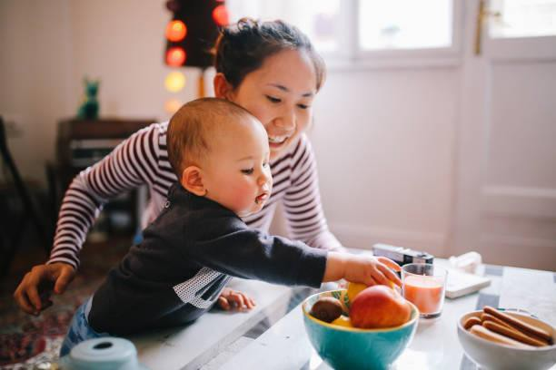

How is observation related to PIWI?
PIWI promotes that the role of the EI Specialist is to partner with caregivers. You are a resource to caregivers in supporting their interactions with their child. Through observation, you can identify strengths and opportunities during everyday activities to reinforce and promote the caregiver and child’s competence, confidence, and mutual enjoyment. You can observe the strengths of the dyad (caregiver-child) and identify which dyadic characteristics and strategies the caregiver is already using when interacting with their child.
These observations will help you decide which triadic strategies can be used to facilitate stronger caregiver-child interactions and potentially a better match within the dyad, thereby helping to ensure caregivers and children achieve their IFSP outcomes. For example, focusing attention allows caregivers to observe their child’s skills. By observing the environment, you may need to establish the dyadic context by arranging or

Beyond Bubbles and Blocks
Information for EI Home Visitors

Massachusetts Department of Public Health, Early Intervention Division November 2022

rearranging elements of the environment, such as caregiver-child positioning.

Having the caregiver observe you as you momentarily model a strategy can help the caregiver learn how to implement a new strategy, especially when paired with explicit instruction and the rationale of “why” the strategy is being used.
Modeling in this way gives caregivers an opportunity to: practice the strategy they’ve just observed during the visit with your guidance and support, gain competence and confidence, and then be able to use the newly learned strategy in between visits during their everyday activities and routines (i.e., when most of the child’s learning actually takes place).

In sum, observation is an important part of what you do in EI. There are different types of observations, and all have value. Observation is an integral part of ongoing functional assessment and PIWI. Sharing observations with caregivers and having them share observations with you fosters family engagement and helps to build a partnership. Observation promotes the Massachusetts Core Values and Key Principles.

Reflect on your use of observation
- Are you taking the time during your visits to observe?
- Are you intentional in your observations?
- What are you observing and why?
- Are you observing just what you see and hear or do your observations include your opinions and perceptions?
- Are you aware of your own biases?
- How can observations help you understand the family, along with their everyday activities/routines?
- How can these observations help you to better support and strengthen caregiver- child interactions?
- How can these observations help the caregiver to support their child’s development and learning?
- If the caregiver is observing you briefly model a strategy, are you letting them know what to look for and why… and then are you giving them a chance to practice so you can observe them and give them support and feedback?

References
- Childress, D. C. (2021). Pause and reflect. Your guide to a deeper understanding of early intervention practice. Paul H. Brookes Publishing Co.
- MA DPH Early Intervention (2015). Massachusetts Early Intervention System.
- Rush, D. D., & Shelden, M. L. (2020). The early childhood coaching handbook (2nd ed.). Paul H. Brookes Publishing Co.
- Yates, T. & McCollum, J. PIWI: Parents interacting with infants and toddlers. Center on the Social and Emotional Foundations for Early Learning. https://pyramidmodel.org

Massachusetts Department of Public Health, Early Intervention Division November 2022

