

COMMONWEALTH OF MASSACHUSETTS

RESPONSE SUBMITTED FOR THE
REQUEST FOR RESPONSE (RFR)

RFR NUMBER: PRF56DESIGNATEDOSC

TITLE: AUDIT, ACCOUNTING, COMPLIANCE, SECURITY AND REVENUE RECOVERY SERVICES

Sub-Category: Information Management, Security and Compliance Audits Including Payment Card Industry (PCI) Compliance

BIDDER NAME: Coalfire Systems, Inc.
INSTRUCTIONS:
- The Written RFR Response must be submitted using this “RFR Response Template” so that all Responses appear uniform and consistent for selection purposes and to enable posting on Comm-PASS once selection is completed.
- This WORD document must be used and may not be altered, reformatted or changed in any way or the Response will be subject to rejection. This document must be saved in a WORD format and not in .pdf so that the document may be modified during negotiations if necessary. Bidders may not save this document as a .pdf format. A .pdf format will subject the Response to rejection. Attachments allowable as .pdf submissions will be specifically noted.
- Bidders must enter, or copy and paste information into the spaces provided for each question. The space will expand to accommodate the data entered. The Bidder may open the “footer” and add the Bidder’s Name to print on each page of the Response.
- Bidders may not refer to outside attachments for key information related to answering the questions unless the Attachment is one of the Required Attachments for the RFR Response or is an attachment that must be completed as specified under the “Forms and Terms” tab for this RFR on Comm-PASS. This form will expand to accommodate the addition of response information.
- Each item must be addressed specifically by entering information in the required ANSWER space. If an item is inapplicable, the Response must indicate "N/A" or “Not applicable” or other appropriate explanation.
- The questions presented are the best guess of what information is needed to evaluate Bidders and are not exhaustive. Bidders should be as comprehensive in responding as possible and include all relevant information and considerations to assist in the review of a Response and demonstrate the full capabilities of the Bidder.
- Bidders are responsible for reviewing the “Forms & Terms” tab under this RFR in Comm-PASS for all the listed specifications and the required Forms that must be submitted with the RFR Response (in order to be considered for selection) or upon contract award and execution. Failure to submit the required Forms with the RFR Response, as specified, will be considered sufficient grounds for rejection of the Bidders Response.

Submission of Responses
Bids will be submitted solely through the www.comm-pass SMARTBID process required for Statewide Contracts as outlined in the RFR.

Deadline for Submission
Submit Responses through SMARTBID by Submission Deadline Date listed in the RFR.

RFR RESPONSE PART A

BIDDER AUTHORIZED CONTACT, INTRODUCTION AND CERTIFICATIONS

A-1. Authorized Representative and RFR Contact. Please complete the information below for the Individual who is an Authorized Representative of the Bidder, who can legally bind the Bidder during the RFR Interview and subsequent negotiations, and who shall serve as the RFR Contact for any questions or communication necessary during the procurement. The Bidder must identify its Legal Name as used for filing Tax Returns to the Internal Revenue Service (IRS) and its Federal Employer Identification Number (FEIN).
Bidder Legal Name: Coalfire Systems, Inc.
D/B/A (if operating under this name): Digital Resources Group (DRG)
Legal Address (for Tax Return Purposes): 361 Centennial Parkway, Suite 150; Louisville CO 80027
FEIN: 84-1600418
Commonwealth of Massachusetts Vendor Code: VC: 0000390523 (existing DRG/Coalfire VC)
Authorized Representative/RFR Contact Name: Alan Ferguson
Title: Executive Vice President
Telephone: 877.224.8077 ext. 7002
Cell: 720.939.5166
TTY/TTD:
Email Address: alan.ferguson@coalfire.com
Fax: 303.554.7555
A-2. INTRODUCTION: In the space below notes ad “BIDDER’s INTRODUCTION”, please provide a brief introduction (not to exceed 3 pages in length) that demonstrates the Bidder's qualifications and experience to perform the work requested. Identify which of the categories the Bidder will be bidding on and include a description of the firm philosophy in providing each of the categories that the Bidder is submitting a Response.

A-2. ANSWER:

Bidders will be selected in three major categories. Identify with an “X” which of the RFR Categories are being submitted under this RFR
Coalfire Systems, Inc. is authorized to provide PCI Approved Quality Security Assessors (QSA); PCI Council Approved Scanning Vendors (ASV) scanning services; and Non-PCI audit, internal control, security and compliance audits and reviews for general information management and security compliance.

X . PCI Security Standards Council Approved Quality Security Assessors (QSAs) and related QSA Consulting Services. Only Approved QSAs may perform PCI Compliance validation.
X . PCI Security Standards Council Approved Scanning Vendors (ASVs) and other Scanning and Compliance and Vulnerability Testing and Security Compliance Scans and Testing. ASVs may also be deemed qualified to provide scanning and other testing and compliance services for non-PCI related compliance audits and reviews.
X . Other Non-PCI related audit, internal control, security and compliance audits and reviews for general information management, security compliance. Full range of audit, compliance reviews and related consulting services for non-PCI related compliance services for Executive Order 504 compliance validation, physical and electronic security of records, PII and confidential information, E-discovery, data breach investigations and remediation, compliance with ITD Enterprise Data Security and other enterprise or Eligible Entity data security policies, G.L. c. 93H and c. 93I and other state and federal data security statutes, and other audits and compliance reviews related to data management systems, and security of Personally Identifiable Information (PII) and other types of confidential and sensitive information. QSAs may bid under this category to provide non- PCI related audit, compliance review and consulting services for non-PCI related compliance audits and reviews.
Bidders will be separately reviewed and ranked in each of the categories in which they bid, and Bidders may bid on any or all of the categories. Bidders will be ranked separately under each category and may or may not be selected to provide more than one category of services, even if a Response has been submitted for more than one category.

ENTER BIDDER’S INTRODUCTION HERE:
Coalfire has been independently ranked as the nation’s largest specialty GRC (Governance, Risk, and Compliance) firm. As a vendor neutral and platform agnostic firm, we do not sell or resell products to remediate gaps discovered during an assessment; allaying the common concern that the assessment is merely a tool to drive additional revenue and advice is slanted to specific remediation consulting services and products.

Headquartered in Louisville CO, with offices in Boston, Dallas, Denver, Los Angeles, New York, San Francisco, Seattle, New York and Washington DC, Coalfire also maintains test labs in Colorado and Washington state and has an industry recognized forensics division, Coalfire Labs.

Coalfire has completed over 5,000 IT audits in the public and private sector in the United States, Canada, the Caribbean, Europe and Asia.

Project Continuity:
As a result of the Coalfire acquisition of Digital Resources Group (DRG) in May 2012, Commonwealth will continue to be well served and supported by the same known team members. Jim Cowing, former DRG CEO and current Coalfire Managing Director, will remain as executive sponsor and advocate for the Commonwealth, Anjna Mehta-Singh, former DRG VP and now Coalfire Director will continue to support the Agencies as Director of Navis PCI Services (SAQ and Scan), Donald Creary, former DRG VP of Service Delivery and current Coalfire Director will continue contributing as a Senior PCI QSA. This team has developed significant experience working with over 25 merchants within the Commonwealth of Massachusetts over the past five (5) years. Their knowledge of many Commonwealth entities, including MassDOT and Registry of Motor Vehicles (RMV), HealthCare Finance (HCF), Information Technology Division (ITD), Executive Office of Labor and Workforce Development (EOLWD), and MBTA provides substantial continuity of service, and in-depth management experience and knowledge transfer.

Services:
Regulatory Compliance Assessments for:
  - The Gramm-Leach-Bliley Act (GLBA) for financial services
  - The Health Insurance Portability and Accountability Act (HIPAA) and the Health Information Technology for Economic and Clinical Health (HITECH) Act for healthcare
  - The Federal Information Systems Management Act (FISMA) for certain federal systems and their business partners
  - The Sarbanes-Oxley Act (SOX) for evaluation of IT controls over financial reporting required by Section 404
The Payment Card Industry Data Security Standard (PCI DSS) - As an assessor authorized by the PCI Security Standards Council, Coalfire offers comprehensive PCI DSS services for merchants, service providers, merchant banks, and application developers worldwide.
General IT Security and Risk Assessments - In accordance with industry best practices for risk management and IT governance (NIST SP-800 Series, COBIT, FFIEC, etc.).
SSAE 16 Audit Support - In conjunction with leading accounting firms, Coalfire provides controls evaluation and testing services to give evidence of the effectiveness of the design and operation of general and application level controls for service organizations. The SSAE 16 standard replaced the SAS 70 report effective June 2011 and provides a more comprehensive approach to controls reporting.
North American Electric Reliability Corporation (NERC)
  - Critical Infrastructure Protection (CIP)
Incident Response and Computer Forensics - For known or suspected compromise of sensitive data, including personally identifiable information (PII), payment card data, intellectual property and others.
Information Security Business Case and Security Program Development

Related Skills:
- Vulnerability Assessments
- Penetration Testing
- Application Security Assessments
- Application Security Code Review
- Business Continuity Planning
- IT Security Awareness Training
- Policy Development and Gap Closure

Qualifications/Certifications:
With a staff of 160 and growing, Coalfire has been independently ranked as the nation’s largest specialty GRC (Governance, Risk, and Compliance) firm. Our professional staff has grown to 90+ experienced IT security auditors, consultants and engineers with the following credentials, including:

- Certified Information Security Assessor (CISA)
- Certified Information Systems Security Professional (CISSP)
- Associate Business Continuity Planner (ABCP)
- Cisco Certified Networking Associate (CCNA)
- Certified Cisco Network Associate (CCNA®)
- Certified Disaster Recovery Planner (CDRP)
- Certified in the Governance of Enterprise IT® (CGEIT®)
- Certified HIPAA Security Professional (CHSP)
- Certified Information Security Manager (CISM)
- Certified Information Technology Professional (CITP)
- Certified Internal Auditor® (CIA®)
- Certified in Risk and Information Systems Control (CRISC)
- Certified TR-39 Auditor (CTGA)
- Check Point Certified Security Administrator (CCSA)
- Check Point Certified Security Expert (CCSE)
- Certified Novell Administrator (CNA)
- CompTIA i-Net+, CompTIA A+
- Federal IT Security Professional – Manager (FITSP-M)
- FedRAMP℠ Third Party Assessment Organization (3PAO)
- GIAC Certified Incident Handler (GCIH)
- GIAC Penetration Tester (GPEN)
- HITRUST Practitioner / HITRUST Assessor
- Internet Security Systems Certified Engineer (ICE)
- Microsoft Certified Professional (MCP)
- Microsoft Certified Systems Engineer (MCSE)
- National Security Agency - INFOSEC Assessment Methodology (NSA IAM)
- PGP Certified Technician (PCT)
- PCI End-to-End Encryption Qualified Assessor (QSA/ P2PE)
- PCI Qualified Security Assessor (QSA)
- PCI Payment Application Qualified Security Assessor (PA-QSA)
- PCI Approved Scanning Vendor (ASV)
- ISO 27001 Certified Lead Auditor
- RedHat Certified Engineer (RHCE)

In addition a number of staff have Top Secret/SCI Clearance and are DoD Information Technology Security Certification and Accreditation Process (DITSCAP) Certified and Accredited.

A-3. CERTIFICATION OF ACCEPTANCE OF COMMONWEALTH TERMS.
The order of precedence of this Statewide Contract is as follows:

- Commonwealth Terms and Conditions
- Standard Contract Form
- Request for Response PRF56DesignatedOSC (as amended)
- This Contractor’s Response, as amended during negotiations
- Any other non-conflicting provisions, terms or materials incorporated herein by reference by the Contractor

It is expected that any legal review of the required contract forms and attachments will be done PRIOR to submission of the RFR Response and that objections to any language in the RFR or attachments will not be raised after selection and during contract negotiations. This means that the Bidder cannot condition execution upon the “opportunity to negotiate final terms” after selection.

Therefore, if the Bidder has any questions related to the interpretation of any language in the required forms or Attachments, these questions must be identified as part of the “On-line Forum” for this RFR during the question and answer period prior to submission, and questions or objections may not be raised at a later date.

Any issues or concerns with the language in the Contract Forms or Attachments, or proposed additions or clarifications to this language MUST BE IDENTIFIED IN DETAIL BELOW as part of the Response, which will be evaluated as part of the selection process, and may not be raised after selection.

Bidders are not authorized to condition execution of a contract with the Commonwealth upon the Commonwealth’s execution of a Bidder contract form, or required use of Bidder Terms and Conditions. Any additional terms and conditions that the Bidder seeks to apply to this Contract MUST BE SPECIFIED IN DETAIL BELOW with a full explanation for consideration as part of the selection process. The Commonwealth shall consider any reasonable “clarification” of terms that defines or outlines the parties’ responsibilities, but does not delete or materially change the Commonwealth terms. Selection for final negotiation of a Contract shall not be interpreted as the Commonwealth’s acceptance of any terms, conditions or recommended clarifications identified in this section and shall be subject to the Commonwealth’s acceptance as part of negotiations. The Commonwealth reserves the right to redact any submitted terms.

The listing of numerous conditions, demands for negotiation of terms, conditioning performance on the Commonwealth’s acceptance of Bidder terms or a demonstration of an unwillingness to operate under the Commonwealth’s boilerplates and terms shall be a significant consideration as part of Qualifications for this Statewide Contract and grounds for rejection of the Bidder’s Response or a significant reduction in points.

A-3. ANSWER:
All approved Additional Terms and Conditions have been negotiated and included as part of the Contract User Guide specifications for this Statewide Contract Posted on www.comm-pass.com under the Forms and Terms page for PRF56DesignatedOSC.

Coalfire accepts the Commonwealth’s terms and conditions. We would request that the following clauses be added given the nature of the services contemplated related to the PCI DSS.

Except as identified to Coalfire, the Commonwealth represents that it is unaware of any on-going or previous compromise, or indications of a potential compromise involving systems it owns or manages resulting in unauthorized access to payment card data.

The Commonwealth acknowledges and agrees that: (i) any outcome of the services involving compliance assessment is limited to a point-in-time examination of the Commonwealth’s compliance or non-compliance status with the applicable standards or industry best practices set forth in the Scope of Work and that the outcome of any audits, assessments or testing by, and the opinions, advice, recommendations and/or certification by Coalfire does not constitute any form of representation, warranty or guarantee that the Commonwealth’s systems are 100% secure from every form of attack, and (ii) in assisting in the examination of the Commonwealth’s compliance or non-compliance status, Coalfire relies upon accurate, authentic and complete information provided by the Commonwealth as well as use of certain sampling techniques.

The parties hereto recognize that changes to the Payment Card Industry Data Security Standard (PCI DSS) implemented subsequent to the date of this Job Order may affect testing and reporting activities required for the services described herein. The parties agree, therefore, that such changes, if implemented by the PCI Security Standards Council (PCI SSC), will be jointly reviewed by the parties and adjustments will be made, as mutually agreed to by the parties, to the activities and associated fixed-fee budget(s) described in this Job Order to support those changes in accordance with PCI SSC requirements. Moreover, all parties hereto agree that Coalfire will have no liability for actions by Visa U.S.A., PCI or PCI’s member organizations, their employees, officers, consultants, subcontractors or affiliates with respect to the Commonwealth’s Confidential Information contained in the any formal compliance attestation report subject to standards published by the PCI SSC (including, but not limited to, Report on Compliance, Report on Validation, ASV Vulnerability Scan Report, and other developed materials).

Commonwealth acknowledges and agrees that Coalfire is required to, and may, comply with the record retention policies of PCI DSS, including without limitation securing and maintaining digital and/or hard copies of case logs, audit results and work papers, notes, and any technical information that was created and/or obtained during the PCI DSS assessment for a minimum of three (3) years, or such longer period of time required to satisfy any applicable legal or regulatory requirements. All such information shall be held confidential in accordance with this Agreement. For the purposes of this section, the terms “Assessment” and “Requesting Organization” have the meaning ascribed to those terms in Appendix A of the PCI Security Standards Validation Requirements for Qualified Security Assessors, a copy of which is located at https://www.pcisecuritystandards.org, and “Results” means the Report on Compliance and any associated working papers, notes and other materials and information generated in connection with an Assessment, including a copy of this Agreement. Notwithstanding any agreement between the parties to the contrary and to meet compliance requirements imposed by the PCI SSC, the Commonwealth understands and agrees that, with notice to the Commonwealth, Coalfire will be permitted to submit the Results of each Assessment to a Requesting the Commonwealth.

Fees are subject to reimbursement of travel and per diem expenses related to on-site services. Unless otherwise provided in the Agreement, such reimbursement will conform to the Commonwealth’s travel reimbursement policy.

Indemnity and Liability for PCI DSS Related Assessment Activities

Notwithstanding anything in this Agreement to the contrary, Coalfire shall defend, indemnify and hold harmless the Commonwealth from and against any and all Claims, and shall promptly reimburse the Commonwealth for all Claims, to the extent arising out of Coalfire’s acts or omissions related to the subject matter of this Agreement that constitute gross negligence or willful misconduct, except that Coalfire’s liability to the Commonwealth shall in no event exceed $2,000,000.

Notwithstanding anything in this Agreement to the contrary, the Commonwealth will defend, indemnify, reimburse and hold harmless Coalfire from and against all third party Claims to the extent attributable to the Commonwealth's having furnished any Deliverable or any portion thereof to any third party, or any third party’s reliance on such Deliverable or portion thereof or arising as a result of Coalfire’s use and/or reliance on information or data provided to it by the Commonwealth. The Commonwealth shall defend, indemnify and hold harmless Coalfire from and against any and all Claims, and shall promptly reimburse Coalfire for all Claims, arising out of or in connection with the Commonwealth’s: (i) breach or alleged breach of any representation or warranty set forth herein regarding the truth, accuracy, and completeness of the data or information provided by the Commonwealth or a third party on its behalf, or (ii) acts or omissions (including negligence or strict liability) giving rise to any third party claim or action based on, arising out of or relating to the Commonwealth’s data or use of the Services or Deliverables in violation or alleged violation of any applicable law, except that the Commonwealth’s liability to Coalfire shall in no event exceed $2,000.000.

No action regarding the Services or Deliverables, regardless of form, may be brought more than one (1) year after the first to occur of either (a) the conclusion of Services and delivery of any Deliverables under the applicable Job Order, or (b) such party's knowledge of the event giving rise to such cause of action. This limitation on actions does not apply to confidentiality obligations herein.

A-4. Please list the following information if applicable. Failure to identify such contingencies as part of a Response will be considered sufficient cause for immediate termination from the Statewide Contract if such information is discovered during the life of the Contract: Details of the particular incidents do not have to be provided unless to identify mitigation or resolution of the incident.
- Penalties and Bankruptcy: A list of all bankruptcy and other similar proceedings within the past five years relating to the Bidder, any officer, director, partner or member thereof, any affiliate or any related entity.
- Litigation: List any outstanding contingencies, such as lawsuits or other claims or charges against the Bidder related to performance of the services sought under this RFR and any and all investigations, indictments or pending litigation by any federal, state or local jurisdiction relating to the Bidder, any officer, director, partner or member thereof, any affiliate or any related company and all criminal convictions within the last five years relating to the Bidder, any officer, director, partner or member thereof, any affiliate or any related entity.
- Civil Penalties: A list of all civil penalties, judgments, consent decrees and other sanctions within the last five years, as a result of any violation of any law, rule, regulation or ordinance in connection with its business activities relating to the Bidder, any officer, director, partner or member thereof, any affiliate or any related entity.
- Suspensions of any permit or authority to do business: A list of all actions occurring within the last five years which have resulted in revocation or suspension of any permit or authority to do business in any jurisdiction relating to the submitting entity, any officer, director, partner or member thereof, any affiliate or any related entity.
- Debarment from public bidding: A list of all actions occurring within the last five years that have resulted in the barring from public bidding relating to the Bidder, an officer, director, partner or member thereof, any affiliate or any related entity.
- Defaults: The Bidder shall list any situation in which the Bidder’s firm (either alone or as part of a joint venture), or a subsidiary of the Bidder’s firm, defaulted or was deemed to be in noncompliance of any contractual obligations, explaining the situation, its outcome and all other relevant facts associated with the event described. Please also provide the name, title and telephone number of the principal manager of the contract user who asserted the event of default or noncompliance.
- Other Adverse Situations or Potential Conflicts: The Bidder shall provide a description of any present facts known to the Bidder that might reasonably be expected to affect adversely its ability to perform any aspect of this Contract or present a conflict of interest or ethical issue.

A-4. ANSWER:
- Penalties and Bankruptcy: None
- Litigation: None
- Civil Penalties or actions: None
- Suspensions of any permit or authority to do business: None
- Debarment from public bidding: None
- Defaults: None
- Other Adverse Situations or Potential Conflicts: None

A-5. Provide a listing of the Bidder’s concurrent material engagements, as well as its current outstanding proposals or bids that could impact the available resources or the provision of concurrent service to multiple Eligible Entities across the Commonwealth. Bidder must be able to certify that the key personnel assigned to this contract will be assigned to Eligible Entity engagements and that the Bidder has the capacity and resources to provide concurrent services to multiple Eligible Entities across the Commonwealth. Bidders must identify in this section if the Bidder seeks to provide services primarily to state department Eligible Entities, or municipalities and local government, or state authorities or to all Eligible Entities.
A-5. ANSWER:
Working with Coalfire provides the Commonwealth with access to over 90 QSAs and security professionals and their support staff. With our bench strength, Coalfire has the capacity, resources and skills to provide concurrent services to multiple Eligible Entities across the Commonwealth. Further, Coalfire certifies that the key personnel assigned to this contract will be assigned to Eligible Entity engagements.

If required, Coalfire is prepared to provide a list of concurrent material engagements but considers such information confidential and proprietary for a preliminary RFR response (which may be publically accessible).

Coalfire seeks to provide services to all Eligible Entities.

A-6 RESPONSE CERTIFICATION: By completion of the information in the space provided below and submission of this RFR Response, the Bidder through its Authorized Representative certifies:

that the Response will remain in effect for a period of 120 days from the submission deadline and thereafter until either the Bidder withdraws it, a Contract is executed, or the procurement is canceled, whichever occurs first; and

that the information provided is accurately represented; and

that the Bidder is ready, willing and able to perform the work required as specified, and

that if selected for final contract negotiation, the Bidder is willing to have authorized signatories meet during the period for final negotiation and contract execution (as identified in the Procurement Calendar) to execute the contract without protracted contract negotiations; and

that this Response is being submitted in good faith and without any collusion or fraud; and

that the Bidder certifies that it will comply with the Statewide Contract terms including amendments, for the duration of any contract awarded to the Bidder under this RFR; and

that the Bidder certifies that this Response is submitted in accordance with the order of precedence outlined in Section A.3, that any legal review of the required contract forms and attachments has been be done PRIOR to submission of the RFR Response, and that any recommended clarifications that do not modify or delete the standard terms have been identified and objections to any language in the RFR or attachments will not be raised after selection or during contract negotiations; and

that this Response is not conditioned upon the Commonwealth’s acceptance of any Bidder standard forms or terms, and the Bidder has not conditioned submission of this Response based upon any stated terms in section A-3, and the Bidder has not condition submission of this Response on the ability to negotiate the standard Commonwealth terms, or the Response may be subject to disqualification or a significant drop in points relative to the Qualifications section, and

that the Bidder certifies that if selected for a contract that the Bidder must obtain a Certificate of Good Standing from the Department of Revenue as part of Contract Execution. (See https://wfb.dor.state.ma.us/webfile/Certificate/Public/WebForms/Help/LearnMore.aspx and http://www.dor.state.ma.us/rul_reg/AdminProcedure/AP613.htm; and
- that the Bidder certifies that it must be in good standing for tax compliance and any other requirement for licensing or good standing in the Commonwealth for the duration of the Statewide Contract; including PCI SSC listing of QSA and ASV companies, the Bidder may be disqualified at any time after selection or contract execution if the Bidder is placed on remediation or terminated status by the PCI Council or loses any other required certification.

A-6. ANSWER:

Authorized Representative Printed Name: Alan Ferguson

Title: Executive Vice President and co-Founder

Date: November 23, 2012

RFR RESPONSE PART B - BIDDER QUALIFICATIONS

In this Section of the Response the Bidder is required to outline the Bidder’s “Qualifications”, the experience, expertise and capabilities to provide the Statewide Contract Services. Details on the specific services and performance details should be included under PART C – WORK PLAN. Part B is limited to demonstrating the Bidder’s Qualifications, and that the Bidder has the requisite skills, experience and expertise to provide the necessary services to Commonwealth Eligible Entities with details of historical demonstrated performance.

In order to promote competition and ensure the most cost effective and comprehensive availability of services, the Commonwealth intends to narrow the field of qualified contractors to the most qualified and competitive firms, not solely based upon low cost but based upon qualifications, success rates, willingness to partner with the Commonwealth, state of the art resources, privacy and security protocols, quality assurance, integrity in audit actions and supplier diversity commitments.

See background policies for current PCI program at: http://www.mass.gov/osc/business-functions/accounts-receivable/ecommerce.html.

Bidders may respond in any of the following three (3) categories of services under this Statewide Contract. If the Bidder is not submitting a response in a category the Bidder must indicate “N/A” or “Not Applicable” in the ANSWER section for EVERY ANSWER section that is not applicable.
- PCI Council Approved Quality Security Assessors (QSAs) and related QSA Consulting Services. Only Approved QSAs can perform PCI Compliance validation.
- PCI Council Approved Scanning Vendors (ASVs) and other Scanning and Compliance and Vulnerability Testing and Security Compliance Scans and Testing. ASVs may also be deemed qualified to provide scanning and other testing and compliance services for non-PCI related compliance audits and reviews.
- Other Non-PCI related audit, internal control, security and compliance audits and reviews for general information management, security compliance. Full range of audit, compliance reviews and related consulting services for non-PCI related compliance services for Executive Order 504 compliance validation, physical and electronic security of records, PII and confidential information, E-discovery, data breach investigations and remediation, compliance with ITD Enterprise Data Security and other enterprise or Eligible Entity data security policies, G.L. c. 93H and c. 93I PII security statutes, or other audits and compliance reviews related to data management systems, and security or Personally Identifiable Information (PII) and other types of confidential information. QSAs may be qualified under this Category to provide other audit, compliance review and consulting services for non-PCI related compliance audits and reviews.

Subcontractor and Prime Bidders. When completing responses the Bidder must indicate if the Bidder will be directly providing the services or contracting out the provision of services through a subcontractor. All subcontractor work will be billed through the Bidder as Primary Contractor under the Primary Contractor’s Tax ID. The Commonwealth does not intend to entertain “joint” bids.

Eligible Entities may contract solely with Contractors approved under the Statewide Contract and may not enter into direct relationships with named subcontractors. Therefore, named subcontractors that desire direct contract relationships for scanning or other services independent of the Primary Contractor must submit their own Response for these services (in addition to being listed as a named subcontractor under a Prime Contractor Response) in order to be considered a Statewide Contractor that can have a direct relationship with Eligible Entities. For Bidders providing both QSA and Scanning Services the Bidder must be able to demonstrate independence of QSA services and Scanning Services to ensure the integrity between scan results and QSA service recommendations.

B-1. FIRM PROFILE

In the ANSWER section below:

State whether the firm is local, national, or international and the total number of employees.

A brief firm history.

State the location of the office(s) from which the work is to be managed and the location from which the work will be performed.
- In-State Presence. Verify that Bidder is a United States firm able to perform on-site work in Massachusetts, with no services being provided outside the continental US. Due to the expense of out of state travel and accommodations, as a costs savings consideration, it is preferred that Contractors have an in state presence, with a local office as opposed to a registered agent location.

State the types of work performed by the office and the percentage of effort devoted to each type.

B-1. ANSWER:
- Coalfire is a US based firm with ~160 employees. Coalfire provides services to customers in Canada, Latin America/Caribbean (LAC) and Europe
- Founded in 2001 and headquartered in Louisville CO, Coalfire has offices in Massachusetts, Colorado, Texas, California (2), New York, Washington and Washington DC. Coalfire also maintains test labs in Colorado and Washington and has an industry recognized forensics division, Coalfire Labs.
Over the years Coalfire has steadfastly remained an “Audit Only” firm. We avoid potential conflict of interest issues by maintaining a strict policy to not resell 3rd party products or services that would diminish the value of our independent assessment. Unlike many organizations, our assessors are also IT auditors. Our goal is to provide an independent review of control design adequacy and effectiveness of operation without bias to specific products, services or architectures. To protect our clients from future claims, Coalfire maintains the audit disciplines to confirm assessment results and project “independence” in validating control effectiveness with no apparent or actual conflict of interest.
As a result, Coalfire has grown to become the nation’s largest independent IT security GRC firm.
- Project work will be managed and performed from our Massachusetts office with support from our New York office and Coalfire Labs (forensics and incident response) if required.
- All work will be performed with Coalfire’s US based resources and staff.
- As Coalfire is exclusively an IT Governance, Risk and Compliance (GRC) firm, 100% of our work is GRC related.

B-2. PCI COUNCIL APPROVED QUALITY SECURITY ASSESSORS (QSAS) AND RELATED QSA CONSULTING SERVICES.

Section B-2 is limited to PCI-related QSA services required for Commonwealth Eligible Entity Merchants required to engage Approved QSAs for PCI Compliance validation (Eligible Entities accepting credit cards for payments).

By state statute, G.L. c, 93H and 93I Commonwealth Eligible Entities are required to protect Personally Identifiable Information including credit card data. As part of current Commonwealth policy, The Office of the Comptroller and the Information Technology Division require state agency merchants to engage an Approved QSA to independently validate PCI compliance, even if the merchant is not required to have an independent QSA assessment by the PCI Council. Given the seriousness of a data breach, it has been determined that having an independent compliance audit is essential to prevent the significant costs and resources that would result in the event of a data breach.

Therefore, this RFR is seeking Bidders qualified to perform traditional QSA services required by the PCI Council and acquiring banks, and also consulting assistance for the completion and independent SAQ review, and any other PCI vulnerability assessments, even if an Eligible Entity Merchant is not required to have an independent evaluation by the PCI Council or their acquiring bank.

Due to the unacceptable risk to the Commonwealth as a whole if a data breach occurs, the Comptroller (CTR) requires that all State Entities that use the Massachusetts Management and Accounting System (for direct activities or summary reporting) annually verify that their accounts receivables processes using credit cards are PCI compliant, and have been independently validated by a QSA. CTR includes ACH transactions in scope for this validation since NACHA has not identified a specific data security framework for ACH (similar to PCI),

For compliance validations for Eligible Entities required only to complete a “Self-Assessment”, the review is expected to be less expensive and extensive than a full audit for merchants that are required to have a mandated independent validation of compliance. Eligible Entities will complete the validation of a SAQ based upon available funding and the extent of the risks identified during an initial evaluation by a QSA and will seek to remediate any risks identified during this evaluation.

Standards for Payment Card Industry Council approved Vendors are posted at: https://www.pcisecuritystandards.org/approved_companies_providers/index.php.

Bidders are instructed to provide DETAILED THOROUGH responses to EACH of the sections listed below. The Responses should NOT merely be a simple statement that the Bidder can provide the listed service. Bidders may NOT attach brochures or other marketing materials. Therefore, Bidders are expected to enter all relevant details and information in the section below that demonstrates experience, specific projects, and any other information supporting exceptional experience. Sparse answers that do not provide supporting details may subject the Response to rejection.

The Responses should NOT include standard marketing jargon but must be targeted to demonstrate the unique needs of the Commonwealth rather than just a generic bid response. Bidders will be rated on their ability to demonstrate a true understanding the unique needs of public entities, and the needs of the Commonwealth, including demonstrating the ability to properly scope assessments for public entities with budget constraints.

EVERY ANSWER section below must be completed. Indicate “N/A” or “Not Applicable” or “Does not have this expertise” or “Does not provide these services” as appropriate.

- PCI COUNCIL APPROVED QUALITY SECURITY ASSESSORS (QSAs) AND RELATED CONSULTING SERVICES. The Bidder must provide evidence that it is a certified Qualified Security Assessor (QSA) approved by the PCI Security Standards Council: http://usa.visa.com/download/merchants/cisp-list-of-pcidss-compliant-service-providers.pdf https://www.pcisecuritystandards.org/resources/qualified_security_assessors.htm as of the date of this RFR to perform on-site PCI Data Security Assessments and validation for a Level 2, 3, or 4 merchant and Level 2 service providers; and Reports on Compliance (ROC) for Level 1 merchants and service providers.
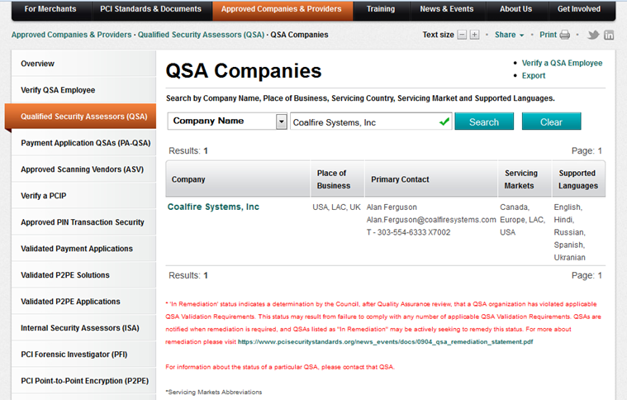
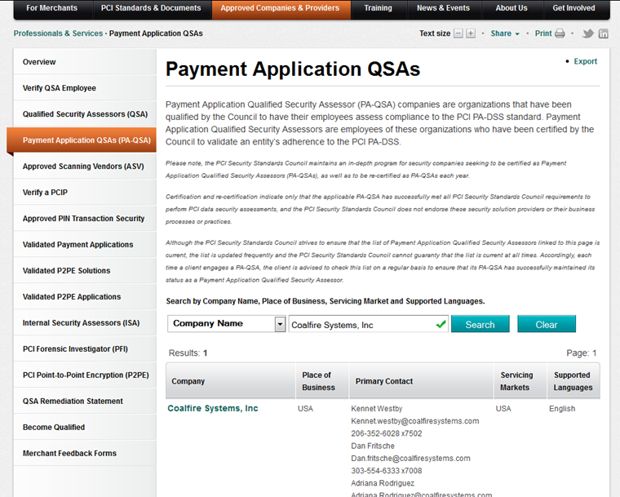
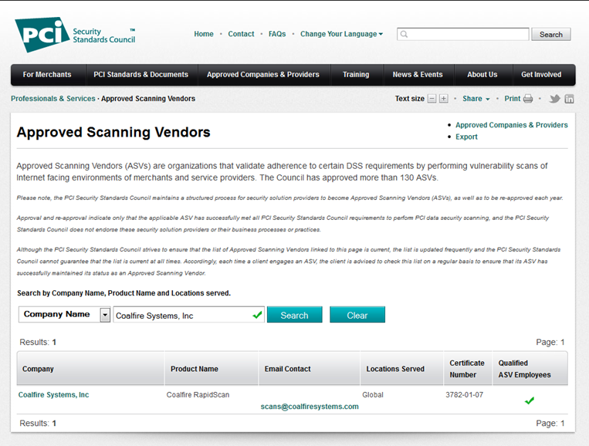
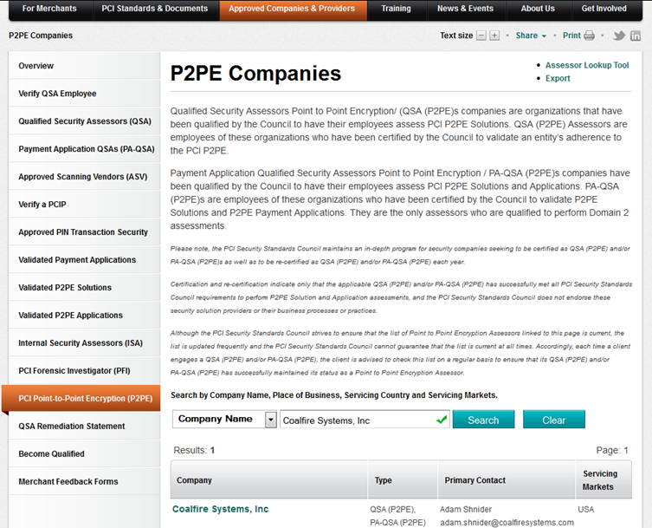
B-1.
a) ANSWER: Coalfire was one of the original Visa Cardholder Information Security Program (CISP) auditors (2001) and has been a PCI Qualified Security Assessor (QSA) since the beginning of the program in 2004. Coalfire is also a PCI Approved Scan Vendor (ASV), a PCI Payment Application Qualified Security Assessor (PA-QSA) and a Payment Application Qualified Security Assessors Point to Point Encryption / PA-QSA (P2PE) company. See screenshots below as evidence of our certifications:
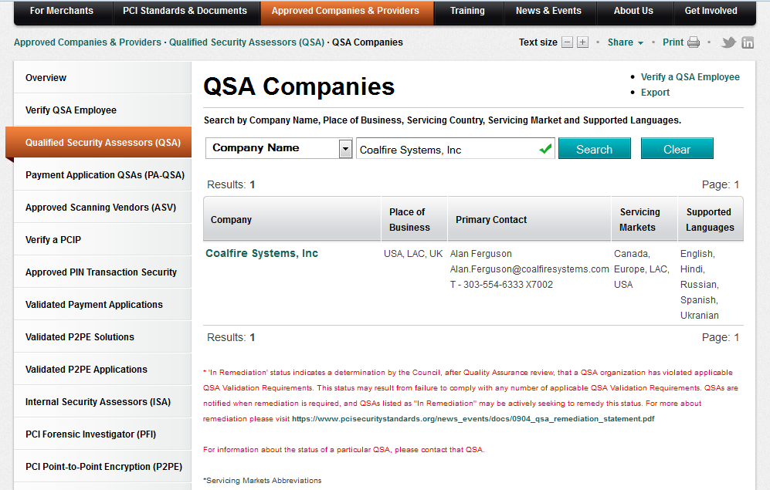

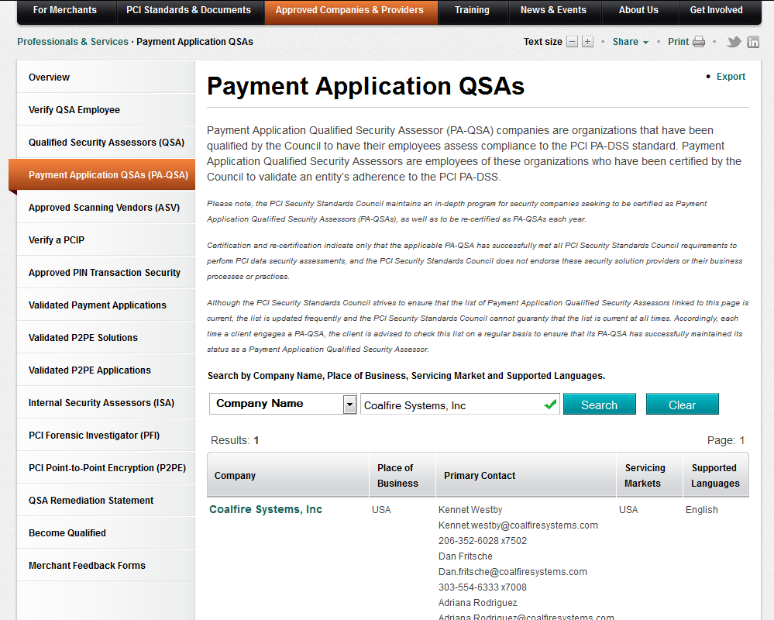

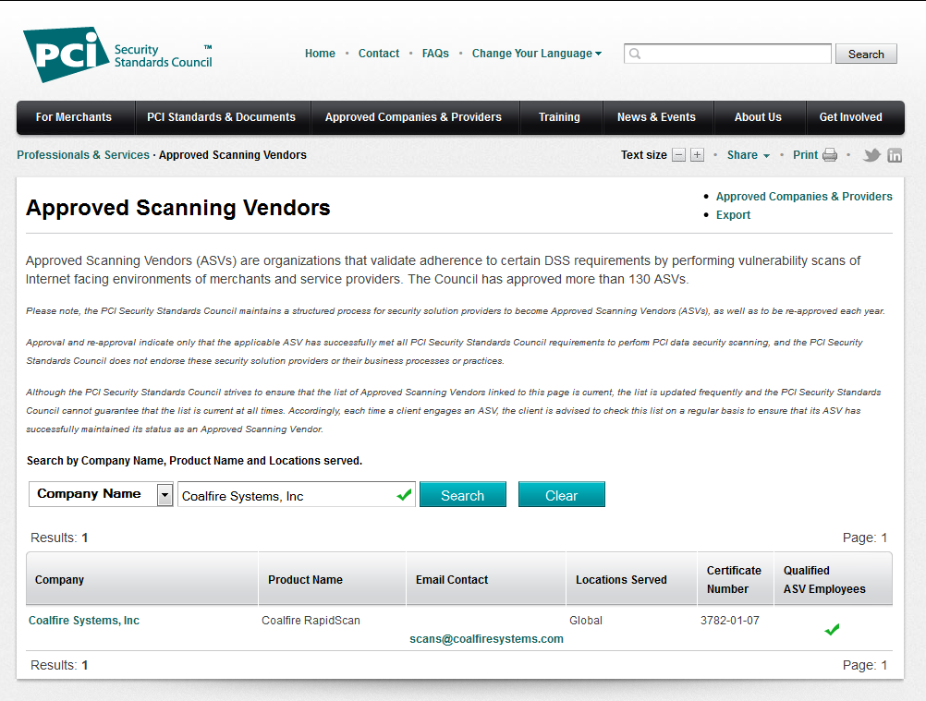

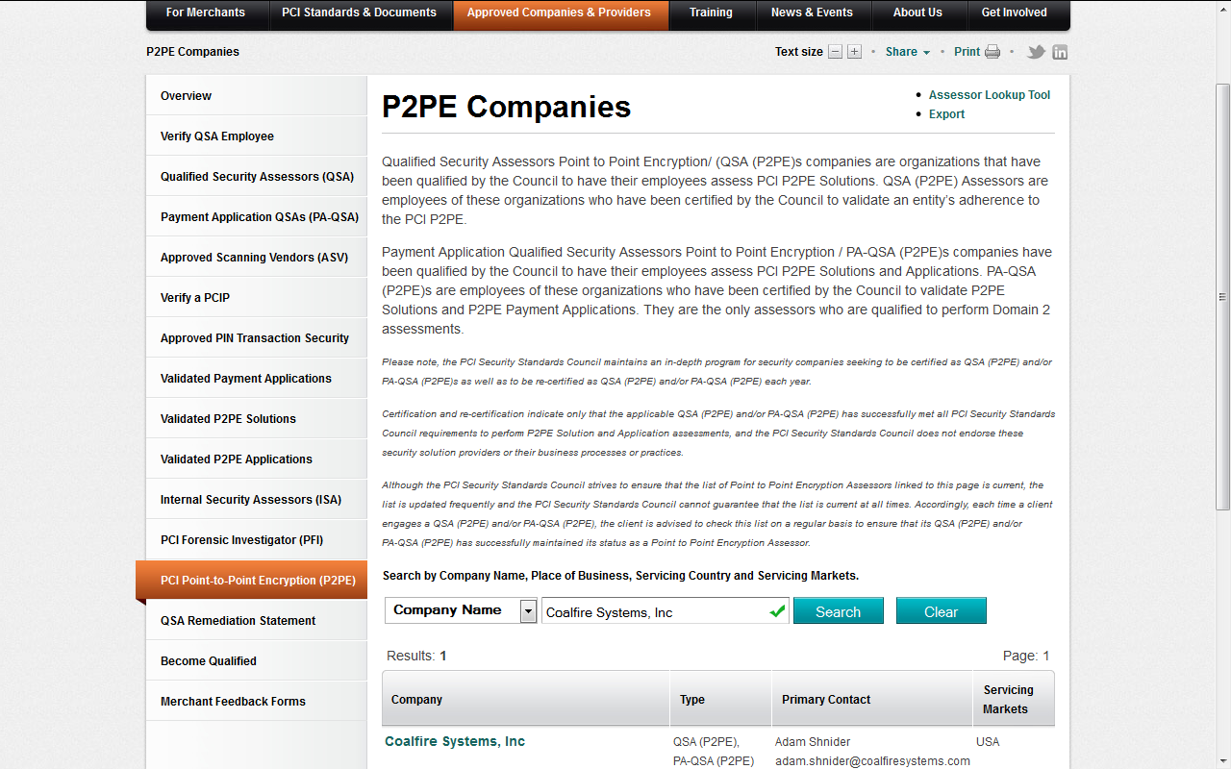

- Bidders must demonstrate that the Bidder has continuously for at least five (5) years provided government PCI services providing a full suite of QSA, consulting and remediation services to entities of similar size and complexity as the Commonwealth, with additional points or consideration to well established firms with more extensive experience. If the Bidder has performed for less than the five (5) year minimum, demonstrated cumulative experience of not less than five (5) years in state government PCI services and at least five (5) years in other PCI services comparable to the services required under this RFR. Bidder should demonstrate the ability and capacity to perform the service required with numerous merchant relationships and heterogeneous cardholder data environments. Describe in detail specific projects and contracts, specifically government engagements, and any other information relevant to demonstrate experience and expertise in this area.
B-1. b) ANSWER:
Coalfire has been providing PCI QSA and related services since 2004. We are currently one of the largest QSA firms and the only one of the larger QSA firms that does not sell or resell security products and/or services. We have over 50 PCI QSAs on staff.

Government Experience:
Coalfire has worked with 40 state governments and many local government organizations. Examples include:

- Commonwealth of Massachusetts (Coalfire/DRG) since 2007, providing PCI QSA services to multiple Agencies and Departments (over 25) within the Commonwealth, including MassDOT, ITD, MBTA, HCF and EOLWD among others.
- State of New Hampshire (Coalfire/DRG) since 2011, providing PCI QSA services including GAP, Advisory and Validation for over 18 entities, including Report on Compliance (ROC)
- State of Colorado since 2004, providing HIPAA and PCI compliance assessments, vulnerability and penetration testing, IT Audit services, remediation guidance and support.
- State of Oklahoma since 2004, providing HIPAA and PCI compliance assessments, vulnerability and penetration testing, IT Audit services, remediation guidance and support.
- Port of Portland since 2007 providing PCI-centric services including assessment, remediation project management, PCI advisory, vulnerability assessments and penetration testing.
- City of Minneapolis - Coalfire has supported the city and their respective agencies since 2006 through various IT security related projects including, network vulnerability and penetration testing, PCI compliance, remediation guidance.
- Clark County Nevada since 2009 providing PCI-centric services including CDE characterization documentation, facilitating the completion of SAQs, conducting external PCI scanning and also conducting quarterly internal vulnerability scans, and performing penetration testing (both external and internal).
- Seattle Sound Transit – Coalfire supports the seven (7) public transportation agencies. Coalfire worked with each agency and the Sound Transit data center and platform hosting provider to identify in-scope business units, business processes, systems and vendors. Coalfire supported each agency in understanding their unique compliance status relative to the ORCA program, as well delineated compliance responsibilities among each participating agency.
- Denver International Airport - Coalfire has supported DIA since 2007 with a comprehensive set of PCI-oriented services including, Incident response support, PCI Report on Compliance audit, Advisory assistance for security remediation activities, IT security program development
- John Wayne Airport – Coalfire has supported JWA since 2010 with services including penetration testing, external and internal vulnerability testing, risk assessment and payment card security compliance testing and reporting.
- State of Oregon - Coalfire has supported the State since 2006. Services include quarterly network scans workshops to assist the agencies in better understanding PCI DSS, the language and intent of the PCI DSS and how to accurately respond to the self-assessment questionnaire. Separately, Coalfire presented a PCI Executive level training session for State CIO’s, CFO’s and IT security management.
Education:
Universities and Colleges are good examples of numerous merchant relationships and heterogeneous cardholder data environments. Coalfire has completed PCI DSS assessments and related services for many large educational institutions, including:
- Emory University, University of Colorado, University of Massachusetts, West Virginia University, University of Houston, University of Oklahoma, Oklahoma State University, etc…
In Massachusetts, Coalfire/DRG has conducted and provided numerous Community Colleges, including Northern Essex CC, Middlesex CC, Roxbury CC, etc.

Large Enterprise Experience:
Coalfire large clients have numerous merchant relationships and complex/heterogeneous cardholder data environments. Our major clients include:
- Amazon
- Microsoft
- VMWare
- IBM
- NCR
- Oracle
- HP
- United States Marine Corp

- Bidders must demonstrate significant experience with evaluating and providing assessments of the cardholder data environment of large scale and diversified or decentralized merchants, as well as the ability to assess areas of internal risks for these type of organizations such as insider fraud, unattended devices, social engineering, third party hosting risks, data leakage prevention, and other related risks and provide emerging technology and PCI scope reductions trends and any other considerations. Describe in detail specific projects and contracts, specifically government engagements. And any other information relevant to demonstrate experience and expertise in this area.

B-1. c) ANSWER:

Tracking compliance across a complex enterprise has been an ongoing challenge. Every agency has unique characteristics and technologies. To facilitate working with and monitoring compliance across multiple agencies Coalfire developed “RapidSAQ Enterprise”, an audit tool that leverages state-of-the-art cloud technology and techniques to facilitate compliance in the most cost effective manner.

RapidSAQ uses an “expert system” intelligence engine to ask a series of high-level questions about an organization and their relationship to cardholder data, which in turn drives more specific questions, which drives other questions, etc. until a merchant arrives at their correct classification and SAQ Validation Type. In this sense, the Coalfire RapidSAQ is very much like a home tax program. You may not know how to fill out the official government forms or understand the legislation, but you complete the correct documents by following a series of organized steps and answering simple questions.

Assessment Process
- Facilitated Support - RapidSAQ completion is facilitated by an assigned Coalfire QSA who works with each Agency to complete the assessment and input the data into Rapid SAQ. Agencies will have questions, particularly when going through the process the first time. Facilitated support allows Agencies to interface with a knowledgeable, experienced Coalfire Systems QSAs to answer specific audit and control questions, resolve issues, and help walk through the more complicated aspects of compliance.
- RapidSAQ makes no assumptions about a merchant’s PCI DSS / security knowledge or interpretation of the standards
- Rapid SAQ does not mimic the PCI SSC’s SAQ form, rather it steps merchants through the process with questions in plain English
- Based on responses:
  - Automatically determines the appropriate SAQ validation type (A, B, C or D) for the merchant
  - Presents only those follow-on questions that are appropriate to the merchant type
  - Provides the ability to save, review and go back
  - Provides contextual help
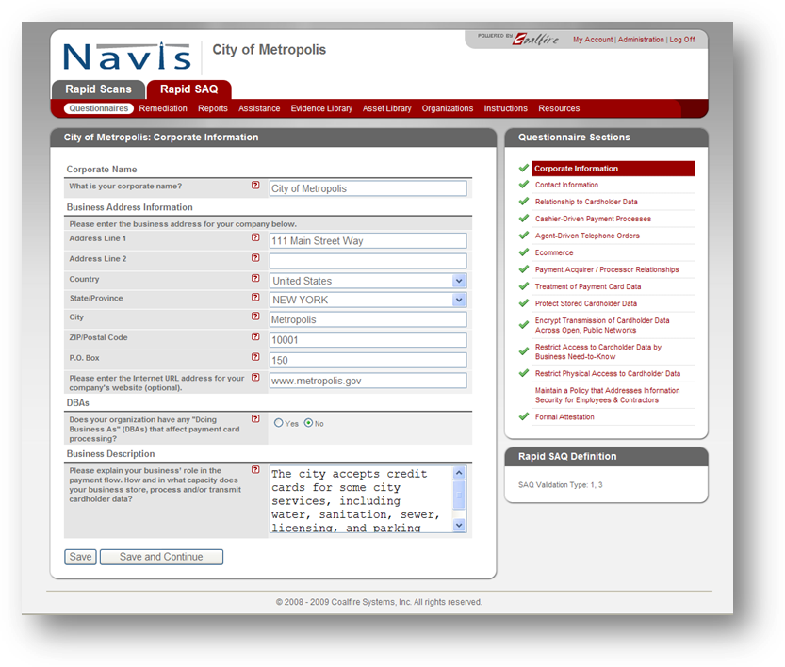

Rapid SAQ was specifically designed to support the complex PCI management, monitoring and reporting requirements of organizations with multiple locations and/or merchants.
- Define the organizational structures responsible for formally reporting SAQ responses;
- Define the organizational structures responsible for providing SAQ responses.

These functions are important, since many organizations may be required (or choose) to submit only one complete SAQ to their acquirer despite maintaining multiple, independent cardholder data environments.

The Reporting Organizations module provides the ability to manage multiple, independent cardholder data environments, consolidate reporting, and prepare multiple SAQ schedules. Reporting organizations may “rollup” their compliance results to a parent and/or produce their own stand-alone PCI DSS compliance documents.

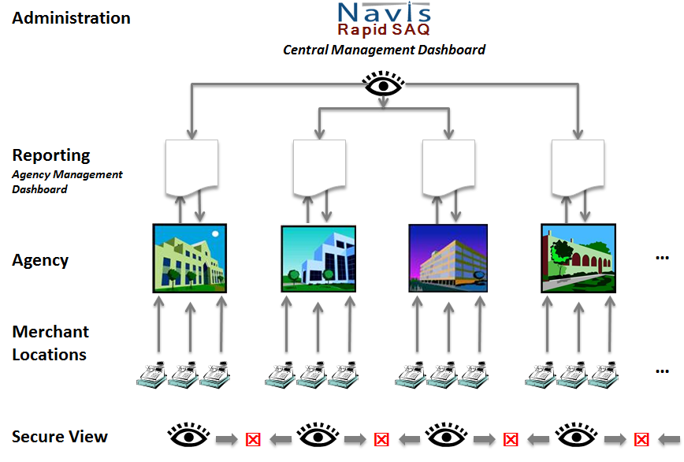

Other Features:

Evidence Library
To protect your organization from future litigation, Coalfire has included the option of uploading ‘evidence of compliance’ into the Navis portal. Evidence files can be in any format – photos, text, Visio, PowerPoint, video clips, etc. The Evidence Library can be viewed at any time and updated as procedures change.

Asset Library
Navis provides the ability to document and track assets that are used in the payment process. Assets can be hardware and software and third party service providers.

Resource Library
Coalfire recognizes that to complete the PCI process may require access to additional materials. The Resource Library is made available to all Navis clients and includes sample Payment Flow Diagrams, Policy templates, sample Vendor Management Contract Provisions, a Guide for Capital Planning, etc.

- Bidders must demonstrate significant experience with payment processing experience and direct payment processing system audit experience and a clear understanding of the payment processing needs unique to government entities. Audit experience must include the ability to validate that Eligible Entity software and applications are PCI compliant if not already approved by the PCI Council software listing. Describe in detail specific projects and contracts, specifically government engagements. And any other information relevant to demonstrate experience and expertise in this area.

B-1. d) ANSWER:
Coalfire is the largest Payment Application Data Security Standards Qualified Security Assessment Company (PCI PA-DSS QSAC). We have evaluated hundreds of payment solutions from small firms to major international players (e.g. Radiant / NCR). We have PCI certified test lab facilities in 2 US locations, staffed with PA QSAs.

In addition, Coalfire is the IT auditor for many major payment processing firms including:
- Heartland Payment Systems
- TransFirst
- Verifone
- NCR
- Radiant Systems
- Mercury Payment Systems
- Merchant eSolutions
- First Data (whitepaper)
- MerchankLink (whitepaper)
- Payment Processing Inc. (PPI)
- Bidders must demonstrate ability to efficiently and effectively develop PCI DSS scope assessments and price engagements reasonably for the size and complexity of the engagement, with a willingness to negotiate scope and pricing relative to the funding available for a merchant Department without compromising the duty to identify PCI risks, remediation and recommendations. Describe in detail specific projects and contracts, specifically government engagements. And any other information relevant to demonstrate experience and expertise in this area.
B-1. e) ANSWER:

Coalfire has worked with State Agencies of all sizes and complexity. From organizations with a single Point of Sales (POS) device to agencies with numerous locations (e.g. RMV). Our pricing for services presented herein this document for a specific agency is based on the size (including for example, number of IP addresses), risk profile and complexity (SAQ) of that agency.

For the majority of agencies, our RapidSAQ and RapidScan service is a perfect fit. Compliance can be documented, tracked and reported on with minimal disruption and expense. For larger merchant departments (Level 1 and 2 based upon card brand definitions), Coalfire Systems will develop assessment and validation engagements based upon scope information provided by the entities under the terms of pricing as disclosed herein.

- Please identify if the Bidder is PA-QSA qualified. https://www.pcisecuritystandards.org/approved_companies_providers/payment_application_qsas.php.Payment Application Qualified Security Assessor (PA-QSA) companies are organizations that have been qualified by the Council to have their employees assess compliance to the PCI PA-DSS standard. Identify how long the Bidder has had this qualification and the extent of expertise and experience in this area.

B-1. f) ANSWER:

Coalfire is a PCI PA-DSS QSA firm and has been conducting payment application assessments since 2008 (originally called Payment Application Best Practices (PABP) which was a Visa Inc. sponsored voluntary program).

- Please identify if the Bidder has Pin Transaction Security (PTS). Identify how long the Bidder has had this qualification and the extent of expertise and experience in this area.
B-1. g) ANSWER:

Coalfire is the IT security and compliance auditor for many of the largest payment providers of such PTS devices, including VeriFone and Ingenico. Coalfire has experienced consultants that are trained and certified to perform both TR-39 audits and Visa PCI PIN-Security reviews. Our organization has extensive knowledge on encryption solutions and appropriate key management methodologies.

- Please identify if the Bidder has PCI PFI Certification. The Council maintains a list of approved PCI Forensic Investigators to replace the individual payment card brand lists as of March 1, 2011. View the list of approved PCI Forensic Investigators. https://www.pcisecuritystandards.org/approved_companies_providers/pfi_companies.php Identify how long the Bidder has had this qualification and the extent of expertise and experience in this area.
B-1. h) ANSWER:
Coalfire has an industry recognized forensics / incident response division, Coalfire Labs. Labs services would be available to Commonwealth Agencies in the event of an incident.

Coalfire is not a PCI PFI company. It is important to understand that, in the event of an incident, a PFI certified company is contractually obligated to represent and work for the card brands. Coalfire believes that this conflict of interest puts our clients at a disadvantage. Therefore, we have elected, instead, to represent our clients in the event of an incident and work, on their behalf, to mitigate potential fines and penalties.
- Please identify if the Bidder has Point-to-Point Encryption (P2PE) qualifications.
  - Qualified Security Assessors Point to Point Encryption/ (QSA (P2PE)s companies are organizations that have been qualified by the Council to have their employees assess PCI P2PE Solutions.
  - Qualified Security Assessors Point to Point Encryption assessors are employees of these organizations certified by the Council to validate P2PE Solutions.
  - Payment Application Qualified Security Assessors Point to Point Encryption / PA-QSA (P2PE)s are organizations that have been qualified by the Council to have their employees assess PCI P2PE Solutions and Application.
  - PA-QSA (P2PE)s are employees of these organizations who have been certified by the Council to validate P2PE Solutions and P2PE Applications. They are the only assessors who are qualified to perform Domain 2 assessments.

Identify how long the Bidder has had any of these qualifications and the extent of expertise and experience in this area.

B-1. i) ANSWER:

Coalfire has been a P2PE company since the launch of the program and serves in an advisory capacity to the PCI SSC.

The Executive Sponsor, Mr. Jim Cowing, and more than 10 other technical professionals within Coalfire have all attended PCI SSC training and passed the rigorous certification for QSA (P2PE).

- Please Bidder expertise relative to providing assessments and security reviews for PCI Compliance for emerging mobile payment acceptance solutions as demand for these services increase. Identify how long the Bidder has had this qualification and the extent of expertise and experience in this area.

B-1. j) ANSWER:

Coalfire has earned a reputation for being on the forefront of emerging technologies:

Mobile Security
Coalfire has led the validation of some of the industry’s most innovative mobile solutions available. Coalfire participates on 5 major mobile standards bodies and was one of only 3 QSA’s to participate on the PCI SSC’s mobile security task force. Coalfire supports global merchants in security advisory role for mobile solutions.

EMV and Contactless Payments
Coalfire leverages our broad industry expertise and participation working with mobile security, global acquirers, card brands, terminal manufactures and EMVCo to help guide our clients in selecting appropriate EMV and contactless payment solutions.

- Please identify any other PCI related qualifications or expertise not previously mentioned that demonstrates qualifications to provide PCI QSA services. Identify how long the Bidder has had this qualification and the extent of expertise and experience in this area.
B-1. k) ANSWER:

Coalfire takes a very active, proactive role in standards bodies and emerging technologies that affect PCI compliance.

Virtualization and Cloud Security
Coalfire is one the world’s leading firms on Cloud Security and Compliance and has been selected by both VMWare and HP to help design and validate their cloud security reference architectures. Coalfire has led many industry special interest groups working on virtualization security including the PCI SSC virtualization SIG and has published many white papers and regularly presents on cloud security challenges and solutions.

P2PE – Point-to-Point Encryption
The use of encryption has always been one of the most challenging security tools for the retailer. Coalfire is established as the leader in these emerging technology trends. Coalfire is the selected independent validation firm for almost every retail encryption solution vendor including VeriFone, Voltage, Magtek and RSA. Coalfire was used as the technical reference firm by the PCI SSC as they formulated their approach to P2PE and was a founding participant of the PCI SSC P2PE SIG.

Cloud Computing and VMware:
Coalfire is currently the only assessor in the country certified to conduct Cloud assessments for PCI, FedRAMP (3PAO) and HITRUST. Our independence as an assessor puts us in a unique position which has allowed us to provide strategic services for cloud providers and vendors. Coalfire is the only assessor which has created a dedicated team of VMware and virtualization experts and is endorsed through the VMware TAP Elite program. With over 1,000 assessments conducted last year, we have the experience and knowledge about the cloud which no others can match.

In addition, Coalfire is a regular speaker, supporter and contributor to the retail industry, including:
- National Retail Federation
- Retail Data Security Forum
- Retail Solutions Provider Association
- National Association of Convenience Stores (NACS)
- Information Systems Audit & Control Association (ISACA)
- PCI Security Standards Council Advisory

- Use of Subcontractors for QSA Services. It is presumed that the selected Bidder will be responsible for and perform all the duties and requirements of this RFR. In this section, the Bidder must identify any subcontractors that will or may be used to conduct any of the work described in this Section, including the names of subcontractors, summaries of their qualifications, experience and duties and responsibilities for performance. The Bidder will remain the sole point of contact and will be responsible for all performance under the contract. For all subcontractors the following information is required in this Response: the name of the firm that will provide direct services; the anticipated number of Full-Time Equivalent (FTE) hours the subcontractor will be utilized during a work week; and the individual performance area(s) the subcontractor will be used under a resulting contract.

B-1. l) ANSWER:

Coalfire has the bench strength to complete all Commonwealth projects with internal resources.

- Qualifications to provide robust Reporting, Results and Analysis for QSA Services. Bidders must demonstrate the capability to provide detailed assessments, analysis of scoping environments, reports and any other information required by Eligible Entities. The Office of the Comptroller and the Information Technology Division track overall PCI compliance for state departments. Contractors will be required to provide overall state compliance assessments, reduction in PCI scope recommendations, and other information for overall PCI compliance.

Please complete this section fully. Do not refer back to other sections.

- Please list and describe types of reporting that your company would provide during the engagement and the frequency of the reports. Also describe a final report that your company would provide at the completion of a QSA engagement.
- Identify if Bidder provides an on-line monitoring/reporting system and describe how the Bidder’s online system will be accessed, security, hours of access, content, and cost.

Identify how Bidder reports can be used to assist Eligible Entity merchants with managing their PCI Security compliance needs (particularly, the PCI Self-Assessment Questionnaire, Report on Compliance, Vulnerability, Scans, and Penetration tests).

Describe how Bidder will allow web-based access to CTR and ITD for central monitoring of compliance status for all Commonwealth merchants.

Describe if reports provide detailed and summary level reporting to management specifying areas of risk, along with recommended corrective actions.

Describe if reporting applications provide the ability to report compliance status of Commonwealth merchants to the Merchant Services Provider(s).

Describe if reporting applications provide the ability to present an on-line Certification of Compliance Validation.

Describe any other relevant information detailing reporting options and recommendations for QSA engagements.

List the titles of available sample reports and Attach samples of QSA available reports (Attachment). (Sample reports may be submitted as .pdf Attachments)

B-1. m) ANSWER:

- Reports for each agency include:
- Cardholder Data Environment (CDE) map,
- Compliance Gap report
- Report with remediation guidance
- Completed Self-Assessment Questionnaire (SAQ)
- Completed quarterly ASV scan report
- Monthly compliance report summary from across all Agencies including gaps, remediation plans, timelines, etc.
- Final Reports –
- Level 1 and 2 merchants – Annual Report on Compliance (ROC) and Attestation of Compliance (AOC)
- Level 3 and 4 merchants – RapidSAQ – completed annual Self-Assessment Questionnaire and Quarterly Scan report
- Coalfire sets up a secure project portal for each engagement PCI ROC engagement (Level 1 and 2 merchant sites). All project communication and reporting is handled through the portal to eliminate duplication and the possibility of sending sensitive information via email.
The RapidSAQ application/portal provides all reporting for Level 3 and 4 merchant locations. Both RapidSAQ and the Project Portal are available 7/24 to approved Agency users with credentials. These services are included at no additional charge. Coalfire will continue to support existing merchants who request and prefer to utilize Qualys for their vulnerability scan and/or SAQ solution.
- All reports are designed to be clear and concise and easily understood. Where compliance gaps exist, Coalfire provides a gap report with remediation guidance. We include the ability for Agencies to monitor their progress towards compliance and the ability to assign resources and track progress
- RapidSAQ Enterprise provides the ability to set up mother/child relationships with password and ID protected access. For example, an Agency which with multiple merchant locations may elect to have each location complete their own SAQ using the RapidSAQ service. This is easy to set up in RapidSAQ and the Agency has the ability to monitor compliance status of all merchant locations within their sphere from their Management Dashboard. NOTE: Individual merchant locations will only be able to see their own data.
Likewise, the Office of the Comptroller has the ability to monitor compliance across all State Agencies from RapidSAQ’ s Central Management Dashboard. Additionally, upon request, Coalfire can provide AOC confirmations and monthly status reports to the Comptrollers office to maintain ongoing compliance status on all agencies. However, individual Agencies will only be allowed to see their own merchant locations.
- Coalfire reports provide detailed and summary level reporting to management specifying areas of risk, along with recommended corrective actions.
- All Agencies will have the ability to submit (electronically or in print format) reports on their compliance to the Merchant Services Provider(s).

- Coalfire’s reporting applications provide the ability to present an on-line Certification of Compliance Validation seal.

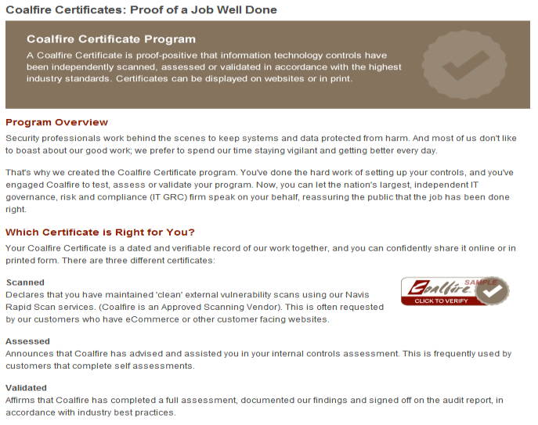
- Coalfire reporting capabilities have been refined and enhanced as PCI DSS requirements have evolved over the past 6 years. We have the ability to provide reports for individual merchant to Commonwealth wide compliance summaries.
- Available reports and related project documents:
- Document Request Form
- Weekly project update
- Reports for each agency include:
- Cardholder Data Environment (CDE) map,
- Compliance Gap report
- Report with remediation guidance
- Completed Self-Assessment Questionnaire (SAQ)
- Completed quarterly ASV scan report
- Monthly compliance report summary from across all Agencies including gaps, remediation plans, timelines, etc.
- Final Reports –
- Level 1 and 2 merchants – annual Report on Compliance and Attestation of Compliance
- Level 3 and 4 merchants – RapidSAQ – completed annual Self-Assessment Questionnaire and Quarterly Scan report

B-3. SCANNING SERVICES – QUALIFICATIONS

Bidders selected in this category must have exceptional experience and expertise in providing a full suite of scanning and security testing and penetration services to identify vulnerabilities and test remediation efforts for PCI Compliance and for non-PCI security compliance testing.

When completing responses the Bidder must indicate if the Bidder will be directly providing the services or contracting out the provision of services through a subcontractor. All subcontractor work will be billed through the Bidder as Primary Contractor under the Primary Contractor’s Tax ID. The Commonwealth does not intend to entertain “joint” bids. Eligible Entities may contract solely with Contractors approved under the Statewide Contract and may not enter into direct relationships with named subcontractors. Therefore, named subcontractors that desire direct contract relationships for solely scanning or other service independent of the Primary Contractor must submit their own Response for these services (in addition to being listed as a named subcontractor under a Primary Contractor Response) in order to be considered a Statewide Contractor that can have a direct relationship with Eligible Entities. For Bidders providing both QSA and Scanning Services the Bidder must be able to demonstrate complete independence of QSA services and Scanning Services.

Bidders are instructed to provide DETAILED THOROUGH responses to EACH of the sections listed below. The Responses should NOT merely be a simple statement that the Bidder can provide the listed service. Bidders may NOT attach brochures or other marketing materials. Therefore, Bidders are expected to enter all relevant details and information in the section below that demonstrates experience, specific projects, and any other information supporting exceptional experience. Sparse answers that do not provide supporting details may subject the Response to rejection.

The Responses should NOT include standard marketing jargon but must be targeted to demonstrate the unique needs of the Commonwealth rather than just a generic bid response. Bidders will be rated on their ability to demonstrate a true understanding the unique needs of public entities, and the needs of the Commonwealth, including demonstrating the ability to properly scope assessments for public entities with budget constraints.

EVERY ANSWER section below must be completed. Indicate “N/A” or “Not Applicable” or “Does not have this expertise” or “Does not provide these services” as appropriate.
- PCI COUNCIL APPROVED SCANNING VENDOR (ASV). For PCI Compliance services, the Bidder must provide evidence that it is a certified Approved Scanning Vendor (ASV) approved by the PCI Security Standards Council at: https://www.pcisecuritystandards.org/approved_companies_providers/approved_scanning_vendors.php of the date of this RFR to perform internal and external network vulnerability scans for all merchants and service providers with externally-facing IP addresses.
B-3. a) ANSWER:

- For PCI compliance services, Bidders must demonstrate a minimum level of at least 5 (five) years experience providing the same type of full suite ASV services to entities of similar size and complexity as the Commonwealth, with additional points or consideration to well established firms with more extensive experience. Identify how long the Bidder has had this qualification and the extent of expertise and experience in this area.

B-3. b) ANSWER:

Coalfire has been an Approved Scan Vendor (ASV) since the beginning of the program in 2004. We have conducted thousands of scans for public and private enterprises. Clients include the Commonwealth of Massachusetts and States of New Hampshire, Colorado, Oklahoma, etc. as well as many Cities such as Town of Brookline, Universities and Colleges.

- For PCI compliance services, Bidders must demonstrate ability to efficiently and effectively develop ASV scope assessments and price engagements reasonably for the size and complexity of the engagement, the PCI or other level of risk, with a willingness to negotiate scope and pricing relative to the funding available for a merchant Eligible Entity without compromising the duty to identify PCI compliance and other vulnerability risks, remediation and recommendations, and provide emerging technology and PCI or vulnerability risk scope reductions recommendations.
B-3. c) ANSWER:

As RapidScan is a cloud service specifically designed to be very cost effective and flexible to accommodate any size/complexity of merchant organization. The service has been independently tested and validated to meet or exceed all requirements of the PCI Security Standards Council.

- SCANNING SERVICES TYPES: (PCI and Non-PCI related). Bidders must be able to furnish a broad range of scanning services including, but not limited to the scanning types displayed below. Identify whether the Bidder provides the listed type of scans, how long the Bidder has performed these types of scans and the extent of expertise and experience in EACH area. :
- Server Hardening Scans
- PCI Compliance Scans
- Penetration Tests
- Vulnerability Scans
- Application Scans
- Web Application Scan s
- Mobile Device Security Scans/Reviews
- Network scans/port scans/traffic monitoring/packet scanning
- Virus Scans
- And any other available scan or testing options for system or other vulnerabilities

B-3. d) ANSWER:
All non-PCI scanning services are performed by Coalfire Labs with a team of professionals that are dedicated to providing these services day in and day out:
- Coalfire has conducted Server Hardening Scans since 2002.
- Coalfire has conducted PCI Compliance Scans since 2004
- Coalfire has conducted Penetration Tests since 2002
- Coalfire has conducted Vulnerability Scans since 2002
- Coalfire has conducted Application Scans since 2004
- Coalfire has conducted Web Application Scans since 2002
- Coalfire has conducted Mobile Device Security Scans/Reviews since 2010
- Coalfire has conducted Network scans/port scans/traffic monitoring/packet scanning since 2003
- Coalfire does not provide Virus Scanning services. This is a specialized service best provided by a firm that maintains up-to-date virus/malware signatures (e.g. Trend Micro, Symantec/Norton, Kaspersky Lab, McAfee, Microsoft Forefront).
- Coalfire also provides Wireless Vulnerability Scanning service to search and identify rogue wireless points.

- QUALIFICATIONS TO PROVIDE ROBUST REPORTING, RESULTS AND ANALYSIS FOR ASV SCANNING AND PENETRATION TESTING AND OTHER SCANNING SERVICES. Bidders must demonstrate the capability to provide detailed reports and any other information required by Eligible Entities related to scanning services. The Office of the Comptroller and the Information Technology Division track overall compliance for state departments. Contractors will be required to provide reports on compliance and risk assessments.
Please complete this section fully. Do not refer back to other sections.

- Please list and describe types of reporting that your company would provide during the engagement and the frequency of the reports. Also describe a final report that your company would provide at the completion of a scanning engagement, or for ongoing engagements, annual year end reporting.
- Identify if Bidder provides an on-line monitoring/reporting system and describe how the Bidder’s online system will:

Identify what reporting or other services are available to assist Eligible Entity merchants with managing their Security compliance needs (particularly Vulnerability Scans and Penetration tests).

Identify if Bidder is able to allow web-based access for central monitoring of compliance status for all Commonwealth merchants provided to CTR.

Identify how Bidder plans to provide detailed and summary level reporting to management specifying areas of risk, along with recommended corrective actions.

Describe any other relevant information detailing reporting options and recommendations for ASV engagements for PCI Compliance and other scanning and testing engagements for non-PCI related security and compliance audits.

List the titles of available sample reports and Attach samples of ASV available reports (Attachment). (Sample reports may be submitted as .pdf Attachments)

B-3. e) ANSWER:
- Reports:
RapidScan ASV Scan Reports:
- Attestation of Scan Compliance -- an overall summary for the entire customer infrastructure. A completed scan has one of the following results:
- Passing scan - Scan customers ONLY submit passing scan reports.
- Failing scan for which the scan customer disputes the results - Scan customer and ASV resolve any scan disputes or exceptions.
- Failing scan that the scan customer does not dispute - Scan customer resolves failing vulnerabilities.
- RapidScan provides both detailed and summary reports:
- Quarterly Testing Report
- Executive Summary -- a component summary for each scanned component.
- Vulnerability Details -- vulnerability details for each scanned component.
- For failing scans – suggested remediation tasks
Reports for other services (penetration testing, application and network vulnerability scanning, etc.):
- For each service conducted, Coalfire provides two sets of reports: one set with a Management focus and the second with a Technical focus (plus, the raw data) to include the following sections:
- Executive summary
- Purpose and scope
- Background
- Process/methodology description
- Areas examined / procedures performed
- Positive security aspects identified
- Findings in order of importance
- Roadmap to remediation
- Conclusions
- Future considerations/recommendations

Coalfire’s Approach to Remediation
Simply providing a gap report does not serve our customers well. Coalfire provides remediation guidance that is prioritized based the Organization’s ability and resources. In addition, we provide high level cost estimates for remediation activities as appropriate.
Documentation on Vulnerabilities found will include:
- Background on the vulnerability.
- Detailed evidence of penetration, and an impact statement, plus specific technical remediation recommendations prioritized according to severity
- Supporting detailed exhibits for vulnerabilities when appropriate.
- The expected benefit of implementation.
- A high level estimate of cost or effort (high, moderate, low) of deployment.
- A listing of the specific security concerns it addresses.
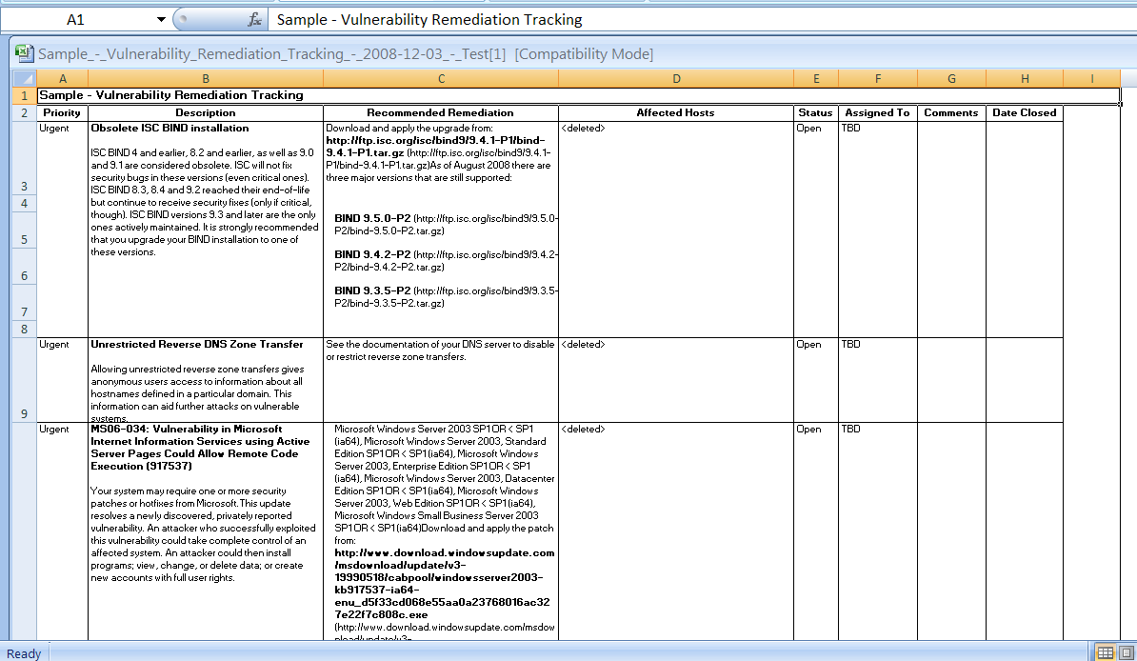

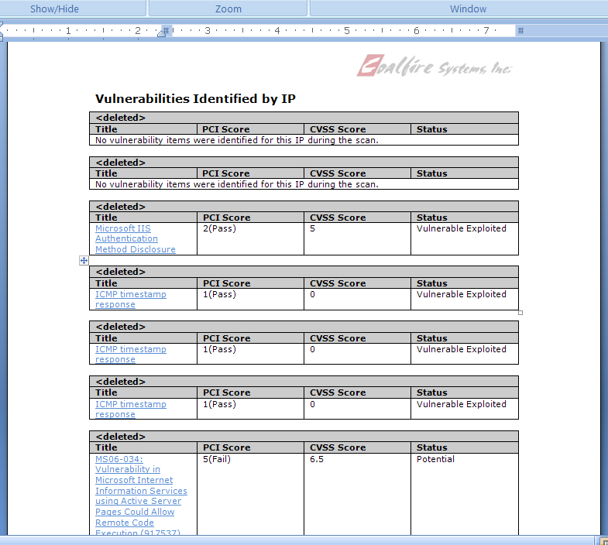

On-line Monitoring/Reporting
For all projects Coalfire provides a secure, on-line project portal. Access to the portal is determined in collaboration with the Commonwealth and has the flexibility to accommodate any combination of post, review, view, edit, etc. permissions.
For PCI projects, RapidSAQ provides a management dashboard that allows CTR to monitor compliance across all merchant locations:
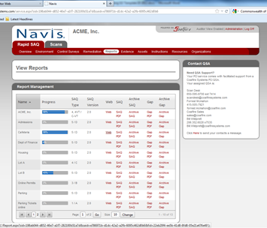

- Coalfire provides two sets of reports: one set with a Management focus and the second with a Technical focus (plus, the raw data) to each merchant location and a quarterly summary reports to CTR.

Reports include the following sections:
- Executive summary
- Purpose and scope
- Background
- Process/methodology description
- Areas examined / procedures performed
- Positive security aspects identified
- Findings in order of importance
- Roadmap to remediation
- Conclusions
- Future considerations/recommendations

- A pass/fail report simply is not good enough and does not help a merchant achieve/monitor compliance. All Coalfire reports, where gaps are identified, contain actionable and concrete remediation guidance and a Coalfire audit team member is always prepared to answer questions and clarify tasks.

- Available Reports:
Quarterly Attestation of Scan Compliance
Summary and Detail Reports including a gap report with remediation guidance

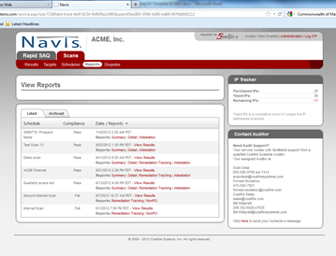

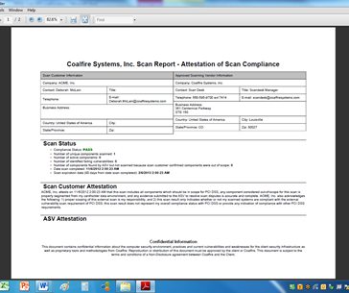

B-4. OTHER NON-PCI RELATED AUDIT, INTERNAL CONTROLS, SECURITY AND COMPLIANCE
REVIEWS.
The Commonwealth of Massachusetts, pursuant to G.L. c. 93H and 93I has responsibility to safeguard data deemed Personally Identifiable Information (PII), in addition to protections mandated by other state and federal statutes and regulations for other types of confidential data. The duties to protect PII under G.L. c. 93H and 93I apply equally to both PCI covered data (credit card holder data) and non-PCI covered data (all other personally identifiable information (PII)). PCI QSA services are covered under Section B-2. Above. This Section includes NON-PCI related services.

For Executive Departments governed by Executive Order 504, a self-assessment process has been completed to document the types of confidential and PII data collected and retained by Departments. In addition, the Information Technology Division (ITD) has published Enterprise Security Standards for the protection of confidential, sensitive and PII.

NOTE: ACH transactions (electronic check) transactions with bank account information is considered PII under G.L. c. 93 H and 93I. Therefore, the Commonwealth deems bank account information and ACH transactions to create the same level of data breach risk as credit card holder data.
Therefore, this Section of the Statewide Contract seeks to qualify contractors that can assist Eligible Entities with the audit and testing of information and data systems and protocols to ensure that all non-PCI related sensitive data, confidential data and PII, as identified under G.L. c. 93H, c. 93I, and other state and federal laws and regulations is properly safeguarded to prevent data breaches, and to provide consulting services to assist with mitigation and remediation of vulnerabilities and data breaches (PCI or non-PCI related). QSAs seeking to provide non-PCI related security and risk assessments, which can use many of the same evaluation considerations and tools used for PCI assessments, should complete this Section.

Bidders must demonstrate the qualifications and experience to provide a full suite of non-PCI related information management, quality assurance, data management, protocol and security audit and compliance review services and resources available, and details about the various types of audit and compliance related to information management systems and procedures and security management systems and procedures and compliance audits that are geared to business improvements and efficiencies, government compliance, internal controls and quality assurance and to protect personally identifiable information and other sensitive data.

Bidders are instructed to provide DETAILED THOROUGH responses to EACH of the sections listed below. The Responses should NOT merely be a simple statement that the Bidder can provide the listed service. Bidders may NOT attach brochures or other marketing materials. Therefore, Bidders are expected to enter all relevant details and information in the section below that demonstrates experience, specific projects, and any other information supporting exceptional experience. Sparse answers that do not provide supporting details may subject the Response to rejection.

The Responses should NOT include standard marketing jargon but must be targeted to demonstrate the unique needs of the Commonwealth rather than just a generic bid response. Bidders will be rated on their ability to demonstrate a true understanding the unique needs of public entities, and the needs of the Commonwealth, including demonstrating the ability to properly scope assessments for public entities with budget constraints.

EVERY ANSWER section below must be completed. Indicate “N/A” or “Not Applicable” or “Does not have this expertise” or “Does not provide these services” as appropriate.

- Identify the relevant qualifications and experience to provide a full suite of non-PCI related information management, quality assurance, data management, protocol and security audit and compliance review services. NOTE: If the Bidder has completed the QSA portion of this Response, the relevant qualifications listed to QSA should be identified here (not just cross referenced).

B-4. a) ANSWER:

Services Available from Coalfire:
- Compliance Audits - for the Payment Card industry (PCI), the Gramm Leach Bliley Act (GLBA), Federal Information Security Management Act (FISMA), Health Insurance Portability and Accountability Act (HIPAA), Health Information Technology for Economic and Clinical Health (HITECH), HITRUST and emerging State data privacy laws
- Cloud Computing and Virtualization Consulting
- FedRAMP Consulting Services
- External Vulnerability and Penetration Testing
- Internal Vulnerability Testing
- Social Engineering
- Wireless Security Testing
- Risk Management Plan Development
- Incident Response, Digital Forensics and Litigation Support
- Business Continuation Planning and Recovery Advisory
- Chain of Trust Testing, Compliance and Guidance
- Server and System Level Security Testing
- Application Security Assessments
- DMZ Design
- Secure Architecture Design, Deployment and Training
- Policy Development and Gap Closure

Qualifications:
- Certified Information Security Assessor (CISA)
- Certified Information Systems Security Professional (CISSP)
- Associate Business Continuity Planner (ABCP)
- Cisco Certified Networking Associate (CCNA)
- Certified Cisco Network Associate (CCNA®)
- Certified Disaster Recovery Planner (CDRP)
- Certified in the Governance of Enterprise IT® (CGEIT®)
- Certified HIPAA Security Professional (CHSP)
- Certified Information Security Manager (CISM)
- Certified Internal Auditor® (CIA®)
- Certified in Risk and Information Systems Control (CRISC)
- Certified VISA and ABA Encryption Auditor (TR-39)
- Check Point Certified Security Administrator (CCSA)
- Check Point Certified Security Expert (CCSE)
- Certified Novell Administrator (CNA)
- CompTIA i-Net+, CompTIA A+
- Federal IT Security Professional – Manager (FITSP-M)
- FedRAMP℠ Third Party Assessment Organization (3PAO)
- GIAC Certified Incident Handler (GCIH)
- GIAC Penetration Tester (GPEN)
- HITRUST Practitioner / HITRUST Assessor
- Internet Security Systems Certified Engineer (ICE)
- Microsoft Certified Professional (MCP)
- Microsoft Certified Systems Engineer (MCSE)
- National Security Agency - INFOSEC Assessment Methodology (NSA IAM)
- PGP Certified Technician (PCT)
- PCI Qualified Security Assessor (QSA)
- PCI Point to Point Encryption Qualified Security Assessor (PCI QSA (P2PE)
- PCI Payment Application Qualified Security Assessor (PA-QSA)
- PCI Approved Scanning Vendor (ASV)
- ISO 27001 Certified Lead Auditor
- RedHat Certified Engineer (RHCE)

In addition a number of staff have Top Secret/SCI Clearance and are DoD Information Technology Security Certification and Accreditation Process (DITSCAP) Certified and Accredited.

- Please identify if the Bidder has Patient Safety and Quality Improvement Act of 2005 Statute and Rule qualifications. The Patient Safety and Quality Improvement Act of 2005 (PSQIA) establishes a voluntary reporting system designed to enhance the data available to assess and resolve patient safety and health care quality issues. To encourage the reporting and analysis of medical errors, PSQIA provides Federal privilege and confidentiality protections for patient safety information, called patient safety work product. PSQIA authorizes HHS to impose civil money penalties for violations of patient safety confidentiality. PSQIA also authorizes the Agency for Healthcare Research and Quality (AHRQ) to list patient safety organizations (PSOs). PSOs are the external experts that collect and review patient safety. Identify how long the Bidder has had this qualification and the extent of expertise and experience in this area.

B-4. b) ANSWER:
Coalfire is an IT security governance, risk and compliance firm with substantial compliance capabilities. Currently, Coalfire has not had a request for or performed engagements under the PSQIA, and is not a Patient Safety Org (PSO). If such skills are required to support Commonwealth compliance engagements, Coalfire will actively investigate the training and resource requirements for such certification

- Please identify if the Bidder has HIPAA SECURITY GUIDANCE qualifications. HHS has developed guidance to assist HIPAA covered entities in complying with the risk analysis requirements of the Security Rule for entities handling health records. http://www.hhs.gov/ocr/privacy/hipaa/administrative/securityrule/rafinalguidancepdf.pdf . Identify how long the Bidder has had this qualification and the extent of expertise and experience in this area.
B-4. c) ANSWER:
Coalfire’s methodology is consistent with the guidance provided in NIST Special Publication (SP) 800-30, Risk Management Guide for Information Technology Systems, as well as NIST SP800-66, An Introductory Resource Guide for Implementing the Health Insurance Portability and Accountability Act (HIPAA) Security Rule. Additionally, Coalfire’s methodology for performing risk assessments is also based on HHS and OCR guidance, such as the HIPAA Security Series and the OCR Audit Protocol.
In addition, Coalfire is one of a select few organizations authorized to conduct assessment of the HITRUST Common Security Framework. HITRUST is a private organization looking to establish a universally adopted framework for HIPAA and HITECH compliance demonstration.

- Please identify if the Bidder has any of the following certifications. Identify how long the Bidder has had the qualification and the extent of expertise and experience in this area.

- Certified Information Privacy Professional (CIPP) by International Association Of Privacy Professionals (IAPP) is a privacy and data protection certification in compliance within the US. IAPP provide other certifications as well.
- Certified Information Privacy Professional/Information Technology (CIPP/IT)
Certified Information Privacy Professional/Government (CIPP/G)
- Certified Information Security Auditor (CISA) is a professional IT security certification governed by ISACA. CISA is suited for IT security auditors, or anyone who has an interest in this area.
- Certified Information Security Manager (CISM) by ISACA is aimed towards security professionals with IT Security management responsibilities.
- Certified in the Governance of Enterprise IT (CGEIT)
Certified in Risk and Information Systems Control (CRISC)
- Certified Information System Security Professional (CISSP) certification by ISC2 is a globally recognized standard of achievement. CISSP is a senior certification for IT professionals throughout the world.
- ACA International (Association of Credit and Collection Professionals);
- FISMA, Federal Information Security Management Act (FISMA);
- SAS-70 Audit documenting control objectives and control activities examined by an independent accounting and auditing firm)
- other awards or professional affiliations that demonstrate qualifications to provide Contract services.

B-4. d) ANSWER:
- CIPP – No
- CIPP/IT / CIPP/G - No
- CISA - Yes
- CISM - Yes
- CGEIT – Yes
- CRISC - Yes
- CISSP - Yes
- FISMA – Yes
- SSAE 16 Audit Support - In conjunction with leading accounting firms, Coalfire provides controls evaluation and testing services to give evidence of the effectiveness of the design and operation of general and application level controls for service organizations. The SSAE 16 standard replaced the SAS 70 report effective June 2011 and provides a more comprehensive approach to controls reporting.
- Other awards or professional affiliations:
- HITRUST Practitioner / HITRUST Assessor
- Associate Business Continuity Planner (ABCP)
- Cisco Certified Networking Associate (CCNA)
- Certified Cisco Network Associate (CCNA®)
- Certified Disaster Recovery Planner (CDRP)
- Certified HIPAA Security Professional (CHSP)
- Certified Information Security Manager (CISM)
- Certified Internal Auditor® (CIA®)
- Certified TR-39 Auditor(CTGA)
- Check Point Certified Security Administrator (CCSA)
- Check Point Certified Security Expert (CCSE)
- Certified Novell Administrator (CNA)
- CompTIA i-Net+, CompTIA A+
- Federal IT Security Professional – Manager (FITSP-M)
- FedRAMP℠ Third Party Assessment Organization (3PAO)
- GIAC Certified Incident Handler (GCIH)
- GIAC Penetration Tester (GPEN)
- Internet Security Systems Certified Engineer (ICE)
- Microsoft Certified Professional (MCP)
- Microsoft Certified Systems Engineer (MCSE)
- National Security Agency - INFOSEC Assessment Methodology (NSA IAM)
- PGP Certified Technician (PCT)
- PCI Qualified Security Assessor (QSA)
- PCI Point to Point Encryption Qualified Security Assessor (PCI QSA (P2PE)
- PCI Payment Application Qualified Security Assessor (PA-QSA)
- PCI Approved Scanning Vendor (ASV)
- RedHat Certified Engineer (RHCE)

- Please identify any other Non-PCI related qualifications or expertise not previously mentioned that demonstrates qualifications to provide data management, security, compliance and other data security audit services. Bidders must provide a detailed explanation of the experience, types of projects that have been performed and any additional details supporting a significant level of expertise in auditing compliance and security protocols for other types of information and data management systems to protect personally identifiable information and other sensitive data.
B-4. e) ANSWER:

Coalfire Labs is a wholly owned division of Coalfire that provides the following IT security related services:

Forensic Ediscovery, Threat Mitigation, Incident Response
Vulnerability Scanning And Assessment
External Vulnerability Assessment
Internal Vulnerability Assessment
Penetration Testing
Attack Vector Analysis
External Network Penetration Test
Internal Network Penetration Test
Internal + External Network Penetration Test (Pci Combo)
Application Penetration Test
Application Security Review
Wireless Assessment
War Dialing
Social Engineering
Pre-Texting
Phishing
Physical Social Engineering

- Qualifications to provide robust Reporting Requirements, Results and Analysis for Non-PCI Compliance Audits. Bidders must demonstrate the capability to provide detailed assessments, analysis of scoping environments, reports and any other information required by Eligible Entities for a Non-PCI related audit.

Please complete this section fully. Do not refer back to other sections.

- Please list and describe types of reporting that your company would provide during the engagement and the frequency of the reports. Also describe a final report that your company would provide at the completion of a an engagement.
- Identify if Bidder provides an on-line monitoring/reporting system and describe how the Bidder’s online system will be accessed, security, hours of access, content, and cost.
- Identify how Bidder reports can be used to assist Eligible Entity merchants with managing their non-PCI Security compliance needs (particularly application reviews, internal protocols, Vulnerability, Scans, and Penetration tests).
- Describe if reports provide detailed and summary level reporting to management specifying areas of risk, along with recommended corrective actions.
- Describe if reporting applications provide the ability to present an on-line Certification of Compliance Validation.
- Describe any other relevant information detailing reporting options and recommendations for non-PCI related engagements.
- List the titles of available sample reports and Attach samples of available reports (Attachment). (Sample reports may be submitted as .pdf Attachments)

B-4. f) ANSWER:

- Reports - for each service conducted, Coalfire provides two sets of reports: one set with a Management focus and the second with a Technical focus (plus, the raw data) to include the following sections:
- Executive summary
- Purpose and scope
- Background
- Process/methodology description
- Areas examined / procedures performed
- Positive security aspects identified
- Findings in order of importance
- Roadmap to remediation
- Conclusions
- Future considerations/recommendations
- On-line Monitoring/Reporting - For all projects Coalfire provides a secure, on-line project portal. Access to the portal is determined in collaboration with the Commonwealth and has the flexibility to accommodate any combination of post, review, view, edit, etc. permissions.
- A pass/fail report simply is not good enough and does not help an Agency achieve their security goals. All Coalfire reports, where gaps are identified, contain actionable and concrete remediation guidance. Agencies will have questions and a Coalfire audit team member is always prepared to answer questions and clarify guidance provided as well as answer “what if” questions and provide alternatives as required.
- Reports - for each service conducted, Coalfire provides two sets of reports: one set with a Management focus and the second with a Technical focus (plus, the raw data) to include the following sections:
- Executive summary
- Purpose and scope
- Background
- Process/methodology description
- Areas examined / procedures performed
- Positive security aspects identified
- Findings in order of importance
- Roadmap to remediation
- Conclusions
- Future considerations/recommendations
- Coalfire’s reporting applications provide the ability to present an on-line Certification of Compliance Validation.
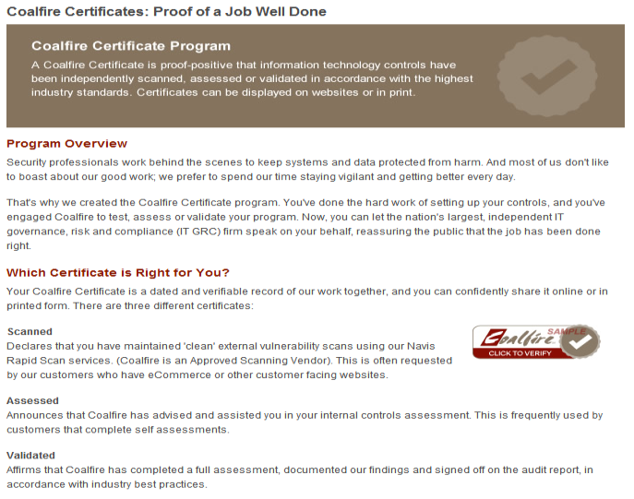

- Coalfire reporting capabilities have been refined and enhanced over the past 11 years. We have the ability to provide reports for individual Agencies to Commonwealth-wide compliance summaries.
- Reporting (type, frequency, detail, etc.) is discussed and agreed upon at the Charter meeting with each specific agency.
B-5. BIDDER SECURITY AND PRIVACY QUALIFICATIONS.
  - Describe in detail the security that you have in place to safeguard the confidentiality of Commonwealth data and systems that may be accessed during performance. With certain merchant Departments, access to data and systems is restricted by state and federal law. Personnel conducting performance may be required to sign confidentiality agreements and undergo a CORI Criminal Offender Report.
  - Describe in detail the ability to communicate, send files, download files, etc. from the Internet at all times in a secure manner.
  - Identify resources that Bidder has to ensure adequate security of its own employees’ conduct and behavior while working with Commonwealth Eligible and Entity information and systems and at Commonwealth locations.
  - The Bidder must describe their procedures for informing a client when the client’s data has been, or may have been, inadvertently disclosed/compromised and its data breach support protocols.
  - Describe the Bidder’s Disaster Recovery Capabilities.
  - Describe in detail any other Security and Privacy standards and protocols that support the services under this Statewide Contract and Eligible Entity compliance with G.L. c. 93H and G.L. c. 93I and other data security requirements.

B-5. ANSWER:

  - Client Confidentiality
Coalfire’s business is exclusively focused on IT governance, compliance management and related services, and we have completed more than 5,000 engagements for organizations in public and private sectors where protection of sensitive information is paramount. As a result, Coalfire’s management team recognizes that our ability maintain client data confidentiality is not only a contractual requirement, but it is also essential to our reputation and success in the marketplace.

Coalfire has implemented and maintains administrative, technical and physical controls over confidential information in accordance with industry standards adopted by ISO, NIST and others. These controls conform to requirements under regulations such as FISMA, GLBA, PCI, HIPAA and others, and they are also are designed to mitigate risk associated with the emerging state-level data privacy laws. Coalfire conducts periodic network vulnerability scans and penetration tests to validate the operational effectiveness of these controls and help Coalfire management understand potential risks and prioritize remediation actions.

As part of Coalfire’s security program, we conduct background checks on Coalfire staff in accordance with our company policy. Our background checks are independently reviewed to meet rigorous standards imposed by standards organizations. Background checks are conducted for all senior management and audit staff with access to sensitive information. These checks consist of criminal background checks, employment history, consumer credit history, education, and Office of Foreign Asset Control reviews (see attached policy for full information).

Our background checks are processed when a new employee comes on board. We keep a copy in their HR file. The background check includes the following:

- Credit Check
- Citizenship
- Education
- Employment History
- Criminal at the Federal level

  - Secure Electronic Communications
Coalfire deploys a secure, on-line Project Portal for each engagement. Coalfire believes in providing the highest level of communication, not just at the end of the project, but also during the project. That’s why all project processes are managed through a web-based portal that maintains the project chartering, budgeting, scoping, project plans, status reports, task assignments, stakeholders and communication channels, milestone tracking, reports and deliverables.

The portal is a living tool for managing the project from our perspective and it helps all staff remain fully informed on project progress.

The portal provides a centralized repository for:
- Final reports, work-in-progress reports, and raw data. The Portal also includes complete change control for documents and check-in and check-out authorization.
- Access is defined by CTR and user roles can be tightly defined based on project role and “need-to-know” including access to critical audit reports.
- Contact information for all team members.
- A calendar that ties to key deliverable dates decided during the Charter Meeting
- Security resources and best practices.

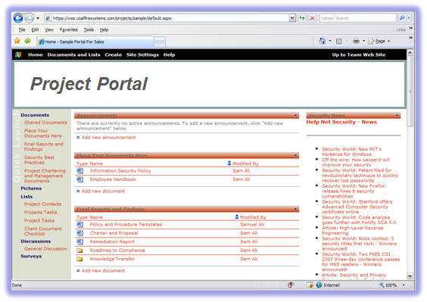
Portal Benefits:
- Secure alternative to sending sensitive information via insecure email
- Centralized document control
- Eliminates duplication
- Full audit trail of user activities
- Notification of changes/new content

  - Conduct and Behavior
Coalfire has an employee handbook that all employees are required to read and sign. The handbook includes clause on acceptable conduct and behavior and an agreement to protect Coalfire and our client’s confidential information.

  - Breach Notification
In the event that our project discovers a breach, incident or potentially harmful vulnerability, Coalfire’s policy is to immediately notify our client’s project manager or key contact. We will provide guidance on remediating the identified issue. If the incident is significant, at our client’s option, Coalfire can deploy a forensics team to assist.

  - Disaster Recovery Procedures
Coalfire follows industry best practices to secure our data resources. In the event of an incident we have a documented and tested DR recovery process. Our data centers (Seattle and Denver) back up each other.

  - Security and Privacy Standards and Protocols
Coalfire’s governance, risk and compliance (GRC) practice is based on industry best practices and standards (ISO, NIST, ITIL, etc.) and regulations (HIPAA, PCI, FISMA, GLBA, etc.).

For Disposition and Destruction of Records (93I) – All information provided to Coalfire as part of an assessment or audit project is considered “Coalfire Confidential” and is subject to strong controls over user access, modification, retention, and destruction. These controls align to ISO 27002 and NIST 800-53 requirements. At the end of an engagement, all confidential information provided to Coalfire is securely removed and destroyed from Coalfire Information Systems. All paper-based diagrams, documents, policies, and other documents are destroyed in accordance with Department of Defense Standard 5220-22.

For Security Breaches we follow industry best practices and the requirements of State Privacy laws.

B-6. QUALIFICATIONS - KEY PERSONNEL ASSIGNED TO CONTRACT. Key personnel include principals/partners, managers, and onsite supervisors; all other staff are considered non-key personnel. The Bidder must certify that all named key personnel in the Response are the Bidder's employees or subcontractors. These specific individuals shall perform the Contract services unless they becomes unavailable for performance under the Contract for reasons of the individual's death, disability, incapacity, relocation, retirement, resignation or termination of the underlying employment relationship. The Bidder will be required to notify the Office of the Comptroller immediately in the event of the unavailability of any key personnel. Key personnel designated or assigned to the valuation engagement must perform as designated in the absence of termination from the firm or other unavoidable circumstances. Bidders submitting a response to this RFR shall be considered to have accepted this condition.

During the period of the Contract, key personnel assigned to the performance of the Contract services may be removed or replaced from work on this Contract by the Bidder only upon the prior written approval of the engaging agency. A significant change in the key personnel listed in the Response prior to, or after, the execution of the Contract, which is unsatisfactory to the engaging agency, shall be grounds for disqualification of the Response or termination of the Contract. Key personnel designated or assigned to the engagement must perform as designated in the absence of termination from the firm or other unavoidable circumstances. Bidders in response to this RFR shall be considered to have accepted this condition. Bidders should describe resources available to replace or supplement assigned personnel should circumstances dictate at some stage of the multi-year contract period.

In the spaces provided below, list the key personnel who will be assigned to this project and identify the following information for each individual. Do not refer to or attach resumes. All relevant information must be contained here for the Contract Manager and separate cells for all principals/partners, managers and on-site supervisors.

CONTRACT MANAGER NAME: Joseph Krause, QSA
Title: Director, Massachusetts
Telephone: (508) 347-5282
Mobile Phone: (443) 745-6710
Email Address: joe.krause@coalfire.com

Qualifications and Experience:
Mr. Krause will be the Boston based Project Leader and will co-ordinate all Coalfire resources. He will be the prime contact with CTR and the Agencies. His areas of specialty include PCI compliance, Health Insurance Portability and Accountability Act (HIPAA), and Data Privacy. Mr. Krause is certified in the National Security Agency InfoSec Assessment Methodology (IAM) and a Payment Card Industry Qualified Security Assessor (QSA).
Individual Name: John Rostern, CISSP, QSA
Title: Managing Director, Northeast Region
Telephone: ((877) 224-8077 ext. 7311
Mobile Phone: (631) 879-1458
Email Address: john.rostern@coalfire.com

Qualifications and Experience:
Mr. Rostern will be the co-Executive Sponsor for this project and co-Executive Contact for the Commonwealth of Massachusetts. He will also be responsible for project quality assurance. Mr. Rostern is Certified in Risk and Information Systems Control (CRISC) and is a Payment Card Industry Qualified Security Assessor (QSA).

Individual Name: Jim Cowing, CISSP, QSA, P2PE (QSA), CISM
Title: Vice President and Managing Director, West and LAC
Telephone: (877) 224-8077 ext. 7410
Mobile Phone: (650) 346-8959
Email Address: jim.cowing@coalfire.com

Qualifications and Experience:
Based on his five years of experience with the Commonwealth, Mr. Cowing will be the co-Executive Sponsor for this project and project continuity coordinator with the Agencies. He will also be responsible for project quality assurance. Mr. Cowing is Certified Information Systems Security Professional (CISSP), Payment Card Industry Qualified Security Assessor (QSA), Payment Card Industry Point to Point Encryption Qualified Security Assessor (P2PE/QSA), Certified Information Systems Manager, and Certified Public Accountant (CPA)

Identify other specialists or individuals within the firm who will be assigned to this contract, the functions they will perform and hourly rates.
Individual Name: Pradeep K. Ponnuswamy
Title: Senior IT Security Consultant / PCI QSA
Telephone: (877) 224-8077 ext. 7317
Mobile Phone: (240) 593-6930
Email Address: pradeep.ponnuswamy@coalfire.com
Hourly rate: $165

Qualifications and Experience:
Mr. Ponnuswamy will be the senior PCI QSA for the Commonwealth and will coordinate Coalfire’s QSA team. Mr. Ponnuswamy Certified Information Systems Security Professional (CISA) and a Payment Card Industry Qualified Security Assessor (QSA).

Individual Name: Donald Creary
Title: Senior IT Auditor / PCI QSA
Telephone: (877) 224-8077 ext. 7411
Mobile Phone: (650) 766-1870
Email Address: don.cleary@coalfire.com
Hourly rate: $165

Qualifications and Experience:
Mr. Cleary will be a member of the QSA team and will provide project continuity from the last 3 years of work with the Agencies. Mr. Cleary is Certified Information Systems Security Professional (CISSP), a Payment Card Industry Qualified Security Assessor (PCI QSA), and a Payment Card Industry Payment Application Qualified Security Assessor (PCI PA-QSA).

Individual Name: Anjna Mehta-Singh
Title: Director of Navis Services (RapidSAQ and RapidScan)
Telephone: (877) 224-8077 ext. 7416
Mobile Phone: (650) 537-0622
Email Address: anjna.mehta-singh@coalfire.com
Hourly rate: $165

Qualifications and Experience:
Ms. Mehta-Singh will coordinate the deployment of RapidSAQ and RapidScan for Agencies and will serve as the prime customer service contact and training coordinator.
Individual Name: Jim Powers
Title: Director, Healthcare Practice – NE Region
Telephone: (877) 224-8077 ext. 7318
Mobile Phone: (914) 645-0434
Email Address: jim.powers@coalfire.com
Hourly rate: $165

Qualifications and Experience:
Mr. Powers will be the lead auditor for any HIPAA/HITECH assessments requested by the Commonwealth. Mr. Powers is a HITRUST Certified Common Security Framework Practitioner (CCSFP), Certified Information Systems Auditor (CISA), Certified in Risk and Information Systems Controls (CRISC) and a Certified Internal Auditor (CIA)

Individual Name: Mike Weber
Title: Managing Director, Coalfire Labs
Telephone: (877) 224-8077 ext. 7052
Mobile Phone: (303) 994-1393
Email Address: mike.weber@coalfire.com
Hourly rate: $165

Qualifications and Experience:
Mr. Weber will be the lead for any IT forensic and/or incident response work requested by the Commonwealth. Mr. Weber is a Certified Information Systems Security Professional (CISSP), Certified Information Systems Auditor (CISA),
Certified HIPAA Security Professional (CHSP), NSA IAM Certified, Microsoft Certified Systems Engineer (MCSE), Cisco Certified Networking Associate (CCNA) and a RedHat Certified Engineer (RHCE)

Individual Name: Bruce DeYoung
Title: Director, Application Security – Coalfire Labs
Telephone: (877) 224-8077 ext. 7030
Mobile Phone: (303) 917-8742
Email Address: bruce.deyoung@coalfire.com
Hourly rate: $165

Qualifications and Experience:
Mr. DeYoung will be the lead for any penetration testing work requested by the Commonwealth. Mr. DeYoung specializes in application security testing, secure code reviews and penetration testing. Mr. DeYoung is a Payment Card Industry (PCI) Qualified Security Assessor (QSA) and a PCI Qualified Payment Application Security Assessor (PA-QSA).

REFERENCE #3. PCI ASSESSMENT (QSA) AND CONSULTING SERVICES

Reference name: Michael Croston, Aviation Business Systems Manager, IT

Firm/Agency: Port of Portland

Phone: # (503) 460-4332

Fax:

Email Address: michael.croston@portofportland.com

Description and date(s) of services provided:

Since 2007, Coalfire has provided the Port of Portland with a number of PCI-centric services including assessment, remediation project management, PCI advisory, vulnerability assessments and penetration testing.

In addition, Coalfire has supported the Port of Portland in the parking system compliance by working with Port and Scheidt & Bachmann to ensure that the network, operating system and application are properly configured and processes to maintain security have been established.

REFERENCE #1. SCANNING SERVICES

Reference name: Susan Nicewander, Deputy Treasurer

Firm/Agency: State of Oklahoma / State Treasurer

Phone: # (405) 522-4214

Fax: (405) 521-4994

Email Address: Susan.Nicewander@osf.ok.gov

Description and date(s) of services provided:
Coalfire has completed regular vulnerability scans for the State Treasurer since 2005.

REFERENCE #2. SCANNING SERVICES

Reference name: Michelle Herd Fletcher

Firm/Agency: University of Denver

Phone: # (303) 871-3273

Fax:

Email Address: michelle.herd@du.edu

Description and date(s) of services provided:
Coalfire has supported the University for three years on PCI Compliance. Coalfire assisted the University in understanding the scope of their Cardholder Data Environment (CDE), to include identifying all merchant ID’s across the enterprise. Coalfire then provided guidance on simplifying and confining the CDE to make PCI compliance easier, without disrupting operations. Finally, Coalfire supported the University in completing its SAQ’s. The University leverages Coalfire’s Rapid SAQ and RapidScan tools for the management, consolidation and reporting on 26 departments. Coalfire continues with that support today.

REFERENCE #3. SCANNING SERVICES

Reference name: Brad Judy

Firm/Agency: Emory University

Phone: # (404) 727-7882

Fax:

Email Address: brad.judy@emory.edu

Description and date(s) of services provided:
PCI Assessment and Gap Analysis, including:
- Quarterly ASV Vulnerability Scans
- Cardholder Data Environment Characterization
As the University has multiple CDEs, Coalfire characterized each one. For each CDE, Coalfire staff reviewed Emory’s documentation covering existing payment card transaction & data flow processes, network diagrams and, as appropriate, conducted on site visits to document specific department’s payment card transaction & data flow processes. Coalfire also interviewed appropriate Emory staff.
- Controls Review
Via documentation review, interviews, physical inspection and “hands on” system reviews, Coalfire staff assessed controls implemented in each of Emory’s CDEs. (Administrative, physical & technical).

REFERENCE #1. OTHER INFORMATION MANAGEMENT AUDITS, INTERNAL CONTROLS, SECURITY AND COMPLIANCE REVIEWS

Reference name: Ken Ontko, Director of IT Security (retired)

Firm/Agency: State of Oklahoma

Phone: # (405) 203-8177

Fax:

Email Address: kontko@sbcglobal.net

Description and date(s) of services provided:

Coalfire has provided governance, risk and compliance (GRC) services to 65 state agencies since 2004 including a Statewide HIPAA Security assessment. Services have included pen testing, wireless vulnerability testing

REFERENCE #2. OTHER INFORMATION MANAGEMENT AUDITS, INTERNAL CONTROLS, SECURITY AND COMPLIANCE REVIEWS

Reference name: Gary Clesson, Chief information Security Officer

Firm/Agency: City of Bellevue

Phone: # (425) 452-6899

Fax:

Email Address: gclesson@ci.bellevue.wa.us

Description and date(s) of services provided:

Coalfire has worked with the City of Bellevue since 2007. Our original work was a comprehensive facilitated risk assessment across three departments. The results of this assessment provided the City of Bellevue with a foundation to build a comprehensive controls program in line with the city’s risk tolerance level. Supporting control objectives are aligned to current control activities and support the city’s on-going risk management planning. Following on this effort, the City of Bellevue elected to have Coalfire provide similar services for five other departments.

REFERENCE #3. OTHER INFORMATION MANAGEMENT AUDITS, INTERNAL CONTROLS, SECURITY AND COMPLIANCE REVIEWS

Reference name: Larry Parker, Cash Manager, Treasury Division

Firm/Agency: City of Minneapolis MN

Phone: # (612) 673-5397

Fax:

Email Address: larry.parker@ci.minneapolis.mn.us

Description and date(s) of services provided:

Coalfire has supported the city of Minneapolis and their respective agencies since 2006 through various IT security related projects including, network vulnerability and penetration testing, PCI compliance, remediation guidance.

RFR RESPONSE PART C – WORK PLAN

SCOPE OF PERFORMANCE- SPECIFIC SERVICE DESCRIPTIONS
C.1 This section provides Bidders with the opportunity to outline their full suite of available services. However, the Bidder may not merely attach a brochure or listing of services. This section should be presented in a logical way to guide an Eligible Entity through the process of how an actual engagement would unfold.
This section of the Bidder’s Response should identify in DETAIL the complete range/suite of services available in each of the Categories for which the Bidder completed qualifications under Part B- Qualifications. Please identify a work plan of how your firm would approach an engagement and perform the services. It is understood that specific engagements have not yet been identified or scoped; therefore Bidders should identify a work plan model that can be adapted to individual engagements identifying how the Bidder approaches an engagement, what resources and information are required, what dependencies need to be considered, what types of questions should an Eligible Entity be prepared to address, the process for implementation and expected outcomes.
Bidders are instructed to provide DETAILED THOROUGH responses to EACH of the items listed below. The Responses should not be a simple statement that the Bidder can provide the listed service. Note that the questions listed are not exhaustive but identify only some of the key questions that the Bidder should address. The Bidder should incorporate each of the questions into the Response. Answers to questions do not have to be answered in the order of the questions presented but can be answered in any order provided the content is addressed in detail.
It is expected that the Response will provide more depth and breadth than the listed questions below. Bidders will be qualified based upon the most comprehensive and best value work plans for each of the categories that they are submitting a bid.

Note also that if the Bidder is submitting a response for more than one category that each category is a stand-alone category and will be reviewed and ranked separately from other categories, so each section should be submitted with a complete and detailed work plan.

WORK PLAN SCOPE OF PERFORMANCE- SPECIFIC SERVICE DESCRIPTIONS

PCI COUNCIL APPROVED QUALITY SECURITY ASSESSORS (QSAS) AND RELATED QSA CONSULTING SERVICES.

For new Eligible Entity merchants using credit cards, identify how the Bidder will assist the merchant with the successful completion of the PCI Self-Assessment Questionnaire (SAQ) or Report on Compliance (ROC) for all Commonwealth merchants and/or service providers.

The PCI SAQ must be used to address any system(s) or system resource component(s) involved in processing, storing, or transmitting cardholder data. Identify what the process is to kick-off an engagement and whether the Bidder has an intake or engagement form to develop a Statement of Work (SOW) scope for a project.

Describe what tasks /work would be performed, step-by-step, when completing a QSA project.

What would Eligible entity be asked to do to facilitate your normal business process? What Eligible Entity resource requirements would your company have in terms of space, dedicated staff, and computer access from an Eligible Entity? Please describe in detail.

Based upon the information provided in this RFR, describe the various types of typical engagement options. If there are various types of engagements, describe in detail these various types and scopes. Stating that each engagement is unique is insufficient. Here the Bidder must demonstrate capabilities, approach, level of performance, etc. so that the PMT and Eligible Entities can gauge the value of the proposed services in relation to prices for these services to compare against multiple Bidders that may be considered for an engagement.

Schedule of Implementation: Summarize how a project statement of work (SOW) would be implemented, accompanied by a Schedule of Implementation to include a project timetable, by phase if applicable.
- It is presumed that Bidders will not charge for their learning curve on overall Commonwealth PCI and other Enterprise policies and procedures, including Commonwealth current information security protocols and the review of the policies, processes, and procedures currently governing merchant entity e-commerce. Confirm Bidder’s protocols for this performance.
- Describe the specific services and procedures the Bidder follows to provide the necessary guidance to Eligible entities to achieve PCI compliance and security compliance for PCI related data. Describe how the Bidder determines areas of non-compliance and its extent (critical, important, minor).
- Describe how the Bidder will identify issues of concern and communicate to the merchant entity potential deficiencies or lack of controls that may result in a potential data breach or failure to achieve PCI compliance. Describe how Bidder will present alternate remediation or compensating control options.
- Describe how Bidder will provide services in an efficient, scheduled manner to allow for efficient use of Eligible Entity Agency and project resources.
- Describe how the Bidder will provide tools and time availability to allow for day-to-day management of merchant entity projects.
- Describe how Bidder will prepare SAQ and ROC documents for submission to merchant banks and the Attestation of Compliance to the Office of the Comptroller.
- Describe how Bidder will provide regular status reports for Eligible Entity compliance on a Statewide basis to the Office of the Comptroller including accomplishments, issues and concerns, and future activities.
- Describe how Bidder will consult and advise the Commonwealth on information security in the emerging mobile payment acceptance solutions landscape as demand for these services increase.
- Describe in detail what process the Bidder has established and ready to implement to assist an Eligible Entity that has a potential data breach under G. L. c. 93H or 93I. What “staging” or emergency preparation could be established ahead of time to prepare or mitigate a data breach. What services does the Bidder provide to establish this preparedness plan ahead of time.

C-1. A. ANSWER:

Introduction
The Coalfire team sees the value of completing an assessment as more than a documentation exercise. Coalfire’s philosophy is to work collaboratively with our clients. Coalfire has no secret processes or techniques and we encourage Eligible Entity staff to be involved in all stages of the assessment. Knowledge transfer cannot simply take place through reports. Coalfire believes there needs to be frequent meetings during the assessment process to effectively communicate our techniques, tools, findings and recommendations. This personal interaction will build staff skills and is critical to ensure your complete understanding of our remediation advice.

We believe our five (5) years experience working with Commonwealth Agencies and Department combined with the depth of skills of our professional team are well suited to the needs of the Commonwealth.

For PCI engagements we have developed two approaches based on the credit card transaction volume of a specific Eligible Entity:

Engagement Methodology for Level 3 and 4 Eligible Entities (PCI SAQ)

To reduce the cost and staff time required to complete the PCI Self-Assessment Questionnaire (SAQ) of Coalfire has developed RapidSAQ™ Enterprise which provides to tools and support for:

- Individual merchant locations to document their compliance and conduct their quarterly scans
- A reporting dashboard that enables the Office of the Comptroller to view the compliance and progress to compliance of all entities using the RapidSAQ service

RapidSAQ is a cloud based service which is facilitated by a Coalfire Qualified Security Assessor (QSA). That is, a Coalfire QSA steps each merchant location through the assessment and completes the on-line questionnaire through an interview style format. If gaps in compliance are identified, the Coalfire QSA, armed with a solid understanding of the merchant’s environment can provide remediation guidance and consultation. This greatly speeds up the process of completing the SAQ as the merchant can ask questions and get clarification from a PCI expert.

In addition, RapidSAQ provides the ability to upload evidence of compliance to specific controls so, in the event of an incident; the evidence library is readily available to investigators which would serve to mitigate fines and liability.

As RapidSAQ is a repository for all required information, next year’s reporting is greatly simplified. If there are no changes to a merchant’s environment, they can simply press print and RapidSAQ produces their PCI SAQ. If there are changes, only updates to those areas are required and all the rest of the information is still intact. This reduces the time required to complete next year’s SAQ.

RapidSAQ Enterprise has two (2) components:
1. RapidSAQ
2. RapidScan

The subscription includes:
- The services of a PCI Qualified Security Assessor (QSA)
- Assessor-supported definition of the organization’s cardholder data environments (CDE);
- Assessor-supported walkthrough and completion of the appropriate (SAQ) for submission;
- Documented remediation guidance for discovered vulnerabilities;
- Library of evidence, assets and other artifacts required to maintain an audit trail;
- A full PCI DSS compliance gap analysis report;
- Quarterly reviews to update environment and compliance data to changes in the merchant’s business;
- Quarterly Internal and External (ASV) network vulnerably scans

The following pages describe the RapidSAQ Enterprise engagement methodology:

Task 1 - Project Charter

Task 2 – Rapid SAQ
RapidSAQ is an annual service that combines expert assistance and tools to help the organization complete its self-assessment questionnaire. Coalfire will assist CTR in setting the reporting structure with merchant sub-organizations.

RapidSAQ uses an “expert system” intelligence engine to ask a series of high-level questions about an organization and their relationship to cardholder data, which in turn drives more specific questions, which drives other questions, etc. until a merchant arrives at their correct classification and SAQ Validation Type. In this sense, the Coalfire RapidSAQ is very much like a home tax program. You may not know how to fill out the official government forms or understand the legislation, but you complete the correct documents by following a series of organized steps and answering simple questions.
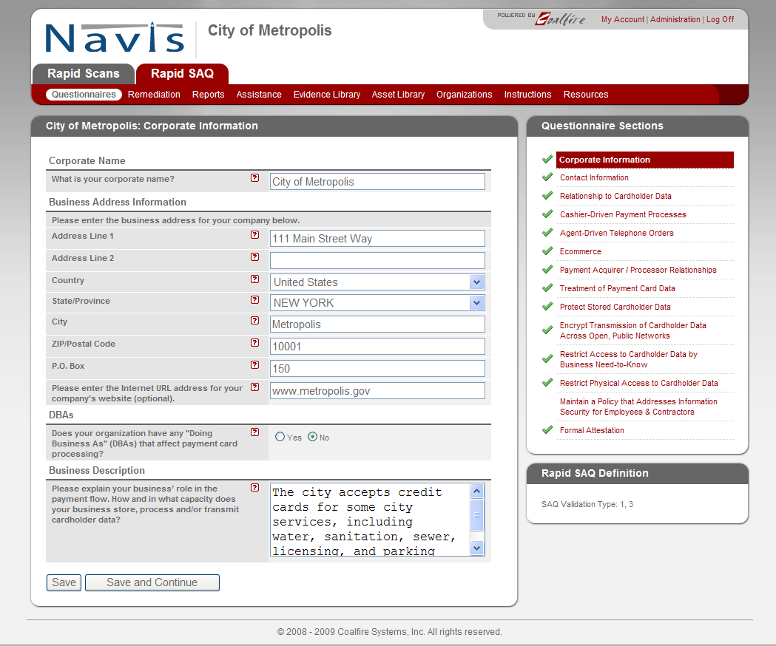

Assessment Process
- Rapid SAQ makes no assumptions about a merchant’s PCI / security knowledge or interpretation of the standards
- Rapid SAQ does not mimic the PCI SSC’s SAQ form, rather it steps merchants through the process with questions in plain English
- Based on responses:
- Automatically determines the appropriate validation type (A, B, C or D) for the merchant
- Presents only those follow-on questions that are appropriate to the merchant type
- Provides the ability to save, review and go back
- Provides contextual help
- Provides live Qualified Security Assessor (QSA) assistance

Contextual Help
Most questions have contextual help available on demand. Simply click on the “?”

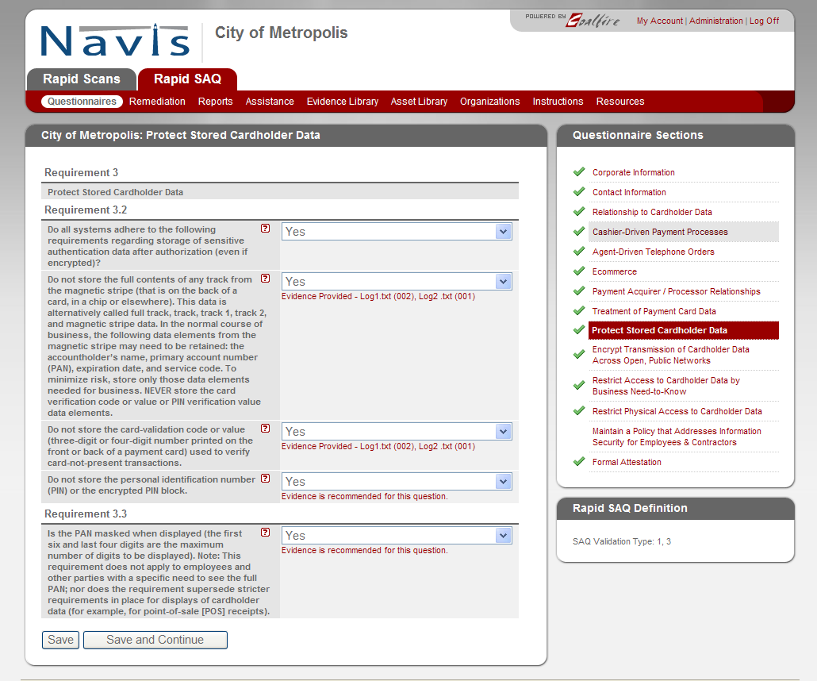

Facilitated Support
Many merchants have questions, particularly when going through the process the first time. To address this, Coalfire provides facilitated support for users of the Navis platform. Facilitated support allows merchants to interface with a knowledgeable, experienced Coalfire Systems QSAs. Facilitated support time can be used to answer specific audit and control questions, resolve issues, and help walk a merchant through the more complicated aspects of compliance.

Evidence Library
To protect your organization from future litigation, Coalfire has included the option of uploading ‘evidence of compliance’ into the Navis portal. Evidence files can be in any format – photos, text, Visio, PowerPoint, video clips, etc. The evidence Library can be viewed at any time and updated as procedures change.
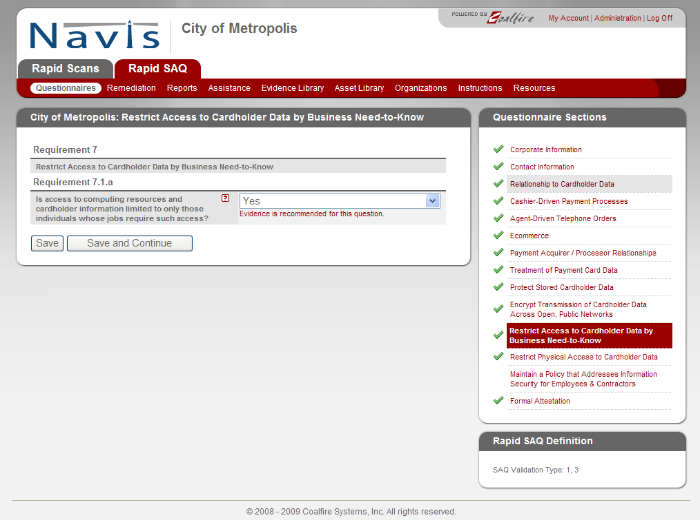

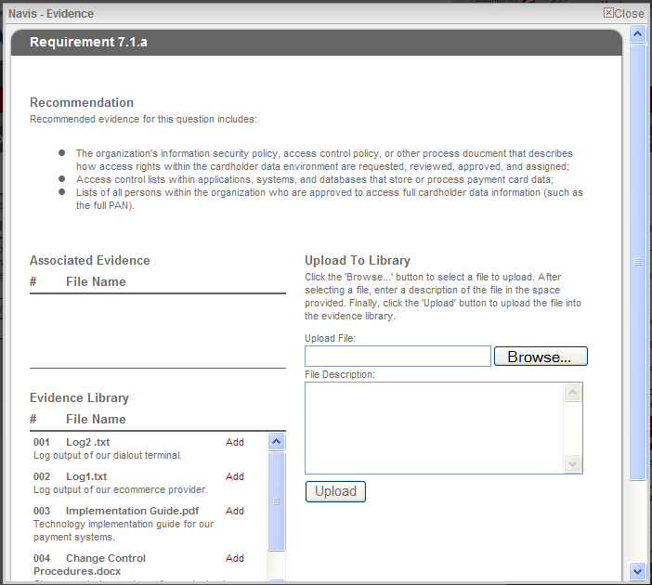

Support for Multiple Reporting Organizations
Rapid SAQ was specifically designed to support the complex PCI management, monitoring and reporting requirements of organizations with multiple locations and/or merchants.
- Define the organizational structures responsible for formally reporting SAQ responses;
- Define the organizational structures responsible for providing SAQ responses.

These functions are important, since many organizations may be required to submit only one complete SAQ to their acquirer despite maintaining multiple, independent cardholder data environments.

The Reporting Organizations module provides the ability to manage multiple, independent cardholder data environments consolidate reporting, prepare multiple SAQ schedules. Reporting organizations may “rollup” their compliance results to a parent and/or produce their own stand-alone PCI compliance documents.

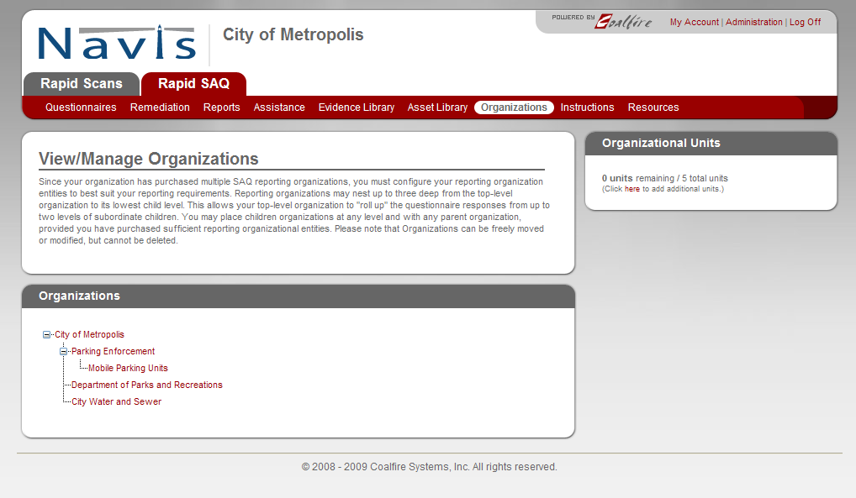

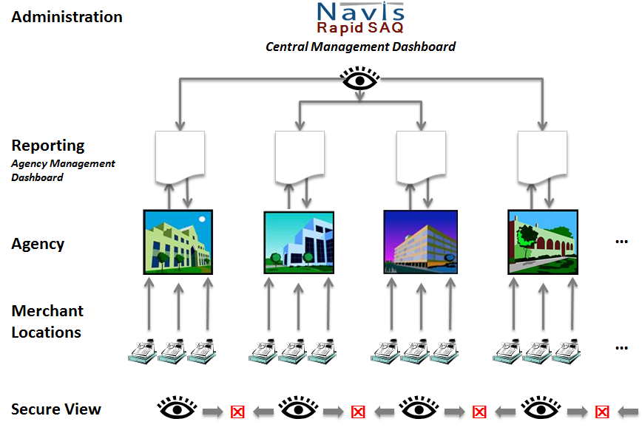
Other Features

Asset Library
Navis provides the ability to document and track assets that are used in the payment process. Assets can be hardware and software and third party service providers.

Resource Library
Coalfire recognizes that to complete the PCI process may require access to additional materials. The Resource Library is made available to all Navis clients and includes sample Payment Flow Diagrams, Policy templates, sample Vendor Management Contract Provisions, a Guide for Capital Planning, etc.

Reporting

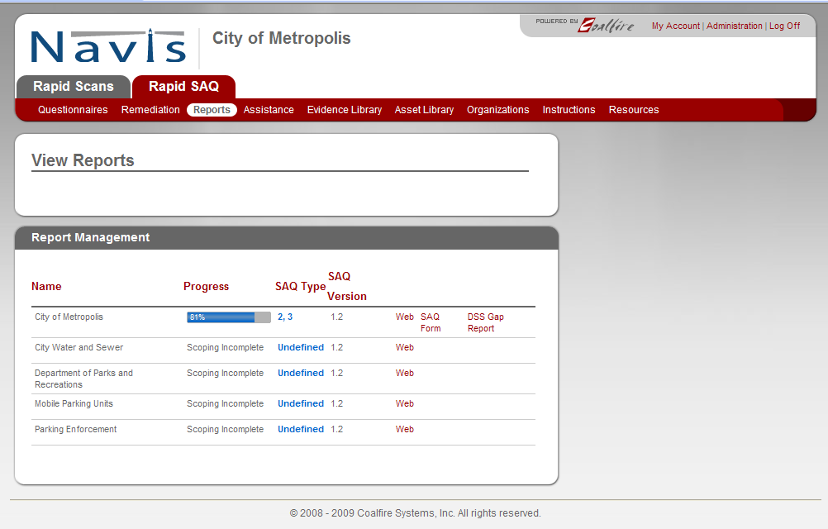
Each location only sees their information while the City has a dashboard view of all locations and can drill into individual reports (gaps, remediation, evidence library, etc.).

Automatically flags non-compliant responses and users can document required remediation tasks with start/end dates and task ownership

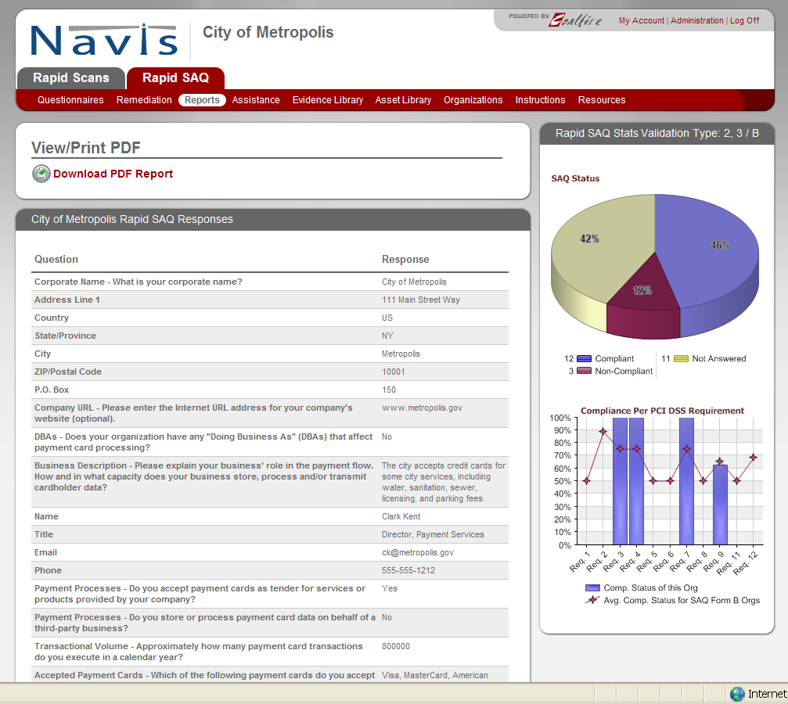

Selecting “Web” view provides a graphical view of compliance activities completed as well as a comparison to like organizations.

Reporting (continued)
When the RapidSAQ is complete (or anytime in the process, simple click on “SAQ Form” and RapidSAQ will automatically complete and generate the appropriate PDF report in the exact format required by the Payment Card Industry Security Standards Council (PCI SSC) and your acquiring bank or processor.

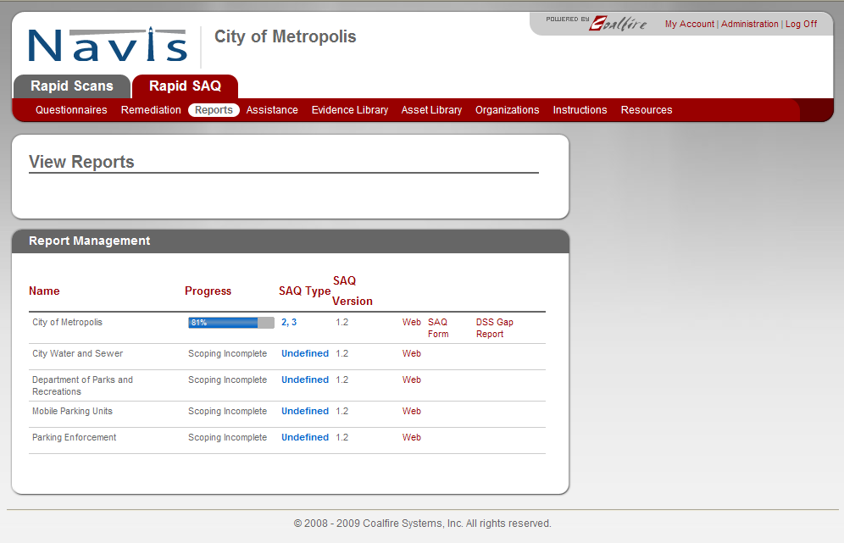



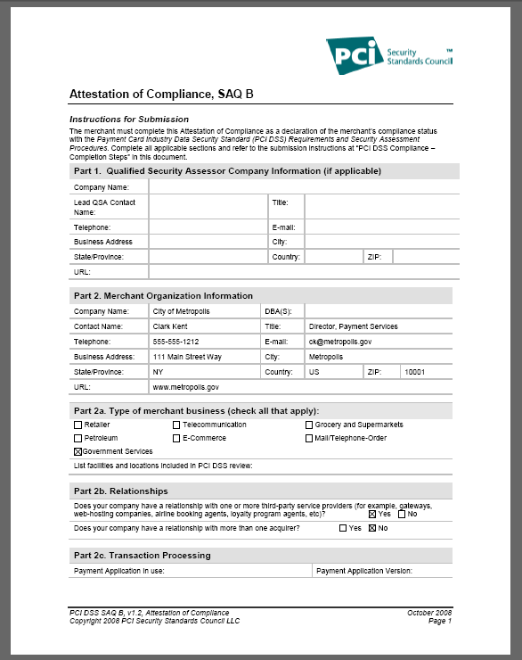

Administration
The Navis platform incorporates a robust and flexible administration interface. Administrative access, hierarchy and privileges can be organized to suit the organization’s requirements.

Task 3 - Quarterly External Scanning Service with RapidScan℠

PCI DSS 11.2 requires an Organization to conduct quarterly external vulnerability scans. An Authorized Scan Vendor (ASV), such as Coalfire Systems, must conduct these vulnerability scans.

Under this Service Order, Coalfire will provide the Organization with external vulnerability scans. As with RapidSAQ described above, RapidScan allows the Organization to self-manage its scans, while having the assurance that the results will meet the PCI DSS 11.2 requirements.

This service provides the four (4) required external quarterly scans and unlimited rescans as needed for each in-scope merchant location. Generally, re-scans are required for those quarters when the Organization needs to verify the success of any remediation actions taken to eliminate vulnerabilities detected in the original scan.

Deliverables:
- Access to the Organization’s RapidScan environment.
- A quarterly report for external vulnerability scans (1 report for each in-scope merchant location).
- A quarterly report showing found vulnerabilities, associated remediation advice and raw data.
- Quarterly check-ins with an assessor to clarify scan results and remediation approaches.

Task 4 - Quarterly Internal Scanning Service with Lighthouse™

PCI DSS 11.2 requires the Organization to conduct periodic internal vulnerability scans. These scans must be conducted across the infrastructure within the Cardholder Data Environment (CDE). Organization will be provided access to the online Rapid Scan service to self-manage its internal scans. These scans are conducted by the Coalfire Lighthouse™ appliance, which will need to be installed in your internal network. The appliance will be shipped to you upon execution of this service order.

The internal scan service provides the four (4) required internal quarterly scans and unlimited rescans as needed. Generally, re-scans are reserved for those quarters when the Organization needs to verify the success of any remediation actions taken to eliminate vulnerabilities detected in the original scan or when devices are added to the network.

Deliverables:
- Access to the Organization’s RapidScan environment
- A quarterly report for the internal vulnerability scans (1 report for each in-scope merchant location);
- A quarterly report showing found vulnerabilities, associated remediation advice and raw data.
- Quarterly check-ins with a Coalfire QSA to clarify scan results and remediation approaches.

Coalfire Leadership with Emerging Technologies

Information based services are evolving and transforming at a faster pace than ever before. This is especially true in the retail market where the convergence of social, mobile and online services are transforming the way retailers sell and consumers buy. The emerging technologies to that are at the heart of these changes bring new and difficult challenges for IT governance, security risks, industry compliance.

Coalfire understands the importance and value we bring our clients when we stay in front of these technologies. By understanding their impact and risks, we can provide thoughtful insights and advice as our clients address the inevitable changes in their IT environment. Our commitment is to maintain deep technical leadership in emerging technologies before our clients must address these challenges.

Coalfire delivers on that commitment through research (Coalfire Labs), security validation work and participation in industry standards groups with emerging technologies. We have been selected as the independent validation lab by some of the industry’s largest technology vendors; including HP, EMC, VMWare, Oracle, Microsoft, VeriFone, HyperCom and Voltage Security. In addition to our technical validation work, we have authored or contributed to many of the leading security reference architectures for emerging technology today.

The following is a brief summary of Coalfire’s Retail focused emerging technology practices and industry participation:

Mobile Payments Security
Coalfire has worked for the last three (3) years on validating retail mobile solutions for payments, POS and inventory management. We have a deep understanding of the significant security challenges the mobile environment presents solution vendors and retailers. Our experience has included direct work with platform OS vendors, payment solution vendors, hardware manufactures and security vendors. Coalfire participates on 5 major mobile standards bodies and was one of only 3 QSA’s to participate on the PCI SSC’s mobile security task force. Our mobile security team is consistently called on to speak at mobile security venues across the world. Coalfire has supported global merchants in security advisory role as they have designed, deployed and validated these mobile solutions. Coalfire has led the validation of some of the industry’s most innovative mobile solution available.

EMV and Contactless Payments Security
Through work with our payment solution and application vendors, Coalfire has assessed EMV and contactless payment technologies across multiple payment regions. We leverage our broad industry expertise and participation working with mobile security, global acquirers, card brands, terminal manufactures and EMVCo to help guide our clients in selecting appropriate EMV and contactless payment solutions.

Virtualization and Cloud Security
Virtualization continues to be the fastest growing IT change for retail server environments. Coalfire has been on the cutting edge for the last 5 years on contributing to industry standards and improving vendor solutions to address virtual security and compliance challenges. Coalfire has led many industry special interest groups working on virtualization security including the PCI SSC virtualization SIG. Over the last couple of years Coalfire has leveraged this expertise to become one the world’s leading firms on Cloud Security and Compliance. Coalfire has been selected by both VMWare and HP to help design and validate their cloud security reference architectures. Coalfire has published many white papers and regularly presents on cloud security challenges and solutions.

Encryption and Scoping
The use of encryption has always been one of the most challenging security tools for the retailer. Using encryption to remove the exposure of credit card data to a merchants systems and environment has had years of attention across the industry. Over the years Coalfire has established ourselves as the leader in these emerging technology trends. Coalfire is the selected independent validation firm for almost every retail encryption solution vendor including VeriFone, Voltage, Magtek and RSA. Coalfire was used as the technical reference firm by the PCI SSC as they formulated their approach to P2PE and Coalfire was a founding participant of the PCI SSC P2PE SIG. Coalfire has validated encryption solutions for merchants with ecommerce, mobile and terminal card present environments. Coalfire continues to support retailers, technology vendors and service providers in deploying encryption solutions to reduce risk to card data and reduce compliance scope.

Cloud Computing and VMware:
Coalfire is currently the only assessor in the country certified to conduct Cloud assessments for PCI, FedRAMP (3PAO) and HITRUST. Our independence as an assessor (not a provider of clouds) puts us in a unique position which has allowed us to provide strategic services for leading providers and software/hardware vendors of the cloud.

We are the only assessor which has created a dedicated team of VMware and virtualization experts and is endorsed through the VMware TAP Elite program. With over 1,000 assessments conducted last year, we have the experience and knowledge about the cloud which no others can match.

Data Breach Response Capability

Incident Response (IR) Support Service from Coalfire Labs

This is an annual retainer service which includes:
- Annual review of an Agency or Department’s IR Plan to ensure it is aligned to PCI and State Privacy Laws (FTC)
- Facilitation of annual test of the IR Plan (4 hour Table Top, with 4 additional hours report preparation)
- Up to 10 hours of Incident Response support
- Reduced rate on forensics services
- Option for a forensics snapshot of a single system as part of the annual IR Test
- Availability of Coalfire forensics personnel for data collection and analysis to support an information breach

Incident Response: Onsite Data Collection
Under the direction of a qualified Incident Project Leader, Coalfire Labs will dispatch a data discovery and acquisition team to the incident site. The data acquisition team will interview key stakeholders to define and/or identify systems architecture, data locations, incident details and key search criteria to be leveraged in subsequent phases. All cases will be considered work product for the project leader and will be protected under a structured Chain of Custody Process.

The primary goal of the data discovery and acquisition team will be to collect perishable evidence that could be used to support claims or defined against counter claims involving the digital evidence in the case. The data collection team will interview staff to determine who is involved, time frames of a potential incident and the location of digital evidence.

The data discovery process will also attempt to identify the specific systems involved in the incident and the environment that could impact those systems. Typical environmental considerations will be the reliability and integrity of the data collected. Are systems compromised with malware in addition to being part of a data breach or data misuse case? If possible, the data discovery team will attempt to identify controls deployed to limit access, monitor system and data use and other controls that could either be useful in defending client claims or proving control weaknesses that would diminish the strength of subsequent findings. Coalfire maintains data discovery teams with data collection tools in Seattle, Boulder, New York and Dallas. Data collection services include the following:

- Interviews and case notes
- Compromised system data dicosvery and image copies
- Chain of Custody process to protect digital evidence
- Collection of evidence for system level controls (access controls, patching, perimter security, other logs, etc)
- Records form previous assessments, current archtecture drawings, etc.
- Optional Forensic Media Duplication / Imaging service

Incident Response: Lab Recovery & Analysis
Upon capture of evidence and data, Coalfire will perform data recovery and analysis at one of its facilities in Seattle, Washington or Louisville, Colorado. This two-step process will forensically duplicate data from the original media to the analysis platform and then launch automated image builds for forensic analysis. This initial process will also include launching automated searches for key terms or criteria. In this early phase, the tools perform most of the work dependent on the parameters entered by the analyst. This recovery, loading and automated search process is media and data format sensitive and the recovery times and initial search minimum fees are listed below.

Once the data is loaded onto the analysis platform (most likely Encase or FTK), and the automated searches are completed, an experienced forensic examiner will review the finding and conduct additional targeted searches based upon early results. This effort varies based upon the data and is typically time limited by the project leader. Once initial findings are reviewed, the project leader may authorize additional time to specifically clarify results or further investigate specific details.

Coalfire Certificate Program

http://www.coalfire.com/Coalfire-Certificate-Program

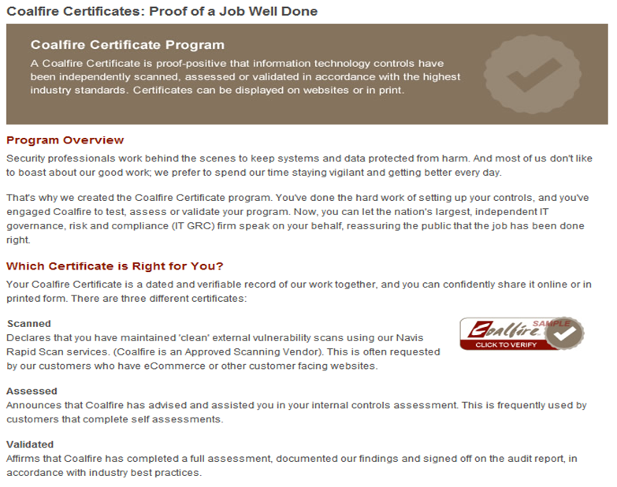

Engagement Methodology for Level 1 and 2 Eligible Entities (PCI ROC)

Completing a Report on Compliance is a multifaceted endeavor and not a trivial undertaking. Coalfire Systems, Inc. (Coalfire) is certified by the PCI Security Standards Council (PCI SSC) as a Qualified Security Assessor company.

Coalfire engagement methodology is intended to meet these project objectives:
- Completion of an Eligible Entity’s PCI Report on Compliance (ROC);
- Completion of an Eligible Entity’s Attestation of Compliance (AoC)
- Facilitation of an Eligible Entity’s quarterly external vulnerability scans;
- Facilitation of an Eligible Entity’s quarterly internal vulnerability scans;
- Provide input and recommendations for an Eligible Entity’s on-going PCI DSS compliance program.

Task 1 - Project Charter – Complete Project Charter process with Eligible Entity
Typically, a few weeks prior to the beginning of a project, the Coalfire Project Leader will schedule a kick off meeting (Project Charter) with the Eligible Entities project team. The purpose is to re-state objectives and align all stakeholders to specific roles and responsibilities, communication methods and schedules. The charter meeting serves to introduce key project participants, communicate and agree on roles and responsibilities, establish key dates and timelines, and discuss project methodologies and tools.

Activity | Activity Description
Introduction | Introduction of all stakeholders and coordination of project team members.
Roles and Responsibilities | Establish and agree on roles and responsibilities for project team members. Identify primary project contact points for project activities.
Timelines & Milestones | Establish and agree on timelines and milestones. Set meeting dates.
Review and Approve Methodologies and Tools | Review the Coalfire methodology and tools. A secure project portal is established to create a central place for all participants to store and retrieve working documents.
Access Rights | All approved team members will be granted access rights to the Project Portal

NOTE:
Prior to the Charter Meeting, Coalfire will provide the Eligible Entity with a list of a list of documents our team would like to review to prepare for the Charter by gaining a god understanding of the environment and make the best use of time while an disruption of the normal staff activities. These may include:
- Previous completed assessment documentation (e.g. penetration test report)
- Previous completed network diagrams
- Current policies and procedures
- Status of previous recommendations / remediation activities identified in prior assessments
- Inventory of applications
- Configuration standards

Task 2 - Project Portal
Coalfire deploys a secure, on-line Project Portal for each engagement. Coalfire believes in providing the highest level of communication, not just at the end of the project, but also during the project. That’s why all project processes are managed through a web-based portal that maintains the project chartering, budgeting, scoping, project plans, status reports, task assignments, stakeholders and communication channels, milestone tracking, reports and deliverables.

The portal is a living tool for managing the project from our perspective and it helps all staff remain fully informed on project progress.

The portal provides a centralized repository for:
- Final reports, work-in-progress reports, and raw data. The Portal also includes complete change control for documents and check-in and check-out authorization.
- Access is defined each Eligible Entity and users roles can be tightly defined based on project role and “need-to-know” including access to critical audit reports.
- Contact information for all team members.
- A calendar that ties to key deliverable dates decided during the Charter Meeting
- Security resources and best practices.

Portal Benefits:
- Secure alternative to sending sensitive information via insecure email
- Centralized document control
- Eliminates duplication
- Full audit trail of user activities
- Notification of changes/new content
Task 3 - Card Data Environment (CDE) Definition

Coalfire will assess the Eligible Entity’s Card Data Environment (CDE) by reviewing IT controls and data security design in accordance with the PCI DSS.

The CDE will be defined in accordance with practices and procedures adopted by the PCI Security Standards Council (PCI SSC) and will be based on interviews, documentation inspection and technical testing tasks conducted by Coalfire. As part of this task, the Organization and Coalfire will jointly review the CDE and determine the completeness and accuracy of the CDE. Work activities are then performed to validate completeness and operating effectiveness of the controls within the CDE compared to the PCI DSS and ROC assessment standards.
Deliverable:
A definition of the Cardholder Data Environment (CDE). The CDE definition is a document that inventories the systems, applications, and business processes owned and operated by the Organization, or provided as a service under Organization management, that store, process, or transmit cardholder data. The Organization and Coalfire will jointly review the CDE and determine the completeness and accuracy of the CDE.

Task 4 - PCI DSS Report on Compliance

The Report on Compliance (ROC) defines and assesses the cardholder environment by reviewing general IT controls and data security design concepts in accordance with the PCI DSS. Testing and validation of controls is required to complete the ROC and identify control compliance and non-compliance to the PCI DSS. Only applicable controls that are part of the CDE are subject to testing. Through a combination of interviews, observations, control performance and technical testing, Coalfire completes the assessment according to PCI DSS testing procedures.

Details regarding QSA security auditing procedures may be downloaded at:
https://www.pcisecuritystandards.org/security_standards/pci_dss_download.html

In the event that controls are found to be non-compliant, Coalfire will provide the reason we found the control/s non-compliant along with prioritized recommendations for remediating the compliance gaps.

All controls that require remediation will be compiled into a Remediation Roadmap that will provide additional detail on each gap and potential remediation strategies. The roadmap will be sorted based on the risk of each as presented in the PCI Security Standard Council’s “Prioritized Approach to PCI” publication and Coalfire’s understanding of the risk within your environment.

Deliverables:
- PCI DSS Report on Compliance
- If compliance gaps are identified, a Remediation Roadmap which identifies the gaps and presents suggested mitigation activities to close the gaps.
- If no compliance gaps are identified, an Attestation of Compliance (AOC) is completed by Coalfire. The AOC can be submitted to the Organization’s acquiring bank and the card brands.

Task 5 - Quarterly External Scanning Service with RapidScan℠

PCI DSS 11.2 requires an Organization to conduct quarterly external vulnerability scans. An Authorized Scan Vendor (ASV), such as Coalfire Systems, must conduct these vulnerability scans.

Under this Service Order, Coalfire will provide the Organization with external vulnerability scans. As with RapidSAQ described above, RapidScan allows the Organization to self-manage its scans, while having the assurance that the results will meet the PCI DSS 11.2 requirements.

This service provides the four (4) required external quarterly scans and unlimited rescans as needed for each in-scope merchant location. Generally, re-scans are required for those quarters when the Organization needs to verify the success of any remediation actions taken to eliminate vulnerabilities detected in the original scan.

Deliverables:
- Access to the Organization’s RapidScan environment.
- A quarterly report for external vulnerability scans (1 report for each in-scope merchant location).
- A quarterly report showing found vulnerabilities, associated remediation advice and raw data.
- Quarterly check-ins with an assessor to clarify scan results and remediation approaches.

Task 6 - Quarterly Internal Scanning Service with Lighthouse™

PCI DSS 11.2 requires the Organization to conduct periodic internal vulnerability scans. These scans must be conducted across the infrastructure within the Cardholder Data Environment (CDE). Organization will be provided access to the online Rapid Scan service to self-manage its internal scans. These scans are conducted by the Coalfire Lighthouse™ appliance, which will need to be installed in your internal network. The appliance will be shipped to you upon execution of this service order.

The internal scan service provides the four (4) required internal quarterly scans and unlimited rescans as needed. Generally, re-scans are reserved for those quarters when the Organization needs to verify the success of any remediation actions taken to eliminate vulnerabilities detected in the original scan or when devices are added to the network.

Deliverables:
- Access to the Organization’s RapidScan environment
- A quarterly report for the internal vulnerability scans (1 report for each in-scope merchant location);
- A quarterly report showing found vulnerabilities, associated remediation advice and raw data.
- Quarterly check-ins with a Coalfire QSA to clarify scan results and remediation approaches.

WORK PLAN SCOPE OF PERFORMANCE- SPECIFIC SERVICE DESCRIPTIONS

PCI COUNCIL APPROVED SCANNING VENDOR (ASV) AND INTERNAL AND EXTERNAL SECURITY AND VULNERABILITY SCANS
Bidders selected in this category must provide the broadest and most sophisticated state of the art suite of scanning and internal and external security and vulnerability audits and penetration testing resources and tools. In this section

Bidder must provide a very detailed description of all available scanning, internal and external penetration testing resources and tools, and any other manual or automated tools and resources available by the Bidder for testing security compliance and vulnerabilities.

Bidder should specifically address the following types of tools and a complete work plan and description of how each is implemented, including what resources are needed from an Eligible Entity to use these tools.

- Hardening Scans
- PCI Compliance Scans (all available)
- Penetration Tests (network, application, other)
- Vulnerability Scans
- Application Scans
- Web Application Scans
- Mobile Device Security Scans/Reviews
- Network scans/port scans/traffic monitoring/packet scanning
- Virus Scans
- And any other available scan or testing options for system or other vulnerabilities

C-1. B. ANSWER: [Insert Work Plan – Full Service Description Here]

- PCI Compliance Scans (all available)

RapidScan™ Overview
Coalfire’s scanning service supports more than 1000 clients globally, and this enterprise-level service is designed to identify and prioritize vulnerabilities in accordance with prevalent risks.

Rapid Scan is a fully automated tool that is supported by Coalfire’s dedicated scan desk. Based on a range of external facing IP addresses provided by the client, Rapid Scan scans the IP range. The purpose of the scan is to identify accessible systems and vulnerabilities on those systems from an un-trusted network location. Identification of these vulnerabilities allows the organization to measure itself against the PCI security program and take proactive remediation actions to maintain adequate protection of cardholder data.

The scanner performs device discovery to identify active IPs using the following:
- ICMP
- TCP ports 21, 22, 23, 25, 80, 88, 110, 111, 135, 139, 143, 220, 264, 389, 443, 445, 449, 524, 585, 636, 993, 995, 1433, 1521, 1723, 3389, 8080, 9100
- UDP ports 53, 67, 111, 135, 137, 161, 500, 1701

For each of the active IPs, the scanner performs service discovery to identify open ports using the following:
- All possible TCP ports (1-65535)
- Well-known UDP ports (1-1023)

For each of the open ports, the scanner performs vulnerability tests as required by PCI SSC. The scanner does not and is not permitted by PCI SSC to perform disruptive tests such as the following:
- Denial of service (DoS)
- Buffer overflow exploit
- Brute-force attack resulting in a password lockout
- Excessive usage of available communication bandwidth

Step 1 - Define IP Range
The first step is to identify the externally facing IPs to scan. This can be an IP range or single IP/s:
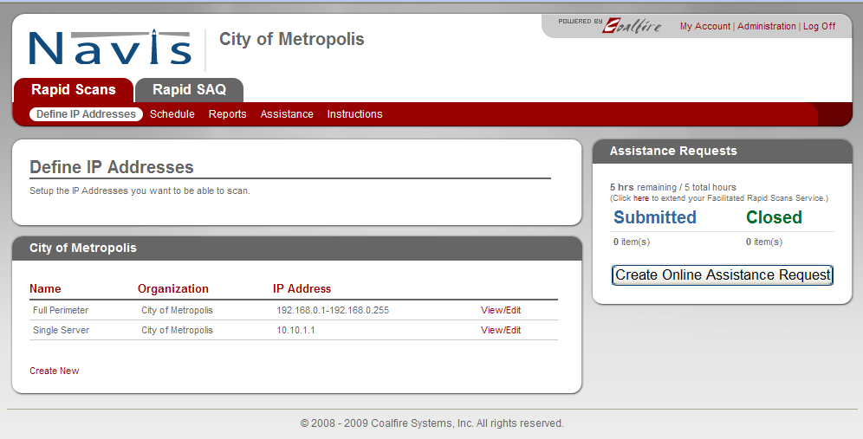

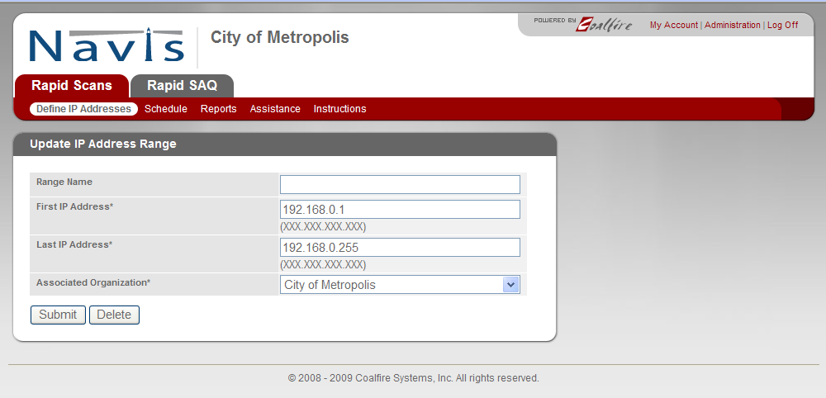
Step 2 - Schedule Scans
The next step is to schedule the scans:
- Start date
- Time of day
- Time zone
- Scan cycle

Help is always available by clicking on assistance.

Step 3 - View Reports
ASV Scan Reports consist of three sections:
- Attestation of Scan Compliance -- an overall summary for the entire customer infrastructure.
- Executive Summary -- a component summary for each scanned component.
- Vulnerability Details -- vulnerability details for each scanned component.

A completed scan has one of the following results:
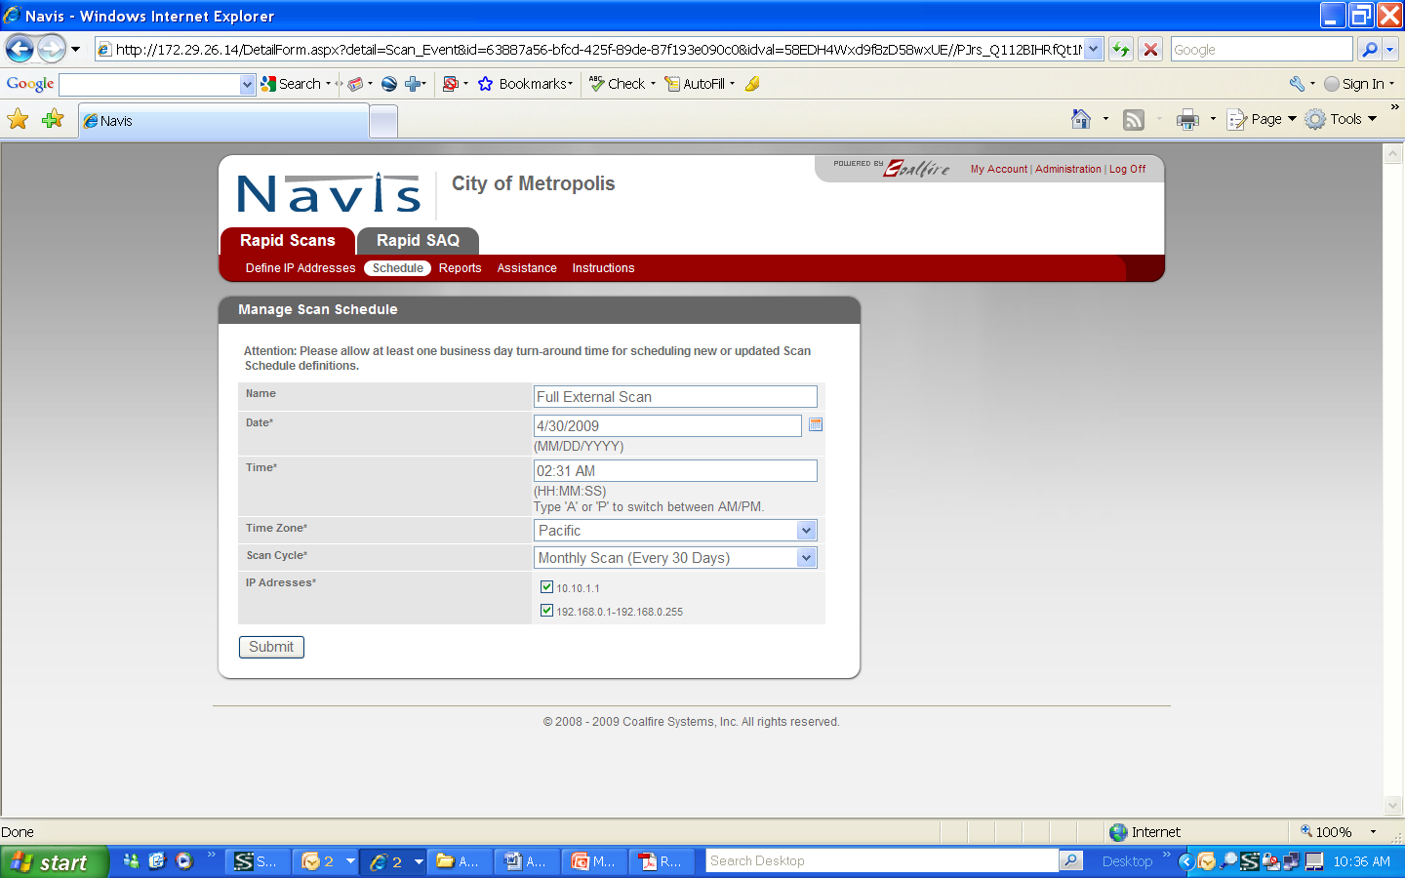
- Passing scan
- Scan customers ONLY submit passing scan reports.
- Failing scan for which the scan customer disputes the results.
- Scan customer and ASV resolve any scan disputes or exceptions.
- Failing scan that the scan customer does not dispute.
- Scan customer resolves failing vulnerabilities.

RapidScan provides both detailed and summary reports:

Step 4 – Remediate Gaps
For failing scans, the scan customer uses the following general process until all failing vulnerabilities are corrected and a passing scan is achieved:
- Scan customer corrects noted failing vulnerabilities.
- Scan customer may seek help from the ASV or other security professional as needed to determine proper corrective actions.
- Scan customer contacts ASV to initiate another scan.
- If passing scan is achieved, scan customer submits results to the acquirer.
- For failing scans, scan customer repeats the above steps.

RapidScan provides remediation guidance for identified vulnerabilities. Example:
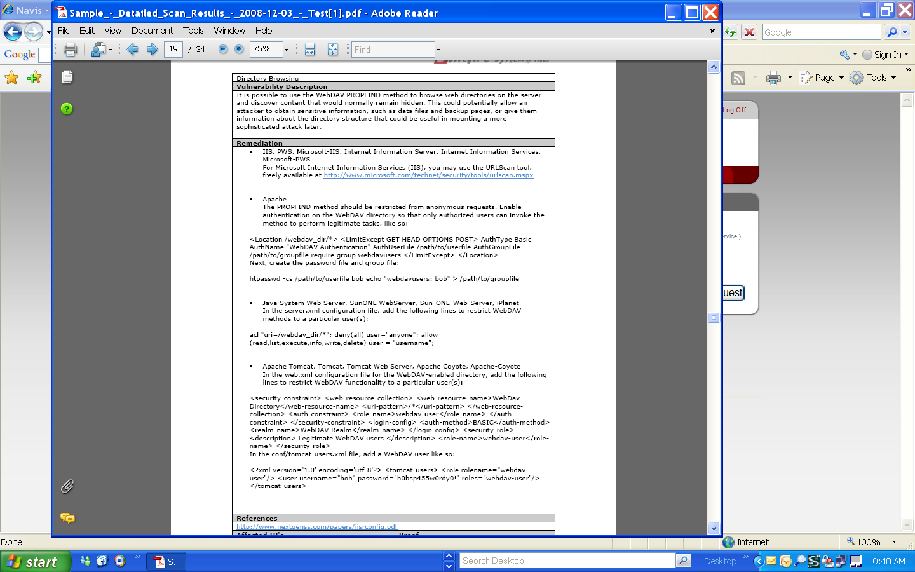

- Penetration Tests (network, application, other)

1. Internal and External Penetration Testing

Methodology
Using a variety of automated scanning tools (both open source and commercial) Coalfire Penetration Assessors will gather and classify all systems, open ports, running services, and vulnerabilities detected within the target environment. Analysis will then be conducted on each vulnerability finding to determine the various attack vectors available. With automated tools, manual techniques and a vast internal knowledge base, Coalfire Assessors will attempt to safely exploit vulnerability findings to demonstrate the level of risk. The following types of vulnerabilities are identified during the network penetration test:

- Remote Code Execution (Stack Overflow, Format String bugs)
- Weak Configuration
- Susceptibility to Malware
- Patch Level enumeration
- Use of insecure services and protocols
- Web Server Vulnerabilities
- Database Server Vulnerabilities

Tools
Standard tools Coalfire utilizes for its Penetration Tests include:

 | Hailstorm – Cenzic’s Hailstorm is a leading suite of automated Web application security and compliance assessment tools that scan for common application vulnerabilities. This tool specializes in detecting application-layer vulnerabilities such as Cross-Site-Scripting and SQL injections.
 | Rapid 7’s NeXpose – Has been named the "Best Vulnerability Assessment Solution” by SC Magazine. Coalfire has found Rapid 7’s award winning NeXpose vulnerability assessment tool to be the best available off-the-shelf tool for internal vulnerability scans and checks for more than 30,000 vulnerabilities. Rapid7 also acquired MetaSploit in 2009, and had integrated its tools into the scanning product.
 | Metasploit is an open-sourced project managed by Rapid7. It provides useful information to people who perform penetration testing, IDS signature development, and exploit research. This project was created to provide information on exploit techniques and to create a useful resource for exploit developers and security professionals.
 | Open Source - In addition to commercial products, Coalfire may leverage open source tools including: Cain & Able, L0phtcrack, Nmap, Nikto/Wikto, Superscan, SSL Digger, Nessus, Microsoft Baseline Security Analyzer (MBSA), and Center for Internet Security (CIS) Benchmarks.
Task 1 – Passive Attack Surface Analysis
The objective of this task is to identify specific exploitable vulnerabilities and expose potential access to Eligible Entity systems and/or sensitive data, including hosts accessible from networks located outside of the Eligible Entity’s perimeter firewalls.

This task begins with a “blind” assessment of an Eligible Entity’s public presence. We have found this to be an important phase of any Penetration Test process. It emulates the first step in a targeted attack that emulates an Internet-based threat agent attempting to gather information in preparation for an attack.

Methodology:
The Attack Surface Analysis aggregates publicly available information that may identify sensitive details regarding an Eligible Entity’s IT operations. With no information about the network, Coalfire engineers will gather public information that is available that would be of value to an Internet-based threat agent. Coalfire engineers not familiar with the Organization will perform this work. No information gathered by the Coalfire Sales team is shared with the team at this point. For this analysis the engineer is provided only the Organization’s name.

This process provides a true perspective of what information a skilled hacker can gather from public sources, and it is potentially the first step before a targeted attack. Many points of information cannot be concealed. This test provides you with an analysis of the extent of information available, and, where possible, how to limit information and better conceal your sensitive information. Limiting publicly available information is an essential “first line of defense”, and this assessment activity any independent external network security assessment.

The following information is gathered from public sources as part of the reconnaissance assessment:
- Service providers for Internet access, Web Hosting, and Domain Name Service (DNS)
- Whois records
- Domain Server records
- BGP Routing Summary from public Internet exchange points
- Header information from public web servers
- Personal address lookups gathered from whois record information
- Personal address lookups listed on the company website
- News Group and Web Board searches for messages posted from the company
- Social Media searches for company presence or staff associations: Facebook, LinkedIn, MySpace, Google+, Pinterest, Twitter, etc.
- Searches for job postings from the company
- Searches for resumes from employees who recently left the company
- Searches for technology used by the company

For this assessment, Coalfire will also perform active network mapping from various Internet locations to create as complete a network map as possible, augmented with the information gathered above. Coalfire uses numerous types of port scanning techniques to identify gateways, stateful / non-stateful firewalls, switching infrastructure, and physical or virtual hosts. Throughout the project, this will be a ‘living document’ - as other tasks progress, any information gained will be added to the network map in order to provide a comprehensive view of the Organization’s public presence.

Task 2 – Network Vulnerability Scanning
Coalfire conducts a vulnerability scan to identify platform and configuration issues as well as to identify focus areas for our security team’s manual penetration efforts. The tests are divided into four components:
- Port Scanning; the invasive probing of system ports on the transport and network level. Included here is also the validation of system reception to tunneled, encapsulated, or routing protocols.
- Service identification; the active examination of the application listening behind the service.
- System identification; the active probing of a system for responses that can distinguish unique systems to operating system and version level.
- Vulnerability testing; an efficient way to determine existing holes and system patch level.

Task 3 – External Penetration Testing
The Vulnerability Scan above provides the Coalfire security team with a large volume of raw data. It is necessary to analyze this data and develop attack plans. It’s important to understand that the attack scenario is highly dependent on the environment. An identified vulnerability may be easily attacked leveraging a known tool or attack script, while a separate vulnerability may require the security team to write unique attack scripts. To keep the scope and level of effort reasonable, lower priority vulnerabilities may not be targeted, as they may not present an obvious threat.

Penetration attempts will be done at the network level. These attacks will attempt to elevate or circumvent network privileges and access sensitive data. If the vulnerability scan identifies ports available for web services, and those ports are not associated with common off-the-shelf software products, Coalfire will contact the Eligible Entities’ project manager to request additional budget to include application penetration testing.

Coalfire will scan all of the Eligible Entities’ external IP addresses and conduct penetration testing on the external IP addresses that present the most risk to the environment. Coalfire will also run a stateful validation test for all firewall IP addresses.

2. Internal Penetration Testing

Target Analysis
Using the output from the reconnaissance activities, and leveraging the vulnerability assessment data, Coalfire will identify likely candidates for attack based on their presumed business purpose or role in the environment. This target selection will be documented as part of the Internal Penetration Testing Attack plan and will be used to assist in refining targets for exploitation.

Internal Penetration Testing
Many cyber losses occur due to intentional or unintentional misuse of informational assets from trusted locations. Using highly controlled and monitored procedures, Coalfire’s internal assessment and penetration test replicates network behavior that exploits weak internal security controls and vulnerabilities on the LAN. Extreme care is taken to avoid disrupting normal operations.

Penetration testing will be performed to assess if the vulnerabilities identified can actually be exploited by an insider. Unlike a vulnerability scan, penetration testing subjects a system to a real-world attack scenario. The benefit of a penetration test is that it identifies the extent to which a system can be compromised through attempts to circumvent the Organization’s security controls, and it assesses the response mechanism’s effectiveness.

This testing will be done from a trusted network location in a black-box manner with no credentials to simulate an internal user with only physical access to a switch port. Goals are similar to the External Penetration Testing task, but can be altered to have our team focus on pursuing and pilfering specific types of information once access is gained.

Deliverable:
The final report will include a detailed description of the penetration tests conducted and their results, and the specific vulnerabilities that led to compromise. These will be accompanied by screenshots or video demonstrating exploitation, and will be ranked according to severity and impact. Recommendations for effectively remediating the root cause of the compromise will be described in detail where appropriate.

3. Wireless Network Security Assessments
The Coalfire wireless assessment tests for all known and unknown (rogue) wireless access points in and around the locations identified by the Eligible Entity. These wireless tests encompass and include the wireless standards currently authorized by the client, whereas rogue wireless testing covers and includes the 802.11(a, b, g) standards.

The wireless assessment is divided into these major assessment activities:
- Determine the range of the 802.11(a/b/g) networks around the facility
- Determine the SSID for all access points on the network
- Determine type and strength of wireless encryption used, if any
- If possible break the encryption (based upon traffic and timeframe)
- If possible, determine IP address range used on the network
- If possible, determine the use of a DHCP server
- If possible, determine if MAC address security is being utilized
- If possible, use an unauthorized computer to join the network
- If possible, determine if additional VPN Software use is implemented

Assuming optimal circumstances, expected results may include:
- A map of the outer most physical edge of the wireless network
- The access points for the network
- The IP range and possible DHCP server of the wireless network
- The encryption used on the network
- Amount of time used to break the encryption
- What security measures are implemented
- If access to the network could be obtained.
- Extent of network access.
- Recommendations for remediation including technical descriptions for securing wireless networks.

Tools that may be used for the wireless network assessment include:
- Kismet
- KisMAC
- Airsnort
- WEPcrack
- Network Stumbler
- Cain and Able
- insider
- Xirrus Wi-Fi Inspector

- Vulnerability Scans:

1. External Vulnerability Scans
Coalfire’s External Network Vulnerability Assessment extends basic automated scanning to provide manual validation and analysis of scanner identified vulnerabilities. The level of analysis and reporting provided with this service helps eliminate common false positives produced by automated scanning, and facilitates a more precise understanding of the actual security posture of systems in scope.

Methodology:
Using a variety of automated scanning tools (both open source and commercial) Coalfire Assessors will gather and classify all systems, open ports, running services, and vulnerabilities detected within the target environment. Analysis will then be conducted on each vulnerability finding taking system configuration and context into consideration to determine precise severity rankings.

The following types of vulnerabilities are identified during the network vulnerability assessment:

- Remote Code Execution (Stack Overflow, Format String bugs)
- Weak Configuration
- Susceptibility to Malware
- Patch Level enumeration
- Use of insecure services and protocols
- Web Server Vulnerabilities
- Database Server Vulnerabilities

Standard tools Coalfire utilizes for its Vulnerability Assessment include:

Tool Name | Description
NeXpose Rapid 7 | Vulnerability assessment tool to identify security issues. Named the "Best Vulnerability Assessment Solution” by SC Magazine.
Cenzic Hailstorm | A suite of automated Web application security and compliance assessment tools that scan for common application vulnerabilities. This tool specializes in detecting application-layer vulnerabilities such as Cross-Site-Scripting and SQL injections.
BackTrack | Open-source security testing toolkit to identify and exploit security issues.
Metasploit | Exploitation framework to compile and execute exploit code.
NMAP | ("Network Mapper") is a free and open source utility for network exploration or security auditing.
Additional tools | Various Search Engines, Whois and DNS Enumeration, Usenet, Google Hacking Database, Wikto, Wayback Machine, Sam Spade, Cain&Able, Nessus, Netcat, Dsniff, Wireshark, THC Hydra, THC SSLCheck, Nikto, MiB Browser, soapUI, NIST CVSS 1998-2008 Archive List

Deliverable:
The result of this Task is a detailed report on validated vulnerabilities including risk ratings, and recommendations for remediation. Coalfire will also provide a debriefing to discuss findings and remediation with stakeholders.

2. Internal Vulnerability Scans
Coalfire’s Internal Network Vulnerability Assessment extends basic automated scanning to provide manual validation and analysis of scanner identified vulnerabilities. The level of analysis and reporting provided with this service helps eliminate common false positives produced by automated scanning, and facilitates a more precise understanding of the actual security posture of systems in scope.

Methodology:
Using a variety of automated scanning tools (both open source and commercial) Coalfire Assessors will gather and classify all systems, open ports, running services, and vulnerabilities detected within the target environment. Analysis will then be conducted on each vulnerability finding taking system configuration and context into consideration to determine precise severity rankings.

The following types of vulnerabilities are identified during the network vulnerability assessment:

- Remote Code Execution (Stack Overflow, Format String bugs)
- Weak Configuration
- Susceptibility to Malware
- Patch Level enumeration
- Use of insecure services and protocols
- Web Server Vulnerabilities
- Database Server Vulnerabilities

Standard tools Coalfire utilizes for its Vulnerability Assessment include:

Tool Name | Description
NeXpose Rapid 7 | Vulnerability assessment tool to identify security issues. Named the "Best Vulnerability Assessment Solution” by SC Magazine.
Cenzic Hailstorm | A suite of automated Web application security and compliance assessment tools that scan for common application vulnerabilities. This tool specializes in detecting application-layer vulnerabilities such as Cross-Site-Scripting and SQL injections.
BackTrack | Open-source security testing toolkit to identify and exploit security issues.
Metasploit | Exploitation framework to compile and execute exploit code.
NMAP | ("Network Mapper") is a free and open source utility for network exploration or security auditing.
Additional tools | Various Search Engines, Whois and DNS Enumeration, Usenet, Google Hacking Database, Wikto, Wayback Machine, Sam Spade, Cain&Able, Nessus, Netcat, Dsniff, Wireshark, THC Hydra, THC SSLCheck, Nikto, MiB Browser, soapUI, NIST CVSS 1998-2008 Archive List

Deliverable:
The result of this Task is a detailed report on validated vulnerabilities including risk ratings, and recommendations for remediation. Coalfire will also provide a debriefing to discuss findings and remediation with stakeholders.

- Web Application Scans

Vulnerable web facing applications are rapidly becoming the most popular attack vector of malicious hackers. Coalfire’s Application Penetration test extends an automated vulnerability scan to determine if vulnerabilities can be exploited to compromise the application and the data it stores.

Methodology:
Testing will be conducted with typical credentials of a standard privilege user. The purpose of these tests is to determine whether a user can “jump” into other accounts, elevate privileges and gain access to restricted portions of the application or the data.

Coalfire uses Cenzic’s Hailstorm tool to quickly scan and analyze the web applications, looking for common logical and coding errors. Additional tools, such as BackTrack & the Metasploit framework, along with manual test scripts expand the scope of the application penetration testing. Even after gathering the raw data from Hailstorm and other methods, the application vulnerabilities usually demand a great deal of manual exploitation activities. Since web applications often exist in distributed environments and could span several architectural tiers, unintentional errors in programming and configuration can lead to vulnerabilities that could compromise an entire network.

The following list is representative of the key areas tested and is aligned with the OWASP Top 10 Vulnerabilities:

A1: Injection
A2: Cross-Site Scripting (XSS)
A3: Broken Authentication and Session Management
A4: Insecure Direct Object References
A5: Cross-Site Request Forgery (CSRF)
A6: Security Misconfiguration
A7: Insecure Cryptographic Storage
A8: Failure to Restrict URL Access
A9: Insufficient Transport Layer Protection
A10: Unvalidated Redirects and Forwards

- Mobile Device Security Scans/Reviews

Mobile Application Footprint Analysis:
By their nature, mobile applications are deployed on highly portable mobile devices, typically managed in a decentralized manner – if managed at all. Mobile devices are rather “new” technology and are increasingly becoming the subject of attack. These can be subject to network-based attacks over the numerous wide area, local area, and near-field communications protocols, as well as physical attacks against the device. A poorly implemented mobile application has the potential to leak sensitive data or authentication credentials, leaving it exposed on the mobile device and susceptible to individuals that gain either logical or physical access of the device on which the application is installed. With exposed data, your application, application back-end, and user’s data is then only as secure as the mobile device is configured to be.

Coalfire’s Mobile Application Footprint Analysis provides a high-level forensic evaluation of your application in a typical deployment scenario. The device examination will include evaluating mobile device management strategies, determining whether the data is secure at rest on the device itself, determining whether the data is secure in transit when communicating with back-end systems, and identify the level of risk a compromised mobile device may incur to the application, application back-end, and user data.

This service addresses one Mobile Device Platform in an ‘as-deployed’ configuration.

Approach:
Our understanding of your environment is that there is a Mobile Device Management solution in use leveraging the Good SDK. Therefore, this testing will require a device to be provided to Coalfire for these tests.

Deliverable:
The result of this task is a section in the overall project report describing the tests performed, the results of the tests, and recommendations for remediating any findings.

Mobile Application Penetration Test:
Coalfire finds that mobile applications often rely on the relative obscurity of mobile network communications, providing a false sense of security. Mobile applications are just as significant an attack vector as Web applications – and in many cases, they’ve been ‘added on’ to existing web frameworks and have taken various short-cuts around existing security mechanisms. Coalfire’s Mobile Application Penetration test focuses on the interaction of the application with the back-end systems that typically provide the API functionality that most applications rely on for content and/or data storage.

As the portion of the mobile solution being addressed here is an API hosted on an Internet-accessible webserver, Coalfire is proposing to perform tests against the application and data parsing mechanisms in the application. Coalfire proposes to test the mobile application servers by beginning with an evaluation of the application in an ‘as-deployed’ configuration to enumerate the function calls made by the application. This information will form the basis of our attack plan, which will involve web service parameter overloading, omission and manipulation, and unexpected formatting of requests in order to cause unexpected behavior of the application, gain unauthorized access to data, escalate privileges, or potentially to execute system-level commands.

Approach:
Coalfire proposes to gather information from this service and application using BurpSuite’s Intruder module, WSFuzzer, and Acunetix to specifically attack the web services. This penetration test will be performed as a ‘black-box’ attack without valid user credentials to emulate an anonymous Internet-based attacker, and will be followed with ‘grey-box’ using valid user credentials to emulate what could happen if a mobile device were to go missing, or if the user credentials were to be compromised in some manner.

This service addresses the API supporting the Mobile Application.

Deliverable:
The result of this task is a section in the overall project report with narrative describing our attack plan, the specific attacks that were successful with proof-of-penetration (screenshots), and, if warranted, other key attacks that were not successful. Each finding will be accompanied by recommendations for remediation.

- Virus Scans
Coalfire does not develop anti-virus software as we are committed to maintaining independence in our audit and control review processes. As part of our assessment process we often review scan results from the virus scan vendor/s selected by our client.

- Other scan or testing options for system or other vulnerabilities

Security Architecture Assessment
Coalfire’s Security Architecture Assessment is a detailed review of the current network topology and system infrastructure architecture. A highly experienced, multi-disciplined team with specific expertise in network architecture will be deployed to provide a full analysis of the current architecture and meaningful and cost effective remediation recommendations. This assessment analyzes the Local Area Network (LAN) and Wide Area Network (WAN) configurations, business systems, service provider network connection controls and policies, information technology assets, and security mechanisms. The assessment outcome provides a comprehensive view of an organization’s infrastructure and identifies areas to improve network confidentiality, integrity, availability. This activity produces a detailed report prioritized recommendations to align the client’s information security program with their organizational objectives as well as best practices and applicable regulatory requirements. All findings and recommendations resulting from the Security Architecture Assessment are compared to and justified by the risk management plan results.

Coalfire Security Architecture Assessment methodology is based on Best Practices designed to ensure that:

1. IT Architecture properly considers security and is appropriately segmented
2. Policies, standards and procedures related to infrastructure align with best practices
3. Data is readily available with high integrity
4. Partners and vendors comply with Chain of Trust requirements

Security Architecture Assessment Activities
The Architecture Review uses client interviews to benchmark documentation and practices against COBIT audit guidelines, industry best practices and Coalfire’s own extensive network architecture knowledge and tools. Some items considered include:

- Catalogue critical informational assets
- Review documentation and policies for all hardware, including workstations, servers, mainframes, and network equipment (routers, switches, firewalls, etc.)
- Review alignment of systems with core business processes and strategy
- Review metrics for security, availability, reliability and performance
- Review current network and systems architecture topology
- Review IP address schema
- Review RAS modem services and practices
- Identify improvements for access controls, content filtering, and port filtering
- Review location and configuration of firewalls and Intrusion Detection Systems (IDS) / Intrusion Prevention Systems (IPS)
- Check location and configuration of the DMZ
- Review termination of VPN connections from remote locations and 3rd party business partners..
- 3rd party service providers will be reviewed to determine if remote rights management and controls has been effectively deployed.
- Review process to grant access to critical network services
- Review compliance reporting and policy management
- Identify structural vulnerabilities and prioritize recommendations for remediation.

Deliverables:
A summary report for IT and Operations Management will be provided that highlights core findings and recommendations. More detailed findings and recommendations will be included in a separate report and reviewed thoroughly with key IT staff.

Business Continuity / Disaster Recovery Planning
Organizations require a Business Continuity Plan (BCP) and Disaster Recovery Plan (DRP) that meets their unique needs and complies with State and Federal guidelines and ISO standards. It encompasses:

A. Business Impact Analysis
B. Business Continuity Plan
C. Implement the Business Continuity Plan
D. Disaster Recovery Planning
E. Business Continuity / Disaster Recovery Plan Review and Testing
F. Maintaining the Plans

Application Security Code Review:
Coalfire will execute technical assessment and testing activities to identify the vulnerability level of the application to each of the significant threat areas identified. This assessment may look at a number of architectural components and control processes to validate their vulnerability or effectiveness. Coalfire will leverage a number of technical assessment tools that can test for application vulnerability. Coalfire may write custom scripts or tools to test for specific transactional vulnerabilities or effectiveness of countermeasures.

Application security code review helps ensure that security best practices and controls are implemented within the application development process. During the security code review, application code is analyzed for design weaknesses and technical flaws which may yield application level vulnerabilities.

Only through independent assessment and verification can you be sure that you have taken all possible steps to ensure the confidentiality, integrity, and availability of the application and assets. Best practice development standards require a peer review process at every stage of the development cycle; including design, implementation and testing. The process of application testing and security code review will provide independent verification that assures secure, reliable applications. Independent verification provides assurances beyond reliance on the development team alone.

Application testing and code review involves the systematic analysis of the application regardless of the application development language. Our code review process includes the following areas:

• Authentication and Authorization
• Data Integrity and Confidentiality
• Application Integrity and Availability
• Input Validation
• Output Manipulation
• Application Logging and Auditing
• Cryptographic Controls
• Configuration Management
• Information Leakage

- OTHER NON-PCI RELATED AUDIT, INTERNAL CONTROLS, SECURITY, REMEDIATION AND COMPLIANCE REVIEWS. Services under this category include information security audits and compliance reviews of standards, systems and controls to protect personally identifiable information and other sensitive data. Includes all types of audits, compliance and quality assurance reviews and testing for information and data management systems (paper or electronic), security compliance, Executive Order 504 compliance validation, PCI compliance, physical and electronic security of records, PII and confidential information, E-discovery, data breach investigations and remediation, or other audits and compliance reviews related to data management systems and security.

Describe a detailed work plan of all the various types of Non-PCI related audit, internal control, quality assurance, security and compliance services available for Eligible Entities.

Describe what level of E-Discovery, forensic audit, data breach management, and other specialized services are available that are related to the audit of confidential data, information management systems (paper and electronic) and how these services are used and managed.

Describe what tasks / work is to be performed by your company for completing a Non-PCI related audit or compliance or security review project.

What would Eligible entity be asked to do to facilitate your normal business process? What Eligible Entity resource requirements would your company have in terms of space, dedicated staff, and computer access from an Eligible Entity? Please describe in detail.

Based upon the information provided in this RFR, describe the various types of typical engagement options. If there are various types of engagements, describe in detail these various types and scopes. Stating that each engagement is unique is insufficient. Here the Bidder must demonstrate capabilities, approach, level of performance, etc. so that the PMT and Eligible Entities can gauge the value of the proposed services in relation to prices for these services to compare against multiple Bidders that may be considered for an engagement.

Schedule of Implementation: Summarize how a project statement of work (SOW) would be implemented, accompanied by a Schedule of Implementation to include a project timetable, by phase if applicable.
- It is presumed that Bidders will not charge for their learning curve on overall Commonwealth Enterprise policies and procedures, including Commonwealth current information security protocols and the review of the policies, processes, and procedures currently governing merchant entity e-commerce. Confirm Bidder’s protocols for this performance.
- Describe the specific services and procedures the Bidder follows to provide the necessary guidance to Eligible entities to achieve security compliance for non-PCI related data. Describe how the Bidder determines areas of non-compliance and its extent (critical, important, minor).
- Describe how the Bidder will identify issues of concern and communicate to the Eligible Entity potential deficiencies or lack of controls that may result in a potential data breach. Describe how Bidder will present alternate remediation or compensating control options.
- Describe how Bidder will provide services in an efficient, scheduled manner to allow for efficient use of Eligible Entity Agency and project resources.
- Describe how the Bidder will provide tools and time availability to allow for day-to-day management of merchant entity projects.
- Describe in detail what process the Bidder has established and ready to implement to assist an Eligible Entity that has a potential data breach under G. L. c. 93H or 93I.
- What “staging” or emergency preparation for a data breach or E-Discovery could be established ahead of time to prepare or mitigate a data breach? What services does the Bidder provide to establish this preparedness plan ahead of time.

C-1. C. ANSWER: [Insert Work Plan – Full Service Description Here]

IT GRC Services Available from Coalfire
Coalfire provides a full complement of services to support our IT security GRC practice:

- Regulatory Compliance Assessments for:
- The Gramm-Leach-Bliley Act (GLBA) for financial services
- The Health Insurance Portability and Accountability Act (HIPAA) and the Health Information Technology for Economic and Clinical Health (HITECH) Act for healthcare
- The Federal Information Systems Management Act (FISMA) for certain federal systems and their business partners
- The Sarbanes-Oxley Act (SOX) for evaluation of IT controls over financial reporting required by Section 404
- Payment Card Industry Data Security Standard (PCI DSS) - As an assessor authorized by the PCI Security Standards Council, Coalfire offers comprehensive PCI DSS services for merchants, service providers, merchant banks, and application developers worldwide.
- General IT Security and Risk Assessments - In accordance with industry best practices for risk management and IT governance (NIST SP-800 Series, COBIT, FFIEC, etc.).
- SSAE 16 Audit Support - In conjunction with leading accounting firms, Coalfire provides controls evaluation and testing services to give evidence of the effectiveness of the design and operation of general and application level controls for service organizations. The SSAE 16 standard replaced the SAS 70 report effective June 2011 and provides a more comprehensive approach to controls reporting.
- North American Electric Reliability Corporation (NERC)
- Critical Infrastructure Protection (CIP)
- Incident Response and Computer Forensics - For known or suspected compromise of sensitive data, including personally identifiable information (PII), payment card data, intellectual property and others.
- Information Security Business Case and Security Program Development

Specific IT Security Risk Assessment Services

- Internal and External Penetration Testing
- Wireless Network Security Assessments
- Application Penetration Testing
- Social Engineering/Physical Security Assessments
- IT Controls Reviews
- Was Dialing
- Policies and Procedures Development
- Computer Forensic
- Incident Response

Project Management
The below methodologies will be in place throughout the entire engagement to ensure consistent deliverables, precise schedules and to provide for an efficient escalation process to minimize impact from unforeseen events. The following aspects of Coalfire’s overall project management have been refined over the course of over 5,000 assessments for public and private organizations. Collectively, these aspects serve to keep lines of communication open and processes and procedures transparent; to keep our client’s staff fully informed at all times.

PMBOK Methodology
The Project Management Body of Knowledge (PMBOK) is a global standard for project management frameworks, developed by the internationally-recognized Project Management Institute (PMI), which establishes best practices and principles for project management. Coalfire has incorporated the PMBOK framework into our project and engagement methodology. We have incorporated the nine core management processes into our project methodology.
1. Integration Management: The processes used to effectively coordinate the various aspects and layers of the project.
2. Scope Management: The processes that focus on the work that needs to be done to achieve project goals.
3. Time Management: The processes that ensure the project is completed on schedule.
4. Cost Management: The processes that ensure the project does not deviate and/or exceed from its budget.
5. Quality Management: The processes that ensure the project satisfies the need that it is based upon, as well as satisfies customer requirements and fitness for use.
6. HR Management: The processes that make effective use of the people involved in the project
7. Communications Management: The processes that create the relevant creating, organizing, sharing, storing, and disposing of project information.
8. Risk Management: The processes that identify, analyze and manage project risk.
9. Procurement Management: The processes that enable the acquisition of goods and services from outside the project staff in order to support the project goal(s).
Engagement Methodology
All Coalfire GRC engagements follow these phases:
- Project Charter – Complete Project Charter process with Eligible Entity
- Project Portal - Launch project portal and grant access to approved members from the Eligible Entity
- Conduct Assessment - Using appropriate staff, techniques and tools
- Quality Assurance Process – To ensure the deliverable meet our exacting standards and the client’s expectations
- Reporting – Both management/executive reporting and technical reporting
- Project Debrief – Review lessons learned, prepare for next year’s assessment
- Follow-on Support – Agencies and Departments may have compliance questions as they make changes to their IT environments

1. Project Charter – Complete Project Charter process with Eligible Entity
Typically, a few weeks prior to the beginning of a project, the Coalfire Project Leader will schedule a kick off meeting (Project Charter) with the Eligible Entities project team. The purpose is to re-state objectives and align all stakeholders to specific roles and responsibilities, communication methods and schedules. The charter meeting serves to introduce key project participants, communicate and agree on roles and responsibilities, establish key dates and timelines, and discuss project methodologies and tools.

Activity | Activity Description
Introduction | Introduction of all stakeholders and coordination of project team members.
Roles and Responsibilities | Establish and agree on roles and responsibilities for project team members. Identify primary project contact points for project activities.
Timelines & Milestones | Establish and agree on timelines and milestones. Set meeting dates.
Review and Approve Methodologies and Tools | Review the Coalfire methodology and tools. A secure project portal is established to create a central place for all participants to store and retrieve working documents.
Access Rights | All approved team members will be granted access rights to the Project Portal

NOTE:
Prior to the Charter Meeting, Coalfire will provide the Eligible Entity with a list of a list of documents our team would like to review to prepare for the Charter by gaining a god understanding of the environment and make the best use of time while an disruption of the normal staff activities. These may include:
- Previous completed assessment documentation (e.g. penetration test report)
- Previous completed network diagrams
- Current policies and procedures
- Status of previous recommendations / remediation activities identified in prior assessments
- Inventory of applications
- Configuration standards

2. Project Portal

Coalfire deploys a secure, on-line Project Portal for each engagement. Coalfire believes in providing the highest level of communication, not just at the end of the project, but also during the project. That’s why all project processes are managed through a web-based portal that maintains the project chartering, budgeting, scoping, project plans, status reports, task assignments, stakeholders and communication channels, milestone tracking, reports and deliverables.

The portal is a living tool for managing the project from our perspective and it helps all staff remain fully informed on project progress.

The portal provides a centralized repository for:
- Final reports, work-in-progress reports, and raw data. The Portal also includes complete change control for documents and check-in and check-out authorization.
- Access is defined each Eligible Entity and users roles can be tightly defined based on project role and “need-to-know” including access to critical audit reports.
- Contact information for all team members.
- A calendar that ties to key deliverable dates decided during the Charter Meeting
- Security resources and best practices.

Portal Benefits:
- Secure alternative to sending sensitive information via insecure email
- Centralized document control
- Eliminates duplication
- Full audit trail of user activities
- Notification of changes/new content

3. Conduct Assessment
Based on the type of assessment we have been engaged to complete, the Coalfire Project Leader will assign appropriate staff with the necessary skills, credentials and experience. The project team with select appropriate techniques and tools which will be discussed and agreed upon at the Project Charter.

4. Quality Assurance Process
A central tenet of Coalfire’s PMBOK based project management methodology is our Quality Management Plan (QMP). The QMP clearly defines roles and responsibilities of each member of the project and supports effective communications across all stakeholders. Coalfire’s flexible management structure enables us to combine the best technical and management assets for every project. This method allows us to construct the most appropriate project technical approach possible, optimizing project activities and cost-effectively meeting all project objectives. The QMP uses a check-and-balance system to reduce project risks and exceed client expectations.

Key aspects to Coalfire’s Quality Management Plan include:
- A specific Project Leader with extensive experience managing the type of IT Security GRC assessment requested.
- The project leader oversees all deliverables, final reports and communication.
- Assignment of appropriate support staff with specialized skills to match the Eligible Entity’s unique environment and industry.
- An independent Coalfire assessor to review all interim and final reports & deliverables. This person is not directly involved with the project and serves to provide an independent quality review role.
- An escalation process with clear lines of communication to senior Coalfire management staff with authority to resolve resource, deliverable, contract or other project issues.

Coalfire Quality Assurance (QA) Review

Maintaining QA Review Independence
Coalfire believes it is important to maintain a level of independence and freshness to the QA Review. In order to do so, Coalfire requires that the QA Review be completed by a Director-level or above employee who has done no fieldwork on the IT audit and compliance assessment.

QA Review Detailed Description
This section describes the process used by the Coalfire Director and Delivery Staff for all compliance assessments. The process described below must be completed prior to finalizing the deliverables.
1. The Delivery Staff who performed or led the fieldwork on the project submits the DRAFT deliverables in Microsoft Word format to the QA Reviewer. In most cases, the QA Reviewer is the Delivery Staff’s Director or Managing Director.
2. The QA Reviewer creates a “Track Changes” version of the DRAFT deliverables identified as the QA version.
3. The QA Reviewer directly edits the DRAFT deliverables and also uses the “Comment” feature of Microsoft Word to question report content or provide feedback.
4. The QA Reviewer reviews the Executive Summary to ensure that it adequately provides the following information:
- Primary client contact information, including contact names, phone numbers and email addresses and the URL of the company website.
- Director, Delivery Staff, and QA Reviewer contact information.
- Timeframe of assessment work and the date the report was finalized.
- This information must include the dates during which assessment testing occurred.
- Include multiple date ranges if appropriate.
- Environment Characterization documentation.
- List of documentation reviewed.
- List of personnel interviewed, including their name, title, role, and contact information.
- Compliance status of each requirement.
- Summary of observations and recommendations.

5. The QA Reviewer reviews all requirement elements. At the core of reviewing each control requirement are the following:
- Ensure each control description stands on its own, to the extent possible, and does not reference content provided in other controls.
- Ensure each control description is supported, as appropriate, by interviews of appropriate personnel and reference to documentation appropriate to the context of the control.
- Ensure each control description supports the conclusion as to whether the requirement is Met, Partially Met, or Not Met.
- Ensure the supporting commentary is clearly and concisely written and leaves no room for ambiguity.
- Ensure the report is internally consistent and that there are no instances of one part of the report contradicting another.

Project Continuity
Coalfire’s mature project management process takes into consideration project continuity. Each project includes a Project Leader and a Managing Director. All projects are also assigned to a member of the Executive team for quality and customer satisfaction assurance. As all senior management, as well as the project team members, are fully briefed on each specific project, in the event of any turnover another auditor is assigned and management ensures continuity. With a staff of 90+ professionals, Coalfire has the bench strength in our audit staff to backfill a project in the event that a member is unable to fulfill their responsibilities for any reason.

Management Oversight
As necessary, Coalfire’s executive management team is brought in to support during times where project success or customer satisfaction is in jeopardy and escalation is required. Similarly, the executive management team serves the role of “Executive Sponsor” for the Project Leader. As instances arise that require the Project Leader to validate the appropriate course of action, the Executive Sponsor provides the required guidance.

5. Reporting:
The findings and remediation recommendations from an assessment must be effectively communicated to be adequately incorporated into an organization’s security and compliance programs. Coalfire recognizes there are different audiences for this information and will provide the appropriate levels of detail for these separate groups. For this reason, Coalfire provides two sets of reports: one set with a Management focus and the second with a Technical focus (plus, the raw data) to include the following sections:
- Executive summary
- Purpose and scope
- Background
- Process/methodology description
- Areas examined / procedures performed
- Findings in order of importance with associated security recommendations
- Conclusions
- Future considerations/recommendations

Executive Reporting
Often, our reports are used by executives who do not have extensive technical backgrounds. It is important they understand our findings so they can take remediation actions. For Executive reporting we provide:
- An Executive Summary. This is highly effective for IT staff to communicate this project with your IT Committee and/or Executives. The executive summary includes the following sections:
- Background on the purpose of the assessment.
- A high level review of our findings, including a summary of penetrable systems and evidence of success.
- Summary of remediation recommendations.
- A Roadmap to Remediation. This document prioritizes all vulnerabilities found across the assessment activities. It provides a timeline for reasonable remediation actions, along with budget estimates for any hardware/software.
- Face-to-Face or Conference Call Meetings, as required. Coalfire will meet directly with IT management to explain our findings. We are often asked to present directly to the IT Committee and/or executives. Regardless of your needs, we commit to helping you accomplish your requirements for Executive education and buy-in.

Engineering Reports
IT staff and management need to remediate the control weaknesses we find and plan for changes to provide long-term security and control in the environment. It is critical that we transfer the knowledge of our findings and provide reports that focus on actionable steps for remediation. For the Engineering Reports, we provide:
- Summary of processes used
- Testing details. Each assessment category will provide detailed findings and recommendations. Each will include a summary of tools and techniques used and why. Control weaknesses found are prioritized according to severity. Each issue found has background on the control weakness, detailed evidence if available, and an impact statement, plus specific remediation advice.
- Technical Roadmap to Remediation. This document prioritizes all vulnerabilities found across the assessment activities with technical guidance on remediation. It provides a timeline for reasonable remediation actions, along with budget estimates for any hardware/software

6. Debriefing / Lessons Learned / Knowledge Transfer
The Coalfire team sees the value of completing the assessment as more than a documentation effort. Coalfire’s philosophy is to work collaboratively with our clients. Coalfire has no secret processes or techniques and we encourage your staff to be involved in all stages of the assessment. Knowledge transfer cannot simply take place through reports. Coalfire believes there needs to be frequent meetings during the assessment process to effectively communicate our techniques, tools, findings and recommendations. This personal interaction will build staff skills and is critical to ensure your complete understanding of our remediation advice.

Our team recommends a project team debriefing after the project is completed to discuss lessons learned and be better prepared for the next assessment. We also recognize that it takes time to absorb the information and commit to ensuring your understanding long after the final report delivery. At your option, we will maintain contact with your team throughout the year; providing guidance and advice as your team works on its ongoing compliance program.

7. Follow-on Support
As many remediation projects have a number of options and many activities are interdependent, we believe it is beneficial to provide continuous contact with your team performing the remediation activities. The goal is to use our team’s knowledge and experience to avoid pitfalls and possibly avoid costly acquisitions and unnecessary staff time.

We anticipate having regular meeting with IT staff and a findings meeting after the project is completed to explain our findings and recommendations. At the end of the project, we recognize that once IT staff actively starts taking corrective action, they will likely have more detailed questions. We anticipate this and provide for it through additional engineering meetings when needed.

This service is optional and, at your request, Coalfire can provide ongoing, unstructured, ad hoc security and compliance guidance as staff work through the remediation activities. Our goal is to work with you to ensure that you have a sustainable security and compliance program.

Coalfire’s Approach to Remediation (in the event of non-compliance)

Reporting on Critical Issues

Specific IT Security Risk Assessment Services

- Internal and External Penetration Testing
- Wireless Network Security Assessments
- Application Penetration Testing
- Social Engineering/Physical Security Assessments
- IT Controls Reviews
- Was Dialing
- Policies and Procedures Review
- Computer Forensic
- Incident Response

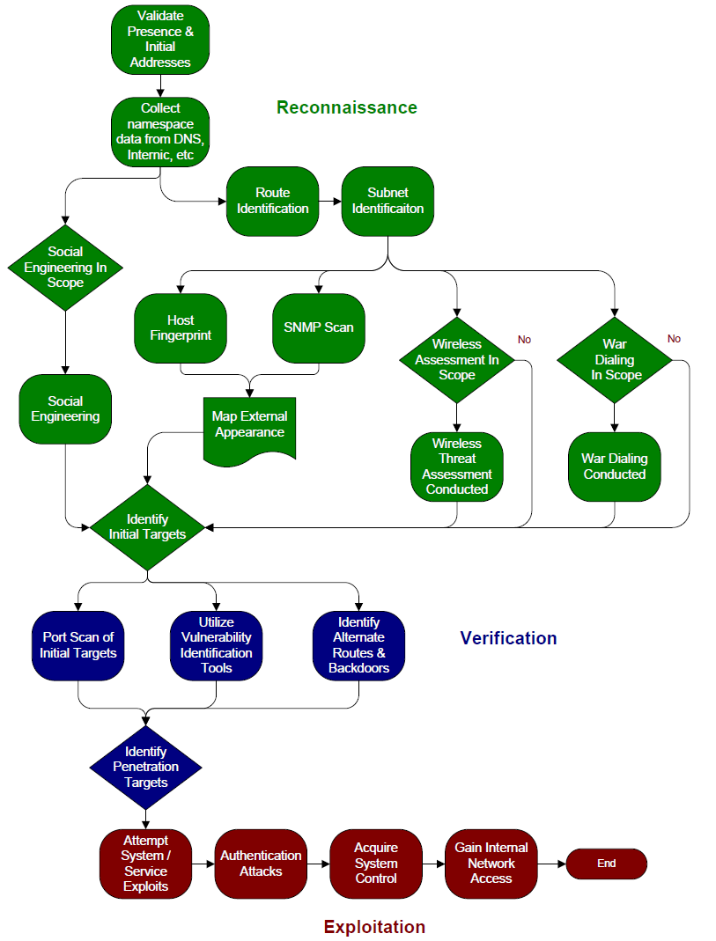

1. Internal and External Penetration Testing

Methodology
Using a variety of automated scanning tools (both open source and commercial) Coalfire Penetration Assessors will gather and classify all systems, open ports, running services, and vulnerabilities detected within the target environment. Analysis will then be conducted on each vulnerability finding to determine the various attack vectors available. With automated tools, manual techniques and a vast internal knowledge base, Coalfire Assessors will attempt to safely exploit vulnerability findings to demonstrate the level of risk. The following types of vulnerabilities are identified during the network penetration test:

- Remote Code Execution (Stack Overflow, Format String bugs)
- Weak Configuration
- Susceptibility to Malware
- Patch Level enumeration
- Use of insecure services and protocols
- Web Server Vulnerabilities
- Database Server Vulnerabilities

Tools
Standard tools Coalfire utilizes for its Penetration Tests include:

Hailstorm – Cenzic’s Hailstorm is a leading suite of automated Web application security and compliance assessment tools that scan for common application vulnerabilities. This tool specializes in detecting application-layer vulnerabilities such as Cross-Site-Scripting and SQL injections.

Rapid 7’s NeXpose – Has been named the "Best Vulnerability Assessment Solution” by SC Magazine. Coalfire has found Rapid 7’s award winning NeXpose vulnerability assessment tool to be the best available off-the-shelf tool for internal vulnerability scans and checks for more than 30,000 vulnerabilities. Rapid7 also acquired MetaSploit in 2009, and had integrated its tools into the scanning product.
Metasploit is an open-sourced project managed by Rapid7. It provides useful information to people who perform penetration testing, IDS signature development, and exploit research. This project was created to provide information on exploit techniques and to create a useful resource for exploit developers and security professionals.

Open Source - In addition to commercial products, Coalfire may leverage open source tools including: Cain & Able, L0phtcrack, Nmap, Nikto/Wikto, Superscan, SSL Digger, Nessus, Microsoft Baseline Security Analyzer (MBSA), and Center for Internet Security (CIS) Benchmarks.

Task 1 – Passive Attack Surface Analysis
The objective of this task is to identify specific exploitable vulnerabilities and expose potential access to Eligible Entity systems and/or sensitive data, including hosts accessible from networks located outside of the Eligible Entity’s perimeter firewalls.

This task begins with a “blind” assessment of an Eligible Entity’s public presence. We have found this to be an important phase of any Penetration Test process. It emulates the first step in a targeted attack that emulates an Internet-based threat agent attempting to gather information in preparation for an attack.

Methodology:
The Attack Surface Analysis aggregates publicly available information that may identify sensitive details regarding an Eligible Entity’s IT operations. With no information about the network, Coalfire engineers will gather public information that is available that would be of value to an Internet-based threat agent. Coalfire engineers not familiar with the Organization will perform this work. No information gathered by the Coalfire Sales team is shared with the team at this point. For this analysis the engineer is provided only the Organization’s name.

This process provides a true perspective of what information a skilled hacker can gather from public sources, and it is potentially the first step before a targeted attack. Many points of information cannot be concealed. This test provides you with an analysis of the extent of information available, and, where possible, how to limit information and better conceal your sensitive information. Limiting publicly available information is an essential “first line of defense”, and this assessment activity any independent external network security assessment.

The following information is gathered from public sources as part of the reconnaissance assessment:
- Service providers for Internet access, Web Hosting, and Domain Name Service (DNS)
- Whois records
- Domain Server records
- BGP Routing Summary from public Internet exchange points
- Header information from public web servers
- Personal address lookups gathered from whois record information
- Personal address lookups listed on the company website
- News Group and Web Board searches for messages posted from the company
- Social Media searches for company presence or staff associations: Facebook, LinkedIn, MySpace, Google+, Pinterest, Twitter, etc.
- Searches for job postings from the company
- Searches for resumes from employees who recently left the company
- Searches for technology used by the company

For this assessment, Coalfire will also perform active network mapping from various Internet locations to create as complete a network map as possible, augmented with the information gathered above. Coalfire uses numerous types of port scanning techniques to identify gateways, stateful / non-stateful firewalls, switching infrastructure, and physical or virtual hosts. Throughout the project, this will be a ‘living document’ - as other tasks progress, any information gained will be added to the network map in order to provide a comprehensive view of the Organization’s public presence.

Task 2 – Network Vulnerability Scanning
Coalfire conducts a vulnerability scan to identify platform and configuration issues as well as to identify focus areas for our security team’s manual penetration efforts. The tests are divided into four components:
- Port Scanning; the invasive probing of system ports on the transport and network level. Included here is also the validation of system reception to tunneled, encapsulated, or routing protocols.
- Service identification; the active examination of the application listening behind the service.
- System identification; the active probing of a system for responses that can distinguish unique systems to operating system and version level.
- Vulnerability testing; an efficient way to determine existing holes and system patch level.

Task 3 – External Penetration Testing
The Vulnerability Scan above provides the Coalfire security team with a large volume of raw data. It is necessary to analyze this data and develop attack plans. It’s important to understand that the attack scenario is highly dependent on the environment. An identified vulnerability may be easily attacked leveraging a known tool or attack script, while a separate vulnerability may require the security team to write unique attack scripts. To keep the scope and level of effort reasonable, lower priority vulnerabilities may not be targeted, as they may not present an obvious threat.

Penetration attempts will be done at the network level. These attacks will attempt to elevate or circumvent network privileges and access sensitive data. If the vulnerability scan identifies ports available for web services, and those ports are not associated with common off-the-shelf software products, Coalfire will contact the Eligible Entities’ project manager to request additional budget to include application penetration testing.

Coalfire will scan all of the Eligible Entities’ external IP addresses and conduct penetration testing on the external IP addresses that present the most risk to the environment. Coalfire will also run a stateful validation test for all firewall IP addresses.

2. Wireless Network Security Assessments
The Coalfire wireless assessment tests for all known and unknown (rogue) wireless access points in and around the locations identified by the Eligible Entity. These wireless tests encompass and include the wireless standards currently authorized by the client, whereas rogue wireless testing covers and includes the 802.11(a, b, g) standards.

The wireless assessment is divided into these major assessment activities:
- Determine the range of the 802.11(a/b/g) networks around the facility
- Determine the SSID for all access points on the network
- Determine type and strength of wireless encryption used, if any
- If possible break the encryption (based upon traffic and timeframe)
- If possible, determine IP address range used on the network
- If possible, determine the use of a DHCP server
- If possible, determine if MAC address security is being utilized
- If possible, use an unauthorized computer to join the network
- If possible, determine if additional VPN Software use is implemented

Assuming optimal circumstances, expected results may include:
- A map of the outer most physical edge of the wireless network
- The access points for the network
- The IP range and possible DHCP server of the wireless network
- The encryption used on the network
- Amount of time used to break the encryption
- What security measures are implemented
- If access to the network could be obtained.
- Extent of network access.
- Recommendations for remediation including technical descriptions for securing wireless networks.

Tools that may be used for the wireless network assessment include:
- Kismet
- KisMAC
- Airsnort
- WEPcrack
- Network Stumbler
- Cain and Able
- insider
- Xirrus Wi-Fi Inspector

3. Web Application Penetration Testing

Vulnerable web facing applications are rapidly becoming the most popular attack vector of malicious hackers. Coalfire’s Application Penetration test extends an automated vulnerability scan to determine if vulnerabilities can be exploited to compromise the application and the data it stores.

Methodology:
Testing will be conducted with typical credentials of a standard privilege user. The purpose of these tests is to determine whether a user can “jump” into other accounts, elevate privileges and gain access to restricted portions of the application or the data.

Coalfire uses Cenzic’s Hailstorm tool to quickly scan and analyze the web applications, looking for common logical and coding errors. Additional tools, such as BackTrack & the Metasploit framework, along with manual test scripts expand the scope of the application penetration testing. Even after gathering the raw data from Hailstorm and other methods, the application vulnerabilities usually demand a great deal of manual exploitation activities. Since web applications often exist in distributed environments and could span several architectural tiers, unintentional errors in programming and configuration can lead to vulnerabilities that could compromise an entire network.

The following list is representative of the key areas tested and is aligned with the OWASP Top 10 Vulnerabilities:

A1 - Cross Site Scripting (XSS)
A2 - Injection Flaws
A3 - Malicious File Execution
A4 - Insecure Direct Object Reference
A5 - Cross Site Request Forgery (CSRF)
A6 - Information Leakage and Improper Error Handling
A7 - Broken Authentication and Session Management
A8 - Insecure Cryptographic Storage
A9 - Insecure Communications Applications
A10 - Failure to Restrict URL Access

4. Social Engineering/Physical Security Assessments

Note on Social Engineering:
In 2012, Coalfire was invited to present our Social Engineering methodology at DEFCON and Derbycon, two of the most notable information security conferences in the country.

Organizational Security Awareness is paramount to the protection of an organization’s digital assets. Truly secure systems and networks rely on measures that go beyond the technology for their protection. Often the people who use, administer and secure these systems unknowingly fall victim to human behavior attacks (social engineering). Social engineering attacks are designed to take advantage of most people’s natural inclination to want to trust and help fellow human beings.

As organizations increase the security of their IT systems, more attackers are directing their attacks to the people and users of critical data. Coalfire can assess the organization’s security awareness and training program though social engineering. Coalfire will attempt to “trick” staff into providing sensitive information by phone and e-mail. The goal is to use the results to raise awareness and improve the current security training program.

Techniques include Pretexting, Phishing, Trojan horse/gimmes, Road apples and Quid pro quo. Techniques will be approved by an Eligible Entity’s project team.

Process
The following 5 steps define the social engineering process:
1. Identify Goals:
It is critical for the Coalfire / WVU team to identify and agree on the goals of the social engineering project. Requirements would include the type of information we are trying to obtain and what constitutes project success or failure.
2. Target Identification:
The Coalfire / WVU team would then identify and agree on the target/s for the social engineering attack. For this we suggest a risk-based approach to identify areas for which social engineering is a high-risk.
3. Enumeration:
Once a target is identified, the goal is to learn everything we can about it, including employee names, other relevant passwords that we've uncovered, system functionality, employee work times, batch process schedules, phone number, etc.
4. Attack:
A single target may have multiple vectors of attack. This could include telephone or email (targeted or spam). It may include calls from different telephones and even different people, including both male and female. Usually calls are made from a script that is developed, discussed and agreed to by the Coalfire / WVU team. Email is usually sent using a forged source address.
5. Documentation and Follow-up:
Social engineering succeeds or fails based on metrics identified in Step 1 (Goals). However, one of the biggest benefits of social engineering testing is in what employees and management can learn from the process. All goals, processes (including call scripts) need to be documented. A presentation and an open discussion with those targeted in such an attack can be a very valuable learning experience; the best way to thwart an actual attack is education.

Suggested Social Engineering Approach
Based on experience For this project, Coalfire proposes to employ a multi-step process. Our attack scenarios would include:
Email – Users are engaged remotely via email and tested if they will interact with untrusted links, websites or requests. Sensitive information will also be requested.
Telephone – Users are engaged remotely via the phone and are tested if they will disclose sensitive information such as their passwords.

Email Social Engineering Assessment
Coalfire will work with the Eligible Entity team to compile a list of email addresses to be tested. A custom email will be crafted and sent using a spoofed source email address to each employee. The email message will encourage the user to perform a variety of non-secure activities such as clicking on a link or visiting an unauthorized website. The activity is recorded and reviewed.
Telephone Social Engineering Assessment
Coalfire will work with the Eligible Entity team to compile a list of names and telephone numbers of a sampling of employees so that employees can be contacted and persuaded to compromise their password. We have found a small sample of contacts and results are usually enough to gauge the effectiveness of training.

5. IT Controls Reviews
With respect to our Onsite IT Controls Assessment, Coalfire’s IT Audit methodology takes into consideration the size and complexity of an Eligible Entity. Our approach is consistent with best practices, including the IT Governance Institute (ITGI) COBIT methodology which has been endorsed by the Public Company Accounting Oversight Board (PCAOB) and as the preferred standards for financial institutions regulated by the Sarbanes-Oxley Act (SOX). Our IT audit includes a variety of administrative, technical, and physical controls based on best-practice frameworks including:
- GLBA Gramm-Leach-Bliley Act
- FFIEC Federal Financial Institutions Examination Council
- COSO Committee on Sponsoring Organizations of the Treadway Commission
- ISO International Organization for Standardization
- COBIT Control Objectives for Information and Related Technology
- FIL Financial Institution Letters
- OTHER Guidance from the NCUA, OCC, FDIC, OTS, and other regulatory agencies

The IT Controls Assessment is conducted through a two (2) tasks:

Phase 1: Pre-Visit Collaboration
The charter provides Coalfire with a high level understanding of WSECU’s environment, infrastructure and management. Following the Charter, Coalfire will work with WSECU to establish a mutually agreeable timeframe to conduct the onsite fieldwork. Project activities in support of the Pre-Visit Collaboration include:
- Establishment of Interview schedule
- Discussion of the IT environment, security and controls environment and IT organization
- Collection and review of WSECU’s documentation (as available) on the secure portal

Phase 2: Onsite IT Controls Assessment
Coalfire will conduct data collection through observation, examination, inquiry and data analysis associated with the assessment of the IT General Controls (ITGC) environment for WSECU. Our approach adheres to the standards defined within the IT Governance Institute (ITGI) CoBiT methodology which has been endorsed by the PCAOB and COSO.

Coalfire’s integrated IT security and controls assessment approach includes: assessment of in-place security and controls against industry standards (best practice) while also considering both “inherent” risk and mitigating or compensating controls which reduce risk resulting from “gaps.” The result is an integrated, risk-based approach which provides extensive information on in-place, gap, and overall risk ratings – for all key components of an Eligible Entities IT general controls (ITGC) environment.

6. War Dialing
Coalfire will assess the security posture of an Eligible Entity’s analog modems. War dialing consists of using a computer to dial a given set of telephone numbers with a modem. Each phone number that answers with modem handshake tones and is successfully connected to is stored in a log. By searching a range of phone numbers for computers, one can find entry points into unprotected systems and backdoors into seemingly secure systems.
Methodology:
This assessment activity identifies vulnerable modems, dialing a predetermined range of numbers to find active modems that could potentially be used to access secure network locations. In some instances, services are delivered using systems managed through dial-up access. These modems represent potential high risk vulnerabilities unless proper policies are developed and implemented.
Phone number blocks in the appropriate numbers are collected and “WAR Dialing” tests are conducted to identify connections that provide access to the Eligible Entity’s network resources or to their directly attached systems. As modems answer, Coalfire determines the extent of vulnerabilities that can be exploited using automated tools. These results are identified in an engineering report that includes identified modem numbers, vulnerabilities rated according to risk factors, and specific remediation advice.
7. Policies and Procedures Review
Coalfire can conduct a review of an Eligible Entity’s policies as related to compliance and security best practices and produce a gap report.

Coalfire maintains a complete policy inventory based on industry best practices that have been used by many public sector organizations. Coalfire will provide templates, where required, to remediate identified compliance gaps as well as guidance on procedure development and documentation.

8. Computer Forensics

In the event an Eligible Entity experiences a loss of data or damage to storage media, Coalfire has a division, Coalfire Labs, which has a team dedicated to helping recover lost data.

Coalfire Labs can provide the Eligible Entity with computer forensic investigation and reporting services, including:
- Review of the computing environment where forensic data will be collected. The review is intended as a high level assessment of the data protection controls to determine the reliably of the data collected during the forensic investigation phase.
- Forensic Image capture of the affected system/s to be delivered to Coalfire Lab’s Colorado forensic laboratory.
- Analyze the disk image to identify potential unauthorized access, misuse of data or other data risk.
- In addition to the primary focus of the investigation, Coalfire will review the image copy of data for pornographic material and malware.
- Review any firewall, IDS or system logs, provided by client on CD, for suspicious activity.

Deliverables will include a computer forensic report, which will be furnished by Coalfire in form and content consistent with industry standards and, where applicable, confirm to chain-of-custody requirements.

9. Incident Response Services

Annual Incident Response Plan Review
This annual diagnostic is intended to review an Eligible Entity’s incident response plans. Through the review, Coalfire will identify potential deficiencies to industry standards and best practices in a Gap Analysis Report.
Annual Network and Operational Environment Review. Conduct an annual review of the Company’s current network and operational environment. This will be done through interviews and review of network diagrams only.
Prioritized Incident Response. Coalfire will prioritize incident response support for clients that subscribe to this Annual Review. Our goal is to respond with phone support within 12 business hours and be onsite, if required, within 48 hours.

C-2. CUSTOMER SERVICE AND TRAINING SERVICES

This section provides Bidders with the opportunity to outline their full suite of available customer service and training services. Statewide Contracts are required to provide training and support to the Commonwealth merchant community. Include in this description how the Bidder will meet the following requirements:

- Identify what Bidder provides as basic training at no additional cost on the use of the Bidder’s on-line systems. The Bidder may deliver the initial training via an interactive web-based training solution or in person at a training facility, which at the discretion of the Commonwealth, may include multiple Regional/geographical locations within the Commonwealth of Massachusetts. Training must be available to all Eligible Entities falling under the scope of this solicitation.
- Identify available customer service arrangements available to the Office of the State Comptroller and the Commonwealth’s merchant community. Most servicing needs of the merchant community are anticipated to be coordinated through the Eligible Entities themselves.
- Identify whether the Bidder provides technical support to Eligible Entities via a toll-free telephone number during normal business hours, which are between 8:00 a.m. and 5:00 p.m. Eastern Time, Monday through Friday.
- Identify all other relevant customer service information. Eligible Entities will use this section to contact Bidders for issues, therefore, this section should be as detailed as possible with the range of available services.

C-2. ANSWER:
- Coalfire recognizes that IT security and compliance is a complex challenge and we welcome the opportunity to support your team with training and mentoring. Therefore, Coalfire offers training in two ways – informal and formal.

Formal Training:
Coalfire provides formal training in three (3) ways:
- Formal Introductory presentation (webinar or in-person) to selected representatives from all Eligible Entities with a Senior Coalfire QSA who will provide the background information and overview of the process and their responsibilities as Coalfire completes their RapidSAQ or PCI Report on Compliance (ROC).
- Individual training as part of the Project Charter on the specific process and responsibilities of an individual Eligible Entity
- End user PCI Security Awareness Training (PCI 12.6 requirement). This is delivered on-line (cloud based) and includes the required testing and record keeping.

Informal Training:
Eligible Entities will always have questions that they may not want to ask in a group setting. Coalfire recognizes this and provides informal training in two (2) ways:
- During the assessment and completion of their SAQ or ROC, Coalfire believes there needs to be frequent meetings to effectively communicate our techniques, tools, findings and recommendations. This personal interaction will build staff skills and is critical to ensure your complete understanding our remediation advice. Coalfire has no secret processes or techniques and we encourage your staff to be involved in all stages of the assessment. We also recognize that it takes time to absorb the information and commit to ensuring your understanding long after the final report delivery.
- In addition to training on processes and techniques, Coalfire feels that the value we can bring is training select staff members on interpreting and prioritizing results and remediating identified gaps.

- Customer Service:
To facilitate the assessment process across multiple Eligible Entities, Coalfire provides four key customer services points to ensure that all parties are well served and satisfied with both the process and the results.
- Project Manager – primary service focus for all Eligible Entities.
- Executive Sponsor – responsible for project Quality Assurance and liaison with the Office of the State Comptroller.
- ASV Scan Desk – responsible for reviewing all scan results and providing remediation guidance related to scans
- RapidSAQ Service Desk – responsible for quality assurance related to SAQ completion

- Technical Support:
Coalfire provides technical support to Eligible Entities via a toll-free telephone number and email during extended business hours - 8:00 a.m. and 8:00 p.m. Eastern Time, Monday through Friday.

- Support Contact Information:
Project Manager: Joe Krause, joe.krause@coalfire.com, 1.877.224.8077 ext. 7312
Navis Services including RapidScan and RapidSAQ: Anjna Mehta-Singh, 1 (877) 224-8077 ext.7416
Or Email: servicedesk@coalfire.com

PART D. OTHER RELEVANT INFORMATION AND VALUE-ADDED SERVICES.

Describe any related value-added services that have not been included already that would be advantageous to the Commonwealth and Eligible Entities. Include any value-added services, specialties, enhanced reporting, cost-effective fees and services, experience, employee training, etc. that you feel sets your company apart.

Describe why the Bidder is the preferred Bidder since the PMT will be selecting only the highest qualified Bidders who are committed to a continuing and increasingly successful partnership with the Commonwealth. Successful past performance will not guarantee continued selection under this Statewide Contract. Describe the performance being offered that sets the Bidder apart from competitors and what resources, services, or specialties are being offered that demonstrate qualifications, commitment to partnership, best interests of the Commonwealth, or a level of service that is exceptional in comparison to other competitors that supports selection of the Bidder.

Partnership Commitment. Bidders must demonstrate a significant commitment to partner with the Commonwealth and Eligible Entities to achieve the highest level of compliance and ensuring that methods prevent fraud, waste and abuse of Commonwealth funds and resources.

This section should be detailed, since this section may be used as a primary section for making final selections of Qualified Bidders after reviews of Qualifications, Work Plans and Pricing.

- ANSWER:
IT Governance, Risk, and Compliance (GRC) is a daunting task, especially for complex, geographically dispersed and heterogeneous organizations like the Commonwealth of Massachusetts. Many of the Commonwealth’s Eligible Entities may have little or no experience in managing compliance with IT security regulations/standards. As cyber threats expand and regulatory oversight increases, data security and compliance is essential to protecting the Commonwealth and its citizens.

As a result Agencies and Department need quality service, training and guidance from a GRC firm that can provide independent, unbiased support and guidance.

The Coalfire Advantage to the Commonwealth

Depth of Skills and Resources
- All the required skills and training to provide the full range of GRC services requested
- Team of 90+ seasoned professionals with a proven track record of project success and client satisfaction.
- Extensive experience with large, complex government organizations.
- Expertise across all of the major IT security and risk management frameworks and compliance regimes (NIST, HIPAA, SOX, CoBiT, ISO, FISMA , GLBA, PCI, CIP, etc.).

Commitment to Vendor Independence and Integrity
- We avoid potential conflict of interest issues by maintaining a strict policy to not resell products or services that would diminish the value of our independence.
- This allays the common concern that the assessment is merely a tool to drive additional revenue and advice is slanted to specific remediation consulting services and products.

Audit vs. Assessment Approach
- Coalfire has always taken an audit approach to engagements.
- In our work we examine, test and verify conformance to a given standard. We consistently gather evidence of conformance or nonconformance.
- Our goal is to provide our clients with documented and verifiable results that withstand scrutiny and assist in mitigating fines and charges in the event of an incident.

Tools and Templates
- To meet project objectives and reduce the impact on Commonwealth staff, our engagement would include access to Coalfire tools and templates including those for policies, asset inventory, data characterization, risk assessment and Navis cloud services.

Collaborative Approach
- The Coalfire team sees the value of completing the assessment as more than documentation. Coalfire’s philosophy is to work collaboratively with our clients. Coalfire has no secret processes or techniques and we encourage your staff to be involved in all stages of the assessment. Knowledge transfer cannot simply take place through reports. Coalfire believes there needs to be frequent meetings during the assessment process to effectively communicate our techniques, tools, findings and recommendations. This personal interaction will build staff skills and is critical to ensure your complete understanding of our remediation advice.
- Our team recommends a project team debriefing after an assessment is completed to discuss lessons learned and be better prepared for next year’s assessment. We also recognize that it takes time to absorb the information and commit to ensuring your understanding long after the final report delivery.

As the nation’s largest independent IT GRC firm Coalfire has the resources and skills to provide unparalleled support to all the Commonwealth’s Eligible Entities.

RFR RESPONSE PART E - COST RESPONSE

Coalfire PCI Service Price List for the Commonwealth of Massachusetts

The following is the price list for PCI Services. Prices are subject to negotiation with each Department and will depend upon the Department’s payment application and negotiated PCI Quote Form/SOW.

PCI DSS Assessment Services | 2013-2016
Self-Assessment Questionnaire (SAQ)
SAQ A or B (4 hours) | $700
SAQ C or C-VT (8 hours) | $1,300
SAQ D (16 hours) | $2,800
PCI DSS Report on Compliance (ROC) | 2013-2016
Level 1 / 2 Service Provider ROC | Starts from $22,200*
Level 1 / 2 Merchant ROC | Starts from $22,200*
PCI Security Consulting Services | 2013-2016
- Security network and solutions design  - Data encryption consultation  - Remediation guidance  - Security policies  - Procedures documentation development  - Network attack analysis | $165 per hour
Table 1: PCI DSS Assessment Services

*Note: Report on Compliance engagements require individual scoping exercises to determine level of effort required to complete the assessment. Each ROC will be negotiated independently.

Prompt Payment Discount (PPD): 1% discount for prompt payment within 15 days following invoice.

Coalfire PCI Approved Scanning Vendor (ASV) and Penetration Testing Service Price List for the Commonwealth of Massachusetts

The following is a standard price list for PCI Approved Scanning Vendor (ASV) Services, including external (ASV) quarterly scanning, internal quarterly scans. Prices are subject to negotiation with each Department and will depend upon the Department’s payment application and negotiated PCI Quote Form/SOW. The table below also includes pricing for various network sizes (as measured by IP address) and two types of forensic engagement.

PCI Technical Testing Services | 2013-2016
External (ASV) Scanning – Unlimited Scanning
Base License, license includes 1 External IP Address | $180
External (ASV) Scanning – Bulk Pricing, Unlimited Scanning | 2013-2016
1-10 Additional IP Addresses | $16/IP/year
1-50 Additional IP Addresses | $12/IP/year
1-250 Additional IP Addresses | $8/IP/year
250+ Additional IP Addresses | $6/IP/year
ASV Advisory Services for ASV Scans | $150 per hour
Internal Scanning – Quarterly Scanning | 2013-2016
Base License – Includes 20 Internal IPs + Lighthouse Scanner Appliance | $1,200
1-50 Additional IP Addresses | $7.50/IP/year
1-250 Additional IP Addresses | $6.50/IP/year
250+ Additional IP Addresses | $6.00/IP/year
Additional Lighthouse Scanner Appliance | $700
Non-ASV Advisory Services for non-ASV Scans | $100 per hour
Penetration Testing – Internal and External Testing | 2013-2016
Up to 28 External IP Addresses and 56 Internal IP Addresses | $6,400
Up to 128 External IP Addresses and 256 Internal IP Addresses | $9,600
Application Security Review
For basic security review of entities or application moving over to HP/EPay (4 hours and up, depending upon scope) | $700 minimum
Table 2: Technical Testing Services

Coalfire Rapid SAQ and Rapid Scan Packages for the Commonwealth of Massachusetts

The following is a standard price list for Coalfire’s Rapid SAQ and Rapid Scan on-line portal. Prices are subject to negotiation with each Department and will depend upon the Department’s payment application and negotiated PCI Quote Form/SOW.

Service | Description | Unit | Retail
PCI Services
RapidSAQ Complete Combo | Recommended approach for value and completeness of PCI validation support.  Provides facilitated SAQ services along with ASV external and internal scans. This package allows the entity to choose their own facilitated SAQ service to provide the lowest possible price. This service would provide:  Cardholder Environment Definition ]  PCI DSS Gap Analysis for each location  Includes internal scans of up to 20 live devices  Lighthouse™ appliance  Includes ASV external scans of up to 10 live devices | Choose SAQ Service from Table 1  Includes RapidScan Complete Combo in Table 2  Price: $1,900 - $4,000
RapidSAQ – Enterprise (Annual Subscription) | Provides facilitation service to complete the PCI Self-Assessment Questionnaire for up to five (5) locations  Cardholder Environment Definition for each location  PCI DSS Gap Analysis for each location  Includes internal scans of up to 20 live devices  Lighthouse™ appliance  Includes ASV external scans of up to 10 live devices | Each | $8,500 per year
Internal & External combo (Annual Subscription) | Includes 10 external and 20 internal IP addresses. Includes Lighthouse™ appliance. | Each | $1,200 per year

Coalfire Pricing for General Information Security Compliance and Audit Services for the Commonwealth of Massachusetts

Non-PCI services are charged on a Time & Materials basis. Each engagement requires a detailed scoping exercise with the customer in order to determine the level of effort required to complete the engagement. Coalfire does not charge for scoping exercises. These engagements are billed at $165 per hour for consulting services.

Coalfire provides the following Information Security and IT Risk and Compliance services:

Regulatory Compliance Assessments:

- The Gramm Leach Bliley Act (GLBA) for financial services
- The Health Insurance Portability and Accountability Act (HIPAA) for healthcare
- FedRAMP certified third party assessment organization (3PAO); for Cloud Service Providers to obtain a FedRAMP Provisional Authorization
- The Federal Information Systems Management Act (FISMA) for certain federal systems and their business partners
- HITRUST Common Security Framework (CSF) assessments for healthcare
- The Sarbanes-Oxley Act (‘SOX’) for evaluation of IT controls over financial reporting
- Red Flags Rule for creditors which must have a formal identity theft prevention program
- North American Electric Reliability Corp. Critical Infrastructure Protection (NERC CIP) for electric utilities
- General IT security and risk assessments – in accordance with industry best practices for risk management and IT governance (NIST SP-800 Series, CoBiT, ISB, etc.)
- SSAE 16 audits - in conjunction with leading accounting firms, to give evidence of operating adequacy covering general and application level controls
- Incident response & computer forensics - for known or suspected compromise of sensitive data, including personally identifiable information (PII), payment card data, intellectual property and others

