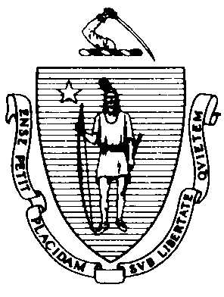
Massachusetts Department of Public Health
Bureau of Environmental Health
305 South Street
Jamaica Plain, MA 02130-3597
(617) 983-6712 (617) 983-6770 - Fax

Food Protection Program
Policies, Procedures and Guidelines

Issue: Coliform Bacteria in Finished Product Samples No: BW-03

The Environmental Protection Agency’s (EPA) National Primary Drinking Water Standards has established a zero tolerance for the presence of coliform in drinking water. When it comes to the attention of the Department that a water and/or carbonated nonalcoholic beverage product has tested positive for coliform, the following actions shall be required.

Total Coliform Determination
Standard: < 1 colony/100 ml.

- The manufacturer will conduct confirmatory heterotrophic plate count, total coliform and fecal coliform tests on samples from the suspect production lot(s) and the lots immediately preceding and following the suspected production lot if they are available. Results of these tests will be forwarded immediately to the Department.
- If deemed appropriate, the Department will conduct a sanitary inspection of the facility.
- If warranted, the manufacturer shall implement its recall procedures.
- Production lot quantity, a distribution list and recall statistics are to be forwarded to the Department as soon as they become available to the manufacturer.
- The manufacturer will be required to forward to the Department weekly microbiological test results for a period of thirty days, or longer if deemed necessary by the Department.

