The Commonwealth of Massachusetts
Executive Office of Health and Human Services
Department of Public Health
Bureau of Infectious Disease and Laboratory Sciences
305 South Street, Jamaica Plain, MA 02130
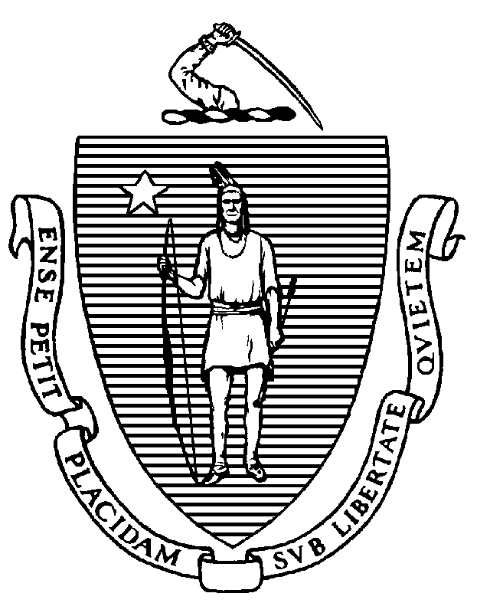
Immunization Division
Tel: (617) 983-6800
Fax: (617) 983-6840
www.mass.gov/dph/imm

KATHLEEN E. WALSH
Secretary
ROBERT GOLDSTEIN, MD, PhD Commissioner

Tel: 617-624-6000
www.mass.gov/dph

MAURA T. HEALEY
Governor
KIMBERLEY DRISCOLL
Lieutenant Governor

To: College Health Service Directors

From: Pejman Talebian, MA, MPH, Director
Immunization Division

Re: 2023-2024 College Immunization Survey

Date: September 2023

The annual College Immunization Survey is conducted by the Massachusetts Department of Public Health (MDPH) Immunization Division. This survey requests immunization information for college students enrolled at your institution. The purpose of this survey is to identify students attending college who are not protected against vaccine-preventable diseases and to ensure that they are properly immunized according to state requirements. These data are publicly available on the Immunization Division website. Completed surveys must be submitted by January 26, 2024.

Immunization Requirements for College Entry
The following vaccines are required for these categories of students regardless of how much time they spend physically on campus and also apply to students visiting from other states and countries:
- all full-time undergraduate and graduate students under 30 years of age
- all full- and part-time health science students
- 2 doses of MMR vaccine: 2 doses of live measles, mumps, and rubella vaccine (these two doses must be given at least four weeks apart beginning at or after 12 months of age).
- 2 doses of varicella vaccine: 2 doses of live varicella vaccine (these two doses must be given at least four weeks apart beginning at or after 12 months of age).
- 1 dose of Tdap vaccine: documentation of a dose of Tdap vaccine, received any time at or after 7 years of age. If more than 10 years since the last Tdap was given, a dose of Td or Tdap is recommended.
- 3 doses of hepatitis B vaccine (when monovalent Hep B vaccine is administered before age 6 weeks) or 2 doses of Heplisav-B given on or after 18 years of age.
- 1 dose of MenACWY meningococcal vaccine: administered on or after the 16th birthday for newly enrolled full-time students 21 years of age and younger. Adolescents and young adults (16-23 years of age) may also be vaccinated with the MenB vaccine, preferably at 16-18 years of age, to provide short-term protection for serogroup B. Please note that the Meningococcal B vaccine does not fulfill the requirement for the MenACWY vaccine.
Proof of Immunity Satisfies Requirement:
Alternative proofs of immunization have been added to clarify that the requirements shall not apply where:
  - The student presents laboratory evidence of immunity to measles, mumps, and rubella. Those born in the United States before 1957 can be considered immune to measles, mumps, and rubella with the exception of all full- and part-time students in a health science program who may be in contact with patients.
  - The student presents laboratory evidence of immunity to varicella; a statement is signed by a physician, nurse practitioner, physician assistant, or designee that the student has a reliable history of chickenpox disease; or the student was born in the United States before 1980, with the exception of all full- and part-time students in a health science program who may be in contact with patients.
  - The student presents laboratory evidence of immunity to hepatitis B.

Meningococcal Vaccine and Postsecondary Students
All post-secondary institutions must distribute the appropriate MDPH-developed documents based on student status (e.g., full-time, part-time).
- Full-time students 21 years of age and younger. Newly enrolled full-time students 21 years of age and younger at postsecondary institutions must receive the document titled Information about Meningococcal Disease, Meningococcal Vaccines, Vaccination Requirements and the Waiver for Students at Colleges and Residential Schools and comply with the meningococcal vaccination requirements or have a medical or religious exemption or sign the waiver (105 CMR 220.700; https://www.mass.gov/lists/meningitis-vaccination-requirements).
- Other students. Newly enrolled part-time students and newly enrolled full-time students 22 years of age and older must receive the document titled Meningococcal Disease and College Students (105 CMR 221.300).

Recommended Vaccines
The following vaccines are strongly recommended to reduce transmission of communicable disease:
- 1 dose of influenza vaccine for the current influenza season
- 1 dose of updated COVID-19 vaccine

Your efforts to complete this survey contribute to protecting students from vaccine-preventable diseases. Please use the survey instructions (https://www.mass.gov/lists/school-immunization-surveys#college-survey-) to help with completing the survey accurately. Retain copies of the survey to facilitate follow-up data inquiries. You may be chosen for a randomized audit of immunization records or be called to review records by MDPH Immunization Division staff. If you have any questions, please contact the MDPH Immunization Data Assessment Unit by email at immassessmentunit@mass.gov.

