COLLEGIUM PRESENTATION TO DFC
Steve Passik, PhD
VP Scientific Affairs, Education, and Policy May 17th, 2018

Collegium Pharmaceutical Mission

- Collegium’s mission is to be the leader in responsible pain management by developing and commercializing innovative, differentiated products for people suffering from pain and the communities we serve

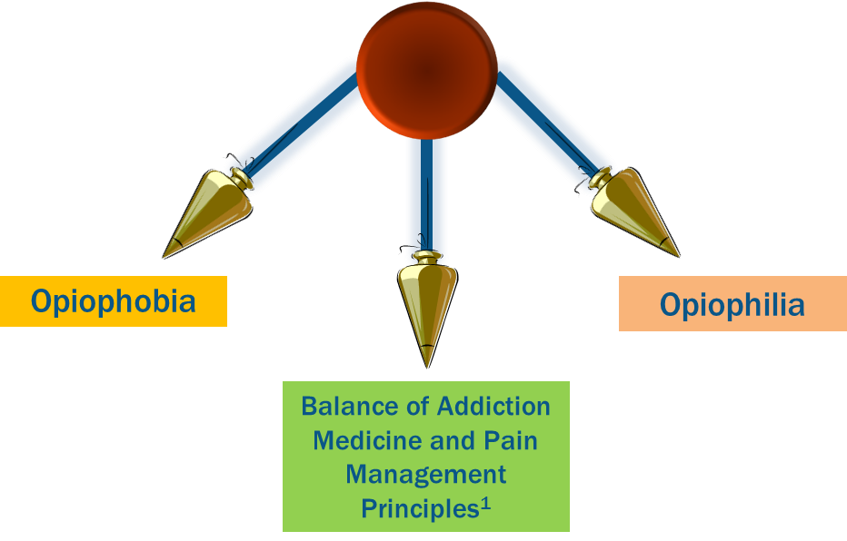The Opioid Pendulum: Where Are We Now?

1Gourlay, D.L. et al. Universal precautions in pain medicine: A rational approach to the treatment of chronic pain. Pain Medicine. 2005; 6(2): 107-112.

Opioid Prescribing and the Healthcare System

What has increased opioid prescribing exposed in our healthcare system?

- Where does our healthcare system fail?
  - Chronicity
  - Conditions with major motivational/psychiatric component
  - CARE COORDINATION: Communication among professionals
  - Ongoing risk assessment
  - Conditions that intersect badly with socioeconomic status
  - Stigmatization

Seniors (Medicare) and low income (Medicaid) populations are at higher risk of opioid misuse and abuse

Medicaid |  | - Medicaid beneficiaries are prescribed opioids at twice the rate of non-Medicaid patients and are at 3-6 times the risk of prescription painkillers overdose. 1  - The prevalence of diagnosed opioid use disorder among Medicaid beneficiaries is 8.7 per 1000, compared to 1 out of every 1000 patients covered with commercial insurance2, 3, 4

Medicare |  | - Medicare beneficiaries are prescribed opioids at twice the rate found in the commercially insured population5  - The prevalence of diagnosed opioid use disorder among Medicare beneficiaries is 6 per 1000, compared to 1 out of every 1000 patients covered with commercial insurance 4

Sources: 1) https://www.medicaid.gov/federal-policy-guidance/downloads/cib-02-02-16.pdf
    - https://blog.cms.gov/2017/01/05/addressing-the-opioid-epidemic/#_ftn9
    - https://www.ncbi.nlm.nih.gov/pubmed/20718646
    - http://khn.org/news/study-medicare-beneficiaries-may-face-treatment-gap-for-painkiller-abuse-misuse/
    - http://lab.express-scripts.com/lab/publications/a-nation-in-pain

Risk Management Is a Package Deal

- Use of Prescription Drug Monitoring Program (PDMP) data

- Screening and risk stratification

- Compliance Monitoring
  - Urine screening
  - Pill/Patch counts

- Education regarding drug storage and sharing

- Psychotherapy and highly “structured” approaches

- Better/safer opioid products

Passik SD, Kirsh KL. The interface between pain and drug abuse and the evolution of strategies to optimize pain management while minimizing drug abuse. Experimental and Clinical Psychopharmacology. 2008; 16(5): 400-404.

Opioid Risk Management Tools Have Come a Long Way
- PDMP:
  - Are there other prescribers of controlled substances?
- LC-MS/MS drug testing in 24 hours:
  - Is the patient taking their prescribed medication – no other licit or illicit opioids/substances?
- Genetic Testing:
  - Is the patient on the best opioid for them – most likely to get best response at most reasonable dose?
- Screening Tools:
  - Ascertain risk level and prescribe appropriate opioid delivery system (e.g., ADFs)
- Giveback Programs:
  - Ensure safe disposal and decrease opioids available for diversion

Responsibility for Optimal and Safer Pain Treatments Rests With Many Stakeholders

 | Stakeholder | Role
 | Health care providers | - Use risk assessment tools  - Discuss benefits and risks of all appropriate medication classes with patients  - Set appropriate guidelines and goals of successful opioid therapy to ensure expectations around opioid continuation
 | Patients | - Develop and strictly follow a mutually agreed-upon treatment plan with HCP  - Take medication only as prescribed without manipulating the delivery system (i.e., tampering)
 | Third-party payors | - Be accommodating of different levels of care for patients based on risks and the tools needed to prevent and/or treat misuse, abuse, diversion, and addiction  - Need to move away from inadequately-monitored, drug-only pain therapy for the majority of patients treated with opioids
 | Law enforcement and government regulators | - Allow stakeholders to combat the opioid epidemic  - Provide reasonable access of necessary treatments to patients suffering from chronic pain
 | Pharmaceutical industry | - Develop potentially safer opioid products  - Conduct more extensive post-marketing studies related to misuse, abuse, diversion, and addiction  - Provide oversight of educational programs for presentation of fair and balanced content  - Closely observe sales techniques to ascertain they focus on providing opioids to only appropriate patients
 | Media | - Raise awareness of the opioid epidemic without suggesting addiction is solely a disease of exposure  - Avoid using terms “addiction” and “physical dependence” interchangeably  - Provide media coverage to both successes and failures of opioid pain management in an accurate way

Passik SD. J Opioid Manage; 2017;13(6):391-396.
8

Third-Party Payors

- Frequent visits
- Urine drug screens
- Psychological care
- Abuse deterrent opioids
- Less drug per prescription

Joranson DE. Are health-care reimbursement policies a barrier to acute and cancer pain management? Journal of Pain and Symptom Management. 1994; 9(4): 244-253.

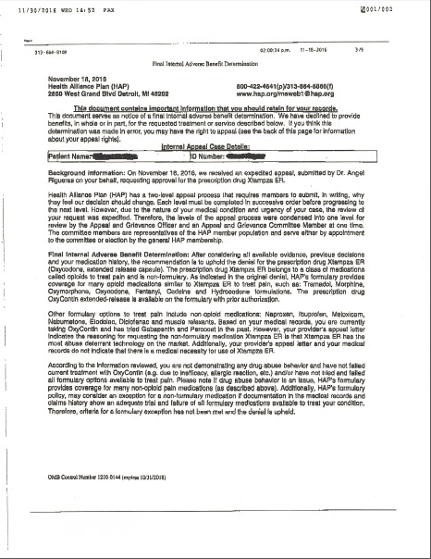Example of “Real World” Coverage Denial

Final Internal Adverse Benefit Determination: After considering all available evidence, previous decisions and your medication history, the recommendation is to uphold the denial for the prescription drug Xtampza ER (Oxycodone, extended release capsule).

Based on your medical records, you are currently taking OxyContin and has tried Gabapentin and Percocet in the past. However, your provider’s appeal letter indicates the reasoning for requesting the non-formulary medication Xtampza ER is that Xtampza ER has the most abuse deterrent technology on the market.

According to the information reviewed, you are not demonstrating any drug abuse behavior and have not failed current treatment
………and/or have not tried and failed all formulary options available to treat pain. Please note that if drug abuse behavior is an issue, [Plan Name]’s formulary provides coverage for many non-opioid pain medications (as described above).

Payors’ Reluctance to Cover Costs of the Entirety of the Opioid Epidemic is Understandable

- Payors bear the costs related to:
  - Drug Treatment
  - Healthcare
  - Disability
- Taxpayers bear the societal costs related to:
  - Criminal Justice
  - Child Services
  - Environmental
- Are we asking payors to make investments in solving social problems that they cannot recoup?

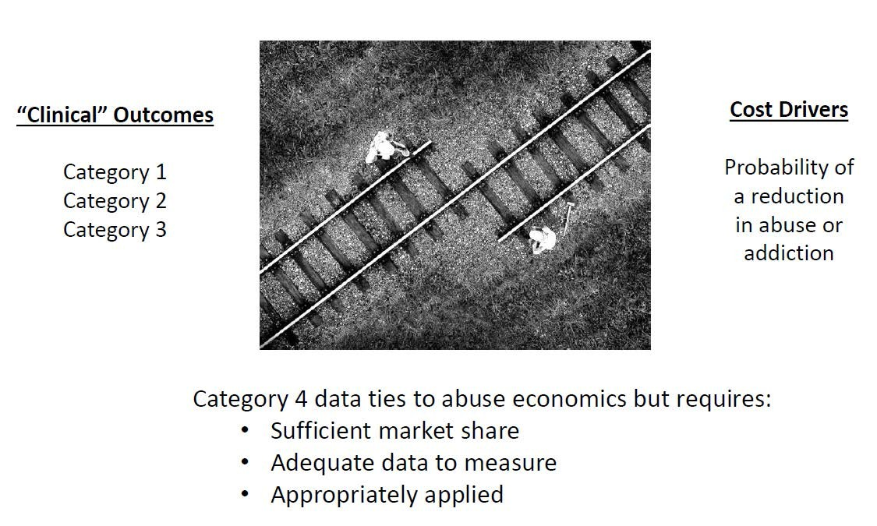The Disconnected ADF World

Courtesy of Bob Jones, CEO of Acura Pharmaceuticals

Passik’s 5 Suggestions for Improving Opioid Safety

- Establish the “Well Opioid Visit”
  - Develop next generation PDMP software
- Develop new treatments for acute pain in young people
- Limit short acting opioids for chronic pain
- Eliminate morphine sulfate equivalent (MSE) limits for opioids to which they do not apply (i.e., real-world evidence suggests increased safety)
  - A case for tapentadol and buprenorphine being considered exempt from MSE limits
  - Develop a more specific opioid-benzo MSE or have 2 cutoffs: one for patients on benzos and one for those not on benzos
- Eliminate fail first policies for ADFs

- Costs associated with diversion or to society (e.g., first responders, criminal justice system, loss in productivity) were not included

- ADFs have the potential to positively impact opioid misuse, abuse, and overdose

- ICER concluded that cost neutrality would be achieved if ADFs were discounted by 41% from their “current market-based price” without all relevant costs included in their model
  - However, actual discounts often exceed 41%
  - Discounts to government payors (e.g., state Medicaid) often exceed 80%

Societal Cost Savings from Abuse Deterrent
Formulations for Prescription Opioids in Canada

140
120
100
80
60
40
20
0

Estimated Societal Costs (billions in USD) to the US and Canada from 2012 and 2015

Healthcare Criminal Justice Productivity Canada United States
- Results:
  - Median reduction in non-medical use rates between 45.1-64%
  - The estimated total societal economic costs was
$17.1 billion from 2012 to 2015
  - The median estimate of societal cost savings was $9.3 billion in the same period
- Conclusions:
  - “The data suggest that the expected reduction in the non-medical use rate for prescription

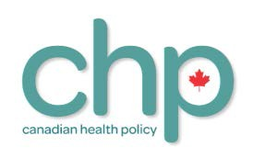Graph generate from data included in: Skinner B. Societal cost savings from abuse deterrent formulations for prescription opioids in Canada. Canadian Health Policy. 2017.
opioids would result from mandating adoption of ADF across all opioids, would very likely produce significant net societal cost savings.”

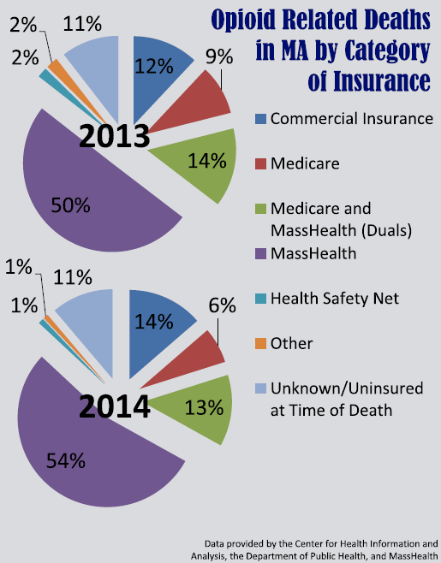Governor’s Working Group – Opioid Related Deaths in MA

    - In MA, 73% of opioid related deaths occurred in patients on Medicare and/or MassHealth in 2013 and 2014

    - Commercial insurers in MA remain unwilling to make changes to their coverage until the DFC has determined their plan

Value of ADF Opioids

Oral Ingestion

Oral Chewing/ Crushing

42% of oral abusers report manipulating tablets1

Snorting
Smoking or Snorting Heroin

Injecting Rx Opioids

Injecting Heroin

ADFs can deter transition from Rx opioids to heroin

Butler S, Black R, Fleming AB. Relative Abuse of Crush-Resistant Prescription Opioid Tablets via Alternative Oral Modes of Administration. Pain Medicine 2017; 0: 1–15 doi: 10.1093/pm/pnx151. Open Access link: https://academic.oup.com/painmedicine/article/3940205/Relative-Abuse-of-Crush-Resistant-Prescription.

ADFs Are Associated With Decreases in Nonmedical Opioid Use and Opioid Abuse
- Introduction of ADFs has been associated with decreases in rates of nonmedical use and diversion1
- Median ADF effectiveness of 45% to 64% reduction in nonmedical use rates2
  - Decreases ranged from 3% to 99% depending on medication and patient population2
  - Decline of 18% to 23% in rates of diagnosed abuse3
- Based on a hypothetical cohort model, ADFs have the potential to substantially reduce the incidence of opioid abuse relative to non-ADFs4

ADF and Non-ADF Opioids: Burden of Abuse and Abuse-Related Outcomes*4

Outcome  (5-Year Time Period/100,000 Patients) | ADF Opioids | Non-ADF  Opioids | Increment (ADF – Non-ADF)
Incident abuse | 8229 | 10,532 | -2303
Person-years of abuse | 23,322 | 29,943 | -6621
Overdose deaths | 1.38 | 1.77 | -0.39

*Cohort model of 100,000 patients with chronic pain with ER opioid prescriptions.
- Gasior M, et al. Postgrad Med. 2016;128(1):85-96. 2. Skinner BJ. Canadian Health Policy, May 29, 2017. 3. Rossiter LF, et al. J Med Econ. 2014;17(4):279-287. 4. Institute for Clinical and Economic Review. Abuse Deterrent
Formulations of Opioids: Effectiveness and Value. 2017. https://icer-review.org/wp-content/uploads/2016/08/NECEPAC_ADF_Final_Report_08_08_17.pdf.
18
Table reprinted with permission from Institute for Clinical and Economic Review. Abuse Deterrent Formulations of Opioids: Effectiveness and Value. 2017.

ADFs Make up a Small Percent of the Opioid Market

2017 Opioid TRx Mix

ER Opioid Generic vs. Brand Mix

ADF vs Non-ADF Branded ER Mix

90%

10%

75%
25%

79%
21%

ADF brands Non-ADF brands

Generic ER TRx Branded ER TRx

Immediate Release ("IR") TRx Extended Release ("ER") TRx

Source: IQVIA Xponent 2017

Opioid Market – Payor Coverage

Opioid Market
(Total Lives: 279,192,804)

Commercial Medicare Part D Medicaid
Opioid Market | % Lives
Commercial: | 65.04%
Medicare Part D: | 11.80%
Medicaid: | 23.16%
Total: | 100%  (279,192,804)

  - Medicaid beneficiaries represent 23% of the lives that consume (all) opioid prescriptions in the US

  - However, Medicaid represents just 3-6% of total ADF prescriptions

  - Despite having access to discounts of 80%+ off list price, the Medicaid channel has been slow to adopt ADFs

Source: IMS Xponent, current 52 weeks; MMIT as of Jan 2017

Three core barriers prevent access and uptake for ADFs

Cost to managed care organizations prevents or limits access
1
    - Data shows highly challenging coverage for ADFs, particularly in Medicare, Medicaid
    - Where coverage exists, “fail first” policies through cheaper generics are major obstacles

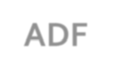ADF
Access & Uptake Barriers
Misconceptions around how opioids are abused marginalize importance of ADFs
- Understanding routes of abuse (oral vs. injection, snorting, crushing, chewing)
2
- Understanding abuser preferences for IR vs. ER formulations

Pharmacy access remains highly challenging
3
- Just in time inventory systems for new drugs can result in abandonment
- DEA and wholesaler allotments dissuade pharmacies from holding new products in inventory

Misconceptions of ADF Opioids

- All ADFs are the same | False
- No “real world” evidence of decreasing abuse | False
- Abusers just take too many pills (i.e. don’t manipulate) | Sometimes
- ADFs should be saved for “high risk” patients | False
- ADFs can’t stop most common method of abuse (Oral) | Sometimes
- Limiting access to ER opioids will decrease abuse | False

Significant Payor Education is Required

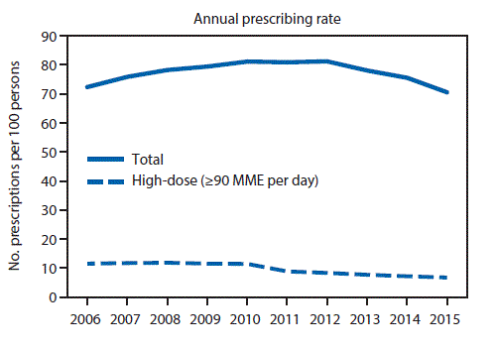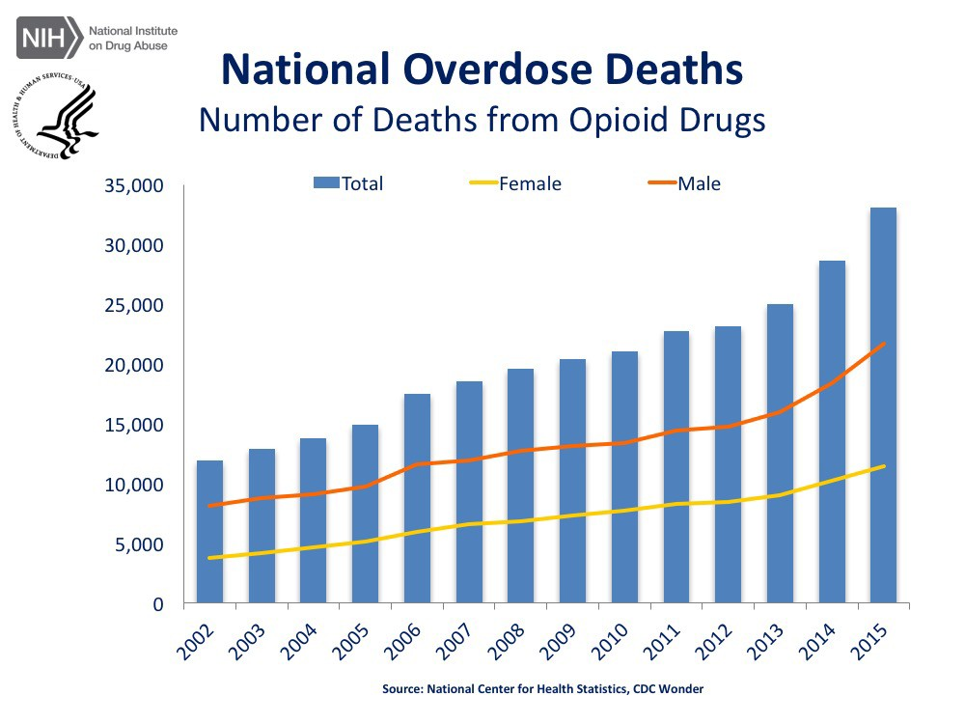Opioid prescribing is going down while overdose deaths are going up – who is new legislation helping? Who is it hurting?

CDC statistics: https://www.cdc.gov/drugoverdose/maps/rxrate-maps.html

BULLPEN SLIDES

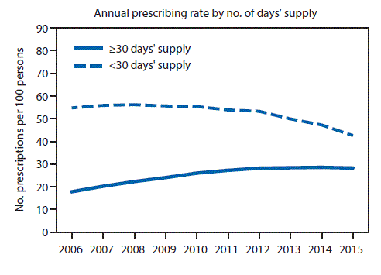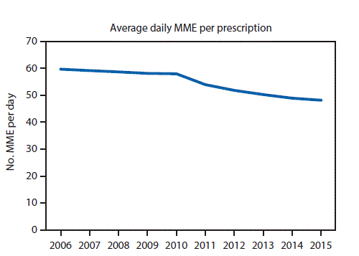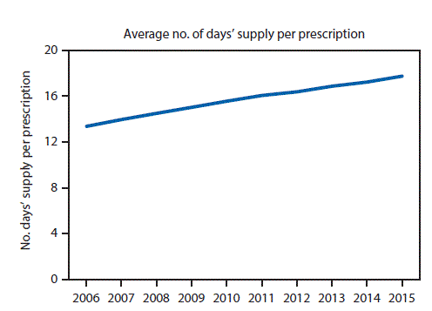Prescribing Rates are Dropping

CDC statistics: https://www.cdc.gov/drugoverdose/maps/rxrate-maps.html

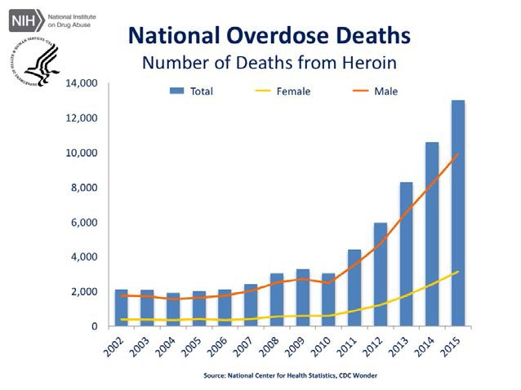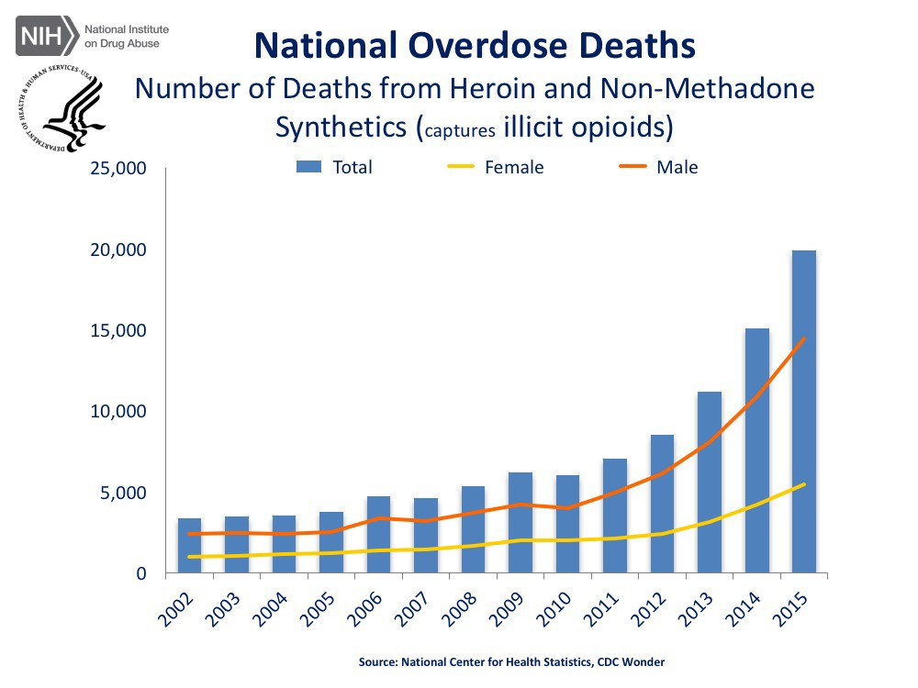But the Death Rate Keeps Climbing

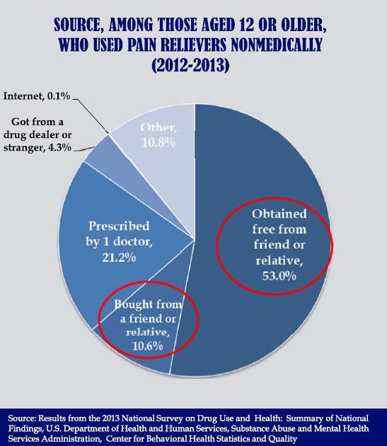Sources of Drug Diversion

- Diversion of legitimately prescribed opioid products is a real concern

- ADF technologies can prevent diverted medications from being manipulated for abuse, likely resulting in better outcomes for abusers

  - Conclusions: “Our results suggest that self-treatment of co-morbid psychiatric disturbances is a powerful motivating force to initiate and sustain abuse of opioids and that the initial source of drugs
– a prescription of experimentation – is largely irrelevant in the progression to a substance use disorder”

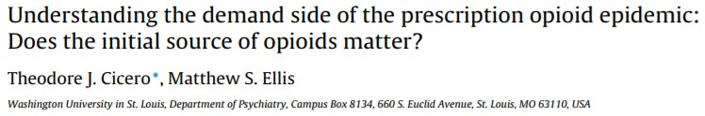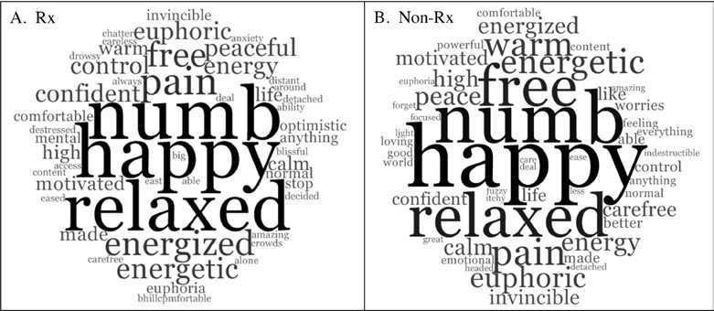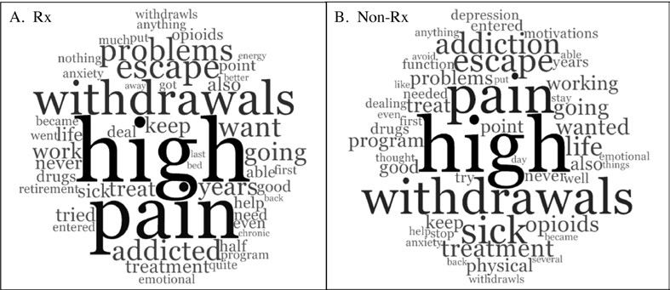
Fig. 1. Top fifty stem words provided by Rx and Non-Rx RAPID participants in response to the question “Please list three words that best describe how opioids made you feel?” Word frequencies are represented as tag cloud (i.e., the larger the word, the more frequently found in the data).
Frequencies ranged from 0.40% to 7.1% of all analyzed words (Rx[N = 198], Non-Rx[N = 250]).

Fig. 2. Top fifty stem words provided by Rx and Non-Rx RAPID participants in response to the question “In your own words, describe your motivations for using opioids right before you entered your first treatment program for opioid abuse.” Word frequencies are represented as tag cloud (i.e., the larger the word, the more frequently found in the data). Frequencies ranged from 0.35% to 3.3% of all analyzed words (Rx[N = 839], Non-
Rx[N = 854]).

ADFs are Associated with Cost Savings
- Introduction of ADFs has also been associated with reductions in medical and societal costs1-4
Annual Cost Savings4
$1200
Caregiver
cost savings
[VALUE]M

Total annual cost savings
$1.035B
Criminal justice cost
savings
[VALUE]M

Workplace cost savings [VALUE]M
Medical cost savings [VALUE]M
(from Rossiter et al.)3

$1000
Cost Savings Associated With
Reformulated ER Oxycodone (Millions)

$800

$600

$400

$200

$0
  - Gasior M, et al. Postgrad Med. 2016;128(1):85-96. 2. Skinner BJ. Canadian Health Policy, May 29, 2017. 3. Rossiter LF, et al. J Med Econ. 2014;17(4):279-287. 4. Kirson NY, et al. Pain Med. 2014;15:1450-1454.
Figure reprinted with permission from Kirson NY, et al. Pain Med. 2014;15:1450-1454. 29

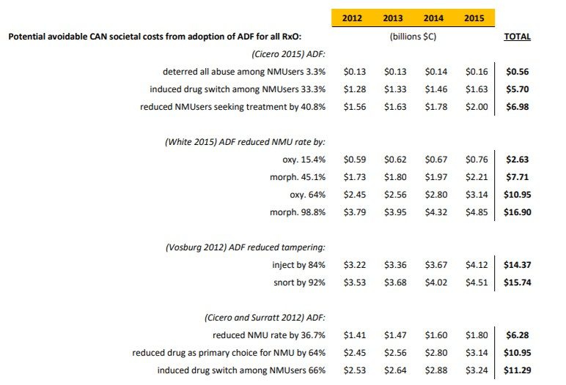Potential Avoidable Societal Costs (CHP Report)

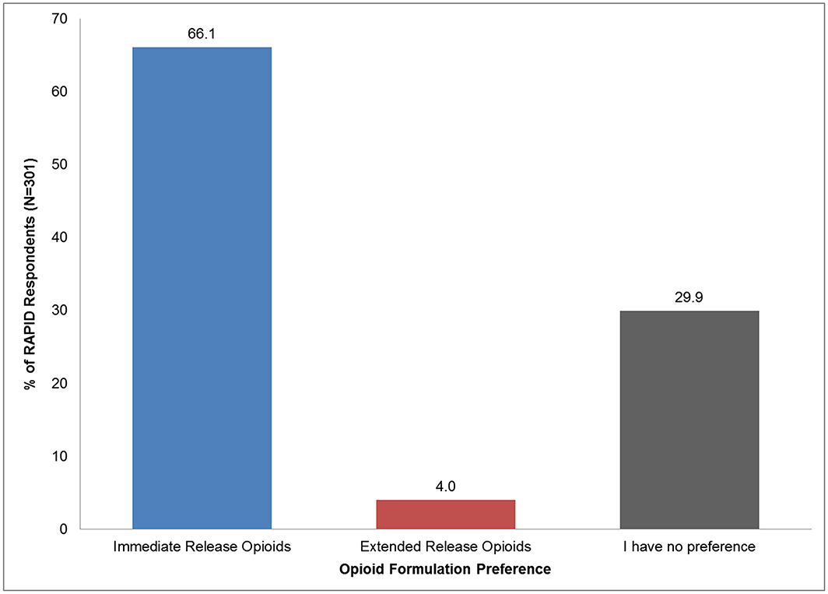Limit Short Acting Opioids for Chronic Pain

- Preference related to immediacy/quality of “high” and ease of use, particularly when manipulated for non-oral abuse
- Payor programs to force use of IR opioids vs. ADF ER opioids may have unintentional consequences

Source: Cicero, Theodore J. et. Al. Relative preferences in the abuse of immediate-release versus extended-release opioids in a sample of treatment-seeking opioid abusers; Pharmacoepidemiology and Drug Safety, September 4, 2016

