INDOOR AIR QUALITY ASSESSMENT

Colrain Central Elementary School
Jacksonville Road
Colrain, Massachusetts

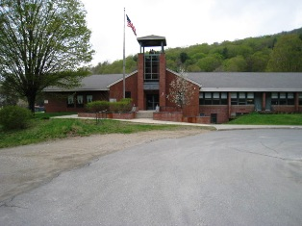

Prepared by:
Massachusetts Department of Public Health
Bureau of Environmental Health
Indoor Air Quality Program
September 2009

Background/Introduction
At the request of Jason Ferenc, Chairman of the Colrain Board of Health, the Massachusetts Department of Public Health (MDPH), Bureau of Environmental Health (BEH) provided assistance and consultation regarding indoor air quality concerns at Colrain Central Elementary School (CCES), Jacksonville Road, Colrain, Massachusetts. The request was prompted by a parent’s concerns related to water damage and indoor air quality in the building.
On May 1, 2009, a visit to conduct an assessment was made to the CCES by Lisa Hébert, Indoor Air Quality Inspector in BEH’s Indoor Air Quality Program. Due to equipment failure on May 1, 2009, the assessment was completed on May 4, 2009 by Mike Feeney, Director, Indoor Air Quality Program and Ms. Hébert.
The CCES is a one story brick building originally constructed in 1952. The original section of the school contains 7 rooms and has a full basement that previously functioned as the kitchen and cafeteria. An addition was built in 1996 which added 9 additional classrooms, staff offices, library, gymnasium, cafeteria and kitchen. The addition is slab on grade. Windows are openable and were closed at the time of assessment unless otherwise indicated. Windows in the original building were not replaced when the addition was constructed. The basement is currently used for storage.

Methods
Air tests for carbon monoxide, carbon dioxide, temperature and relative humidity were conducted with the TSI, Q-Trak, IAQ Monitor, Model 7565. Air tests for airborne particle matter with a diameter less than 2.5 micrometers were taken with the TSI, DUSTTRAK™ Aerosol Monitor Model 8520. BEH staff also performed visual inspection of building materials for water damage and/or microbial growth.

Results
The CCES has an employee population of approximately 36 and serves 121 children in grades Pre-K through 6. Approximately 16 individuals visit the CCES daily. Tests were taken under normal operating conditions and results appear in Table 1. Air sampling results are listed by location that the air sample was taken. Due to the failure of DUSTTRAK equipment on May 1, 2009, BEH staff returned to conduct PM 2.5 testing on May 4, 2009. Sampling results are PM2.5 appears in Table 2.

Discussion
Ventilation
It can be seen from Table 1 that carbon dioxide levels were above 800 parts per million (ppm) in 6 of 25 areas, indicating adequate air exchange in the majority of areas surveyed on May 1, 2009. It is also important to note that several classrooms had open windows and/or were empty/sparsely populated, which can greatly reduce carbon dioxide levels. Carbon dioxide levels would be expected to increase with full occupancy and windows closed.
Fresh air in the majority of classrooms is supplied by unit ventilator (univent) systems (Figure 1). A univent draws air from the outdoors through a fresh air intake located on the exterior wall of the building and returns air through an air intake located at the base of the unit. Fresh and return air are mixed, filtered, heated and provided to classrooms through an air diffuser located in the top of the unit (Picture 1).
Classrooms are provided with wall mounted, ducted exhaust vents (Picture 2). Ceiling mounted air handling units (AHUs) provide ventilation to the gym, cafeteria, kitchen, staff areas, administration and nurse’s office, library and a few classrooms. AHUs are reportedly serviced annually and univents are serviced twice a year. Heat is provided by two boilers. BEH staff was informed that the boilers were shut down for the season approximately two weeks prior to the assessment.
To maximize air exchange, the MDPH recommends that both supply and exhaust ventilation operate continuously during periods of school occupancy. In order to have proper ventilation with a mechanical supply and exhaust system, the systems must be balanced to provide an adequate amount of fresh air to the interior of a room while removing stale air from the room. It is recommended that HVAC systems be re-balanced every five years to ensure adequate air systems function (SMACNA, 1994). The systems at CCES were reportedly balanced upon installation in 1996.
The Massachusetts Building Code requires that each room have a minimum ventilation rate of 15 cubic feet per minute (cfm) per occupant of fresh outside air or openable windows (SBBRS, 1997; BOCA, 1993). The ventilation must be on at all times that the room is occupied. Providing adequate fresh air ventilation with open windows and maintaining the temperature in the comfort range during the cold weather season is impractical. Mechanical ventilation is usually required to provide adequate fresh air ventilation.
Carbon dioxide is not a problem in and of itself. It is used as an indicator of the adequacy of the fresh air ventilation. As carbon dioxide levels rise, it indicates that the ventilating system is malfunctioning or the design occupancy of the room is being exceeded. When this happens, a buildup of common indoor air pollutants can occur, leading to discomfort or health complaints. The Occupational Safety and Health Administration (OSHA) standard for carbon dioxide is 5,000 parts per million parts of air (ppm). Workers may be exposed to this level for 40 hours/week, based on a time-weighted average (OSHA, 1997).
The MDPH uses a guideline of 800 ppm for publicly occupied buildings. A guideline of 600 ppm or less is preferred in schools due to the fact that the majority of occupants are young and considered to be a more sensitive population in the evaluation of environmental health status. Inadequate ventilation and/or elevated temperatures are major causes of complaints such as respiratory, eye, nose and throat irritation, lethargy and headaches. For more information concerning carbon dioxide, consult Appendix A.
Temperature measurements in the school ranged from 68° F to 73° F, which were within the MDPH recommended range in the majority of areas surveyed (Table 1). The MDPH recommends that indoor air temperatures be maintained in a range of 70º F to 78º F in order to provide for the comfort of building occupants. In many cases concerning indoor air quality, fluctuations of temperature in occupied spaces are typically experienced, even in a building with an adequate fresh air supply.
The relative humidity measured in the building ranged from 41 to 60 percent at the time of the assessment, which was within the MDPH recommended comfort range (Table 1). The MDPH recommends a comfort range of 40 to 60 percent for indoor air relative humidity. Relative humidity levels in the building would be expected to drop during the winter months due to heating. The sensation of dryness and irritation is common in a low relative humidity environment. Low relative humidity is a very common problem during the heating season in the northeast part of the United States.

Microbial/Moisture Concerns
Several potential sources of water damage and/or mold growth were observed during the assessment. Water damaged ceiling tiles were observed in several locations at CCES. This condition generally occurs as a result of roofing or plumbing leaks. It was reported to BEH staff that some water damage occurred to the interior of CCES over the winter as a result of ice dams. BEH staff examined the exterior of the building to identify breaches in the building envelope that could provide a source of water penetration. Several potential sources were identified:
- Exterior doors exhibited large gaps (Picture 3).
- Sealant on exterior windows was in disrepair (Picture 4).
- Sealant at base of building was deteriorated and missing in some areas, leaving sizable gaps between wall and walkway (Picture 5).
- Broken window was sealed with plywood.
- Peeling paint was observed on numerous exterior surfaces. This condition allows building components to come into direct contact with moisture.
- Bottom of several door casings exhibited rotted wood (Picture 6).
- Efflorescence was observed on the exterior of the building (Picture 7).
- The slope of the earth where the original building meets the addition creates a convergence of moisture moving toward the basement door.
- CCES lacks gutters to collect and disperse rain water away from the base of the building. As a result, troughs have been created close to the base of the building by water deposition, which in turn, allow water to pool, creating saturated conditions adjacent to the building’s foundation (Picture 8). This was particularly evident in areas where roofs converged. In addition, water is deposited against exterior walls, which has caused deterioration of the wall surface, as seen in Picture 9.
- Saturated conditions have allowed moss to proliferate on the grounds surrounding the building as well as on the building itself (Pictures 10, 11). The presence of moss on the brick and mortar shown in Picture 10 and the heavy moss accumulation on the roof in Picture 11 are indicative of repeated water exposure. The two main requirements of a moss are sufficient moisture and accessible nutrients.
- Plants were observed growing from crevices adjacent to the building. The growth of roots against exterior walls can bring moisture in contact with the foundation. Plant roots can eventually penetrate, leading to cracks and/or fissures in the sublevel foundation. Over time, this process can undermine the integrity of the building envelope, providing a means of water entry into the building via capillary action through foundation concrete and masonry (Lstiburek & Brennan, 2001).
- Pieces of asphalt shingles were observed on the sidewalk on the east side of the building (Picture 12). This condition may indicate that in addition to the roof leakage reportedly due to ice dams, there may be some shingles in disrepair that are contributing to the moisture problem. Roofing should be examined for areas of disrepair.
- Portions of pavement in parking areas were cracked and in disrepair, particularly adjacent to storm drains. This condition may allow surface water to penetrate beneath the pavement and can cause saturation of the soil beneath.
The aforementioned conditions represent potential water penetration sources. Over time, these conditions can undermine the integrity of the building envelope and provide a means of water entry into the building via capillary action through foundation concrete and masonry (Lstiburek & Brennan, 2001). These breaches may also provide a means for pests/rodents to enter the building.
Plant soil and drip pans can serve as a source of mold growth. A number of plants did not have drip pans. In some areas plants were resting on cloth. Plant fragments were observed on shelves/countertops. Plants should be properly maintained and be equipped with drip pans. In addition, flowering plants can be a source of pollen. Therefore, plants should be located away from the air stream of ventilation sources to prevent aerosolization of mold, pollen and particulate matter. An aquarium was observed in one classroom. Aquariums should be properly maintained to prevent microbial/algae growth, which can emit unpleasant odors.
The US Environmental Protection Agency (US EPA) and the American Conference of Governmental Industrial Hygienists (ACGIH) recommend that porous materials be dried with fans and heating within 24 to 48 hours of becoming wet (US EPA, 2001; ACGIH, 1989). If not dried within this time frame, mold growth may occur. Once mold has colonized porous materials, they are difficult to clean and should be removed/discarded.

Other IAQ Evaluations
Indoor air quality can be negatively influenced by the presence of respiratory irritants, such as products of combustion. The process of combustion produces a number of pollutants. Common combustion emissions include carbon monoxide, carbon dioxide, water vapor and smoke (fine airborne particle material). Of these materials, exposure to carbon monoxide and particulate matter with a diameter of 2.5 micrometers (μm) or less (PM2.5) can produce immediate, acute health effects upon exposure. To determine whether combustion products were present in the school environment, BEH staff obtained measurements for carbon monoxide and PM2.5.

Carbon Monoxide
Carbon monoxide is a by-product of incomplete combustion of organic matter (e.g., gasoline, wood and tobacco). Exposure to carbon monoxide can produce immediate and acute health affects. Several air quality standards have been established to address carbon monoxide and prevent symptoms from exposure to these substances. The MDPH established a corrective action level concerning carbon monoxide in ice skating rinks that use fossil-fueled ice resurfacing equipment. If an operator of an indoor ice rink measures a carbon monoxide level over 30 ppm, taken 20 minutes after resurfacing within a rink, that operator must take actions to reduce carbon monoxide levels (MDPH, 1997).
The American Society of Heating Refrigeration and Air-Conditioning Engineers (ASHRAE) has adopted the National Ambient Air Quality Standards (NAAQS) as one set of criteria for assessing indoor air quality and monitoring of fresh air introduced by HVAC systems (ASHRAE, 1989). The NAAQS are standards established by the US EPA to protect the public health from six criteria pollutants, including carbon monoxide and particulate matter (US EPA, 2006). As recommended by ASHRAE, pollutant levels of fresh air introduced to a building should not exceed the NAAQS levels (ASHRAE, 1989). The NAAQS were adopted by reference in the Building Officials & Code Administrators (BOCA) National Mechanical Code of 1993 (BOCA, 1993), which is now an HVAC standard included in the Massachusetts State Building Code (SBBRS, 1997). According to the NAAQS, carbon monoxide levels in outdoor air should not exceed 9 ppm in an eight-hour average (US EPA, 2006).
Carbon monoxide should not be present in a typical, indoor environment. If it is present, indoor carbon monoxide levels should be less than or equal to outdoor levels. On the day of assessment, outdoor carbon monoxide concentrations were non-detect (ND) (Table 1). Carbon monoxide levels measured inside the school were also ND.

Particulate Matter (PM2.5)
The US EPA has established NAAQS limits for exposure to particulate matter. Particulate matter is airborne solids that can be irritating to the eyes, nose and throat. The NAAQS originally established exposure limits to particulate matter with a diameter of 10 μm or less (PM10). According to the NAAQS, PM10 levels should not exceed 150 microgram per cubic meter (μg/m³) in a 24-hour average (US EPA, 2006). These standards were adopted by both ASHRAE and BOCA. Since the issuance of the ASHRAE standard and BOCA Code, US EPA established a more protective standard for fine airborne particles. This more stringent PM2.5 standard requires outdoor air particle levels be maintained below 35 μg/m³ over a 24-hour average (US EPA, 2006). Although both the ASHRAE standard and BOCA Code adopted the PM10 standard for evaluating air quality, MDPH uses the more protective PM2.5 standard for evaluating airborne particulate matter concentrations in the indoor environment.
Outdoor PM2.5 concentrations the day of the assessment were measured at 15 μg/m³. PM2.5 levels measured inside the school ranged from 8 to 32 μg/m³ (Table 1), which were below the NAAQS PM2.5 level of 35 μg/m³. Frequently, indoor air levels of particulates (including PM2.5) can be at higher levels than those measured outdoors. A number of mechanical devices and/or activities that occur in schools can generate particulate during normal operations. Sources of indoor airborne particulates may include but are not limited to particles generated during the operation of fan belts in the HVAC system, cooking in the cafeteria stoves and microwave ovens; use of photocopiers, fax machines and computer printing devices; operation of an ordinary vacuum cleaner and heavy foot traffic indoors.

Volatile Organic Compounds
Indoor air concentrations can be greatly impacted by the use of products containing volatile organic compounds (VOCs). VOCs are carbon-containing substances that have the ability to evaporate at room temperature. Frequently, exposure to low levels of total VOCs (TVOCs) may produce eye, nose, throat and/or respiratory irritation in some sensitive individuals. For example, chemicals evaporating from a paint can stored at room temperature would most likely contain VOCs. In an effort to identify materials that can potentially increase indoor VOC concentrations, BEH staff examined classrooms for products containing these respiratory irritants.
In an effort to reduce noise from sliding chairs and desks, tennis balls were sliced open and placed on desk and chair legs (Picture 13). Tennis balls are made of a number of materials that are a source of respiratory irritants. Constant wearing of tennis balls can produce fibers and off-gas VOCs. Tennis balls are made with a natural rubber latex bladder, which becomes abraded when used as a chair leg pad. Use of tennis balls in this manner may introduce latex dust into the school environment. Some individuals are highly allergic to latex (e.g. spina bifida patients) (SBAA, 2001). It is recommended that the use of materials containing latex be limited in buildings to reduce the likelihood of symptoms in sensitive individuals (NIOSH, 1997). A question and answer sheet concerning latex allergy is attached as Appendix B (NIOSH, 1998).
Some classrooms contained dry erase boards and dry erase markers. Materials such as dry erase markers and dry erase board cleaners may contain volatile organic compounds (VOCs) (e.g., methyl isobutyl ketone, n-butyl acetate and butyl-cellusolve), which can be irritating to the eyes, nose and throat (Sanford, 1999).
Air deodorizing materials were observed in one area. Air deodorizers contain chemicals that can be irritating to the eyes, nose and throat of sensitive individuals. Many air fresheners contain 1,4-dichlorobenzene, a VOC which may cause reductions in lung function (NIH, 2006). Furthermore, deodorizing agents do not remove materials causing odors, but rather mask odors that may be present in the area.
Other conditions that can affect indoor air quality were observed during the assessment. The kitchen was equipped with a six burner gas stove. Gas appliances can provide opportunities for exposure to combustion products such as carbon monoxide. A carbon monoxide detector should be installed in the kitchen vicinity in accordance with Fire Department guidelines.
The exhaust vents in numerous classrooms were blocked by furniture and file cabinets. Likewise, some univents were blocked by paper, sheets of plastic, and an accumulation of materials. These conditions impede the ventilation system from operating properly. A plant was observed on top of a univent. This condition can cause aerosolization of mold, pollen and particulate matter.
Univents were observed with metal filters, which provide minimal filtration in comparison to disposable filters. Disposable filters with an increased dust spot efficiency should be considered for installation. The dust spot efficiency is the ability of a filter to remove particulates of a certain diameter from air passing through the filter. Filters that have been determined by ASHRAE to meet its standard for a dust spot efficiency of a minimum of 40 percent (Minimum Efficiency Reporting Value equal to 9) would be sufficient to reduce many airborne particulates (Thornburg, 2000; MEHRC, 1997; ASHRAE, 1992). Note that increasing filtration can reduce airflow, a condition known as pressure drop, which can reduce efficiency due to increased resistance. Prior to any increase of filtration, a ventilation engineer should be consulted as to whether the univents can maintain function with more efficient filters.
The ceiling of the basement area, now used for storage, has been constructed by using plastic sheeting held in place with wood strapping (Picture 14). Missing ceiling tiles were observed in some areas of the basement and one classroom had buckled ceiling tiles. In addition, open utility holes were observed in walls of basement (Picture 15). These conditions can provide a means of egress for odors, fumes, dusts and vapors between rooms and floors. In addition, these materials can migrate into the air handling chambers of unit ventilators and be distributed to occupied areas.
In one classroom, items were observed on the counters and bookcases (Picture 16). In addition to blocking access to the windows, the large number of items stored in the classroom provides a source for dusts to accumulate. These items (e.g., papers, folders, boxes) make it difficult for custodial staff to clean. Items should be relocated and/or be cleaned periodically to avoid excessive dust build up. In addition, these materials can accumulate on flat surfaces (e.g., desktops, shelving and carpets) in occupied areas and subsequently be re-aerosolized causing further irritation.
Window glazing/caulking is in disrepair in some classrooms. This condition can allow unconditioned air to enter the building, potentially causing condensation to occur on the interior of the building. In addition, some caulking material manufactures prior to 1979 may contain PCBs. While PCBs in caulking that is intact does not present health concerns, if it begins to deteriorate it should be repaired/replaced.
Numerous dead flies were observed within a light fixture in Room 9 (Picture 17). As they decay, parts of these insects can become dried out and aerosolized and may serve as a source of allergenic material for certain sensitive individuals. Breaches or gaps in the building envelope in this area of CCES must be identified and remedied in order to eliminate this condition.
Upholstered furniture was observed at the CCES. Upholstered furniture is covered with fabric that comes in contact with human skin. This type of contact can leave oils, perspiration, hair and skin cells. Dust mites feed upon human skin cells and excrete waste products that contain allergens. In addition, if relative humidity levels increase above 60 percent, dust mites tend to proliferate (US EPA, 1992). In order to remove dust mites and other pollutants, frequent vacuuming of upholstered furniture is recommended (Berry, M.A., 1994). It is also recommended that upholstered furniture (if present in schools), be professionally cleaned on an annual basis. If an excessive dusty environment exists due outdoor conditions or indoor activities (e.g., renovations), cleaning frequency should be increased (every six months) (IICR, 2000). Elevated outdoor levels of airborne particulates can result in increased levels of indoor particulates by entering into the building through open windows, doors and filter bypass.
A personal fan had accumulated dust and debris. Numerous classrooms exhibited an accumulation of chalk dust. Dust can be a source for eye and respiratory irritation. Personal fans with dust can distribute particles once activated. A heavy accumulation of sand was observed on one classroom floor (Picture 18). As the sand is disturbed throughout the course of a day, this particulate matter can become airborne and can be irritating to the eyes, nose and throat.
In the basement, numerous floor tiles were in disrepair (Picture 19). These tiles may contain asbestos and if so, should be remediated in conformance with all applicable Massachusetts asbestos abatement and hazardous materials disposal laws.

Conclusions/Recommendations
The conditions noted at the CCES raise a number of indoor air quality issues. A two-phase approach is required for remediation. The first consists of short-term measures to improve air quality and the second consists of long-term measures that will require planning and resources to adequately address the overall indoor air quality concerns.
In view of the findings at the time of the assessment, the following short-term recommendations are made for consideration:
- Use openable windows in conjunction with mechanical ventilation to facilitate air exchange. Care should be taken to ensure windows are properly closed at night and weekends to avoid the freezing of pipes and potential flooding.
- Consider adopting a balancing schedule of every 5 years for all mechanical ventilation systems, as recommended by ventilation industrial standards (SMACNA, 1994).
- Consider replacing metal univent filters with higher efficiency disposable filters. Note that increased filtration can reduce airflow produced through increased resistance. Prior to any increase of filtration, the univents should be evaluated by a ventilation engineer to determine whether they can maintain function with more efficient filters.
- Change filters for air-handling equipment (e.g., univents and AHUs) as per the manufacturer’s instructions or more frequently if needed. Vacuum interior of units prior to activation to prevent the aerosolization of dirt, dust and particulates. Ensure filters fit flush in their racks with no spaces in between allowing bypass of unfiltered air into the unit.
- Consider removing obstructions from univents and in front of exhaust vents in classrooms. Move plants away from ventilation system.
- Repair/replace broken window.
- Repaint surfaces with peeling paint. Prior to repainting, determine if paint contains lead. If peeling paint contains lead, all work must comply with applicable state and federal lead paint removal and disposal regulations.
- Repair/replace rotted exterior door casings.
- Design and install gutter and downspout system to collect rain and deposit it away from the building.
- Routinely maintain drain near basement door.
- Repair/Replace sealant on exterior of the building
- Remove plants from crevices at base of building.
- Inspect asphalt shingles for deterioration and repair/replace as necessary.
- Repair crevices in pavement.
- Install a carbon monoxide detector in kitchen.
- Seal open utility holes throughout building.
- Consider providing plants with drip pans and avoid over-watering. Examine drip pans periodically for mold growth. Disinfect with an appropriate antimicrobial where necessary. Discontinue practice of resting planters on cloth. Remove and dispose of plant fragments as they drop off plants.
- Continue to maintain aquarium to prevent microbial/algae growth.
- Seal gaps in doors and any breaches in the building envelope that allow unconditioned air and insects to enter the interior of the building.
- Evaluate condition of window caulking material throughout the building. If in poor condition, repair or replace.
- Discontinue use of tennis balls on classroom desks and chairs.
- Periodically clean dry erase boards and trays. Consider using dry erase markers that emit fewer VOCs.
- Discontinue use of deodorizing materials.
- Determine composition of basement floor tiles. If they contain asbestos, remediate in accordance with state and federal asbestos removal and hazardous materials disposal regulations.
- Store cleaning products out of reach of students. All cleaning products used at the facility should be approved by the school department with MSDS’ available at a central location.
- Relocate or consider reducing the amount of materials stored in classrooms to allow for more thorough cleaning of classrooms. Clean items regularly with a wet cloth or sponge to prevent excessive dust build-up. Arrange materials to allow access to windows.
- Remove accumulation of dead flies from within light fixture. Investigate area for breaches.
- Professionally clean upholstered furniture on an annual basis.
- Clean dust from personal fans and chalk trays. Routinely clean classroom floors to eliminate accumulation of sand. Consider providing additional walk-off mats at entrances.
- For buildings in New England, periods of low relative humidity during the winter are often unavoidable. Therefore, scrupulous cleaning practices should be adopted to minimize common indoor air contaminants whose irritant effects can be enhanced when the relative humidity is low. To control for dusts, a high efficiency particulate arrestance (HEPA) filter equipped vacuum cleaner in conjunction with wet wiping of all surfaces is recommended. Avoid the use of feather dusters. Drinking water during the day can help ease some symptoms associated with a dry environment (throat and sinus irritations).
- Consider adopting the US EPA (2000) document, “Tools for Schools”, as an instrument for maintaining a good indoor air quality environment in the building. This document is available at: http://www.epa.gov/iaq/schools/index.html.
- Refer to resource manual and other related indoor air quality documents located on the MDPH’s website for further building-wide evaluations and advice on maintaining public buildings. These documents are available at: http://mass.gov/dph/iaq.

In view of the findings at the time of the assessment, the following long-term recommendations are made for consideration:
- Consider replacing windows in the original building.
- Consider installing a suspended ceiling in basement.
- Consider constructing an apron adjacent to the building that will be less pervious to water. Where feasible, improve the grading of the ground away from the foundation to eliminate saturation of soils adjacent to the exterior wall.

References
ACGIH. 1989. Guidelines for the Assessment of Bioaerosols in the Indoor Environment. American Conference of Governmental Industrial Hygienists, Cincinnati, OH.
ASHRAE. 1989. Ventilation for Acceptable Indoor Air Quality. American Society of Heating, Refrigeration and Air Conditioning Engineers. ANSI/ASHRAE 62-1989
Berry, M.A. 1994. Protecting the Built Environment: Cleaning for Health, Michael A. Berry, Chapel Hill, NC.
BOCA. 1993. The BOCA National Mechanical Code/1993. 8th ed. Building Officials and Code Administrators International, Inc., Country Club Hill, IL.
IICR. 2000. IICR S001 Reference Guideline for Professional On-Location Cleaning of Textile Floor Covering Materials Institute of Inspection, Cleaning and Restoration Certification. Institute of Inspection Cleaning and Restoration, Vancouver, WA.
Lstiburek, J. & Brennan, T. 2001. Read This Before You Design, Build or Renovate. Building Science Corporation, Westford, MA. U.S. Department of Housing and Urban Development, Region I, Boston, MA
MDPH. 1997. Requirements to Maintain Air Quality in Indoor Skating Rinks (State Sanitary Code, Chapter XI). 105 CMR 675.000. Massachusetts Department of Public Health, Boston, MA.
NIH. 2006. Chemical in Many Air Fresheners May Reduce Lung Function. NIH News. National Institute of Health. July 27, 2006. http://www.nih.gov/news/pr/jul2006/niehs-27.htm
NIOSH. 1997. NIOSH Alert Preventing Allergic Reactions to Natural Rubber latex in the Workplace. National Institute for Occupational Safety and Health, Atlanta, GA.
NIOSH. 1998. Latex Allergy A Prevention. National Institute for Occupational Safety and Health, Atlanta, GA.
OSHA. 1997. Limits for Air Contaminants. Occupational Safety and Health Administration. Code of Federal Regulations. 29 C.F.R 1910.1000 Table Z-1-A.
OSU 2000. Basic Moss Biology. Retrieved August 19, 2008, from Oregon State University, Living with Mosses website: http://bryophytes.science.oregonstate.edu/mosses.htm.
Sanford. 1999. Material Safety Data Sheet (MSDS No: 198-17). Expo® Dry Erase Markers Bullet, Chisel, and Ultra Fine Tip. Sanford Corporation. Bellwood, IL.
SBAA. 2001. Latex In the Home And Community Updated Spring 2001. Spina Bifida Association of America, Washington, DC. Http://www.sbaa.org/html/sbaa_mlatex.html
SBBRS. 1997. Mechanical Ventilation. State Board of Building Regulations and Standards. Code of Massachusetts Regulations. 780 CMR 1209.0
SMACNA. 1994. HVAC Systems Commissioning Manual. 1st ed. Sheet Metal and Air Conditioning Contractors’ National Association, Inc., Chantilly, VA.
US EPA. 1992. Indoor Biological Pollutants. US Environmental Protection Agency, Environmental Criteria and Assessment Office, Office of Health and Environmental Assessment, Research Triangle Park, NC. ECAO-R-0315. January 1992.
US EPA 2001, Office of Air and Radiation, Indoor Environments Division, Washington, D.C. EPA 402-K-01-001. March 2001.
US EPA. 2006. National Ambient Air Quality Standards (NAAQS). US Environmental Protection Agency, Office of Air Quality Planning and Standards, Washington, DC. http://www.epa.gov/air/criteria.html.
Picture 1

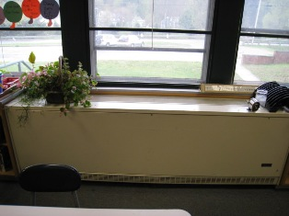

Unit Ventilator (Univent) in Classrooms
Note Plant on Univent
Picture 2

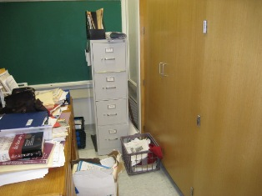

Wall Mounted Exhaust Vent
Note Vent is Obstructed by File Cabinet, Papers
Picture 3

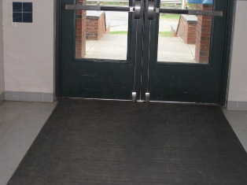

Gaps Below Exterior Doors

Picture 4

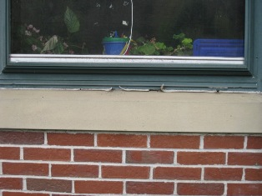

Window Sealant in Disrepair

Picture 5

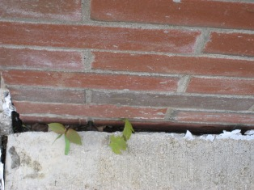

Gap Adjacent to Building Due to Deteriorated Sealant
Note Plant Growth Adjacent to Masonry

Picture 6

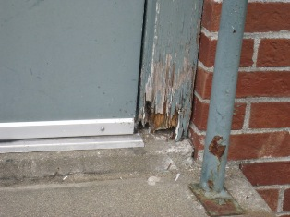

Rotted Door Casing
Picture 7

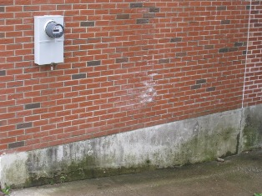

Efflorescence on Brick Wall
Note Discoloration and Moss Growth on Concrete

Picture 8

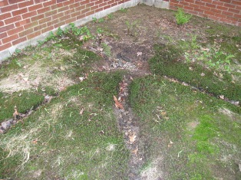

Depressions Created Where Water Drains Off Roof
Picture 9

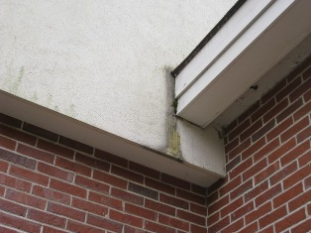

Water Damaged Exterior Wall

Picture 10

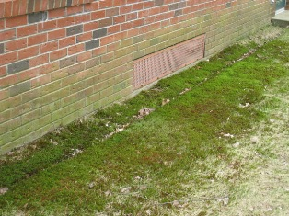

Moss Growth On Ground and Masonry

Picture 11

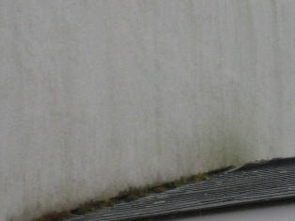

Moss Growth At Juncture of Wall and Asphalt Shingles on Roof

Picture 12

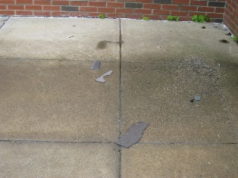

Portions of Asphalt Shingles on Sidewalk

Picture 13

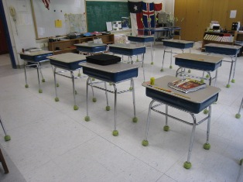

Latex Tennis Balls on Legs of Desks
Picture 14

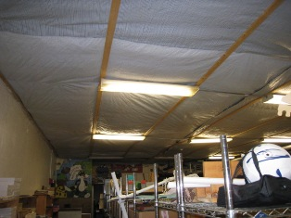

Basement Ceiling

Picture 15

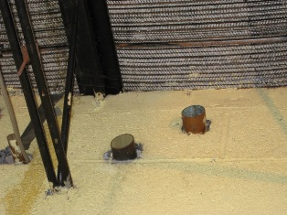

Open Utility Holes
Picture 16



Accumulation of Materials Stored in Classroom
Note Materials Obstruct Access to Windows

Picture 17

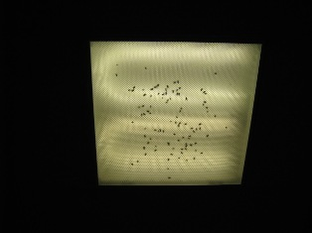

Dead Flies on Light Fixture
Picture 18

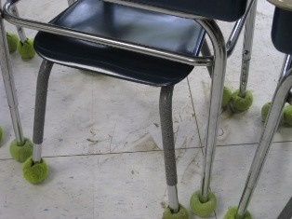

Soil Accumulation on Classroom Floor

Picture 19

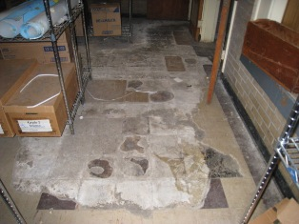

Basement Floor Tiles in Disrepair

Location/ Room | Occupants  in Room | Temp  (°F) | Relative  Humidity  (%) | Carbon  Dioxide  (ppm) | Carbon Monoxide  (ppm) | PM2.5  (µg/m3) | Windows  Openable | Ventilation |  | Remarks
 |  |  |  |  |  |  |  | Supply | Exhaust | Remarks
background |  | 66 | 68 | 362 | ND | - | - | - | -
(1952 Section of Building)  Basement | 0 | 70 | 41 | 609 | ND | - | N | ? | ? | Old cafeteria, floor tiles in very poor repair
Room 7 | 3 | 70 | 47 | 730 | ND | - | Y | Y  Uv Off | Y  Off | DO, TB, DEM, Plants
Room 6 | 0 | 71 | 50 | 645 | ND | - | Y | Y  UV On | Y  Off and blocked | DO, PF, DEM, TB
Room 4 | 0 | 70 | 49 | 559 | ND | - | Y | Y  UV on | Y  Off and blocked | DO, DEM, TB, CD, Opened UV
Room 2 | 18  (five minutes ago) | 69 | 53 | 1338 | ND | - | Y | Y  UV Off | Y  Off | DO, TB, Exhaust blocked by door, clothes
Room 1 | 26 | 70 | 58 | 2252 | ND | - | Y | Y  UV Off | Y  Off and blocked | DC, TB, DEM, CD
Room 3 | 18 | 70 | 50 | 1831 | ND | - | Y | Y  UV Off | Y  Off and blocked | DO, CD, DEM, TB
Room 5 | 0 | 70 | 52 | 838 | ND | - | Y | Y  UV On | Y  Off and blocked | 22 computers
Copy Room | 1 | 73 | 48 | 652 | ND | - | N | Y | Y | DO, DEM
(New Addition) Library | 1 | 72 | 44 | 747 | ND | - | Y | Y | Y | DO
Cafeteria | 38 | 72 | 55 | 657 | ND | - | Y | Y | Y | DO
Kitchen | 2 | 72 | 60 | 530 | ND | - | N | Y | Y | DO, Gas range (6 burner), CO detector needed
Room 12 | 15 | 72 | 53 | 917 | ND | - | Y | Y  UV Off | Y | DO, CD, TB, Plants, 2 comp.
Room 14 | 2 | 69 | 57 | 634 | ND | - | Y | Y  UV Off | Y | DC, CD, Plants
Room 11 | 2 | 71 | 53 | 654 | ND | - | Y | Y  UV Blocked | Y | DO, UF, CD, DEM,
Room 10 | 15 | 72 | 55 | 1028 | ND | - | Y | Y  UV Off | Y | DO, DEM, TB, Windows blocked
Room 15 | 2 | 71 | 51 | 690 | ND | - | Y | Y  UV Off | Y | DO, TB, DEM, PF, CD, Plants
Gymnasium | 0 | 68 | 48 | 735 | ND | - | N | Y | Y | DO
Room 13 | 0 | 69 | 53 | 710 | ND | - | Y  1/3 open | Y  Off | Y | DO
Title 1 Math | 7 | 73 | 47 | 767 | ND | - | N | Y | Y | DO, DEM
Room 8  (Pre K) | 0 | 72 | 50 | 581 | ND | - | Y | Y | Y | DO, DEM
Room 9 | 1 | 72 | 47 | 662 | ND | - | Y | Y | Y | DC
Room 9  (bathroom) |  |  |  |  |  |  | N | N | Y | DC, Flies observed above light fixture
Office  (front) | 2 | 73 | 45 | 713 | ND | - | N | Y | Y | DO
Principal’s Office | 0 | 73 | 41 | 663 | ND | - | Y | Y | Y | DO, Plants
Nurse | 1 | 72 | 45 | 644 | ND | - | N | Y | Y | DO, WDCTs

Location/ Room | PM2.5  (µg/m3)
Background | 15
Basement | 10
Cafeteria | 14
Copy room | 8
Gymnasium` | 15
Health | 9
Library | 11
Library (inner room) | 10
Office (front) | 10
Principal’s | 9
Room 1 | 18
Room 10 | 14
Room 11 | 14
Room 12 | 16
Room 13 | 13
Room 14 | 15
Room 15 | 13
Room 2 | 13
Room 3 | 32
Room 4 | 11
Room 5 | 12
Room 6 | 12
Room 7 | 14
Room 8 | 10
Room 9 | 9

Efflorescence is a characteristic sign of water damage to building materials, but it is not mold growth. As moisture penetrates and works its way through building materials (e.g., plaster, mortar, brick), water-soluble compounds dissolve, creating a solution. As this solution moves to the surface, the water evaporates, leaving behind white, powdery mineral deposits.

