INDOOR AIR QUALITY ASSESSMENT

Columbus Park School
75 Lovell Street
Worcester MA

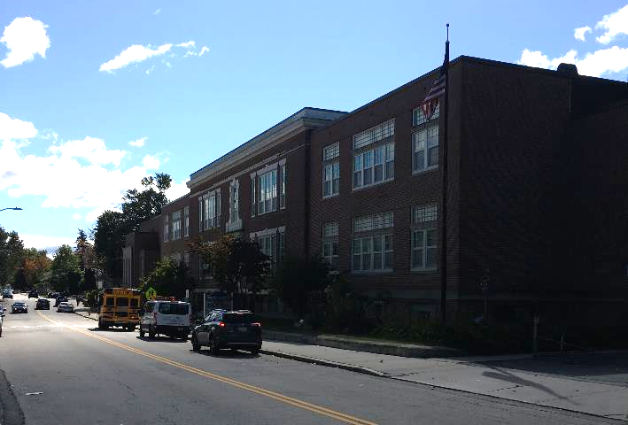

Prepared by:
Massachusetts Department of Public Health
Bureau of Environmental Health
Indoor Air Quality Program
November 2019

Background
Building: | Columbus Park School (CPS)
Address: | 75 Lovell Street, Worcester MA
Assessment Requested by: | James Bedard, Director Of Environmental Compliance & Capital Projects, Worcester Public Schools
Reason for Request: | General Indoor Air Quality (IAQ)
Date of Assessment: | October 4, 2019
Massachusetts Department of Public Health/Bureau of Environmental Health (MDPH/BEH) Staff Conducting Assessment: | Michael Feeney, Director, IAQ Program
Building Description: | The CPS is a brick building complex. The original building was constructed in 1913. A wing was added in the 1950s. When the 1950s addition was built, classrooms were equipped with mechanical ventilation.
Windows: | Windows are openable

Methods
Please refer to the IAQ Manual for methods, sampling procedures, and interpretation of results (MDPH, 2015).

IAQ Testing Results
The following is a summary of indoor air testing results (Table 1):
- Carbon dioxide levels were above the MDPH guideline of 800 parts per million (ppm) in more than half of the locations assessed, indicating a lack of air exchange, mainly due to sealed fresh air intakes and deactivated/outdated ventilation components. This is explained further in the Ventilation section of this report.
- Temperature was within or close to the recommended range of 70°F to 78°F the day of assessment. Note it is difficult to control temperature/maintain comfort without operating the mechanical ventilation systems as designed.
- Relative humidity was within the recommended range of 40 to 60% the day of assessment.
- Carbon monoxide levels were non-detectable (ND) in all areas tested.
- Fine particulate matter (PM2.5) concentrations measured were below the national ambient air quality standard (NAAQS) limit of 35 μg/m³ in all areas tested.

Discussion

Ventilation
A heating, ventilating and air conditioning (HVAC) system has several functions. First it provides heating and, if equipped, cooling. Second, it is a source of fresh air. Finally, an HVAC system will dilute and remove normally occurring indoor environmental pollutants by not only introducing fresh air, but by filtering the airstream and ejecting stale air to the outdoors via exhaust ventilation. Even if an HVAC system is operating as designed, point sources of respiratory irritation may exist and cause symptoms in sensitive individuals.
Mechanical ventilation equipment was deactivated in almost every area throughout the building the day of assessment, in both classrooms and common areas (e.g., cafeteria, gym, and library) (Table 1).
The building has two types of ventilation systems. The 1913 wing was originally equipped with a natural ventilation system that used the stack effect to circulate heat and air through classrooms. It appears that the original airshafts were converted into a mechanical ventilation system with an air handling unit (AHU) located in the basement. Classrooms in the 1913 wing have vents that now function as mechanical supply and return vents (Pictures 1 and 2). The basement has been subdivided into classrooms; added ductwork supplies fresh air through diffusers (Picture 3).
The 1913 portion of the building appears to be originally designed to provide fresh air by opening windows and using cross-ventilation. The building is equipped with windows on opposing exterior walls along with hinged windows (called transoms, Picture 4) located above the doors between classrooms and the hallways. The transom enables the classroom doors to be closed while maintaining a pathway for airflow. This design allows for airflow to enter an open window, pass through a classroom, pass through the open transom, enter the hallway, pass through the opposing open classroom transom, into the opposing classroom and exit the building on the leeward side (opposite the windward side) (Figure 1). With all windows and transoms open, airflow can be maintained in a building regardless of the direction of the wind. The system fails if the windows or transoms are closed (Figure 2). All transoms in the building were sealed, which prevents cross-ventilation as originally designed. The 1950s building has no transoms.
Fresh air for classrooms in the 1950s wing is supplied by a unit ventilator (univent) system (Picture 5). Univents draw air from outdoors through a fresh air intake located on the exterior walls of the building and return air through an intake located at the base of each unit. Fresh and return air are mixed, filtered, heated and provided to classrooms through an air diffuser located in the top of the unit (Figure 3).
In order to have proper ventilation with a mechanical supply and exhaust system, these systems must be balanced to provide an adequate amount of fresh air to the interior of a room while removing stale air from the room. It is recommended that existing ventilation systems be re-balanced every five years to ensure adequate air systems function (SMACNA, 1994). In its current condition, the HVAC system cannot be balanced.
With regard to HVAC system function, according to the American Society of Heating, Refrigeration and Air-Conditioning Engineers (ASHRAE), the service life for a unit heater, hot water or steam is 20 years, assuming routine maintenance of the equipment (ASHRAE, 1991). Despite attempts to maintain the univents (e.g., oiling bearings, changing filters regularly), the operational lifespan of this equipment has been exceeded in all areas of the CPS. Maintaining the balance of fresh to exhaust air will become more difficult as the equipment ages and as replacement parts become increasingly difficult to obtain.

Microbial/Moisture Concerns
As mentioned previously, the lowest floor of the building was converted into classrooms sometime in the 1950s-1960s. The basement has several flooring materials, including terrazzo and tile. Due to the condition of hallway floor tiles (Picture 6), it appears that the basement floor becomes wet with condensation during hot, humid weather, despite the use of dehumidifiers in basement classrooms. This phenomenon was likely exacerbated during the weather conditions experienced in New England during the summer of 2018:
The New England area experienced an unprecedented period of extended hot, humid weather. According to the Washington Post, “[d]ata…show[s]…cities in the Northeast have witnessed such humidity levels for record-challenging duration...[i]ncluding Albany, Boston, Burlington Portland and Providence” during the summer of 2018 (WP, 2018). “Boston and nearby locations… [saw]…historic numbers of those warm nights with low temperatures at or above 70 degrees…Providence and Blue Hill Observatory have already broken their annual records” (WP, 2018).
Since the building was originally constructed in 1913, it is highly unlikely that the floor has either insulation or a vapor barrier. In this condition, the floor likely has a temperature similar the material beneath the floor (e.g, soil, sand, rock ledge, rock fill). If the temperature of the floor is below or equal to the dew point, the floor will begin to accumulate condensation.
The key to managing condensation is understanding dew point. Condensation is the collection of moisture on a surface at or below the dew point. The dew point is the temperature that air must reach for saturation to occur. If a building material/component has a temperature below the dew point, condensation will accumulate on that material. Over time, condensation can collect and form water droplets. With a floor chilled through contact with soil/rock, and the infiltration of unconditioned hot, humid air during the warmer months, condensation on the floor is likely.
In addition, the presence of high relative humidity (>70%) alone for a significantly long period, can also cause water damage to susceptible materials. If these materials are porous, carbon-containing items (e.g., gypsum wallboard, carpeting, cloth, paper, and cardboard), mold can grow (ASHRAE, 1989).
It is recommended that porous material be dried with fans and heating within 24 to 48 hours of becoming wet (US EPA, 2008, ACGIH, 1989). If porous materials are not dried within this time frame, mold growth may occur. Water-damaged porous materials cannot be adequately cleaned to remove mold growth.
The basement level of the building contains a significant amount of materials that can support mold growth if exposed to moisture (Pictures 7 and 8). In addition, a number of conditions exist that may increase relative humidity/moisture conditions in the basement:
- The basement used to contain locker rooms including a shower (Picture 9). It could not be determined if the shower floor drains were permanently sealed. Drains are usually equipped with curved pipe in an “s” shape to form a device called a trap. Drain traps are normally filled with water to create a seal between the building's sanitary sewer line and the system designed to ventilate sewer gas. Without the water seal in a drain trap, water vapor and sewer gas can be drawn into an area. Sewer water can contain a number of bioaerosols (including fungi such as mold) that can be drawn into an area with a dry drain trap, particularly when a sewer system has a large influx of water during heavy rainstorms. The water inside the trap requires replenishment on a regular basis (every other day, particularly during the heating season) to maintain airtightness of the trap.
- Sinks in the lower level may also develop dry drain traps during summer months when school is on break.
- The fresh air intake for the main retrofitted HVAC system is located at the rear of the building. Hot, moist air may migrate into classrooms under westerly/southwesterly wind conditions via the deactivated HVAC system if the fresh air intake dampers are in the open position.
- Porous materials were present in the basement area. It is highly recommended that materials that can support mold growth be removed. Porous materials such as paper, cardboard, cloth and leather can all become mold colonized if repeatedly exposed to moisture.
These types of conditions conducive to mold growth may result in an indoor environment that could adversely affect the health of occupants with respiratory disease such as asthma.
Note that EPA conducted a National School Radon Survey in which it discovered nearly one in five schools had “…at least one frequently occupied ground contact room with short-term radon levels above 4 [picocuries per liter] pCi/L” (US EPA, 1993). The BEH/IAQ Program therefore recommends that every school be tested for radon, and that this testing be conducted during the heating season while school is in session in a manner consistent with USEPA radon testing guidelines. Radon measurement specialists and other information can be found at www.nrsb.org and http://aarst-nrpp.com/wp, with additional information at: http://www.mass.gov/eohhs/gov/departments/dph/programs/environmental-health/exposure-topics/iaq/radon.

Conclusions/Recommendations
The conditions related to IAQ problems at the CPS raise a number of issues. The general building conditions/design, maintenance, and the condition of HVAC equipment, if considered individually, present conditions that could degrade IAQ and are typically found in buildings of this age. When combined, these conditions can serve to degrade IAQ. Some of these conditions can be remedied by actions of building occupants. Other remediation efforts will require alteration to the building structure and equipment. For these reasons, a two-phase approach is recommended. The first consists of short-term measures to improve air quality and the second consists of long-term measures that will require planning and resources to adequately address overall IAQ concerns.

Short-term measures:
- Operate existing HVAC components to the extent possible when school is occupied to provide fresh air and exhaust.
- Use openable windows to provide fresh air during temperate weather. Ensure windows are closed tightly at the end of each day and during heavy rain.
- Consider temporarily sealing the fresh air intake of the HVAC system during hot, humid weather with a non-porous, solid material to prevent wind-driven hot, moist air from entering the building.
- Remove all porous materials from the basement floor including carpeting and stored materials. Reduce the amount of materials stored in the basement area in general, and store remaining materials in waterproof totes.
- Ensure all former locker room drains are permanently sealed.
- Operate dehumidifiers during hot, humid weather to reduce relative humidity in basement areas. Ensure all dehumidifiers are emptied, cleaned and maintained regularly to prevent spills and odors.
- Ensure all sinks in the lower level have wet drain traps throughout the summer break. Run faucets at least twice a week to maintain the airtight seal of the trap.
- After consulting with a ventilation engineer, examine the feasibility of changing filters in HVAC units at least twice a year with Minimum Efficiency Reporting Value (MERV) 8 (or higher) filters. Clean HVAC and univent cabinets of debris and dust when filters are changed.
- Clean carpeting annually or semi-annually in soiled high traffic areas as per the recommendations of the Institute of Inspection, Cleaning and Restoration Certification (IICRC 2012).
- For more information on mold refer to “Mold Remediation in Schools and Commercial Buildings” published by the US Environmental Protection Agency (US EPA, 2008). http://www.epa.gov/mold/mold-remediation-schools-and-commercial-buildings-guide.
- In not done so already, the school should be tested for radon by a certified radon measurement specialist during the heating season when school is in session. Radon measurement specialists and other information can be found at: www.nrsb.org, and http://aarst-nrpp.com/wp.
- Consider adopting the US EPA (2000) document, “Tools for Schools”, as an instrument for maintaining a good IAQ environment in the building. This document is available at: http://www.epa.gov/iaq/schools/index.html.
- Refer to resource manual and other related IAQ documents located on the MDPH’s website for further building-wide evaluations and advice on maintaining public buildings. These documents are available at: http://mass.gov/dph/iaq.

Long-term Recommendations:
- Consideration should be given to replace HVAC units/components as they become past their service life. If not conducted already, consider contacting an HVAC engineering firm for an assessment of the ventilation system’s components and control systems (e.g., controls, air intake louvers, thermostats). Based on the age, physical deterioration, and availability of parts for ventilation components, such an evaluation is necessary to determine the operability and feasibility of repairing/replacing the equipment.

REFERENCES
ACGIH. 1989. Guidelines for the Assessment of Bioaerosols in the Indoor Environment. American Conference of Governmental Industrial Hygienists, Cincinnati, OH.
ASHRAE. 1991. ASHRAE Applications Handbook, Chapter 33 “Owning and Operating Costs”. American Society of Heating, Refrigeration and Air Conditioning Engineers, Atlanta, GA.
IICRC. 2012. Institute of Inspection, Cleaning and Restoration Certification. Carpet Cleaning: FAQ.
MDPH. 2015. Massachusetts Department of Public Health. “Indoor Air Quality Manual: Chapters I-III”. Available at: http://www.mass.gov/eohhs/gov/departments/dph/programs/environmental-health/exposure-topics/iaq/iaq-manual/.
SMACNA. 1994. HVAC Systems Commissioning Manual. 1st ed. Sheet Metal and Air Conditioning Contractors’ National Association, Inc., Chantilly, VA.
US EPA. 1993. Radon Measurement in Schools, Revised Edition. Office of Air and Radiation, Office of Radiation and Indoor Air, Indoor Environments Division (6609J). EPA 402-R-92-014.
US EPA. 2000. Tools for Schools. Office of Air and Radiation, Office of Radiation and Indoor Air, Indoor Environments Division (6609J). EPA 402-K-95-001, Second Edition. http://www.epa.gov/iaq/schools/tools4s2.html.
US EPA. 2008. “Mold Remediation in Schools and Commercial Buildings”. Office of Air and Radiation, Indoor Environments Division, Washington, DC. EPA 402-K-01-001. September 2008. Available at: http://www.epa.gov/mold/mold-remediation-schools-and-commercial-buildings-guide.
WP. 2018. ‘It’s been relentless’: Smothering summer humidity in the Northeast has crushed records. Washington Post, Washington, DC. https://www.washingtonpost.com/news/capital-weather-gang/wp/2018/08/30/its-been-relentless-smothering-summer-humidity-in-the-northeast-has-crushed-records/
Picture 1
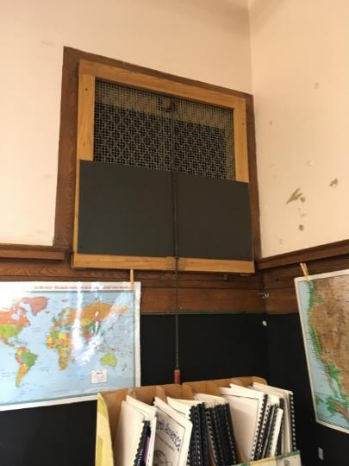
Fresh air supply vent
Picture 2
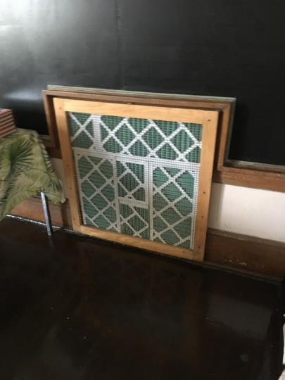
Return air vent with filters attached
Picture 3
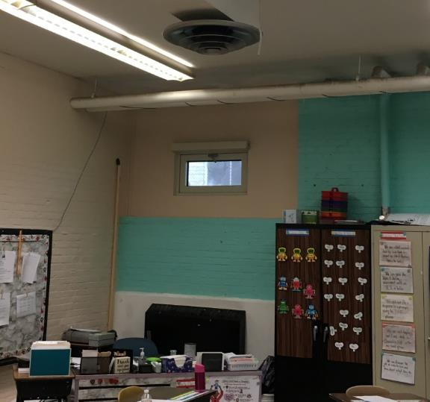
Retrofitted basement fresh air supply and ductwork
Picture 4
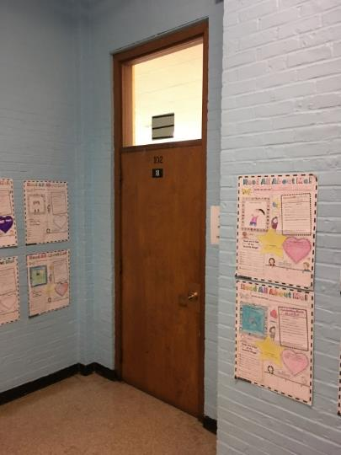
Transom
Picture 5
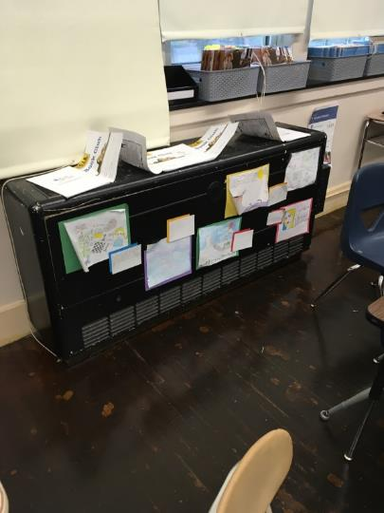
Unit ventilator (univent)
Picture 6
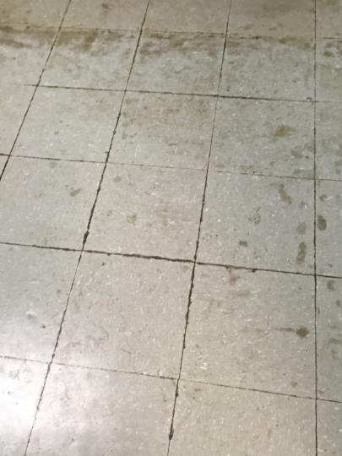
Water-damaged floor tiles in basement
Picture 7
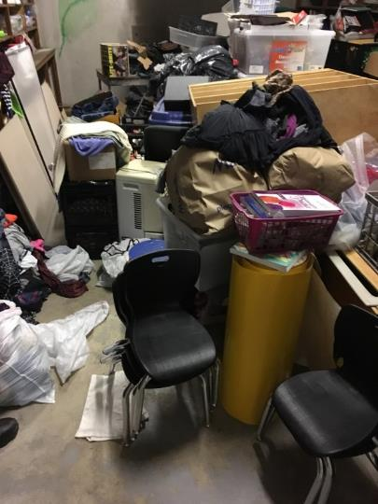
Stored materials in basement
Picture 8
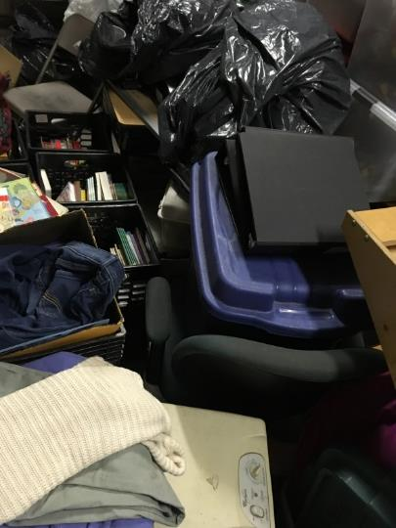
Stored materials in basement
Picture 9
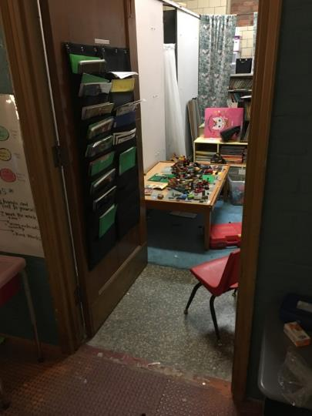
Former locker room shower area

Location | Carbon  Dioxide  (ppm) | Carbon Monoxide  (ppm) | Temp  (°F) | Relative  Humidity  (%) | PM2.5  (µg/m³) | Occupants  in Room | Windows  Openable | Ventilation |  | Remarks
 |  |  |  |  |  |  |  | Supply | Exhaust
Background (outside) | 422 | ND | 62 | 72 | 11
Special Education | 682 | ND | 70 | 52 | 1 | 2 | N | N | N
Custodian | 786 | ND | 70 | 53 | 1 | 1 | Y | N | N
Teacher’s room | 842 | ND | 71 | 51 | 2 | 2 | Y | N | Y
Cafeteria | 1347 | ND | 73 | 56 | 1 | 100+ | Y | Y | Y
Gym | 609 | ND | 70 | 45 | 1 | 20+ | Y | Y | Y | 20+ water-damaged ceiling tiles
101 | 877 | ND | 71 | 54 | 1 | 22 | Y | Y | Y
105 | 995 | ND | 72 | 52 | 3 | 18 | Y | Y | N | Tennis balls
106 | 1087 | ND | 70 | 52 | 3 | 15 | Y | Y | Y
108 | 604 | ND | 68 | 49 | 0 | 0 | Y | Y | N
110 | 577 | ND | 70 | 42 | 0 | 1 | Y | Y | N
201 | 878 | ND | 70 | 51 | 1 | 17 | Y | Y | Y
202 | 748 | ND | 69 | 48 | 2 | 16 | Y | Y | Y
204A | 796 | ND | 70 | 48 | 1 | 4 | Y | N | N
205 | 808 | ND | 70 | 49 | 0 | 6 | Y | Y | Y
206 | 801 | ND | 70 | 49 | 1 | 10 | Y | Y | Y | Upholstered furniture
207 | 802 | ND | 69 | 48 | 1 | 14 | Y | Y | Y | Tennis balls
302 | 764 | ND | 70 | 46 | 0 | 0 | Y | Y | Y
303 | 1336 | ND | 70 | 53 | 1 | 0 | Y | Y | N | Exhaust sealed
305 | 1577 | ND | 71 | 54 | 3 | 2 | Y | Y | Y
306 | 1810 | ND | 71 | 54 | 1 | 0 | Y | Y | Y
307 | 1198 | ND | 68 | 52 | 1 | 1 | Y | N | N

Condensation is the collection of moisture on a surface with a temperature below the dew point. The dew point is a temperature determined by air temperature and relative humidity. For example, at a temperature of 73°F and relative humidity of 57 percent indoors, the dew point for water to collect on a surface is approximately 57°F.

