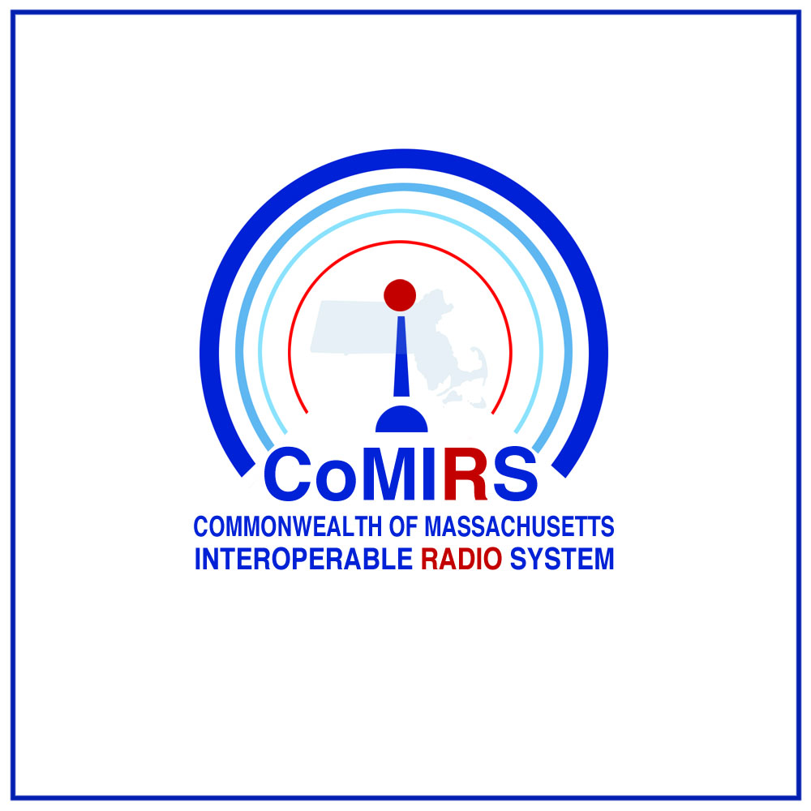
system access request

Email completed form and any attachments to CoMIRS@mass.gov

Checklist
The CoMIRS statewide radio network is comprised of state-of-the-art technology as well as legacy components that are up to 20 years old. The heart of the system consists of two master-site zone controllers, located in Framingham and Boston. This network of zone controllers is commonly referred to as the CORE. The system uses more than 200 700/800 MHz radio frequencies, 78 microwave links, 91 radio consoles, more than 80 tower sites, and there are more than 15,000 subscriber units on the network. Changes to any component of the system may affect the overall performance of the system as a whole and has the potential to introduce unintended consequences. For these reasons, a planned and analytical approach is necessary before adding talkgroups, granting access to the CORE, adding or modifying subscriber units, or making any changes to the configuration of the system.

Overview
The checklist ensures that requests for participation in the radio network can be carefully evaluated for its impact on the system.. It is important to ensure that issues of radio coverage, channel-loading capacity, equipment compatibility, resiliency, operating standards, interoperability, interference potential and performance are all considered beforehand.

Requesting Agency-
Informal discussions about technical possibilities are recommended before a formal request is made. These discussions will inform and shape the formal request. A formal letter of request from an agency head or an executive officer of the political subdivision will be required to begin the request process. Requesting letter should explain the rationale for the request and explain the anticipated use of the system.

Formal request:
Date of Request
Requested Activation Date
Requesting Agency
Point of Contact Name
Address
City, State, Zip
Telephone
Email

Request for:
Subscriber unit access to CoMIRS talkgroups/channels (mobile, portable control station)
Check all that apply
Interoperability Talkgroup/Channel Access
Creation of new Talkgroup(s) -new talkgroups frozen as of 7/10/2018

Agency Specific Talkgroup(s)-List Below
Agency | Talkgroup Name
Access to agency specific talkgroups requires a separate, written authorization from the talkgroup owner. Please provide a brief description of the need for agency specific talkgroup(s) not met by standard interoperability talkgroups:

Access to CORE
Check all that apply
Radio Dispatch Console-New
Description: (attach preliminary drawings if available)

Radio Dispatch Console-Modification
Description: (attach preliminary drawings if available)

Conventional Radio System(s)
Description: (attach preliminary drawings if available)

Network Management
Describe desired functionality:

Signal Boosting Equipment (BDA/DAS)
Location:

Private System Support
Check all that apply
Request for Backhaul/Transport
Endpoint A:
Endpoint Z:
Request for Equipment Shelter Use
Shelter Location:
Equipment Description:
Request for Tower Use
Tower Location:
# and model antenna(s):

NOTE: The Interoperable Radio Bureau will contact the requesting agency to collect additional information as required.

