INCIDENT HIGHLIGHTS
DATE:
October 15, 2019
TIME:
6:30 a.m.
VICTIM:
83-year-old commercial property owner
INDUSTRY/NAICS CODE:
Lessors of Nonresidential Buildings/531120
EMPLOYER:
Property owner renting commercial property
SAFETY & TRAINING:
No safety and health program or on-the-job-training
SCENE:
Mixed-use commercial property
LOCATION:
Massachusetts
EVENT TYPE:
Explosive air release

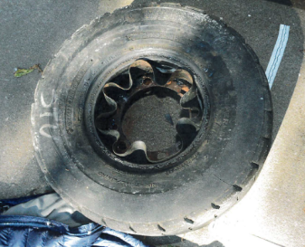

REPORT#: 19MA049 REPORT DATE: November 10, 2021
Commercial Property Owner Fatally Injured When Forklift Tire Ruptures– Massachusetts

SUMMARY
On October 15, 2019, an 83-year-old commercial property owner was fatally injured while working on a forklift wheel. The wheel would not fit on the hub and he was working on the wheel on the ground when the tire ruptured, releasing an air blast that caused multiple injuries.
READ THE FULL REPORT> (p.3)

CONTRIBUTING FACTORS
Key contributing factors identified in this investigation include:
- Standing within the trajectory of the air blast force of a pressurized tire;
- Lack of safety training on multi-piece wheels; and
- Performing job task alone.
LEARN MORE> (p.7)
______________________________________________________
RECOMMENDATIONS
Massachusetts FACE Program concluded that, to help prevent similar occurrences, employers should:
- Ensure workers create a controlled safe work environment prior to servicing a multi-piece wheel;
- Ensure that workers have the necessary tools, equipment, and training to safely service wheels and associated components; and
- Consider developing policies that prevent workers from working alone in certain situations. LEARN MORE> (p.7)
Fatality Assessment and Control Evaluation (FACE) Program

The Massachusetts Department of Public Health, in cooperation with the National Institute for Occupational Safety and Health (NIOSH), conducts investigations on the causes of work-related fatalities. The goal of this program, known as Massachusetts Fatality Assessment and Control Evaluation (Massachusetts FACE) is to prevent future fatal workplace injuries. Massachusetts FACE aims to achieve this goal by identifying and studying the risk factors that contribute to workplace fatalities, by recommending intervention strategies, and by disseminating prevention information to employers and employees.

NIOSH funded state-based FACE Programs currently include: California, Louisiana, Kentucky, Massachusetts, Michigan, New York, Oregon, and Washington.

SUMMARY

On October 15, 2019, an 83-year-old commercial property owner was fatally injured while working on a forklift wheel. The wheel had recently been repaired but would not fit on the hub. He was working on the wheel on the ground when the tire ruptured, releasing an air blast. The victim fell back, striking his head on the ground and was struck by a four-way lug wrench propelled by the explosion. A tenant arrived two hours later and found the victim unconscious and lying on his back. They immediately placed a call for emergency medical services (EMS). The victim was transported to a nearby hospital where he was pronounced dead.

INTRODUCTION

On October 16, 2019, the Massachusetts FACE Program was alerted by the Occupational Safety and Health Administration (OSHA) about the incident. A representative from the Massachusetts FACE Program spoke with a co-owner of the property, a property tenant, and an acquaintance of the victim to discuss the incident and the victim. The police reports, death certificate, and manufacturer information were reviewed during the investigation.

EMPLOYER
The victim was a co-owner of the commercial property. He had owned the property with a partner, his brother, for over 30 years. They used the space for their unfinished wood furniture manufacturing company. They ran this business for approximately 20 years. In 2004, the victim and his partner went into business with a fellow craftsman who they let use the space. Upon retiring from woodworking in 2013, the partners sold the business assets to a fellow craftsman and maintained ownership of the property. The new business owner used the property as a manufacturing site for his independent carpentry business building wine racks. Recently, he had decided to close the business and move. The victim and this tenant were working together to clean up the property.

WRITTEN SAFETY PROGRAMS AND TRAINING

The victim had been an owner/operator and reportedly did not have any training specific to the equipment or procedures involved in the fatal incident. At the time of the incident, the company did not have employees other than the co-owners. There is no evidence the company had a safety and health program.

WORKER INFORMATION
The victim was an 83-year-old White, non-Hispanic retiree and commercial property owner who functioned as the landlord of the property. He was a retired carpenter with over 20 years of experience. At the time of the incident, he had co-owned a commercial property with his business partner and brother for approximately 30 years. Prior to becoming a commercial property lessor, the victim and his brother manufactured furniture at the site. The victim routinely rented the property to lessees who provided carpentry products and services. In 2004, the victim took on a mentee, who in 2013 developed his own business as a wine rack manufacturer for a local distributor. In 2013, the victim retired from the woodworking business and continued in a part-time role managing the building’s maintenance. The victim was described to be determined and self-motivated, often completing tasks independently despite his age.

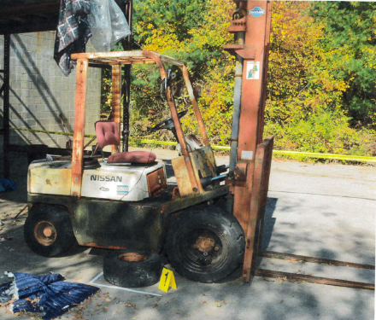
EQUIPMENT
The equipment being worked on by the victim at the time of the incident was a diesel-powered forklift (Figure 1). The maximum lifting capacity of the unit was 5,000 lbs. The purchase history of the equipment was not known. The victim’s brother and partner reported they had no maintenance issues with the forklift. They did report that the tires had deteriorated. As the victim was using the forklift to move items around the property, the tires became flat. The two larger tires were repaired at the site and the rear wheel was removed so the tire could be repaired off-site.

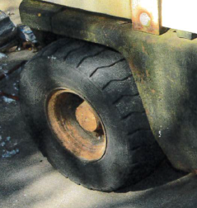
The rear forklift tire involved in the incident was a heavy-duty tire designed for industrial and mining equipment. This tire was a tube-style tire with a diameter of 21 inches and width of 9 inches. It had a recommended air inflation of 110 psi and a weight rating of 4,645 pounds when used as a non-steering wheel as in the configuration on this front-wheel steering forklift.
Figure 1 – Diesel forklift (photograph taken by first responders)

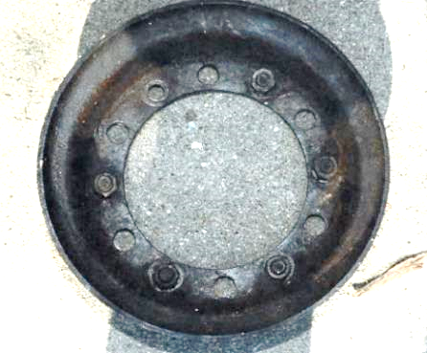
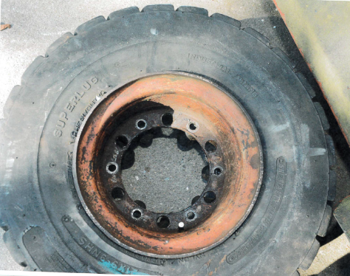
The steel wheel on this tire was a multi-piece wheel with two halves. Large truck and heavy-duty equipment wheels can contain multiple components, including multiple rim plates and rings or hoops that bolt together or are held in place by the pressure of the inflated tire. In this case, the rim included two halves that were held together by bolts. This type of two-piece rim is commonly used on larger construction and mining vehicles, including forklifts, tractors, and other heavy equipment. Figure 3 shows what is the outer rim component when the wheel is mounted on the forklift. Figure 4 shows the inner rim component. Six bolts spanned the rim and would have been in place on the wheel when it was assembled.
Figure 3 – Left side rear tire, as found on the ground after the incident (photograph taken by first responders)
Figure 2 – Right side rear wheel, in place on forklift (photograph taken by first responders)
Figure 4 – Inner half of split wheel (photograph taken by first responders)

INCIDENT SCENE

The location of the incident was a commercial property with one building. The concrete block building had two floors and was approximately 4,500 square feet. The incident occurred at the rear of the premises near a metal stairway and deck attached to the second level of the building (Figures 5 and 6). This is where the forklift had been parked. The outdoor space where the forklift was located was concrete and mostly flat. The concrete slab was roughly 3,200 square feet.

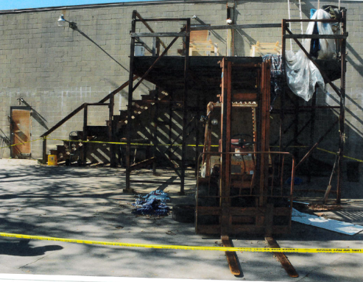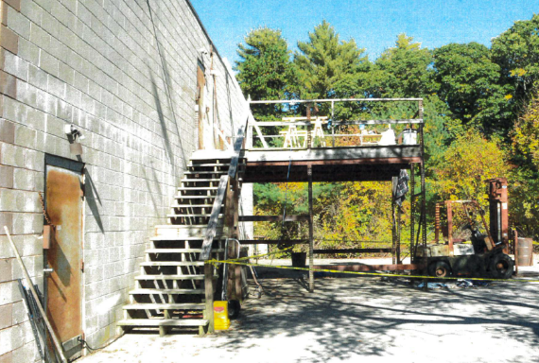

Figures 5 and 6 – Rear of commercial property where forklift was located (photographs taken by first responders)

WEATHER

The weather at the time of the incident was approximately 61 degrees Fahrenheit, 58% humidity, with a 20 mile per hour south-southwest wind, and fair skies. The weather is not believed to have been a factor in this incident.

INVESTIGATION

The deceased and his brother co-owned the property for approximately 30 years. In the years leading up to the incident, the owners let a carpenter who manufactured wine racks use the space in exchange for payment. That tenant had decided to close his shop and move and was helping the property owners clean up the property. The primary goal was to remove old and unused materials and equipment from the property.

The forklift was located at the rear of the property, on the concrete slab behind the building. During the clean-up and in using the forklift all tires were discovered to be flat. A week prior to the incident, the tenant had the front tires repaired. The victim had sent a flat rear tire to a tire repair shop for similar servicing. After receiving the tire back from the repair shop, multiple attempts were made to install the wheel on the axle of the forklift, without success. The exact source of the difficulty is not known and was not documented. One hypothesis is that the bolts used to assemble the two rim pieces were placed in incorrect holes such that the remaining holes did not fit the lugs on the forklift axle. To fix this, the wheel would need to be disassembled and the bolts reinstalled in the correct holes.

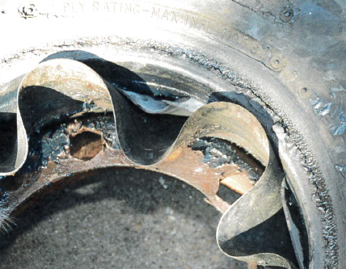
On the day of the incident, the victim started his day around 5:00 a.m. According to a source, the victim indicated he was going to be working again with the forklift wheel. The former tenant was planning to meet the victim at the premises at around 9:00 a.m. to help with this task. While no one witnessed the incident, evidence suggests the victim was using the lug wrench to work on the forklift wheel and the wheel was laying on the ground. It is believed he was disassembling the rim parts and had removed at least one nut, compromising the strength of the rim. Shortly after 6:30 a.m., a neighbor who lived a quarter of a mile away heard a loud boom. Due to the high pressure of the inflated tube and tire, and the force exerted by the victim on the wheel, the tube ruptured and there was a release of air pressure. Evidence suggests this caused the two rim halves to separate with such force that any remaining bolts tore through the rim, as visible in Figure 7. The smaller inner rim was found fully separated after the incident. The scalloped shape of the rim suggests it was also deformed by the air pressure.
Figure 7 – Outer half of split wheel; torn holes suggest bolts were torn through the rim plate (photograph taken by first responders)
Part of the rim may have been propelled downward into the ground as evidenced by an impression in the concrete slab. The victim was struck by the blast and fell backwards. The victim sustained multiple fatal injuries, including head trauma and spinal trauma from the fall to the ground. He also sustained a puncture wound and blunt trauma to the chest, a fracture to one eye socket, and trauma to his hands: this is believed to be from the air release and the four-way lug wrench striking him in the chest. At approximately 8:30 a.m. the tenant arrived at the property and found the victim unconscious next to the forklift. A 911 call was placed for emergency services. EMS arrived at the scene and transported the victim to a local hospital where he was pronounced dead.

CAUSE OF DEATH
The medical examiner listed the cause of death as: stab wound of left chest and blunt force injuries of head and neck.

CONTRIBUTING FACTORS

Occupational injuries and fatalities are often the result of one or more contributing factors or key events in a larger sequence of events that ultimately result in the injury or fatality. The Massachusetts FACE Program identified the following contributing factors in this incident:
- Standing within the trajectory of the air blast force of a pressurized tire;
- Lack of safety training on split-rim tires; and
- Performing a job task alone.

RECOMMENDATIONS/DISCUSSION

Recommendation #1: Ensure workers create a controlled safe work environment prior to servicing a rim wheel.

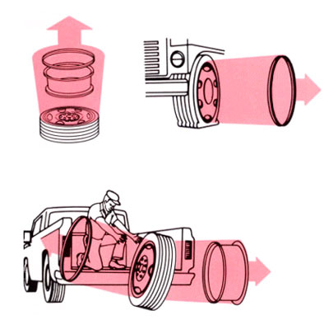
Discussion: Tires are a source of hazardous potential energy because of the pressurized air they contain. If this pressurized air is released during a tire or wheel component failure, the force of the air released is enough to seriously injure or kill those in its trajectory (Figure 8). Furthermore, multi-piece rim tires present an elevated risk-level due to their structure. Split-rim tires contain multiple pieces which are held together by a locking ring or by hardware that holds the pieces together. Failure of any of the pieces can cause separation of the pieces and an explosion of pressurized air, resulting in serious injuries and death. For this reason, several OSHA guidelines have been created to prevent injury and create a safe environment for the servicing of multi-piece rims.²

Figure 8 – Trajectory of multi-piece rim parts in different scenarios (images from 1910.177)

The victim was working in the blast trajectory of the tire as it lay on the ground. For this reason, it is essential and required that; 1) trained professionals examine multi-piece and single piece wheels prior to assembly in accordance with OSHA standard 1910.177(e)(2) and that employers 2) establish safe operating procedures for multi-piece rim wheels including completely deflating a rim wheel before removal from the axle if any obvious or suspected damage is identified in accordance with OSHA standard 1910.177(f).²

In addition, it is good practice for individuals designated to perform any tire servicing have the proper training, safety equipment and tools. This includes, but is not limited to, employee training on servicing, tire handling, and hazard awareness, tire servicing equipment, including restraining devices and barriers, and specific safety procedures for multi-piece rim wheels. This will be discussed further in Recommendation 2.

Recommendation #2: Ensure that workers have the necessary tools, equipment, and training to safely service wheels and associated components.

Discussion: Due to industrial tires having dangerously high pressure, it is good practice to have these tires serviced and installed by trained professionals when possible. While this is not always an available option, it is critical to ensure workers have the proper safety training, tools, and equipment to understand and work on industrial wheels.²

OSHA has established several employee training guidelines to ensure workers are safe while servicing tires. Key aspects required in this training are mounting and demounting, inspection of components, handling, and safe procedures for single and multi-piece rims. Additionally, in accordance with OSHA standard 1910.177(c)(2)(vii) and (f)(10), employees should have hazard awareness training of tire trajectory paths and should avoid standing in such a path unless absolutely necessary for servicing.²

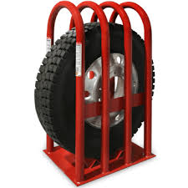
Additionally, measures should be taken to ensure employees have the proper equipment to service tires, including restraining devices or barriers (Figure 9). Restraining devices are utilized during inflation to prevent injury from components of multi-piece wheels in the event of an explosive separation.² Specifically, barriers or restraining devices must have the capacity to withstand 150 percent of the specified maximum tire pressure.² A safety cage/tire inflation cage is one method of containing wheel components in the event of an explosive separation.

It is best practice to have all tires inspected by professionals trained in the repair of highly pressurized tires. Not every situation will allow for a thorough examination by a trained professional. However, a careful examination of a tire for irregular wear and any improperly fit rims prior to installation is good practice for those without formal training. Moreover, it is best practice not to attempt to install, remove, inflate, or deflate any tire that appears to be functioning improperly. Taking a malfunctioning wheel or its components to a trained professional will help prevent potential injury.
Figure 9 – Safety cage for use while inflating and deflating tires (image of example shown is from BendPak)

Evidence shows that the victim had no previous training on wheels or tires prior to the incident. Additionally, no evidence suggests the victim had reviewed the rim manual prior to repair or installation. Due to the hazards posed by the potential energy stored in tires and the danger of wheel rim component failure, it is important that anyone who works with industrial tires be trained to identify and understand these hazards. OSHA standard 1910.177(c) requires that workers be trained and assessed on how to safely service multi-piece and single-piece wheel rims.² As this individual was not a formal repairman, as a proactive step to prevent injury or death while handling tires, written or verbal educational material should be disseminated at any location that sells tires to non-trained individuals. This material can provide an overview of the hazards associated with single and multi-piece rims and provides basic safety procedures on handling, installation, and removal.

Recommendation #3: Consider developing policies that prevent workers from working alone in certain situations.

Discussion: Although not all tasks require additional assistance, when work tasks present an excess level of hazard, it is best practice to ensure workers are not alone. It is good practice to ensure more than one worker is present to complete a task if a task involves a location away from other workers, workers come in close proximity to high-pressure tires, or workers have not completed the proper safety and hazard training. Having more than one worker can shorten the amount of time needed to complete the task. Moreover, a second person could immediately assist a worker and seek help from others, such as placing a call for emergency medical services if medical assistance is needed.

Interviews with friends and family of the deceased stated that the former tenant was planning to help with the installation of the forklift tire on the morning of the incident. To avoid potential injury or death it is best practice to ensure staff servicing tires have at least two workers present at the time of the work. This can be done by verifying staff scheduling or waiting until all staff have arrived prior to service starting.

ADDITIONAL RESOURCES

1910.177 - Servicing multi-piece and single piece rim wheels. | Occupational Safety and Health Administration. https://www.osha.gov/laws-regs/regulations/standardnumber/1910/1910.177

Occupational Safety and Health Administration. Multi-Piece and Single-Piece Rim Wheels https://www.osha.gov/publications/bytopic/multi-piece-and-single-piece-rim-wheels

NIOSH publication 2004-101: Servicing Multipiece & Single-Piece Rim Wheels https://www.cdc.gov/niosh/docs/2004-101/chklists/n58rim~1.htm

DISCLAIMER

Mention of any company or product does not constitute endorsement by the National Institute for Occupational Safety and Health (NIOSH). In addition, citations to websites external to NIOSH do not constitute NIOSH endorsement of the sponsoring organizations or their programs or products. Furthermore, NIOSH is not responsible for the content of these websites. All web addresses referenced in this document were accessible as of the publication date.

REFERENCES

Specifications of the tire [Internet]. [cited 2021 Jun 28]; https://www.stausaonline.com/tires/superlug-heavy-duty/#lightbox/6/
1910.177 - Servicing multi-piece and single piece rim wheels. | Occupational Safety and Health Administration [Internet]. [cited 2021 Jan 24]; Available from: https://www.osha.gov/laws-regs/regulations/standardnumber/1910/1910.177
Area weather for region, New Bedford, MA Weather History | Weather Underground [Internet]. [cited 2021 Jan 24]; Available from: https://www.wunderground.com/history/daily/us/ma/new-bedford/KEWB/date/2019-10-15

