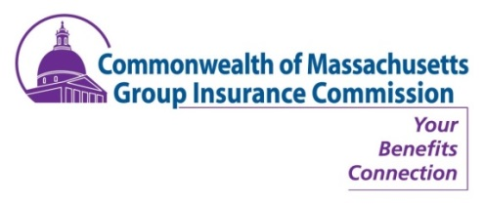
PUBLIC NOTICE
GIC COMMISSION MEETING
Thursday, November 1, 2018
8:30 A.M.
*extended*

John W. McCormick Building
Conference Rooms 1&2, 21st Floor
1 Ashburton Place, Boston, MA 02108

**Please note: The sequence of the agenda is under review and may change as a result of Commissioner feedback**

  - Approval of Meeting Minutes (VOTE)
    - October 4, 2018
  - Director’s Report (INFORM)
    - Flexible Spending Account Procurement Update
    - Annual Health Plan Stewardship Meetings
    - Heat Map of Employee disbursement across Massachusetts
    - Calendar of upcoming events
    - Medicare Advantage Rate Renewal
    - Cost Trend Hearings review
  - Introduction: CHIA & Health Policy Commission (INFORM)
    - Presentations by Ray Campbell (CHIA) and David Seltz (HPHC)
  - Break
  - Healthcare Financial Benchmarking (INFORM)
    - Continuation of Willis Tower’s benchmarking discussion from October meeting. (if time permits)
  - Accenture Update (INFORM)
    - Project Update
    - Business Process Redesign
  - Functional Reviews (INFORM)
    - Monthly GIC financial updates
  - In Closing: Out & About, Misc. Updates, Wrap-Up & Discussion & Other Business
    - Governance – follow up on subcommittee formation, Charter and Next Steps

