
The Commonwealth of Massachusetts
Executive Office of Elder Affairs

One Ashburton Place, 5th Floor

Boston, Massachusetts 02108

CHARLES D. BAKER
Governor

KARYN E. POLITO
Lieutenant Governor

MARYLOU SuDDERS
Secretary, Executive Office of Health and Human Services
ELIZABETH C. CHEN, PhD, mba, mph
Secretary

Tel: (617) 727-7750
Fax: (617) 727-9368
TTY/TTD: 1-800-872-0166
www.mass.gov/elders

Commission on Malnutrition Prevention among older adults
Year THREE Annual Report - December 2020
An Act Establishing a Commission on Malnutrition Prevention Among Older Adults (MPC) was passed by the Massachusetts state legislature and signed into law by Governor Baker on November 29, 2016. Since the Commission began meeting in February 2018, much work has been accomplished in raising public awareness about the importance of proper nutrition for older adults, including education materials, social marketing, statewide campaigns and hosting public events. The Commission’s work also took on changing the stigma often associated with malnutrition (only for sick and poor) and introduced the concept of nutrition balance (over or under consumption), and not limited to people who are socially, economically or physically disadvantaged. Further, the Commission identified evidence-based strategies, including community nutrition programs, used to reduce the rate of malnutrition among older adults and health care acquired infections related to malnutrition. Additionally, the Commission encouraged and fostered communication between medical and community settings to promote the role of appropriate nutrition in medicine.
Chapter 19A Section 42 of the Massachusetts General Laws states:
There shall be with the department a commission on malnutrition prevention among older adults. The commission shall consist of the secretary of elder affairs or a designee, who shall serve as chair, the commissioner of public health or a designee, the commissioner of transitional assistance or a designee, the commissioner of agricultural resources or a designee, the senate and house chairs of the joint committee on elder affairs or their designees and 9 persons to be appointed by the governor, 1 of whom shall be a physician, 1 of whom shall be a university researcher, 1 of whom shall be a community-based registered dietitian or nutritionist working with an Older Americans Act-funded program, 1 of whom shall be a representative of a hospital or integrated health system, 2 of whom shall be nurses working in home care, 1 of whom shall be a registered dietitian or nutritionist working with a long-term care or assisted living facility, 1 of whom shall be a registered dietitian or nutritionist representing the Massachusetts Dietetic Association and 1 of whom shall be a representative from the Massachusetts Association of Councils on Aging, Inc.
The commission shall make an investigation and comprehensive study of the effects of malnutrition on older adults and of the most effective strategies for reducing it. The commission shall monitor the effects that malnutrition has on health care costs and outcomes, quality indicators and quality of life measures on older adults. The commission shall: (i) consider strategies to improve data collection and analysis to identify malnutrition risk, health care cost data and protective factors for older adults; (ii) assess the risk and measure the incidence of malnutrition occurring in various settings across the continuum of care and the impact of care transitions; (iii) identify evidence-based strategies that raise public awareness of older adult malnutrition including, but not limited to, educational materials, social marketing, statewide campaigns and public health events; (iv) identify evidence-based strategies, including community nutrition programs, used to reduce the rate of malnutrition among older adults and reduce the rate of re-hospitalizations and health care acquired infections related to malnutrition; (v) consider strategies to maximize the dissemination of proven, effective malnutrition prevention interventions, including community nutrition programs, medical nutrition therapy and oral nutrition supplements, and identify barriers to those interventions; and (vi) examine the components and key elements of clauses (i) to (v), inclusive, consider their applicability and develop strategies for pilot testing, implementation and evaluation.
The commission shall file a report annually on its activities and on any findings and recommendations to the house and senate chairs of the joint committee on elder affairs and chairs of the senate and house committees on ways and means not later than December 31.
This is the third annual report of the MPC’s work and highlights the accomplishments of the past year during the unprecedented challenges brought on by the COVID-19 pandemic. Due to the pandemic, the MPC members emphasized identifying evidence-based strategies that raise public awareness of older adult malnutrition including, including, educational materials, social marketing, statewide campaigns and public health events.

Membership
2020 MPC Members
Representing | Current Appointee
Secretary of Elders Affairs, Designee (Chair) | Carole Malone Co-Chair  Shirley Chao, Co-Chair  Amy Sheeley, Secretary
Commissioner of Public Health, (Designee) | Diana M. Hoek
Commissioner of Transitional Assistance (Designee) | Penny McGuire
Commissioner of Agricultural Resources (Designee) | Rebecca Davidson
Member of the House of Representatives (Designee) | Representative Elizabeth Poirier
Member of the House of Representatives (Designee) | Representative Danielle Gregoire
Member of the Senate (Designee 1) | Mary Giannetti
Member of the Senate (Designee 2) | Linnea L. Hagberg
Physician | Dr. Sarah Phillips
University Researcher | Helen Rasmussen
Community-based registered Dietitian or Nutritionist Working With Program Funded by Older Americans Act | Margery Gann
Rep. of a Hospital of Integrated Health System | Kris M. Mogensen
Nurse Working In Home Care 1 | Milaina Mainieri
Nurse Working In Home Care 2 | Myclette Theodule
Registered Dietitian or Nutritionist Working with Long-Term Care | Dalia Cohen
Registered Dietitian or Nutritionist Representing MA Dietetic Association | Tara Hammes
Rep. from MA Association of Councils on Aging, Inc. | Pamela Hunt, Tara Hammes

Older populations are at high risk for malnutrition due to underlying chronic conditions, economic adversity, and social isolation. The COVID-19 pandemic constraints exacerbated the risks for malnutrition in this population, and the Commission steadily focused its work on raising awareness to prevent malnutrition. This report covers the Commission’s activities from January to December 2020.

2020 ACCOMPLISHMENTS

The following summarizes the MPC 2020 accomplishments:

- Do a COVID Check Campaign (April, 2020)

- Together with Defeat Malnutrition Today https://defeatmalnutrition.today/, EOEA and commission members promoted the #DoaCOVIDcheck campaign which include information and memes for the public to ensure older adults were not in need of food and other resources during the pandemic. This was distributed through 36 organizations and individuals via their websites and a variety of social media channels (Facebook, Twitter, and LinkedIn). There were more than 12,000 followers on these postings. Some examples below.
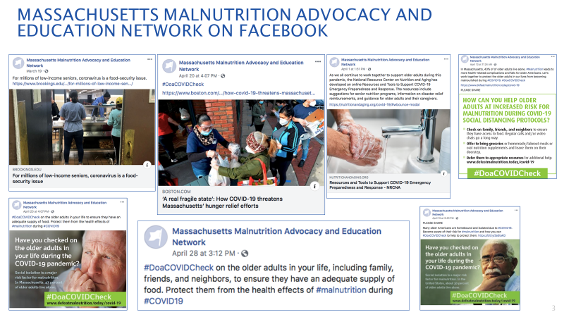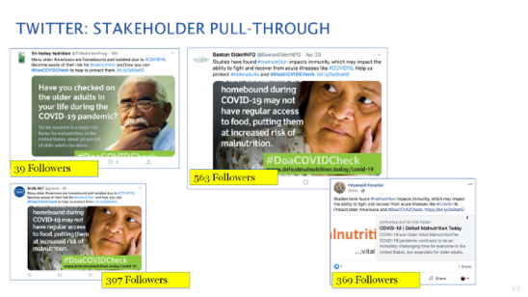
- Be a Nutrition Neighbor Campaign
- Memes and infographics
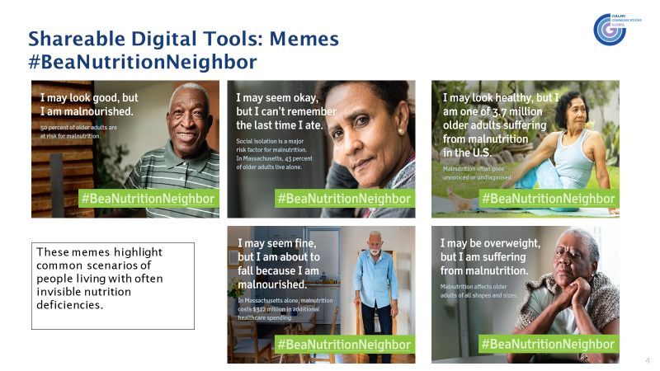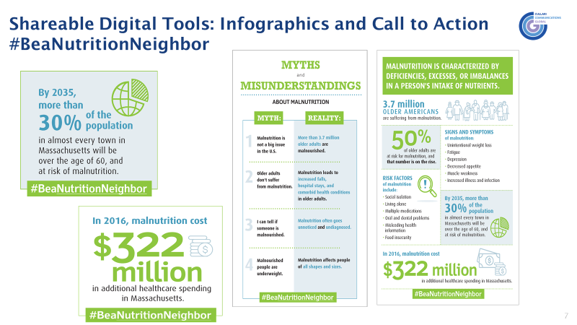
- The campaign had 32 engaged groups who posted the campaign message over 100 times, resulting in close to 110,000 impressions.

- The Malnutrition awareness message was delivered to more than 100,000 people in MA during Malnutrition Awareness Week, October 3-9, 2020.
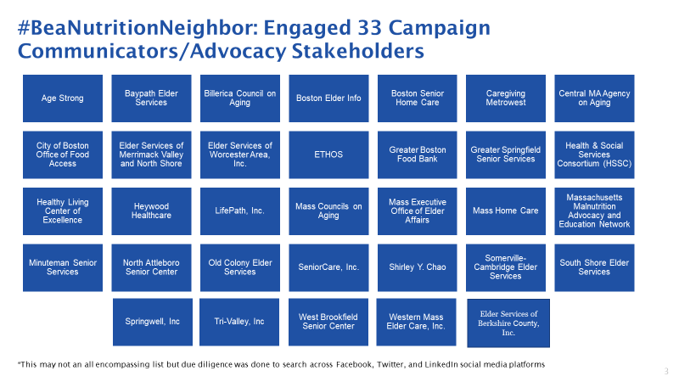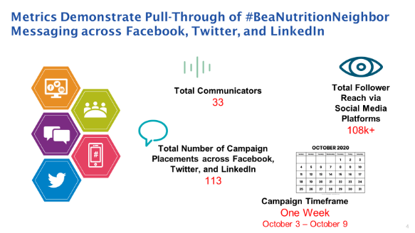
- #BeaNutritionNeighbor spotlight will be featured in first “Malnutrition Connection” edition in 2021.

III. Malnutrition Awareness Weeks

- Promoted malnutrition awareness during Older Americans month in May launching “Adopt a Neighbor” – A nutritional health awareness campaign to raise awareness statewide with all members’ represented organizations.
- Member organizations delivered malnutrition information on menu backs, at “grab and go” sites, and used remote technology and social media.
IV. Presentations and Publications:

Presentations
Date | Audience | Presenters | Title
August 1, 2020 | MCOA Statewide Outreach Meeting | Tara Hammes | An overview of the impact of malnutrition
September 1, 2020 | MCOA Membership Meeting | Tara Hammes | Malnutrition: Five Tools you Can Use’
October 7, 2020 | ASPEN’S Malnutrition Awareness WeekTM international session in conjunction with the Canadian Nutrition Society and the British Association for Parenteral and Enteral Nutrition. | Kris Mogensen | “Learning from COVID-19: the Value of Nutrition Across the Care Spectrum
October 18, 2020 | MCOA’s Fall Conference | Tara Hammes/ Robert Blancato | Nutrition Programs in and Around COAs’ plenary session
October 19, 2020 | MCOA’s Fall Conference | Amy Sheeley and Leigh Hartwell | Healthy Nutrition in a Pandemic: Eating for a Strong Immune System and Innovative Education Methods to Reach Seniors
October 19, 2020 | The Academy of Nutrition and Dietetics Food & Nutrition Annual Conference & Expo | Shirley Chao/Helen Rasmussen/ Heather Keller (Canada) and Clare Corish (Ireland). | “Are You Prepared for the Decade of Healthy Aging 2020-2030?” titled "Strategies to Engage Older Adults and Their Caregivers"
November 1, 2020 | Massachusetts Dietetics in Health Care Communities Dietetic Practice Group | Kris Mogensen | Nutrition Challenges in the Aging Bariatric Patient
November 1, 2020 | MCOA Membership Meeting | Tara Hammes | Food as Medicine’
December 1, 2020 | National Center for Equitable Care for Elders | Tara Hammes | Motivating Healthy Habits’ for the

V. Publications and Activities:

Publications
Date | Audience/publication journal | Author | Title/online access
February 2020 | Malnutrition Connection | National Defeat Malnutrition Today (DMT) | WHO Decade of Healthy Aging  https://www.defeatmalnutrition.today/sites/default/files/February%202020%20MC%20V4.pdf  (please hold control & click the title  or copy & paste the link)
March 2020 | Monthly Newsletter – Malnutrition Connection. | National Defeat Malnutrition Today (DMT) | COVID-19 and Older Adult Malnutrition  See Appendix
May 2020 | Monthly Newsletter – Malnutrition Connection. | National Defeat Malnutrition Today (DMT) | Older Americans Month, #DoACOVIDCheck, and Malnutrition Quality Measures  See Appendix
June 2020 | Farmer's Market Coupon participants | MA Department of Agriculture | MA Senior Farmers’ Market Nutrition Program” magazine which is published in three languages (English, Spanish and Chinese).
July 2020 | Senior centers | MA Department of Transitional Assistance (DTA) | SNAP Education (SNAP-ED)  https://www.mahealthyfoodsinasnap.org/  (please hold control & click the title  or copy & paste the link)
September 2020 | Monthly Newsletter – Malnutrition Connection. | MA Executive Office of Elder Affairs (EOEA) | Malnutrition information on its website and link to all resource materials  https://www.mass.gov/nutrition-program-for-seniors  (please hold control & click the title  or copy & paste the link)
October 23, 2020 | JPEN J Parenteral Enteral Nutr. 2020 Oct 23. Online ahead of print | Mechanick JI, et.al., (Mogensen KM, Commission member) | Clinical nutrition research and the COVID-19 pandemic: a scoping review of the ASPEN COVID-19 Task Force on Nutrition Research
October 30, 2020 | Nutr Clin Pract. 2020 Oct 30. Online ahead of print | Evans DC, et.al., (Mogensen KM, Commission member) | The use of visceral proteins as nutrition markers: an ASPEN position paper
December, 2020 | Monthly Newsletter – Malnutrition Connection. | National Defeat Malnutrition Today (DMT) | Celebrating the Success of Raising Malnutrition Awareness in2020  See Appendix

The Commission held one meeting in 2020

The MPC met remotely on August 11, 2020, and meeting minutes are shown below.

  - Presentation of “The COVID-19 Crisis in Long-Term Care” by Karl Pillemer PhD,
Department of Human Development, Professor of Gerontology in Medicine at Weill Cornell Medicine, Senior Associate Dean for Research and Outreach, College of Human Ecology Cornell University.
- Commission members learned that Long Term Care (LTC) facilities tend to be highly conducive to the spread of COVID-19 and have accounted for a disproportionate number of COVID-19 cases, as well as COVID-19 deaths.
- COVID-19 as well as its associated effects from increased isolation, including depression, anxiety, and decreased appetite, put nursing home residents at an increased risk for malnutrition. Therefore, the Commission will target its awareness campaign messages to residents and staff of LTC facilities. The MPC representative for LTC will facilitate these communications on behalf of the Commission.

  - Presentation of “Novel Implementation of a Multicomponent intervention for Brain Health in underrepresented Elders (NIMBLE)” by Kieran Reid, PhD MPH, Scientist / Assistant Professor USDA Human Nutrition Research Center on Aging Tufts University.
- Commission members learned about the profound impact of age-related cognitive decline has a on the daily functioning of older adults, their families and healthcare systems. The impact of reduced social interaction and environmental stimulation due to the COVID-19 pandemic may also be detrimental to brain aging. These effects can negatively impact a senior’s nutritional health.
- The NIMBLE study, which is currently underway will develop a remote /home based multicomponent intervention to reach underserved older adults at risk for cognitive decline. The intervention includes meal kit delivery, homebased physical activity, cognitive training, social engagement, and metabolic and vascular risk reduction as well as telehealth coaching. If the study produces the expected positive results, the Commission will incorporate these interventions into its recommendations and outreach communications.

  - Presentation of “Be a Good Nutrition Neighbor” Nutritional Health Awareness Campaign by Tiffany Nagle
- Commission members reviewed the successful #DoaCOVIDCheck campaign which had wide social media engagement and was used as a model for the #BeaNutritionNeighbor campaign. The #BeaNutritionNeighbor campaign was developed under the guidance of the Commission to raise awareness and prevent malnutrition throughout the Commonwealth. Commission members reviewed and provided feedback to the toolkit including memes, infographics and Facebook frames. Members also discussed the best way to promote the campaign via various networks to reach seniors and their caregivers.

Member Report: COVID-19 impact

- Carole Malone (EOEA): Mass Grown Farm Exchange platform was launched. It assists farmers, fishers, food buyers, and ag-related businesses to connect, exchange, and find products and services. Also, the EOEA nutrition program team has been participating in the cross-agency Food Security Task Force. Through the work of the task force, a Food Assistance Decision Tree was recently launched to help residents in need determine which programs they might be eligible for. The Food Assistance Decision Tree tool can be accessed at www.mass.gov/decision-tree/find-food-assistance.
- Shirley Chao (EOEA): Food security is the most important issue. Home meal delivery increased 50% to 40,000 meals daily, congregate meal programs shifted to grab and go offerings (averaging 2000 daily), and programs stood up mobile markets with “Senior on the Go” buses providing transport. The Commonwealth used the federal government’s Family First Coronavirus Respond Act (FFCRA) funds to distribute 7 days of frozen or shelf stable meals to 85,000 seniors and participated in the US Department of Agriculture Farmers to Families food box program, completing two rounds of deliveries to over 34,000 seniors in need in the community by September.
- Amy Sheeley (EOEA): Materials including slide presentations and menu backs related to nutrition and food safety during the pandemic were distributed to the local nutrition programs. Programs are implementing remote nutrition education to seniors.
- Pam Hunt (N. Attleboro COA) COAs have many increases in number of participants receiving home-delivered meals and many started grab-and-go meals due to congregate meal sites being closed. Many COAs are providing a weekly bag of groceries and/or pantry items and have had 2-4 federal food box distributions. Food insecurity is being addressed throughout the Commonwealth.
- Margery Gann (ETHOS): Program saw approximately 50% increase in home delivered meals. Agency received a large Boston Resiliency grant allowing the program to provide meals to those under 60.
- Kris Mogensen (BWH): Many floors of the hospital were converted to ICUs to handle the influx of COVID patients with many of the most critical begin over 65 years of age.
- Diana Hoek (DPH): The WIC Nutrition Program is providing remote services until at least Sept. 30th., There was a rapid influx of applications in April which leveled out during the summer. Program caseload increased by about eight percent
- Linnea Hagberg (SeniorCare): Program has weekly calls with COAs, providing contactless deliveries.
- Dalia Cohen: Home delivered meals increased drastically. Wellness checks have been critical, provided by phone when necessary. “Grab and go” participation at meal sites has increased. There has been higher than usual demand for Farmer’s Market Program coupons.
- Pamela Hunt (MCOA) and Tara Hammes (MCOA):
- MCOA has been hosting regional calls to share information. The website has a COVID-19 information section as well as nutrition updates and a nutrition advocacy page. 8 COA’s have become SNAP partners with another 15 to begin in January.
- COAs have seen many increases in the number of participants receiving home-delivered meals. Many COAs started grab-and-go meals due to congregate meal sites being closed. Many COAs are also providing a weekly bag of groceries and/or pantry items and have had 2-4 federal food box distributions. Food insecurity is being addressed throughout the Commonwealth.
- Milaina Mainieri (Minuteman): Conducted assessments by telephone. Seniors have had increased need of homemaking support such as shopping and meal preparation. Also meals on wheels participation has increased resulting in the need for more drivers.
- Penny McGuire: (DTA): As the COVID-19 pandemic peaked in the spring, the Department saw an increase of 400% in client applications across all programs. As opportunities for other federal assistance programs changed throughout the summer, DTA saw subsequent spikes in demand for services. As of November 2020, DTA’s SNAP caseload was comprised of 526,837 households, consisting of 889,968 recipients. Of these recipients, 187,904 were 60 or over; 283,552 were persons with disabilities; and 303,141 were age 18 or under. The Department leveraged federally approved administrative flexibilities, program modifications, and new programs to provide additional supports to applicants and clients, meet increased demand, and maintain stable benefit issuance. Each month during the pandemic, SNAP households not already receiving the maximum allowable SNAP allotment for their household size have received supplemental benefits to bring them up to the maximum amount, which has included a number of senior SNAP recipients. In May, the state was approved to begin allowing SNAP clients to make food purchases online with EBT cards through Amazon and Walmart. Lastly, the Healthy Incentive Program (HIP), which is a reimbursement program supporting fruit and vegetable purchases at farmers markets, remained active through the year. As part of the Administration’s COVID-19 Command Center and its Food Security Task Force’s efforts to strengthen our local food system, DTA was able to enroll 39 new farm stands, mobile markets, and farmers markets to the program. Massachusetts seniors have maintained a high participation rate in HIP – 44% of households accessing HIP benefits include people who are 60 and over.
- Helen Rasmussen (HNRCA, Tufts University), as moderator, collaborated with Shirley Chao who presented “Are You Prepared for the Decade of Healthy Aging 2020-2030?” at the Academy of Nutrition and Dietetics FNCE virtual conference 10/19/2020.
Preparation for future events
- ASPEN’s Malnutrition Awareness Week TM October 5-9, 2020
  - Kris Mogensen discussed the program which consists of educational CE webinars, on-demand videos, infographics and other resources on malnutrition. Topics for the 5 webinars include sarcopenia, malnutrition in the community and learning from COVID-19.
  - All members and partners were encouraged to become ambassadors.

COMING YEAR ACTIVITIES (2021)

As the New Year begins, MPC members will continue to adapt to the needs facing older adults during the COVID-19 crisis. The work of MPC will remain committed to its statutory mission.

The 2021 MPC agenda includes the following:

- MPC will do a similar Malnutrition Awareness campaign with a specific call to action aligned to the goals of the Commission.

- MPC members will encourage healthcare stakeholders to conduct Awareness Campaigns at state legislative gatherings and community events.

- MPC will encourage member agencies to publish and promote evidence-based malnutrition information

- MPC will promote the 2020-2025 US Dietary Guidelines and continue to advocate the importance of raising awareness of malnutrition among older adults.

- MPC will join ASPEN to celebrate the passage of Senate Resolution 716, designating the week of October 4 through October 8, 2021, as “Malnutrition Awareness Week.” Not only does the resolution raise awareness of malnutrition, it recognizes ASPEN and healthcare professionals for their efforts in the treatment and prevention of malnutrition. Its passage underscores the importance of funding existing federal nutrition programs to combat malnutrition, and supports emergency funding for critical nutrition programs for the duration of the COVID-19 pandemic.

- MPC will distribute and present their report to key stakeholders including Massachusetts Councils on Aging (MCOA), ASAPS/Nutrition Programs, Health Policy Commission, Massachusetts Academy of Nutrition and Dietetics, and the Massachusetts Hospital Association.

SUGGESTED NEXT STEPS FOR COMMISSION MEMBER AGENCIES INCLUDE THE FOLLOWING:

Massachusetts Executive Office of Elder Affairs (EOEA):
- EOEA will work with the Governor’s office to designate a week in May of 2021 for “Older Adult Nutrition Week”.
- EOEA will further promote and participate in national events such as ASPEN’s Malnutrition Awareness WeekTM in October 2021. Materials regarding malnutrition in older adults will be distributed to the entire senior network of consumers and providers.
- EOEA’s website will continue to publish and promote evidence-based malnutrition resources to enhance the likelihood information will reach seniors, healthcare providers and caregivers.
- EOEA will explore how best to facilitate collaboration between hospitals and the aging services network in MA regarding the value and role of home delivered meals in reducing hospital readmission.

Massachusetts Department of Public Health (DPH):
- DPH will help to coordinate “Older Adult Malnutrition Awareness Week” and participate in corresponding events.
- DPH will assist the MPC on both data collection and public awareness campaigns.
- DPH will work with the MPC to raise awareness about malnutrition in older adults throughout its bureaus, divisions and programs.
- DPH will disseminate the commission’s studies and findings to appropriate DPH programs to reduce barriers and health care costs as well as improve quality indicators and outcomes.
- DPH will participate in national events such as ASPEN’s Malnutrition Awareness WeekTM in October 2021.

Massachusetts Department of Transition Assistance (DTA):
- DTA is committed to providing low-income individuals food assistance and a path to economic long-term self- sufficiency.
- DTA will continue to partner with EOEA and a working group of advocates to focus on initiatives to help elders access and maximize SNAP benefits.
- DTA and MCOA’s ongoing collaboration has resulted in an additional 20 COAs becoming contracted SNAP Outreach Partners in 2020. A total of 39 COAs receive federal reimbursement for the work they do with assisting seniors enroll in SNAP.
- DTA’s Senior Assistance Office is a specialized unit which designed to meet the specific needs of the Commonwealth’s elder population. Included in this office is a dedicated phone line for elders that will directly connect them with a live case manager.
- DTA has recognized that SNAP benefits can help prevent malnutrition in older adults and therefore will commit to promote and attend the “Older Adult Malnutrition Awareness Week” events.
- DTA will include malnutrition information along with its Nutrition Education program (SNAP-Ed) on its website which highlights programming for elders.
- DTA will continue working on the SNAP senior medical deduction and Elderly Simplified Application Project (ESAP)

Massachusetts Department of Agriculture (MDAR):
- MDAR has identified opportunities to incorporate the Commission’s recommendations into existing programs and initiatives. MDAR will continue to collaborate with partner organizations to evaluate how to effectively integrate the recommendations into its programs.
- MDAR has committed to incorporating evidence-based malnutrition awareness information into The Senior Farmers’ Market Nutrition Program (SFMNP), nutrition education magazine. The program will also work with participating market managers to increase awareness of malnutrition and provide information on the resources needed to reduce it.
- MDAR will continue to collaborate with the Massachusetts Department of Transitional Assistance on the Healthy Incentives Program (HIP). The program provides a monthly reimbursement for SNAP recipients to purchase fruits and vegetables. Approximately 50% of the families who have earned HIP reimbursements have included seniors.

Aging Services Access Points Agencies (ASAPs)/OAA Nutrition Programs:
- ASAP/OAA nutrition programs will promote “Older Adult Malnutrition Awareness Week” and participate in corresponding events.
- ASAP/OAA nutrition programs will support dissemination of materials regarding malnutrition in older adults provided by EOEA.
- ASAP/OAA Nutrition programs will develop and institute internal processes to implement EOEA-mandated MST screening and follow-up.
- ASAP/OAA nutrition programs will establish protocols to address needs of individuals identified as experiencing or being at-risk for malnutrition.
- ASAP/OAA nutrition programs will encourage outreach to local healthcare providers to raise awareness of malnutrition risk and MST screening and availability of ASAP nutrition services to address malnutrition.
- ASAP case managers and intake workers will receive basic training in identifying overt physical manifestations of malnutrition.
- Home Care consumers who are certified as nursing-facility eligible (ECOP and waiver) will be offered an annual nutrition consultation.

Massachusetts Association of Councils on Aging (MCOA):
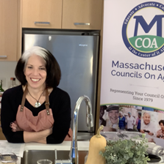
- MCOA will continue to focus on food security and malnutrition in 2021 to reach a large number of older adults in the Commonwealth
- MCOA will participate in Older Adult Malnutrition Awareness Week and related events.
- MCOA will publish evidence-based malnutrition prevention research on the revised nutrition advocacy website page
- MCOA will provide training, technical assistance and educational opportunities for councils on aging (COAs) and senior center staff to enhance their ability to provide malnutrition prevention information and effective programs to Massachusetts older adults
- MCOA will include malnutrition prevention in their yearly conference that provides training on topics relevant to COAs, senior centers and other providers working with older adults
- MCOA will continue to partner with/participate in task forces, work groups, coalitions and agencies to strengthen its malnutrition prevention work
- MCOA will continue to provide one-on-one assistance to council on aging directors and their staff to evaluate and enhance their nutrition initiatives
- MCOA will create and share additional nutrition tools to improve older adult nutrition
- MCOA will form an advisory committee to guide the trade association's nutrition activities

Massachusetts Academy of Dietitians and Nutritionists (MAND):
- MAND will share Food is Medicine information and related campaigns raising awareness of inadequate nutrition to families, caregivers, and peers of seniors
- MAND will encourage healthcare stakeholders to conduct appropriate malnutrition prevention campaigns at state legislative gatherings and community event
- MAND will highlight malnutrition through its Public Policy Workgroup, action alerts and the MA Day on the Hill event for dietetic students
- MAND will contribute to the work of MPC by reaching its members throughout the Commonwealth. The malnutrition week and related events will be promoted via the blog and social media accounts
- MAND members will be offered a list of malnutrition resources and website links via the blog and at the Annual Nutrition Convention & Exposition (ANCE)
- MAND will highlight evidence-based malnutrition research and food insecurity resources

Jean Mayer USDA Human Nutrition Research Center on Aging (HNRCA) /Tufts University (Academic/Research organization):
- HNRCA will attend “Older Adult Malnutrition Awareness Week” and participate in corresponding events.
- HNRCA will work with other academic research organizations and MPC to make dietary policy recommendations, and offer trainings and education which will improve the nutrition status of older adults. These topics from their study results include immune function, vitamin and mineral absorption, physical capacity as well osteoporosis, cardiovascular disease, diabetes, cataracts and macular degeneration.
- HNRCA/ Tufts University will publish evidence-based malnutrition research as it comes available.
- HNRCA will also assist community organizations to conduct MNT outreach to treat malnutrition.
- HNRCA researcher Dr. Susan Roberts with support from Dr. Shirley Chao and Commission Member Dr. Helen Rasmussen will collaborate with MA EOEA, Boston Commission and Ethos in proposing a clinical research study that involves cognitive measurements, with an intervention involving a nutrition supplement bar rich in nutrients of interest for optimal brain function in older adults.

Brigham and Woman Hospital (BWH):

- Malnutrition has a negative impact in the acute care setting. BWH is exploring participating in the Malnutrition Quality Improvement Initiative, in accordance with the Academy of Nutrition and Dietetics. A number of studies conducted at BWH have demonstrated how this problem directly affects members of the Commonwealth.
- Use BWH Malnutrition QI initiative as a best practice and encourage other hospitals to participate.
- Request data collection on malnutrition screening from hospitals as a baseline, and analyze data to see if there are any disparities among certain groups, to assist in the focusing of efforts. Continued collection of prevalence data can show change over time.

The Greater Boston Food Bank (GBFB):
• GBFB will continue to promote malnutrition awareness campaigns on social media platforms.
• GBFB will promote “Older Malnutrition Awareness Week” on social media platforms and blogs.
• GBFB will participate in “Older Malnutrition Awareness Week” events.
• GBFB will work with DTA on activities to help close the “SNAP Gap” for seniors.

CLOSING

EOEA is grateful to the Massachusetts State Legislature for its continued interest in the impact of malnutrition prevention research and education, and for creating the Commission on Malnutrition Prevention Among Older Adults to allow us to study methods to prevent and reduce malnutrition in the commonwealth. With increased needs brought by the pandemic, continued growth in older populations, and the high cost of health care, MPC will continue to serve an important function by working with the EOEA Secretary to help improve nutrition among elders and reduce rising health care costs.

APPENDIX

GLIM Criteria for the Diagnosis of Malnutrition: A Consensus Report From the Global Clinical Nutrition Community - Jensen - 2019 - Journal of Parenteral and Enteral Nutrition - Wiley Online Library
CE: Malnutrition in Older Adults : AJN The American Journal of Nursing (lww.com)

