**What is a One‐Pot?**

One‐Pot methamphetamine laboratories, also called “Shake and Bake” labs, are increasing in popularity. These portable labs create smaller batches of methamphetamine in a shorter amount of time than traditional methods.

The process involves the combination of several common household ingredients in a single container. The chemical reaction produces a crystalline powder that users then smoke, snort, or inject.

One‐Pot labs are **extremely** dangerous. The concentration of these products builds up pressure within the sealed containers and can **cause a violent explosion** if disturbed or oxygen is introduced upon opening.

The ease of transport and concealment of One‐Pot labs creates a significant concern for officer and public safety. Substances and containers used to create a One‐Pot lab can be easily overlooked. Awareness of the precursor chemicals and containers are key to identifying an active or abandoned lab.

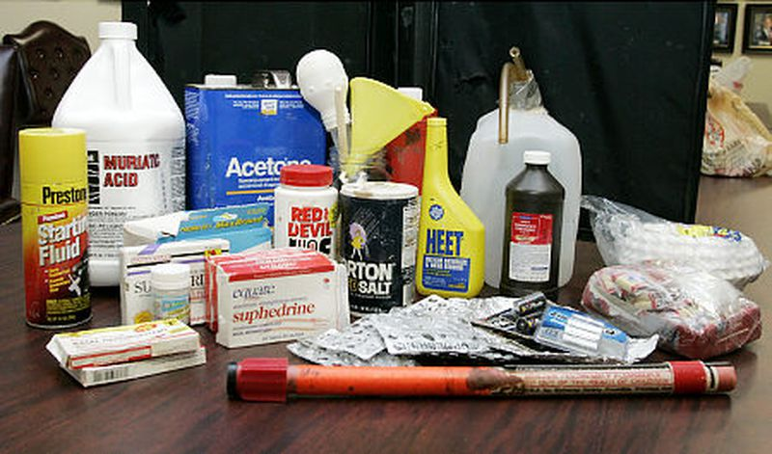

One-Pot Methamphetamine Labs utilize ingredients that are found in many common household products:

* Pseudoephedrine
* Organic solvent
* Ammonium Nitrate
* Lithium Metal
* Lye

When these ingredients are combined, they form a volatile compound which can ignite and explode if disturbed.



If you suspect that you have encountered an active lab or the remnants of a one-pot lab, **call 911 immediately** and vacate the area.

**One-Pot**

**Methamphetamine Laboratories**

**Understanding and Recognizing the Dangers Associated with One-Pot Laboratories**

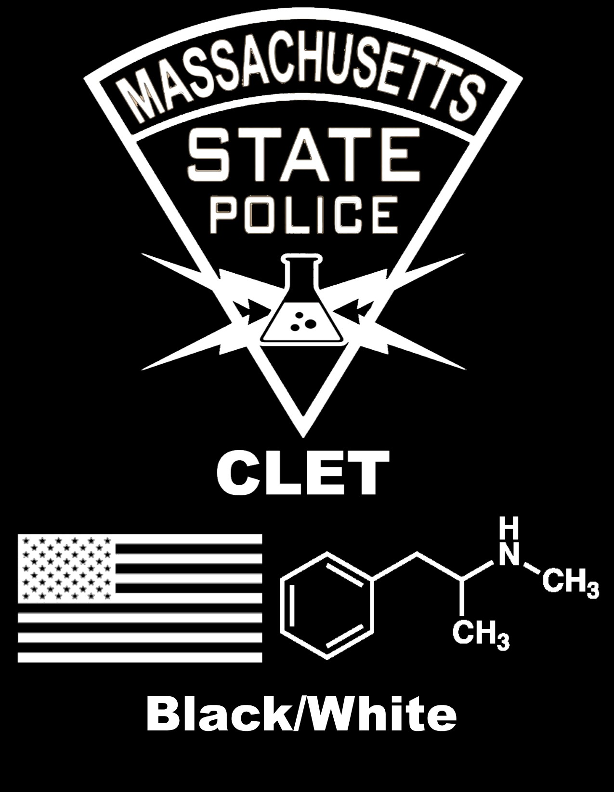

**Call 911 if you encounter a One-Pot lab or what you suspect may be the remnants of a lab.**

**The Massachusetts State Police Clandestine Laboratory Enforcement Team can be contacted at (508) 820-2121**

**Public Safety Awareness**

When a One‐Pot lab is located, it is important to understand the dangers it might pose and determine whether it is operational.

The combination of ingredients in the bottle have the potential to build up and cause extreme pressure, resulting in the potential for explosion and the release of harmful toxins.

The public should note that nitrate is not only a methamphetamine lab indicator, but an explosive indicator as well. Common ingredients are mixed with ammonium nitrate to create an improvised explosive device.



**What to look for**

**Signs of a potential one-pot lab:**

* Cold medicine packets *(Sudafed, etc.)*
* Batteries *(Lithium)*
* Camp fuel or lighter fluid
* Cold packs *(Ammonium Nitrate)*
* Household drain opener *(Lye)*
* Soda bottles with white crystals
* Tubing
* Coffee filters
* Grinders
* Acids
* Salt

**Where?**

**One‐Pot laboratories have been encountered in:**

* Department store restrooms
* Vehicles during traffic stops
* School property
* Alleys, behind buildings
* Homes and garages
* Hotels/motels
* Wooded areas

**If a lab is encountered:**

* **DO NOT** touch anything
* **DO NOT** turn on/off any electrical power or light switches
* **DO NOT** eat or drink in or around a lab
* **DO NOT** smoke anywhere near a lab
* **DO NOT** move or open containers
* **DO NOT** sniff any containers
* **DO** remain upwind or uphill from the lab
* **DO** remove contaminated clothing and footwear if necessary
* **DO** call 911