Background
CPCS

INDOOR AIR QUALITY
PRE-OCCUPANCY ASSESSMENT

Committee for Public Council Services
35 Congress Street
Salem, MA

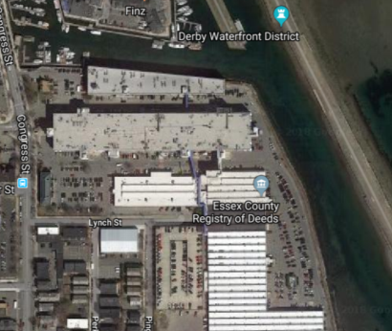

Prepared by:
Massachusetts Department of Public Health
Bureau of Environmental Health
Indoor Air Quality Program
October 2018
Building: | Committee for Public Council Services (CPCS)
Address: | 35 Congress Street Salem, MA
Division of Capital Asset Management and Maintenance (DCAMM) Project Manager: | Virginia Platt, Project Manager, Division of Capital Asset Management and Maintenance (DCAMM)
Date of Pre-Occupancy Assessment: | October 5, 2018
Massachusetts Department of Public Health/Bureau of Environmental Health (MDPH/BEH) Staff Conducting Assessment: | Jason Dustin, Environmental Analyst/Inspector, Indoor Air Quality (IAQ) Program
Surrounding Businesses/Activities:
The building is located in the Shetland Park complex adjacent to Derby Wharf, facing east towards Salem Harbor. The building also contains a number of private businesses.
Prior use of Building:
This building was constructed in the mid-1800s as a large commercial textile factory. The space has been converted a number of times for use as office space.

Previous Relevant Environmental History:
According to the Mass Department of Environmental Protection’s (MDEP) Bureau of Waste Cleanup searchable database, a fuel oil release from an underground storage tank occurred in the parking lot area in front of the building in 2005 (MDEP, 2014). Supporting documents report that remediation efforts included the installation of an underground recovery system, oil/water separator, and removal of approximately 80-100 cubic yards of petroleum-impacted soil and groundwater affected at the site (Pennoni Associates, 2011). A Release Abatement Measure (RAM) Completion Report issued in 2011 reported that the excavation area was backfilled with clean material (confirmed by soil samples) and the affected area was paved over, thus completing abatement activities (Pennoni Associates, 2011). No adverse impacts to IAQ would be expected at this time, considering the location of the affected area outdoors, as well as the removal of contaminated materials and remedial efforts conducted.

Methods
Air tests for carbon monoxide, temperature and relative humidity were taken with the TSI, Q-Trak, IAQ Monitor 7565. Air tests for airborne particle matter with a diameter less than 2.5 micrometers were taken with the TSI, DUSTTRAK II™ Aerosol Monitor Model 8532. Screening for volatile organic compounds (VOCs) was conducted using a MiniRAE LITE 7600 Photo Ionization Detector. BEH/IAQ staff also performed visual inspection of building materials for water damage and/or microbial growth and examined the space for the presence of odors or other environmental concerns.

Air Testing Results

Media sampled |  | MDPH Guideline/  Comparison Value |  | Measured Range |  |  | Comments
 |  |  |  | Outdoors/  Background |  | Indoors
Carbon Dioxide (CO₂) |  | < 800 parts per million (ppm) is preferred |  | 412 |  | 444-551 | HVAC system operating. Note the limited building occupancy at this time.
Total Volatile Organic Compounds (TVOCs) |  | Equal to or below background level measured |  | ND |  | ND
Carbon Monoxide (CO) |  | Non-detectable (ND) or equal to or below background level measured |  | ND |  | ND
Particulate Matter 2.5 (PM2.5) |  | US EPA National Ambient Air Quality Standards (NAAQS) 35 μg/m³ or less |  | 11 μg/m³ |  | 12 to 19 μg/m³
Temperature |  | 70 to 78 ºF |  | 64 ºF |  | 70 to 72 ºF | Readings were within MDPH recommended comfort guidelines
Relative Humidity (RH) |  | 40% to 60% |  | 45% |  | 56 to 62% | Readings were within or slightly above MDPH recommended comfort guidelines
ppm = parts per million | µg/m³ = microgram per cubic meter |  | ND = non-detectable

Discussion/Visual Observations
The newly-renovated office suite will serve as office space for employees at the CPCS. The space contains offices, open work areas, meeting areas, and a break room. The heating, ventilation and air conditioning (HVAC) system consists of rooftop air handling units (AHUs) that draw in fresh air from an intake on the roof. The space utilizes a ducted return system.
At the time of the assessment, the space was almost completely built out with some repairs and finishing activity to be completed. New lighting, ceiling tiles, carpet squares, and vinyl flooring had been installed during the remodel. Some ceiling tiles were missing likely due to wiring/network activities that were ongoing (Picture 1).
BEH recommends that all thermostats allow for continued fresh air ventilation/filtration and are set to the “on” setting rather than the intermittent “auto” setting during occupied hours (Picture 2).
Although the bathrooms are equipped with direct exhaust ventilation, the break room does not have a direct/local exhaust vent. BEH staff typically recommends these areas be fitted with a direct exhaust vent in the vicinity of cooking equipment (e.g., microwave, toaster oven) to avoid heat, food odors, and particulates from being distributed throughout the office space via the HVAC return system.
IAQ staff noted a water stain on the carpet tiles in the public side of the reception area. There was no water stain noted in the ceiling tiles above. This stain did not have any odor but was still moist at the time of the assessment (Picture 3). Property management staff reported that the carpeting was just recently cleaned following construction activities and that it was likely a carpet cleaning fluid leak. BEH staff requested that a fan be put on the water stain to dry the carpet tile more quickly.
Most windows in the CPCS space are openable. These windows can be used to supplement fresh air but it is important to inform staff to keep the windows closed while the air conditioning is operating. Open windows can allow warm, moist air to produce condensation on surfaces cooled below the dew point temperature. Chronic condensation may cause microbial colonization of porous materials.
Some pathways to unconditioned areas were noted in the CPCS such as holes in gypsum wallboard, gaps around utilities, and the previously mentioned missing ceiling tiles (Picture 4). These pathways should be sealed to avoid entrainment of unconditioned air and particulates.
Some normal construction dust and debris was observed in the areas of active construction. This dust/debris should be thoroughly cleaned before occupancy.

Recommendations
In view of the findings at the time of assessment, the following recommendations are made:
- Continue with plans to set thermostat controls to the fan “on” setting (not “auto”), throughout the space to provide continuous filtration and ventilation during occupied hours.
- Set fans up as soon as water leaks are discovered so that any moisture is dried within the first 24-48 hours.
- Seal the spaces around utilities, repair open holes in gypsum wallboard, and replace any missing ceiling tiles. This will prevent them from serving as pathways to unconditioned areas.
- Inform staff that windows must remain closed while air conditioning is operating to reduce the risk of condensation/microbial colonization.
- Consider installing a direct/local exhaust vent in the kitchen/break area to remove food odors.
- Use filters with a Minimum Efficiency Reporting Value (MERV) 8 or better in the AHU and ensure they are changed a minimum of twice per year.
- Upon completion of renovations, perform a final, thorough cleaning of the office space including wet-wiping of all surfaces and use of a high-efficiency particulate arrestance (HEPA) vacuum of all carpeting prior to staff moving into the space.
- Consistent with previously established protocol, once the space has been occupied for a minimum of three weeks, contact the BEH/IAQ Program to conduct a follow-up assessment of the space.

References
Pennoni Associates. 2011. Pennoni Associates Inc. Release Abatement Measure Completion Report, Shetland Park, 45 Congress Street, Salem, MA, DEP RTN 3-25120. March 30, 2011.
Massachusetts Department of Environmental Protection (MDEP). 2014. Waste Site/Reportable Release File Viewer for 45 Congress St, Salem, MA. Available at http://public.dep.state.ma.us/file/Rtn.aspx?rtn=3-0025120.

Picture 1
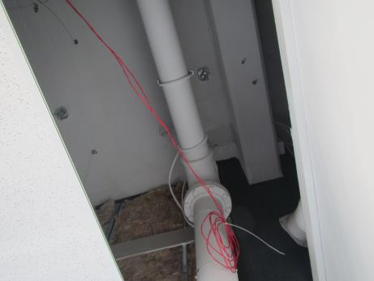
One of several missing ceiling tiles in the CPCS space

Picture 2
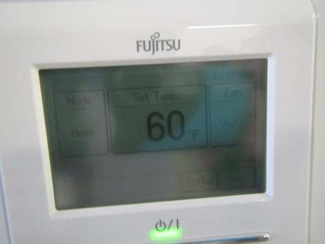
Thermostat showing fan “auto” setting instead of recommended fan “on”
Picture 3
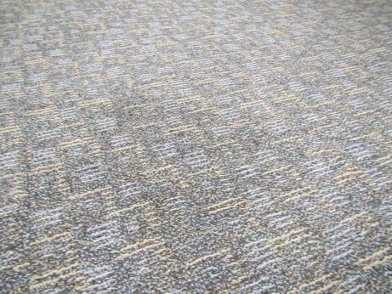
Water stain noted in public reception area still moist at the time of inspection

Picture 4
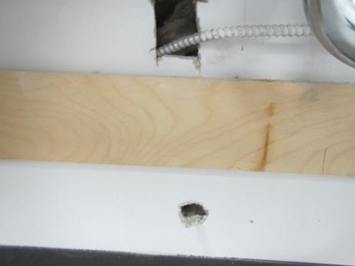
Holes in gypsum wallboard in staff support room

