WATER DAMAGE/REMEDIATION ASSESSMENT

Committee for Public Counsel
21 McGrath Highway
Somerville, Massachusetts

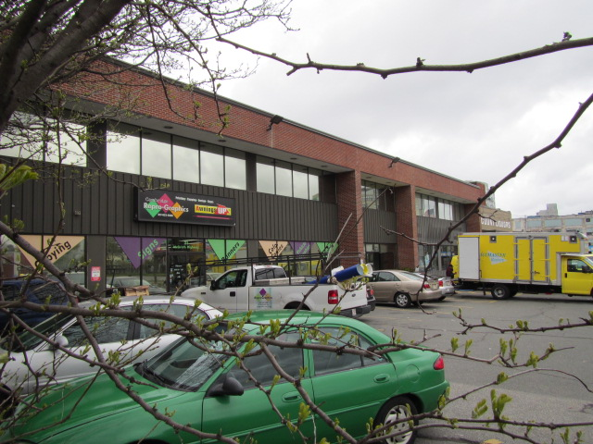

Prepared by:
Massachusetts Department of Public Health
Bureau of Environmental Health
Indoor Air Quality Program
August 2016

BACKGROUND
Building: | Committee for Public Counsel (CPC) Offices
Address: | 21 McGrath Highway, Somerville, MA
Assessment Requested by: | Ginny Platt, Division of Capital Asset Maintenance and Management (DCAMM)
Reason for Request: | Water damage/remediation
Date of Assessment: | May 4, 2016
Massachusetts Department of Public Health/Bureau of Environmental Health (MDPH/BEH) Staff Conducting Assessment: | Michael Feeney, Director, Indoor Air Quality (IAQ) Program
Date of Building Construction: | 1940s
Building Description: | Office located on the second floor of a two-story, brick-faced building.
Building Population: | The affected areas have an employee population of approximately 25.
Windows: | Not openable

METHODS
Please refer to the IAQ Manual and appendices for methods, sampling procedures, and interpretation of results (MDPH, 2015).

IAQ Testing Results
The following is a summary of indoor air testing results (Table 1). Please consult Picture 1 for the location of each sample.
- Carbon dioxide levels were below 800 parts per million (ppm) all areas tested, indicating adequate fresh air supply for the space.
- Temperature was within or very close to the recommended range of 70°F to 78°F in areas tested.
- Relative humidity was within the recommended range of 40 to 60% in all but one of the areas tested (66%).
- Carbon monoxide levels were non-detectable (ND) in all indoor areas tested.

Ventilation
A heating, ventilating and air conditioning (HVAC) system has several functions. First it provides heating and, if equipped, cooling. Second, it is a source of fresh air. Finally, an HVAC system will dilute and remove normally occurring indoor environmental pollutants by not only introducing fresh air, but by filtering the airstream and ejecting stale air to the outdoors via exhaust ventilation. Even if an HVAC system is operating as designed, point sources of respiratory irritants may exist and cause symptoms in sensitive individuals. The following analysis examines and identifies components of the HVAC system and likely sources of respiratory irritant/allergen exposure due to water damage, aerosolized dust and/or chemicals found in the indoor environment.
The testing indicates that the ventilation system is providing adequate fresh air for building occupants. However, please note that many areas were empty or sparsely occupied, which reduces carbon dioxide in the space. To maximize air exchange, the BEH recommends that mechanical ventilation systems operate continuously during periods of occupancy.
Fresh air is supplied by ceiling mounted fresh air diffusers connected to an air handling unit (AHU). Air from the AHU is filtered, heated/cooled and delivered to rooms via ducted supply vents. Return vents are located on ceilings in some offices/areas and are ducted back to the AHU.

Microbial/Moisture Concerns
As reported by Ms. Platt, the CPC office was flooded due to a catastrophic failure of a urinal fixture in a restroom, which resulted in water damage to approximately half the office suite. Water-damaged materials included gypsum wallboard (GW), ceiling tiles, and carpeting. Once discovered, the water was shut off and the pipes repaired (Picture 2). At the time of assessment, the landlord had contractors drying carpeting and GW with heavy-duty fans (within 24 hours after the flood occurred).
In order for building materials to support mold growth, a source of water exposure is necessary. The US Environmental Protection Agency (US EPA) and the American Conference of Governmental Industrial Hygienists (ACGIH) recommends that porous materials (e.g., wallboard, carpeting) be dried with fans and heating within 24 to 48 hours of becoming wet (US EPA, 2008; ACGIH, 1989). If porous materials are not dried within this time frame, mold growth may occur. As mentioned, during the BEH/IAQ assessment, remediation was underway, which included drying of carpeting and other building materials, and removal of wall coving.
BEH/IAQ staff performed moisture testing of carpeting in the affected areas, as well as adjacent areas for comparison to help determine the extent of the carpet moistening. In addition, a visual inspection of building materials for any residual water damage and/or microbial growth was conducted.
All tested materials were drying at the time of assessment and no mold growth or associated odors were observed in the area of water damage. Some GW did appear to be mold-colonized behind the wall coving in one office due to window leaks; this damage most likely preceded the flooding incident. BEH/IAQ staff recommended removal of this GW in a manner consistent with the US EPA guidance set forth in Mold Remediation in Schools and Commercial Buildings (US EPA, 2008).

CONCLUSIONS and RECOMMENDATIONS
In view of the findings at the time of the visit, the area appeared to be undergoing proper remediation in a manner consistent with US EPA recommendations for flood remediation. If additional assistance is needed, please contact the BEH/IAQ Program, or consult materials found on the BEH/IAQ webpage at http://mass.gov/dph/iaq.

REFERENCES
ACGIH. 1989. Guidelines for the Assessment of Bioaerosols in the Indoor Environment. American Conference of Governmental Industrial Hygienists, Cincinnati, OH.
MDPH. 2015. Massachusetts Department of Public Health. Indoor Air Quality Manual: Chapters I-III. Available at: http://www.mass.gov/eohhs/gov/departments/dph/programs/environmental-health/exposure-topics/iaq/iaq-manual/.
US EPA. 2008. Mold Remediation in Schools and Commercial Buildings. US Environmental Protection Agency, Office of Air and Radiation, Indoor Environments Division, Washington, D.C. EPA 402-K-01-001. http://www.epa.gov/mold/mold-remediation-schools-and-commercial-buildings-guide.

Picture 1
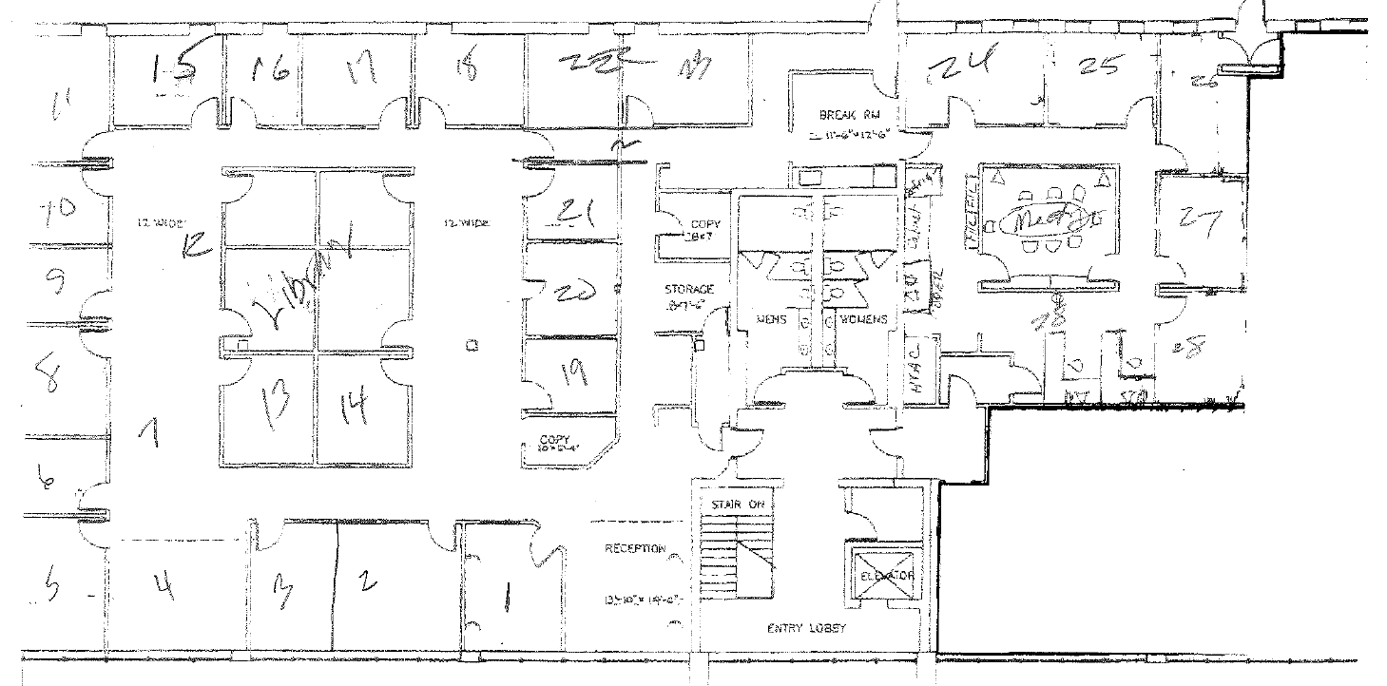
Sampling locations corresponding to Table 1
Picture 2
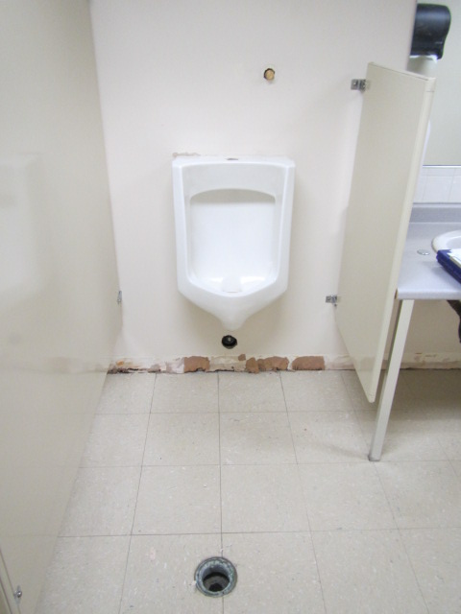
Source of water damage was failed urinal flush valve, now repaired
Location | Carbon  Dioxide  (ppm) | Carbon Monoxide  (ppm) | Temp  (°F) | Relative  Humidity  (%) | Occupants  in Room | Windows  Openable | Ventilation |  |  | Remarks
 |  |  |  |  |  |  | Intake | Exhaust
Background | 479 | ND | 55 | 54
1 | 722 | ND | 74 | 53 | 1 | N | Y |  | Y
2 | 788 | ND | 74 | 52 | 0 | N | Y |  | N
3 | 725 | ND | 74 | 52 | 0 | N | Y |  | N
4 | 705 | ND | 74 | 49 | 0 | N | Y |  | N
5 | 723 | ND | 74 | 48 | 0 | N | Y |  | N
6 | 682 | ND | 74 | 47 | 1 | N | Y |  | N
7 | 790 | ND | 74 | 47 | 0 | N | Y |  | Y
8 | 698 | ND | 74 | 47 | 0 | N | Y |  | N
9 | 671 | ND | 74 | 47 | 0 | N | Y |  | N
10 | 665 | ND | 73 | 47 | 0 | N | Y |  | N
11 | 648 | ND | 73 | 47 | 0 | Y | Y |  | N
12 | 668 | ND | 72 | 48 | 0 | N | N |  | N
Library | 714 | ND | 73 | 50 | 2 | N | Y |  | Y
13 | 689 | ND | 74 | 47 | 0 | N | Y |  | Y
14 | 756 | ND | 74 | 52 | 0 | N | Y |  | N
15 | 671 | ND | 73 | 46 | 0 | N | Y |  | N
16 | 622 | ND | 71 | 44 | 0 | Y | Y |  | N | Window open
17 | 710 | ND | 72 | 54 | 0 | N | Y |  | N
18 | 646 | ND | 69 | 48 | 0 | Y | Y |  |  | Water-damaged wall
19 | 759 | ND | 72 | 55 | 0 | N | Y |  |  | Water-damaged wall
20 | 749 | ND | 72 | 66 | 0 | N | Y |  |  | Water-damaged wall
21 | 730 | ND | 73 | 59 | 0 | N | Y |  |  | Water-damaged wall
22 | 678 | ND | 73 | 58 | 0 | N | Y |  | N | Water-damaged wall
23 | 664 | ND | 74 | 53 | 0 | N | Y |  | N | Water-damaged wall
Break room | 661 | ND | 75 | 52 | 0 | N | Y |  | N | Water-damaged wall
24 | 692 | ND | 74 | 51 | 0 | N | Y |  | N | Water-damaged wall
25 | 611 | ND | 73 | 53 | 2 | N | Y |  | N
26 | 715 | ND | 73 | 53 | 0 | N | Y |  | N
27 | 710 | ND | 73 | 54 | 0 | N | Y |  | N
28 | 737 | ND | 73 | 54 | 0 | N | Y |  | N
Meeting room | 734 | ND | 73 | 56 | 0 | N | Y |  | N
29 | 733 | ND | 73 | 50 | 0 | N | Y |  | N | Water-damaged wall
Reception | 670 | ND | 72 | 51 | 0 | N | Y |  | Y
Men’s RR | 667 | ND | 72 | 51 | 0 | N | N |  | Y

