INDOOR AIR QUALITY ASSESSMENT

Committee for Public Counsel
340 Main Street, 7th floor
Worcester, MA

Prepared by:
Massachusetts Department of Public Health
Bureau of Environmental Health
Indoor Air Quality Program
June 2016

Background
Building: | Committee for Public Counsel (CPC) Offices
Address: | 340 Main Street, 7th floor, Worcester, MA
Assessment Requested by: | Virginia Platt, Senior Project Manager,  Division of Capital Asset Management & Maintenance (DCAMM)
Reason for Request: | Occupant health concerns and general indoor air quality (IAQ) concerns.
Date of Assessment: | May 23, 2016
Massachusetts Department of Public Health/Bureau of Environmental Health (MDPH/BEH) Staff Conducting Assessment: | Ruth Alfasso, Environmental Engineer/Inspector, IAQ Program
Building Description: | Brick and stone building in downtown Worcester. The CPC is a large portion of the space on the 7th floor
Building Population: | Approximately 75 staff
Windows: | Some openable, most sealed/blocked shut

METHODS
Please refer to the IAQ Manual for methods, sampling procedures, and interpretation of results (MDPH, 2015).

IAQ Testing Results
The following is a summary of indoor air testing results (Table 1).
- Carbon dioxide levels were below 800 parts per million (ppm) almost all of the over 100 areas tested, indicating adequate fresh air supply for the space.
- Temperature was within the recommended range of 70°F to 78°F in all areas tested.
- Relative humidity was within or close to the lower level of recommended range of 40 to 60% in all areas tested.
- Carbon monoxide levels were non-detectable (ND) in all indoor areas tested.
- Fine particulate matter (PM2.5) concentrations measured were below the National Ambient Air Quality Standard (NAAQS) level of 35 μg/m³ in all areas tested.
- Total Volatile Organic Compounds (TVOC) were ND in all areas tested.

Ventilation
A heating, ventilating and air conditioning (HVAC) system has several functions. First it provides heating and, if equipped, cooling. Second, it is a source of fresh air. Finally, an HVAC system will dilute and remove normally occurring indoor environmental pollutants by not only introducing fresh air, but by filtering the airstream and ejecting stale air to the outdoors via exhaust ventilation. Even if an HVAC system is operating as designed, point sources of respiratory irritants may exist and cause symptoms in sensitive individuals. The following analysis examines and identifies components of the HVAC system and likely sources of respiratory irritant/allergen exposure due to water damage, aerosolized dust and/or chemicals found in the indoor environment.
The testing indicates that the ventilation system is providing adequate fresh air for the occupancy in the building. However, please note that many areas were empty or sparsely occupied, which reduces the creation of carbon dioxide in the space. To maximize air exchange, the BEH recommends that mechanical ventilation systems operate continuously during periods of occupancy.
Fresh air is provided by air handling units (AHUs) located in mechanical closets located in various areas of the space. Fresh air enters most of these AHUs through a vent from the outside of the building into the mechanical closets, which serve as mixing rooms for the units (Picture 1). Air from the AHUs is filtered, heated/cooled and delivered to rooms via ducted supply vents (Picture 2). Return vents are located on ceilings in some offices/areas (Picture 2) and are ducted back to the AHU. The closet doors are louvered and also serve as return vents for the nearby areas. Many offices are not equipped with exhaust/return vents, however the doors are undercut to allow airflow from the offices to hallway return vents on closet doors. Fresh air vents could not be located for some of the AHUs and it is possible that some units only filter, heat/cool and distribute air in the space.
Additional exhaust vents are located in toilet rooms and conference rooms with direct venting to a fan on the roof. The exhaust in the women’s restroom just outside the CPC space is activated only in response to occupancy; it is recommended that exhaust fans in restrooms be on during all occupied periods.
DCAMM reported that the HVAC system was balanced most recently in 2013 after some renovations were completed. It is recommended that HVAC systems be re-balanced every five years to ensure adequate air systems function (SMACNA, 1994).
Vents in two offices had been blocked off with cardboard (Table 1; Picture 3). Neither the occupants nor building maintenance staff knew why this had been done. The blockages should be removed to restore airflow to these locations, and the areas examined to ensure that the vents are correctly installed.

Microbial/Moisture Concerns
A stained ceiling tile was observed in one area (Picture 4; Table 1). Water-damaged ceiling tiles can be a source of mold and should be replaced after a water leak is discovered and repaired.
A window in room 7119 had been reportedly installed before the ductwork in that office had been completed, and, as a result, the window could not be properly fitted and closed (Picture 5). This condition can allow unconditioned air, moisture and pests into the building. In addition, the material used to seal the gap in the window is porous and may be subject to mold colonization if it becomes wet. This window should be installed correctly as soon as possible.
The women’s restroom located in shared space had reportedly been subject to a flooding event over the past winter when a downspout had been damaged along the side of the building. Water-damaged materials had reportedly been removed and the area cleaned. The restroom had a musty odor, which may indicate that hidden water-damaged materials remain in the area of the leak. Drain traps and plumbing should also be investigated in case they are the source of the odor. Improving restroom exhaust ventilation so that it is continually on during occupied periods will also remove any odors as well as moisture that may be a source of future water damage.
Plants were observed in many offices (Picture 6; Table 1) including on porous surfaces (e.g., carpet, paper towels) and on radiators which can heat and distribute debris to occupied areas. Plants can be a source of pollen and mold, which can be respiratory irritants to some individuals. Plants should be properly maintained and equipped with drip pans to prevent water damage to porous materials. Plants should also be located away from HVAC components to prevent the aerosolization of dirt, pollen and mold.
A small aquarium was observed in an office (Picture 7), and it appeared to be in need of cleaning. Stagnant water such as that found in aquariums can be a source of odors and microbial contamination.
Water dispensers and refrigerators were found in carpeted areas (Picture 8). Spills or leaks from these appliances can moisten carpeting and lead to microbial growth and odors.

Other IAQ Evaluations
Exposure to low levels of total volatile organic compounds (TVOCs) may produce eye, nose, throat, and/or respiratory irritation in some sensitive individuals. To determine if VOCs were present, BEH/IAQ took measurements for TVOCs and none were detected. Staff also examined rooms for products containing VOCs and observed air fresheners, hand sanitizers, cleaners, and dry erase materials in use within the building (Picture 9; Table 1). All of these products have the potential to be irritants to the eyes, nose, throat, and respiratory system of sensitive individuals.
Filters in the AHUs were examined. In some cases, they were not fitted properly and allowed a gap between the filter and the housing which can allow filter bypass of particulates into the AHU. Some of the filters examined also appeared to be of a mesh type that provides less filtration than the recommended pleated filters. A Minimum Efficiency Reporting Value (MERV) value of at least 9 is recommended for use in AHUs. In one case, the filters appeared to be missing entirely.
Note that the closets in which the AHU are located serve as mixing rooms for fresh air for the building. In some of the rooms, there were missing ceiling tiles and other gaps between the closet and internal spaces in the building (Picture 10); these should be sealed to prevent dust, debris, and odors from unoccupied areas from getting drawn into the ventilation system. In one room, carpeting was observed on the floor underneath condensate pumps for the HVAC system (Picture 11). Carpeting can be a source of dust, and, if moistened, can also become mold-colonized; any odors from this carpet would then be distributed to the occupied spaces served by that AHU. Worn insulation was also visible in one of the mixing rooms (Picture 1). In general, these rooms should be kept free of dust, debris and anything that may produce odors/irritation.
Sunlight was streaming into some offices (Table 1). Although all temperatures measured at the time of the visit were within the BEH/IAQ guidelines, direct sun may lead to occupants feeling too warm and may also contribute to glare on computer screens which may cause eye strain and headaches. Use of adjustable blinds and relocation of office furniture can assist with reducing the impact of direct sunlight on occupants.
Some supply and exhaust vents were found to be dusty and should be cleaned to prevent redistributing dusts to occupied areas. Air purifiers were observed in some offices. These items should be kept clean and maintained in accordance with manufacturer’s instructions to avoid rearesolizing dusts. One air purifier was a model made by Sharper Image™ (Picture 12). According to product literature this item has both HEPA filtration and ionization (Sharper Image, 2016). This means it produces ozone, which is a respiratory irritant and should not be used in occupied spaces (US EPA, 2003).
Accumulated items were found stored on floors and other flat surfaces in some areas. These items (e.g., papers, folders, boxes) make it difficult for custodial staff to clean. Items should be relocated and/or be cleaned periodically to avoid excessive dust build up.
The office suite is carpeted. Carpets should be cleaned regularly in accordance with Institute of Inspection, Cleaning and Restoration Certification (IICRC) recommendations (IICRC, 2012).

Conclusions/Recommendations
The following recommendations are made to assist in improving IAQ:
- Operate supply and exhaust ventilation in all areas during occupied periods including exhaust in restrooms.
- Remove blockages from the vents such as the one shown in Picture 3 and ensure the vents are properly installed.
- Replace stained ceiling tiles.
- Complete the installation of the window in room 7119 as soon as possible and seal around the window frame to prevent drafts.
- Inspect materials near the window in the women’s restroom to find any hidden water damage and microbial growth and inspect drains to find the source of the musty odor.
- Keep plants in good condition, avoid overwatering, avoid placing them on porous items, and remove from radiators and out of airflow.
- Keep aquariums clean to avoid generating odors.
- Avoid placing refrigerators and water dispensers on carpet; use a waterproof mat underneath them or place them in uncarpeted areas.
- Avoid the use of air freshening products such as diffuser reeds. Reduce the use of VOC-containing cleaners and sanitizers.
- Change HVAC filters regularly (2 to 4 times a year). Ensure that all filters fit flush inside the casings with no gaps and that they are of an appropriate MERV rating.
- Ensure that mixing rooms/HVAC closets are kept clean and free of dust/debris and sources of dust (e.g., carpeting or insulation), that any missing/ajar ceiling tiles are replaced to fit flush with the ceiling tile system, and that any other gaps between the closets and other non-occupied spaces are properly sealed.
- Use blinds to moderate temperature in areas subject to direct sunlight. Consider moving office furniture to reduce glare if needed.
- Avoid the use of air purifiers that may produce ozone. Maintain all other air purifiers in accordance with manufacturer’s instructions.
- Clean supply and exhaust vents and personal fans regularly to prevent aerosolization of debris.
- Clean carpeting and upholstered items regularly in accordance with IICRC recommendations (IICRC, 2012).
- Consider reducing the amount of items stored in offices to make cleaning easier. Periodically move items to clean flat surfaces.
- Refer to resource manual and other related IAQ documents located on the MDPH’s website for further building-wide evaluations and advice on maintaining public buildings. These documents are available at: http://mass.gov/dph/iaq.

References
IICRC. 2012. Institute of Inspection, Cleaning and Restoration Certification. Carpet Cleaning: FAQ. Retrieved from http://www.iicrc.org/consumers/care/carpet-cleaning/#faq.
MDPH. 2015. Massachusetts Department of Public Health. Indoor Air Quality Manual: Chapters I-III. Available at: http://www.mass.gov/eohhs/gov/departments/dph/programs/environmental-health/exposure-topics/iaq/iaq-manual/.
SMACNA. 1994. HVAC Systems Commissioning Manual. 1st ed. Sheet Metal and Air Conditioning Contractors’ National Association, Inc., Chantilly, VA.
Sharper Image. 2016 Lighted Globe HEPA Air Purifier Item No. 203182. http://www.sharperimage.com/pdf/manuals/203182.pdf
US EPA. 2003. “Ozone Generators that are Sold as Air Cleaners: An Assessment of Effectiveness and Health Consequences”. US Environmental Protection Agency, Office of Air and Radiation, Indoor Environments Division, Washington, D.C. https://www.epa.gov/indoor-air-quality-iaq/ozone-generators-are-sold-air-cleaners last updated on March 17, 2016.
Picture

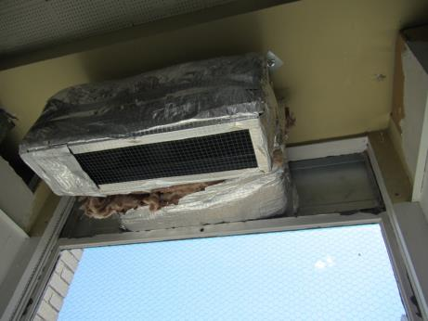

Typical fresh air vent for AHU, note damaged insulation

Picture 2

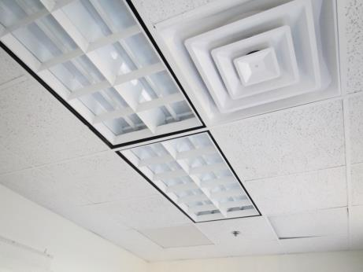

Supply (front) and return vent (rear) in an office
Picture 3

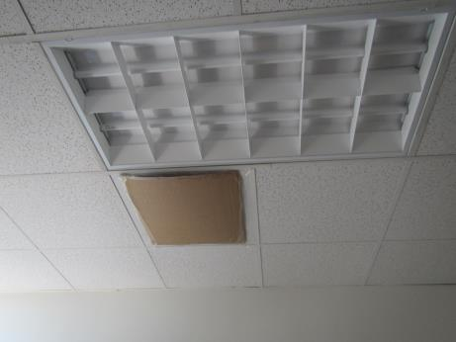

Blocked off supply vent

Picture 4

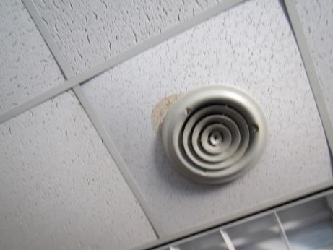

Water-damaged ceiling tile
Picture 5

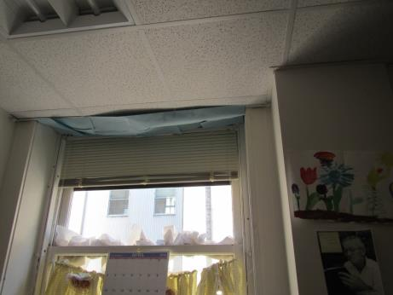

Improperly installed window and temporary fix

Picture 6

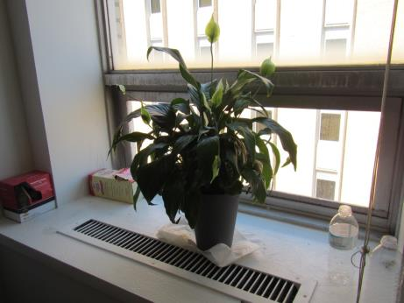

Plant on paper towel on radiator
Picture 7

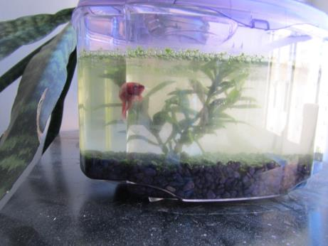

Aquarium in an office

Picture 8

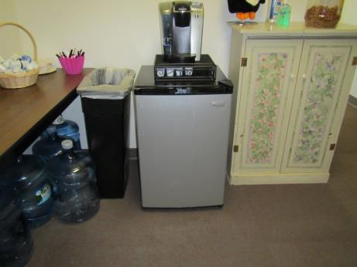

Refrigerator on carpet
Picture 9

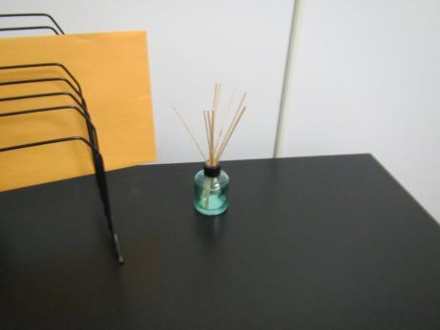

Air freshener diffuser reeds

Picture 10

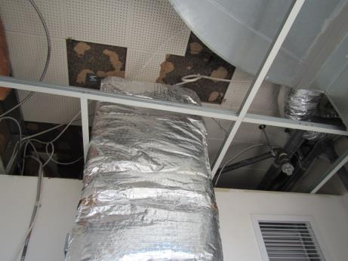

Gaps in wall around AHU closet/mixing room and damaged ceiling tiles
Picture 11

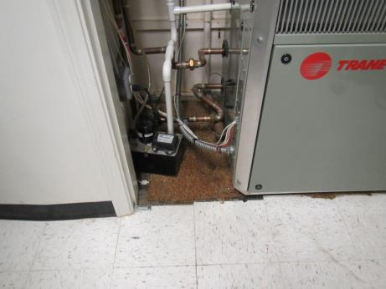

Carpet under condensate pump

Picture 12

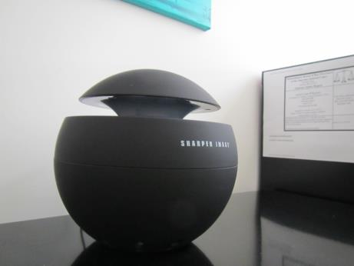

Sharper Image™ air purifier
Location | Carbon  Dioxide  (ppm) | Carbon Monoxide  (ppm) | Temp  (°F) | Relative  Humidity  (%) | TVOCs  (ppm) | PM2.5  (µg/m³) | Occupants  in Room | Windows  Openable | Ventilation |  | Remarks
 |  |  |  |  |  |  |  |  | Intake | Exhaust
Background (outdoors) | 352 | ND | 72 | 38 | ND | 10 |  |  |  |  | Sunny, side street next to building
7002 | 450 | ND | 70 | 38 | ND | 6 | 0 | N | Y | Y | AI, old books
7005 kitchen | 447 | ND | 70 | 40 | ND | 6 | 0 | N | Y | Y | NC, solar gain, fridge and food prep equipment
7006 | 503 | ND | 70 | 42 | ND | 6 | 0 | N | Y | Y
7007 | 462 | ND | 71 | 42 | ND | 6 | 0 | N | Y | Y | Boxes on floor
7009 | 486 | ND | 71 | 42 | ND | 6 | 0 | N | Y | Y | Solar gain
7010 | 467 | ND | 71 | 41 | ND | 6 | 0 | N | Y | N
7011 | 474 | ND | 72 | 40 | ND | 6 | 0 | N | Y | N
7012 | 432 | ND | 73 | 39 | ND | 7 | 0 | N | Y | N
7013 | 479 | ND | 73 | 40 | ND | 6 | 0 | N | Y | N | AF–reeds
7014 | 573 | ND | 73 | 40 | ND | 6 | 0 | N | Y | N
7017 storage |  |  |  |  |  |  |  | N | N | N | DEM
7018 | 561 | ND | 71 | 43 | ND | 6 | 1 | N | Y | N | Plant
7019 | 471 | ND | 71 | 42 | ND | 6 | 0 | N | Y | N | Plants on radiator
7021 | 463 | ND | 70 | 42 | ND | 6 | 1 | N | Y | Y | Boxes on floor, solar gain
7022 | 466 | ND | 70 | 42 | ND | 6 | 0 | N | Y | Y | Plants on radiator
7023 | 506 | ND | 70 | 41 | ND | 7 | 0 | N | Y | Y | AI on radiator, DEM
7024 | 522 | ND | 71 | 40 | ND | 6 | 0 | N | Y | N | Plants, solar gain, area rug, AI on floor
7025 | 500 | ND | 71 | 41 | ND | 6 | 1 | N | Y | Y | Plants
7026 | 439 | ND | 70 | 39 | ND | 7 | 0 | N | Y | Y | Fridge on carpet, AI on desks
7027 | 508 | ND | 71 | 39 | ND | 6 | 0 | Y | Y | N
7028 | 560 | ND | 73 | 40 | ND | 7 | 2 | Y | Y | Y | AI
7031 | 593 | ND | 73 | 38 | ND | 10 | 1 | N | Y | Y | AF odor (vanilla), DO, plant
7032 | 571 | ND | 72 | 38 | ND | 11 | 1 | Y | Y | Y | DEM, DO, plants and water
7033 | 539 | ND | 72 | 38 | ND | 11 | 0 | N | Y | Y | AI, plants
7033 Open area adjacent | 555 | ND | 72 | 38 | ND | 11 | 1 | N | Y | N
7034 | 532 | ND | 72 | 32 | ND | 11 | 0 | N | Y | Y | DEM, plants
7035 | 608 | ND | 72 | 37 | ND | 10 | 0 | N | Y | Y | Fridge on carpet, PF, plant, DEM
7036 | 532 | ND | 72 | 37 | ND
7037 | 521 | ND | 72 | 37 | ND | 12 | 0 | Y | Y | Y
7043 kitchen | 530 | ND | 73 | 38 | ND | 9 | 0 | N | Y | Y | NC
7045 | 610 | ND | 73 | 40 | ND | 11 | 0 | N | Y | Y
7046 | 577 | ND | 74 | 38 | ND | 11 | 0 | N | Y | Y
7047 conference | 580 | ND | 74 | 39 | ND | 11 | 0 | N | Y | Y
7048 | 546 | ND | 73 | 40 | ND | 11 | 0 | N | Y | Y
7050 | 550 | ND | 74 | 39 | ND | 13 | 1 | N | Y | Y
7051 | 548 | ND | 74 | 39 | ND | 12 | 0 | N | Y | Y | PF on
7052 | 518 | ND | 74 | 39 | ND | 11 | 0 | N | Y 2 | Y | DEM, CP/AF
7053 | 576 | ND | 74 | 39 | ND | 13 | 0 | N | Y | Y | Plant
7054 | 551 | ND | 75 | 38 | ND | 12 | 0 | N | Y | Y | Items on radiator
7055 | 602 | ND | 74 | 38 | ND | 11 | 0 | N | Y | Y
7056 | 527 | ND | 74 | 38 | ND | 13 | 0 | N | Y | Y | Aquarium and plant, DEM
7057 | 588 | ND | 74 | 38 | ND | 12 | 0 | N | Y | N | WD CT by vent
7058 | 541 | ND | 74 | 38 | ND | 11 | 0 | N | Y | N | DEM
7058 adjacent | 548 | ND | 74 | 38 | ND | 12 | 0 | N | Y | Y | Area rug
7063 | 567 | ND | 75 | 38 | ND | 12 | 0 | N | Y | Y | Fake plant
7064 | 561 | ND | 75 | 39 | ND | 12 | 0 | N | Y | Y | Plants
7065 | 548 | ND | 75 | 38 | ND | 13 | 0 | N | Y | N | AP
7066 | 578 | ND | 74 | 39 | ND | 11 | 0 | N | Y | N | Books
7067 open area | 649 | ND | 74 | 37 | ND | 7 | 2 | N | y | n | PC, shredder
7068 | 689 | ND | 73 | 38 | ND | 6 | 3 | n | Y | N | Plants, solar gain
7069 | 731 | ND | 73 | 37 | ND | 6 | 0 | N | Y | n | WC on carpet
7070 | 671 | ND | 73 | 38 | ND | 6 | 1 | N | Y | Y | Boxes
7072 | 565 | ND | 72 | 41 | ND | 8 | 0 | N | Y | N
7073 | 578 | ND | 72 | 41 | ND | 9 | 0 | N | Y | N
7074 | 621 | ND | 72 | 39 | ND | 8 | 2 | N | Y | N | Solar gain
7075 | 580 | ND | 72 | 38 | ND | 9 | 0 | N | Y | N | Carpets, solar gain
7076 | 601 | ND | 73 | 37 | ND | 9 | 0 | N | Y | N | Solar gain
7077 | 564 | ND | 72 | 41 | ND | 9 | 0 | N | Y | N
7078 interview | 609 | ND | 72 | 41 | ND | 9 | 0 | N | Y | N
7079 | 654 | ND | 72 | 40 | ND | 8 | 0 | N | Y | N
7080 copy | 566 | ND | 71 | 40 | ND | 6 | 0 | N | Y | N
7081 | 537 | ND | 72 | 38 | ND | 9 | 0 | N | Y | N
7082 | 553 | ND | 73 | 38 | ND | 6 | 0 | N | Y | N | Microwave, fridge, NC
7090 Youth services open area | 708 | ND | 73 | 36 | ND | 6 | 0 | N | Y | Y
7094 (cube area) | 516 | ND | 73 | 36 | ND | 6 | 1 | N | Y | N | Plants
7095 | 591 | ND | 73 | 36 | ND | 6 | 0 | N | Y | N | Boxes
7096 | 578 | ND | 73 | 36 | ND | 6 | 0 | N | Y | N | Plants
7097 | 580 | ND | 73 | 37 | ND | 6 | 2 | N | Y | N
7098 | 622 | ND | 73 | 36 | ND | 6 | 0 | N | Y | N | Plants
7099 | 594 | ND | 73 | 38 | ND | 6 | 1 | N | y | n | Plant
7100 | 622 | ND | 71 | 39 | ND | 7 | 0 | N | Y | N
7101 | 578 | ND | 71 | 38 | ND | 6 | 0 | N | Y | N
7101 | 634 | ND | 73 | 38 | ND | 6 | 0 | N | Y | N | Plants, solar gain
7102 | 574 | ND | 71 | 38 | ND | 7 | 0 | N | Y | N | Solar gain
7103 | 572 | ND | 71 | 38 | ND | 6 | 0 | N | Y | N | Solar gain, area rug
7104 | 581 | ND | 72 | 38 | ND | 7 | 0 | N | Y | N | DEM, solar gain
7106 | 592 | ND | 72 | 39 | ND | 9 | 0 | N | Y | N
7110 | 587 | ND | 72 | 39 | ND | 6 | 0 | N | Y | N | DO
7112 cubes | 580 | ND | 72 | 40 | ND | 8 | 0 | N | Y | N
7113 | 605 | ND | 72 | 39 | ND | 7 | 0 | N | Y | N | Plants
7114 | 600 | ND | 72 | 39 | ND | 7 | 1 | N | Y | N | DO
7115 | 592 | ND | 72 | 38 | ND | 7 | 0 | N | Y | N | Food, AI
7116 | 601 | ND | 72 | 39 | ND | 7 | 1 | N | Y | N | DO, PF
7117 | 649 | ND | 73 | 39 | ND | 6 | 1 | N | Y | N | AI
7118 conference | 610 | ND | 72 | 39 | ND | 6 | 0 | N | Y | Y
7119 | 677 | ND | 73 | 38 | ND | 5 | 0 | N | Y | N | Window issue, installed incorrectly with supply duct, and currently blocked shut, needs repair
7120 | 761 | ND | 74 | 38 | ND | 5 | 0 | N | Y | N | Boxes on floor
7123 | 646 | ND | 73 | 37 | ND | 15 | 0 | N | Y | N | AC unit next, filter ajar
7124 | 648 | ND | 73 | 37 | ND | 8 | 0 | N | Y | N
7125 | 689 | ND | 73 | 39 | ND | 5 | 0 | N | Y | N
7126 | 652 | ND | 73 | 37 | ND | 6 | 0 | N | Y | N | DEM
7127 | 683 | ND | 73 | 37 | ND | 5 | 0 | N | Y | N | DEM
7128 | 703 | ND | 74 | 39 | ND | 5 | 0 | N | Y | N
7129 AC closet |  |  |  |  |  |  |  |  |  |  | Filters
7131 | 662 | ND | 73 | 37 | ND | 5 | 0 | N | Y | N
7132 | 692 | ND | 73 | 38 | ND | 5 | 0 | N | Y | N | Plants, on radiator
7133 | 686 | ND | 73 | 38 | ND | 7 | 0 | N | Y | N | AP – see pic
7134 | 702 | ND | 74 | 38 | ND | 5 | 0 | N | Y | N | Food, old books
7135 | 723 | ND | 74 | 37 | ND | 5 | 2 | N | Y | N | Perfume odor
7138 AC closet
7139 kitchen | 744 | ND | 74 | 38 | ND | 6 | 0 | N | Y | N | NC, fridge and microwave
7141 | 700 | ND | 74 | 37 | ND | 5 | 0 | N | Y | N | Solar gain, food
7142 | 831 | ND | 74 | 37 | ND | 5 | 1 | N | Y | N
7143 | 754 | ND | 74 | 38 | ND | 7 | 1 | N | Y covered | N | PF
7144 | 865 | ND | 74 | 37 | ND | 5 | 1 | N | Y covered | N | Plants
7145 | 760 | ND | 75 | 37 | ND | 5 | 1 | N | Y | N | Solar gain
7148 cubes | 740 | ND | 74 | 37 | ND | 5 | 1 | N | Y | N | AI
7152 | 815 | ND | 75 | 37 | ND | 6 | 1 | N | Y | N | Heater, plants
7153 | 740 | ND | 74 | 37 | ND | 6 | 1 | N | Y | N | Plants
7154 | 750 | ND | 74 | 37 | ND | 5 | 1 | N | Y | N | Solar gain, plants
7155 | 737 | ND | 74 | 39 | ND | 5 | 1 | N | Y | N
7156 | 748 | ND | 74 | 39 | ND | 5 | 0 | N | y | N
Conference room | 565 | ND | 73 | 38 | ND | 6 | 0 | N | Y | Y
Hallway women’s  restroom |  |  |  |  |  |  |  | N | y | y
Reception | 657 | ND | 73 | 38 | ND | 9 | 1 | Y open | Y | Y
Records | 451 | ND | 71 | 41 | ND | 6 | 0 | N | Y | N
Waiting area | 721 | ND | 74 | 37 | ND | 5 | 0 | N | Y | N

