INDOOR AIR QUALITY ASSESSMENT

Committee for Public Counsel Services
973 Iyannough Road
Barnstable, MA

Prepared by:
Massachusetts Department of Public Health
Bureau of Environmental Health
Indoor Air Quality Program
October 2021

BACKGROUND
Building: | Committee for Public Counsel Services (CPCS)
Address: | 973 Iyannough Road, Barnstable, MA
Assessment Requested by: | Debbie Russell, Deputy Director, Division of Capital Asset Management & Maintenance, Office of Leasing and State Office Planning
Reason for Request: | Chronic moisture issues and mold concerns
Date of Assessment: | September 14, 2021
Massachusetts Department of Public Health/Bureau of Environmental Health (MDPH/BEH) Staff Conducting Assessment: | Cory Holmes, Assistant Director, Indoor Air Quality (IAQ) Program
Building Description: | The CPCS has occupied this leased office space for the last four years located on the first floor of a multi-unit brick and wood structure in the Hyannis portion of Cape Cod. The space consists of offices, open work areas and conference rooms with carpet squares, gypsum walls and suspended ceiling tile systems.
Windows: | Openable in some areas

METHODS
Please refer to the IAQ Manual for methods, sampling procedures, and interpretation of results (MDPH, 2015).

RESULTS AND DISCUSSION
The following is a summary of indoor air testing results (Table 1):
- Carbon Dioxide was below the MDPH recommended guideline of 800 parts per million (ppm) in all areas assessed indicating adequate airflow, although the building was minimally occupied at the time of assessment.
- Temperature was within or close to the MDPH recommended range of 70°F to 78°F in all areas tested.
- Relative Humidity was above or close to the upper end of the MDPH recommended range of 40 to 60% in areas tested, which were reflective of outside conditions.
- Carbon Monoxide was not detected (ND) in any area tested.
- Particulate matter (PM2.5) concentrations measured were below the National Ambient Air Quality (NAAQS) level of 35 μg/m³ in all areas tested.

Ventilation
A heating, ventilating and air conditioning (HVAC) system has several functions. First it provides heating and, if equipped, cooling. Second, it is a source of fresh air. Finally, an HVAC system will dilute and remove normally-occurring indoor environmental pollutants by not only introducing fresh air, but by filtering the airstream and ejecting stale air to the outdoors via exhaust ventilation. Even if an HVAC system is operating as designed, point sources of respiratory irritation may exist and cause symptoms in sensitive individuals.
Fresh air in the areas assessed is provided by a combination of rooftop units (RTUs) and air handling units (AHUs) located in the ceiling plenum. Fresh air is drawn into the AHUs from outside, heated or cooled, and delivered to occupied space via supply diffusers. Return air is drawn into ceiling grates and ducted back to AHU/RTUs. To maximize air exchange, the IAQ program recommends that both supply and exhaust ventilation operate continuously during periods of occupancy. To have proper ventilation with a mechanical ventilation system, the systems must be balanced after installation to provide an adequate amount of fresh air to the interior of a room while removing stale air from the room. It is recommended that HVAC systems be re-balanced every five years to ensure adequate air systems function (SMACNA, 1994). The CPCS has occupied the space for over four years, therefore due for HVAC system rebalancing soon.

Microbial Concerns

Building Materials Prone to Condensation
It is important to note that Massachusetts has experienced extended periods of relative humidity during the summer of 2021. This July was the wettest ever recorded in Massachusetts, and the three-month period from June through August, known as the meteorological summer, was the fourth-wettest on record, according to the National Oceanic and Atmospheric Administration’s Centers for Environmental Information. The three-month period also was the third-warmest ever in the state and was tied for the warmest on record across the United States. (HG, 2021, NOAA, 2021).
The key to managing condensation in hot, humid weather indoors is understanding dew point. When warm, moist air passes over a cooler surface, condensation can form. Condensation is the collection of moisture on a surface at or below the dew point. The dew point is the temperature that air must reach for saturation to occur. If a building material/component has a temperature below the dew point, condensation will accumulate on that material. Over time, condensation can collect and form water droplets.
According to American Society of Heating, Refrigerating and Air-Conditioning Engineers (ASHRAE), if relative humidity exceeds 70%, mold growth may occur due to wetting of building materials (ASHRAE, 1989). It is recommended that porous material be dried with fans and heating within 24 to 48 hours of becoming wet (US EPA, 2008, ACGIH, 1989). If porous materials are not dried within this time frame, mold growth may occur. Water-damaged porous materials cannot be adequately cleaned to remove mold growth.
As previously noted, CPCS staff have reported a history of chronic relative humidity/comfort control issues during the cooling season over their four years of occupation. Recent issues with excessive relative humidity conditions were reported to have resulted in visible mold growth on upholstered furniture, which had been cleaned/removed at the time of the assessment. Chronic relative humidly control issues were evident by the presence of condensation on vertical blinds in several offices and visible mold growth on refrigerators in the kitchen area (Pictures 1 and 2).
Water-damaged ceilings/tiles were observed in several areas (Table 1), which can indicate current/historic roof/plumbing leaks or other water infiltration. Water-damaged ceiling tiles can provide a source of mold and should be replaced after a water leak is discovered and repaired.
Light could be seen penetrating around the exterior door near suite 119. Without a proper seal around the door, uncontrolled drafts/moisture can infiltrate into the building creating thermal control issues and condensation on cool surfaces. In addition, these breaches can create entryways for insects/pests.

Other Issues
Most areas of the CPCS examined during this assessment are carpeted. Carpets should be cleaned regularly in accordance with Institute of Inspection, Cleaning and Restoration Certification (IICRC) recommendations (IICRC, 2012).
A few supply/return/exhaust vents were observed to have accumulated dust/debris. These vents can aerosolize accumulated dust once activated/deactivated and provide a source for mold growth under moist conditions if not cleaned.
Finally, noted was a lack of draw from restroom exhaust vents. Exhaust ventilation is important in restrooms to remove excess moisture and odors.

CONCLUSIONS AND RECOMMENDATIONS
In view of the findings at the time of the visit, the following recommendations are made:

Ventilation recommendations
- Consider raising the set point for the HVAC system during periods of hot weather when building is mostly empty of occupants to limit condensation.
- Operate the HVAC system to provide for continuous fresh air ventilation during occupied hours.
- Periodically assess whether restroom exhaust vents are drawing air and make repairs as needed.
- Use openable windows to supplement fresh air during temperate weather. Ensure all windows are closed tightly at the end of each day. Do not use windows while AC system is operating to prevent condensation/mold growth.
- Consider working with an HVAC engineering firm in consultation with CPCS staff to map/identify and troubleshoot temperature control/comfort problems.
- Consider adopting a balancing schedule of every 5 years for all mechanical ventilation systems, as recommended by ventilation industrial standards (SMACNA, 1994).

Water Damage Recommendations
- There are many factors that must be taken into consideration to operate the building’s HVAC system efficiently over summer months to provide comfort and prevent condensation/mold growth; consult with an HVAC engineering firm regarding best practices for operation.
- Where possible, adjust HVAC system controls to reduce humidity in the space. Until such adjustments can be made, or the weather changes, consider the following activities to increase comfort and reduce potential water damage to materials:
  - Ensure that supply/exhaust/return vents are kept free of dust to avoid potential mold colonization.
  - Seal spaces around exterior doors, monitor for light penetration.
  - Store porous items such as paper away from directly under the path of supply air.
  - Any water-damaged material that has become colonized with mold should be cleaned/removed in a manner consistent with recommendations listed in the US EPA’s “Mold Remediation in Schools and Commercial Buildings” (US EPA, 2008).
  - Ensure that condensation from AC equipment is draining properly. Check collector pans, piping and any associated pumps for clogs and leaks and clean periodically to prevent stagnant water build-up and remove debris that may provide a medium for microbial growth.
  - Consider utilizing portable dehumidifiers as needed during excessive relative humidity periods (>70%) to supplement the HVAC system. Ensure dehumidifiers are cleaned/maintained as per the manufacturer’s instructions to prevent mold/bacterial growth.
- Clean refrigerator gaskets and other surfaces with a mild antimicrobial solution to remove debris and mold. If they cannot be adequately cleaned-replace.
- For more information about mold, consult the US EPA’s “Mold Remediation in Schools and Commercial Buildings” (US EPA, 2008). Available at: http://www.epa.gov/mold/mold-remediation-schools-and-commercial-buildings-guide.

Other Recommendations
- Utilize a system to report and track maintenance issues so that concerns can be reported by staff and maintenance staff can report when issues have been resolved.
- Continue with regular filter changes for AHU/RTUs using the best quality/highest Minimum Efficiency Reporting Value (MERV) rated filters that can be used with current equipment.
- Clean carpeting annually or semi-annually in soiled high traffic areas as per the recommendations of the Institute of Inspection, Cleaning and Restoration Certification (IICRC 2012).
- Refer to the resource manual and other related indoor air quality documents located on the MDPH’s website for further building-wide evaluations and advice on maintaining public buildings. These documents are available at http://mass.gov/dph/iaq.

REFERENCES
ACGIH. 1989. Guidelines for the Assessment of Bioaerosols in the Indoor Environment. American Conference of Governmental Industrial Hygienists, Cincinnati, OH.
ASHRAE. 1989. Ventilation for Acceptable Indoor Air Quality. American Society of Heating, Refrigeration and Air Conditioning Engineers. ANSI/ASHRAE 62-1989
HG. 2021. Mold keeps South Hadley High School shuttered. Hampshire Gazette. https://www.gazettenet.com/South-Hadley-High-School-still-closed-amid-mold-remediation-42413519.
IICRC. 2012. Institute of Inspection, Cleaning and Restoration Certification. Carpet Cleaning: FAQ. Retrieved from https://www.iicrc.org/page/IICRCStandards.
MDPH. 2015. Massachusetts Department of Public Health. “Indoor Air Quality Manual: Chapters I-III”. Available at: https://www.mass.gov/lists/indoor-air-quality-manual-and-appendices#indoor-air-quality-manual-
NOAA. 2021. Summer 2021 neck and neck with Dust Bowl summer for hottest on record. National Oceanic and Atmospheric Administration, 1401 Constitution Avenue NW, Room 5128, Washington, DC 20230 https://www.noaa.gov/news/summer-2021-neck-and-neck-with-dust-bowl-summer-for-hottest-on-record
SMACNA. 1994. HVAC Systems Commissioning Manual. 1st ed. Sheet Metal and Air Conditioning Contractors’ National Association, Inc., Chantilly, VA.SMACNA. 1994. HVAC Systems Commissioning Manual. 1st ed. Sheet Metal and Air Conditioning Contractors’ National Association, Inc., Chantilly, VA.
US EPA. 2008. “Mold Remediation in Schools and Commercial Buildings”. Office of Air and Radiation, Indoor Environments Division, Washington, DC. EPA 402-K-01-001. September 2008. Available at: http://www.epa.gov/mold/mold-remediation-schools-and-commercial-buildings-guide
Picture 1
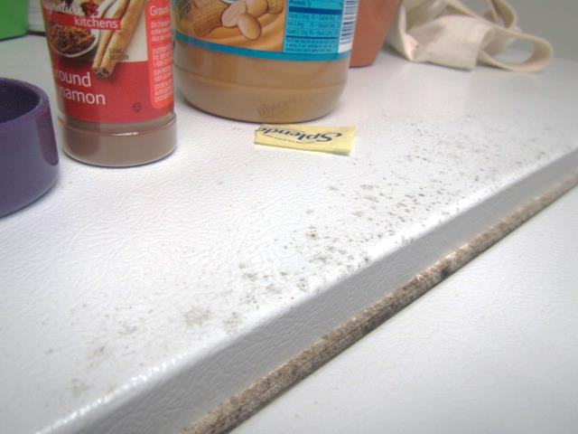
Mold growth on refrigerator and gasket
Picture 2
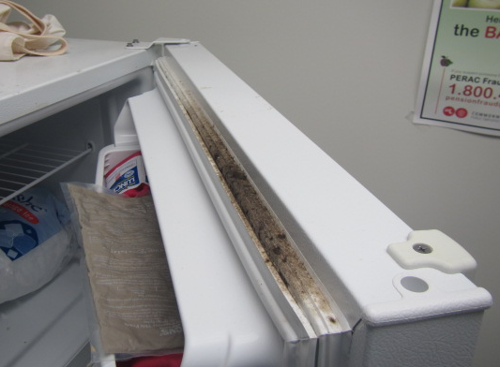
Mold growth on refrigerator and gasket

Location | Carbon  Dioxide  (ppm) | Carbon Monoxide  (ppm) | Temp  (°F) | Relative  Humidity  (%) | PM2.5  (µg/m³) | Occupants  in Room | Windows  Openable | Ventilation |  | Remarks
 |  |  |  |  |  |  |  | Supply | Exhaust
Background | 440 | ND | 77 | 69 | 16 |  |  |  |  | Warm, clear skies, moderate traffic
Conference Room | 535 | ND | 74 | 58 | 1 | 2 | N | Y | Y
109 | 477 | ND | 72 | 59 | 1 | 0 | Y | Y | Y
110 | 508 | ND | 72 | 60 | 1 | 0 | N | Y | Y
111 | 480 | ND | 72 | 59 | 1 | 0 | N | Y | Y
112 Kitchen | 564 | ND | 73 | 59 | 0 | 0 | N | Y | Y | Visible mold growth on top of fridge/gaskets
113 | 493 | ND | 73 | 58 | 1 | 0 | N | Y | Y
114 | 466 | ND | 72 | 60 | 2 | 0 | N | Y | Y
115 | 531 | ND | 72 | 60 | 2 | 0 | N | Y | Y
116 | 477 | ND | 71 | 60 | 2 | 0 | N | Y | Y
117 | 481 | ND | 71 | 60 | 2 | 0 | N | Y | Y
118 | 482 | ND | 71 | 60 | 2 | 0 | N | Y | Y
119 | 493 | ND | 71 | 62 | 1 | 0 | N | Y | Y
120 | 489 | ND | 70 | 61 | 2 | 0 | N | Y | Y | Occasional leaks reported
121 | 471 | ND | 70 | 62 | 1 | 0 | N | Y | Y
122 | 473 | ND | 70 | 62 | 1 | 0 | N | Y | Y
124 | 456 | ND | 70 | 61 | 2 | 0 | N | Y | Y | WD CT
125 | 468 | ND | 70 | 61 | 1 | 0 | N | Y | Y | Supply vent sealed with sheet metal
127 | 483 | ND | 68 | 62 | 1 | 0 | N | Y | Y | WD CT
126 | 521 | ND | 69 | 62 | 1 | 0 | N | Y | Y
129 | 472 | ND | 67 | 58 | 2 | 0 | N | Y | Y | Visible condensation on blinds, 2 WD CTs
C102 | 476 | ND | 67 | 60 | 1 | 0 | N | Y | Y | WD CT, reported condensation on blinds
C103 | 467 | ND | 67 | 60 | 2 | 0 | N | Y | Y | Reported condensation on blinds
102 | 458 | ND | 67 | 60 | 1 | 0 | N | Y | Y
103 | 459 | ND | 67 | 63 | 2 | 0 | N | Y | Y
104 | 458 | ND | 67 | 62 | 1 | 0 | N | Y | Y
C104/C106 | 467 | ND | 67 | 64 | 3 | 0 | N | Y | Y
106 | 487 | ND | 68 | 66 | 1 | 0 | N | Y | Y
107 | 488 | ND | 68 | 65 | 1 | 0 | N | Y | Y
C108 | 487 | ND | 69 | 64 | 2 | 0 | N | Y | Y

