INDOOR AIR QUALITY ASSESSMENT

Committee for Public Counsel Services
44 Bromfield Street
Boston

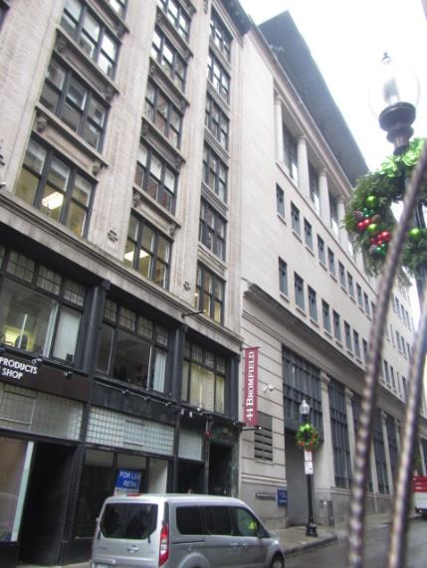

Prepared by:
Massachusetts Department of Public Health
Bureau of Environmental Health
Indoor Air Quality Program
December 2019

Background
Building: | Committee for Public Counsel Services (CPC)
Address: | 44 Bromfield Street, Boston
Assessment Requested by: | Virginia Platt, Senior Project Manager, Division of Capital Asset Management & Maintenance (DCAMM)
Reason for Request: | General indoor air quality (IAQ) assessment
Date of Assessment: | November 20, 2019
Massachusetts Department of Public Health/Bureau of Environmental Health (MDPH/BEH) Staff Conducting Assessment: | Ruth Alfasso, Environmental Engineer, IAQ Program  Cory Holmes, Environmental Analyst, IAQ Program
Building Description: | These offices occupy all 8 and a half floors of a multi-story building in Downtown Crossing, Boston. The building was originally constructed in the early 1900s. The space contains offices, workstations, conference rooms and auxiliary spaces. The CPC has occupied these offices for over a decade.
Windows: | Many are openable, some are sealed or blocked

Methods
Please refer to the IAQ Manual for methods, sampling procedures, and interpretation of results (MDPH, 2015).

IAQ Testing Results
The following is a summary of indoor air testing results (Table 1).
- Carbon dioxide levels were below the MDPH guideline of 800 parts per million (ppm) in most of the areas surveyed, indicating adequate fresh air for the occupancy in most areas of the building.
- Temperature was within or close to the lower end of the MDPH recommended range of 70°F to 78°F in areas tested.
- Relative humidity was below the MDPH recommended range of 40 to 60% in all areas tested, which is typical of the heating season.
- Carbon monoxide levels were non-detectable (ND) in all indoor areas tested.
- Fine particulate matter (PM2.5) concentrations measured were below the National Ambient Air Quality Standard (NAAQS) limit of 35 μg/m³ in all but two areas tested.

Ventilation
A heating, ventilating, and air conditioning (HVAC) system has several functions. First it provides heating and, if equipped, cooling. Second, it is a source of fresh air. Finally, an HVAC system will dilute and remove normally-occurring indoor environmental pollutants by not only introducing fresh air, but by filtering the airstream and ejecting stale air to the outdoors via exhaust ventilation. Even if an HVAC system is operating as designed, point sources of respiratory irritation may exist and cause symptoms in sensitive individuals.
The HVAC system consists of numerous heat exchange units located in the ceilings of each floor which heat or cool the air and distribute it to occupied spaces through ceiling-mounted vents (Picture 1). Each of these units has a filter which needs to be changed a minimum of 2 times a year or more if filters are found to be significantly soiled/occluded when changed. Filters in one unit were examined and appeared to be of a good quality pleated type. A box of filters of the appropriate size for these units were found, which have a Minimum Efficiency Reporting Value (MERV) rating of 10 (Picture 2). This rating is more efficient than the recommended MERV 8 and should be more than adequate to remove particles such as pollen and mold spores (ASHRAE 2012).
Return/exhaust vents were noted in hallways on one floor. Some ceiling-mounted return vents were present in other locations, and it also appeared that there were vents around lights to draw air into the ceiling plenum as a return.
There is a set of restrooms on each floor of the building in an area without windows. Apart from the 9th floor, the exhaust fans in every restroom were not functioning. Restrooms generate moisture and odors which need to be removed from the building, so restroom exhaust vents need to be functioning and turned on during occupied periods. Occupants expressed complaints about odors and each restroom had cans of air freshener, which will only cover up odors, not remove them. In addition, air fresheners can be a source of irritants.
Fresh air circulation should be on and operating during all occupied periods. There are thermostats for each ceiling-mounted unit, and many of them were found set to the fan “auto” setting (Picture 3), which does not provide for circulation of air when the temperature preset is satisfied. Ventilation should be on and operating during business hours in all occupied locations. In addition, some thermostats appeared to have the wrong time (Picture 3), which will prevent appropriate use of occupancy settings.
In order to have proper ventilation with a mechanical ventilation system, the systems must be balanced after installation to provide an adequate amount of fresh air to the interior of a room while removing stale air from the room. It is recommended that HVAC systems be re-balanced every five years to ensure adequate air systems function (SMACNA, 1994). It is unknown when the last time these systems were balanced.
Temperature control issues were expressed by many occupants, including a lack of heat in the weeks before the visit. In most occupied areas examined, the temperature was within the BEH/IAQ guidance of 70°F to 78°F. However, on the second floor, some temperatures were below 70°F. Occupants should work with building facility staff to address temperature control issues. In addition, some areas on the second floor had windows that were slightly open (Table 1). Windows should be tightly closed, including locked, when not intentionally opened. Some windows in the building appear original, and are in poor condition, which can lead to drafts even when windows are closed. In some rooms, a clear plastic screen was fastened in front of the lower half of the window (Picture 4), presumably to block drafts. Some windows in the building appear to have been replaced with new systems which are likely to seal better and be more energy efficiency in general.
Portable air conditioners were noted in a few areas (Picture 5; Table 1). Most were unplugged for the season. These units should be cleaned and maintained in accordance with manufacturer’s instructions, including emptying out any condensation collection chambers and cleaning/replacing filters (Picture 6). They should be stored in a clean, dry area when not in use to prevent dust and debris from settling on/in the units.
Portable heaters were also observed in many areas (Table 1). Where these units are allowed in the building, they should also be cleaned and maintained in accordance with manufacturer’s instructions, should only be used in safe locations free from flammable materials, and should be turned off whenever the office/area is not occupied. Where possible, heating complaints should be resolved with adjustments to the general circulation system.

Microbial/Moisture Concerns
A musty odor was detected on entering the 7th floor reception office area. Occupants in this area reported that this odor has existed for at least a month. Several areas/items were examined to see if the source of the odor could be determined, including: the heating unit, the ceiling plenum (above the ceiling tiles), carpeting, and other nearby areas and items. No obvious source was present. The ceiling plenum in this area is a wide open space with the concrete ceiling above it (Picture 7). There were numerous breaches in the ceiling where wires and other utilities were inserted, with gaps around them (Picture 8). Odors present in between walls/above the ceiling could be distributed to occupied areas through these gaps by the air handling system.
If sealing these gaps with an appropriate sealant doesn’t eliminate the odor, it may be helpful to consult with an HVAC specialist regarding the condition of the nearest HVAC unit to the odor complaints and any piping/conduits to it. HVAC units may be subject to microbial colonization and corrosion of heat exchange surfaces which can emit odors when the units are activated. Frequently the units can be cleaned to remove the sources of the odor, but under some conditions, the heat exchangers or whole units will need to be replaced to stop the odor.
A few water-damaged ceiling tiles were found in a 7th floor restroom, and water-damaged ceiling tiles and plaster/paint were found in one of the conference rooms on the first floor (Picture 9). Both of these appeared to be from historic leaks and did not appear recent. Water-damaged ceiling tiles should be replaced once the leak is found and repaired. Water-damaged plaster and paint can be refinished.
Building occupants report a history of overflows/flooding from toilets in the building. Overflows of blackwater (water from toilets) should be cleaned with antimicrobial cleaners. Porous materials (e.g., carpeting, wallboard) that have been moistened with blackwater should be removed and replaced as it is difficult to clean these items sufficiently to eliminate risk from blackwater.
Water dispensers and refrigerators were found in carpeted areas (Picture 10; Table 1). These appliances can spill or leak and moisten carpeting. These items should be placed in areas with non-porous flooring where possible or on a waterproof mat to protect carpeting.
Plants were noted in some areas (Picture 11; Table 1). Plants should be properly maintained and equipped with drip pans and should be located away from airflow to prevent the aerosolization of dirt, pollen, and mold. Plants should not be placed on porous surfaces.
There were showers located near the restrooms on some floors (Picture 12). If showers are not used, the drains may dry out and compromise the trap seal. This can lead to sewer odors in occupied areas. Infrequently used drains, including showers and janitorial sinks, should be watered periodically to maintain the trap seal. Drains/plumbing fixtures that are no longer needed should be cut and otherwise rendered non-functional.

Other Concerns
Exposure to low levels of total volatile organic compounds (TVOCs) may produce eye, nose, throat, and/or respiratory irritation in some sensitive individuals. BEH/IAQ staff examined areas for products containing VOCs. BEH/IAQ staff noted hand sanitizers, air fresheners, fragrance products, cleaners, and dry erase materials in the office space (Picture 13; Table 1). All of these products have the potential to be irritants to the eyes, nose, throat, and respiratory system of sensitive individuals.
As noted in the results section above, there were two PM2.5 measurements that were above the EPA NAAQS limit of 35 μg/m³, which appeared to be due to the cutting of drywall (gypsum wallboard). Construction activities that may produce dusts or odors should be conducted to minimize impacts to impacts to occupants, including isolation of work areas with plastic sheeting and conducting activities during unoccupied periods.
Air purifiers were noted in several areas (Picture 14). The unit shown in Picture 14 has built-in ionizing capabilities. Many ionizers create ozone, which is a respiratory irritant.
In some offices and common areas, accumulated items were on the floor or surfaces such as desks and windowsills (Picture 15; Table 1). These items make it more difficult for custodial staff to clean. Items should be relocated and/or be cleaned periodically to avoid excessive dust build up. Some vents (Picture 16) and personal fans were dusty. This dust can be reaerosolized when the equipment is in use. Dust and debris should also be regularly cleaned from areas such as MDF rooms and closets.
Food and food preparation equipment, including microwaves and toasters, were observed in offices and common areas. Kitchen areas lack direct-vented exhaust and many had no windows. Without exhaust, odors can be distributed to other areas of the office. Care should be taken to keep food preparation equipment clean to prevent smoke, odors and pests.
Most of the offices are carpeted. Carpets should be cleaned annually (or semi-annually in soiled/high traffic areas) in accordance with Institute of Inspection, Cleaning and Restoration Certification (IICRC) recommendations, (IICRC, 2012). Some of the carpeting in the office was carpet tiles which appeared fairly new. In some offices, older wall-to-wall style carpeting was present. Older carpeting can become worn and difficult to clean, and may become a source of dust, debris and odors. In addition, carpet tiles are easier to replace when small amounts are water-damaged or stained. Vacuum cleaners were noted on many floors, and these did not appear to be equipped with High-efficiency Particulate Arrestance (HEPA) filters. Without a HEPA filter, a vacuum cleaner will aerosolize and distribute dust and debris during use.

Conclusions/Recommendations
Based on observations at the time of assessment, the following is recommended:
- Operate supply and exhaust ventilation continuously in all areas during occupied periods. Ensure all HVAC equipment is cleaned/maintained in accordance with manufacturer’s instructions.
- Seal breaches in the ceiling above the plenum to see if that reduces the odor on the 7th floor. Use an appropriate fire-rated sealant and perform these activities when the building is unoccupied to reduce impact on occupants. If odors are not reduced/eliminated, consider the following:
- Have an HVAC contractor check the condition for of the unit supplying air to the reception area on the 7th floor for odors, scale/corrosion, or other conditions that may contribute to the odors experienced and clean/repair as needed.
- Consult a licensed plumber/contractor to investigate any abandoned pipes/components to the plumbing and/or HVAC system as source of odors.
- Ensure thermostat settings, including time of day, are correct to allow for use of set-back temperatures and operations.
- Change filters for HVAC equipment 2-4 times a year. Use pleated filters of MERV 8 (or higher), which are adequate in filtering out pollen and mold spores (ASHRAE, 2012).
- Repair restroom exhaust vent fans and set to operate during occupied hours.
- Occupants should work with facility staff to address temperature issues.
- Ensure all windows are tightly closed when not deliberately opened. Locking windows will ensure they are completely closed. Windows should not be opened while air conditioning is operating.
- Consideration should be given to replacement of remaining original windows with new energy efficient ones where possible.
- Maintain portable AC units in accordance with manufacturer’s recommendations including cleaning. Store them in a clean dry area during the cooling season.
- If personal heaters are allowed to be used, ensure they are only used in safe areas, kept clean, and turned off whenever the area is not occupied.
- Balance the HVAC system every 5 years in accordance with Sheet Metal and Air Conditioning Contractors’ National Association (SMACNA) recommendations (SMACNA, 1994).
- Replace water-damaged ceiling tiles when they are found and examine above them for an ongoing source of water or additional water-damaged materials and repair/clean as needed.
- Address the water-damaged paint in the conference room.
- Ensure that items moistened by blackwater are sanitized, if non-porous, or replaced if porous.
- Consult with a plumber to determine the best way to prevent clogs and overflowing of toilets.
- Consider placing refrigerators and water dispensers in areas without carpeting, or use a waterproof mat to protect carpeting.
- Keep plants in good condition, avoid overwatering, and remove from the airstream of heating and ventilation equipment.
- Regularly pour water down unused drains to prevent dry drain traps and associated sewer gas odors.
- Reduce the use of cleaning products, sanitizers, and other items that contain VOCs. Keep containers sealed when not in use.
- Perform any construction/renovation activities that may produce dust and odors with containment to protect occupants. Ideally, such work should be conducted during unoccupied hours.
- For buildings in New England, periods of low relative humidity during the winter are often unavoidable. Therefore, scrupulous cleaning practices should be adopted to minimize common indoor air contaminants whose irritant effects can be enhanced when the relative humidity is low. To control for dusts, a high efficiency particulate arrestance (HEPA) filter equipped vacuum cleaner in conjunction with wet wiping of all surfaces is recommended. Avoid the use of feather dusters. Drinking water during the day can help ease some symptoms associated with a dry environment (throat and sinus irritations).
- Ensure all dusty surfaces are cleaned periodically, including supply and return vents, personal fans and flat surfaces. If surrounding ceiling tiles cannot be cleaned, replace (e.g., Picture 16).
- Keep air purifiers clean and maintained in accordance with manufacturer’s instructions. Avoid using any product that may produce ozone.
- Keep food preparation equipment clean, and clean out refrigerators, including the gaskets, regularly.
- Clean carpeting in accordance with IICRC recommendations (IICRC, 2012).
- Refer to resource manual and other related IAQ documents located on the MDPH’s website for further building-wide evaluations and advice on maintaining public buildings. These documents are available at: http://mass.gov/dph/iaq.

References
ASHRAE. 2012. American Society of Heating, Refrigeration and Air Conditioning Engineers (ASHRAE) Standard 52.2-2012 -- Method of Testing General Ventilation Air-Cleaning Devices for Removal Efficiency by Particle Size (ANSI Approved). 2012.
IICRC. 2012. Institute of Inspection, Cleaning and Restoration Certification. Carpet Cleaning: FAQ.
MDPH. 2015. Massachusetts Department of Public Health. Indoor Air Quality Manual: Chapters I-III. Available at: http://www.mass.gov/eohhs/gov/departments/dph/programs/environmental-health/exposure-topics/iaq/iaq-manual/.
SMACNA. 1994. HVAC Systems Commissioning Manual. 1st ed. Sheet Metal and Air Conditioning Contractors’ National Association, Inc., Chantilly, VA.
Picture 1
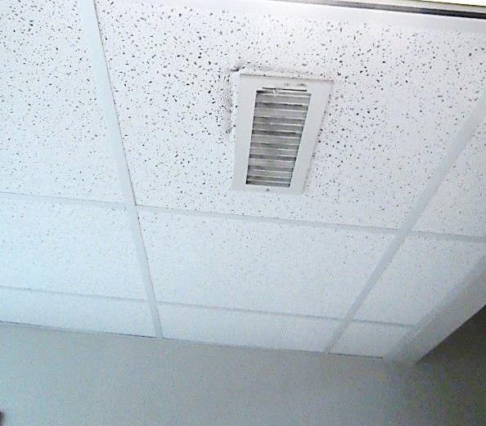
Ceiling-mounted vent
Picture 2
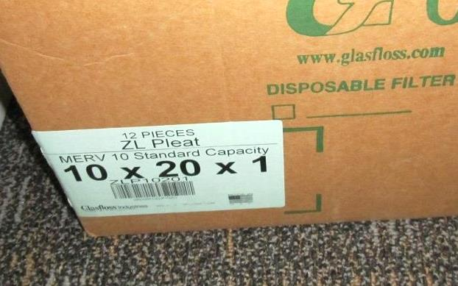
Box of filters showing MERV 10 rating
Picture 3
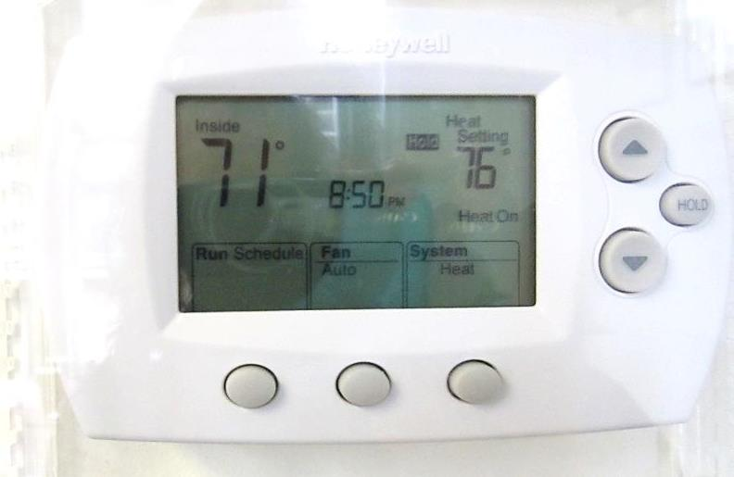
Thermostat set to fan “auto” (arrow) and time set to 8:50 PM
Picture 4
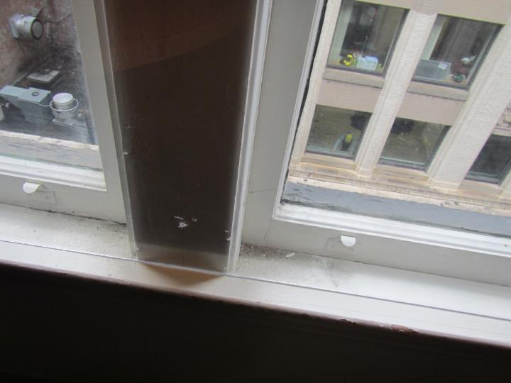
Old window with plastic screen to block drafts, note dust/debris from window inside
Picture 5
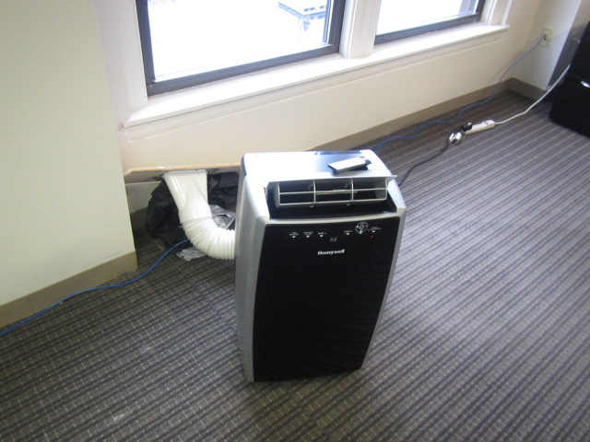
Portable air conditioner, intake removed from window for the season
Picture 6
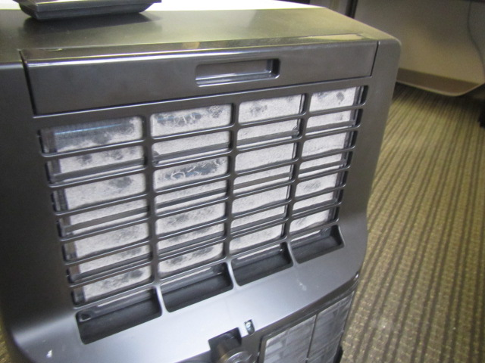
Dusty vent/filter on portable air conditioner
Picture 7
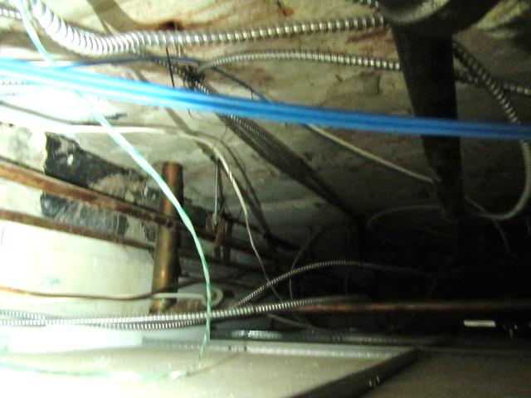
Ceiling plenum (space above ceiling tiles)
Picture 8
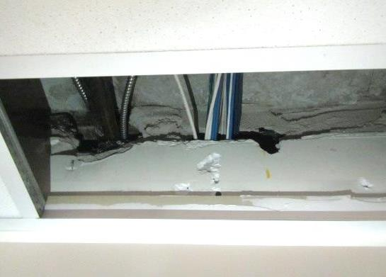
Gaps around pipes/wires in the ceiling plenum
Picture 9
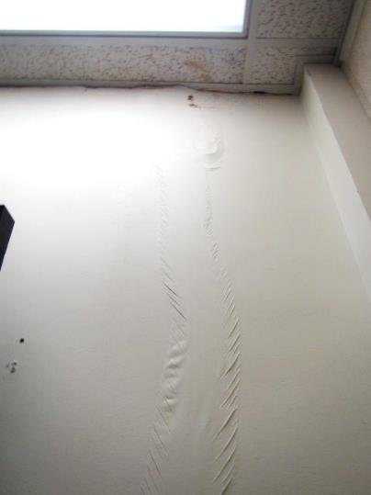
Water-damaged paint and ceiling tiles in the first floor conference room
Picture 10
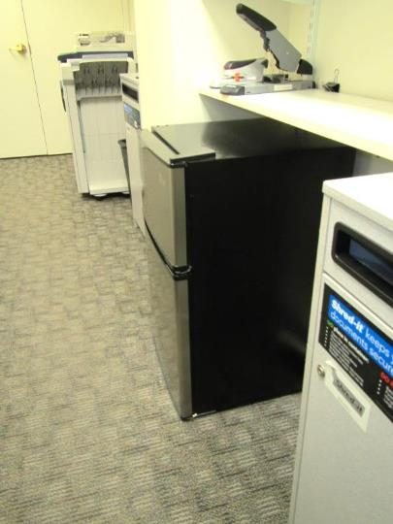
Refrigerator on carpet
Picture 11
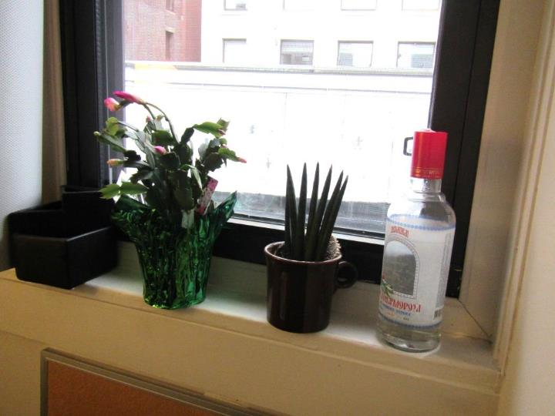
Plants on a windowsill
Picture 12
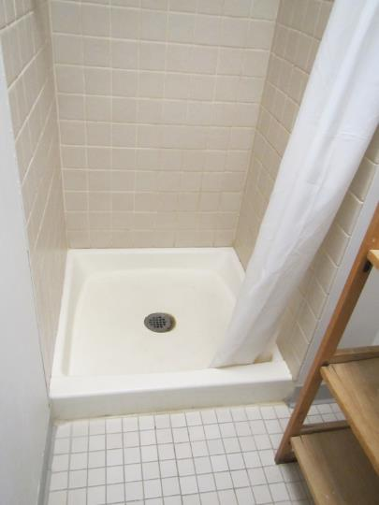
Shower that appears unused
Picture 13
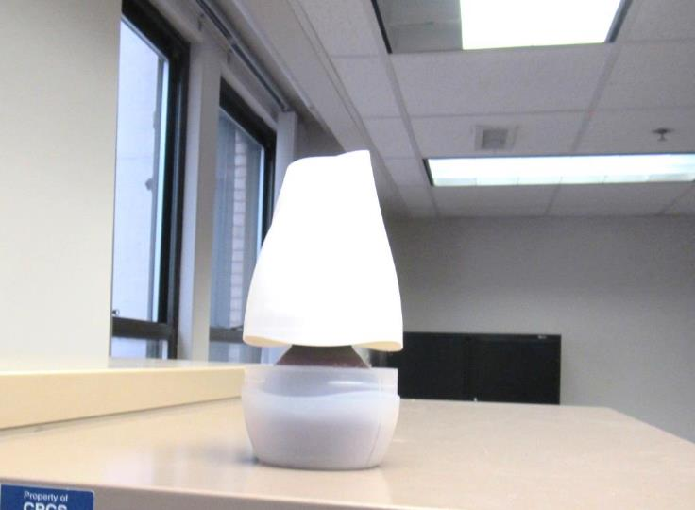
Pop-up air freshener
Picture 14
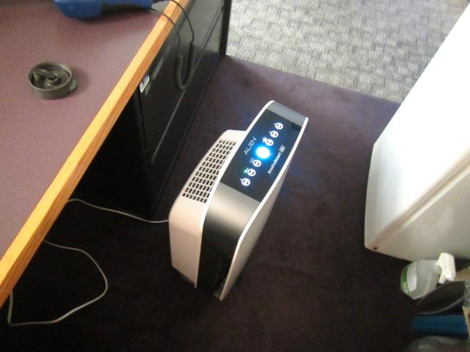
Air purifying unit
Picture 15
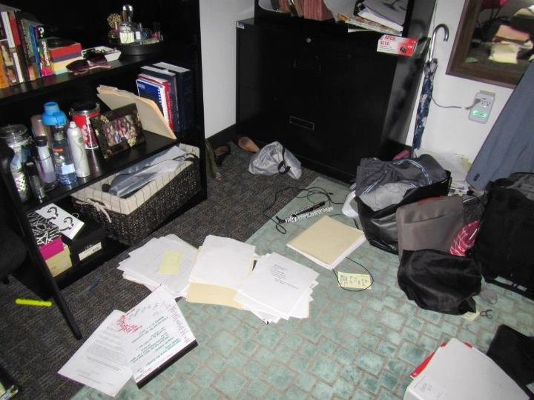
Items on an office floor
Picture 16
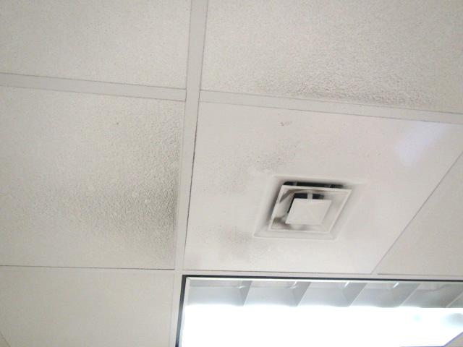
Dust on supply vent and nearby ceiling tiles
Location | Carbon  Dioxide  (ppm) | Carbon Monoxide  (ppm) | Temp  (°F) | Relative  Humidity  (%) | PM2.5  (µg/m³) | Occupants  in Room | Windows  Openable | Ventilation |  | Remarks
 |  |  |  |  |  |  |  | Supply | Exhaust
Background | 394 | 0.4 | 54 | 38 | 7 |  |  |  |  | Rain, taken outside front of building
9th Floor
Frasier Office | 760 | ND | 72 | 34 | 6 | 3 | N | Y | Y | PF, carpet
Kitchen | 807 | ND | 75 | 33 | 5 | 1 | N | Y |  | Microwave and fridge, NC, HS
Cube near front | 734 | ND | 75 | 29 | 5 | 1 | N | Y | Y
Restrooms | 693 | ND | 75 | 31 | 5 | 0 | N |  | Y on | AF, shower (probably unused)
902 | 697 | ND | 74 | 32 | 5 | 0 | N |  |  | Thermostat (auto), door open, plants, PF
904 | 708 | ND | 76 | 28 | 6 | 1 | Y | Y | N
905 | 924 | ND | 75 | 31 | 6 | 1 | Y | Y | N | Thermostat fan-“Auto”
8Th Floor
C801-C804 | 720 | ND | 76 | 27 | 5 | 1 | Y | Y | N
Terasi office | 739 | ND | 74 | 30 | 4 | 1 | Y | Y dusty |  | Microwave, portable AC, plant, PF
MDF | 715 | ND | 67 | 31 | 5 | 0 | Y | Y dusty |  | 2 portable ACs with tube out window, old ductless AC on wall, missing floor tiles (most)
Kitchen | 634 | ND | 74 | 32 | 7 | 0 | Y | Y |  | Kitchen appliances (all new) including stove and oven. No direct exhaust.
Restrooms |  |  |  |  |  | 0 | N | N | Y off | Odor, AF
Human Resources | 570 | ND | 74 | 29 | 6 | 0 | Y | Y |  | MT, AF
801 | 689 | ND | 76 | 29 | 6 | 2 | Y | Y |  | DEM, printer outside
802 | 987 | ND | 75 | 30 | 6 | 1 | Y | Y
803 | 827 | ND | 75 | 29 | 9 | 0 | Y | Y
805 | 691 | ND | 71 | 34 | 5 | 1 | Y | Y dusty |  | AI
806 | 670 | ND | 71 | 31 | 4 | 0 | Y | Y | N
807 | 695 | ND | 71 | 30 | 4 | 0 | Y | Y | N | AC-filter dusty, thermostat fan-“on”
808 Storeroom | 698 | ND | 73 | 28 | 4 | 0 | Y | Y | Y | Thermostat fan-“Auto”
7th Floor |  |  |  |  |  |  |  |  |  | Musty odors
Restrooms | 753 | ND | 76 | 31 | 6 | 0 | N |  | Y off | CPs, AP, WD CT
C703-C703 | 749 | ND | 75 | 29 | 4 | 1 | Y | Y |  | Portable AC (unplugged)
C701 | 731 | ND | 75 | 29 | 5 | 0 | Y |  |  | Window sealed with hard plastic draft shield
C715 conference | 663 | ND | 75 | 29 | 4 | 0 | Y | Y |  | DEM, PFs, HS
C714 | 703 | ND | 77 | 28 | 4 | 1 | N | Y |  | Heater, AF
Reception | 781 | ND | 75 | 31 | 4 | 1 | N | Y |  | Fridge and microwave, AP, AI
701 | 613 | ND | 76 | 26 | 5 | 0 | N | Y | N
702 | 687 | ND | 74 | 30 | 7 | 0 | Y | Y |  | Old carpet
703 | 640 | ND | 74 | 29 | 4 | 0 | Y | Y |  | Plant, heavy blinds closed, old carpet
704 | 677 | ND | 74 | 28 | 4 | 0 | Y | Y |  | UF, old carpet, paint cans on shelf
706 | 728 | ND | 74 | 29 | 4 | 1 | Y | Y |  | Plant
707 | 633 | ND | 75 | 27 | 4 | 3 | Y | Y |  | PF
708 | 689 | ND | 76 | 28 | 3 | 0 | Y | Y |  | DEM
709 | 710 | ND | 75 | 27 | 4 | 0 | Y | Y
710 | 691 | ND | 75 | 28 | 4 | 0 | Y | Y |  | DEM
711 | 706 | ND | 75 | 28 | 5 | 1 | Y | Y
712 | 753 | ND | 75 | 29 | 4 | 0 | Y | Y |  | Fridge on carpet, HS
713 | 729 | ND | 75 | 30 | 11 | 0 | Y | Y
716 | 717 | ND | 75 | 29 | 5 | 0 |  |  |  | Older carpet
717 | 767 | ND | 76 | 30 | 5 | 1 | Y |  |  | Plant
6th Floor
601 Storage | 790 | ND | 75 | 28 | 5 | 0 | N | Y | N
601-603 | 918 | ND | 74 | 31 | 4 | 2 | N | Y | N | Plants, dust/debris on vents
602 | 775 | ND | 75 | 28 | 3 | 0 | Y | Y | N | Thermostat fan-“Auto”
603 | 950 | ND | 74 | 31 | 5 | 1 | Y | Y | N | DO
604 | 939 | ND | 74 | 31 | 4 | 1 | Y | Y | N | Dust/debris on vents
605 | 882 | ND | 74 | 30 | 4 | 0 | Y | Y | N | DO, plant, PF
606 | 875 | ND | 73 | 30 | 4 | 0 | Y | Y | N | DO
607 | 841 | ND | 73 | 30 | 4 | 0 | Y | Y | N | DO, plant
608 | 1060 | ND | 74 | 32 | 4 | 1 | Y | Y | N | Plants
609 | 953 | ND | 76 | 31 | 5 | 1 | Y | Y |  | AF, PF, blackout shades
610 | 951 | ND | 75 | 30 | 5 | 0 | Y | Y |  | PF
611 | 942 | ND | 76 | 30 | 6 | 0 | Y | Y |  | AI, DEM, heater
613 | 741 | ND | 76 | 31 | 8 | 1 | N | Y dusty |  | Candle, door between this and 614 ajar
614 | 695 | ND | 74 | 30 | 5 | 0 | Y | Y |  | Plant, DEM, fridge
615 | 634 | ND | 74 | 28 | 3 | 0 | Y | Y |  | Plants, food
616 | 677 | ND | 75 | 27 | 3 | 0 | Y | Y |  | Plants, fridge
C606 and 607 | 878 | ND | 76 | 30 | 5 | 2 | N | Y |  | PC
C608 | 922 | ND | 76 | 30 | 6 | 1 | N | Y
Cube next to 612 | 820 | ND | 76 | 30 | 4 | 1
Restrooms |  |  |  |  |  |  | N | N | Y off | AF
5th Floor
501 | 724 | ND | 75 | 28 | 6 | 0 | Y | Y |  | Plant, DEM, plastic draft shield on window, HS
502 | 756 | ND | 74 | 30 | 5 | 1 | Y | Y |  | DEM, plant, plastic draft shield on window
503 | 732 | ND | 74 | 29 | 5 | 0 | Y | Y |  | Heater
504 | 671 | ND | 73 | 29 | 5 | 0 | Y | Y |  | Plants
505 | 650 | ND | 72 | 29 | 6 | 0 | Y | Y |  | Plant, DEM
506 | 634 | ND | 72 | 30 | 5 | 0 | Y | Y
507 | 683 | ND | 73 | 31 | 5 | 0 | Y | Y |  | HS
508 | 688 | ND | 74 | 32 | 5 | 1 | Y | Y |  | Old carpet, plant
508 | 714 | ND | 73 | 32 | 4 | 1 | Y | Y | N
509 | 686 | ND | 73 | 31 | 5 | 0 | Y | Y
509 | 710 | ND | 70 | 31 | 4 | 0 | Y | Y | N
510 | 735 | ND | 71 | 33 | 4 | 1 | Y | Y | N | DO, window needs repair-draft/loose
511 | 765 | ND | 71 | 32 | 5 | 0 | Y | Y | N | DO
512 | 722 | ND | 70 | 31 | 4 | 0 | Y | Y | N | DO
513 | 777 | ND | 74 | 30 | 4 | 1 | Y | Y | N | DO
514 | 717 | ND | 74 | 28 | 4 | 0 | N | Y | N | Dust/debris on vents
515 | 764 | ND | 74 | 29 | 4 | 0 | Y | Y | N | Dust/debris on vents
516 | 660 | ND | 72 | 34 | 4 | 1 | Y | Y |  | Shower next to kitchen, appears to be used sometimes, AP machine
517 | 563 | ND | 70 | 32 | 19 | 0 | Y, Open | Y | N
518 | 659 | ND | 76 | 27 | 5 | 0 | N | Y |  | Will be lactation room, UF, unplugged fridge
C502 | 722 | ND | 75 | 28 | 5 | 1 | N | Y
C504 | 697 | ND | 73 | 29 | 6 | 1 | Y | Y |  | HS
Open area conference room | 731 | ND | 75 | 29 | 10 | 0 | N | N
Restroom |  |  |  |  |  |  |  |  | Y off | AF
4th Floor
401 | 605 | ND | 73 | 32 | 5 | 0 | N | Y |  | Heater DEM, container of water on the floor
402 | 667 | ND | 73 | 31 | 6 | 0 | Y | Y |  | Heater, area rug, UF, old carpet
403 | 664 | ND | 73 | 31 | 8 | 0 | Y | Y |  | Heater, DEM, AI
404 | 635 | ND | 74 | 31 | 6 | 0 | Y | Y |  | Plants
406 | 791 | ND | 73 | 30 | 7 | 0 | Y | Y |  | UF, AI on floor
407 | 682 | ND | 74 | 30 | 7 | 0 | Y | Y |  | Heater, plant
409 | 719 | ND | 74 | 30 | 7 | 0 | Y | Y |  | Area rug, PF – dusty
C402 | 663 | ND | 73 | 31 | 7 | 0 | N | Y
C409 | 700 | ND | 75 | 29 | 5 | 0 | Y | Y | N
C411-C416 | 687 | ND | 74 | 30 | 7 | 3 | Y | Y | Y
C418-C420 | 751 | ND | 76 | 31 | 5 | 1 | Y | Y | N | PF, DEM
C421-C424 | 745 | ND | 76 | 29 | 6 | 2 | Y | Y | N | PF, AT, thermostat fan-“Auto”
Computer Office | 487 | ND | 72 | 29 | 4 | 0 | Y | Y | N
Conference/lunch area | 640 | ND | 74 | 31 | 6 | 7 | Y | Y |  | PC, debris on carpet
Restroom |  | ND |  |  |  |  | N | Y  Passive | Y | Exhaust not drawing air
Work Stations Center | 676 | ND | 74 | 29 | 7 | 0 | N | Y | Y
3rd Floor
301 | 714 | ND | 74 | 28 | 8 | 1 | Y | Y
302 | 754 | ND | 75 | 28 | 6 | 1 | Y | Y
303 | 741 | ND | 75 | 28 | 6 | 1 | Y | Y
304 | 733 | ND | 74 | 29 | 4 | 0 | Y | Y | N | DO, plant
305 | 707 | ND | 75 | 28 | 5 | 1 | Y | Y | N | DO
306 | 717 | ND | 74 | 28 | 4 | 0 | Y | Y | N | DO, plant, PF
309 | 723 | ND | 76 | 30 | 10 | 1 | Y | Y
310 | 653 | ND | 75 | 29 | 7 | 1 | Y | Y | N
311 | 680 | ND | 75 | 29 | 11 | 2 | Y | Y | N | DO
312 | 735 | ND | 76 | 30 | 10 | 1 | Y | Y
315 | 581 | ND | 73 | 28 | 5 | 1 | Y | Y | N | DO
316 | 590 | ND | 73 | 28 | 7 | 0 | Y | Y
Appeals Unit Secretaries | 606 | ND | 73 | 28 | 6 | 0 | Y | Y | N | CP
Harris office (2/3 wall) | 846 | ND | 74 | 32 | 8 | 1 | N | Y
HR reception area | 695 | ND | 75 | 31 | 10 | 1 | Y | Y
Open area conference room | 710 | ND | 76 | 28 | 6 | 0 | Y | Y
Restrooms |  |  |  |  |  |  |  |  | Y off | CP, AF
2nd Floor
201 Office | 624 | ND | 72 | 29 | 23 | 0 | N | Y | N | DO
201 Reception | 608 | ND | 73 | 32 | 11 | 1 | N | Y | N | DO
202 | 682 | ND | 71 | 30 | 37 | 1 | Y | Y | N | DO
203 | 672 | ND | 71 | 30 | 37 | 1 | Y | Y | N | Cutting drywall-pipe wrapping project
204 | 696 | ND | 70 | 31 | 6 | 0 | Y | Y | N | DO
205 | 653 | ND | 69 | 32 | 6 | 1 | Y | Y | N | DO
206 | 554 | ND | 69 | 30 | 4 | 0 | Y | Y | N | DO
207 | 553 | ND | 69 | 30 | 4 | 0 | Y | Y | N | DO
208 | 549 | ND | 71 | 30 | 5 | 0 | Y | Y
209 | 515 | ND | 71 | 29 | 6 | 0 | Y | Y |  | AI
210 | 540 | ND | 71 | 28 | 6 | 0 | Y | Y
211 | 513 | ND | 72 | 30 | 6 | 1 | Y | Y |  | Drafty
212 | 582 | ND | 73 | 30 | 5 | 1 | Y | Y |  | DEM, old carpet
214 | 561 | ND | 73 | 29 | 6 | 0 | N | Y |  | Cloth covers on furniture and walls
215 | 547 | ND | 72 | 29 | 5 | 0 | N | Y
216 | 551 | ND | 71 | 30 | 5 | 0 | Y | Y dusty
217 | 641 | ND | 72 | 33 | 6 | 1 | Y | Y |  | DEM
218 | 607 | ND | 71 | 32 | 4 | 0 | N | Y | N | DO, dust/debris on vents and CT
C202-C205 | 593 | ND | 71 | 31 | 4 | 0 | N | Y | N | Dust/debris on vents, plant
C205 | 741 | ND | 72 | 32 | 5 | 0 | N | Y |  | HS, heater
C206-C207 | 560 | ND | 69 | 31 | 5 | 0 | N | Y | N | Dust/debris on vents
C208 | 557 | ND | 69 | 31 | 3 | 0 | N | Y | N
C209 | 552 | ND | 71 | 31 | 5 | 1 | Y | Y
Restrooms |  |  |  |  |  |  | N | N | Y off | CP
1st Floor
101 conference room | 466 | ND | 66 | 35 | 6 | 0 | N | Y | Y | Wall between this room and the next is movable, water cooler on carpet, DEM
102 Conference Room | 498 | ND | 69 | 32 | 5 | 0 | N | Y | Y | WD gypsum wallboard/paint from leak near ceiling/corner, WD CT, PFs

