INDOOR AIR QUALITY ASSESSMENT

Committee for Public Counsel Services
1 Congress St, Suite 102
Boston, MA 02114

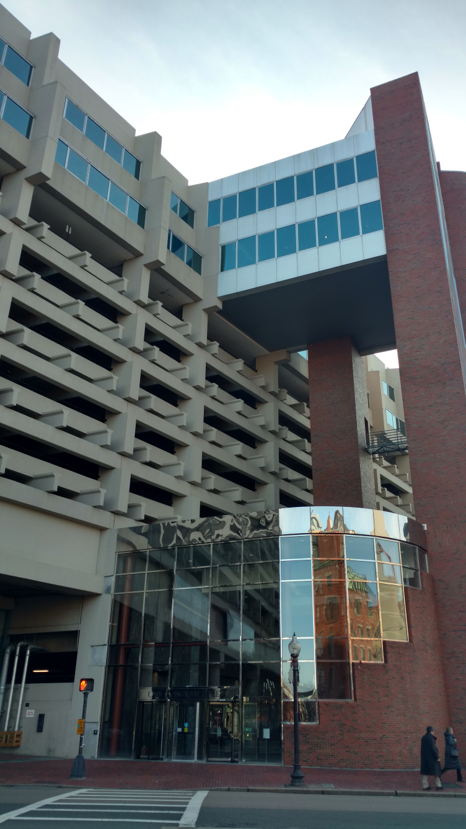

Prepared by:
Massachusetts Department of Public Health
Bureau of Environmental Health
Indoor Air Quality Program
January 2017

Background
Building: | Committee for Public Counsel Services, Children and Family Law
Address: | 1 Congress St, Suite 102, Boston, MA 02114
Assessment Requested by: | Virginia Platt, Project Manager, Division of Capital Asset Management and Maintenance (DCAMM)
Reason for Request: | General IAQ concerns
Date of Assessment: | November 28, 2016
Massachusetts Department of Public Health/Bureau of Environmental Health (MDPH/BEH) Staff Conducting Assessment: | Sharon Lee, Environmental Analyst, Indoor Air Quality (IAQ) Program
Building Description: | Multi-story building; renovations prior to occupancy
Building Population: | Approximately 125 employees
Windows: | Not openable

Methods
Please refer to the IAQ Manual for methods, sampling procedures, and interpretation of results (MDPH, 2015).

IAQ Testing Results
The following is a summary of indoor air testing results (Table 1).
- Carbon dioxide levels were below 800 parts per million (ppm) in all but one area assessed, indicating adequate fresh air in the space.
- Temperature was within the recommended range of 70°F to 78°F in all areas assessed.
- Relative humidity was below the recommended range of 40% to 60% in all areas assessed.
- Carbon monoxide levels were non-detectable in all indoor areas assessed.
- Fine particulate matter (PM2.5) concentrations measured were below the National Ambient Air Quality Standard (NAAQS) level of 35 micrograms per cubic meter (μg/m³) in all areas assessed.

Ventilation
Heating, ventilation and air conditioning (HVAC) are provided by rooftop air-handling units (AHUs) ducted to supply and return vents. Conditioned air is delivered to occupied areas via louvered supply vents (Picture 1), and the air is returned to the AHUs via exhaust vents (Picture 2). It should be noted that some return vents had louvered supply diffusers (Picture 3), which can hinder the draw of return air. At the time of assessment, the HVAC system was operating. The AHUs are monitored by an energy management system. It should be noted that one of the energy management controls was on the air conditioning setting. AHU controls should be operating to in a manner that ensures continuous air filtration and circulation throughout the space. Lack of air exchange/circulation can lead to the build-up of naturally occurring pollutants in the space, which can result in IAQ/comfort complaints.
Some staff reported temperature concerns, indicating air supplied by the AHU is too cool. Directional blades for air diffusers along the windows were pointed downwards. These air diffusers should be directed at a 45-degree angle to improve occupant comfort. It is recommended that HVAC systems be re-balanced every five years to ensure adequate air systems function (SMACNA, 1994); it was not known the last time these systems were balanced.

Microbial/Moisture Concerns
Stained ceiling tiles were observed in some areas of the building (Table 1). Water-damaged ceiling tiles can indicate roof or plumbing leaks. Any leaks should be reported promptly to building maintenance staff to ensure they can be repaired and materials can be dried. The United States Environmental Protection Agency (US EPA) and the American Conference of Governmental Industrial Hygienists (ACGIH) recommend that porous materials be dried with fans and heating within 24 to 48 hours of becoming wet (US EPA, 2008; ACGIH, 1989). If porous materials are not dried within this time frame, mold growth may occur. Once mold has colonized porous materials, they are difficult to clean and should be removed and discarded.
Plants were observed in a few areas (Table 1). Plants can be a source of pollen and mold, which can be respiratory irritants to some individuals. Plants should be properly maintained and equipped with drip pans and should be located away from air diffusers to prevent the aerosolization of dirt, pollen, and mold.
Breaches due to failing caulking were observed around windows (Picture 4). Measures should be taken to ensure windows are sealed to prevent moisture from entering the building. Breaches also increase air movement from the outdoors and may provide a pathway for pests.
Small refrigerators and water bubblers were directly on carpet (Picture 5). Leaks from these appliances can damage carpeting. Plastic or rubber mats with raised edges should be placed under these items to catch water from spills or leaks.

Other IAQ Evaluations

TVOCs
Exposure to low levels of TVOCs may produce eye, nose, throat, and/or respiratory irritation in some sensitive individuals. In addition to testing, BEH/IAQ staff examined spaces for products containing VOCs. BEH/IAQ staff noted air fresheners, deodorizers, candles, hand sanitizers, cleaning products, compressed air canister, and dry erase materials in a number of areas throughout the office space (Table 1; Picture 6). All of these products have the potential to be irritants to the eyes, nose, throat, and respiratory system of sensitive individuals.

Other Concerns
CPCS staff reported that musty odors occur in some areas of the building, however no odors were reported by CPCS staff in the days prior to the visit, nor did BEH staff observe any odors during the assessment. Building staff should keep a record of when odors occur in the building to assist in determining a source.
Personal fans observed in some offices appeared dusty. Dust collected on fan blades can be aerosolized. Dust is a respiratory and eye irritant. Fans should be cleaned periodically to prevent aerosolization of dust when the units are activated.
Items were observed on a number of flat surfaces, such as windowsills, tabletops, counters, bookcases, and desks. The large number of items stored in offices provides a source for dusts to accumulate. These items (e.g. papers, folders, boxes) also make it difficult for custodial staff to clean. Items should be relocated and/or be cleaned periodically to avoid excessive dust build up.
Missing ceiling tiles were observed in some areas (Table 1; Picture 7). Missing and ajar tiles can allow dust and debris in the plenum system to migrate into occupied areas. Care should be taken to ensure all the ceiling tile system is complete and ceiling tiles are flush.
Small food appliances and food items were observed in a common area (Picture 8). These items can attract pests. Food should be stored in air-tight containers, and appliances should be cleaned periodically to prevent pest infestation.
Space heaters were observed in a number of areas. Care should be taken when space heaters are used. These units are a fire hazard, particularly when operating unattended.

Conclusions/Recommendations
Based on observations at the time of assessment, the following is recommended:
- Operate supply and exhaust ventilation continuously in all areas during occupied periods. Ensure all HVAC equipment is maintained and supply and return vents are cleaned periodically to prevent dust re-aerosolization.
- Ensure energy management systems are set to the appropriate settings.
- Consider replacing return vents with louvers with non-louvered vents.
- Adjust directional blades for air diffusers along the window to a 45-degree angle.
- Have the HVAC system balanced every 5 years in accordance with SMACNA recommendations (SMACNA, 1994).
- Replace water-damaged ceiling tiles once the source of the leak is repaired.
- Keep plants in good condition, avoid overwatering, and remove from the airstream of heating and ventilation equipment.
- Repair seals around windows to prevent moisture and drafts into the building.
- Place plastic or rubber mats below refrigerators and water dispensers to catch water.
- Reduce the use of cleaning products, sanitizers, and other items that contain VOCs. Eliminate the use of scented candles and other air freshening products.
- Monitor for odors in areas where previously reported and keep a record, including building activities and weather conditions, when odors are noted. Contact BEH/IAQ staff if odors reoccur.
- Clean blades of personal fans to prevent aerosolization of dust.
- Reduce the amount of items stored on flat surfaces to allow regular cleaning.
- Ensure all ceiling tiles are intact and installed flush in the ceiling tile system. Missing tiles should be replaced to prevent movement of dust and debris from plenum into occupied areas.
- Ensure food appliances such as toasters are cleaned regularly to prevent pests. Food should also be stored appropriately.
- Ensure space heaters are not left unattended.
- Refer to resource manual and other related IAQ documents located on the MDPH’s website for further building-wide evaluations and advice on maintaining public buildings. These documents are available at: http://mass.gov/dph/iaq.

References
American Conference of Governmental Industrial Hygienists (ACGIH). 1989. Guidelines for the Assessment of Bioaerosols in the Indoor Environment. American Conference of Governmental Industrial Hygienists, Cincinnati, OH.
Massachusetts Department of Public Health (MDPH). 2015. Massachusetts Department of Public Health. Indoor Air Quality Manual: Chapters I-III. Available at: http://www.mass.gov/eohhs/gov/departments/dph/programs/environmental-health/exposure-topics/iaq/iaq-manual/.
SMACNA. 1994. HVAC Systems Commissioning Manual. 1st ed. Sheet Metal and Air Conditioning Contractors’ National Association, Inc., Chantilly, VA.
United States Environmental Protection Agency (US EPA). 2008. “Mold Remediation in Schools and Commercial Buildings”. Office of Air and Radiation, Indoor Environments Division, Washington, DC. EPA 402-K-01-001. March 2001. Available at: https://www.epa.gov/mold/mold-remediation-schools-and-commercial-buildings-guide
Picture 1
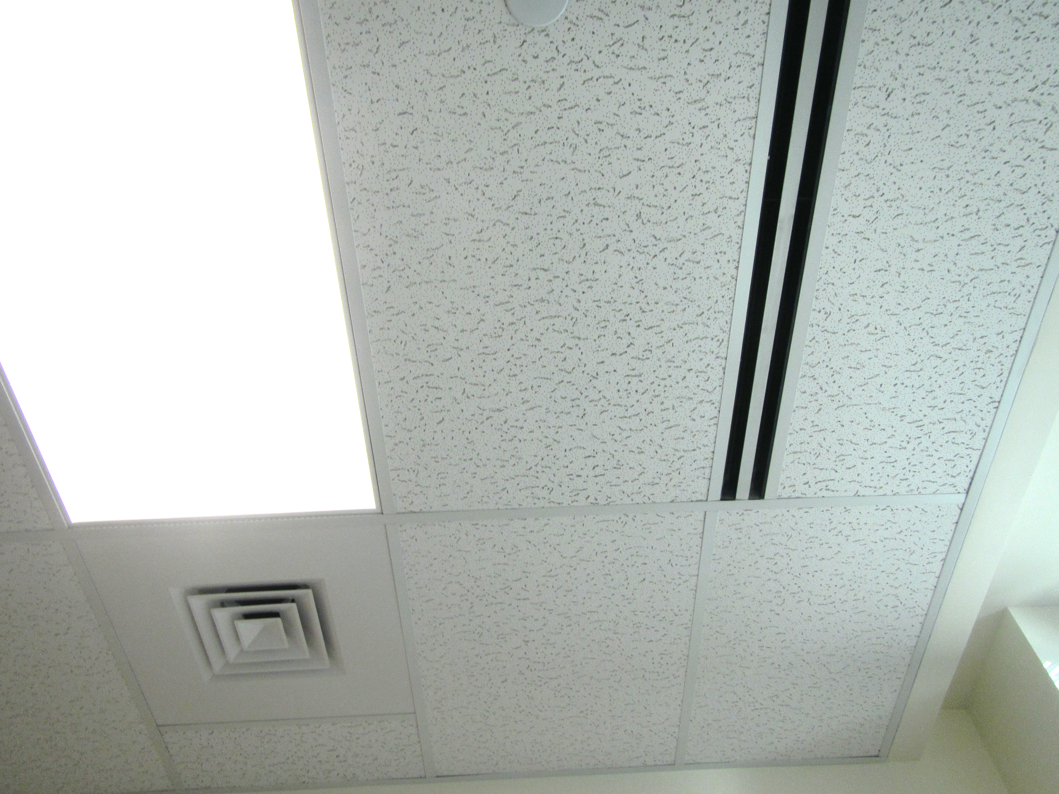
Supply vents
Picture 2
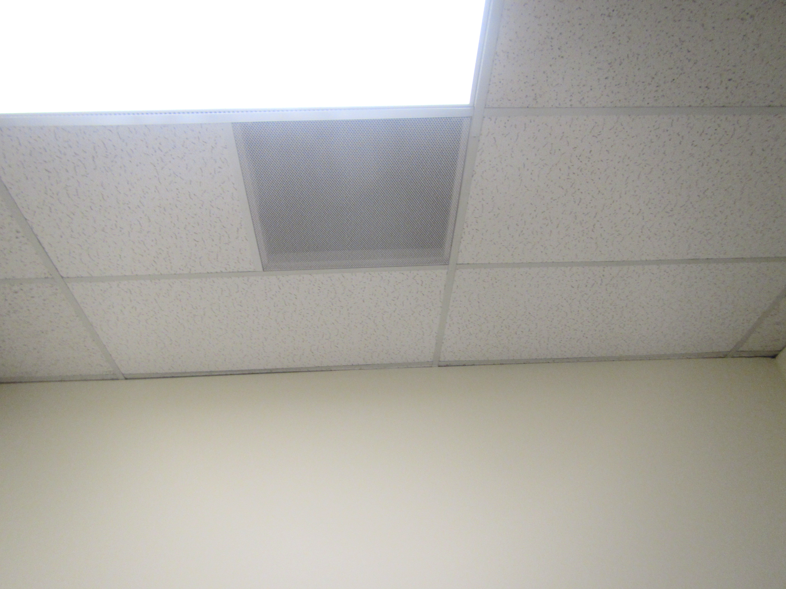
Return vent
Picture 3
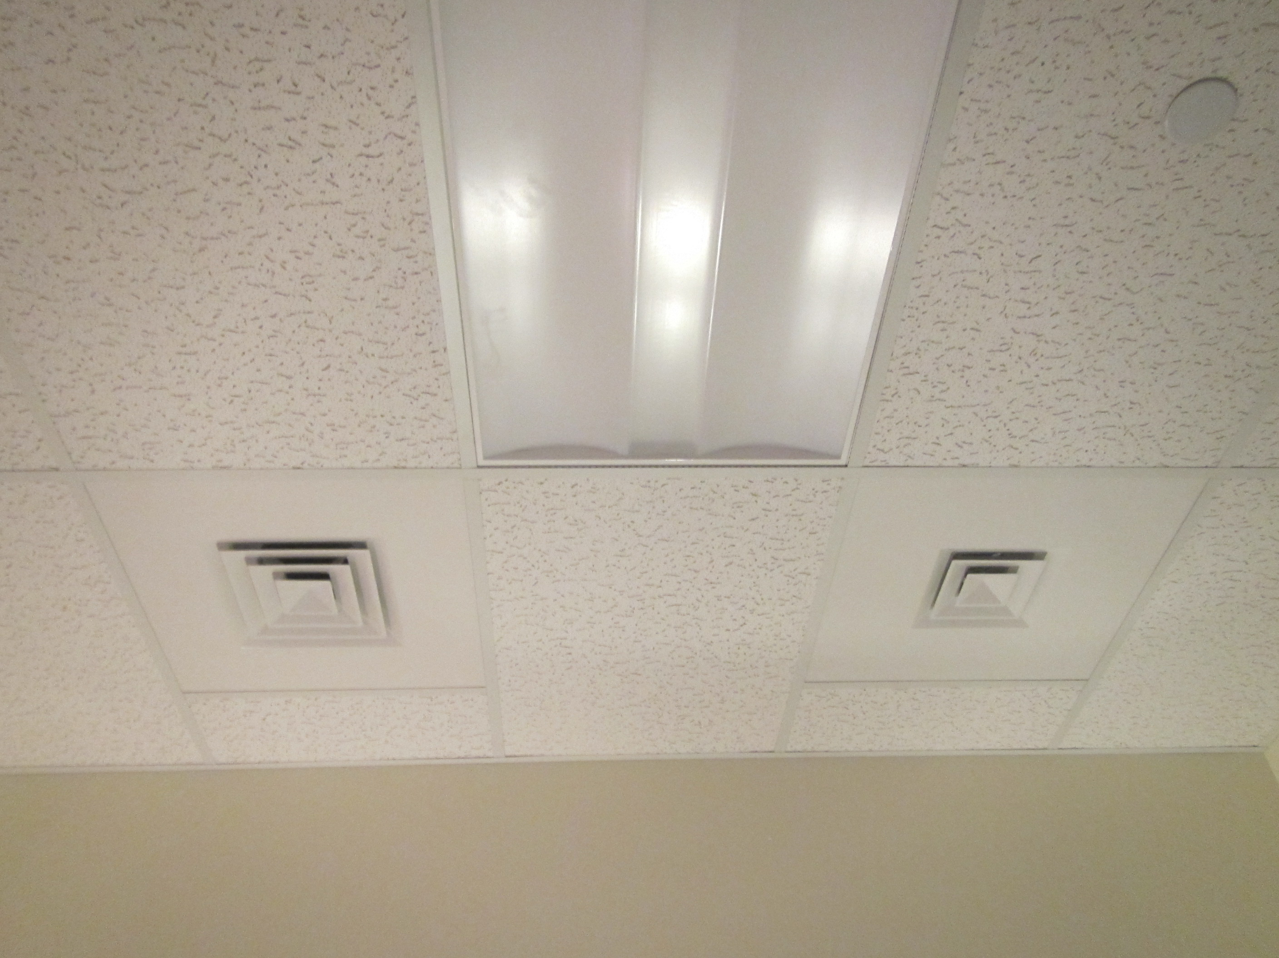
Supply louver on return vent
Picture 4
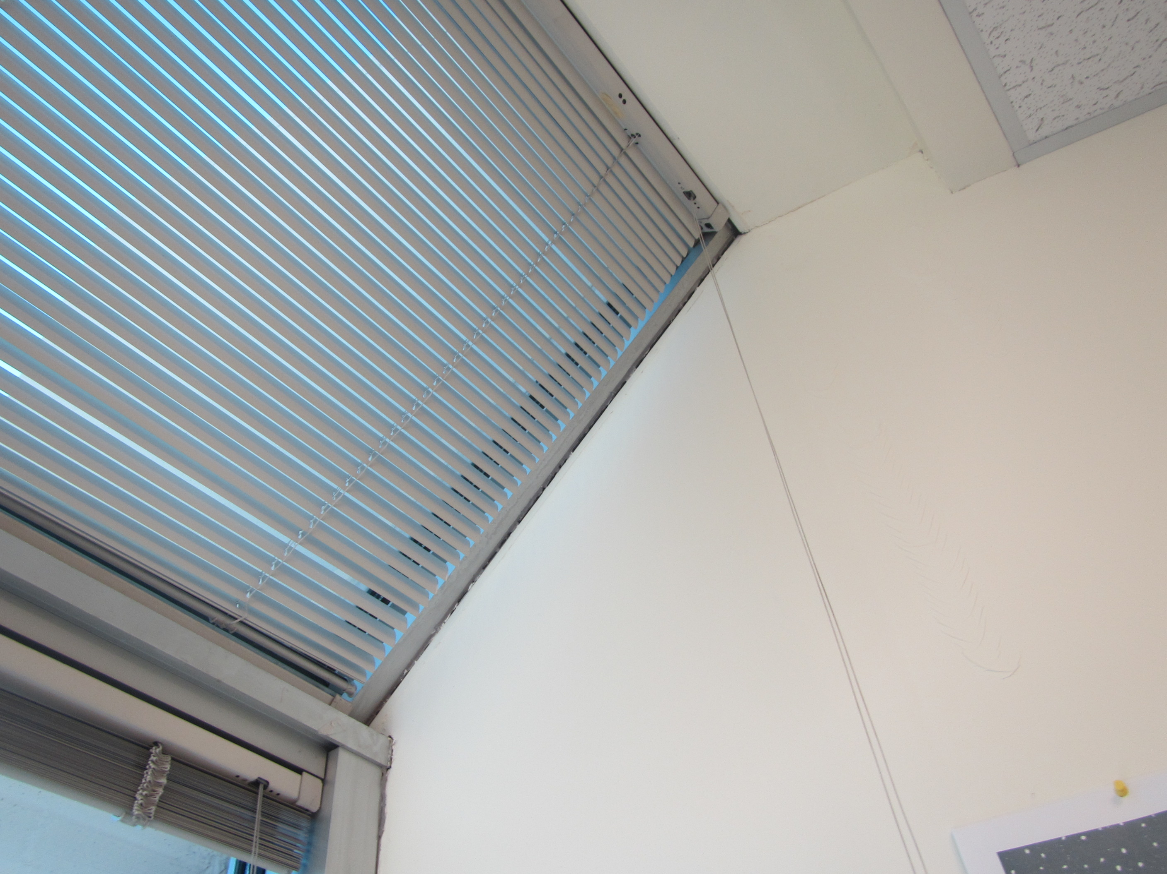
Damaged/failing caulking around window system
Picture 5
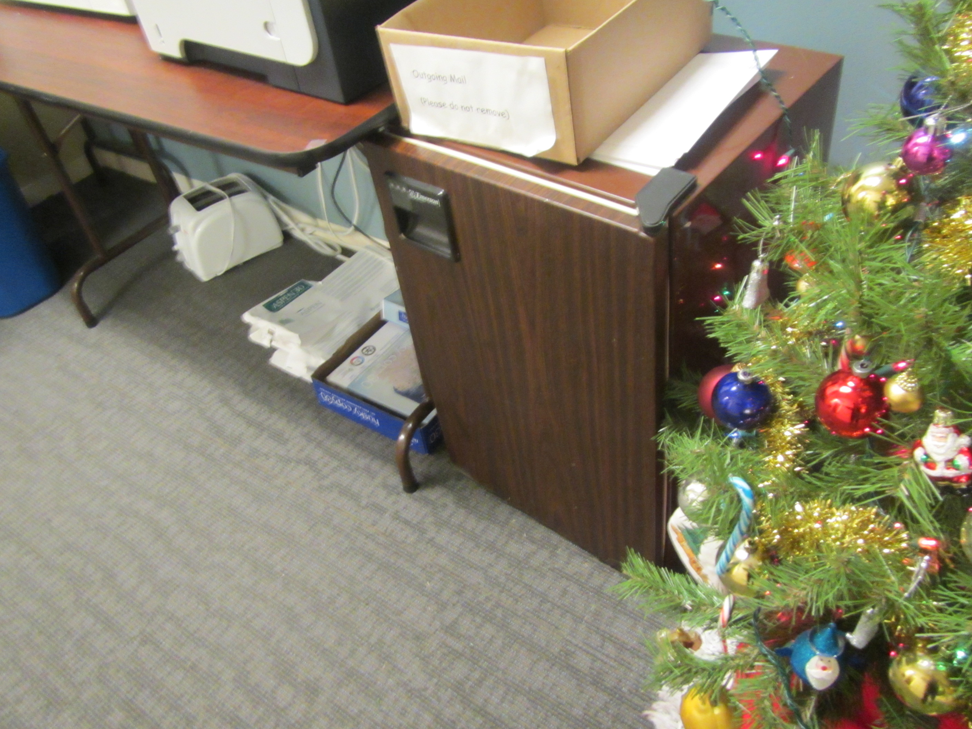
Small refrigerator on carpet
Picture 6
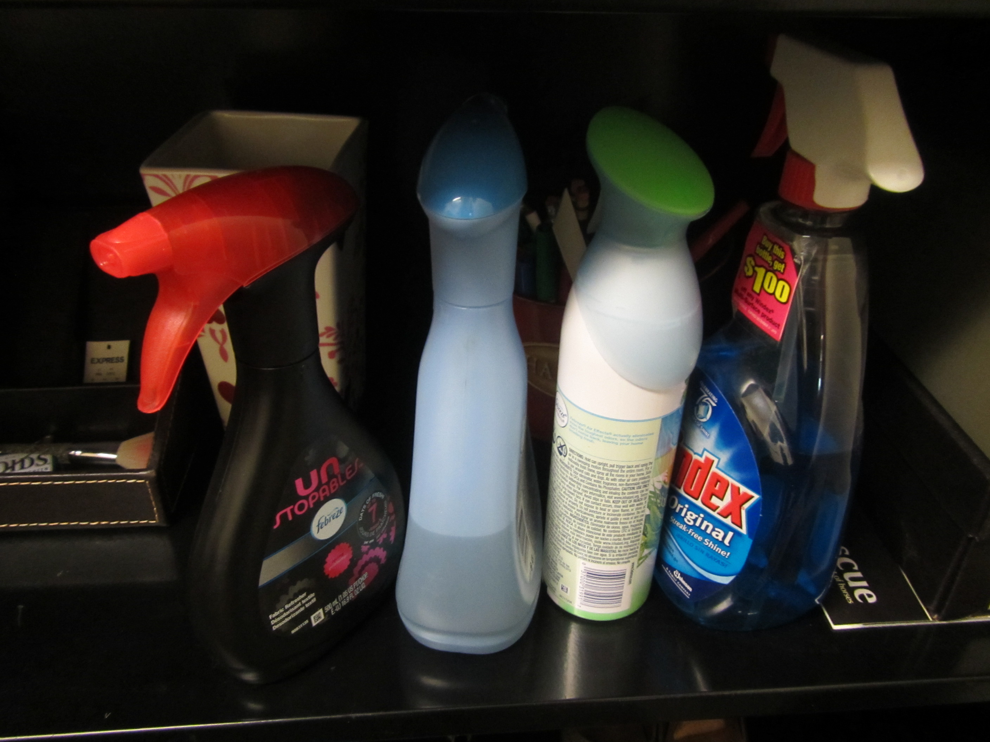
Cleaning products and air deodorizers
Picture 7
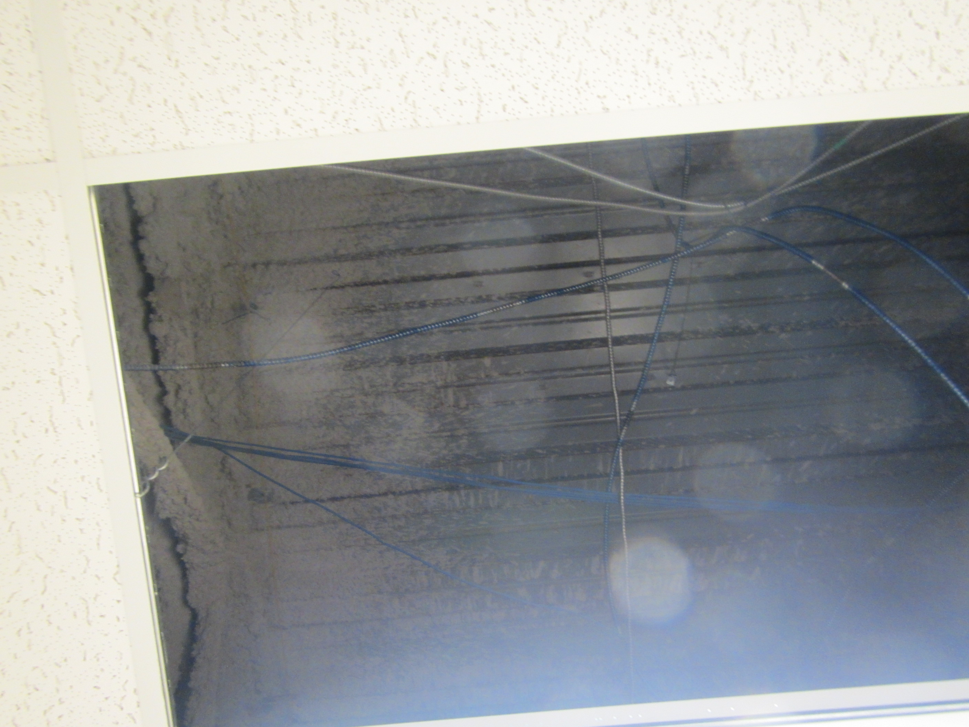
Missing ceiling tile, note dust/debris in plenum space
Picture 8
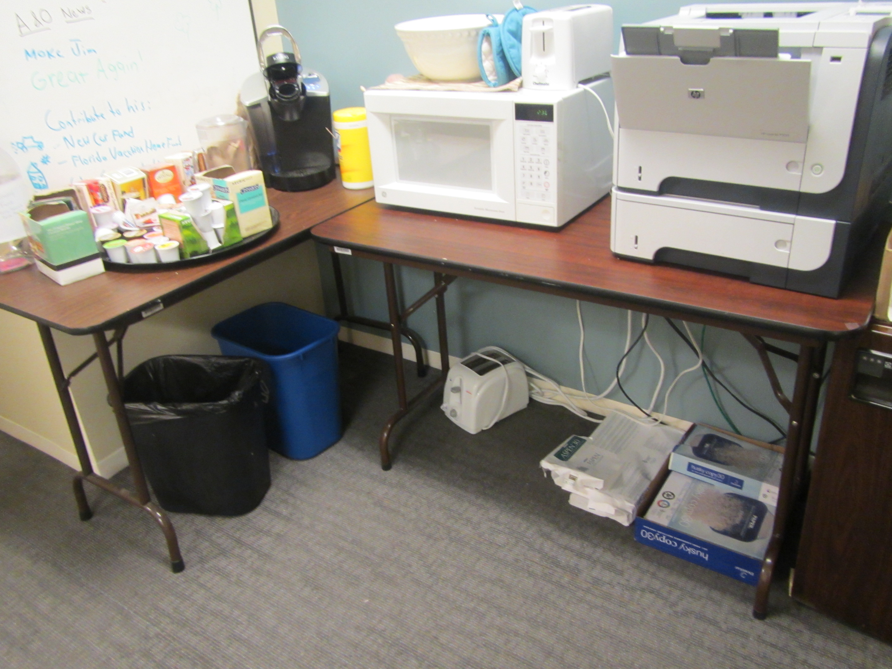
Food appliances and food in common area
Location | Carbon  Dioxide  (ppm) | Carbon Monoxide  (ppm) | Temp  (°F) | Relative  Humidity  (%) | PM2.5  (µg/m3) | Occupants  in Room | Windows  Openable | Ventilation |  | Remarks
 |  |  |  |  |  |  |  | Supply | Exhaust
Background (outdoors) | 344 | ND | 45 | 25 | 10
Records room | 570 | ND | 72 | 23 | 3 | 0 | N | Y | Y | MT, 1 WD-CT
Copy area |  |  |  |  |  |  |  |  |  | Copier below diffuser
Cubicles (Fuller/Aghaanari) | 572 | ND | 74 | 23 | 4 | 3 | N | Y | Y
10-104 | 771 | ND | 74 | 24 | 4 | 0 | N | Y | Y | DO, energy management system in cooling mode
10-106 | 545 | ND | 74 | 22 | 4 | 0 | N | Y | Y | DO
10-107 | 560 | ND | 74 | 23 | 4 | 0 | N | Y | Y | Electric kettle, storage of soda cans
10-108 | 612 | ND | 74 | 23 | 4 | 1 | N | Y | Y | DO
10-109 | 584 | ND | 74 | 23 | 4 | 2 | N | Y | Y | DO, HS
10-115 | 574 | ND | 74 | 23 | 4 | 0 | N | Y | Y | DO
10-116 | 540 | ND | 74 | 22 | 4 | 0 | N | Y | Y | Candles, DO
10-117 | 517 | ND | 74 | 22 | 4 | 0 | N | Y | Y | PF
10-118 | 518 | ND | 74 | 22 | 3 | 0 | N | Y | Y | PF
10-120 | 590 | ND | 74 | 24 | 5 | 1 | N | Y | Y | DO
10-121 | 669 | ND | 73 | 23 | 4 | 0 | N | Y | Y | Candles, DO
10-122 | 598 | ND | 73 | 24 | 4 | 0 | N | Y | Y
10-123 | 600 | ND | 73 | 24 | 4 | 0 | N | Y | Y | DEM
10-125 | 523 | ND | 73 | 24 | 5 | 1 | N | Y | Y | DEM, plants, DO
10-126 | 593 | ND | 73 | 24 | 5 | 1 | N | Y | Y | DO
10-127 | 556 | ND | 74 | 22 | 4 | 0 | N | Y | Y | DO
10-129 | 507 | ND | 75 | 21 | 4 | 0 | N | Y | Y | DO, DEM, PF
10-131 | 535 | ND | 75 | 22 | 5 | 1 | N | Y | Y | PF, HS
10-132 | 579 | ND | 74 | 22 | 5 | 0 | N | Y | Y | Plants, food/storage
10-133 | 531 | ND | 74 | 23 | 4 | 0 | N | Y | Y | AD/perfume, plants, fridge/carpet, DO
10-134 | 546 | ND | 74 | 23 | 5 | 0 | N | Y | Y
10-135 | 538 | ND | 74 | 23 | 4 | 0 | N | Y | Y | DO, CPs, AD
10-136 | 603 | ND | 74 | 23 | 4 | 1 | N | Y | Y | DO, plants
10-137 | 624 | ND | 74 | 24 | 4 | 0 | N | Y | Y | DO
10-138 | 556 | ND | 75 | 22 | 4 | 0 | N | Y | Y | DO, items
10-139 | 575 | ND | 74 | 22 | 4 | 1 | N | Y | Y | DO, DEM
10-140 | 560 | ND | 75 | 22 | 4 | 1 | N | Y | Y | DO
10-141 | 560 | ND | 75 | 22 | 4 | 0 | N | Y | Y | DEM, HS, DO
10-142 | 512 | ND | 76 | 20 | 4 | 0 | N | Y | Y | Plants on carpet, items, DO
10-143 | 516 | ND | 75 | 20 | 4 | 0 | N | Y | Y | Items
10-144 | 598 | ND | 75 | 22 | 4 | 0 | N | Y | Y | DO, DEM
10-145 | 629 | ND | 74 | 24 | 4 | 0 | N | Y | Y | Plants, candle
10-146 | 512 | ND | 75 | 21 | 4 | 0 | N | Y | Y | Plants, space heater
10-147 | 572 | ND | 75 | 22 | 4 | 1 | N | Y | Y | DO, items
10-150 | 546 | ND | 74 | 21 | 4 | 0 | N | Y | Y
10-152 | 528 | ND | 75 | 21 | 4 | 0 | N | Y | Y | DO, plants
10-153 | 474 | ND | 75 | 21 | 4 | 0 | N | Y | Y | DO
10-156 | 491 | ND | 75 | 21 | 4 | 0 | N | Y | Y | Plants, DO
10-157 | 512 | ND | 73 | 22 | 5 | 0 | N | Y | Y | CPs, coffee, DO
10-158 (Conference C) | 734 | ND | 75 | 24 | 4 | 5 | N | Y | Y | DO
10-160 | 508 | ND | 73 | 22 | 4 | 1 | N | Y | Y | DO, scented candle
10-161 | 518 | ND | 72 | 22 | 4 | 1 | N | Y | Y | DO
10-162 | 510 | ND | 73 | 22 | 4 | 1 | N | Y | Y | DO
10-163 | 492 | ND | 73 | 22 | 4 | 1 | N | Y | Y | DO
10-164 | 518 | ND | 73 | 21 | 4 | 1 | N | Y | Y | Plants
10-166 | 566 | ND | 74 | 22 | 4 | 1 | N | Y | Y | CPs, space heater, DO
10-167 | 579 | ND | 73 | 23 | 3 | 1 | N | Y | Y | HS
10-168 | 650 | ND | 73 | 23 | 3 | 2 | N | Y | Y | CPs, HS, plants, DO
10-169 | 651 | ND | 73 | 22 | 3 | 0 | N | Y | Y | DO
10-170 | 960 | ND | 74 | 23 | 4 | 0 | N | Y | Y | CPs, DO
10-171 | 651 | ND | 73 | 24 | 4 | 0 | N | Y | Y | Space heater, AD, plants, DO
10-172 | 562 | ND | 73 | 24 | 4 | 0 | N | Y | Y | DO
10-173 | 670 | ND | 74 | 22 | 4 | 0 | N | Y | Y | AP, DP, space heater
10-174 | 645 | ND | 73 | 22 | 4 | 0 | N | Y | Y | DO
10-175 | 631 | ND | 73 | 24 | 3 | 1 | N | Y | Y | DO, AT
10-176 | 647 | ND | 73 | 23 | 3 | 0 | N | Y | Y
10-177 | 502 | ND | 73 | 23 | 3 | 0 | N | Y | Y | HS
10-178 | 529 | ND | 73 | 23 | 3 | 0 | N | Y | Y | HS, DO
10-180 | 580 | ND | 74 | 23 | 4 | 1 | N | Y | Y | HS, AD
10-181 | 598 | ND | 74 | 23 | 3 | 0 | N | Y | Y | HS
10-182 | 537 | ND | 74 | 22 | 3 | 0 | N | Y | Y | DO, files on floor
10-183 | 471 | ND | 75 | 21 | 4 | 0 | N | Y | Y | Space heater, breaches around window frame, DO, HS
10-184 | 509 | ND | 75 | 21 | 3 | 0 | N | Y | Y | Space heater, spray/can of air,
10-185 | 451 | ND | 74 | 21 | 3 | 0 | N | Y | Y | DO, plants, items/files
10-186 | 477 | ND | 75 | 21 | 4 | 0 | N | Y | Y | PF, food storage (empty soda cans), plants, HS, DO
10-188 | 558 | ND | 73 | 23 | 4 | 2 | N | Y | Y | DO, items
10-189 | 485 | ND | 75 | 22 | 4 | 0 | N | Y | Y | PF
10-190 (kitchen) | 530 | ND | 75 | 21 | 4 | 0 | N | Y | Y  dedicated

