**INDOOR AIR QUALITY ASSESSMENT**

**Committee for Public Council Services**

**144 Main Street**

**Brockton, Massachusetts**

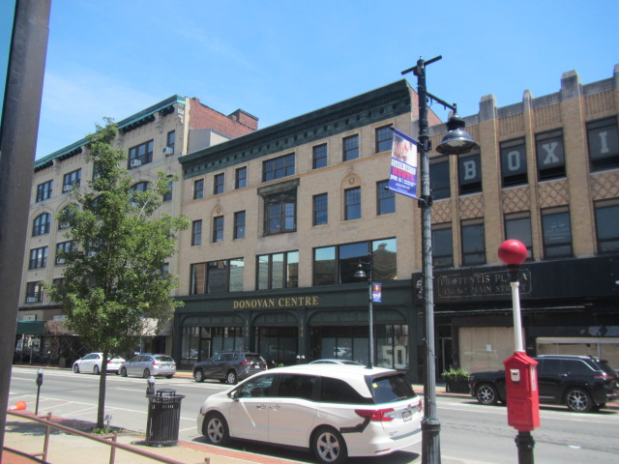

Prepared by:

Massachusetts Department of Public Health

Bureau of Climate and Environmental Health

Indoor Air Quality Program

August 2024

# BACKGROUND

|  |  |
| --- | --- |
| Building: | Committee for Public Council Services (CPCS) |
| Address: | 144 Main Street, 3rd and 4th floor, Brockton |
| Assessment Requested by: | Jamie Merrill Blood, Regional Planner, Senior Project Manager  Division of Capital Asset Management & Maintenance (DCAMM) |
| Reason for Request: | Post-occupancy indoor air quality (IAQ) assessment. The space was recently renovated as part of the lease-renewal process. |
| Date of Assessment: | July 16, 2024 |
| Massachusetts Department of Public Health/Bureau of Climate and Environmental Health (MDPH/BCEH) Staff Conducting Assessment: | Cory Holmes, Assistant Director, IAQ Program |
| Building Description: | The CPCS office is located on the 3rd and 4th floors of an office building in downtown Brockton known as the Donovan Centre. The CPCS also uses a conference room on the 1st floor and has occupied this space since the late 1980’s. Interior renovations included new paint, and carpeting. |
| Windows: | Windows are not openable |

# METHODS

Please refer to the IAQ Manual for methods, sampling procedures, and interpretation of results (MDPH, 2015).

# RESULTS AND DISCUSSION

The following is a summary of indoor air testing results (Table 1).

* ***Carbon dioxide*** measurements were below the MDPH guideline of 800 parts per million (ppm) in all areas tested indicating adequate air exchange at the time of assessment. However, it should be noted that the space was minimally occupied at the time of testing due to hybrid work conditions and CPCS staff working off-site. Carbon dioxide levels would be expected to be higher with increased occupancy.
* ***Temperature*** was within or close to the recommended range of 70°F to 78°F in all areas.
* ***Relative humidity*** was within the recommended range of 40% to 60% in all areas examined.
* ***Carbon monoxide*** levels were non-detectable (ND) in all indoor areas tested.
* ***Fine particulate matter (PM2.5)*** concentrations were below the National Ambient Air Quality Standard (NAAQS) level of 35 μg/m3 in all areas tested.
* ***Total Volatile Organic Compounds***were ND in all areas tested.

## Ventilation

A heating, ventilating, and air conditioning (HVAC) system has several functions. First, it provides heating and, if equipped, cooling. Second, it is a source of fresh air. Finally, an HVAC system will dilute and remove normally occurring indoor environmental pollutants by not only introducing fresh air, but also filtering the airstream and ejecting stale air to the outdoors via exhaust ventilation. Even if an HVAC system is operating as designed, point sources of respiratory irritation may exist and affect symptoms in sensitive individuals.

HVAC functions for the CPCS areas are computer controlled at a central location. Fresh air is provided by air handling units (AHUs) on the roof (Picture 1). Air from the AHUs is filtered, heated/cooled, and delivered to rooms via ducted supply vents (Picture 2). Air is drawn through passive exhaust grills into the ceiling plenum or spaces around light fixtures (Pictures 2 and 3) and returned to the AHUs. AHUs appeared to be in good working order and are reported to range from 1 to 6 years old, well within their service life of 15-20 years, assuming routine maintenance of the equipment (ASHRAE, 1991).

The MDPH IAQ program recommends that filters be changed 2-4 times a year (or in accordance with the manufactures recommendations) and be at least minimum efficiency reporting value (MERV) 8, or higher if the equipment can handle them without a degradation in airflow, as these are adequate to filter out pollen, mold, and similar particulates (ASHRAE, 2012). AHUs at the CPCS were equipped with filters with a rating of MERV 9 (Picture 4) that are reportedly changed at least twice a year under a preventative maintenance program with an HVAC contractor.

It is recommended that HVAC systems be re-balanced every five years to ensure adequate air systems function (SMACNA, 1994). The systems were last balanced in June of 2024.

## Microbial/Moisture Concerns

Hot humid summers are becoming more frequent due to climate change. Massachusetts has experienced hot, humid, and rainy summers in 2018, 2021, and 2023. July of 2021 was the wettest ever recorded in Massachusetts, and the three-month period from June through August, known as the meteorological summer, was the fourth wettest on record, according to the National Oceanic and Atmospheric Administration’s (NOAA) Centers for Environmental Information (NOAA, 2021). The summer of 2023 was also hot, and wet, being measured as the second rainiest on record (WBUR, 2023).

Water-damaged ceiling tiles were noted in a few areas, specifically in office 406 and in the main corridor on the 4th floor. MDPH IAQ staff removed ceiling tiles in these areas and found condensation on metal ductwork directly above (Pictures 5 and 6). At the time of the assessment this issue was pointed out to building maintenance personnel.

If occupants report uncomfortable humidity, or if signs of condensation, such as droplets of water on supply vents occur, HVAC settings should be adjusted. Helpful adjustments to reduce humidity include temporarily reducing the amount of fresh air into the system during very humid weather, or increasing the setpoint temperature a few degrees, which will reduce relative humidity. If adjusting the HVAC settings does not work, the ductwork may need to be insulated or some other ventilation-engineering solution may be required.

Water pooling and plant debris were noted on the roof (Pictures 7 and 8). These conditions can compromise the roof membrane and lead to leaks and water damage to building materials. It was reported by building maintenance personnel that the capital plans were being developed to replace the roof in the next year.

A few windows were noted to have condensation between windowpanes, which indicates the seal has been compromised (Table 1, Picture 9). One window in room 413 had a cloth inserted at the top corner, presumably to stop a leak (Picture 10). Please note, the cloth is a porous material that can grow mold if wetted repeatedly.

Water dispensers were observed on carpet in several areas (Picture 11). Spills or leaks from these appliances can damage carpeting and lead to microbial growth and odors.

## Other IAQ Concerns

Testing was conducted for total volatile organic compounds (TVOCs). All measurements were non-detect (ND). An examination was conducted for products that may be a source of VOCs in indoor air. Products such as dry erase markers and hand sanitizers were noted. VOCs from these products can build up and lead to irritation of the mucous membranes or irritating odors.

In several areas of the CPCS, efflorescence on interior brickwork was noted (Table 1, Picture 12), which is made up of minerals from the brick and mortar that have dissolved and then deposited on the interior surface of the wall. While efflorescence is not mold, it indicates water penetration and may eventually result in a weakened building envelope. Damage to the exterior of the building can eventually lead to water infiltration inside. According to building maintenance personnel, repointing of exterior brickwork is ongoing with a waterproofing contractor. It is also important to note that no elevated levels of PM2.5 were measured in the breathing zone, indicating that this debris consists of larger particles that are not suspended in the air (i.e., an inhalation exposure) therefore this should be considered an ongoing cleaning issue.

Air purifiers were noted in a number of areas (Picture 13; Table 1). These appear to be units which use high efficiency particulate arrestance (HEPA) filters, and, in some cases, an *ionization* function. HEPA filtration units are a good choice for use in occupied areas. Air purifiers that may produce ozone should not be used (US EPA, 2003). All air purifiers should be cleaned and maintained in accordance with manufacturer’s instructions.

Finally, most areas of the office are carpeted. Carpets should be cleaned regularly in accordance with Institute of Inspection, Cleaning and Restoration Certification (IICRC) recommendations (IICRC, 2012).

# CONCLUSIONS/RECOMMENDATIONS

In view of the findings at the time of the visit, the following short-term and long-term recommendations are made:

## Short-term Recommendations

### Ventilation recommendations

1. Work with facility staff to address temperature/comfort issues if they occur and make appropriate adjustments to the thermostat settings.
2. Continue to ensure filters are replaced on HVAC units at least twice a year. Use filters with a minimum efficiency rating value (MERV) of 8 or better.
3. It is recommended that HVAC systems be re-balanced every five years to ensure adequate air systems function (SMACNA, 1994).

### Water damage recommendations

1. HVAC settings should be adjusted to reduce condensation and water damage to ceiling tiles. Helpful adjustments to reduce humidity may include:
   1. temporarily reducing the amount of fresh air into the system during very humid weather,
   2. adjusting the setpoint temperature up a few degrees, which will reduce relative humidity, or
   3. if adjusting the HVAC settings does not work, the ductwork may need to be insulated or some other ventilation-engineering solution may be required.
2. Replace water-damaged ceiling tiles. Repeated water damage to ceiling tiles indicates leaks from the roof or plumbing/HVAC system which should be repaired.
3. Examine window in room 413 (Picture 10) for leaks and make repairs as necessary.
4. Consider moving water dispensers to areas without carpeting or use a waterproof mat underneath.
5. Continue with plans for repointing exterior brickwork.
6. Remove plant growth from pooling water areas on the roof.

### Other recommendations

1. Use VOC-containing products in areas with good ventilation and keep tightly closed when not in use. Avoid products with strong scents and avoid mixing incompatible products.
2. Clean carpeting in accordance with IICRC recommendations (IICRC, 2012); annually (or semi-annually in soiled/high traffic areas).
3. Clean efflorescence from walls, floors and flat surfaces with a HEPA-equipped vacuum cleaner or wet wiping method as needed.
4. Clean and maintain air purifiers in accordance with manufacturer’s instructions. Avoid the use of air purifiers that may produce ozone.
5. Refer to resource manual and other related IAQ documents located on the MDPH’s website for further building-wide evaluations and advice on maintaining public buildings. These documents are available at: <http://mass.gov/dph/iaq>.

**Long-term Recommendations**

1. Continue with plans for roof replacement. Ensure plans include proper pitching towards roof drains to prevent water pooling.
2. Replace windows with damaged seals.

# REFERENCES

ASHRAE. 1991. ASHRAE Applications Handbook, Chapter 33 “Owning and Operating Costs”. American Society of Heating, Refrigeration and Air Conditioning Engineers, Atlanta, GA.

ASHRAE. 2012. American Society of Heating, Refrigeration and Air Conditioning Engineers (ASHRAE) Standard 52.2-2012 -- Method of Testing General Ventilation Air-Cleaning Devices for Removal Efficiency by Particle Size (ANSI Approved).

IICRC. 2012. Institute of Inspection, Cleaning and Restoration Certification. Carpet Cleaning: FAQ.

MDPH. 2015. Massachusetts Department of Public Health. Indoor Air Quality Manual: Chapters I-III. Available at: <https://www.mass.gov/lists/indoor-air-quality-manual-and-appendices>.

NOAA. 2021. Summer 2021 neck and neck with Dust Bowl summer for hottest on record. National Oceanic and Atmospheric Administration, 1401 Constitution Avenue NW, Room 5128, Washington, DC 20230 <https://www.noaa.gov/news/summer-2021-neck-and-neck-with-dust-bowl-summer-for-hottest-on-record>

SMACNA. 1994. HVAC Systems Commissioning Manual. 1st ed. Sheet Metal and Air Conditioning Contractors’ National Association, Inc., Chantilly, VA.

US EPA. 2003. “Ozone Generators that are Sold as Air Cleaners: An Assessment of Effectiveness and Health Consequences”. United States Environmental Protection Agency, Office of Air and Radiation, Indoor Environments Division, Washington, DC. Last updated September, 2018. <https://www.epa.gov/indoor-air-quality-iaq/ozone-generators-are-sold-air-cleaners>

WBUR. 2023. “It's been a summer of rain and flooding misery in Mass.” WBUR local news. September 12, 2023. <https://www.wbur.org/news/2023/09/12/summer-flooding-rain-massachusetts>.

**Picture 1**

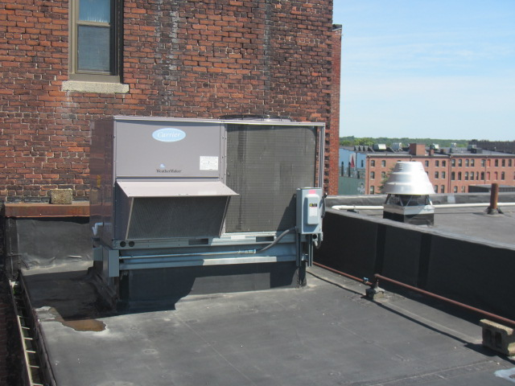

**Rooftop AHU**

**Picture 2**

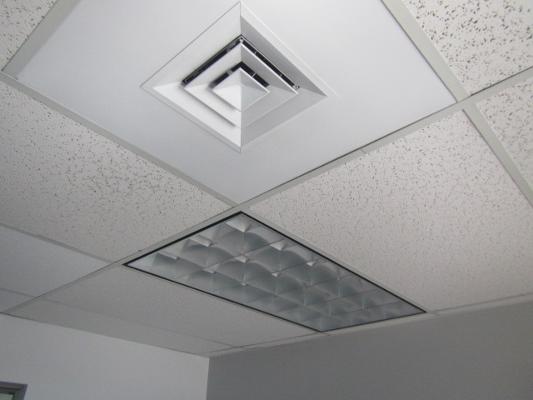

**Multi-directional supply diffuser and light fixture with space around it (for return air into plenum)**

**Picture 3**

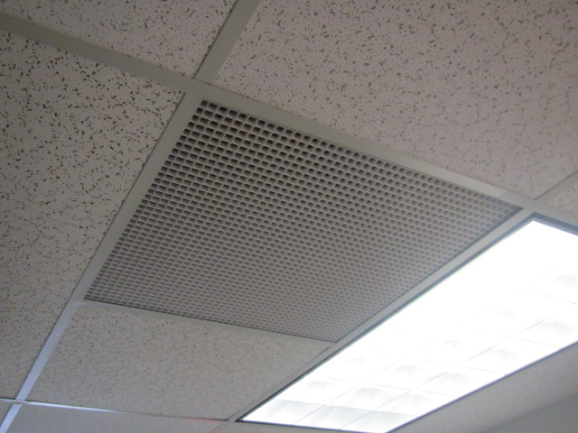

**Return vent into ceiling plenum exhaust**

**Picture 4**

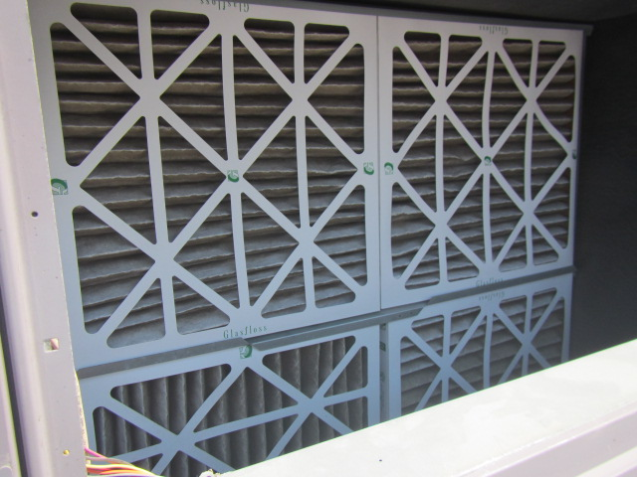

**Pleated MERV 9 filters in rooftop AHU**

**Picture 5**

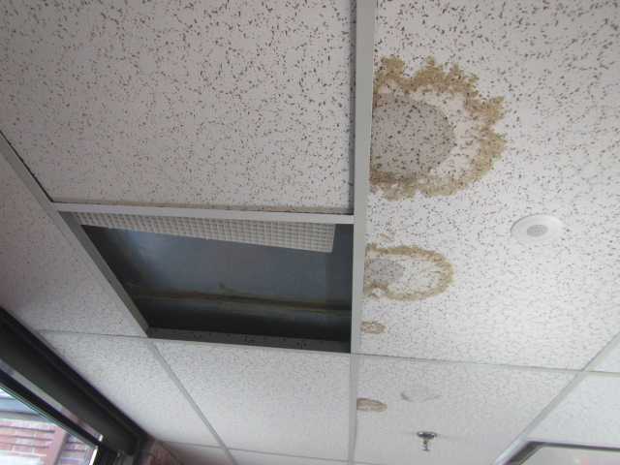

**Water-damaged/wet ceiling tiles in 4th floor corridor from condensation on metal ductwork**

**Picture 6**

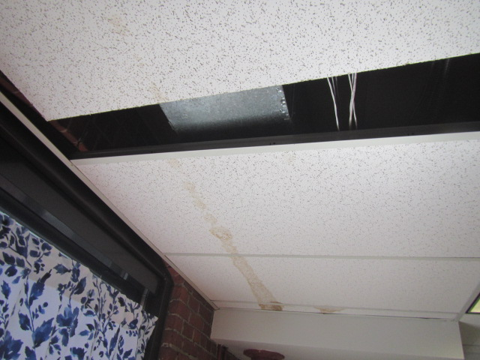

**Water-damaged/wet ceiling tiles in room 406 from condensation on metal ductwork**

**Picture 7**

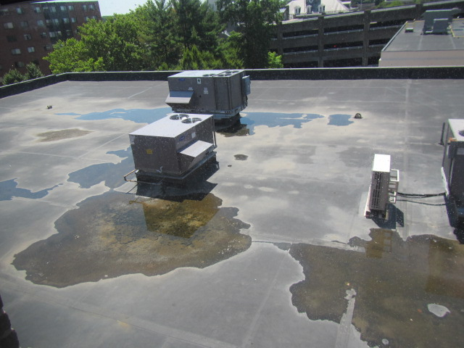

**Water pooling on roof**

**Picture 8**

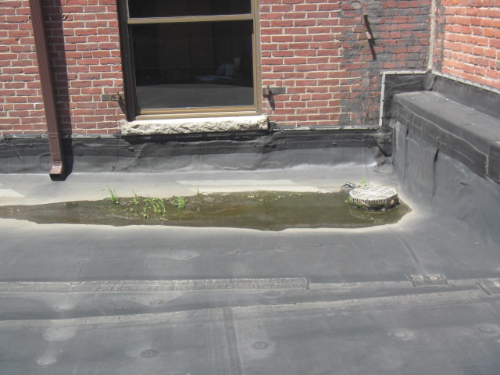

**Water pooling and plant/debris on roof**

**Picture 9**

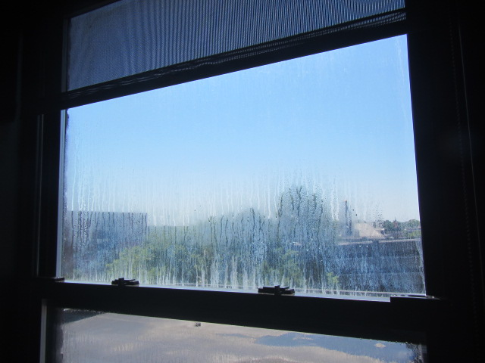

**Condensation between windowpanes indicating seal has failed**

**Picture 10**

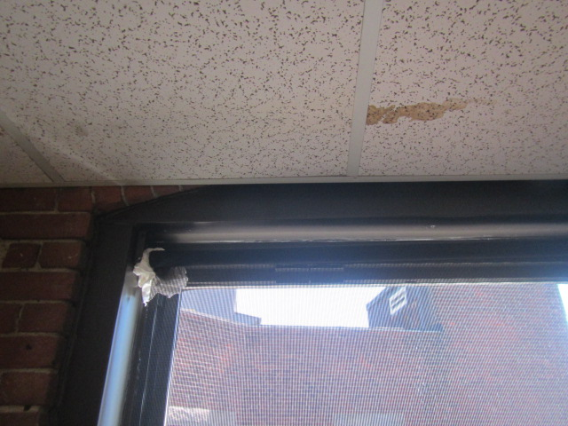

**Cloth inserted in top corner of window**

**Picture 11**

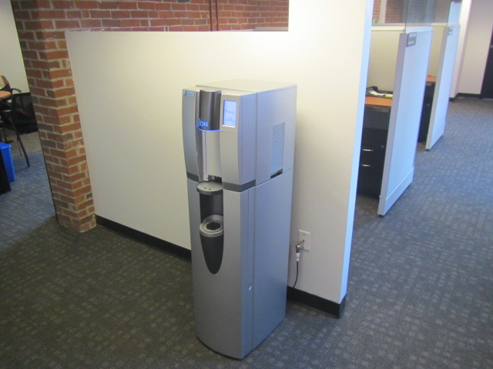

**Water dispenser on carpet**

**Picture 12**

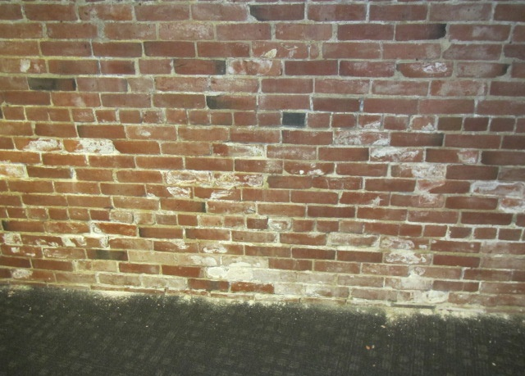

**Efflorescence (mineral deposits) on interior brickwork and on carpet at base of wall**

**Picture 13**

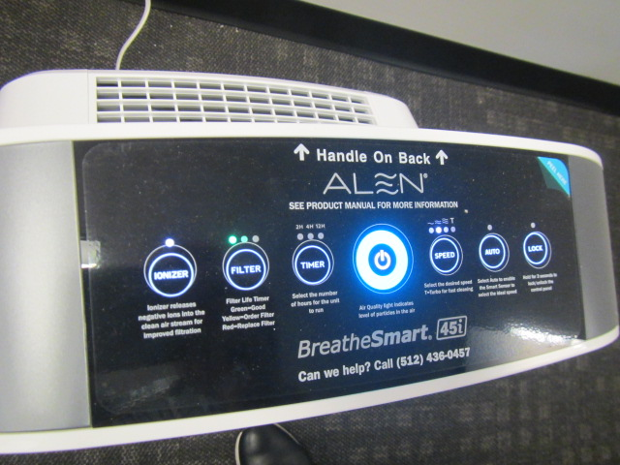

**Portable air purifier with *Ionizing* feature**

| **Location** | **Carbon**  **Dioxide**  **(ppm)** | **Carbon Monoxide**  **(ppm)** | **Temp**  **(°F)** | **Relative**  **Humidity**  **(%)** | **PM2.5**  **(µg/m3)** | **TVOC**  **(ppm)** | **Occupants**  **in Room** | **Windows**  **Openable** | **Ventilation** | | **Remarks** |
| --- | --- | --- | --- | --- | --- | --- | --- | --- | --- | --- | --- |
| **Supply** | **Exhaust** |
| Background | 459 | ND-1 | 89 | 53 | 6 | ND |  |  |  |  | Clear, sunny, hot, and breezy |
| 401 | 648 | ND | 72 | 53 | 1 | ND |  | N | Y | Y |  |
| Reception: cubes 401-402 | 620 | ND | 72 | 52 | 1 | ND |  | N | Y | Y |  |
| 4th Floor Connector Hallway |  |  |  |  |  |  |  |  |  |  | WD CTs-condensation from metal ductwork |
| 403 Open Cube | 636 | ND | 72 | 51 | 1 | ND |  | N | N | Y |  |
| 403 | 614 | ND | 73 | 52 | 4 | ND |  | N | Y | Y |  |
| 404 | 687 | ND | 73 | 50 | 1 | ND | 1 | N | Y | Y |  |
| 405 | 585 | ND | 73 | 52 | 1 | ND |  | N | Y | Y |  |
| 406 | 644 | ND | 73 | 52 | 1 | ND |  | N | Y | Y | 3 WD CT-condensation from metal ductwork |
| 407 | 697 | ND | 73 | 53 | 2 | ND |  | N | Y | Y | 1 WD CT |
| 408 | 658 | ND | 74 | 50 | 1 | ND | 1 | N | Y | Y |  |
| 409 | 646 | ND | 74 | 49 | 2 | ND |  | N | Y | Y | Efflorescence |
| 411 | 619 | ND | 74 | 49 | 2 | ND |  | N | Y | Y | Efflorescence, room not occupied |
| 412 | 617 | ND | 75 | 46 | 1 | ND |  | N | Y | Y | Efflorescence-carpet, surfaces |
| 413 | 602 | ND | 74 | 48 | 1 | ND |  | N | Y | Y | 6 WD CT, cloth top corner of window (leak?) |
| File Storage | 614 | ND | 73 | 49 | 1 | ND |  | N | Y | Y |  |
| Storage | 672 | ND | 74 | 50 | 1 | ND |  | N | Y | Y | Efflorescence-deteriorating brick |
| Breakroom | 591 | ND | 72 | 51 | 1 | ND |  | N | Y | N | NC, 1 WD CT (light stain) |
| Breakroom Hallway |  |  |  |  |  |  |  |  |  |  | Water cooler on carpet |
| Conference Room | 613 | ND | 73 | 50 | 1 | ND |  | N | Y | Y |  |
| 415 | 609 | ND | 71 | 51 | 1 | ND |  | N | Y | Y | 1 WD CT around sprinkler head (historic), windowpane condensation-failed seal |
| 416 | 616 | ND | 71 | 51 | 1 | ND |  | N | Y | N |  |
| 418 | 639 | ND | 71 | 52 | 1 | ND |  | N | Y | N |  |
| 419 | 627 | ND | 71 | 53 | 1 | ND |  | N | Y | Y | Windowpane condensation-failed seal |
| 420 | 613 | ND | 71 | 52 | 1 | ND |  | N | Y | Y |  |
| 421 | 629 | ND | 72 | 51 | 1 | ND |  | N | Y | Y |  |
| 422 | 609 | ND | 73 | 52 | 1 | ND |  | N | Y | Y |  |
| 301 | 651 | ND | 71 | 55 | 3 | ND |  | N | Y | Y |  |
| 301-302 Cubes | 607 | ND | 71 | 54 | 3 | ND |  | N | Y | Y |  |
| 303 | 607 | ND | 71 | 54 | 4 | ND |  | N | Y | Y | WD CT corner |
| 305 | 626 | ND | 70 | 56 | 2 | ND |  | N | Y | Y |  |
| 307 | 599 | ND | 70 | 52 | 2 | ND |  | N | Y | Y |  |
| 309 | 595 | ND | 69 | 54 | 3 | ND |  | N | Y | Y |  |
| 310 | 606 | ND | 70 | 55 | 2 | ND |  | N | Y | Y |  |
| 311 | 596 | ND | 70 | 54 | 1 | ND |  | N | Y | Y |  |
| 312 | 636 | ND | 69 | 55 | 2 | ND |  | N | Y | Y |  |
| 315 | 586 | ND | 69 | 56 | 3 | ND |  | N | Y | Y | Windowpane condensation-failed seal |
| 316 | 604 | ND | 69 | 54 | 3 | ND |  | N | Y | Y | Windowpane condensation-failed seal |
| 317 | 596 | ND | 69 | 54 | 3 | ND |  | N | Y | Y |  |
| 318 | 607 | ND | 70 | 55 | 1 | ND |  | N | Y | N |  |
| 320 | 608 | ND | 70 | 55 | 1 | ND |  | N | Y | N |  |
| Conference Room | 617 | ND | 70 | 55 | 1 | ND |  | N | Y | N |  |
| Breakroom | 615 | ND | 76 | 56 | 1 | ND |  | N | Y | N | NC |
| 322 | 605 | ND | 69 | 56 | 1 | ND |  | N | Y | N |  |
| 325 | 610 | ND | 69 | 55 | 2 | ND |  | N | Y | N |  |
| Storage | 598 | ND | 69 | 55 | 1 | ND |  | N | Y | N |  |
| 1st floor Conference Room | 593 | ND | 67 | 55 | 4 | ND |  | N | Y | Y |  |