INDOOR AIR QUALITY
POST-OCCUPANCY ASSESSMENT

Committee for Public Counsel Services
100 Laurel Street
East Bridgewater, MA

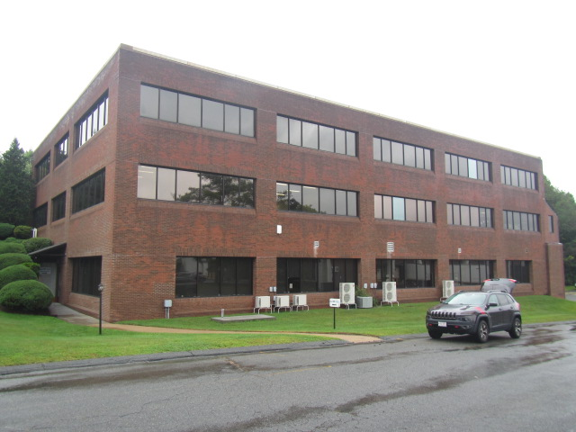

Prepared by:
Massachusetts Department of Public Health
Bureau of Climate and Environmental Health
Indoor Air Quality Program
September 2023

BACKGROUND
Building: | Committee for Public Counsel Services (CPC)
Address: | 100 Laurel Street, East Bridgewater, MA
Division of Capital Asset Management and Maintenance (DCAMM) Project Manager: | Jamie Merrill Blood
Reason for Request: | Post-occupancy assessment
Date of Assessment: | August 25, 2023
Massachusetts Department of Public Health/Bureau of Climate and Environmental Health (MDPH/BCEH) Staff Conducting Assessment: | Cory Holmes, Assistant Director, Indoor Air Quality (IAQ) Program
Building Description: | The CPC space consists of a large warehouse area used to store/ship IT/communications equipment. The remainder of the space is made up of office space and common areas located on the ground floor of a multi-story office building constructed in the 1980’s, with the front built into a hill. The building has a brick façade and a flat roof located in an industrial area on a side street in East Bridgewater. A full interior renovation was conducted prior to tenancy including heating, ventilation, and air conditioning (HVAC) systems.
Windows: | Not openable

METHODS
Please refer to the IAQ Manual for methods, sampling procedures, and interpretation of results (MDPH, 2015).

IAQ TESTING RESULTS
The following is a summary of indoor air testing results (Table 1).
- Carbon dioxide levels were below the MDPH guideline of 800 parts per million (ppm) in all areas assessed, however it should be noted that carbon dioxide levels would increase with occupancy.
- Temperature was within or very close to the recommended comfort range of 70°F to 78°F in all areas assessed.
- Relative humidity was above the recommended comfort range of 40% to 60% in all areas assessed, this is discussed further in the Microbial/Moisture Concerns section of this report.
- Carbon monoxide levels were non-detectable in all areas assessed.
- Fine particulate matter (PM2.5) concentrations measured were below the National Ambient Air Quality Standard (NAAQS) level of 35 micrograms per cubic meter (μg/m³) in all areas assessed.

Ventilation
Heating, ventilation, and air conditioning (HVAC) is provided by air-handling units (AHUs) located above the ceiling tile system, which draw in air from outside intakes on the exterior wall (Picture 1). Conditioned air is delivered to occupied areas via louvered supply vents and stale air is removed via return vents (Picture 2). The HVAC system is controlled by digital thermostats. Of note is that return vents in the main area outside of offices were drawing air, but no draw could be detected from return vents inside of offices (Pictures 3 and 4), it was not clear if this was by design. Typically, if return vents in common areas are to be used, offices doors are undercut to allow draw from the space.
Please note, temperature (heat) control issues were reported in rooms 103 & 104. Although these rooms have blinds to reduce solar glare, the balancing/airflow and temperature regulation should be evaluated by the HVAC vendor and discussed with building management and occupants to improve comfort. Also, the main doors to the warehouse were wide open to the main office area (Picture 5). These doors should be shut to better control temperature within the space.

Microbial/Moisture Concerns
No water-damaged materials were observed during the assessment. However, relative humidity measurements exceeded the MDPH comfort guidelines of 40 to 60% and were reflective of outside conditions (73%). These elevated relative humidity levels can indicate the HVAC units may be drawing to much outside air or may not be operating at proper capacity to reduce moisture in indoor air and should be adjusted. Please note, that even in the absence of liquid water, high humidity above 70% for an extended period of time can lead to water damage and mold growth in susceptible materials (ASHRAE, 2019), as well as lead to thermal comfort complaints.
Loose exterior strip-caulking was observed around the window in room 107 (Picture 6). No leaks or water damage were noted but should be monitored and repaired if needed.

Other IAQ Evaluations
The breakroom contains a restroom, which has a local exhaust vent to remove excess moisture and odors. DPH IAQ staff checked the vent and it had not been ducted to the outside at the time of the post-occ (Picture 7).
Missing ceiling tiles, an open duct, and spaces/holes around utilities were observed in the warehouse (Pictures 8 and 9). These breaches can provide a pathway for drafts, odors, and particulates from the ceiling plenum and wall cavities into occupied areas.

CONCLUSIONS/RECOMMENDATIONS
Based on observations at the time of assessment, the following is recommended:
- Work with HVAC vendor to determine if the mechanical ventilation system can be adjusted to reduce relative humidity and to check balancing, investigate/troubleshoot temperature (heat) issues in rooms 103 & 104.
- Determine if return vents in office space should be operating continuously or are auxiliary equipment.
- Have the HVAC system balanced every 5 years in accordance with SMACNA recommendations (SMACNA, 1994).
- Ensure restroom vents are ducted to the exterior of the building.
- Monitor loose strip-caulking around the window in room 107 for leaks, make repairs if needed.
- Keep doors shut between the warehouse and office areas to better control thermal comfort and temperature regulation.
- For buildings in New England, periods of low relative humidity during the winter are often unavoidable. Therefore, scrupulous cleaning practices should be adopted to minimize common indoor air contaminants whose irritant effects can be enhanced when the relative humidity is low. To control for dusts, a high efficiency particulate arrestance (HEPA) filter equipped vacuum cleaner in conjunction with wet wiping of all surfaces is recommended. Avoid the use of feather dusters. Drinking water during the day can help ease some symptoms associated with a dry environment (throat and sinus irritations).
- Clean carpeting in accordance with IICRC recommendations (IICRC, 2012); annually (or semi-annually in soiled/high traffic areas).
- Replace missing ceiling tiles.
- Determine purpose of open duct in warehouse, if not needed cap both ends or remove and seal hole.
- Seal breaches in walls and space around utilities with a fire-rated insulation or foam.
- Refer to resource manual and other related IAQ documents located on the MDPH’s website for further building-wide evaluations and advice on maintaining public buildings. These documents are available at: http://mass.gov/dph/iaq.

REFERENCES
ASHRAE. 2019. American Society of Heating, Refrigeration and Air Conditioning Engineers (ASHRAE) Ventilation for Acceptable Indoor Air Quality. ANSI/ASHRAE Standard 62.1-2019. Atlanta, GA.
IICRC. 2012. Institute of Inspection, Cleaning and Restoration Certification. Carpet Cleaning: FAQ. Retrieved from http://www.iicrc.org/consumers/care/carpet-cleaning.
MDPH. 2015. Massachusetts Department of Public Health. “Indoor Air Quality Manual: Chapters I-III”. Available at: Indoor air quality - manual and appendices | Mass.gov
SMACNA. 1994. HVAC Systems Commissioning Manual. 1st ed. Sheet Metal and Air Conditioning Contractors’ National Association, Inc., Chantilly, VA.

Picture 1
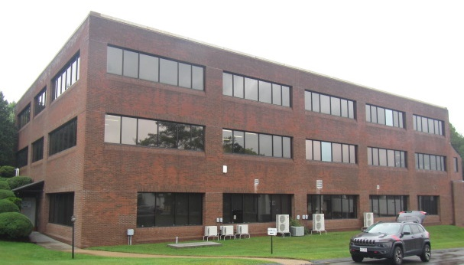
Fresh air intakes for HVAC system (arrows)

Picture 2
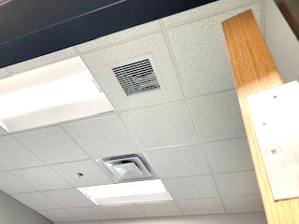
Louvered supply vent and grated return vent
Picture 3
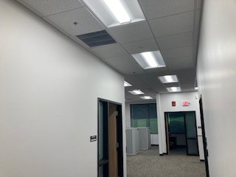
Return vent outside of offices (arrow)
Picture 4
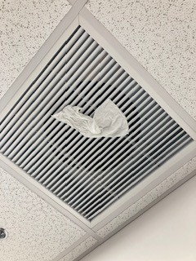
Return vent in main hallway, tissue indicates draw of air

Picture 5
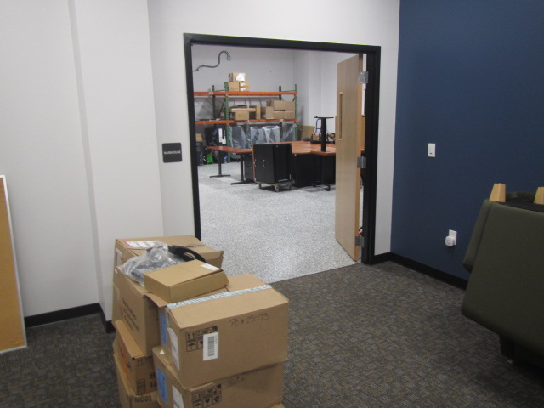
Doors between warehouse and office space wide open
Picture 6
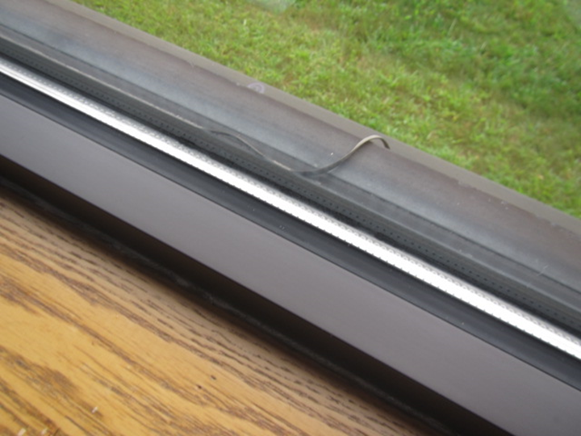
Loose strip caulking on window in room 107

Picture 7
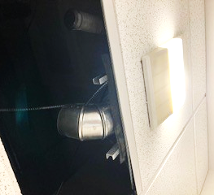
Restroom exhaust vent off Breakroom, note ductwork terminates above ceiling (arrow)
Picture 8
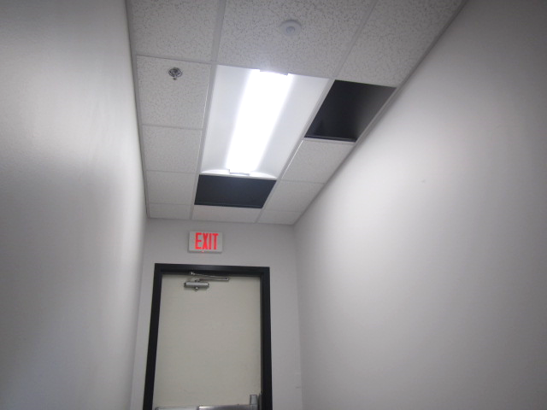
Missing ceiling tiles near the warehouse exit
Picture 9
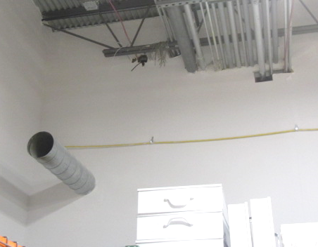
Open duct and spaces around utilities in warehouse

Location | Carbon  Dioxide  (ppm) | Carbon Monoxide  (ppm) | Temp  (°F) | Relative  Humidity  (%) | PM2.5  (µg/m³) | Occupants  in Room | Windows  Openable | Ventilation |  |  | Remarks
 |  |  |  |  |  |  |  | Intake | Exhaust
Background | 405 | ND | 69 | 100 | 1 |  |  |  |  |  | Moderate to heavy rain
Warehouse | 471 | ND | 69 | 73 | 1 | 0 | N | Y |  | Y | Open duct, spaces around utility holes, missing tiles near exit
Main Office Area | 447 | ND | 69 | 77 | 2 | 0 | N | Y |  | Y | Door to warehouse wide open
101 | 468 | ND | 71 | 73 | 1 | 0 | N | Y |  | Y
102 | 466 | ND | 71 | 73 | 1 | 0 | N | Y |  | Y
103 | 451 | ND | 70 | 73 | 2 | 0 | N | Y |  | Y
104 | 460 | ND | 71 | 73 | 1 | 0 | N | Y |  | Y | Exhaust/return weak
105 | 472 | ND | 71 | 72 | 1 | 0 | N | Y |  | Y
106 | 459 | ND | 71 | 73 | 1 | 0 | N | Y |  | Y
107 | 472 | ND | 69 | 75 | 1 | 0 | N | Y |  | Y | Loose strip caulking on window
Cubicles 101-104 | 536 | ND | 71 | 73 | 1 | 0 | N | Y |  | Y
Kitchen/Breakroom | 453 | ND | 69 | 76 | 1 | 0 | N | Y |  | Y
Restroom |  |  |  |  |  |  | N | N |  | Y | Exhaust not vented to outside

