March 3, 2017

George Zachos, Esq.
Executive Director
Board of Registration in Medicine
200 Harvard Mills Square -- Suite 330
Wakefield, MA 01880

Re: Proposed Amendments to BORIM Regulations

Dear Mr. Zachos:

The Committee of Interns and Residents (CIR) is a labor organization that represents more than 14,000 intern, resident and fellow physicians (hereinafter "residents") at hospitals throughout the country, including in Massachusetts. CIR works to improve residency training and education, advance patient care and enhance the working conditions of interns, residents and fellows through collective bargaining and advocacy.

We are writing to offer our comments on the proposed amendment to 243 CMR 1.01(2)(c), which identifies the actions that would constitute a "disciplinary action" under BORIM's regulations. Specifically, the proposed amendment seeks to expand the definition of disciplinary action to include "remediation" and "probation, including academic probation." In our view, this proposed amendment, if approved, would have the unintended consequence of adversely impacting physician training and patient care. As such, we urge the BORIM to reject the proposed amendment to 243 CMR 1.01(2)(c).

In our role as advocates for the interests of resident physicians, we are often asked to advise and assist residents who are being placed on probation or for whom it has been determined that remediation is needed for them to successfully complete their training. (Sometimes, though not always, probation and remediation are coupled as a singular event for a resident). I personally have been involved in hundreds of these cases during my nearly 20 years with CIR. Residents are put on remediation and/or probation for a variety of reasons including but not limited to (1) an insufficient fund of medical knowledge, (2) clinical skills that are below the level expected of a resident in their particular post-graduate year; (3) weak interpersonal and/or communication skills and (4) difficulty handling the significant workload and stress of residency to such a degree that there is concern for the resident's well-being as well as the potential for an adverse impact on their ability to provide effective patient care.

In such situations, CIR typically counsels residents to fully participate in remediation and we have even have gone as far as to request a more robust remediation plan in instances for which we believe the plan to be lacking in sufficient detail, effective tools or recommendations to achieve the desired result, or where there is an absence of clear benchmarks for success. CIR does so because we understand that while residents provide crucial patient care services, residency is the part of the continuum of medical education during which residents learn to become competent physicians who can practice independently. It is understood that while we must hold our physicians-in-training to high standards, many of them will struggle with an aspect of their training at some point during residency and will need additional support to overcome their deficiency. In fact, a 2012 study of certain general surgery residency programs found that nearly one-third (31 percent) of those residents needed remediation during their training and that being placed on remediation was not an indicator of whether the resident would ultimately succeed in completing their program. Arch. Surg. 2012; 147(9):829-833.

When a resident is placed on probation or remediation, they often become very fearful and defensive, and immediately want to challenge the decision. What drives this reaction is the belief that they are being punished and that by being placed on remediation or probation they will be forever branded as a substandard or incompetent physician. In CIR's collective experience, what has been absolutely critical in convincing a resident to fully cooperate and become engaged in the remediation process is when they understand that remediation or probation is not considered a disciplinary action that will follow them around for the remainder of their career. Once they come to this realization, the resident will oftentimes acknowledge their deficiency and then actively participate in the development of a remediation plan by, for example, enlisting the help of a trusted teaching attending to serve as a mentor during the process.

The same can be true for teaching attendings who are often reluctant to provide comments on evaluations that are critical of a resident's performance because of concern that such feedback will result in the resident being punished. While such attendings typically mean well, it is our view that an unwillingness to provide honest but critical feedback does residents a disservice in the long run. Clearly, a regulation that requires a residency program to report remediation or probation as a disciplinary action to BORIM will only exacerbate this problem. Similarly, fear of being reported to BORIM will also discourage residents from being reflective about their own performance. An important part of the evaluative process can be when a resident is given the opportunity to do a self-evaluation. For the self-evaluation process to have any chance of success, residents must be able to critically examine their own performance and develop the insight to identify areas in which they need to improve and then seek out the assistance needed to achieve it. It is hard to imagine any resident who will complete a self-evaluation form that documents any weaknesses in their skills and which could result in a remediation plan to address the weakness if it could cause them to be reported to BORIM.

Residency programs function at their best when residents are receptive to feedback that is provided honestly and regularly from senior physicians. If such a system does not exist or is hindered because of factors that cause both residents and teaching attendings to not buy-in to the remediation process, then the physicians that are turned out by that program are less likely to become the highly competent medical professionals that our patients need.

One resident from our chapter at Boston Medical Center was shaken when she was recently placed on remediation because it caused her to fear that her pursuit of a career in medicine, for which she had worked hard to attain, was in jeopardy. What helped her overcome her anxiety was her understanding that the program's goal was to provide her with needed support. Last week she wrote to us, "Despite being under stress, I still strive for improvement every day because I believe the intention of my residency program was not to penalize me by placing a lasting stigma on my professional record, but to ensure that I progress towards the levels of excellence demanded by my program." A regulation that designates remediation or probation as disciplinary actions that are reportable to BORIM, thus becoming part of their professional record, will only serve to undermine a resident's confidence and willingness to fully participate in a remediation plan. The regulation, if adopted, will serve to create an impediment for our residency programs in their efforts to train residents to become excellent physicians. That surely is not the result sought by BORIM.

Thank you for your consideration.

Very truly yours,

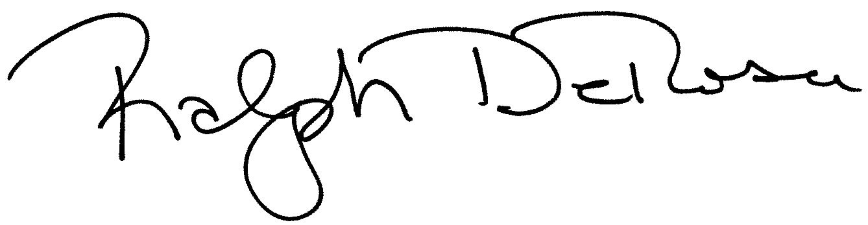

Ralph DeRosa
General Counsel

