Trauma Systems Committee Proposal
Trauma Systems Committee March 17, 2021
Reginald Alouidor MD, FACS
Assistant Professor of Surgery, UMMS-Baystate Health
Division of Trauma/Critical Care and Acute Care Surgery

Trauma Systems Committee Proposal

- Modification MA DPH OEMS Trauma Field Trauma Criteria
  - Anatomic Criteria:
    - Add Known Solid Organ Injury
- Outpatient Management
  - NOM Solid Organ Injury

2) Does the patient have
Physiologic Criteria:
      - Glasgow Coma Scale <14
      - Respiratory rate < 10 or > 29 or respiratory rate out of range for age?
      - Systolic Blood Pressure < 90 mmHg or < 70-90 (age appropriate) in pediatrics

Anatomic Criteria:
      - Flail Chest?
      - Open or depressed skull fractures?
      - Penetrating trauma to head, neck, torso, or extremities proximal to elbow and knee?
      - Crushed, degloved or mangled extremity
      - Pelvic fractures (excluding simple fractures)
      - Paralysis
      - 2 or more proximal long bone fractures, or any open proximal long bone fracture?
      - Amputations proximal to wrist or ankle

2) Does the patient have
Physiologic Criteria:
      - Glasgow Coma Scale <14
      - Respiratory rate < 10 or > 29 or respiratory rate out of range for age?
      - Systolic Blood Pressure < 90 mmHg or < 70-90 (age appropriate) in pediatrics

Anatomic Criteria:
      - Flail Chest?
      - Open or depressed skull fractures?
      - Penetrating trauma to head, neck, torso, or extremities proximal to elbow and knee?
      - Crushed, degloved or mangled extremity
      - Pelvic fractures (excluding simple fractures)
      - Paralysis
      - 2 or more proximal long bone fractures, or any open proximal long bone fracture?
      - Amputations proximal to wrist or ankle
      - Known Solid Organ Injury

Background: Solid Organ Injuries

- NOM accepted SOC for many types of patients with blunt and even penetrating Solid Organ Injuries
  - Patients do well accepted SOC
  - Risks and complications
    - Delayed rupture/ Delayed bleeding
    - Emergency hospital admission and interventions
      - Resuscitation
      - Angiography embolization
      - Emergency operative management

Current OEMS POE Protocol
Trauma Field Triage Criteria

1. Primary Survey
2A. Physiologic criteria
2B. Anatomic criteria
3. Mechanism of Injury Criteria
4. Special patient/system considerations

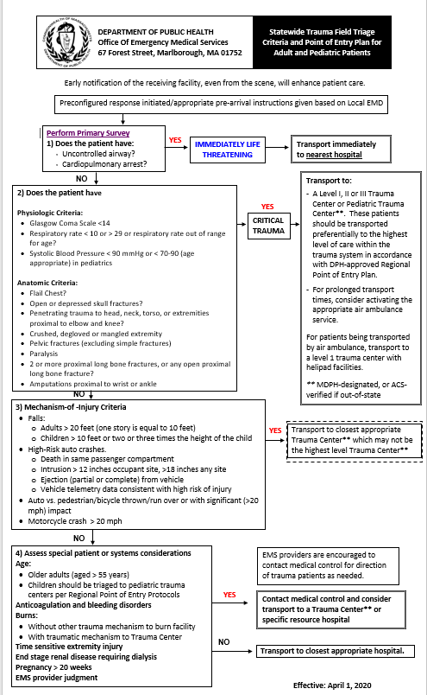
To view the following document in its entirety, visit the Statewide Trauma Field Triage Criteria and Point of Entry Plan for Adult and Pediatric Patients page, which will trigger an automatic download of the document.

Current OEMS POE Protocol
Trauma Field Triage Criteria
1. Primary Survey
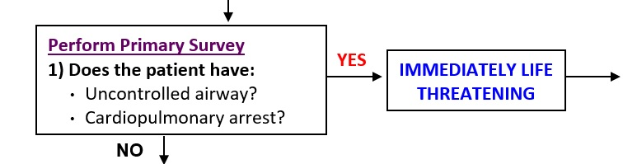
To view the document in its entirety, visit the Statewide Trauma Field Triage Criteria and Point of Entry Plan for Adult and Pediatric Patients page, which will trigger an automatic download of the document.

Current OEMS POE Protocol
Trauma Field Triage Criteria
2A. Physiologic criteria
2B. Anatomic criteria
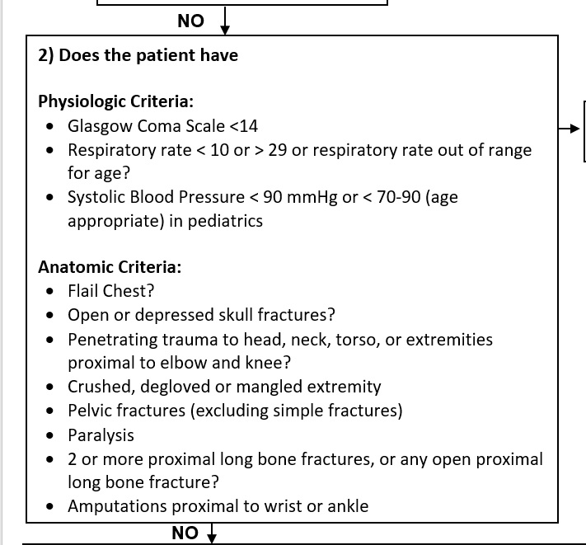
To view the document in its entirety, visit the Statewide Trauma Field Triage Criteria and Point of Entry Plan for Adult and Pediatric Patients page, which will trigger an automatic download of the document.

Current OEMS POE Protocol
Trauma Field Triage Criteria
3. Mechanism of Injury Criteria
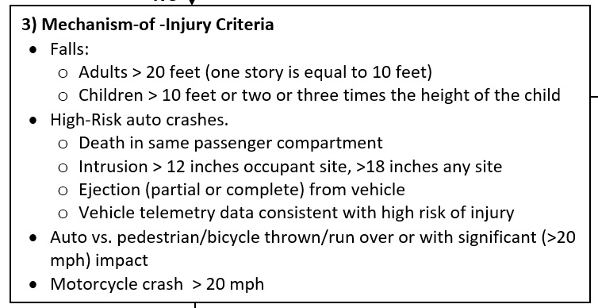
To view the document in its entirety, visit the Statewide Trauma Field Triage Criteria and Point of Entry Plan for Adult and Pediatric Patients page, which will trigger an automatic download of the document.

Current OEMS POE Protocol
Trauma Field Triage Criteria
4. Special patient/system considerations
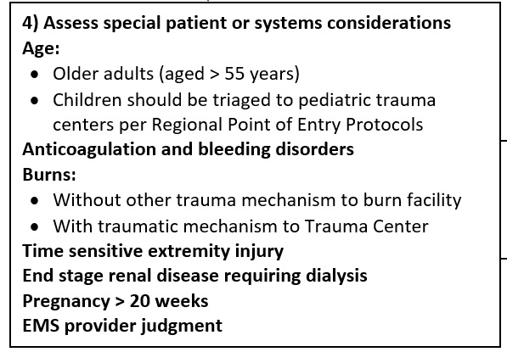
To view the document in its entirety, visit the Statewide Trauma Field Triage Criteria and Point of Entry Plan for Adult and Pediatric Patients page, which will trigger an automatic download of the document.

What this allows: Right Patient → Right Place

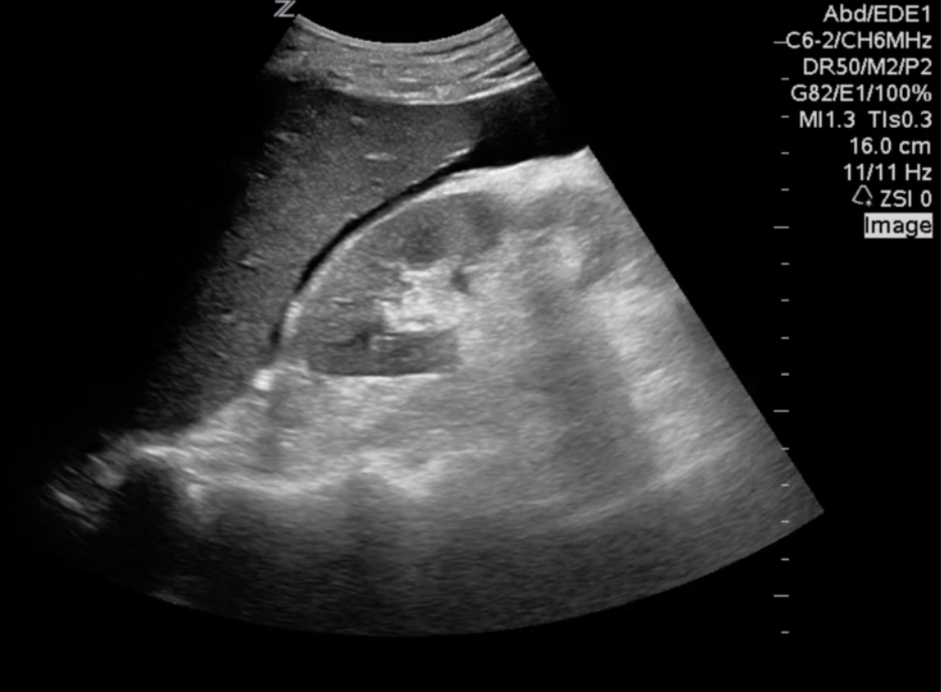
Trauma Center:
- 24 hr. availability
- Blood Products
- Operative Room
  - Surgery
  - Anesthesia
- Interventional Radiology

What this allows: Right Patient → Right Place
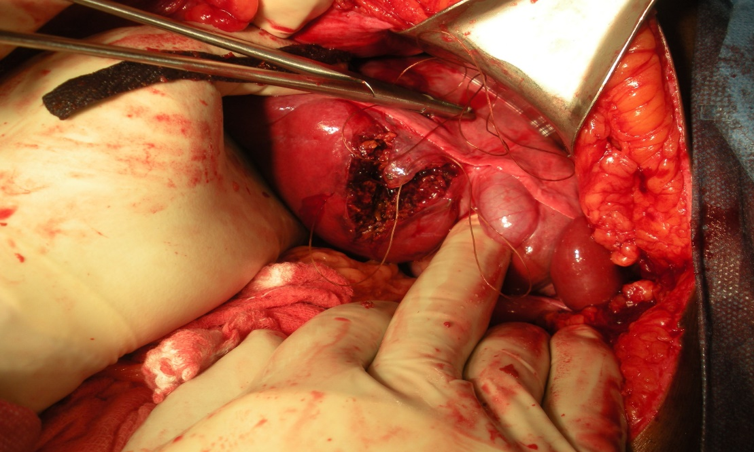

How to identify solid organ injury NOM?

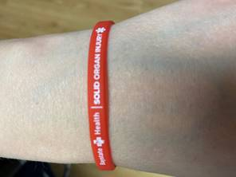
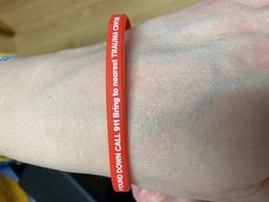

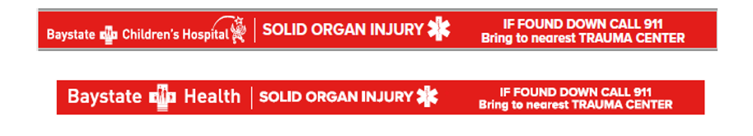

How to identify solid organ injury NOM?
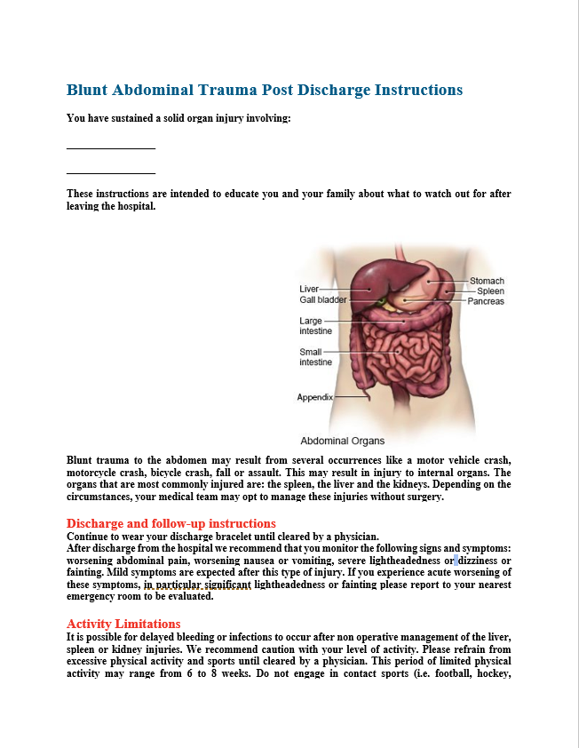
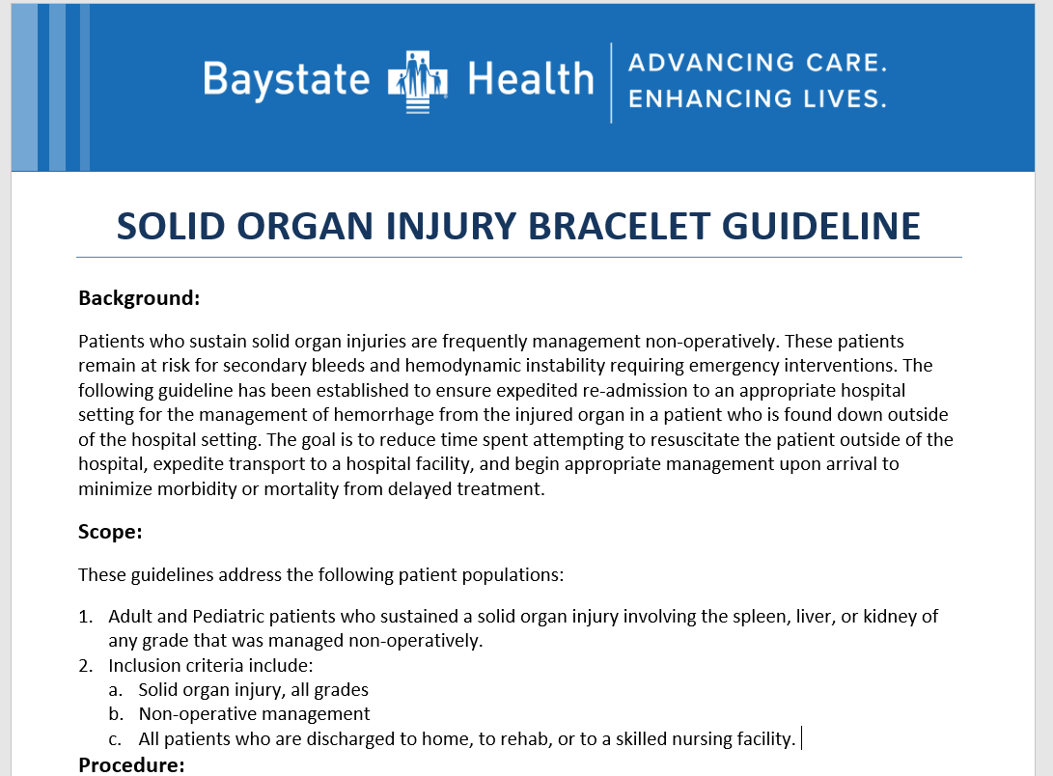

Disclosure

- EMS Medical Services Committee - April 9th 2021
- Attorneys at Massachusetts, DPH

Trauma Systems Committee Meeting Proposal

- Modification MA DPH OEMS Trauma Field Trauma Criteria
  - Anatomic Criteria:
    - Add Known Solid Organ Injury
- NOM Solid Organ Injury Bracelet

Questions:

