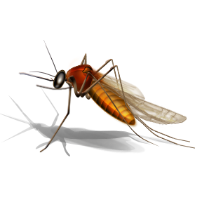Massachusetts Department of Public Health, 305 South Street, Jamaica Plain, MA 02130
Common Mosquitoes That Can Spread Disease in Massachusetts

Most mosquito bites will only result in itching or skin irritation. However, some kinds of mosquitoes found in Massachusetts carry viruses (germs) that can cause illness. Information about common kinds of mosquitoes that are most likely to spread disease in Massachusetts is shown below.

Mosquito Species  Name | When are they most active? | Where do they live and what kind of water do they like? | What types of animals do they bite? | What time of year are they most common?
Aedes vexans | Dusk/dawn, night | River floodplains and salt-marshes – temporary flooded areas | Mammals/humans | Summer and early fall
Coquillettidia perturbans | Dusk/dawn, night | Woodlands – cat-tail marshes | Birds  Mammals/humans | Summer
Culex pipiens | Dusk/dawn, night | Urban areas – artificial containers | Birds, Occasionally mammals/humans | Summer and early fall
Culex restuans | Dusk/dawn, night | Urban areas – natural and artificial containers | Birds, Occasionally mammals/humans | Spring, summer and fall
Culex salinarius | Dusk/dawn, night | Salt-marshes – brackish and freshwater wetlands | Reptiles  Birds  Mammals/humans | Summer
Culiseta melanura | Dusk/dawn, night | Woodlands – white cedar and red maple swamps | Birds, Occasionally mammals/humans | Spring and summer
Ochlerotatus canadensis | Dusk/dawn, day | Woodlands – woodland pools | Birds  Mammals/humans | Late spring through summer
Ochlerotatus japonicus | Day | Urban areas – natural and artificial containers | Mammals/humans | Summer through fall
For information on diseases spread by mosquitoes and how to prevent them: contact the MDPH, Division of Epidemiology and Immunization at 617-983-6800 or visit the MDPH Arbovirus website at http://www.mass.gov/dph/mosquito

This document was developed in conjunction with the State Reclamation and Mosquito Control Board and the Massachusetts Mosquito Control Projects. Updated April 2018

