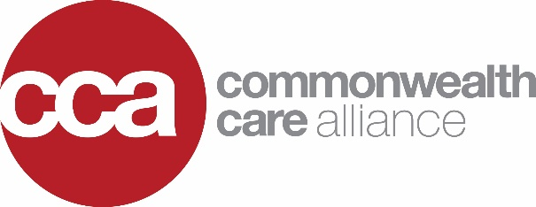

June 27, 2018

Department of Public Health
Office of the General Counsel
250 Washington Street, Boston, MA 02108.

RE: 801 CMR 4.02(105) (MIH Fees)

On behalf of Commonwealth Care Alliance, I am writing to express our support for the proposed amendment to 801 CMR 4.02(105). In anticipation of FY19, the Department of Public Health has appropriately recognized that establishing a fee schedule for Mobile Integrated Health is in the best interests of the Commonwealth. We are supportive of the new fees at the levels proposed by the Department of Public Health.

Commonwealth Care Alliance (CCA) is a not-for-profit, community-based healthcare organization dedicated to improving care for individuals who are dually eligible for MassHealth (Medicaid) and Medicare with complex medical, behavioral health and social needs, including persons with disabilities. It is our mission to provide the best possible care individually tailored to the members we serve. CCA is recognized nationally for its innovative Model of Care that improves quality and health outcomes and reduces overall cost of care. Our success is evident in our increasing enrollment; currently CCA covers over 27,000 members.

CCA has participated in an MIH pilot program with EasCare Ambulance Services for several years allowing us to see the benefits of MIH. We are very excited to see the authority for comparable programs to expand statewide enabling more and more people to receive the assistance they need, without unnecessarily utilizing the resources of Emergency Departments across the state.

If you have any questions about our support for the proposed regulations, our programming or any other issue, please feel free to contact me at jkrintzman@commonwealthcare.org or (617) 426-0600 ext. 1847.

Yours sincerely,

Josh Krintzman
Director of Government Affairs

