January 25, 2022

Via Email and First Class Mail
Lara Szent-Gyorgi, MPA
Director, Determination of Need Program
Massachusetts Department of Public Health
67 Forest Street
Marlborough, MA 01752

Re: Mass General Brigham Incorporated Determination of Need Applications - Massachusetts General Hospital # MGB-20121612-HE, Brigham and Women’s Faulkner Hospital # MGB-20121716-HE, and Multisite # Multisite-21012113-AS Independent Cost-Analysis Comment

Dear Ms. Szent-Gyorgi:

Pursuant to Mass. Gen. Laws ch.111, § 25C(g) and (i) and the Department of Public Health’s (DPH) regulations at 105 CMR 100.405(D), the Health Policy Commission (HPC) submits the following comment regarding the above-referenced matters and the independent cost-analyses (ICAs) thereof for consideration by DPH and the applicant, Mass General Brigham (MGB).

The HPC has elected to exercise its authority to comment on the three above-referenced applications and the ICAs thereof based on (1) results of HPC analyses showing that the above-referenced applications are likely to increase Massachusetts health care spending, result in increased commercial insurance premiums, and impair market functioning in a manner inconsistent with the Commonwealth’s goals for cost containment, including impacts to health care access and equity, and (2) the HPC’s determination that it can provide analyses of these impacts that may aid DPH in its review of all relevant factors for approval of the applications.

Specifically, and as further detailed in the attached comment, the HPC’s analyses show that the above-referenced proposals are likely to:
- Result in increased health care spending, likely $46.0 million to $90.1 million for the three projects per year for commercially insured patients, with approximately $9.3 million to $27.9 million due to the proposed ambulatory expansion, $6.4 million to $7.9 million due to the proposed Faulkner Hospital expansion, and $30.3 million to $54.4 million due to the proposed Mass General Hospital expansion, based on conservative projections for the subset of potential spending drivers that the HPC was able to quantify with available data and information;
- Drive substantial patient volume and revenue to the higher-cost MGB system, particularly commercially insured volume, and likely away from other lower-cost providers; and
- Negatively impact market functioning, including health care access and equity, as a substantial amount of the commercial revenue mentioned above is likely to shift to MGB and away from other provider systems that have fewer financial resources, lower average prices
for commercial patients, and generally serve larger proportions of MassHealth patients and communities with higher indicia of social need.

Due to the interrelatedness of the applications—all three filed by MGB on the same date, citing similar rationales, and described by the applicant as part of a “system-wide strategy”—the HPC is filing one document that describes analyses in common across the three applications (e.g. the background of the applicant and its position in the market), but which also discusses the impacts of each project individually where such impacts are easily divisible.

We hope that this comment provides important and relevant factual context for the consideration of DPH and Mass General Brigham in this process.

Sincerely,

<signature on file>

Dr. Stuart Altman
Chair

Introduction

Massachusetts has long been a leader in health care coverage, innovation, and quality. However, the cost of health care has been, and remains, a profound challenge. In an effort to restrain rapidly increasing health care costs, Massachusetts passed comprehensive health care reform in 2012 (Chapter 224) and set a first-in-the-nation, statewide target for sustainable growth in total health care spending (3.6 percent for the first five years, lowered to 3.1 percent in 2018). Chapter 224 also established the independent Massachusetts Health Policy Commission (HPC) and charged it with setting goals for health care spending and developing policies to reduce overall cost growth while improving quality, including efforts to foster the continued development of a competitive, value-based health care market while protecting patient access to necessary health care services and seeking to reduce health care disparities.

Because health care costs, quality, and access to services may be influenced by changes in the delivery system, Chapter 224 directs the HPC to monitor changes in our health care market; to provide objective, data-driven analyses of changes that have the potential to significantly impact health care costs or market functioning; and to thus increase public transparency and accountability for market changes that may impact health care costs, quality, and access. For provider changes that require the filing of a determination of need (DoN) application with the Department of Public Health (DPH), Chapter 224 provides that DPH may require an independent cost-analysis (ICA) to demonstrate that an application is “consistent with the commonwealth’s efforts to meet the health care cost-containment goals established by the [health policy] commission”, and the statute and DPH regulations provide that the HPC may comment on any application and any such analysis.

The HPC conducts this work during a time in which both our health care system and our broader community are facing unprecedented challenges. The COVID-19 pandemic has profoundly impacted the health care system, as well as all individuals, families, and businesses across the Commonwealth. At the same time, job losses and widespread economic disruption from the pandemic have underscored persistent health care affordability challenges, and health care costs have continued to escalate. In both 2018 and 2019, Massachusetts’s total health care expenditures exceeded the health care cost growth benchmark, and in 2020 price growth for health care services accelerated even as utilization fell.

It is in this context that the Mass General Brigham (MGB) system— which includes two renowned academic medical centers and is the largest and generally highest-priced health care system in the Commonwealth—is seeking to spend nearly $2.3 billion in Massachusetts on expansions and improvements at two of its hospitals and on the creation of three new ambulatory sites the communities of Westborough, Westwood, and Woburn.

The HPC now releases its analysis of the impacts of these three proposed expansions to contribute important information to the public dialogue as providers, payers, government, consumers, and other stakeholders strive to address these challenges and develop a more affordable, accessible, and equitable health care system.

Executive Summary

On January 21, 2021, Mass General Brigham (MGB) filed three applications with the Massachusetts Determination of Need (DoN) program describing significant expansion, renovation, and improvement of Massachusetts General Hospital (MGH) and Brigham and Women's Faulkner Hospital (Faulkner), as well as the creation of three new ambulatory sites in the communities of Westborough, Westwood, and Woburn. In total, the three applications propose a capital expenditure of $2.25 billion in Massachusetts, with substantial additions of inpatient, outpatient, imaging, and other capacity at MGH and Faulkner, as well as extensive new ambulatory surgery, imaging, primary care, and specialty care services in Westborough, Westwood, and Woburn. MGB’s DoN applications and supporting filings describe these proposed expansions as cost-saving and designed to provide needed services to MGB’s patients. On March 14, 2021, the DoN program notified MGB that it was requiring an independent cost-analysis (ICA) to be conducted on each of the three applications, as authorized under its statute, to demonstrate that each proposed project is “consistent with the commonwealth’s efforts to meet the health care cost-containment goals established by the [health policy] commission,” and a third-party vendor was engaged to conduct the analyses at MGB’s expense.

The HPC conducted its own analyses, detailed throughout the remainder of this comment, to determine the likely impacts of these proposals on the Commonwealth’s health care cost containment goals. The HPC’s analyses focus on impacts to commercial spending, which are expected to result in higher commercial insurance premiums for Massachusetts residents and businesses, but the projects are also likely to have spending impacts for Medicare and Medicaid.

The HPC’s analyses show that these proposals are likely to drive substantial patient volume and revenue to the higher-cost MGB system—particularly commercially insured volume—resulting in increased health care spending, increased commercial insurance premiums, and a negative impact on health care market functioning, including access and equity. Based on conservative projections for the subset of potential spending drivers that the HPC was able to quantify with available data and information, the projects are likely to increase yearly commercial health insurance spending in Massachusetts by $46.0 million to $90.1 million in total, with approximately $9.3 million to $27.9 million due to the proposed ambulatory expansion, $6.4 million to $7.9 million due to the proposed Faulkner expansion, and $30.3 million to $54.4 million due to the proposed MGH expansion. These projects are also likely to shift substantial commercial revenue to the MGB system and away from other providers in the Commonwealth, with a loss for other providers in the range of $152.9 million to $261.1 million in commercial revenue each year for the subset of proposed services that the HPC was able to quantify. These providers have fewer financial resources and lower average prices for commercially insured patients, and they generally serve larger proportions of MassHealth patients and communities with higher indicia of social need than MGB. Given these impacts, the projects are not consistent with the Commonwealth’s goals for cost containment.

This comment is organized into four parts. Part I provides a brief overview of the review process to-date including the independent cost-analyses and the HPC’s concerns regarding those analyses. Part II provides background on MGB and the current structure and functioning of the health care system in Massachusetts as important context for understanding the potential impact of the proposed expansions. Part III presents our findings on the likely spending impacts from the proposed projects, distinguishing the impacts for each project where possible, and Part IV outlines some broader implications of the proposed expansions on market functioning, including potential impacts to health care access and equity. Below is a summary of the findings presented in Parts II through IV.
Background: MGB and the Current Provider Landscape in Massachusetts: MGB is the largest provider system in Massachusetts, with significantly higher prices than nearly all other Massachusetts providers and higher spending for its patients. MGB is a high-quality provider system, but much of the care that MGB provides—and the services it is proposing to expand—constitutes routine care that can be provided by other high-quality Massachusetts providers. MGB providers generally serve higher proportions of commercially insured patients and patients from wealthier communities. Reflecting many of these dynamics, MGB has substantially more financial resources than other Massachusetts provider systems.
Projected Impacts on Health Care Spending: The projects described in the three DoN applications are likely to increase total health care spending and result in increased commercial insurance premiums. Specifically:
  - The new and expanded capacity from the proposed projects is likely to drive significant patient volume and revenue—particularly commercially insured volume—to the higher-cost MGB system and away from other lower-cost providers;
  - Both the ambulatory expansion and the hospital expansions are anticipated to result in increased health care spending, based on conservative projections for a subset of potential spending drivers:
    - The ambulatory expansion would likely increase annual commercial spending by $9.5 million to $15.4 million due to new primary care patients joining the higher cost MGB system. Substantial additional spending increases are expected due to increased inpatient and outpatient volume at MGB hospitals coming from patients living near the ambulatory sites. These increases would be $4.5 million to $17.9 million for inpatient care if the three proposed sites allow MGB to achieve half of its market share growth expectations for its larger multiyear ambulatory plan, or half of that amount if the three proposed sites allow MGB to achieve a quarter of its expectations for the larger plan. At the same time, an estimated annual commercial savings of approximately $3.4 million based on current prices may result from shifts of care to the ambulatory sites out of hospital outpatient departments, after accounting for backfilling capacity at MGB’s hospitals that would likely reduce such savings.
    - The MGH expansion would likely increase annual commercial spending by $23.7 million to $40.6 million through new MGH inpatient capacity and $573K through new CT and MR capacity, with additional increases attributable to other new outpatient capacity.
    - The Faulkner expansion would likely increase annual commercial spending by $2.9 million to $3.8 million through new Faulkner inpatient capacity, while the spending impacts of additional outpatient services would likely be small.
    - In addition to these spending impacts, each of the projects is likely to increase MGB’s market share and bargaining leverage with commercial payers, allowing it to negotiate higher commercial rates in the future that would further increase spending. The expansions at MGH and Faulkner would result in price increases of $9.7M to $17.3M for inpatient care, with additional price increases expected from the ambulatory and outpatient expansions. Loss of commercial volume by other providers may also further widen the disparity in prices between MGB and other providers.
  - The development of the three proposed projects together, described by MGB as part of a system-wide strategy, undermines MGB’s claims that the ambulatory expansion would reduce health care spending, and may result in combined impacts greater than those the HPC has modeled for each project individually. While shifting care out of hospitals and into ambulatory sites will generally produce savings, MGB is not seeking to reduce the care at its hospitals to reflect any diversion of care to lower cost settings. Instead, by also seeking to substantially expand inpatient and hospital outpatient services as part of its broader strategy, MGB will increase spending as it increases the volume of care at both MGB’s high-priced hospitals and its proposed new ambulatory sites.
Additional Impacts on Market Functioning, including Health Care Access and Equity: There are also likely to be significant follow-on impacts to the market from the proposed expansions, including potential impacts to health care access and equity. Specifically:
- For each proposed project, a substantial amount of commercial revenue is likely to shift to MGB and away from other provider systems that serve a greater share of public payer patients and communities with greater indicia of social need, leaving those providers with fewer resources to serve those populations. In total, other providers are expected to lose $152.9 million to $261.1 million in commercial revenue each year for the subset of proposed services that the HPC was able to quantify.
- The services for which MGB has provided the most detail in its ambulatory expansion plans are ones likely to generate substantial financial margin and drive additional volume to its system.
- MGB’s projections of future utilization at its facilities, which do not take capacity at other providers into account, do not indicate that the projects are necessary to meet unmet need. The proposed ambulatory expansions would also be located in areas that report already having good access to health care services.
- The proposed ambulatory expansions would be located in relatively affluent areas with low MassHealth payer mix, consistent with MGB’s stated goals of increasing network lives and commercial referrals. As a result, the expansions are likely to reinforce MGB’s already small share of MassHealth patients relative to other systems.
- MGB would need substantial new staff for the new capacity, which could result both in increased staffing costs for some providers and in staff being recruited away from other providers, particularly those providers with more limited financial resources.
These spending impacts, and the shifts in projected revenue between MGB and other providers are summarized below.
Summary of Projected Impacts of the Expansions on Annual Commercial Health Care Spending and Provider Revenue

 | Spending Dynamic |  | Annual Commercial Spending Impact | Annual Commercial Revenue Gain by MGB | Annual Commercial Revenue Loss by Other Providers
- Ambulatory Expansion | - New MGB primary care patients |  | $9.5M to $15.4M | Not Modeled, but likely to increase revenue. | Not Modeled, but likely to decrease revenue.
 | - Increased utilization of MGB hospitals |  | Likely significant. If the three proposed sites allow MGB to achieve half of its market share expectations for the larger multiyear ambulatory expansion, $4.5M to $17.9M for inpatient care. Outpatient would further increase spending. | Likely significant. If the three proposed sites allow MGB to achieve half of its market share expectations for the larger multiyear ambulatory expansion, $19.1M to $76.5M for inpatient care. Outpatient would further increase revenue. | Likely significant.  If the three proposed sites allow MGB to achieve half of its market share expectations for the larger multiyear ambulatory expansion, -$14.6M to -$58.6M for inpatient care. Outpatient would further reduce revenue.
 | - Patients at new ambulatory locations and backfill of outpatient capacity at MGB hospitals |  | -$3.4M for ambulatory surgery, CT and MRI. Other services could further impact spending. | $24.2M to $28.2M for ambulatory surgery, CT and MRI. Other services would further increase revenue. | -$27.6M to -$31.6M for ambulatory surgery, CT and MRI. Other services would further reduce revenue
 | - Increased MGB prices as market concentration and MGB’s commercial market shares increase |  | Not Modeled | Not Modeled | Not Modeled
 | Total yearly commercial impact for modeled services and spending dynamics |  | $9.3M to $27.9M | $43.3M to $104.6M | -$42.2M to -$90.2M
- MGH and Faulkner Expansions | - Patients filling new inpatient capacity | MGH | $23.7M to $40.6M | $91.3M to $156.3M | -$67.6M to -$115.7M
 |  | Faulkner | $2.9M to $3.8M | $41.8M to $54.9M | -$39.0M to -$51.1M
 | - Patients filling new outpatient capacity | MGH | $573K for CT and MRI imaging only. Other services would further increase spending | $3.8M for CT and MRI imaging only. Other services would further increase revenue | -$3.3M for CT and MRI imaging only. Other services would further reduce revenue
 |  | Faulkner | -$91K for MRI imaging only. Other services could further impact spending. | $788K for MRI imaging only. Other services would further increase revenue | -$879K for MRI imaging only. Other services would further reduce revenue
 | - Increased MGB prices as market concentration and MGB’s commercial market shares increase | MGH | $6.0M to $13.2M due to inpatient volume increases. Outpatient market share increases are likely to drive further price increases. | $6.0M to 13.2M due to inpatient volume increases. Outpatient market share increases are likely to drive further revenue increases. | Not Modeled
 |  | Faulkner | $3.6M to $4.1M due to inpatient volume increases. Outpatient market share increases are likely to drive further price increases. | $3.6M to $4.1M due to inpatient volume increases. Outpatient market share increases are likely to drive further revenue increases. | Not Modeled
 | Total yearly commercial impact for modeled services and spending dynamics | MGH | $30.3M to $54.4M | $101.2M to $173.3M | -$70.1M to -$119.0M
 |  | Faulkner | $6.4M to $7.9M | $46.3M to $59.8M | -$39.8M to -$52.0M
Total yearly commercial impact for modeled services and spending dynamics - all projects combined |  |  | $46.0M to $90.1M | $190.7M to $337.8M | -$152.9M to  -$261.1M
Notes: When totaling spending impacts, the HPC discounts the spending impact in row 1 by the portion of total medical expense (TME) for MGB’s primary care patients that represents spending on inpatient care received at MGB hospitals. Additional shifts of patients and revenue to higher-priced providers would be expected if projected revenue losses disrupt the operations of lower-priced providers. Additional spending and revenue impacts are also likely for other payer categories, particularly for Medicare Advantage plans and MassHealth Managed Care Organizations, which do not operate with standardized fee schedules. The HPC’s calculations are likely to be conservative.

The HPC’s conclusions stand in contrast to those of the ICAs, which were released on December 28, 2021 and conclude that all three projects are consistent with the Commonwealth’s cost containment goals. However, the ICAs fail to address certain major drivers of spending for the three projects, particularly for the ambulatory projects, minimize significant cost impacts identified in their own findings, do not consider important and relevant publicly available information, and do not consider key context about the current state of the health care market in Massachusetts. These limitations of the ICAs are discussed in more detail in Section I and Appendix I.B, and the remainder of this comment details the HPC’s analyses.

Overview of Review Process to Date: DoN Filings, HPC Review Process, and Independent Cost-Analyses
On January 21, 2021, Mass General Brigham (MGB) filed three applications with the Massachusetts Determination of Need (DoN) program, describing:
- Massachusetts General Hospital: a proposed capital expenditure of $1.88 billion for significant expansion, renovation, and improvement of Massachusetts General Hospital (MGH), including the addition of 54 new medical/surgical beds and 40 new intensive care unit (ICU) beds; the conversion of 388 semi-private beds to private rooms, freeing up additional capacity that is often “blocked” in semi-private rooms and potentially bringing 24 beds licensed but not operational back into service; centralization and significant expansion of oncology, cardiology, and radiology services; and various other renovations and improvements (MGH expansion);
- Brigham and Women’s Faulkner Hospital: a proposed capital expenditure of $150 million for significant expansion, renovation, and improvement of Brigham and Women’s Faulkner Hospital, including the addition of 78 new medical/surgical beds and 8 new observation beds; expansion of endoscopy and imaging services; and creation of shell space for future clinical additions (Faulkner expansion); and
- New Ambulatory Sites: a proposed capital expenditure of $223.7 million for the creation of three new ambulatory sites in Massachusetts in Westborough, Westwood, and Woburn, each of which would include an independently licensed ambulatory surgery center (ASC) with 4 operating rooms per site; extensive physician services, including primary care, behavioral health, and a range of specialty services; and imaging services, with a total of 5 new CT units and 5 new MRI units across the three sites (ambulatory expansion).
MGB’s applications state that the proposed projects are part of a “system-wide strategy that is grounded in the excellence of Mass General Brigham’s two academic medical centers, focused on improved patient outcomes and experience, and supported by its historical and ongoing commitment to digital health and data analytics, population health, ambulatory care and insurance risk management.” MGB states that its ambulatory proposal will address health care access challenges and the needs of its patient panel and shift care to lower cost settings (the application states that the ambulatory sites would be priced 25% lower than MGB’s community hospitals), which will lower costs and reduce total medical expenses (TME) and health care spending. MGB states that both hospital projects will update the hospital campuses, relieve hospital capacity constraints, and co-locate related services. MGB also states that the Faulkner expansion will allow care to be shifted to Faulkner from higher-cost cost settings, and that both hospital expansions will reduce operational costs and increase efficiency and timely care delivery, reducing health care spending and TME.,
On March 14, 2021, the DoN program notified MGB that it was requiring an independent cost-analysis (ICA) to be conducted on each of the three applications, as authorized under its statute to demonstrate that a proposed project is “consistent with the commonwealth’s efforts to meet the health care cost-containment goals established by the [health policy] commission”. A third-party vendor was engaged to conduct the analyses, at MGB’s expense.
While the ICAs were pending, a limited amount of new information was disclosed publicly from confidential internal MGB documents related to the ambulatory expansions by the Office of the Attorney General—after balancing the public interests in disclosure relative to MGB’s interest in confidentiality (MGB Internal Document Disclosures). Such disclosures included that:
- The ambulatory sites proposed in the DoN filings are part of a larger multi-year ambulatory expansion plan for Eastern Massachusetts (including but not limited to the three sites currently proposed in the Ambulatory DoN Application) that MGB expects will ultimately contribute direct margins to the system of $385 million per year. This reflects both anticipated new ambulatory volume and incremental hospital volume from the ambulatory sites, and MGB expects the new hospital margin to outweigh any losses from shifting care out of MGB hospitals to lower-priced sites;
- MGB expects the multi-year ambulatory expansion plan to increase MGB’s market share by 1% to 2% for secondary inpatient admissions and 3% to 4% for tertiary inpatient admissions in Eastern Massachusetts. MGB also projected a 1% to 2% increase in covered lives in Eastern Massachusetts;
- Specific to the three ambulatory sites proposed in the Ambulatory DoN Application, MGB’s internal projections in 2018 for expected surgery capacity at the three sites were substantially higher (20-60%) than the capacity projections in its DoN filings; and
- MGB expects substantial physician staffing at the three sites in the Ambulatory DoN Application, including 22 new PCPs.
The HPC also conducted its own review of the likely impacts of the three proposed projects, consistent with its role of providing objective, data-driven analyses of significant changes to the health care delivery system. To conduct its review, the HPC used all available public information, including all materials provided to the DoN program and the MGB Internal Document Disclosures, as well as the data and methodologies that it has used extensively in past market investigations, including cost and market impact reviews. The HPC worked closely with economists, actuaries, accountants, and care delivery experts to conduct its analyses and wishes to acknowledge the expert analytic support provided by Bates White, LLC, Freedman Healthcare, LLC, Gorman Actuarial, Inc., BerryDunn, LLC, and Health Management Associates, Inc. An overview of the data and methodologies used by the HPC is attached as Appendix I.A.
The ICAs were released on December 28, 2021, concluding that all three projects are consistent with the Commonwealth’s cost containment goals. This conclusion is contrary to the HPC’s findings, and while many of the methodologies used by the ICAs appear similar to the methodologies employed by the HPC, the HPC has identified a number of key limitations:
- The ICAs fail to address major drivers of spending for the three projects that would negate any projected savings, particularly for the ambulatory expansion. For example, the Ambulatory ICA calculates savings from shifting care to the new ambulatory sites—consistent with the HPC’s analyses that find the potential for small savings from shifting care from hospitals to the ambulatory sites. However, the ICAs do not address the likelihood that if MGB shifts care out of its hospitals to the ambulatory sites, that would free up capacity at those hospitals that MGB would likely seek to backfill, particularly given that MGB does not propose to reduce any existing hospital capacity to account for the diverted care, but rather proposes to simultaneously expand hospital capacity. The ICAs also do not address the fact that the ambulatory sites would be likely to drive inpatient and outpatient hospital volume into MGB hospitals, consistent with the well-known principle that physician referrals strongly influence where patients seek hospital care and with MGB’s own expectations of increased hospital market share from ambulatory expansions. The Ambulatory ICA also does not acknowledge the likelihood of spending impacts for services other than ambulatory surgery and advanced imaging (i.e. it does not appear to address new primary care patients MGB would be anticipated to serve or any of the other professional services at the sites). Finally, none of the three ICAs addresses impacts on professional spending for care that would shift to MGB from other providers, generally evaluating only facility spending. The impact of these spending drivers would likely be far greater than the savings the Ambulatory ICA projects from shifting care to the new ambulatory sites.
- The ICAs minimize significant cost impacts identified within their own findings. The ICAs dismiss large spending increases as insignificant, particularly for the hospital expansions. For example, the MGH ICA finds that spending would increase by an average of 18% across services and payer types for patients anticipated to switch to receiving care at MGH, with spending for inpatient cancer services specifically increasing of 38% across payer types. In the attached tables that disaggregate spending impacts by payer type, the ICA identifies much higher increases for specific services and payers, projecting that commercial payers would see a 33.8% increase for all inpatient care that would switch to MGH from other area providers and a 72.7% increase for inpatient cancer services. Medicare Advantage plans would see increases of 121.2% for inpatient cancer services for care switching to MGH. The Faulkner ICA finds that, for patients anticipated to switch to receiving outpatient MR scans at Faulkner, spending would likely increase by 11.3% overall, with Original Medicare and Medicare Advantage plans seeing increases of 22.8%. Yet the ICAs conclude that the projects are nonetheless consistent with the Commonwealth’s cost containment goals. All three ICAs also present spending impacts as percentage increases rather than dollar spending figures, generally calculated for specific service lines and often averaged across payer categories, making it difficult to distinguish the often greater impacts the ICAs project for commercial payers—which more directly impact Massachusetts residents and businesses through higher insurance premiums—from impacts on Medicare and MassHealth that would generally be lower, particularly where prices are standardized and set administratively.
- The ICAs do not consider important and relevant publicly available information. Most notably, the Ambulatory ICA does not address or incorporate the information made public in the MGB Internal Document Disclosures documenting that MGB expects its larger multi-year ambulatory expansion plan, of which the three ambulatory sites are part, to result in significant increases in inpatient hospital market share and covered lives, as well as significant new revenue to its system, including new hospital margin that would outweigh any losses from diverting care to lower-cost ambulatory settings. Nor does that ICA incorporate information on volume projections and staffing projections for the three ambulatory sites that were included in the MGB Internal Document Disclosures.
- Finally, the ICAs are missing key context about the current state of the health care market in Massachusetts. This context is essential for understanding the impact of the proposed projects on health care spending and market functioning. The ICAs do not address the impact of MGB’s historic position as the largest and generally highest-priced provider system in Massachusetts, or of its other recent expansions. The ICAs also characterize MGB as a market entrant, particularly in the Ambulatory ICA, despite the fact that MGB already has significant market share in the ambulatory service areas, and contrary to the evidence that the expansions are part of an explicit effort to grow market share by a provider system that already generally has the highest market share in the state. The ICAs also rely on academic literature to assert that increased capacity will reduce prices, while failing to acknowledge that MGB prices have continued to increase and remain among the highest in Massachusetts despite increases in capacity in the MGB system in recent years.
In addition to these concerns, many of the methodologies used in the ICAs, while facially reasonable, lack the level of detail on assumptions and calculations for the HPC to fully assess their validity. A full listing of the HPC’s key methodological questions and concerns is attached as Appendix I.B.
The remainder of this comment details the HPC’s findings regarding the three proposed expansions, with comments regarding the relationship between the HPC’s findings and those of the ICAs where applicable.

Background: MGB and the Current Provider Landscape in Massachusetts
To fully understand the impact of the three proposed expansions, it is important to consider the current provider landscape in Massachusetts and how Mass General Brigham (MGB) fits into that landscape, specifically:
- MGB is already the largest provider system in Massachusetts, with the highest share of revenue for inpatient, outpatient, and physician services in the state, and generally the highest share by volume. It also has significant market share in each of the service areas in which it is proposing to expand and has been expanding more than other provider systems in recent years. Given these facts, none of the expansions can properly be considered “entry” by a new provider, but rather expansion of and an expectation of increased market share by the largest provider system, which already has significant market power.
- MGB’s commercial prices are already higher – often significantly – than nearly all other providers in Massachusetts. As the HPC and others have reported extensively, MGB has generally had higher commercial prices than most other providers in Massachusetts for many years. In the most recent year of data, MGB’s commercial prices for hospital inpatient, hospital outpatient, and physician services continue to be higher than nearly all other hospitals and physician groups in the Commonwealth. Even the proposed price point for the three ambulatory expansion sites is higher than many other area providers. Given MGB’s pricing, shifts to MGB from other providers will generally increase spending, regardless of any impact on MGB’s future bargaining leverage.
- MGB is a high-quality provider system, but much of the care that MGB provides—and the services it is proposing to expand—constitutes routine care that can be provided by other high quality Massachusetts providers. The MGB system includes two renowned academic medical centers, MGH and Brigham and Women’s Hospital, that provide highly specialized tertiary and quaternary services. However, much of the care MGB provides–and many of the services it seeks to expand—are services available at a range of high-quality providers in Massachusetts. The HPC has examined MGB hospital and physician performance on a range of quality measures in the past and has generally found that MGB providers perform comparably to the statewide average on process and outcome measures. The most recent available data show a continuation of these trends, although most MGB hospitals score higher than average on patient experience ratings and “willingness-to-recommend” and MGB practices often perform better than the statewide average on adult primary care patient experience measures. Prior work by the HPC has also shown that MGB performs comparably to other Massachusetts providers on measures of the frequency of use of low-value care in the areas of screening, pre-operative testing, and procedures.
- MGB’s primary care patients have substantially higher health status adjusted spending than primary care patients of other providers, and unadjusted spending for MGB’s primary care patients is growing faster than average. Total medical expenses (TME) for MGB’s primary care patients, a measure that reflects all medical spending by patients over time, incorporating both utilization and pricing, shows that MGB primary care patients with commercial insurance have substantially higher total health care spending, on both an unadjusted and health status adjusted basis, as compared to primary care patients of other systems, as well as higher than average spending growth. MGB’s primary care patients with Tufts Medicare Advantage also have higher-than-average health status adjusted spending. MGB’s high prices and utilization of low-value care services noted above have a substantial combined impact on spending. Although MGB has repeatedly described its efforts to monitor and control costs and highlighted in its applications both its population health management efforts generally, as well specific initiatives that it claims will reduce operational costs and the costs of care “thereby reducing TME, and ultimately total healthcare expenditures,” MGB’s primary care patients have persistently higher spending than primary care patients of the vast majority of other provider systems in Massachusetts.
- MGB providers generally serve higher proportions of commercially insured patients and patients from wealthier communities, on average, as compared to other provider systems in Massachusetts. MGB hospitals have the highest percentage of commercial volume among Massachusetts hospitals, and the lowest percentage of Medicaid volume. MGB primary care providers also serve patients who generally come from higher-income communities with fewer indicia of social need as compared to other providers. MGB’s general acute care hospitals generally serve a lower share of Black, Indigenous, and people of color (BIPOC) inpatients than comparable hospitals and a lower share as compared to those that reside in its hospitals’ service areas.
- MGB has substantially more financial resources than other Massachusetts provider systems. As a result of many of the dynamics highlighted above, MGB has been able to accumulate greater resources than other provider systems. For example, MGB’s net assets of approximately $10.6 billion in 2020 is greater than that of the next four largest systems combined. These resources allow MGB to invest in patient-attractive expansions such as those contemplated in the DoN applications, and better positions MGB to recruit physicians and other staff and draw patients to fill new capacity.

Projected Impacts on Health Care Spending
HPC analysis of MGB’s three proposed expansions indicates that these projects are likely to increase health care spending in the Commonwealth, and result in increased commercial health insurance premiums, even based on conservative projections for a subset of potential spending drivers. Much of this impact would be due to the fact that the new and expanded capacity created by all three projects is likely to drive significant patient volume and revenue to the higher-cost MGB system, particularly commercially insured volume, and likely away from other lower-cost provider systems. The key mechanisms for these impacts are summarized below.
- MGB’s ambulatory expansions would likely impact total health care spending through the following key mechanisms:
  - New MGB primary care patients: Spending would increase as MGB recruits primary care physicians (PCPs) to the ambulatory sites from existing area practices or as patients switch to new MGB PCPs from other local providers, reflecting differences in price, utilization, provider mix, and service mix between primary care patients managed by MGB and those managed by other local providers.
  - Increased utilization of MGB hospitals: Spending would increase as MGB’s hospitals draw increased inpatient and outpatient volume from areas surrounding the ambulatory sites.
  - Patients at new ambulatory locations and backfill of outpatient capacity at MGB hospitals: Commercial prices at the ambulatory sites would be lower than those at some, but not all, local providers. While care shifts to the ambulatory sites may produce some net savings, impacts on total spending would depend on where patients would otherwise have received care. However, any care diverted to the ambulatory sites from MGB hospital outpatient departments (HOPDs) is likely to be backfilled, given that MGB is not proposing to reduce any existing HOPD capacity. This backfill, which the ICAs do not evaluate, would reduce any savings.
  - Market leverage: Total spending may further increase as care shifts to MGB and MGB gains commercial market share, increasing its leverage to obtain higher price increases in the future. Loss of commercial market share by other providers may further widen the disparity in prices between MGB and other providers.
- Proposed expansions at MGH and Faulkner would likely impact health care spending through the following key mechanisms:
- Patients filling new inpatient capacity: Total spending would likely increase as MGH and Faulkner fill proposed new inpatient capacity. Most patients who receive inpatient care in net new capacity at MGH and Faulkner would otherwise have been seen at non-MGB hospitals, often at lower price points. This includes patients filling net new medical/surgical beds at MGH and Faulkner, new ICU beds at MGH, and new capacity at MGH as it moves beds from semi-private to private rooms and potentially brings licensed beds back into operation.
- Patients filling new outpatient capacity: Most patients who receive outpatient services in new advanced imaging and other outpatient capacity MGH and Faulkner would otherwise have been seen at non-MGB hospitals, often at lower price points. Commercial spending would likely increase as MGH fills proposed new outpatient capacity, while the spending impacts of adding Faulkner outpatient capacity may be mixed.
- Market leverage: Total spending would likely further increase as care shifts to MGH and Faulkner and MGB gains commercial market share, increasing its leverage to obtain higher price increases in the future. Loss of commercial market share by other providers may further widen the disparity in prices between MGB and other providers.
- The development of the three proposed projects together, described by MGB as a system-wide strategy, may result in combined impacts greater than those the HPC has modeled for each project individually.
The HPC quantified likely impacts on health care spending and on revenue for MGB and other Massachusetts providers for each of the three proposed projects using the best available data, focusing primarily on impacts for commercially insured patients. The HPC anticipates additional impacts on spending and revenue that could not be reliably quantified at this time, due to data limitations and a lack of key details in MGB’s public plans and projections. MGB’s expectations for revenue and market share shifts in connection with its larger multi-year ambulatory expansion plan suggest that additional impacts on spending and revenue could be substantial. A summary of the annual commercial spending impact the HPC was able to quantify is below in the column “Annual Commercial Spending Impact.” The impact of commercial revenue shifts in the two columns on the right is discussed in Section IV.
Summary of Projected Impacts of the Expansions on Annual Commercial Health Care Spending and Provider Revenue
 | Spending Dynamic |  | Annual Commercial Spending Impact | Annual Commercial Revenue Gain by MGB | Annual Commercial Revenue Loss by Other Providers
- Ambulatory Expansion | - New MGB primary care patients |  | $9.5M to $15.4M | Not Modeled, but likely to increase revenue. | Not Modeled, but likely to decrease revenue.
 | - Increased utilization of MGB hospitals |  | Likely significant. If the three proposed sites allow MGB to achieve half of its market share expectations for the larger multiyear ambulatory expansion, $4.5M to $17.9M for inpatient care. Outpatient would further increase spending. | Likely significant. If the three proposed sites allow MGB to achieve half of its market share expectations for the larger multiyear ambulatory expansion, $19.1M to $76.5M for inpatient care. Outpatient would further increase revenue. | Likely significant.  If the three proposed sites allow MGB to achieve half of its market share expectations for the larger multiyear ambulatory expansion, -$14.6M to -$58.6M for inpatient care. Outpatient would further reduce revenue.
 | - Patients at new ambulatory locations and backfill of outpatient capacity at MGB hospitals |  | -$3.4M for ambulatory surgery, CT and MRI. Other services could further impact spending. | $24.2M to $28.2M for ambulatory surgery, CT and MRI. Other services would further increase revenue. | -$27.6M to -$31.6M for ambulatory surgery, CT and MRI. Other services would further reduce revenue
 | - Increased MGB prices as market concentration and MGB’s commercial market shares increase |  | Not Modeled | Not Modeled | Not Modeled
 | Total yearly commercial impact for modeled services and spending dynamics |  | $9.3M to $27.9M | $43.3M to $104.6M | -$42.2M to -$90.2M
- MGH and Faulkner Expansions | - Patients filling new inpatient capacity | MGH | $23.7M to $40.6M | $91.3M to $156.3M | -$67.6M to -$115.7M
 |  | Faulkner | $2.9M to $3.8M | $41.8M to $54.9M | -$39.0M to -$51.1M
 | - Patients filling new outpatient capacity | MGH | $573K for CT and MRI imaging only. Other services would further increase spending | $3.8M for CT and MRI imaging only. Other services would further increase revenue | -$3.3M for CT and MRI imaging only. Other services would further reduce revenue
 |  | Faulkner | -$91K for MRI imaging only. Other services could further impact spending. | $788K for MRI imaging only. Other services would further increase revenue | -$879K for MRI imaging only. Other services would further reduce revenue
 | - Increased MGB prices as market concentration and MGB’s commercial market shares increase | MGH | $6.0M to $13.2M due to inpatient volume increases. Outpatient market share increases are likely to drive further price increases. | $6.0M to 13.2M due to inpatient volume increases. Outpatient market share increases are likely to drive further revenue increases. | Not Modeled
 |  | Faulkner | $3.6M to $4.1M due to inpatient volume increases. Outpatient market share increases are likely to drive further price increases. | $3.6M to $4.1M due to inpatient volume increases. Outpatient market share increases are likely to drive further revenue increases. | Not Modeled
 | Total yearly commercial impact for modeled services and spending dynamics | MGH | $30.3M to $54.4M | $101.2M to $173.3M | -$70.1M to -$119.0M
 |  | Faulkner | $6.4M to $7.9M | $46.3M to $59.8M | -$39.8M to -$52.0M
Total yearly commercial impact for modeled services and spending dynamics - all projects combined |  |  | $46.0M to $90.1M | $190.7M to $337.8M | -$152.9M to  -$261.1M
Notes: When totaling spending impacts, the HPC discounts the spending impact in row 1 by the portion of TME for MGB’s primary care patients that represents spending on inpatient care received at MGB hospitals. Other dynamics could further increase spending, including net new utilization for supply-sensitive care (i.e. supply-induced demand and practice pattern shifts) and additional shifts of patients to higher-priced providers if projected revenue losses disrupt the operations of lower-priced providers. Additional spending and revenue impacts are also likely for other payer categories, particularly for Medicare Advantage plans and MassHealth Managed Care Organizations, which do not operate with standardized fee schedules. The HPC’s calculations are also likely to be conservative as described in note 49.
A number of the analyses in the ICAs that quantify spending and market shifts are directionally consistent with the HPC’s findings, although the HPC and the ICAs employ some different methodologies and assumptions. However, the HPC’s conclusions differ from those in the ICAs because the HPC considered important features of the current provider landscape as described in Section II and analyzed multiple spending drivers not examined in the ICAs as discussed in Appendix I.B.
The remainder of this section discusses HPC’s analyses in greater depth.
- MGB’s ambulatory expansions would likely impact total health care spending through several mechanisms, resulting in increased total spending.
MGB’s Ambulatory DoN Application states that the project will allow it to “make substantial progress in achieving its strategic priorities of improving patient access and outcomes while also lowering the total cost of health care for its patients and other residents of The Commonwealth.” However, MGB statements in other settings and internal analyses indicate that it expects the ambulatory expansions to grow commercial referral volume at its hospitals and increase its market shares of inpatient care and covered lives, suggesting that MGB may also be focused on increasing volume, particularly of commercial patients, at its system. As described below, the resulting increase in MGB hospital and patient panel volume is likely to increase total commercial health care spending as patients shift to MGB’s higher-priced network, outweighing any potential commercial savings as a result of care shifting to the new ambulatory sites from higher-priced settings such as hospitals.
  - Total spending would likely increase as MGB adds primary care physicians at the ambulatory sites.
MGB’s Ambulatory DoN Application identifies primary care as one component of physician services that would be provided at each site. MGB provides no details in its application on the number of physicians to be staffed at the sites. The Ambulatory ICA states that MGB provided current staffing estimates to the firm conducting the ICAs, indicating that 14 net new primary care physicians (PCPs) would be staffed across two of the proposed sites, while the MGB Internal Document Disclosures indicate that MGB planned to staff 22 net new PCPs across the three proposed sites. Many of these PCPs are likely to be recruited from existing local practices, as MGB states it has done in order to staff its primary care offices in Westwood and Woburn in recent years. Some may be new to the Massachusetts physician workforce, although the patients filling their panels would likely have been seen by other local providers.
The HPC compared total annual health status adjusted spending per commercially insured patient for patients of MGB PCPs to spending for patients of PCPs affiliated with other physician groups practicing in the proposed ambulatory service areas. We found that commercial patients with an MGB PCP have health status adjusted annual total medical spending approximately 11% to 12% higher than patients of other local PCPs, which could reflect differences in the prices of the providers used by MGB primary care patients, as well as differences in provider practice patterns, or other dynamics. As patients switch from other local providers to the proposed net new MGB PCPs, we would therefore expect commercial spending to increase by 11% to 12%, on average, for those patients. This would translate to an increase of approximately $9.5 million to $15.4 million per year based on estimated patient panel sizes and payer mix, depending on whether MGB were to add 14 or 22 new PCPs at the ambulatory sites. Spending may also change for patients with other types of insurance coverage (e.g., managed and Original Medicare and MassHealth) as they join MGB patient panels.
  - MGB hospitals would likely receive increased volume from the ambulatory service areas, increasing health care spending.
The HPC used an econometric model based on historical Massachusetts discharge and claims data to confirm that commercial patients living in areas where a hospital system has higher primary care or specialist physician market share are significantly more likely to use the affiliated system’s hospitals for inpatient care even when those patients do not live near a system hospital. Increases in MGB’s commercial physician market shares in the proposed service areas would likely increase commercial discharges at MGB’s hospitals and, consequently, commercial spending for patients from these service areas. However, the scope of increase the HPC was able to quantify likely understates the potential impact of the ambulatory expansions on hospital volume, particularly given the scope of MGB’s expectations for increased hospital referrals.
MGB’s planning materials as described in the MGB Internal Document Disclosures estimate an increase in inpatient market shares of 1% to 2% for secondary admissions and 3% to 4% for tertiary admissions in Eastern Massachusetts as a result of MGB’s larger planned multi-year ambulatory expansion. It is unclear what proportion of this expected increase would be driven by the three ambulatory sites proposed in MGB’s Ambulatory DoN Application; for the purpose of modeling, the HPC has assumed the ambulatory expansion currently under review may represent half of the multi-year project. If MGB were to achieve half of this projected increase in Eastern Massachusetts commercial inpatient market share across its hospitals, this would translate to approximately 712 to 2,849 additional commercial discharges per year at its hospitals. Because MGB hospitals and physicians generally have higher commercial inpatient prices than those of other systems, as discussed in Section II, this shift would increase annual commercial spending by approximately $4.5 million to $17.9 million as these admissions are seen at MGB hospitals rather than at hospitals of other systems.,
The estimates above reflect potential increases in commercial inpatient spending. Spending would likely further increase due to increased utilization of MGB HOPDs by patients from the ambulatory service areas, especially for outpatient specialties or advanced procedures not provided at the proposed ambulatory sites, and shifts of patients covered by non-commercial payers, based on spending impacts modeled in the MGH and Faulkner ICAs.
  - Commercial prices at the ambulatory sites would likely be lower than those at some, but not all, local providers. Impacts on total spending would depend on where patients would otherwise have received care. Any care diverted to the ambulatory sites from MGB HOPDs is likely to be backfilled, reducing any savings.
MGB states that the sites “will have a positive impact on TME as these patients [in the ambulatory service areas] will no longer need to be seen in higher cost settings,” estimating that it will be “25% less costly to receive the Ambulatory Surgery Services at a Project Site, as compared to one of [MGB’s] community hospitals… based on the average rates from [MGB’s] top three payers.”, The HPC calculated differences in commercial prices between providers currently serving the proposed ambulatory service areas and estimated prices for the ambulatory sites for relevant services. As shown in the example below for MRI scans, assuming MGB’s estimated price point represents a commitment regarding ambulatory site pricing, commercial prices at the proposed sites would likely be lower than those at some, but not all, other local providers. In particular, smaller providers and non-hospital providers tend to have lower price points than the proposed MGB ambulatory sites, meaning that any care diverted from those providers to MGB sites would increase, not decrease, spending.
Commercial MRI Prices for Proposed Ambulatory Service Areas and Estimated MGB Ambulatory Prices (HPHC, 2018)
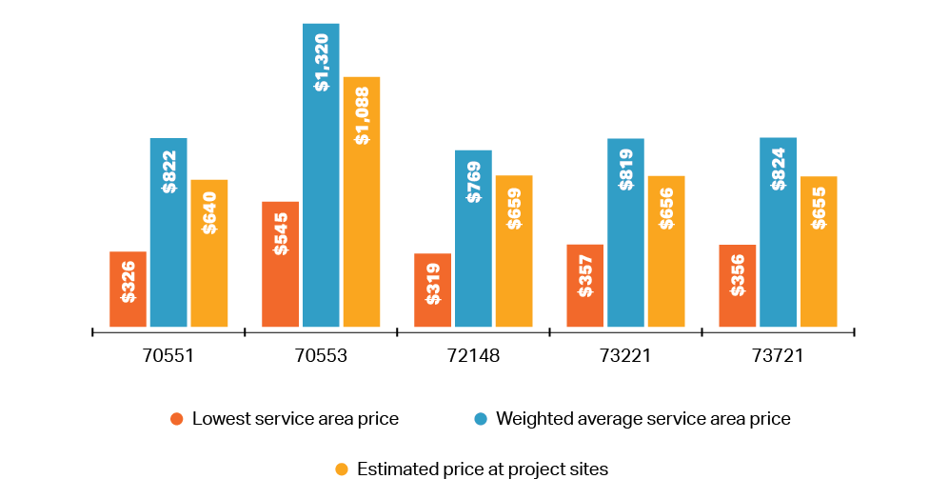

Source: HPC analysis of CHIA All-Payer Claims Database, HPHC 2018.
Note: See Appendix I.A for description of the HPC’s methodology. CPT codes shown represent the highest volume outpatient diagnostic MRI codes for Massachusetts commercial patients.

The spending impacts of patients seeking care at the proposed ambulatory sites would depend on the mix of existing providers that would have otherwise provided that care. MGB’s application suggests that virtually all of the proposed ambulatory service capacity would be filled by patients who would otherwise have received care at an MGB hospital, estimating commercial savings of $7.9 million for every thousand ambulatory surgery patients and $1.75 million for every thousand CT and MRI scans provided at the proposed ambulatory sites instead of one of its other facilities. MGB refers to consumer research informing its projections, but does not reference assessments of actual site of care choices by patients living near MGB’s many existing ambulatory sites.
To assess the likelihood that the patients at the new ambulatory sites would only have otherwise used MGB’s more expensive HOPDs, the HPC analyzed utilization patterns of patients with MGB PCPs living within 10 minutes of MGB’s existing clinic-licensed CT and MRI service in Waltham. When those patients used an MGB provider for outpatient CT and MR imaging, they used the clinic site only 27% of the time, with most of the rest of their advanced imaging provided at MGB hospitals. In the four years of data the HPC examined, there was no decrease in the volume of scans provided at any MGB hospital for commercial patients from the area around the Waltham clinic. Given this historic experience, as well as the number of other providers serving substantial shares of patients in the proposed service areas, the HPC considers it unlikely that the proposed capacity at MGB’s outpatient sites would be filled by volume shifting only from MGB’s hospitals. It is more likely that capacity at the new ambulatory sites would be filled by volume shifting from other area providers, including MGB sites. The HPC modeled potential impacts on commercial spending per case shifted to the proposed ambulatory sites under four scenarios based on different assumptions about where care would otherwise have been provided, as shown below. In no scenario, including care coming solely from MGB HOPDs, can the HPC identify potential savings per case as great as that suggested in MGB’s application. The estimated percent savings per case under the HPC’s proportional model generally aligns with the percent savings per case for commercial patients predicted by the market-based diversion model used in the Ambulatory ICA.
Commercial Spending Impacts per Case at Proposed Ambulatory Sites
 | Patient Origin Scenario | CT scans | MRI scans | Ambulatory surgeries
MGB claimed savings per case (DoN application) |  | -$1,750 |  | -$7,900
HPC modeling | All care diverted from MGB hospitals, not accounting for backfilled cases (MGB claim) | -$221 | -$402 | -$691
 | Care diverted proportionally from MGB and other current area providers | -$152 | -$309 | -$52
 | All care diverted from existing area providers except from MGB | -$128 | -$285 | +$463
 | Each net new case at ambulatory sites (service would not otherwise have been provided) | +$530 | +$771 | +$3,187
Sources: HPC analysis of CHIA All-Payer Claims Database, 2018; Ambulatory Narrative, supra note 11 at 16.
Notes: Ambulatory surgery price differentials calculated based on current mix of commercial orthopedic, ophthalmology, otolaryngology, and general surgery cases in the proposed ambulatory service areas. Scenario 4 rates assume new volume would reflect a service mix similar to the current service mix across all providers in the proposed ambulatory service areas.

In addition, MGB does not identify any expected reduction in volume or capacity at any of its HOPDs resulting from diversion of care to the proposed ambulatory sites. Thus, to the extent that care shifts from MGB HOPDs to the ambulatory sites, the HPC expects that MGB would backfill the newly available HOPD capacity, likely reducing any commercial savings from shifting outpatient care from its hospitals to the ambulatory sites, as shown below.,

Weighted Average Commercial Spending Impact per Case Backfilled at MGB HOPDs
CT scan | MRI scan | Generic outpatient visit
+$64 | +$58 | +$150

Sources: HPC analysis of CHIA All-Payer Claims Database, 2018; CHIA hospital outpatient relative price data, 2019; and CHIA physician relative price data, 2018.

Assuming that cases at the ambulatory sites would otherwise have been provided by the current mix of providers serving the areas, annual commercial spending for the service lines examined above would likely decrease by approximately $3.4 million., Public payers would likely also see savings as care shifts to the ambulatory sites; these savings would impact total healthcare spending in the Commonwealth, but would not impact commercial health insurance premiums. These estimates do not incorporate several factors that would tend to increase rather than reduce spending that the HPC could not quantify due to data limitations and lack of information in MGB’s submissions to the DoN program, including the impact of specialist physician visits at the ambulatory sites not directly related to ambulatory surgery or advanced imaging. The fact that MGB physician relative prices tend to be higher than those of other groups suggests that a shift of physician visits to the ambulatory sites may increase spending.

  - Total spending may further increase as MGB gains commercial market share, increasing its leverage to obtain higher price increases in the future.
As discussed in prior sections, MGB expects its multi-year ambulatory expansion project to increase its market share for physician and hospital services. The Ambulatory ICA also models increases in MGB shares of outpatient services if patients come to the ambulatory sites from all providers. HPC analyses indicate that MGB is likely to gain commercial outpatient volume, and that the scope of the shift is likely to be substantial. For example, filling new capacity at the proposed ambulatory sites from both MGB and other providers currently serving the area at roughly the same proportion as their current market shares, which the HPC considers more plausible than all care diverting from MGB hospitals, would increase MGB’s shares of commercial visits in the service areas by 26% for MRI, 40% for CT, and 31% for ambulatory surgery.
As discussed in prior work by the HPC and others, increases in commercial market share, particularly in a highly concentrated market, are generally associated with greater leverage for a provider organization to negotiate higher prices with commercial payers. Likewise, the HPC has found that a higher mix of public payer patients is associated with lower commercial relative prices. If MGB gains market share as a result of the ambulatory expansion, and is particularly growing its commercial market share, other area providers will likely be left both with lower volume and with larger proportions of public payer patients. Additional commercial volume at MGB would likely allow MGB to obtain higher commercial rate increases, while decreased commercial volume at other provider organizations means that those providers are likely to receive lower rate increases. These changes would be magnified if revenue losses destabilize other local provider organizations, leading to further market consolidation and more patients shifting to higher-priced systems. Any price increases at MGB relative to other providers would reduce any potential savings modeled in Section III.A.3 from care shifting from higher-priced non-MGB providers to the ambulatory sites and would further increase spending as patients backfill capacity at MGB HOPDs.
- Proposed expansions at MGH and Faulkner would likely increase health care spending.
  - Total spending would likely increase as MGH and Faulkner fill proposed new inpatient capacity.
The MGH application proposes the addition of 54 net new medical/surgical beds and 40 net new ICU beds, while the Faulkner application proposes the addition of 78 new medical/surgical beds. The MGH expansion would also make 30 to 50 additional beds available that are currently routinely blocked due to patient incompatibility in semi-private rooms, as those beds would be relocated to single rooms as part of the project. The MGH expansion may also allow MGH to staff 24 additional medical/surgical beds currently licensed but out of service, but MGH has provided insufficient public information regarding this potential additional capacity increase. In total, this would represent a net increase in medical/surgical bed capacity of 16.6% to 18.9% at MGH (depending on whether the 24 additional beds are included) and 45.6% at Faulkner.
MGB expects that it will fill all newly available inpatient capacity. Although MGH and Faulkner provide some highly specialized care, most patients who would receive inpatient care in net new capacity at MGH and Faulkner would otherwise receive care at non-MGB hospitals. Regardless of whether proposed new capacity serves new or existing patients, differences in price between these other hospitals and MGH and Faulkner would increase health care spending as patients fill the proposed new inpatient capacity. Using econometric modeling and hospital relative price data, the HPC estimates that the expected shift of approximately 3,825 to 5,363 commercial discharges each year would increase commercial spending on inpatient care by $26.6 million to $38.7 million annually, adjusting for patient acuity. These figures would increase by approximately 17% to 19% (an additional 418 to 530 discharges and $4.6 million to $5.8 million) if the MGH project allows MGH to bring 24 additional licensed beds into operation.
Commercial Discharge Shifts to Fill New MGB Inpatient Capacity
 | Lower volume assumptions |  | Higher volume assumptions
MGH | 2,161 to 2,579 |  | 3,182 to 3,712
Faulkner | 1,664 |  | 2,181
Impact on Commercial Hospital Spending
 |  | Lower volume assumptions | Higher volume assumptions
MGH |  | $23.7M to $28.3M | $34.8M to $40.6M
Faulkner |  | $2.9M | $3.8M
Total annual |  | $26.6M to $31.2M | $38.7M to $44.5M
Sources: HPC analysis of 2009-2019 CHIA hospital discharge data, 2019 CHIA hospital relative price data, and MGH and Faulkner DoN Application narratives and change in service forms.
Notes: See Appendix I.A and note 103 for methodology description. Estimates assume new capacity will not divert patients from other MGB hospitals, or that those hospitals will backfill any volume that shifts. Range of impacts shown for MGH reflects the omission or addition of 24 beds licensed but out of service.

Although the HPC did not estimate spending impacts for non-commercial payers, the ICAs find that the MGH expansion would increase inpatient spending for managed and non-managed Medicare and MassHealth care, while the Faulkner expansion would reduce spending for managed and non-managed Medicare and managed MassHealth care and increase spending for non-managed MassHealth care.

  - Commercial spending would likely increase as MGH fills proposed new outpatient capacity, while spending impacts of adding Faulkner outpatient capacity may be mixed.

The proposed hospital expansions would also add capacity for outpatient care across several service lines, including new advanced imaging units at both hospitals, endoscopy procedure capacity and observation beds at Faulkner, and cardiac and cardiovascular procedure rooms, oncology infusion bays, and non-procedural outpatient cardiovascular and oncology care at MGH. Most patients filling this new capacity would likely otherwise receive care at other providers, either other area HOPDs or non-HOPD (ASC or clinic-licensed) locations. Differences in price between these other providers and MGH and Faulkner would impact health care spending as patients fill the proposed new outpatient capacity.
Because of MGH’s high commercial prices for outpatient care relative to other providers, outpatient care filling new capacity at MGH is likely to increase commercial spending. Because Faulkner competes for outpatient care with some higher-priced providers, including AMCs, commercial spending may decrease for some services, like MRI. However, this may not be true across all service lines; for example, Faulkner commercial prices for some outpatient endoscopy procedures are relatively high. The HPC quantified potential spending impacts for outpatient imaging as shown below.
Commercial Spending Impacts per New MR or CT Scan at MGH and Faulkner
Average spending impact per case | MRI scans | CT scans
MGH | $176 | $126
Faulkner | -$113 | N/A
Sources: HPC analysis of 2018 CHIA APCD, MGH DoN Application, supra note 8; Faulkner DoN Application, supra note 10.
Notes: Spending impacts based on prices as described in Appendix I.A. The HPC calculated the percent difference in price between average prices MGH and Faulkner and other providers in each hospital’s outpatient service area, weighted by service area visits, for the top five CPTs by volume in each clinical cluster. We then applied this differential to the weighted average price for the entire cluster. See notes 70 and 75, supra, for additional detail on this methodology.

The HPC estimates that annual commercial spending on advanced imaging would increase at MGH by approximately $573,000 and decline at Faulkner by approximately $91,000 based on available volume and payer mix information., The HPC did not quantify spending impacts for the expansion of other outpatient service lines at the hospitals, but we note that the ICAs predict spending increases for both commercial and public payer care for every outpatient service line being expanded at both MGH (CT, MR, PET/CT, cardiovascular procedures, and oncology visits) and Faulkner (MR). While the potential spending increase for any one of these service lines would likely be small compared to the inpatient spending increases discussed above, they would all increase total health care spending.
  - Total spending would likely further increase as care shifts to MGH and Faulkner and MGB gains commercial market share, increasing its leverage to obtain higher price increases in the future.
MGB’s commercial market share would likely substantially increase as it fills the new capacity proposed in its hospital expansion projects. The new beds would represent a 7.1% to 7.9% increase in bed capacity for the MGB system, and MGB’s inpatient commercial market share in Eastern Massachusetts would likely increase by 2.7% to 3.8% as those beds are filled, based on the HPC’s inpatient diversion models. This would also increase market concentration for inpatient services in already highly concentrated markets. As discussed in Section III.A.5, these increases in market shares and consolidation would tend to enhance MGB’s ability to obtain higher commercial rate increases, while other provider organizations may receive lower rate increases as they lose commercial market share. A multivariate regression model similar to that utilized in prior HPC provider price analyses suggests that the proposed hospital expansions would be expected to result in system-wide inpatient prices at MGB that are approximately 0.9% to 1.7% higher than current pricing, with approximately 0.59% to 1.29% attributable to the MGH expansion and 0.36% to 0.4% attributable to the Faulkner expansion. This would translate to an annual increase in commercial spending of $9.7 million to $17.3 million ($6 million to $13.2 million for MGH, $3.6 million to $4.1 million for Faulkner). This could exacerbate the existing, extensive variation in provider prices for similar services and increase spending impacts above the figures modeled in this section. These changes would be magnified if revenue losses destabilize other local provider organizations, leading to further market consolidation and more patients shifting to higher-priced systems.
- The development of the three proposed projects together, described by MGB as a system-wide strategy, undermines MGB’s claims that the ambulatory expansion would reduce health care spending, and may result in total impacts greater than those the HPC has modeled for each project individually.
MGB has stated that the ambulatory and hospital projects are part of a system-wide strategy to achieve its strategic goals. However, the proposed hospital projects conflict with MGB’s claim that the ambulatory project will reduce health care spending. As discussed in Section III.A.3, shifting outpatient care out of hospitals and into ambulatory sites could result in savings, but the amount of any savings depends, in large part, on which hospitals would have otherwise provided that care and whether the hospitals subsequently backfill newly available HOPD capacity. MGB proposes to substantially expand hospital inpatient and outpatient services in the MGH and Faulkner expansions and has not suggested that total volume or capacity would decline at any of its facilities due to the ambulatory expansion, which is why HPC analyses include the impact of MGB hospitals backfilling any capacity that becomes available. Thus, while MGB states a goal of these projects is to shift care out of higher-priced settings, they are likely to increase the volume of care both at MGB’s relatively high-priced hospitals and at the new ambulatory sites.
The expansion of inpatient capacity at MGH and Faulkner, concurrent with the expectation of additional hospital volume from the ambulatory expansions, may also affect where MGH and Faulkner are expected to draw patient volume. If the ambulatory sites increase utilization of MGB hospitals by residents of the ambulatory service areas, more of the care filling new MGH and Faulkner beds may be diverted from hospitals outside of the Boston metro area. These hospitals tend to be lower-priced than Boston hospitals, meaning that care shifting to MGB hospitals from these hospitals outside Boston is likely to have a somewhat higher spending impact than the figures provided in Section III.B.1. Finally, as detailed in Section IV, the potential for these projects to destabilize lower-priced providers is greater if all three projects proceed, given that the projected revenue losses (particularly commercial revenue and traditionally higher-margin services) would be far higher if MGB significantly expands capacity across multiple projects at the same time.

Additional Impacts on Market Functioning, including Health Care Access and Equity
Improving access, equity, and market functioning are also core components of the HPC’s cost containment goals and a key part of HPC’s reviews of provider market changes. HPC’s key findings regarding the impact of the proposed expansions on health care market functioning, including access and equity are summarized below.
- Projected shifts in care as MGB fills new capacity would result in the loss of substantial revenue, especially commercial revenue, for other provider systems that serve greater shares of public payer patients and communities with greater indicia of social need, leaving those providers with fewer resources to serve those populations;
- The services for which MGB has provided the most detail, particularly in its ambulatory expansion plans, are ones likely to generate substantial financial margin and drive additional volume to its system;
- MGB’s projections of future utilization at its facilities do not indicate that the projects are necessary to meet unmet need. The proposed ambulatory expansions would also be located in areas that report already having good access to health care services;
- The proposed ambulatory expansions would be located in relatively affluent areas with low MassHealth payer mix where residents report already having good access to health care services. These features, in concert with MGB’s stated goals of increasing network lives and commercial referrals, are likely to reinforce MGB’s already small share of MassHealth patients relative to other systems; and
- MGB will need substantial new staff for the proposed capacity, which could result both in increased staffing costs for some providers and staff being recruited away from others, particularly those providers with more limited financial resources.
The remainder of this section discusses these findings in greater depth.
- Projected shifts in care as MGB fills new capacity would result in the loss of substantial revenue, especially commercial revenue, for other provider systems that serve greater shares of public payer patients and patients with greater indicia of social need, leaving those providers with fewer resources to serve those populations.
Each of the commercial spending changes detailed in Section III reflect even greater changes in commercial revenue at different provider systems, reflecting expected shifts in commercial revenue to the MGB system and away from other providers as shown below. In total, the HPC estimates that other provider organizations would lose $152.9 million to $261.1 million of annual commercial revenue, just from those aspects of the proposals that the HPC was able to analyze, as a result of shifts in care due to MGB’s proposed expansions.

Summary of Projected Impacts of the Expansions on Annual Commercial Health Care Spending and Provider Revenue

 | Spending Dynamic |  | Annual Commercial Spending Impact | Annual Commercial Revenue Gain by MGB | Annual Commercial Revenue Loss by Other Providers
- Ambulatory Expansion | - New MGB primary care patients |  | $9.5M to $15.4M | Not Modeled, but likely to increase revenue. | Not Modeled, but likely to decrease revenue.
 | - Increased utilization of MGB hospitals |  | Likely significant. If the three proposed sites allow MGB to achieve half of its market share expectations for the larger multiyear ambulatory expansion, $4.5M to $17.9M for inpatient care. Outpatient would further increase spending. | Likely significant. If the three proposed sites allow MGB to achieve half of its market share expectations for the larger multiyear ambulatory expansion, $19.1M to $76.5M for inpatient care. Outpatient would further increase revenue. | Likely significant.  If the three proposed sites allow MGB to achieve half of its market share expectations for the larger multiyear ambulatory expansion, -$14.6M to -$58.6M for inpatient care. Outpatient would further reduce revenue.
 | - Patients at new ambulatory locations and backfill of outpatient capacity at MGB hospitals |  | -$3.4M for ambulatory surgery, CT and MRI. Other services could further impact spending. | $24.2M to $28.2M for ambulatory surgery, CT and MRI. Other services would further increase revenue. | -$27.6M to -$31.6M for ambulatory surgery, CT and MRI. Other services would further reduce revenue
 | - Increased MGB prices as market concentration and MGB’s commercial market shares increase |  | Not Modeled | Not Modeled | Not Modeled
 | Total yearly commercial impact for modeled services and spending dynamics |  | $9.3M to $27.9M | $43.3M to $104.6M | -$42.2M to -$90.2M
- MGH and Faulkner Expansions | - Patients filling new inpatient capacity | MGH | $23.7M to $40.6M | $91.3M to $156.3M | -$67.6M to -$115.7M
 |  | Faulkner | $2.9M to $3.8M | $41.8M to $54.9M | -$39.0M to -$51.1M
 | - Patients filling new outpatient capacity | MGH | $573K for CT and MRI imaging only. Other services would further increase spending | $3.8M for CT and MRI imaging only. Other services would further increase revenue | -$3.3M for CT and MRI imaging only. Other services would further reduce revenue
 |  | Faulkner | -$91K for MRI imaging only. Other services could further impact spending. | $788K for MRI imaging only. Other services would further increase revenue | -$879K for MRI imaging only. Other services would further reduce revenue
 | - Increased MGB prices as market concentration and MGB’s commercial market shares increase | MGH | $6.0M to $13.2M due to inpatient volume increases. Outpatient market share increases are likely to drive further price increases. | $6.0M to 13.2M due to inpatient volume increases. Outpatient market share increases are likely to drive further revenue increases. | Not Modeled
 |  | Faulkner | $3.6M to $4.1M due to inpatient volume increases. Outpatient market share increases are likely to drive further price increases. | $3.6M to $4.1M due to inpatient volume increases. Outpatient market share increases are likely to drive further revenue increases. | Not Modeled
 | Total yearly commercial impact for modeled services and spending dynamics | MGH | $30.3M to $54.4M | $101.2M to $173.3M | -$70.1M to -$119.0M
 |  | Faulkner | $6.4M to $7.9M | $46.3M to $59.8M | -$39.8M to -$52.0M
Total yearly commercial impact for modeled services and spending dynamics - all projects combined |  |  | $46.0M to $90.1M | $190.7M to $337.8M | -$152.9M to  -$261.1M
Notes: When totaling spending impacts, the HPC discounts the spending impact in row 1 by the portion of TME for MGB’s primary care patients that represents spending on inpatient care received at MGB hospitals. Additional shifts of patients and revenue to higher-priced providers would be expected if projected revenue losses disrupt the operations of lower-priced providers. Additional spending and revenue impacts are also likely for other payer categories, particularly for Medicare Advantage plans and MassHealth Managed Care Organizations, which do not operate with standardized fee schedules. The HPC’s calculations are likely to be conservative as described in note 49.

Much of the shift in commercial revenue detailed above is in relatively high-margin service lines like ambulatory surgery and imaging, which providers rely on to balance the cost of more resource-intensive and lower reimbursement care. The shift of commercial volume to MGB may also reduce the bargaining leverage of other providers and lead to lower future commercial price increases for those providers, which would also exacerbate the disparity in prices between MGB and other providers and further depress revenues for non-MGB providers. Shifts in public payer patients to MGB would also further reduce revenue for other provider organizations, regardless of whether those shifts would increase or decrease total spending.
While revenue losses are likely to be spread across many area provider organizations as MGB diverts patients to its system, these losses would almost universally represent a flow of health care dollars away from providers serving higher proportions of traditionally underserved patients than MGB. Most other hospital systems serve higher proportions of MassHealth patients compared to MGB, MGB patients generally live in communities with higher median incomes and lower indicia of social need than patients of other provider systems, and other hospital systems generally serve higher proportions of BIPOC inpatients compared to MGB hospitals. If decreased revenue destabilizes other providers or diminishes their ability to invest in or maintain facilities and staff, that impact is likely to increase health disparities.
Many of these hospitals have already seen substantial declines in commercial volume relative to public payer volume (e.g., 71% of community hospitals in Massachusetts were considered “high public payer” hospitals by CHIA in 2019 compared to 39% in 2010), shrinking their commercial revenue. Community hospitals, in particular, often state that they depend on commercial rates to offset the cost of caring for public payer patients.
- The services for which MGB has provided the most detail, particularly in its ambulatory expansion plans, are ones likely to generate substantial financial margin and drive additional volume to its system.
MGB’s Ambulatory DoN Application and supplemental filings provide relatively greater detail on the advanced imaging and ambulatory surgery services MGB proposes at the sites, including analyses of recent utilization trends, projected capacity of new imaging units and operating rooms, and projected utilization of the new capacity after a three-year ramp-up period. Both advanced imaging and ambulatory surgery are generally identified as service lines generating relatively high margin per case, and diagnostic imaging is both a component of and driver of follow-up care.
By contrast, MGB has provided fewer details on its plans for behavioral health at the ambulatory sites. There is an acute need for expanded behavioral health services across Massachusetts, including in the proposed ambulatory service areas as discussed in the next section, and MGB has stated a commitment to expanding these services. MGB’s proposed services for the ambulatory sites list integrated behavioral health services, and the Ambulatory DoN Application narrative provides substantial descriptions of the benefits of the integration of behavioral health with primary care services and MGB’s anticipated model of behavioral health care at the ambulatory sites. However, MGB does not provide assessments of recent or future growth in demand for these services, expected capacity based on anticipated staffing, or projected service volumes as it does for ambulatory surgery and advanced imaging. Moreover, while behavioral health integration has substantial benefits, we also note that MGB states it will strongly encourage behavioral health patients to have an MGB primary care provider, which could pose a barrier to patients seeking behavioral health services at the new sites who have primary care providers with other systems.

- MGB’s projections of future utilization at its facilities do not indicate that the projects are necessary to meet unmet need. The proposed ambulatory expansions would also be located in areas that report already having good access to health care services.
In all three of its DoN applications, MGB asserts that the proposed expansions will serve growing need for its services. In support of this claim, MGB projects future utilization at its facilities based on its own current utilization, population demographic shifts based on 2015 data, expected changes in patient utilization of specific services, patient preferences for MGB, anticipated changes in site of care and case mix, and the assumption that the projects will be approved and constructed as described. The ICAs similarly include demographic projections alongside current utilization for MGB providers, though these projections are not used as an input into ICA projections of potential market share and spending impacts of the projects. However, these data points ultimately do not address the question of whether the projects would meet need that would otherwise go unmet.
Evaluating the need for additional capacity in services of the types that MGB proposes to add or expand requires assessing current capacity not only at MGB facilities, but at other area providers as well. Neither MGB’s applications nor the ICAs attempt to assess current capacity at other providers or compare it to projected future need; indeed, MGB does not address capacity that may even be available at its own hospitals and non-hospital sites. While the HPC similarly could not assess all other existing capacity in the market, we note that the diversion model used in the ICAs assumes that all care that would be provided in the MGB expansions could be provided elsewhere, other local providers testified that they have available capacity to meet patient needs in the proposed ambulatory service areas, and other data suggests available capacity at other providers. In surveys conducted in the service areas for the proposed Westborough, Westwood, and Woburn ambulatory service areas, residents also highly ranked “access to healthcare services” as a community strength across all three areas, and few identified health services other than behavioral health as a perceived need.,
Additionally, the projections of future demand for services by both MGB and in the ICAs largely rest on the fact that the Massachusetts population is growing and aging, leading to a prediction of a greater number of total patients and the use of more services per capita. However, utilization is heavily influenced by factors such as health care payment policies, technology advances, provider supply, and physicians’ clinical approaches, and these factors typically outweigh demographic and other demand-side changes. This is particularly true for services like advanced imaging.
Recent Massachusetts market experience reinforces that relying on demographics alone to project future health care need often results in incorrect predictions. For example, the Massachusetts population has grown by 6% and aged significantly (37.9% growth in residents 65 years or older) over the past decade. In 2010, a projection based on those trends and contemporary utilization rates by age category would have predicted an increase in statewide bed days of 19.4% over the next decade. However, inpatient bed days actually increased by 0.7% statewide from 2010 to 2019, and 3% across hospitals in the MGB system. Similarly, despite population growth and aging from 2014 to 2019, the ICA reports that MGH discharges and patient days related to cancer services declined by 4% and 2%, respectively, from 2015 to 2019.
Finally, MGB’s own utilization projections exceed those likely based on demographic shifts alone, and MGB has stated an expectation of increased market share from its larger multiyear ambulatory expansion, suggesting that MGB’s plans reflect more than incremental increases in need for services by an aging population, but rather attempts to grow its market share relative to other providers in the market.
- The proposed ambulatory expansions would be located in relatively affluent areas with low MassHealth payer mix, consistent with MGB’s stated goals of increasing network lives and commercial referrals. As a result, the expansions are likely to reinforce MGB’s already small share of MassHealth patients relative to other systems.
As discussed in Section II, MGB acute care hospitals generally provide a lower proportion of care to MassHealth patients and BIPOC patients, both relative to comparator hospitals and to the patient mix of their service areas, and MGB patients tend to come from higher-income communities with lower indicia of social need. Based on the characteristics of the communities in which MGB proposes to locate its ambulatory sites, the ambulatory expansion seems unlikely to reduce these differentials.
The community health needs assessments (CHNAs) that were prepared by MGB for the Westborough, Westwood, and Woburn ambulatory service areas found the towns that make up the service areas generally have median household income above the statewide mean household income. Most of the towns within the service area also have higher proportions of residents identifying as “white, non-Hispanic” than the statewide average.
HPC analysis also suggests that the communities closest to the proposed ambulatory sites have lower indicia of social need compared to the broader regions in which they would be located and to the Commonwealth as a whole. Examining data on social determinants of health (e.g., limited English proficiency, identifying as non-White, unemployment, Medicaid coverage, and income-to-poverty ratio), the HPC found that residents living within a 10-minute drive of the proposed ambulatory sites generally had lower rates of measures associated with greater social disadvantage compared to the regional and statewide populations. In particular, residents living closest to all three proposed ambulatory sites reported a lower population with Medicaid or any means-tested public insurance coverage and a lower income-to-poverty ratio than residents of the regions overall, raising questions about whether the sites will tend to enhance access for underserved residents or attract higher proportions of commercial patients.,
MGB has stated in its application that “the Proposed Project will increase access to the clinical services for all of the applicant’s patients and will not discriminate based on ability to pay or payer source[.]” However, in other contexts, MGB has stated a goal of attracting commercial patients in connection with its ambulatory expansion plans. Given this expectation, the characteristics of the communities in which MGB proposes to construct the sites, and the lack of explicit plans to attract traditionally underserved patients, the ambulatory expansion appears likely to reinforce MGB’s current patient mix.
- MGB will need substantial new staff for proposed new capacity, which could result both in increased staffing costs for some providers and staff being recruited away from others, particularly those providers with more limited financial resources.
While MGB provides almost no information about the number of staff that would be needed for new capacity in its DoN applications, the scale of new capacity proposed by MGB across the three proposed expansions, including a 7% to 8% increase in MGB system-wide inpatient capacity, 12 new ambulatory operating rooms, 17 new advanced imaging units, and new cardiology procedure and oncology care capacity, would require substantial new clinical and support staff. These staffing needs would likely require MGB to hire staff currently working for other provider organizations and to compete aggressively for new health care workers entering the workforce, potentially driving up labor costs for other providers with fewer financial resources.
The market for health care workers in Massachusetts has been highly competitive for years, with recent reports identifying a growing deficit in nurses and non-clinical health care workers in Massachusetts. As widely reported, the COVID-19 pandemic has resulted in unprecedented instability in the Massachusetts health care labor market, which was already facing existing widespread health care staffing shortages. Critical staffing shortages, e.g. for nurses and other clinical and non-clinical support staff, are generally cited as the reason Massachusetts hospitals have temporarily suspended staffing of approximately 700 beds as compared to the beginning of 2020, and MGB itself has identified staffing shortages as a key limitation on hospital capacity. Although the Ambulatory ICA references some projections of surpluses of healthcare workers in Massachusetts, many of these projections predate the pandemic.
MGB provided staffing projections for the ambulatory expansion to the firm conducting the ICAs for use in the Ambulatory ICA, but has not provided staffing estimates for the proposed hospital expansions. Given the additional staffing needs for the hospital expansions, the ICAs understate the potential impact of the projects on the health care labor market. It also does not account for the possibility that even small percentage shifts may have significant effects given current strains on health care labor market in the Commonwealth. MGB’s efforts to staff its new capacity may result in further disruption of other providers, particularly for those with fewer financial resources to retain current staff or compete for new workers. As discussed above, this too would likely represent a shift of resources away from providers that, in general, have lower prices for commercial patients, larger proportions of public payer patients, and serve communities with higher indicia of social need.

Conclusion

In sum, the HPC’s analyses show that these proposals are likely to drive substantial patient volume and revenue to the higher-cost MGB system—particularly commercially insured volume—resulting in increased health care spending, increased commercial insurance premiums, and a negative impact on health care market functioning, including access and equity. Based on conservative projections for the subset of potential spending drivers that the HPC was able to quantify with available data and information, the projects are likely to increase yearly commercial health insurance spending in Massachusetts by $46.0 million to $90.1 million in total, with approximately $9.3 million to $27.9 million due to the proposed ambulatory expansion, $6.4 million to $7.9 million due to the proposed Faulkner expansion, and $30.3 million to $54.4 million due to the proposed MGH expansion. These projects are also likely to shift substantial commercial revenue to the MGB system and away from other providers in the Commonwealth, with a loss in the range of $152.9 million to $261.1 million in commercial revenue each year for the subset of proposed services that the HPC was able to quantify. These providers have fewer financial resources and lower average prices for commercially insured patients, and they generally serve larger proportions of MassHealth patients and communities with higher indicia of social need than MGB.

For all of the reasons detailed above, the HPC concludes that the proposed expansions are not consistent with the Commonwealth’s goals for cost containment.

We hope that this comment provides important and relevant factual context for the consideration of DPH and Mass General Brigham in this process.
Appendix I.A: HPC Methods and Data Sources Overview

Data Sources

To conduct this review, we relied exclusively on publicly-available information, including MGB’s DoN applications and supporting materials filed with DPH and other publicly available statements by MGB, information on MGB’s ambulatory expansion planning process made available in testimony at the HPC’s 2021 Cost Trends Hearings (referred to throughout as the “MGB Internal Document Disclosures”), and information about the projects newly made public in the ICAs. The HPC also utilized information from the Massachusetts Registration of Provider Organizations program (MA-RPO) and obtained data and documents from a number of other sources. These include other state agencies such as the Massachusetts Attorney General’s Office (AGO) Non-Profit Organizations/Public Charities Division, from which we received audited financial statements for non-profit institutions relevant to our review, and the Center for Health Information and Analysis (CHIA), from which we received provider- and payer-level data, hospital discharge data, and claims-level data from the All-Payer Claims Database (APCD); federal agencies such as the Agency for Healthcare Research and Quality (AHRQ) and the Centers for Medicare and Medicaid Services (CMS).

To assist in our review and analysis of information, the HPC engaged consultants with extensive experience evaluating provider organizations and their impact on health care costs and the health care market, including economists, actuaries, accountants, and experts in health care quality and care delivery. Working with these experts, the HPC comprehensively analyzed the data and other materials detailed above.

For each analysis, the HPC utilized the most recent and reliable data available. Because data is usually generated on a variable schedule from entity to entity, the most recent and reliable data primarily reflect 2015 to 2019 data; historic data used in longitudinal analyses are from as early as 2009. We have noted the applicable year for the underlying data throughout this report and, wherever possible, we examined multiple years of data to analyze trends and to report on the consistency of findings over time.

The HPC’s analyses were guided in part by availability of accurate data, time constraints, and a focus on those analyses most directly related to impacts on Massachusetts residents and of most potential use to the DoN program’s evaluation. Future reviews may encompass new and evolving analyses depending on the facts of a transaction, recent market developments, areas of public interest, and the availability of improved data resources and methodologies.

Finally, most of our analyses of spending and market impacts focus on anticipated impacts on the commercially insured market. In the commercially insured market, prices for health care services—whether fee-for-service, global budgets, or other forms of alternative payments—are established through private negotiations between payers and providers. The terms of these payer-provider contracts vary widely with regard to both price and other material terms that impact health care costs and market functioning. Changes in spending for care of commercially insured patients also largely flows more directly back to Massachusetts residents and businesses through commercial insurance premiums.

Methodology notes

Outpatient Clinical Clusters

To examine market shares and prices in outpatient service lines relevant to MGB’s proposed projects, the HPC defined clusters of Current Procedural Terminology (CPT) codes. The CPT Codebook published by the American Medical Association. includes approximately 300 clinical categories, which the HPC aggregated into 42 categories that parallel major specialties and subspecialties in clinical care. The HPC then further refined these categories into relevant clusters based on descriptions of the proposed projects and the guidance of clinical experts.

- Advanced imaging: Starting with the relevant CT and MRI imaging AMA CPT categories, the HPC further excluded certain codes not commonly used for outpatient diagnostic imaging. CT codes used were 70450-70498, 71250-72133, 72191-72194, 72292, 73200-73202, 73700-73702, 73706, 74150-74178, 74261, 74263, 75571-75574, 76362, 75635, 76376, 76380, 76497, 77011-77014, 77073, 77078-77079. MRI codes used were 70336, 70540, 70542-70549, 70551-70555, 70557-71552, 71555, 72141-72142, 72146-72149, 72156-72159, 72195-72198, 73218-73223, 73225, 73718-73723, 73725, 74181-74183, 74185, 75557, 75559, 75561, 75563, 75565, 76376-76377, 76390-76391, 76498, 77021-77022, 77046-77049, 77058-77059, 77084.
- Orthopedic surgery: The HPC defined orthopedic surgery based on the relevant AMA CPT category, but limited its analyses to those visits that include ICD-9 codes that meet the “narrow” surgery flag definition from the Healthcare Cost and Utilization Project (HCUP), defined as “[a]n invasive therapeutic surgical procedure involving incision, excision, manipulation, or suturing of tissue that penetrates or breaks the skin; typically requires use of an operating room; and also requires regional anesthesia, general anesthesia, or sedation to control pain.” CPTs used were 20005-29999
- Ophthalmology surgery: The HPC defined outpatient ophthalmology surgery based on the relevant AMA CPT category, limited to visits that met the HCUP surgical flag definition referenced above. CPTs used were 65091-65290, 65400-66999, 67005-67299, 67311-67999, 68020-68899, 92002-92287, 92310-92326, 92340-92499, 99172, 99174.
- Otolaryngology surgery: The HPC defined outpatient otolaryngology surgery based on the relevant AMA CPT category, limited to visits that met the HCUP surgical flag definition referenced above. CPTs used were 30000-31599, 40490-40899, 41000-41599, 42000-42999, 69000-69020, 69105-69799, 69801-69979, 69990, 92502-92526, 92531-92534, 92540-92548, 92601-92633, 92640, 92700.
- General surgery: The definition of services falling within the category of general surgery may vary broadly depending on the staffing structure and degree of specialization within a given provider organization. The HPC defined a set of general surgery CPT codes with a relatively narrow interpretation of general surgery, representative of services that would commonly be provided by general surgeons even in settings with greater surgical subspecialization. CPT codes used were 10021, 10060, 10080, 10120, 10140-10160, 11008, 11012-11201, 11450, 11462, 11470, 11770-11771, 12001-12004, 12020-12034, 12041-12044, 15850-15852, 19000-19020, 19081-19105, 19120-19294, 19301-19303, 20612, 21920, 21930, 22902-22904, 23065, 23075, 23330, 24065, 24075, 25065, 25075, 27040, 27047, 27323, 27327, 27613, 27618, 36556, 36558, 36561, 36565, 36569, 36571, 36573, 36578-36590, 36595-36597, 38100-38129, 38300, 38500-38505, 38740-38745, 38747-38760, 43279-43288, 43320-43327, 43330, 43332-43333, 43338-43340, 43400-43405, 43500-43502, 43605-43641, 43651-43653, 43800-43840, 43850-43880, 44005-44050, 44110-44125, 44130, 44139-44144, 44147-44151, 44160-44206, 44210, 44213, 44300-44312, 44320-44340, 44602-44625, 44680, 44701-44705, 44800-44850, 44900-44970, 45000-45108, 45190, 45300-45320, 45900-45990, 46020-46060, 46080-46261, 46320-46500, 46600-46615, 46900-46948, 47001, 47100, 47350, 47562-47564, 47600-47610, 48000, 48100, 49000-49002, 49013-49040, 46062-49084, 49185-49203, 49250-49326, 49402-49407, 49418-49424, 49505-49572, 49585-49590, 49650-49657.

We counted all claims from a given provider on the same day for a single patient as a visit so long as they included a facility or non-person professional claim with a CPT within the relevant cluster.

Outpatient Visits

The HPC identified outpatient visits in the 2018 APCD within each clinical cluster as all claims with the same relevant CPT code for the same patient on the same day. To link visits to specific provider organization facilities, each visit had to include an “anchor” claim identified in the claims data as a facility-type claim or a professional claim with a non-person provider type (i.e., an institutional or medical group provider rather than an individual).

We used only claims for BCBS, HPHC, and THP due to greater confidence in data integrity for these payers; when calculating shares of commercial market visits, we impute provider’s shares of visits for these three payers to the total commercial market. However, one key limitation of this methodology is that some clinic-licensed providers bill for relevant services solely under individual provider identifiers rather than institutional identifiers for certain payers, making it impossible to distinguish anchor claims for visits from the professional component of a visit with the same CPT. For example, Atrius Health (Atrius) claims to BCBS for advanced imaging include non-person professional type claims, but Atrius imaging claims to HPHC and THP use individual professional type claims. Our models thus understate the share of services attributable to certain non-hospital providers for certain payers.

The HPC also defined general outpatient facility visits for the purpose of examining hospital outpatient department shares. The HPC defined a general outpatient facility visit as all claims for the same patient on the same day as an “anchor” claim identified in the claims data as a facility-type claim with the site of service of “hospital outpatient department” or a non-person professional claim for which the site of service “ambulatory surgery center.”

Outpatient Prices Per Visit

To calculate average prices per service for services in the outpatient clusters defined above, the HPC examined prices per visit for outpatient services using the 2018 APCD. We used only claims for BCBS, HPHC, and THP due to greater confidence in data integrity for these payers. Claims paid under global payment arrangements or other non-fee-for-service methods were not included in price calculations. The HPC identified allowed amounts for all facility and professional claims associated with visits, as defined above, at a given provider. We then then divided by the number of facility and professional claims and added the per-visit facility and professional allowed amounts to create a price per visit.

MGB HOPD Backfill Spending Differentials

The HPC estimated commercial spending and revenue impacts for MGB hospitals (MGH, Faulkner, Brigham & Women’s Hospital, North Shore Medical Center, and Newton-Wellesley) backfilling care that would shift to the proposed ambulatory sites.

To estimate a per-case spending impact for the CT and MR service clusters, as defined above, the HPC calculated the difference in 2018 APCD facility and professional rates between each MGB hospital and the weighted average price of other advanced imaging providers in each hospital’s 75% hospital outpatient service area. This was done by observing the average rate differential for the top five CPT codes by volume in each cluster and applying this differential to the total revenue for the cluster. We then weighted these price differentials by the proportion of commercial advanced imaging scans that would shift from each MGB hospital to the new ambulatory sites under the HPC’s proportional diversion model.

Because it is unclear whether MGB hospitals would backfill ambulatory surgery volume shifting to the new ambulatory sites with the same type of surgery, another type of ambulatory surgery, or another type of service, the HPC calculated a generic commercial outpatient spending differential to use as the backfill differential for outpatient surgery. The HPC calculated the average facility revenue per commercial outpatient visit in the APCD for non-MGB hospitals in each MGB hospital’s 75% outpatient service area, weighted by those hospitals’ outpatient volume in the service area. We then calculated the difference in commercial outpatient relative price between the MGB hospital and the non-MGB hospitals in each MGB hospital’s 75% outpatient service area, weighted by those hospitals’ outpatient volume in the service area. We then applied this differential to the other hospitals’ outpatient facility revenue per commercial visit in order to estimate the difference in average commercial spending per visit between the MGB hospital and other service area hospitals. The HPC then estimated the physician component of the spending differential by observing the proportion of hospital revenue to facility revenue for ambulatory surgeries we examined in the APCD, per the clinical cluster descriptions above. We applied this ratio to the calculated average facility outpatient revenue figures and applied the difference in relative price between MGB’s physician group, PCPO, and the average physician RP of groups affiliated with other hospitals, weighted by those hospitals’ outpatient volume in each MGB hospital’s 75% outpatient service area. This produced an average difference in commercial facility and professional spending per outpatient case shifted to MGB hospitals from other hospitals in their service areas; we then weighted these price differentials by the proportion of commercial ambulatory surgery care that would shift from each MGB hospital to the new ambulatory sites under the HPC’s proportional diversion model.

Inpatient Diversion Model and Spending Impacts

The HPC used a multinomial logit hospital choice model to estimate the likelihood that particular patients would choose to receive inpatient care at MGB hospitals either as the ambulatory expansions drive additional volume to the MGB system or to fill increased bed capacity at MGH or Faulkner. CHIA 2018 hospital discharge data used in the estimation account for patient factors, including geographic origin, demographic information (age, gender, race), and clinical information (diagnosis, disease category, number of diagnoses, and number of procedures). These data are combined with indicator variables (fixed effects) for each Massachusetts hospital that capture the combined effect of each hospital’s attributes (e.g., location, teaching status, service offerings, etc.) to allow for an econometric analysis of the factors that, on average, lead particular types of patients to choose a given hospital.

The HPC then used CHIA hospital relative price data to estimate impacts on total spending and hospital revenues based on inpatient facility revenue per discharge at MGH and Faulkner compared to the hospitals at which the diversion model estimates patients would otherwise have received care. Spending and revenue estimates were adjusted for the predicted acuity (case mix) profile of patients likely to shift to MGB. The HPC then estimated the physician component of revenue for shifting care by applying the proportion of physician commercial revenue observed for inpatient services in the APCD to estimate of shifting facility revenue. We then applied to this physician component the difference in relative price between MGB’s physician group, PCPO, and the average physician RP of groups affiliated with the hospitals from which inpatient care would come, weighted by the portion of facility revenue that would shift from other facilities to MGB facilities. This produced an estimated impact of shifts in inpatient care on total commercial spending, MGB revenue, and revenue for other provider organizations, inclusive of both facility and professional spending.

Inpatient Relative Price Regression Model

The HPC used a statistical model to examine the effect of patient, hospital, and market factors on hospital inpatient relative prices for all commercial insurance products in Massachusetts. Inpatient relative prices compare price levels paid to different hospitals within a payer’s network, while accounting for differences in intensity, type, and quality of services delivered by those hospitals, as well as the types of insurance products offered by payers. The HPC evaluated the impact of explanatory factors for these relative prices using a generalized linear regression model. Factors evaluated included patient clinical conditions, demographics, and social conditions within their residential area; hospital type, system affiliation, size, financial performance, payer and service mix, as well as system-level discharge volume; and hospital clinical outcome measures along with patients’ perception of hospital quality. Patient, hospital, and market factors were sequentially added to the model to evaluate interactive dynamics and the pathways (mediating effects) by which they impact inpatient relative prices. These analyses were enhanced through the inclusion of time series data from 2015, 2017, and 2019.

The model drew upon a dataset with 1,488 observations defined by unique hospital-payer combinations for 2015 (N=524), 2017 (N=506), and 2019 (N=458). The dataset included 14 payers and 57 acute-care hospitals in Massachusetts, with data coming from several sources: (a) CHIA Hospital Profile and hospital financial reports; (b) MA-RPO; (c) CHIA hospital inpatient discharge data; (d) the Agency for Healthcare Research and Quality social determinants of health database; (e) the CMS Hospital CAHPS survey; and (f) Agency for Healthcare Research and Quality's Inpatient quality indicators (IQI).
Appendix I.B: Methodological Questions and Concerns Regarding the ICAs

The HPC has identified the following questions, concerns, and ambiguities regarding the ICAs for the three projects:

- Concerns With Models of Patient Shifts
- The Ambulatory and Faulkner ICAs each evaluate improbable spending impact scenarios.
Both the Ambulatory and Faulkner ICAs include models in which new or expanded capacity would be filled only by MGB or Brigham & Women’s Hospital (BWH) patients, respectively. However, there is no mechanism or incentive for MGB to restrict patients at the expansions to come only from other MGB providers. The scenarios also embed the assumption that MGB would spend a total of $374 million on the ambulatory and Faulkner expansions with no expectation of a net increase in systemwide patient volume, but rather only a reallocation of patients from existing MGB locations to the expansion sites. The ICAs present these improbable scenarios alongside more realistic scenarios, in which new volume would come from all providers—MGB and non-MGB—based on diversions, without commenting on which would be more likely.
- The ICA diversion model for outpatient care may have been impacted by data limitations on locations of outpatient healthcare providers.
To predict where MGB would likely draw patients from as it fills its new outpatient capacity, both at the hospital sites and ambulatory sites, the ICAs adopt a well-established methodology of estimating consumer demand for healthcare services. This methodology is flexible and does not require explicitly specifying the characteristics, except for location, of each healthcare provider administering the relevant service. Location is an important driver of patient choice of providers. However, because many hospital satellites providing outpatient services bill under the license of the main hospital campus, it is often impossible to identify when services are performed at satellite locations in the APCD. For example, the outpatient MGH West location in Waltham cannot be readily distinguished from MGH’s Boston main campus, meaning that all patients treated at MGH West appear in the APCD to have been treated at the main MGH campus. This may distort the diversion model used in the ICAs if patients’ choices of provider locations are inaccurately assigned to a significant extent. HPC analysis suggests that the ICAs’ steps of combining information on provider location from the APCD medical claims files with APCD provider files does not reliably resolve this issue. The ICAs do not acknowledge this data limitation and do not discuss how this limitation affects estimates of outpatient services volume shifts and spending in the three ICAs.
- The MGH ICA does not include assessment of inpatient capacity that would become available as beds are relocated to private rooms.
The MGB DoN Application states that the MGH expansion would make available 30 to 50 additional beds that are currently routinely blocked due to patient incompatibility in semi-private rooms, as those beds would be relocated to single rooms as part of the project. The MGH ICA omits consideration of capacity that would become available as blocked beds are decompressed.
- Omission of Potential Spending Drivers
- The Ambulatory ICA does not address or incorporate the MGB Internal Document Disclosures.
As discussed in Section I, the information published in the disclosures document MGB’s expectation that its larger multi-year ambulatory expansion plan, of which the three ambulatory sites are part, would result in significant increases in inpatient hospital market share and covered lives. The Ambulatory ICA also does not incorporate information on volume projections and staffing projections for the three ambulatory sites that were included in the MGB Internal Document Disclosures.
- The ICAs do not address potential additional volume to the MGB system from the ambulatory expansion.
The Ambulatory ICA does not evaluate the possibility that the ambulatory sites might drive additional inpatient and outpatient volume to MGB’s hospitals, either directly (e.g., due to physician referrals) or indirectly (e.g., more local residents choosing insurance products that include MGB in their hospital networks because they want to use the ambulatory sites), consistent with MGB’s own expectations of increased hospital market share from ambulatory expansions, or assess potential spending impacts associated with such shifts.
- The ICAs do not address the likelihood that MGB hospitals would backfill any capacity newly available as patients shift to new or expanded services.
The patient choice models used in all three ICAs assume that some patients filling the new capacity would come from other MGB locations. However, as this happens, those other MGB locations are likely to attract and serve other patients, particularly if those locations are capacity-constrained. The ICAs do not account for this possibility, instead assuming substantial proportions of volume for the expansions would be drawn from other MGB facilities and not backfilled. This assumption leads the ICAs to predict lower potential spending increases for MGH and greater potential savings for Faulkner and the ambulatory expansion.
- The ICAs do not assess impacts on professional spending, and do not consider differences in rates between MGB physicians and those of other systems.
None of the three ICAs address spending on professional services from care that would shift to MGB from other providers, evaluating only differences in facility prices. MGB physician rates are generally higher than those of other groups, as described in Appendix II.B, and shifts to MGB physicians from those groups would generally increase spending. The ICAs omit this component of spending from their analyses of inpatient care and the outpatient service lines they examine. The Ambulatory ICA also does not assess the potential spending impact of patients shifting to the proposed ambulatory sites for primary care or specialist care despite MGB’s expectation of substantial physician visit volume.
- The ICAs assume that the expansion of MGB’s capacity will not result in greater utilization of services (supply-driven demand).
The ICAs dismiss the probability that additional capacity will result in additional unwarranted utilization, citing literature finding that provider practice variation (differences in clinical preference, risk tolerance, financial incentives, etc.) plays the largest role in variation in utilization of outpatient services. However, the ICAs’ definition of supply-induced demand as only including care that provides little or unknown clinical benefit is too narrow and does not account for the probability that the availability of capacity (e.g., a clinician's ability to schedule a same-day appointment for imaging in the same facility) may influence provider practice norms. Literature cited in the ICAs also indicates that total ambulatory surgery volume in an area tends to increase following the entry of an ASC. We therefore think it likely that some supply-sensitive utilization of outpatient care would increase spending across all payers as a result of the expansions, a possibility that the ICAs do not incorporate.
- Presentation of Findings
- The ICAs dismiss large spending increases as insignificant, particularly for the hospital expansions.
The MGH ICA finds that spending would increase by an average of 18% across services and payer types for patients anticipated to switch to receiving care at MGH, with spending for inpatient cancer services seeing increases of 38% across payer types. In the attached tables that disaggregate spending impacts by payer type, the ICA finds much higher increases for specific services and payers, projecting that commercial spending would increase 33.8% for all inpatient care that would switch to MGH from other area providers, including a 72.7% increase for inpatient cancer services. Medicare Advantage plans would see increases of 121.2% for inpatient cancer services for care switching to MGH. The Faulkner ICA finds that, for patients anticipated to switch to receiving outpatient MR scans at Faulkner, spending would increase by 11.3% overall, with Original Medicare and Medicare Advantage plans seeing increases of 22.8%. The ICAs do not directly address these impacts, but conclude that the projects are consistent with the Commonwealth’s cost containment goals.
- The ICAs present all impacts on spending as percentage point increases or decreases, but do not quantify the changes in absolute dollars.
Because spending impacts are reported only as percentages, it is not clear what the impact of each MGB expansion project would be in terms of the change in dollars spent on healthcare services. Percentage spending changes also prevent a reader from readily identifying the overall spending impact of the three expansions. Because of the scale of the MGH expansion, which the MGH ICA projects would increase spending, the dollar amount of the spending increase estimated in the MGH ICA likely outweighs the spending decreases predicted in the ICAs for the ambulatory and Faulkner expansions, even incorporating the limitations of each of the ICA models. The ICAs do not evaluate that question or provide data sufficient to do so.
Additionally, the Ambulatory ICA reports percentage changes in spending only on an aggregate, all-payer basis in the body of the text; moreover, the ICAs present percentage spending changes attributable to the expansions relative to statewide total spending on the relevant service lines. Aggregating multiple payers and using a statewide denominator both act to deflate the percentage increases estimated in the ICAs.
- Assessment of market leverage impacts
- The ICAs portray MGB as a market entrant in the ambulatory service areas and equate the effects of expansion by an incumbent with those of market entry by a new competitor.
In examining the relationship between increased market share and price, the ICAs suggest that expansion by MGB would be equivalent to market entry by a new competitor, and that the expansions would therefore depress prices—in effect treating the expansions as the opposite of market consolidation. This assertion ignores MGB’s status as an incumbent provider with the largest or second-largest shares across all relevant service lines in the proposed ambulatory service areas and the largest hospital inpatient market share. An increase in the share of the largest or second largest provider of services to patients in an area is not the functional equivalent of entry. The ICAs likely understate potential changes in leverage due to changes in market concentration because they assume that other MGB facilities would lose market share as patients shift to newly expanded capacity rather than backfilling, and because they present all-payer shares and concentration figures that would tend to be lower than MGB’s commercial share, even though bargaining dynamics do not influence rates for Original Medicare and MassHealth. The Ambulatory ICA also does not evaluate the potential for increased volume at MGB hospitals from the ambulatory expansions in its assessment of market share and concentration changes.
It is also unclear why both the MGH and Faulkner ICAs suggest that the hospital expansions would tend to reduce MGB’s market leverage even though the ICAs find that MGB’s shares and market concentration would increase. In particular, the Faulkner ICA identifies that the HHI increase for inpatient care predicted under the “market scenario” diversion for Faulkner exceeds the Department of Justice/Federal Trade Commission screening guidelines for potential impacts on market leverage, but then states “The direct effect of [cost savings from care shifting away from higher-priced hospitals] would likely outweigh any indirect effect resulting from an increase in MGB’s negotiating leverage.” Although the ICAs cite papers linking HHI increases in markets for inpatient services with hospital price increases and state that they will “predict changes in inpatient prices that may be associated with changes in MGB’s bargaining leverage that result from its expansion,” these predictions are not included and are not identified as part of the projected spending impacts.
- The ICAs suggest regulatory programs like DoN are anticompetitive and that therefore permitting expansion by MGB is likely to reduce costs.
The ICAs provide an overview of economics literature suggesting that programs like the DoN program, which are commonly called “certificate of need” programs in other states, are anticompetitive and thus increase health care spending, and inferring that this means that allowing MGB’s expansion will be procompetitive and decrease spending. However, other researchers have emphasized these programs “might also be procompetitive, primarily by preventing predatory behavior of established hospital systems seeking to expand their own capacity for specialized services lines, such as cancer care and cardiac surgery, by limiting excessive expansion from incumbent hospitals while preempting the potential entry of would-be competitors.”
- The ICAs suggest that permitting expansion by MGB will lower prices by reducing capacity constraints, without considering MGB’s prior market activity.
The ICAs cite a paper by Kate Ho for the proposition that capacity-constrained providers have higher prices on average, and that therefore expansions of the sort contemplated by MGB will tend to lower provider market leverage and decrease prices. However, the cited paper finds that the effect of being capacity constrained is not statistically significant when controlling for whether a capacity constrained provider has the brand effect of being a “star hospital,” which may be the case for MGB. The assertion that having additional capacity could lead to lower prices for MGB also ignores the Massachusetts market context that, although volume at MGB facilities was substantially lower earlier in the 2010s as described by MGB across its DoN applications, MGB’s prices at the time were still generally higher than those of other providers, as well as the fact that MGB prices have continued to increase and remain among the highest in Massachusetts despite increases in capacity in the MGB system in recent years. This is also consistent with past HPC work finding a “system effect” for hospitals affiliated with the Partners (now MGB) system, meaning that affiliation with Partners was associated with higher prices than other factors (e.g. a hospital’s payer mix, the extent of tertiary services it provides, or its capacity) would otherwise predict.
Appendix II.A: MGB Size and Market Share
Including its two flagship academic medical centers (AMC), Massachusetts General Hospital (MGH) and Brigham & Women’s Hospital (BWH), MGB owns eight general acute care hospitals in Massachusetts with a total of 3,073 staffed beds. MGB also owns the Massachusetts Eye and Ear Infirmary, an acute care specialty hospital; McLean Hospital, a psychiatric specialty hospital; the Spaulding Rehabilitation Network, a system of inpatient and outpatient rehabilitation care providers; and Wentworth-Douglas Hospital, a general acute care hospital located in Dover, New Hampshire. Additionally, MGB negotiates contracts with major payers on behalf of Emerson Hospital. MGB provides outpatient and ambulatory care at over 100 hospital satellite and clinic locations in Massachusetts. MGB also has the largest physician network in Massachusetts, which currently negotiates payer contracts on behalf of more than 7,200 physicians, including approximately 1,150 primary care physicians and 6,080 specialists.
On an all payer basis in fiscal year 2019, MGB general acute care hospitals accounted for the largest shares of inpatient discharges and inpatient net patient service revenue (NPSR). Beth Israel Lahey Health (BILH) accounted for slightly more outpatient hospital volume in 2019; however, MGB hospitals received a larger share of outpatient net patient service revenue than BILH., MGB’s consistently higher share of revenue than of patient volume is largely attributable to its higher prices.

System Share of MA FY19 Hospital Volume and Revenue
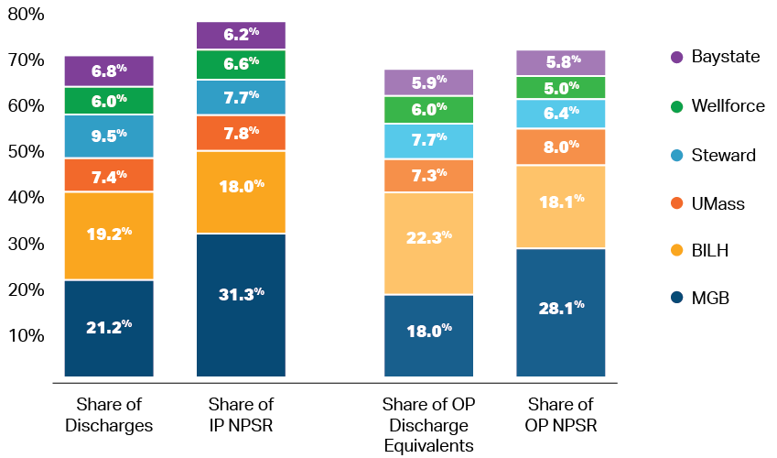
Source: CHIA Hospital Profiles Databook, supra note 64.
Notes: Current provider affiliations (as of December 2021), including corporate and contracting affiliations; includes general acute care hospitals only. Figures reported above are for all payers, including commercial (managed and non-managed), Medicare (managed and non-managed), Medicaid (managed and non-managed), ConnectorCare, Health Safety Net, other government, and other (including self-pay and worker’s compensation).
For physician services, in 2018, MGB had the largest share of both primary care physicians (19%) and specialists (30%) in Massachusetts.

System Share of Primary Care Physicians and Specialists (2018)

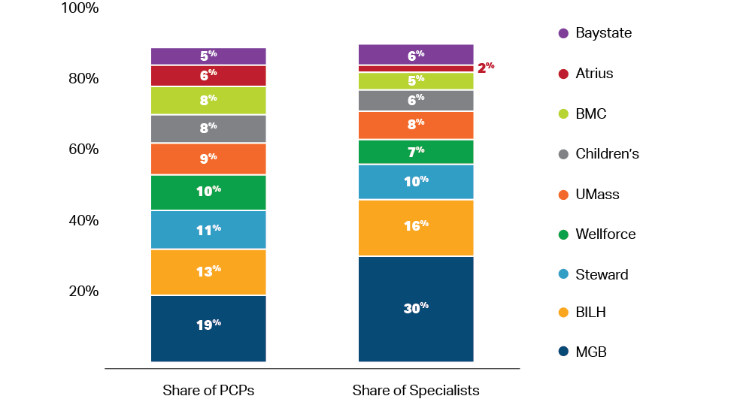
Source: MA-RPO Data, supra note 166.
Notes: 2018 data were reported separately by Beth Israel Deaconess Care Organization and Lahey Health System (prior to the BILH merger) but combined for the purpose of this analysis.

In calendar year 2018, MGB also provided the largest share of adult primary care physician services for patients insured by one of the three largest commercial payers and the had highest share of commercial statewide member months.

System Share of Adult Primary Care Services and Member Months (2018)

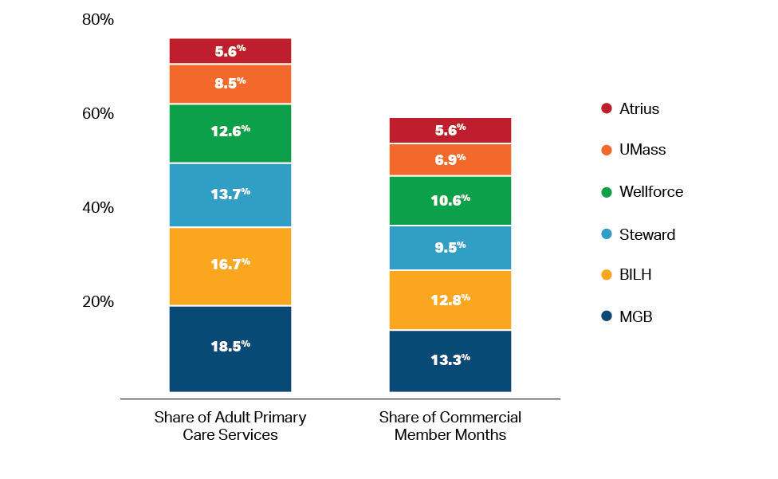
Source: All-Payer Claims Database, supra note 169; MA-RPO Data, supra note 166, Total Medical Expenses, supra note 167.
Notes: Reflects physician affiliations as of December 2021.

Appendix II.B: MGB’s Commercial Pricing

In the most recent year of data, MGB’s average inpatient and hospital outpatient relative prices were the highest of all Massachusetts hospital systems for the three largest commercial payers in Massachusetts, largely but not solely driven by significantly higher prices at MGH and BWH. MGB’s physician group pricing was also generally higher than other Massachusetts hospital systems; generally only physician groups without an affiliated hospital (which have a different financing structure) had higher pricing.

Physician Group and System Average Hospital Relative Price
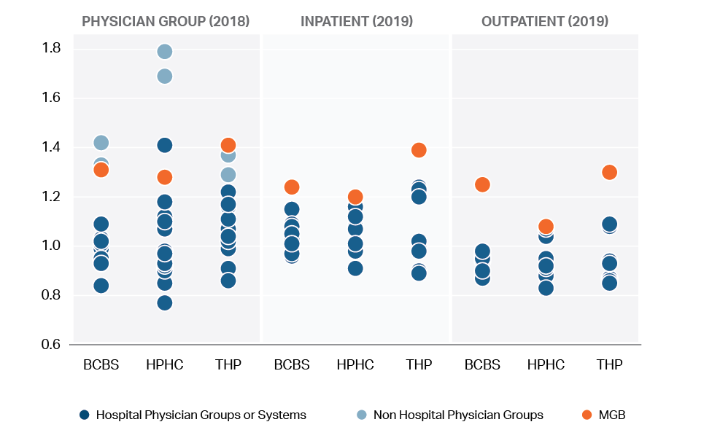
Source: HPC analysis of CHIA Relative Price Databook, supra note 12.
Notes: Because relative price is calculated individually by payer, the price level associated with each payer’s network average relative price (1.0) is not the same for different payers. Therefore, relative price should not be compared across payers.
Comparator physician groups include: Atrius, BIDCO, Boston Medical Center Mgt Service, Lahey Clinical Performance ACO/Physician Community Organization, Lawrence General IPA, Lowell General PHO, Mt. Auburn IPA, New England Quality Care Alliance (NEQCA), Partners Community Physician Organization, Reliant Medical Group, Signature Healthcare Medical Group, South Shore PHO, Southcoast Physicians Group (/Network), Steward Network Services and UMass Medical Group.
Comparator systems include: Baystate Health, Beth Israel Lahey Health, Boston Medical Center, Independent Community Hospitals, Mass General Brigham, Steward Health Care, Tenet Healthcare, UMass Memorial Health Care, Wellforce.
At the hospital level, we compared MGB inpatient and outpatient relative prices to comparator AMC and community hospitals. We found that MGH and BWH had higher inpatient and outpatient relative prices compared to other Massachusetts AMCs. MGB community hospitals’ relative prices were also higher than most, but not all, community hospital comparators.

MGB and Comparator Hospital Relative Price

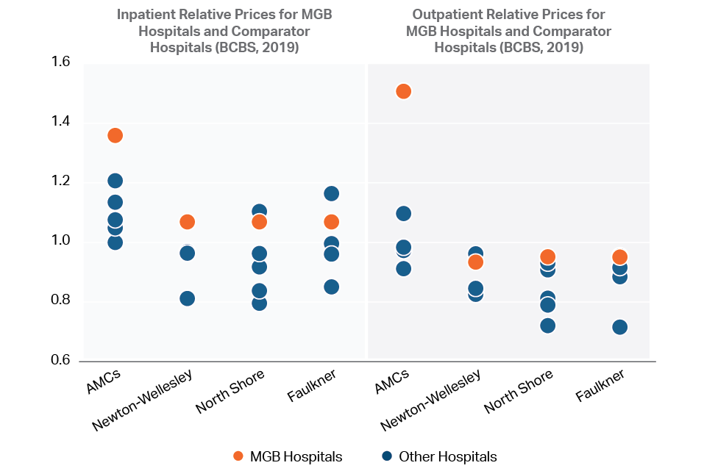
Source: HPC analysis of CHIA Relative Price Databook 2019.
Comparators: AMC (Beth Israel Deaconess Medical Center, Tufts Medical Center, Boston Medical Center, Lahey Hospital and Medical Center, UMass Memorial Medical Center, Brigham and Women's Hospital, Massachusetts General Hospital), Community Hospitals Comparators: Newton-Wellesley Hospital (Beth Israel Deaconess Hospital – Needham, MetroWest Medical Center, Mount Auburn Hospital), North Shore Medical Center (Northeast Hospital (Beverly Hospital), MelroseWakefield Healthcare (formerly Hallmark Health), Cambridge Health Alliance, Winchester Hospital, Lawrence General Hospital) Brigham and Women's Faulkner Hospital (Steward Carney Hospital, Steward Norwood Hospital, Beth Israel Deaconess Hospital – Milton, Steward St. Elizabeth's Medical Center)

Average Price of GI Endoscopy in a HOPD by Hospital, 2018, With Percent Change in Price, 2016 – 2018

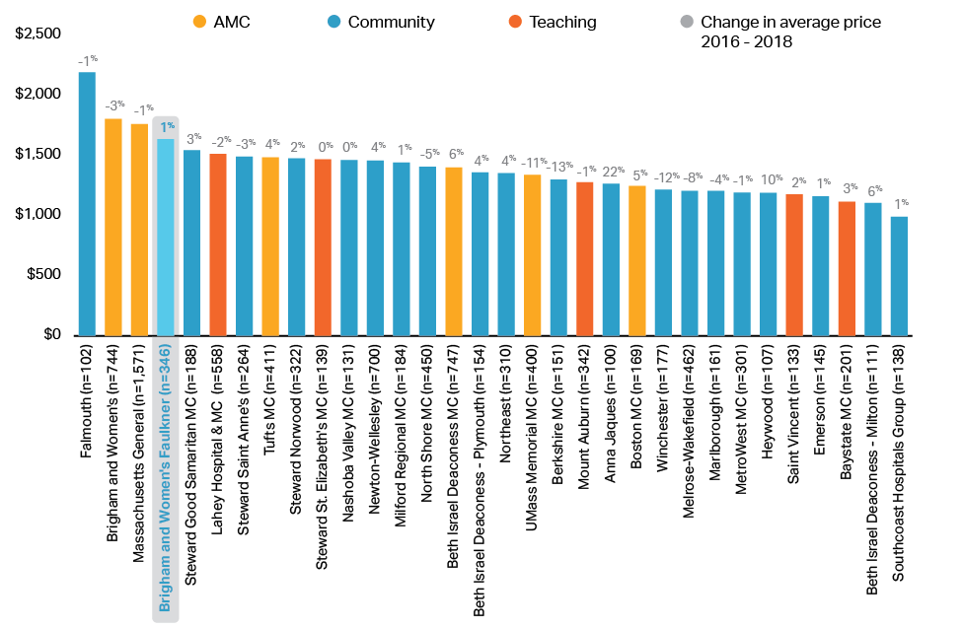

Sources: HPC analysis of CHIA APCD 2016-2018.
Notes: Prices reflect encounters (same person, same date of service, same procedure code) to capture the potential for both facility and professional claims billed on the same day. GI endoscopy (CPT 43239, ‘Esophagogastroduodenoscopy’). Prices for services paid under global payment arrangements or other non-fee-for-service methods are not included in the calculation of average price. Percent change in average price by HOPD between 2016 and 2018 is listed in grey above each price bar.
Appendix II.C: Hospital and Physician Quality Measures and MGB Case Mix
MGB Hospital Quality and Acuity Mix

The HPC evaluated hospital quality by examining three composite outcomes measures that evaluate risk-adjusted inpatient mortality for certain procedures and conditions (IQI 90 and IQI 91, respectively) and observed-to-expected ratios for 11 measures of patient safety and adverse events (PSI 90). Measure results were calculated based on the 2019 CHIA Hospital Discharge Database, and we compared identified lower or higher hospital performance on each measure based on whether a given hospital’s performance was statistically significantly different (i.e., outside of the confidence interval) compared to statewide average performance. On the IQI 90, all MGB hospitals performed in line with the statewide average. On IQI 91, MGH and BWH performed below the statewide average; the remaining MGB hospitals performed in line with the statewide average. On the PSI 90, BWH and Newton-Wellesley Hospital performed above the statewide average; they were the only two hospitals in the state to perform above the statewide average.

We also obtained performance data from CMS for two global measures of patient experience in hospitals: Overall Rating of Hospital and Willingness to Recommend Hospital. We analyzed “top-box” response rates for each measure. The “top-box” score indicates how often patients selected the most positive response category when asked about their hospital experience. Responses of either “9” or “10” are considered top-box for the Overall Rating of Hospital measure; a response of “Definitely yes” is considered top-box for the Willingness to Recommend Hospital measure. Six of MGB’s nine acute care hospitals performed above the statewide average on both measures in 2019. One MGB hospital, North Shore Medical Center, performed below the statewide average on patients’ overall rating of the hospital and no MGB hospitals performed below the statewide average on patients’ willingness to recommend the hospital.

The HPC assessed the acuity mix of patient care delivered at MGB hospitals as compared to all other hospitals in Massachusetts by examining the case weight of primary Medicare Diagnosis Related Group (DRG) codes for discharges in the CHIA 2019 Hospital Discharge Database. Higher case weights are given to DRGs for higher-acuity care. The HPC found that MGB hospitals, like all other Massachusetts hospitals, treat substantial amounts of lower-acuity inpatient care in addition to higher-acuity care. Excluding normal newborns, patients with primary behavioral health DRG codes, and non-Massachusetts residents, the HPC sorted all discharges by Medicare DRG weight into quintiles, with the bottom quintile reflecting the 20% of lowest-acuity DRGs and the top quintile reflecting the 20% of highest-acuity DRGs. On an all-payer basis, the three lower quintiles account for 71% of discharges and 58% of patient days for Massachusetts hospitals statewide, and 69% of discharges and 53% of patient days for MGB hospitals. Although the proportion of lower-acuity care is somewhat smaller for MGH (64% of discharges, 47% of bed days), these data suggest that most patients using MGH and Faulkner could receive inpatient care at other Massachusetts hospitals.

MGB Physician Group Quality

For physician quality performance, we examined the performance of MGB physician groups on 27 NCQA Healthcare Effectiveness Data and Information Set (HEDIS) measures as reported by CHIA. MGB physician groups performed above the statewide average on four of the 27 measures and worse than the statewide average on eight of the 27 measures.

We also examined 14 adult and 17 pediatric measures of primary care patient experience as reported by CHIA. On adult primary care patient experience measures, MGB practices performed better than the statewide average on 9 measures and comparable to the statewide average on 5 measures. On pediatric primary care patient experience measures, MGB practices performed better than the statewide average on one measure and comparable to the statewide average on 16 measures.

Appendix II.D: Low-Value Care for MGB and Other MA Providers
Low-value care refers to medical services recognized by clinicians as not based on evidence and typically unnecessary. In the 2021 Cost Trends Report Chartpack, the HPC reported on seven measures of low-value care across three domains (screening, pre-operative, and procedures). MGB performed slightly better than average on two pre-operative testing measures and slightly below average on spinal injections for lower back pain.
Low-value Pre-operative Testing and Procedures (2018)
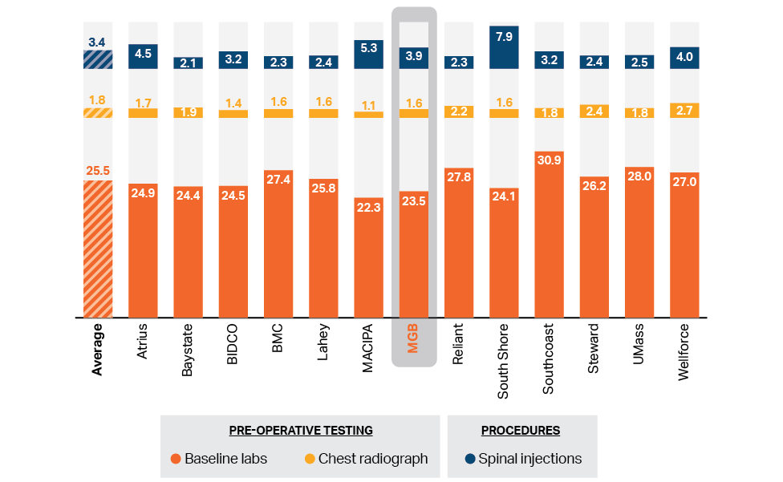
Source: HPC analysis of CHIA All-Payer Claims Database, 2018.
Notes: Lower rates indicate better performance. Baseline labs = Baseline labs in patients without significant systemic disease undergoing low risk surgery; Chest radiograph = Chest radiographs occurring less than 30 days before a low or intermediate risk non-cardiothoracic surgical procedure (not associated with inpatient or emergency care). Based on a patient’s medical history and inclusion criteria for each low value measure, a patient could be counted in multiple measures. Average reflects rate for all commercial patients, including patients not attributed to a listed provider organization.
MGB’s rates were higher than average on two screening measures (T3 and Vitamin D) and lower than average on the stress testing metric.

Low-value Screenings: T3 (Thyroid), Cardiac Stress, and Vitamin D (2018)
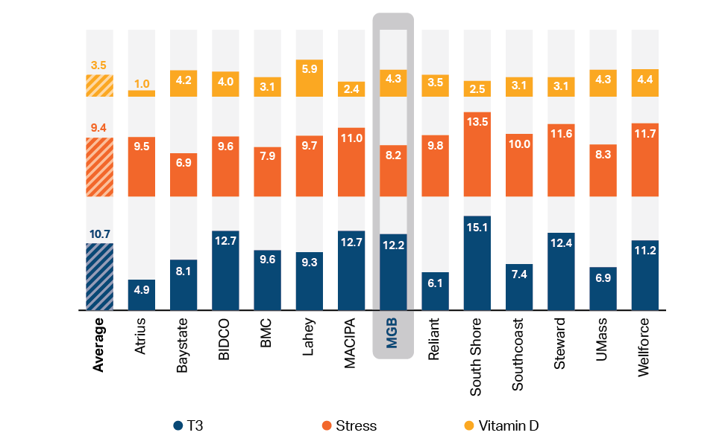
Source: HPC analysis of CHIA All-Payer Claims Database, 2018.
Notes: T3 = Total or free T3 level measurement in a patient with a hypothyroidism diagnosis during the year; Stress = Stress testing for patients with an established diagnosis of ischemic heart disease or angina at least 6 month before the stress test, and thus not done for screening purposes; Vitamin D = Population based screening for 25-OH-Vitamin D deficiency (all adults). Based on a patient’s medical history and inclusion criteria for each low value measure, a patient could be counted in multiple measures. Average reflects rate for all commercial patients, including patients not attributed to a listed provider organization.

The HPC also examined provider spending on these low-value services. In 2018, MGB had the second-highest low value spending per 100 patients. Spending reflects both the number of low value services per patient and the average price for those services. As noted above, MGB often provides low value services at a level comparable to other Massachusetts provider organizations; however, MGB has significantly higher prices than most other providers.

Spending for Seven Low Value Services per 100 Patients and Volume of Attributed Members, by Provider Organization, 2018
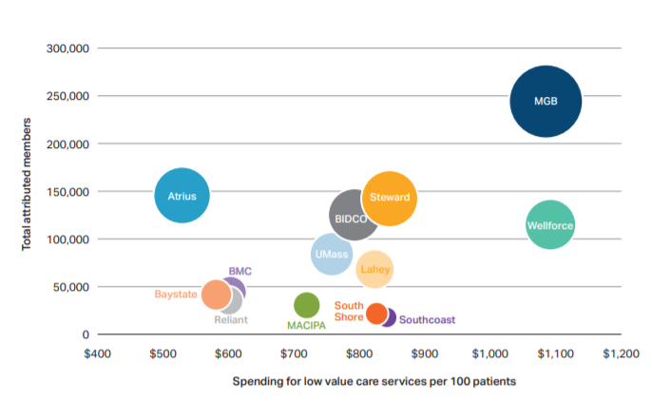

Source: HPC analysis of CHIA All-Payer Claims Database, 2018.
Notes: Low value spending across all seven measures was summed by provided organization and then divided by the total number of commercial adult attributed patients and reported as a rate per 100 patients. Results for the low value stent procedure are not presented by provider organization due to small numbers at some organizations in the two previous charts but are included here in overall spending. Patients included in this population were not restricted to 12 months of continual coverage, N=1,117,933.

Appendix II.E: Total Medical Expenses for MGB Primary Care Patients

The HPC examined MGB’s unadjusted total medical expenses (TME) and health status adjusted total medical expenses (HSA TME) for the three largest commercial payers in Massachusetts to understand its baseline spending levels relative to other provider groups. For each of these payers, Partners Community Physician Organization (PCPO, MGB’s largest provider group, now known as Mass General Brigham Community Physicians) always had both TME and HSA TME above the network average, and frequently had one of the highest levels of both adjusted and unadjusted spending from 2014 to 2018 compared to other provider groups. In the preliminary 2019 data, MGB’s TME and HSA TME continues to be among the highest both among commercial payers and for Tufts Medicare Advantage (4% higher than network average for comparable area providers), the only Medicare Managed Care Plan in which MGB participates that is reported in publicly available data.

Unadjusted TME and HSA TME Levels, 2014 & 2018
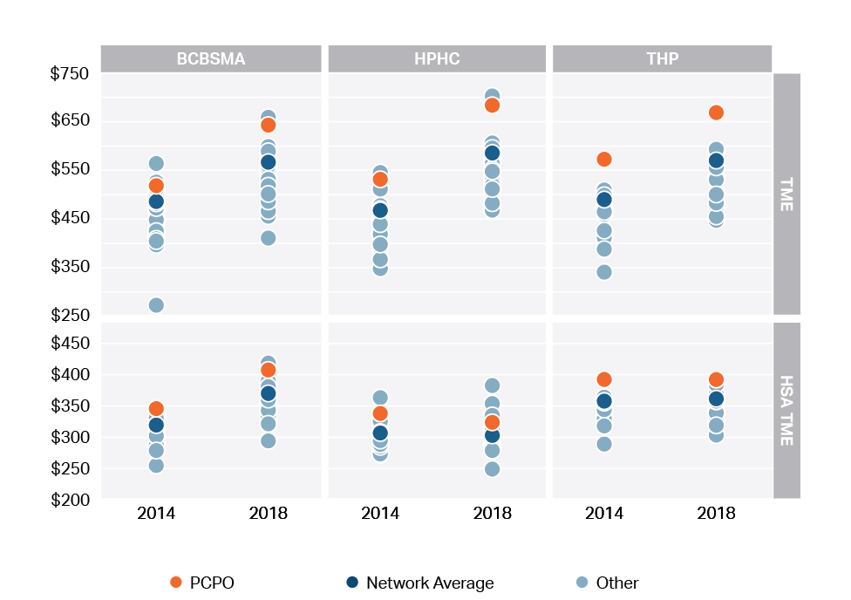
Source: HPC analysis of CHIA Total Medical Expense Data (2014-2019).

PCPO also had a higher rate of unadjusted spending growth compared to the network average of those same three commercial payers between 2014 and 2019.

Unadjusted TME Growth of PCPO Compared to the Payer’s Network Average (2014-2019)
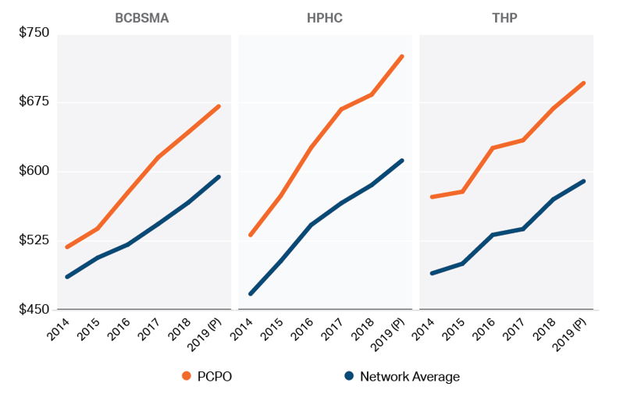
Source: HPC analysis of CHIA Total Medical Expense Data (2014-2019).
Appendix II.F: MGB Hospital Payer Mix Relative to Other Hospitals

The HPC examined the inpatient and outpatient payer mix of MGB hospitals relative to other hospital systems and relative to MGB hospitals’ primary service areas (PSAs). In fiscal year 2019, MGB had the highest average commercial mix compared to all other hospital systems. MGB had the lowest average public payer mix (57%), and more specifically the lowest Medicaid mix (13%), compared to all other hospital systems statewide. ,

Weighted Average System Inpatient and Outpatient Payer Mix (2019)
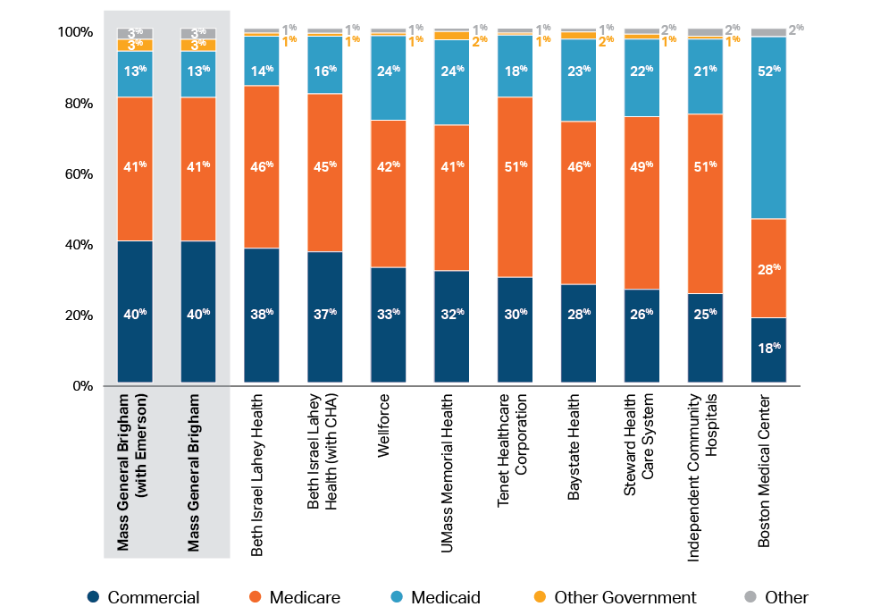
Source: HPC analysis of CHIA Hospital Profiles Databook, supra note 64.
Notes: Current affiliations (as of December 2021); affiliations include corporate and contracting affiliations; includes general acute care hospitals only.

Examining inpatient discharges alone, from 2009 to 2019 MGB’s inpatient commercial mix was consistently the highest of all hospital systems and its Medicaid mix was the lowest relative to other systems. MGB’s inpatient Medicare mix was either comparable to or lower than that of other major systems over the ten-year period.,

Since there are regional differences within Massachusetts regarding the proportion of patients covered by commercial, Medicare and Medicaid, we also compared each hospital’s inpatient payer mix to the mix of inpatients in that hospital’s primary service area (PSA). We found that many MGB hospitals have higher shares of inpatients with commercial insurance and lower shares of inpatients with Medicare and Medicaid, as compared to the overall mix in the hospital’s service area, with these differences often being greater than for hospitals of other systems.

Inpatient Payer Mix at Hospital Systems Compared to PSA (2019)

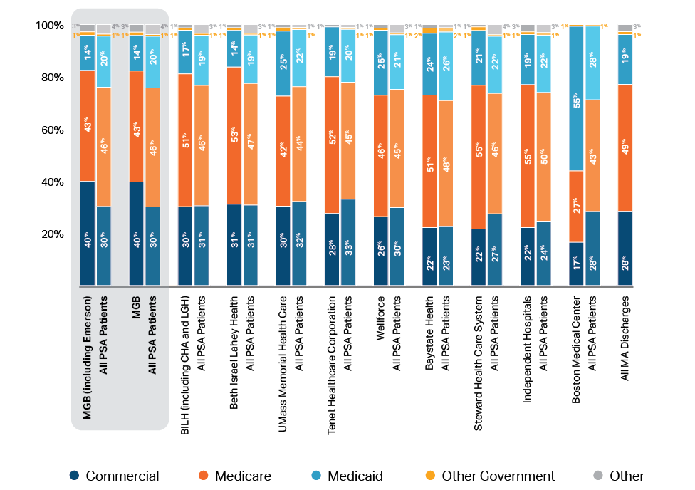
Source: HPC analysis of CHIA 2019 hospital discharge data.
Notes: In this analysis, Commonwealth Care Plans, Free Care, and Health Safety Net are all grouped under Medicaid. Self Pay/Other includes auto insurance, secondary payers, self-pay, worker’s compensation, and other non-managed care. In 2019, Boston Medical Center (BMC) reported a major decline in Medicaid discharges and a major increase in Self Pay discharges. After reviewing the data, CHIA determined that most of those discharges reported as self pay were ultimately paid for by Medicaid. As such, for BMC alone, we have grouped self pay discharges with Medicaid discharges, instead of with discharges with Other Government payers.

Appendix II.G: MGB Primary Care Patient Panel Characteristics

Payer mix at each health system is directly tied to socioeconomic characteristics of the health system’s patient panel. Relative to other Massachusetts providers, MGB primary care patients generally come from higher income communities with fewer indicia of social need compared to almost all other systems in Massachusetts.,

Provider Organization | Median Zip Code Income of Attributed Patients (2016) | Area Deprivation Index (2018)
MACIPA | $105,065 | 10.7
MGB (with Emerson) | $103,738 | 17.2
MGB | $103,738 | 17.2
Children's Medical Center Corporation | $103,337 | 17.3
BILH (with contracting affiliates) | $101,397 | 15.2
Wellforce | $100,693 | 19.6
Atrius | $100,680 | 15.4
South Shore | $99,381 | 17.3
BILH (corporate system) | $98,978 | 16.0
Reliant | $91,706 | 29.0
Steward | $83,346 | 24.9
UMass | $80,943 | 34.3
Southcoast | $80,221 | 32.9
BMC | $74,069 | 23.1
Baystate | $68,042 | 42.2

Sources: APCD 6.0, 2014-2016; MA-RPO and SK&A data, 5-year American Community Survey demographic and housing estimates, 2019, Neighborhood Atlas Area Deprivation Index (ADI) 2018.
Notes: Income and ADI are reported at the zip-code level for primary care patients attributed to the provider organization’s physicians. For a system that negotiates payer contracts on behalf of physician organizations that it does not own (i.e., MGB contracts on behalf of Emerson and BILH contracts on behalf of CHA and MACIPA) we calculated the median zip code income and area deprivation index of attributed patients both for the corporate system alone and for the system, including contracting affiliate physician organizations.
Appendix II.H: Racial and Ethnic Mix at MGB Hospitals

The HPC examined the race and ethnicity of MGB hospital patients compared to the mix of patients in the hospitals’ PSAs. Given the availability and completeness of data, we could only conduct analyses on race and ethnicity for inpatient care. As a whole, MGB hospitals serve a lower proportion of inpatients who are Black, Indigenous, and people of color (BIPOC) compared to the mix of patients in the hospitals’ service areas., MGB hospitals, along with Tenet Healthcare, had the greatest difference between the number of inpatients self-reporting as BIPOC compared to the total mix of inpatients reporting as BIPOC in the hospitals’ PSAs. This pattern was consistent over a ten-year period.

Inpatient Racial/Ethnic Mix at Hospital Systems Compared to PSA (FY 2019)
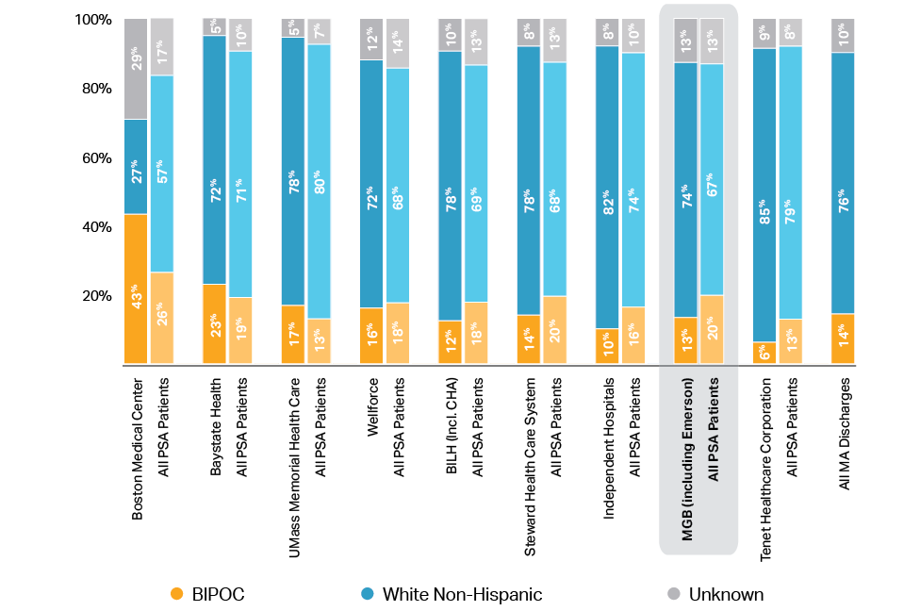
Source: HPC Analysis of the Center for Health Information and Analysis (CHIA), Hospital Inpatient Discharge, FY2019.
Notes: Hospital affiliations are based on 2021 affiliations. Systems include contracting affiliates.

We also examined the race/ethnicity of MGB’s AMCs compared to other Massachusetts AMCs. We found that MGH and BWH served proportionally fewer BIPOC patients and discharged fewer BIPOC patients in FY 2019 despite having more total discharges.

Discharges by Race/Ethnicity at AMCs (2019)
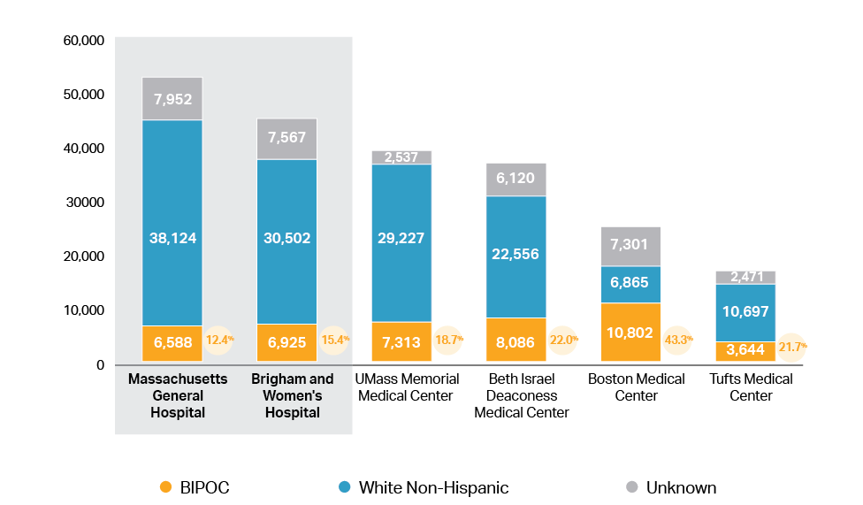
Source: HPC Analysis of CHIA 2019 hospital discharge data.

Appendix II.I: Financial Metrics for MGB and Other Large Massachusetts Providers

Metric | Year | MGB | BILH | Wellforce | UMass | Baystate
Total net assets (millions) | 2018 | $8,973 | $3,139 | $621 | $1,016 | $1,102
 | 2019 | $9,748 | $3,065 | $693 | $1,077 | $1,085
 | 2020 | $10,620 | $3,053 | $727 | $1,055 | $1,132
Net assets to total assets ratio | 2018 | 49.00% | 50.50% | 34.00% | 41.00% | 50.70%
 | 2019 | 45.90% | 48.20% | 33.60% | 40.40% | 49.00%
 | 2020 | 42.40% | 41.60% | 26.70% | 32.30% | 39.80%
Operating revenue (millions) | 2018 | $13,307 | $5,668 | $1,936 | $2,487 | $2,382
 | 2019 | $13,951 | $3,638 | $2,055 | $2,825 | $2,376
 | 2020 | $14,059 | $6,274 | $2,137 | $2,811 | $2,507
Operating margin | 2018 | 2.20% | -0.20% | 0.20% | -2.80% | 2.20%
 | 2019 | 3.50% | 1.20% | 0.00% | 4.60% | 2.30%
 | 2020 | -2.40% | 0.50% | -0.50% | -2.00% | 1.40%
Total margin | 2018 | 6.00% | 1.70% | 2.00% | -0.80% | 2.80%
 | 2019 | 3.50% | 2.80% | 5.90% | 7.50% | 3.00%
 | 2020 | 1.80% | 1.20% | 1.40% | -0.80% | 1.80%
MGB has substantially greater financial resources than other Massachusetts provider systems. Based on a review of hospital system financial information for fiscal years 2018 through 2020, MGB’s total net assets and operating revenue were consistently greater than the next four largest systems combined. Compared to these other large Massachusetts provider systems, MGB also had a higher average total margin over those three fiscal years. MGB has publicly stated that its financial position has been improving over the past several years, including in FY20, and the system posted a positive operating margin in FY21.
Source: HPC analysis of CHIA Annual Acute Hospital and Health System Financial Performance Reports, FY2018 – FY2020.
Notes: 2020 revenue and margin figures include state and federal COVID-19 relief funding received by each provider organization. 2019 cash flow metrics for BILH represent partial year data from March 1 through Sept. 30. 2018 figures for BILH represent a combination of CareGroup and Lahey predecessor organization financials. Steward Health Care has been omitted due to noncompliance with state reporting requirements.
Appendix IV.A: Impacts of Population Growth and Demographic Change on Utilization

The following examples illustrate that demographic changes alone often cannot be used to predict future utilization. Indeed, health care utilization tends to be driven by a number of other factors such as health care payment policies, technology advances, provider supply, and physicians’ clinical approaches more than by changes in total population and aging.

The HPC constructed a projection of future demand for total inpatient bed days based on demographic shifts starting in 2010. We started with actual 2010 bed days across all Massachusetts hospitals, segmented by age cohort. We then applied changes in population by age cohort to baseline utilization, similar to the methodology described in the MGH and Faulkner ICAs. As illustrated below, this method would have produced a predicted increase in demand for inpatient beds of over 19%. However, actual inpatient bed days statewide increased by 0.7% through 2019.

Predicted Inpatient Bed Day Growth Based on Demographic Trends Compared to Actual Growth (2010-2020) 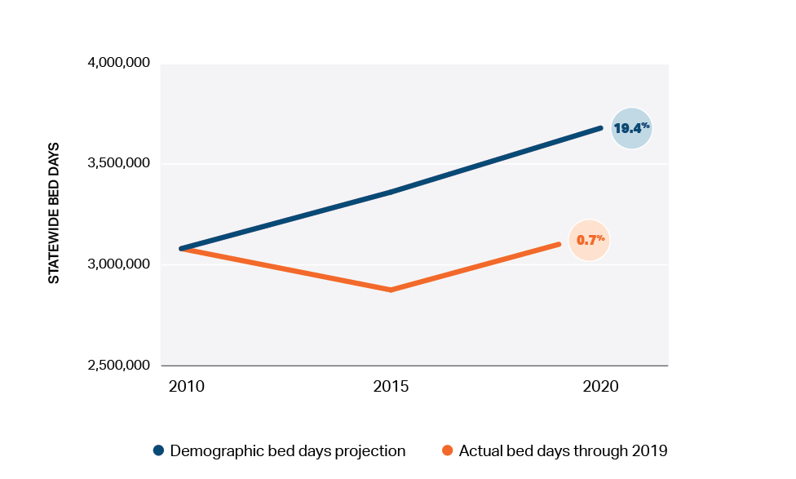
Source: HPC analysis of CHIA hospital discharge data 2010-2019 and UMass Donahue Institute population projections (2018), available at https://donahue.umass.edu/business-groups/economic-public-policy-research/massachusetts-population-estimates-program/population-projections.

A recent Brookings Institute paper examining trends in utilization of advanced imaging (including MRIs, CT scans, and nuclear scans) among Medicare beneficiaries illustrates that changes in utilization due to demographic changes are far outweighed by supply-side factors. Total imaging utilization was roughly 17.6 million among 40 million Medicare beneficiaries in 2000. Imaging use grew rapidly over the decade (by 85%, or 59% per beneficiary) to nearly 33 million scans in 2009. Over the next decade, from 2009 to 2018, the Medicare population grew 25%. Thus simple demand projections based on demographic change, performed in 2009, would have likely projected demand, and thus utilization of advanced imaging, in Medicare to grow at least 25% by 2018, to more than 40 million scans. Yet, in fact, total imaging utilization fell by 21% over this period (37% on a per-beneficiary basis), to under 26 million scans in 2018. The drop largely stems from a series of policy decisions made by CMS that reduced payment rates for imaging and changed the basis of payment, along with changing technology.

Appendix IV.B: Ambulatory Sites Indicia of Social Need
The immediate areas around the proposed ambulatory sites generally have relatively lower indicia of social need as compared to the Commonwealth as a whole and as compared to the region in which those sites are proposed to be located.
 | Social Determinant of Health Indicators | Zip codes ≤10 min drive | HPC Region | Statewide
WESTWOOD | Limited English Speaking Households | 2% | 2% | 6%
 | Population Reporting as Non-White Race | 15% | 12% | 22%
 | Population that was Unemployed (Ages 16+) | 3% | 3% | 4%
 | Population with any Medicaid/Means-Tested Public Coverage (Ages ≤64) | 9% | 10% | 20%
 | Population with Income to Poverty Ratio <1.24 (%) | 5% | 7% | 14%
WOBURN | Limited English Speaking Households | 4% | 4% | 6%
 | Population Reporting as Non-White Race | 17% | 20% | 22%
 | Population that was Unemployed (Ages 16+) | 2% | 3% | 40%
 | Population with any Medicaid/Means-Tested Public Coverage (Ages ≤64) | 10% | 13% | 21%
 | Population with Income to Poverty Ratio <1.24 (%) | 8% | 9% | 14%
WESTBOROUGH | Limited English Speaking Households | 3% | 5% | 6%
 | Population Reporting as Non-White Race | 26% | 16% | 22%
 | Population that was Unemployed (Ages 16+) | 2% | 4% | 4%
 | Population with any Medicaid/Means-Tested Public Coverage (Ages ≤64) | 7% | 21% | 20%
 | Population with Income to Poverty Ratio <1.24 (%) | 6% | 14% | 14%

Social Determinant of Health Indicators
Higher % Represents Greater SDOH Burden
Statewide or regional indicator higher than immediate area near site
Statewide or regional indicator lower than immediate area near site
Source: HPC analysis of Agency for Healthcare Research and Quality, Social Determinants of Health Database (Beta Version), available at https://www.ahrq.gov/sdoh/data-analytics/sdoh-data.html. Measures assessed included Sum of Households with Limited English Speaking, Sum of Population Reporting as Non-White Race, Sum of Population that was Unemployed (Age 16 Years +), Sum of Population with Any Medicaid/Means-Tested Public Coverage (Ages 64 and Under) and Sum of Population with Income to Poverty Ration < 1.24. We compared the communities within a 10-minute drive of the Westwood site to the HPC’s Norwood/Attleboro region; communities within a 10-minute drive of Woburn to the Merrimack/Middlesex region; and communities within a 10-minute drive of the Westborough site to the HPC’s Central MA region. For further information on HPC regions, see Mass. Health Policy Comm’n, 2013 Cost Trends Report Technical Appendix (Jan. 2014), available at https://www.mass.gov/doc/b3-regions-of-massachusetts/download.

Mass. Gen. Laws ch. 111, § 25C(g), (h), and (i). See also 105 CMR 100.100, definition of “Party of Record” stating that a Party of Record may provide written comment for consideration by the Department, “including written comment by the…HPC as it relates to any independent cost-analyses made pursuant to 106 CMR 100.405”. Upon release of the ICAs for the above-referenced applications, DPH further emphasized this important role. See Independent Cost Analysis Reports for the Mass General Brigham Applications, Mass. Dept. of Pub. Health, https://www.mass.gov/alerts/independent-cost-analysis-reports-for-the-mass-general-brigham-applications#2093871 (last visited Jan 23, 2022).
See Mass. Health Policy Comm’n, Presentation by David Seltz and Dr. David Auerbach: Health Care Spending and Affordability in Massachusetts 11-18 (Nov. 17, 2021), available at https://www.mass.gov/doc/full-2021-cost-trends-hearing-presentation/download.
See Determination of Need for Substantial Capital Expenditure and Substantial Change in Service at MGH (Jan. 21, 2021), available at https://www.mass.gov/doc/mass-general-brigham-incorporated-mgh-application-form-and-attachments/download; Determination of Need for Substantial Capital Expenditure and Substantial Change in Service at Brigham and Women’s Faulkner Hospital (Jan. 21, 2021), available at https://www.mass.gov/doc/mass-general-brigham-incorporated-bwfh-application-form-and-attachments/download; Determination of Need for Ambulatory Surgery, Clinic Substantial Capital Expenditure, and purchase of DoN-required equipment (Jan. 21, 2021), available at https://www.mass.gov/doc/mass-general-brigham-incorporated-multisite-application/download and at https://www.mass.gov/doc/mass-general-brigham-incorporated-multisite-application-attachments/download.
MGB simultaneously announced the creation of a similar ambulatory site in Salem, NH, stating that the Salem site and the three Massachusetts sites would cost nearly $400 million in total. The Salem site is not subject to review by the Massachusetts DoN program. See Madeline Hughes, Eagle Tribune, Partners Healthcare announces Salem location, at https://www.eagletribune.com/news/new_hampshire/partners-healthcare-announces-salem-location/article_7b9838b3-4176-59bf-b538-36c11efc3cc0.html (Dec. 2019).
Mass. Gen. Laws ch. 111, § 25C(h).
These figures assume that MGB will achieve approximately 50% of its expected market share increases from its larger multiyear ambulatory expansion plan through the three ambulatory sites currently proposed, as detailed in Section III.A.2. The HPC does not have sufficient information about the multiyear ambulatory expansion plan to assess whether 50% is a reasonable expectation for the three proposed sites. If MGB achieves 25% of its expected market share increases instead of 50%, the commercial spending impact from the ambulatory expansion would be $7.1 million to $18.9 million, the total commercial spending impact across the projects would be $43.8 million to $81.2 million each year, and the loss of commercial revenue at non-MGB providers would be $145.6 million to $231.8 million each year.
Independent cost-analysis for MGB DoN application for Substantial Capital Expenditure and Substantial Change in Service at MGH, available at https://www.mass.gov/doc/independent-cost-analysis-2/download; Independent cost-analysis for MGB DoN application for Substantial Capital Expenditure and Substantial Change in Service at Brigham and Women’s Faulkner Hospital, available at https://www.mass.gov/doc/independent-cost-analysis-1/download; Independent cost-analysis for MGB DoN application for Ambulatory Surgery, Clinic Substantial Capital Expenditure, and purchase of DoN-required equipment, available at https://www.mass.gov/doc/independent-cost-analysis-4/download.
MGB reports that approximately 30 to 50 beds are “blocked” in semi-private rooms daily due to patient need. Determination of Need for Substantial Capital Expenditure and Substantial Change in Service at MGH, Narrative at 11, (Jan. 21, 2021) [hereinafter MGH DoN Application], available at https://www.mass.gov/doc/mass-general-brigham-incorporated-mgh-application-form-and-attachments/download.
Id.
See Determination of Need for Substantial Capital Expenditure and Substantial Change in Service at Brigham and Women’s Faulkner Hospital, (Jan. 21, 2021), [hereinafter Faulkner DoN Application], available at https://www.mass.gov/doc/mass-general-brigham-incorporated-bwfh-application-form-and-attachments/download
See Determination of Need for Ambulatory Surgery, Clinic Substantial Capital Expenditure, and purchase of DoN-required equipment, (Jan. 21, 2021), [hereinafter Ambulatory DoN Application], available at https://www.mass.gov/doc/mass-general-brigham-incorporated-multisite-application/download; Application by Mass General Brigham for Determination of Need – Multisite 21012113-AS, Narrative 3 (Jan. 21, 2021) [hereinafter Ambulatory Narrative], available at https://www.mass.gov/doc/mass-general-brigham-incorporated-multisite-application-attachments/download.
MGH DoN Application, supra note 8, Appendix 2, DoN Narrative at 1.
Note that “patient panel”, as used by the Determination of Need program, means all patients seen by the applicant over the past 36 months. See 105 CMR 100.100.
Ambulatory Narrative, supra note 11 at 15.
Faulkner DoN Application, supra note 10, Appendix 2, DoN Narrative at 24.
While MGB describes these projects as consistent with the Commonwealth’s cost containment goals, it misstates that those goals are related solely to TME. See Ambulatory Narrative, supra note 11, at 3. TME is a measure reflecting all medical spending for a provider’s primary care patients, and it can be a useful accountability tool for understanding spending for a given provider’s patient population. However, because it is expressed as a per-member-per-month amount, it does not generally reflect growth in a provider’s patient population over time. While the movement of patients from a lower-cost provider system to a higher-cost provider system may not impact those providers’ TME, it could have a significant impact on total health care expenditures (THCE) in the state.
Mass. Gen. Laws ch. 111, § 25C(h).
The independent cost-analyses were conducted by a team led by Dr. Sean May.
Office of Atty. Gen. Maura Healey, Examination of Health Care Cost Trends and Cost Drivers Pursuant to G.L. c. 12C, § 17. Report for Annual Public Hearing Under G.L. c. 6D, § 8 (Nov. 17, 2021) [hereinafter MGB Internal Document Disclosures], available at https://www.mass.gov/doc/ago-examination-into-cost-drivers/download. These materials were released publicly at a summary level. The underlying documents have not been made publicly available, and the HPC did not have access to any underlying documents. The HPC sought to make reasonable assumptions based on the information disclosed. The HPC’s assumptions are noted throughout this document.
As a party of record to the DoN review process, but without having separate authority to review the proposals, the HPC did not have the authority to pose questions to the applicant directly or to solicit confidential data or information as part of its review.
Independent cost-analysis for MGB DoN application for Substantial Capital Expenditure and Substantial Change in Service at MGH [hereinafter MGH ICA], available at https://www.mass.gov/doc/independent-cost-analysis-2/download, at https://www.mass.gov/doc/tables-2/download, https://www.mass.gov/doc/maps-3/download; Independent cost-analysis for MGB DoN application for Substantial Capital Expenditure and Substantial Change in Service at Brigham and Women’s Faulkner Hospital [hereinafter Faulkner ICA], available at https://www.mass.gov/doc/independent-cost-analysis-1/download, at https://www.mass.gov/doc/tables-0/download, https://www.mass.gov/doc/maps-1/download; Independent cost-analysis for MGB DoN application for Ambulatory Surgery, Clinic Substantial Capital Expenditure, and purchase of DoN-required equipment [hereinafter Ambulatory ICA], available at https://www.mass.gov/doc/independent-cost-analysis-4/download, at https://www.mass.gov/doc/tables-4/download, https://www.mass.gov/doc/maps-5/download.
MGB Internal Document Disclosures, supra note 19 (also describing that MGH expects that the new hospital margin from the ambulatory sites would outweigh any losses from diverting care to the ambulatory sites).
MGH ICA, supra note 21, Figure MGH22.
Faulkner ICA, supra note 21, Figure BWFH14.
See Appendix II.A.
HPC analyses of market share are generally in line with those of the ICAs. The ICAs report that MGB has the highest share in MGH’s service area for overall inpatient services, including across cancer services, heart and vascular services, and other services, with shares ranging from 32% (other inpatient services) to 45% (inpatient cancer services). See MGH ICA, supra note 21, at Figure MGH15. Similarly, the ICA reports MGH and other MGB facilities consistently have the highest combined shares in MGH’s service areas for all outpatient services examined (outpatient CT scans, MR scans, PET/CT scans, cardiovascular procedures, and oncology visits). See MGH ICA, supra note 21, at Figures MGH17 through MGH21. The ICA also reports that MGB has the largest share in Faulkner’s service area for inpatient services with 38% and MR scans with 32.6%. See Faulkner ICA, supra note 21, at Figures BWFH10 and BWFH12. The Ambulatory ICA similarly finds that MGB already has the largest or second-largest share for all services examined in all three ambulatory service areas (largest share of CT scans, MR scans, and surgical procedures for Westwood and MR scans for Woburn; second largest share for CT and surgical procedures for Woburn and for CT scans, MR scans, and surgical procedures for Westborough). See Ambulatory ICA, supra note 21, at Figures ICC9 through ICC17.
MGB has surpassed all other providers in new outpatient locations and expansions in recent years. Between 2014 and 2019, MGB created or was approved for construction of 17 new facilities (nine for urgent care centers), while the system with the next highest number of new facilities was approved for six. MGB also had seven expansion projects during this time that were subject to DoN review (four for advanced imaging services). MA-RPO data, infra note 166; DoN Completed Projects, Mass. Dept. of Public Health, at https://www.mass.gov/info-details/don-completed-projects (last visited Dec. 17, 2021); DoN Pending Projects and Applications, Mass. Dept. of Public Health, at https://www.mass.gov/info-details/don-pending-projects-and-applications (last visited Dec. 17, 2021).
See MGB Internal Document Disclosures, supra note 19, detailing expected market share increases in connection with MGB’s larger multi-year ambulatory expansion plan. The DoN applications and ICAs also reinforce that MGB expects its market share to grow as MGB projects far higher increases in volume in its DoN applications than those predicted by demographics alone. For example, the MGH ICA projects an increase in CT volume of 16% and an increase in PET/CT volume of 17% by 2030 based on demographics alone, whereas MGB projects an increase of CT volume of 77% and an increase in PET/CT volume of 112% at MGH. See MGH ICA, supra note 21 at 45 and Figure MGH14.
See, e.g., Office Of Att’y Gen. Martha Coakley, Examination Of Health Care Cost Trends And Cost Drivers Pursuant To G.L. c. 118G, § 6 ½(B): Report For Annual Public Hearing (Mar. 2010), available at https://www.mass.gov/doc/2010-examination-of-health-care-cost-trends-and-cost-drivers-with-appendix/download; MA Health Policy Comm’n, 2015 Cost Trends Report Provider Price Variation (Jan. 2016) [hereinafter HPC Provider Price Variation Report], available at http://www.mass.gov/ago/docs/healthcare/cctcd5.pdf at https://www.mass.gov/doc/2015-cost-trends-report-provider-price-variation/download; Massachusetts Health Policy Commission, Review of Partners HealthCare System’s Proposed Acquisition of Massachusetts Eye and Ear Infirmary, Massachusetts Eye and Ear Associates, and Affiliates (HPC-CMIR-2017-1) (Jan. 2018) [hereinafter PHS-MEE Final CMIR Report], available at https://www.mass.gov/doc/final-cmir-report-phs-mee-0/download.
See Appendix II.B.
See Section III.A.3.
See Appendix II.C for a comparison of the acuity mix of MGB hospitals compared to other Massachusetts hospitals. As described in the DoN applications, MGB is proposing to expand oncology, cardiology, and radiology services at MGH; endoscopy and imaging services at Faulkner; and surgical, imaging, and physician services at three new ambulatory sites in Massachusetts. Across all services examined in the MGH and Faulkner ICAs, MGH’s and Faulkner’s respective market shares in their services areas are expected to increase, with new volume drawn from other providers. This implies that there are currently other providers in the service areas that can and do provide these services. Likewise, the Ambulatory ICA shows the predicted increases to MGB’s market share for CT scans, MR scans, and surgical procedures in the Westborough, Westwood, and Woburn service areas, predicting that the proposed facilities will draw patients from other provider organizations. Other providers also provided extensive testimony that they have available capacity to provide the services proposed in the Ambulatory DoN. See, e.g., Comments on MGB Multisite DoN Application by Robert Andrew Wilkinson, Director of Finance for Ambulatory Surgery at Shields Health Care Group at 14 (April 6, 2021) and Comments on MGB Multisite DoN Application by Douglas Brown, President of UMass Memorial Community Hospitals at 29 (April 16, 2021), available at https://www.mass.gov/doc/mass-general-brigham-public-comments-all-locations-batch-1/download.
Massachusetts Health Policy Commission, Review of Partners HealthCare System’s Proposed Acquisitions of South Shore Hospital (HPC-CMIR-2013-1) and Harbor Medical Associates (HPC-CMIR-2013-2) Pursuant to M.G.L. c. 6D, § 13 (February 2014), available at https://www.mass.gov/doc/final-cmir-report-partners-south-shore-harbor/download; PHS-MEE Final CMIR Report, supra note 29.
See Appendix II.C.
See Appendix II.D.
TME is expressed as a per member per month dollar figure that reflects the average monthly covered medical expenses paid by the payer and the member for all of the health care services the payer’s members receive in a year. TME includes the amounts paid by the payer and patient cost-sharing, and covers all categories of medical expenses (e.g., hospital, physician, and pharmacy expenditures) and all non-claims related payments to providers, including provider performance payments.
See Appendix II.E and Mass. Health Policy Comm’n, 2018 Cost Trends Report: Chartpack 32 (Feb. 2019), available at https://www.mass.gov/doc/2018-cost-trends-report-chartpack/download.
In 2019, MGB’s Health Status Adjusted (HSA) TME was 4% higher than the network average for comparable providers in Eastern Massachusetts for Tufts Medicare Advantage, as described in Appendix II.E.
See generally Mass. Health Policy Comm’n, Annual Cost Trends Hearing, Pre-Filed Testimony of Partners Health Care System and Mass General Brigham, available at https://www.mass.gov/service-details/annual-health-care-cost-trends-hearings.
See, e.g., Faulkner DoN application, supra note 10, attachments at 23 and 24.
See, e.g., MGH DoN application, supra note 8, attachments at 27 and 28.
See Appendix II.F.
See Appendix II.G.
See Appendix II.H.
See Appendix II.I.
Some aspects of the proposed projects, e.g., renovations and conversion of double-bedded rooms to single-bedded rooms absent the addition of capacity, are less likely to impact health care spending. The spending effects discussed in this section are specifically focus on those aspects of the proposed projects that will increase capacity at MGB facilities.
See note 50, infra.
We focus primarily on impacts on commercial market spending since, as discussed in Appendix I.A, the commercial market has a greater degree of price variation that drives spending impacts, and because commercial spending increases are expected to translate into higher commercial insurance premiums for Massachusetts residents and businesses. The HPC also reviews potential spending impacts for managed and non-managed Medicare and MassHealth identified in ICA analyses throughout this section.
The HPC expects significant spending and revenue impacts that it was not able to quantify at this time from: increased market share for MGB and increased market concentration for outpatient services that would allow it to negotiate even higher prices, net new utilization for supply-sensitive care (i.e. supply-induced demand and practice pattern shifts), increased outpatient referrals to MGB hospitals as a result of the ambulatory expansions, spending and revenue impacts from specialist physician services provided at the proposed ambulatory sites, and shifts of patients to higher-priced providers if projected revenue losses disrupt the operations of lower-priced providers. The HPC’s calculations are also likely to be conservative. For example, the HPC models commercial market spending impacts for outpatient services on data for BCBS, HPHC, and THP due to APCD data quality concerns for other payers; however, price differentials (and therefore spending impacts) are likely larger for smaller payers, meaning that commercial spending impacts are likely understated. Data for smaller and independent outpatient providers (which are generally lower-cost) are also often more limited and less reliable in the APCD, likely resulting in underrepresentation of those providers in our analyses. Finally, as described in note 48, supra, the HPC primarily modeled impacts for commercially insured patients where price differentials (which drive much of the spending increases) are the greatest; however, additional spending impacts are likely for other payer categories, particularly for Medicare plans and MassHealth Managed Care Organizations, which do not operate with standardized fee schedules.
See MGB Internal Document Disclosures, supra note 19, at 2-3. MGB’s presentations to bond investors regarding its ambulatory expansions explicitly refer to the expectation for increased “secondary and tertiary commercial referral volume.” Mass. General Brigham, Presentation by Dr. Anne Klibanski and Peter Markell at J.P. Morgan Healthcare Conference at 12 (Jan. 13, 2020) [hereinafter MGB J.P. Morgan Presentation], available at https://emma.msrb.org/ER1298616-ER1012536-ER1417697.pdf.
Ambulatory Narrative, supra note 11 at 1.
See footnote 50, supra.
This is consistent with MGB’s expectation for its multi-year ambulatory expansion plans that “New hospital margin from patient referrals from the ambulatory sites to MGB hospitals was projected to outweigh losses resulting from the shift of visits from MGB hospitals to the ambulatory sites.” MGB Internal Document Disclosures, supra note 19, at 2.
Ambulatory Narrative, supra note 11, at 10.
Ambulatory ICA, supra note 21, at 83 and Figure ICC28; MGB Internal Document Disclosures, supra note 19, at 3. The reason for the difference in estimates is unclear, and not addressed in the ICA. MGB’s plans for staffing may have changed subsequent to the creation of the documents described in the MGB Internal Document Disclosures, supra note 19, MGB may have already hired the PCPs that would be associated with the Westwood site, or MGB may have chosen not to disclose staffing increases planned for physician services at the Westwood site to the firm conducting the ICAs because those services are provided by existing MGB practices and MGB does not consider them part of the proposed project, as described in the Ambulatory Narrative, supra note 11, at 2 and 10. The Ambulatory ICA describes the expected staffing at the sites, but does not quantify the potential spending impacts associated with changes in TME for primary care patients, referrals by specialists to other MGB facilities, or the professional component of services at the ambulatory sites.
Application by Mass General Brigham for Determination of Need – Multisite 21012113-AS, Responses to DoN Questions 9 (Oct. 2021) [hereinafter Ambulatory Q&A], available at https://www.mass.gov/lists/don-mass-general-brigham-incorporated-multisite-21012113-as#mass-general-brigham-incorporated-%E2%80%93-mgh-%E2%80%93-responses-to-don-questions at 38-39 (“Mass General Brigham opened a new primary care practice in 2018 in the Westwood Site’s primary service area…. Primary care physicians were hired from existing practices in the area;” “Mass General Brigham added approximately 11 FTE primary care physicians in the Woburn Site’s primary service area between 2017 and 2020, by hiring primary care physicians from existing practices in the area”).
The HPC calculated the differential in 2018 CHIA commercial health status adjusted (HSA) TME between Partners Community Physician Organization (PCPO) and each other physician group for BCBS, HPHC, and THP. We applied the resulting differential to each physician group’s payer-specific unadjusted TME to calculate an estimated spending impact per patient transitioning to an MGB PCP. The HPC then weighted the spending impact for each provider group by the group’s share of primary care visits within each proposed service area to calculate a blended spending differential for an average patient in each service area transitioning to an MGB PCP. We applied this spending differential to the average unadjusted TME for non-MGB physician groups in each service area, weighted by the groups’ primary care visits within each service area.
MGB did not specify the expected size or payer mix of new PCP patient panels in its DoN application or supplemental filings. The HPC assumed a commercial payer mix of 47.5% based on the percent of commercial gross patient service revenue (charges), which does not generally vary by payer, for MGB’s physician groups reported by MGB to the MA-RPO program in 2021. This is likely to be an underestimate of the commercial mix for new MGB PCPs given that the commercial mix of MGB’s patients from the ambulatory PSAs is currently higher, as shown in the Ambulatory Narrative, supra note 11, at Attachment 4, and people living in the service areas for the proposed ambulatory sites tend to have relatively high incomes and lower rates of public assistance. See Section IV.D. The HPC assumes an average primary care patient panel size of approximately 2,000 patients based on a review of relevant literature.
HPC analysis of CHIA 2018 TME data, multiplying differences in TME (see supra note 57) by estimated number of new PCPs and MGB commercial mix (see supra note 58). When totaling spending impacts, the HPC discounts the spending impact in row 1 by the portion of TME for MGB’s primary care patients that represents spending on inpatient care received at MGB hospitals. This is due to the fact that that some proportion of the spending differentials between the primary care patients of MGB and those of other systems reflect increased use of MGB's higher-priced hospitals, which overlaps with the expectation described in Section III.A.3 of increased patient volume going to MGB hospitals as a result of the ambulatory expansion.
As an example, Tufts Medicare Advantage is the only managed Medicare payer for which CHIA TME data are available for PCPO. The HPC compared PCPO’s HSA TME for Tufts Medicare Advantage to the average HSA TME of all other provider groups serving Eastern Massachusetts, weighted by total member months. The HPC found that PCPO’s HSA TME for Tufts Medicare Advantage is approximately 4% higher than the average for other groups, suggesting that spending for these patients would increase as they join the patient panels of new MGB PCPs.
The HPC used 2018 CHIA All-Payer Claims Database (APCD) and Hospital Inpatient Discharge Database data to examine patients’ choices of hospitals for inpatient care. The HPC’s inpatient choice model is described in more detail in Appendix I.A. Adjusting for patient and hospital characteristics, the HPC found a statistically significant relationship between a hospital system’s shares of commercial adult physician visits and patient choice of hospitals of that system. This effect was found for both primary care and secondary care visits. The model estimates this effect only for patients living more than 15 minutes away from any chosen system hospital in order to minimize the confounding effect of physician visits conducted on hospital campuses.
The HPC used the model described id. to estimate that a 25% to 50% increase in MGB’s market share for specialist physician services in the service areas of the proposed ambulatory sites would result in the diversion of approximately 200 to 400 additional commercial discharges to MGB hospitals per year, increasing annual commercial spending by approximately $1.3 million to $2.6 million based on hospital and professional price differentials as described in Appendix I.A. The Ambulatory ICA tables (Figures ICC9 through ICC17) show predicted increases in MGB’s share of visits in the ambulatory service areas of greater than 25% across most service lines, supporting the range of modeled share increases. However, this model likely does not capture the full effect that ambulatory expansions may have on hospital volume and spending. First, our approach models only the effect of interactions between patients and physicians, rather than the broader potential impact of MGB activities, such as advertising, that may accompany the ambulatory centers. Second, we only measure the effect of hospital system physician share for patients residing more than 15 minutes away from a chosen system hospital because at lesser distances we cannot cleanly distinguish the effect of physician share from mere proximity to that hospital. Finally, we were not able to model similar potential impacts of the expansions on outpatient hospital volume.
MGH Internal Document Disclosures, supra note 19. MGB’s public submissions do not provide specific definitions of secondary and tertiary care. MGB’s focus in investor presentations on the potential of its multi-year ambulatory expansion to build commercial hospital referral volume, coupled with the use of the term “market share” in the Internal Document Disclosure, lead the HPC to believe that the projections relate primarily, if not exclusively, to commercial care.
The HPC calculated the number of discharges needed to increase MGB’s commercial market share by 1% and 4% based on analysis of current shares in the CHIA 2019 Hospital Inpatient Discharge Database. This increase in commercial discharges may not represent net new volume of discharges, but rather a shift toward a higher mix of commercial patients at MGB hospitals as MGB draws patients from communities with higher rates of commercially insured patients. To the extent the change in market share would be driven by new discharges, they would increase the occupancy rate of MGB hospitals system-wide from 64.8% to between 75.8% to 77.1%, and capacity constraints at MGB’s AMCs could result in more of the new care being provided in MGB’s community hospitals where occupancy rates are lower. HPC analysis of CHIA 2019 hospital discharge data and 2019 Hospital Profiles. Ctr. For Health Info. & Analysis, Massachusetts Hospital Profiles Databook (Mar. 2021) [hereinafter CHIA Hospital Profiles Databook], available at https://www.chiamass.gov/hospital-profiles/.
This shift would result in increased annual commercial revenue for MGB ($19.1 million to $76.5 million for half of the expected market share growth from the larger multiyear ambulatory expansion) and decreased revenue for other hospitals (-$14.6 million to -$58.6 million). If MGB achieved only a quarter of its projected market share increase rather than half, this would translate into an annual commercial spending increase of $2.2 million to $8.9 million, with MGB gaining $9.6 million to $38.2 million in annual commercial revenue and other providers losing $7.3 million to $29.3 million. Note that these ranges are large due to uncertainty about the scope of MGB’s multiyear plan and estimates, as HPC did not have access to the underlying assumptions and calculations upon which the market share changes in the MGB Internal Document Disclosures were based.
The HPC calculated commercial spending and revenue impacts of increases in MGB commercial inpatient market shares by calculating revenue per discharge at each MGB hospital, using BCBS, THP, and HPHC 2019 hospital revenue in CHIA’s Relative Price Databook. After weighting discharges and revenue by the proportion of discharges from Eastern Massachusetts at each MGB hospital, we applied several econometric models of hospital choice for inpatient care to determine which other hospitals would otherwise likely have served the discharges and estimated spending and revenue shifts as described in Appendix I.A. The spending and revenue shift figures above represent the most conservative model, generally assuming that MGB hospitals would divert care more often from higher-priced hospitals and assuming payment on a case mix of 1.0 rather than assuming MGB would attract higher case mix patients more similar to the acuity of current MGB hospital patients, for which payment rates are higher.
The MGH and Faulkner ICAs predict spending increases for managed and non-managed Medicare and MassHealth care as patients divert to fill new beds at MGH and new outpatient capacity at both hospitals. MGH ICA, supra note 21, at Figures MGH22 through MGH27; Faulkner ICA, supra note 21, at BWFH13. Because we would expect the majority of new commercial discharges to go to MGH and BWH as MGB’s market share grows, we would expect net spending increases for non-commercial payers across the MGB system based on the spending increases modeled in the MGH ICA.
Ambulatory Narrative, supra note 11, at 15 and footnote 44. Although MGB states in response to questions from the DoN program that its goal is for ambulatory site rates to be “50% less than Mass General Brigham AMC rates and 25% less than Mass General Brigham community hospital rates” (Ambulatory Q&A, supra note 56, at 52), these two calculations would produce substantially different price points, as shown by the separate scenarios using each assumption in the Ambulatory ICA. Ambulatory ICA, supra note 21, at 64 and Figures ICC18 through ICC26. We assume ambulatory site rates will be 25% lower than MGB community hospital rates given that this was the differential stated in the Ambulatory DoN application. We estimate prices for the proposed ambulatory sites using an average of prices at Faulkner and Newton-Wellesley Hospital in the 2018 CHIA All-Payer Claims Database for relevant services, applying a 25% discount to facility rates.
MGB describes the ambulatory expansion as reducing TME. Even if it were to reduce MGB’s TME, the expansion would not necessarily reduce total health care expenditures or be consistent with the health care cost containment goals of the Commonwealth. As described in note 16, a provider’s TME may not change as members shift in or out of that provider network. However, shifts from a lower-cost to higher-cost provider network, as described here, could nonetheless have a substantial impact on total health care expenditures.
The HPC calculated commercial prices per visit for each outpatient service cluster, including both facility and professional payments as described in Appendix I.A. The HPC calculated weighted average prices under three scenarios: (1) care would shift only from MGB hospitals proportional to their current shares in the service areas; (2) care would shift from all current providers proportional to their current shares; and (3) care would shift only from non-MGB providers proportional to their current shares. For the top five CPTs by volume in each clinical cluster, the HPC observed the average price differential between these weighted prices and an estimated MGB ambulatory site rate, described supra note 68, and applied this differential to the weighted average price for the entire cluster to arrive at a service mix adjusted estimate of the MGB ambulatory rate under each scenario.
MGB provided only service line level descriptions of services it intends to provide at the proposed ambulatory sites. The HPC defined outpatient service clusters for outpatient services as described in Appendix I.A.
MGB defines the patient panel for the proposed ambulatory sites as all persons who live within the proposed service areas and received care from one of its hospitals or physician groups in the prior three years. See Ambulatory Narrative, supra note 11 at 4, footnote 3, for a full description of providers MGB includes in its patient panel for the ambulatory sites. MGB assumes that 100% of these patients who have an MGB PCP and 50% of patients of other PCPs will transfer their care to the proposed sites after a three-year ramp-up period. Ambulatory Narrative, supra note 11, at 8.
Id. at 16. MGB does not provide expected savings by surgical service line or separately for MRI and CT services. It does not identify the volume of care that would be expected to shift from any specific hospital to the new sites to generate the estimated savings. MGB’s savings estimates do not account for any backfill of volume at its hospitals as patients move to the new site.
Ambulatory Q&A, supra note 56 at 9 (“In 2016, Mass General Brigham conducted consumer research to better understand how consumers in Eastern Massachusetts make choices about which healthcare providers and services to use…. The Applicant used this information to inform its projection that 50% of Mass General Brigham patients that do not have a Mass General Brigham PCP would be willing to receive their care at one of the Project Sites – assuming their consumer preferences track with the general market”).
HPC analysis of CHIA All-Payer Claims Database 2015 – 2018. See Appendix I.A for a description of diagnostic CT and MRI service definitions.
This assumption is likely to overstate potential savings, as smaller, lower-priced area providers may be less able to take steps to retain commercial patients than larger, higher-priced providers.
The last scenario modeled shows that each service provided at the ambulatory sites that would not have been provided at some other location had the ambulatory site not existed would increase total spending. This is an estimate of the per-case impacts of supply-sensitive utilization for these services. The ICAs dismiss the probability that additional capacity will result in additional unwarranted utilization, but examine the question narrowly and ignore documented provider practice variation in Massachusetts, as described in Appendix I.B. Although we therefore think it likely that some supply-sensitive utilization of outpatient care would increase spending across all payers as a result of the expansions, we conservatively do not incorporate such increases into our spending impacts except for the TME spending impacts for primary care patients discussed in Section III.A.1, which inherently incorporate practice pattern variation.
The savings per case estimated by MGB, in many cases, is as great as the entire allowed amount for a visit of the relevant type observed by the HPC in the APCD.
The HPC’s estimated commercial savings per case shifting to the ambulatory sites under a proportional diversion model is 22.3% for CT, 28.6% for MR, and 1.6% for ambulatory surgery across all three service areas. The Ambulatory ICA, in Figures ICC18 through ICC26, predicts commercial savings per case shifted of 16% to 24% for CT, 24.4% to 27.3% for MR, and 2.6% to a spending increase of 6.1% for ambulatory surgery. See Ambulatory ICA, supra note 21, at Figures ICC18 through ICC26.
The HPC considers backfill likely given: (1) the lack of declines in volume at MGB HOPDs for advanced imaging despite its current community-based advanced imaging sites, (2) MGB’s Ambulatory Q&A states that it “did not analyze the… shift of ASC eligible procedures on an origin/destination site-specific basis,” and (3) MGB does not identify any expected reduction in volume or capacity at any of its HOPDs as a result of the proposed expansions. Ambulatory Q&A, supra note 56, at 12, 15, and 26. The impact of backfill is likely to be more substantial than the HPC has quantified, as other providers will also try to backfill any care diverted to the MGB sites, with higher-priced provider organizations with greater resources more likely to succeed. This would lead to the greatest net losses falling to smaller and generally lower-priced providers, and further reducing or eliminating any savings from care shifting to the ambulatory sites. The ICAs assume no backfill at MGB hospitals, as discussed in Appendix I.B.
See Appendix I.A for a description of the HPC’s methodology for calculating MGB hospital backfill spending differentials.
While the HPC only quantified the impact of MGB backfilling diverted volume from its HOPDs, it is likely that other providers that would see a shift in volume to MGB would try to backfill that volume as well. If higher-priced providers were more able to backfill diverted commercial volume as compared to lower-priced providers, this dynamic would also increase spending, further reducing or eliminating any savings from diverting care to the proposed ambulatory sites.
The HPC based its spending and revenue impact calculations on the total capacity for CT, MRI, and ambulatory surgeries identified by MGB in its DoN application, using the greater of the annual expected throughput per CT or MRI unit or operating room or the expected cases per site at the end of the three-year ramp-up. These figures assume MGB HOPDs backfill cases diverted to the ambulatory sites, and that all care would otherwise have been provided by another provider. MGB did not provide the expected payer mix of cases at the ambulatory sites; the HPC assumed a 40% commercial patient mix across all service lines based on MGB’s hospital outpatient payer mix calculated from gross patient service revenue in CHIA’s FY19 Hospital Profiles Databook. See CHIA Hospital Profiles Databook, supra note 64. This may be an underestimate of the likely commercial mix for the relevant services, as MGB’s patient panel for the proposed ambulatory service areas currently has a higher commercial payer mix. Ambulatory Narrative, supra note 11, Attachment 4: Patient Panel.
This shift would result in increased annual commercial revenue to MGB of approximately $24.2 million to $28.2 million and a loss of annual commercial revenue for other providers of $27.6 million to $31.6 million.
See supra note 48.
In addition to potential commercial spending impacts of patients shifting to the ambulatory sites for other physician services, for which MGB did not provide sufficient information for the HPC to formulate a potential spending impact, other factors include: shifts from lower-priced clinic-based providers more difficult to identify in in THP and HPHC claims data as discussed in note 70; the likelihood that smaller and non-system affiliated providers, which tend to be lower-priced, may also be less able to take steps to retain or backfill volume than higher-priced providers; and supply-sensitive utilization as discussed in note 77.
See Appendix II.B.
See Ambulatory ICA, supra note 21, at Figures ICC9 through ICC17. Although the ICA shows predicted changes in shares on an all-payer basis, it predicts commercially insured patients would make up a substantial portion of shifting volume, and MGB would gain commercial market share if the proportion of care shifting from other local providers (see Figures ICC18 through ICC26) is higher than the commercial payer mix of those providers.
HPC analysis of CHIA All-Payer Claims Database 2018.
See, e.g., U.S. Dep’t of Justice & Fed. Trade Comm’n, Horizontal Merger Guidelines § 5.3 (2010), available at http://www.justice.gov/atr/public/guidelines/hmg-2010.pdf (describing the use commercial market share and market concentration as key screening tools for market changes that may enhance market power); see also HPC Provider Price Variation Report, supra note 29, at 12.
HPC Provider Price Variation Report, supra note 29, at 13.
This finding is in contrast to those of the ICAs, which are addressed in Appendix I.B. A multivariate regression model, described in Appendix I.A, suggests that if MGB achieves its full expected increase in inpatient discharges as a result of its multi-year ambulatory expansion, it would be expected to have system-wide inpatient prices that are 0.1% to 0.52% higher than its current prices. This would translate to an annual increase in commercial spending of $1.0 million to $5.3 million, and reflects only the impact of increased commercial inpatient market share on prices. Increased commercial market share for other services (e.g. physician services) would also likely increase MGB’s bargaining leverage and commercial prices.
See Section IV.A for a discussion of the implications of these revenue shifts on health equity.
MGH DoN Application, supra note 8; Faulkner DoN Application, supra note 10.
MGH DoN Application, supra note 8, Appendix 2, DoN Narrative at 11.
MGB’s responses to questions from DPH regarding bed planning projections mention a further 24 beds currently licensed but not operational that would become operational as part of the proposed project. Mass General Brigham, MGH Bed Summary 2 – 3 (Oct. 2021) [hereinafter MGH Bed Summary], available at https://www.mass.gov/doc/mass-general-brigham-incorporated-mgh-bed-summary-0/download. These beds are not discussed in any other part of the application and do not appear on MGB’s Change in Service filed with the DoN application. These beds appear to be distinct from currently blocked beds, which are discussed separately in MGH’s Bed Summary. The MGH ICA includes these 24 beds in its modeling but omits consideration of capacity that would become available as blocked beds are decompressed. MGH ICA, supra note 21, at 2 (“a net increase in the number of licensed beds at MGH of 94 and a net increase in the number of operational beds at MGH of 118”).
MGH percent increase in medical/surgical beds based on a denominator of 889 operational beds as described in MGH Bed Summary, supra note 96 at 3.
See projected utilization in MGH DoN Application, supra note 11; Faulkner DoN Application, supra note 10.
The HPC examined the acuity mix of patient care delivered at MGB hospitals as compared to all other hospitals in Massachusetts using the CHIA 2019 HDD and found that MGB hospitals, like all other Massachusetts hospitals, treat substantial amounts of lower-acuity inpatient care in addition to higher-acuity care. See Appendix II.C.
The MGH and Faulkner ICAs support this assumption, as the diversion model used in the ICAs assumes patients filling new MGH and Faulkner capacity could use other hospitals. See Faulkner ICA, supra note 21, at 44 to 46 (Indicating that diversion ratios “can be used to predict which competing hospitals BWFH would attract patients from if the proposed project…were approved” and that the ICAs “calibrate the demand model so that the predicted increase in inpatient volume at BWFH exactly matches MGB’s inpatient volume projections…”).
See Section IV.C. The models used by both the HPC and ICAs predict shifts specifically for Massachusetts patients, although the HPC’s model assumes that some proportion of new care at MGH and Faulkner would be for patients from outside Massachusetts, as described in note 103, and thus have no impact on spending for Massachusetts payers.
The HPC’s preferred model of inpatient diversion assumes that newly proposed capacity would be filled by patients who would otherwise have received care at non-MGB hospitals, or that other MGB hospitals would backfill any care shifting to MGH and Faulkner. We consider this likely given that MGB has not suggested that the projects will reduce the total volume of inpatient care at its other hospitals, despite extensive discussion in the Faulkner Narrative of opportunities to provide care at Faulkner that otherwise would be provided at BWH. Such shifts from AMCs to Faulkner would reduce spending, with the HPC estimating annual commercial savings of up to $1.2 million if Faulkner drew inpatients from MGB hospitals (excluding MGH); however, absent evidence that total volume will fall at other MGB hospitals, we consider this scenario less likely. The ICAs assume no backfill at other MGB sites, as described in Appendix I.B.
See Appendix I.A for detail on the HPC’s methodology for calculating volume and spending impacts. The HPC’s higher volume model assumes an increase in bed capacity of 144 at MGH (including 50 beds no longer blocked) and 78 beds at Faulkner, with commercial mix, out-of-state patient mix, and length of stay equal to current levels. The HPC’s lower volume model assumes 30 beds no longer blocked at MGH for a net increase in capacity of 124, and a decrease in commercial mix and increase in out-of-state patient days equal to the changes at each hospital from 2009 to 2019, adjusting rates for ICU beds separately for MGH projections. The lower volume model also assumes an increase in average length of stay for all patients equal to statewide increases from 2009 to 2019. Both models assume utilization rates equal to those provided in MGB’s Change in Service forms; this may represent a conservative approach for MGH, as some supplemental filings indicate a higher projected utilization rate. Mass General Brigham, MGH – Applicant Response Submission Excel File tab 3.a (Oct. 2021), available at https://www.mass.gov/doc/mass-general-brigham-incorporated-mgh-applicant-response-submission-excel-file-1/download (showing projected occupancy rates of 94% for med/surg beds and 81% for ICU beds). Due to the lack of clarity from MGB regarding the 24 beds discussed supra note 96, the HPC did not include these beds in its diversion models of new volume at MGH. However, since the further addition of 24 beds to the proposed capacity increase of 124 – 144 beds at MGH would represent a 16% to 19% greater inpatient expansion, we estimate ranges of volume and spending impacts for MGH based on an increase of this scale.
These shifts in discharges would result in increased annual commercial revenue to MGB of between $133.1 million and $211.2 million and a loss of annual commercial revenue for other providers of $106.6 million to $166.8 million.
MGH ICA, supra note 21, at Figure MGH22; Faulkner ICA, supra note 21, at Figure BWFH13. As discussed in supra note 102, because the ICAs assume MGH and Faulkner would draw care from other MGB hospitals with no backfill, the they likely predict lower spending increases for MGH and greater savings for Faulkner across all payers than if one assumes MGB would try to divert care preferentially from competitors or backfill newly-available capacity.
MGH DoN Application, supra note 8; Faulkner DoN Application, supra note 10; MGH ICA, supra note 21, at 24-26; Faulkner ICA, supra note 21, at 26-27.
As discussed in note 100, the approach used in the ICAs to model patient diversion assumes, as we do, that patients could choose other providers for the relevant services. Both the MGH and Faulkner applications state that some of the proposed capacity across some of these expanded services would support inpatients, particularly patients filling proposed new inpatient capacity. The proportion of new capacity expected to be devoted to inpatient and outpatient care is not always clear from the project descriptions provided by MGB.
We note that the ICA finds a likelihood that MRI scans shifting to Faulkner would increase commercial spending slightly rather than decreasing it as the HPC’s model predicts. This likely due to differences in the providers from which the ICA predicts Faulkner would divert care and the HPC’s assumption that diversion would be proportional to current market shares in Faulkner’s 75% outpatient hospital service area.
See Appendix II.B (showing Faulkner having the fourth highest commercial hospital price for outpatient GI endoscopy procedures in 2018, 12% higher than the statewide average). The HPC did not examine whether Faulkner’s prices for advanced endoscopy, specifically, were similarly high, given the limited volume in the relevant codes.
The HPC estimated outpatient capacity increases for new advanced imaging units at MGH and Faulkner based on MGB projected annual outpatient scan volume per MRI and CT unit in the Ambulatory Narrative, reduced by 32% for Faulkner based on the proportion of Faulkner MRI capacity currently serving outpatient referrals. Faulkner DoN Application, supra note 10, Appendix 2, at 20. In the absence of a similar description of the proportion of MGH imaging capacity serving outpatients, the HPC assumed that 60% of new imaging volume for MGH’s proposed CT and MR units would be used for outpatient care. The HPC assumed commercial payer mix for new volume would be the same as each hospital’s current inpatient and outpatient (GPSR) commercial payer mix.
These shifts would result in increased annual commercial revenue to MGB of approximately $4.6 million and a loss of annual commercial revenue for other providers of $4.2 million.
MGH ICA, supra note 21, at Figures MGH23 through MGH26; Faulkner ICA, supra note 21, at Figure BWFH14.
HPC analysis of CHIA FY2019 Hospital Profiles, supra note 64. The total increase would depend on the number of currently blocked beds that would become available at MGH and whether 24 licensed beds would be returned to service as part of the proposed MGH project, as described in Section III.B.1.
See Appendix I.A. An academic paper cited by the ICAs assessing the impact of concentration of hospital beds also suggests that the hospital expansions would increase MGB’s prices. MGH ICA, supra note 21, at 62-63, citing Zack Cooper et al., The Price Ain’t Right? Hospital Prices and Health Spending on the Privately Insured, 134 Quarterly Journal of Economics, 51 (2019) [hereinafter Cooper et al 2019] available at https://www.ncbi.nlm.nih.gov/pmc/articles/PMC7517591/ (The HPC estimates a 0.24% increase in MGB hospital prices based solely on the proposed addition of beds at MGH and Faulkner based on partial replication of the Cooper model, which would translate to over $3.5 million in additional annual commercial spending based on 2019 MGB hospital inpatient revenue. We were not able to fully replicate the Cooper model, as the paper includes coefficients for concentration that allow us to evaluate the impacts of an increase in beds but does not include the coefficients controlling for the level of beds overall).
HPC analysis of CHIA hospital relative price data.
See Section IV.A for a discussion of the implications of these revenue shifts on health equity.
MGH DoN Application, supra note 8, Appendix 2, DoN Narrative at 1; Faulkner DoN Application, supra note 10, Appendix 2 DoN Narrative at, at 1; Ambulatory Narrative, supra note 11, at 1.
See Mass. Gen. Laws ch. 6D, § 5; Mass. Gen. Laws ch. 6D, § 13(d).
To the extent MGB’s expanded capacity it filled by increases in total utilization of services by patients rather than by literal shifts of patients, these losses would represent MGB absorbing revenue from services that could have been provided by other systems, rather than declines in current patient service revenue. As discussed in Appendix I.B, it is not clear that projections by MGB or in the ICAs of increased utilization are sound, particularly for inpatient care. Even if they are sound, the diversion model used in the ICAs is based on the assumption that patients could use other providers for that care. Whether utilization filling MGB’s expansions is current or net new, the result is fewer dollars available to other providers that generally serve larger proportions of patients covered by MassHealth and communities with higher indicia of social need.
The HPC previously discussed this dynamic in its report Community Hospitals at a Crossroads. Mass. Health Policy Comm’n, Community Hospitals at a Crossroads 60-61 (Mar. 2016), [hereinafter Crossroads Report] available at https://www.mass.gov/files/documents/2016/07/xf/community-hospitals-at-a-crossroads.pdf. As discussed in the ICA for the ambulatory project, literature on the impacts of ASCs on hospital outpatient surgery supports the probability of significant volume and revenue shifts. See Ambulatory ICA, supra note 21, at 42-44, citing Carey et al., Hospital Competition and Financial Performance: The Effects of Ambulatory Surgery Centers, 20 Health Economics 571 (2011), available at https://onlinelibrary.wiley.com/doi/abs/10.1002/hec.1617 (finding that decreases in revenue for competing hospitals were larger than decreases in those hospitals’ costs); Ariel Winter, Comparing the mix of patients in various outpatient surgery settings, 22 Health Affairs (2003), available at at https://www.healthaffairs.org/doi/full/10.1377/hlthaff.22.6.68 (finding that hospital outpatient departments treat beneficiaries who are more medically complex, and that ASCs may therefore incur lower costs when providing similar procedures); Chad. D. Meyerhoefer, Margaret S. Colby, & Jeffrey T. McFetridge, Patient mix in outpatient surgery settings and implications for Medicare payment policy, 69 Medical Care Research and Review (2012), available at https://journals.sagepub.com/doi/10.1177/1077558711409946 (finding that for four common outpatient surgeries, ASCs treat less severe patients and benefit from positive selection); David Wenner, Health care gold mines: outpatient centers rack up big profits in Harrisburg area and all over Pa., PennLive (November 20, 2014), available at https://www.pennlive.com/midstate/2014/11/health_care_costs_harrisburg_p.html (news coverage on a report by the Pennsylvania Health Care Cost Containment Council finding high margins for Pennsylvania outpatient surgery centers and determining that they are significantly more profitable than regular hospitals).
Kathleen Carey, Ambulatory Surgery Centers and Prices in Hospital Outpatient Departments, 74 Medical Care Research and Review 236 (2017), available at https://pubmed.ncbi.nlm.nih.gov/26951624/ (Finding, for four common procedures, lower prices at HOPDs in markets with more ASCs per capita, likely due to the HOPD having less negotiating leverage with commercial insurers); Laurence C. Baker, MK Bundorf, & Daniel P. Kessler, Competition in Outpatient Procedure Markets, 57 Medical Care 36 (2019), available at https://pubmed.ncbi.nlm.nih.gov/30507654/ (finding ASC availability associated with decreases in prices paid to hospital outpatient departments, but cautioning, “Any conclusions about the broader welfare implications of the rise in ASCs, however, must balance the price reductions that we found with the volume increases found in previous work, particularly the volume increases at physician-owned ASCs”).
See Appendix II.F.
See Appendix II.G.
See Appendix II.H.
HPC analysis of CHIA Hospital Profiles 2010 and 2019. CHIA identifies hospitals as “high public payer” when their public payer mix is greater than 63%. Ctr. For Health Info. & Analysis, Massachusetts Hospital Profiles Technical appendix (March 2021), available at https://www.chiamass.gov/assets/docs/r/hospital-profiles/2019/FY19-Massachusetts-Hospital-Profiles-Technical-Appendix.pdf. (last visited January 22, 2022).
Crossroads Report, supra note 120, at 9 (“While community hospitals play an important role in providing access to care for such patients, public payers pay lower rates than commercial payers, and thus this high proportion of public payer patients can strain hospital operating margins”). See also Reed Abelson, Many Hospitals Charge Double or Even Triple What Medicare Would Pay, New York Times (May 9, 2019), available at https://www.nytimes.com/2019/05/09/health/hospitals-prices-medicare.html (reporting on a RAND study on payment differences between commercial and public payers, and quoting hospital executives who argue that they lose money under Medicare); Massachusetts Health Policy Commission, 2019 Cost Trends Hearing Pre-Filed Testimony: Signature healthCare 4 (Nov. 2019), available at https://www.mass.gov/doc/signature-healthcare-brockton-hospital-2019-pre-filed-testimony/download; Massachusetts Health Policy Commission, 2018 Cost Trends Hearing Pre-Filed Testimony: Baystate Health 9-10, 14 (Sept. 2018), available at https://www.mass.gov/doc/baystate-health-2018-pre-filed-testimony/download.
Although this section focuses on services at the ambulatory sites, the hospital projects also include substantial additions of services that are considered to be high-margin and a driver of follow-up care, such as imaging. Additionally, the MGH expansion is particularly targeted at cardiac and cancer care. One of the ways in which researchers have highlighted that Certificate of Need programs may be procompetitive is “by preventing predatory behavior of established hospital systems seeking to expand their own capacity for specialized services lines, such as cancer care and cardiac surgery, by limiting excessive expansion from incumbent hospitals…”. (emphasis added). Robert Berenson et al., Urban Institute, Addressing Health Care Market Consolidation and High Prices: The Role of the States 46-47 (Jan. 2020) [hereinafter Berenson et al 2020], available at https://www.urban.org/research/publication/addressing-health-care-market-consolidation-and-high-prices/view/full_report.
See Ambulatory Narrative, supra note 11, at 9-12; Ambulatory Q&A, supra note 56, at 2-3, 9,12, 17-23, 27.
Consulting firms advising providers on profitable service lines for expansion often identify ambulatory surgery as particularly profitable. See, e.g., McKinsey & Company, Walking out of the hospital: The continued rise of ambulatory care and how to take advantage of it (September 2020), available at https://www.mckinsey.com/~/media/McKinsey/Industries/Healthcare%20Systems%20and%20Services/Our%20Insights/Walking%20out%20of%20the%20hospital/Walking-out-of-the-hospital.pdf (stating that ambulatory care is one of the fastest growing and highest-margin segments of the healthcare industry); see also Michael Robert Plotzke & Charles Courtemanche, Does procedure profitability impact whether an outpatient surgery is performed at an ambulatory surgery center or hospital? 20 Health Economics 817 (2011), available at https://doi.org/10.1002/hec.1646 (finding that higher profit surgeries have a higher probability of being performed at an ASC compared to a hospital); Christopher Lee Sistrom & Niccie L. McKay, Costs, charges, and revenues for hospital diagnostic imaging procedures: differences by modality and hospital characteristics, 2 Journal of the American College of Radiology 511 (2005), available at https://doi.org/10.1016/j.jacr.2004.09.013 (finding that if the cost structure of nonhospital imaging is at all similar to the cost structure of hospitals, the profit potential for performing CT and MRI services is substantial).
Ambulatory Narrative, supra note 11, at 49-51; Ambulatory Q&A, supra note 56, at 44-46. The narrative describes the expected use of both in-person and telehealth tools for behavioral health services and consultation. Much of the integrated care model is described in terms of providers and patients at the sites having “access to” behavioral health care supports, and it is not clear to what extent MGB plans to physically co-locate relevant staff and supports at the sites. The staffing projections MGB provided for the ICAs do not clarify the question, as “MGB expects that the physicians who provide care at each site may also provide care at other locations affiliated with MGB….” Ambulatory ICA, supra note 21, at 83.
See Ambulatory Narrative, supra note 11, at 10, where MGB groups behavioral health with all other primary care and specialist physician visit projections.
Ambulatory Q&A, supra note 56, at 44.
The most recent demographic data generally available, and that relied upon by both the MGB applications and the ICAs, predate the pandemic. Homepage: Massachusetts Population Projections, University of Massachusetts Donahue Institute, at https://donahue.umass.edu/business-groups/economic-public-policy-research/massachusetts-population-estimates-program/population-projections (last visited Jan. 23, 2022) (“Like all forecasts, the UMDI projections make assumptions about how past or recent trends will continue into the future. For the V2018 series, we use a component-of-change method based on trends observed in: town-level fertility and mortality from 2000 through 2010; state-level mortality and fertility trends through 2016; regional, gross migration-by-age trends observed in data from the 2005-2012 American Community Survey; and 2015 launch populations controlled to the U.S. Census Bureau’s Vintage 2017 County-level Annual Population Estimates by age and sex”). Given the significant changes in demographics from the pandemic, it is highly likely that these projections are no longer accurate. For example, projections of total population growth for the US made by the Census Bureau in 2017 projected growth in 2021 of 2.4 million. 2017 National Population Projections Tables: Main Series, U.S. Census Bureau, at https://www.census.gov/data/tables/2017/demo/popproj/2017-summary-tables.html (last visited Jan. 23, 2022). In fact, the US population grew by under 400,000 people in 2021. New Vintage 2021 Population Estimates Available for the Nation, States and Puerto Rico, U.S. Census Bureau, at https://www.census.gov/newsroom/press-releases/2021/2021-population-estimates.html (Dec. 21, 2021).
See, e.g., MGH DoN Application, supra note 8, at 17-26.
See, e.g., MGH ICA, supra note 21, at 48.
See, e.g., Comments on MGB Multisite DoN Application by Robert Andrew Wilkinson, Director of Finance for Ambulatory Surgery at Shields Health Care Group at 14 (April 6, 2021) and Comments on MGB Multisite DoN Application by Douglas Brown, President of UMass Memorial Community Hospitals at 29 (April 16, 2021), available at https://www.mass.gov/doc/mass-general-brigham-public-comments-all-locations-batch-1/download.
For inpatient care, pre-pandemic hospital occupancy rates in the CHIA Hospital Profiles indicate substantial available capacity in general acute care hospitals in the Commonwealth. See CHIA Hospital Profiles Databook, supra note 64. While occupancy is generally higher at AMCs, a substantial proportion of care provided at AMCs could generally be provided at community hospitals. Crossroads Report, supra note 120, at 47 (showing over half of inpatient care at Boston AMCs could likely have been provided safely and effectively in a community hospital setting). MGB has stated in its applications that it expects a return to pre-pandemic trends. See MGH DoN Application, supra note 8, Narrative at 6.
Ambulatory Narrative, supra note 11, attachments B-1 through B-3. In the Westborough service area, 68.9% of respondents listed “accessible medical services” as a strength of their community, and only 10.4% of respondents listed “accessing health and social services” as a perceived need; in Westwood, 60.7% of respondents listed access to medical services as a strength of their community, while only 14.1% listed it as a perceived need; and in Woburn, 64.5% reported access to medical services as a strength, with only 10% reporting it as a perceived need. However, behavioral health was generally identified as a need: 49.1% listed “mental health issues” as an issue impacting the community in the Westborough service area, 50.6% in Woburn, and 49.8% in Westwood
Notably, survey respondents also reported “cost of services” as a common barrier to accessing medical, mental, or social services—an access barrier that could be amplified if the proposed expansions drive further increases in the cost of care as projected in Section III. In Westborough, 28.2% reported the cost of services as key barrier to accessing medical, mental health and social services, 27.4% in Westwood, and 34.5% in Woburn. Financial insecurity was also high among listed areas of concern and perceived need in all three communities. (44.4% in Westborough, 43.3% in Westwood, 40.8% in Woburn). Transportation limitations may further limit access to the proposed sites by patients with lower incomes, as “Good public transportation” was ranked last on community strengths for Westborough (17 out of 17), number 14 out of 17 for Westwood, and number 11 out of 17 for Woburn. Id. at 228, 340, 467.
See MGH ICA, supra note 21, at 44.
Numerous studies, including some cited in the ICAs, have illustrated this dynamic. See, e.g., Song et al., New Engl. J. Med., Regional Variation in Diagnostic Practices (Jul. 1, 2010), available at https://www.ncbi.nlm.nih.gov/pmc/articles/PMC2924574/ (showing that patients moving from areas of the country with less resource-intensive practice to areas with more resource-intensive practice styles experience increases in diagnosed conditions and utilization of care, including imaging, though the patients’ own demand for care would not have changed).
See Appendix IV.A.
HPC analysis of UMass Donahue Institute population projections (2018), available at https://donahue.umass.edu/business-groups/economic-public-policy-research/massachusetts-population-estimates-program/population-projections.
See Appendix IV.A.
HPC analysis of CHIA hospital discharge data 2009-2019.
MGH ICA, supra note 21, at 34.
See, e.g., MGH ICA, supra note 21, at 45 (The ICA projects growth in CT volume of 16% based on demographic growth while MGB projects growth of 77%).
See MGB Internal Document Disclosures supra note 19.
Ambulatory Narrative, supra note 11, attachments B-1 through B-3.
Id. at Attachment B-1 at 177, Attachment B-2 at 291, Attachment B-3 at 408. Of the 41 communities that make up the three service areas, only one, Hyde Park, had a median household income below the statewide average. Furthermore, when the HPC limited the comparison to median income in Eastern Massachusetts – which is higher than the statewide median – we found that only three additional communities in the proposed service areas fell below the median (Framingham, Marlborough, and Milford).
Id. at Attachment B-1 at 11, Attachment B-2 at 11, Attachment B-3 at 10-11. The Westborough service area includes the greatest number of towns in which the number of residents identifying as “white, non-Hispanic” is lower than the state average. The Ambulatory ICA also indicates that residents of each of the proposed service areas who use ambulatory surgery and advanced imaging services tend to identify as white. Ambulatory ICA, supra note 21, at Figures ICC1 and ICC3.
See Appendix IV.B.
The Ambulatory ICA similarly identified high proportions of commercial insured patients and low proportions of patients with MassHealth coverage among patients receiving ambulatory surgery and advanced imaging in the ambulatory service areas. Ambulatory ICA, supra note 21, at Figures ICC1 and ICC3.
Research also suggests that ASCs generally are less likely to serve Black patients, patients with public health insurance, and patients of lower socio-economic status (despite greater access barriers to care for these patients). See, e.g., Megan G. Janeway et al, Association of Race, Health Insurance Status, and Household Income With Location and Outcomes of Ambulatory Surgery Among Adult Patients in 2 US States, 55 JAMA Surgery 1123 (Dec. 2020), available at https://doi.org/10.1001/jamasurg.2020.3318; Seth A. Strope et al., Disparities in the use of ambulatory surgical centers: a cross sectional study, 9 BMC Health Services Research (2009), available at https://doi.org/10.1186/1472-6963-9-121; Awori Jeremiah Hayanga et al, Residential segregation and access to surgical care by minority populations in US counties, 208 Journal of the American College of Surgeons 1017 (2009), available at https://doi.org/10.1016/j.jamcollsurg.2009.01.047.
See, e.g., Ambulatory Narrative, supra note 11 at 33. MGB states that “To ensure health equity to all populations, including those deemed underserved, the Proposed Project will not adversely affect accessibility of services for poor, medically indigent, and/or Medicaid eligible individuals. The Applicant does not discriminate based on ability to pay or payer source and this practice will continue following implementation of the Proposed Project. As further detailed throughout this narrative, the Proposed Project will increase access to the Clinical Services for all of the Applicant’s patients.”
MGB J.P. Morgan Presentation, supra note 50.
Mercer LLC, US Health Care Labor Market (2021), available at https://www.mercer.us/content/dam/mercer/assets/content-images/north-america/united-states/us-healthcare-news/us-2021-healthcare-labor-market-whitepaper.pdf.
Taube at al., Harvard University, COVID-19 and the Changing Massachusetts Healthcare Workforce (Sept. 2021), available at https://www.pw.hks.harvard.edu/post/ma-healthcare-workforce (finding 1. Massachusetts has faced shortages in the healthcare workforce for more than a decade. A number of factors have contributed to the shortages, including challenges in the recruitment and training pipeline, and the acceleration of job creation in the healthcare sector; 2. Existing shortages of critical care nurses and behavioral health care providers intensified during the pandemic; and 3. The pandemic interrupted health care workforce pipelines and increased attrition among existing workers. Attrition has been especially high among RNs). A recent survey by the Massachusetts Nursing Association found that 37% of nurses reported being more likely to leave the nursing profession sooner because of the pandemic. Massachusetts Nurses Association, As National Nurses Week Begins, ‘State of Nursing in Massachusetts’ Survey Shows Existing Quality of Care, Staffing and Safety Problems Worsened by Inadequate COVID-19 Preparedness and Lack of Support for Frontline Healthcare Workers, (May 6, 2021), available at https://www.massnurses.org/news-and-events/p/openItem/12063. Every provider organization surveyed as part of the HPC’s 2021 Cost Trends Hearing pre-filed testimony acknowledged that COVID-19 exacerbated a health care workforce shortage, leaving providers with unprecedented vacancy rates and high levels of burnout. See Mass. Health Policy Comm’n, Annual Cost Trends Hearing Testimony (2021), available at https://www.mass.gov/info-details/testimony-for-the-2021-health-care-cost-trends-hearing.
Travis Andersen, Baker Administration Issues New Emergency Orders as Mass. Hospitals Struggle amid COVID-19 Surge, Boston Globe (January 14, 2022), available at https://www.bostonglobe.com/2022/01/14/nation/baker-administration-issues-new-emergency-orders-mass-hospitals-struggle-amid-covid-19-surge/.
Ayla Ellison, Mass General Brigham CEO: Capacity crisis to continue, Becker’s Hospital Review (Dec. 10, 2021), available at https://www.beckershospitalreview.com/hospital-management-administration/mass-general-brigham-ceo-capacity-crisis-to-continue.html (“’While we saw growth across care delivery, insurance and research activities over the course of the past year, recent capacity challenges exacerbated by staffing shortages will continue to put pressure on our operating performance in 2022,’ Niyum Gandhi, treasurer and CFO of Mass General Brigham, said in an earnings release”).
Ambulatory ICA, supra note 21, at Figure ICC28.
Additionally the ICA uses the National Plan and Provider Enumeration System database and health care professional licensure data as the denominators for some categories of health care workers. Ambulatory ICA, supra note 21, at 85. This is likely to overstate the number of workers since not all professionals licensed or having an NPPES number are practicing, working full time, or working in positions similar to those that MGB would seek to staff.
For example, the HPC in 2018 analyzed the impact of potential mandated nurse staffing ratios and found labor costs of additional registered nurses (RNs) to be approximately $133,000 to $139,000 per year, an estimate that did not include turnover costs between $40,000 and $60,000 per RN. Mass. Health Policy Comm’n, Mandated Nurse Staffing Ratios in Massachusetts 26 (Oct. 3, 2018), available at https://www.mass.gov/doc/presentation-analysis-of-potential-cost-impact-of-mandated-nurse-to-patient-staffing-ratios/download.
These figures assume that MGB will achieve approximately 50% of its expected market share increases from its larger multiyear ambulatory expansion plan through the three ambulatory sites currently proposed. The HPC does not have further information about the multiyear ambulatory expansion plan to assess whether 50% is a reasonable expectation for the three proposed sites. If MGB achieves 25% of its expected market share increases instead of 50%, the commercial spending impact from the ambulatory expansion would be $7.1 million to $18.9 million, the total commercial spending impact across the projects would be $43.8 million to $81.2 million each year, and the loss of commercial revenue at non-MGB providers would be $145.6 million to $231.8 million each year.
Office of Atty. Gen. Maura Healey, Examination of Health Care Cost Trends and Cost Drivers Pursuant to G.L. c. 12C, § 17 Report for Annual Public Hearing Under G.L. c. 6D, § 8 (Nov. 17, 2021), available at at https://www.mass.gov/doc/ago-examination-into-cost-drivers/download.
Mass. Gen. Laws ch. 6D, § 11 and ch. 12C, § 9 (requiring provider organizations to register annually with the HPC and CHIA and provide information on organizational structure and affiliations, and other requested information); see also 958 CMR §§ 6.00 (2014) and 957 CMR §§ 11.00 (2017); Massachusetts Registration of Provider Organizations, Mass. Health Policy Comm’n [hereinafter MA-RPO Data], at https://www.mass.gov/service-details/ma-rpo-data (last visited January 22, 2022).
These data include relative price (RP) data and total medical expense (TME) data. See Relative Price and Provider Price Variation, Ctr. for Health Info. & Analysis, at http://www.chiamass.gov/relative-price-and-provider-price-variation/ (last visited January 22, 2022); Total Medical Expenses, CTR. FOR HEALTH INFO. & ANALYSIS, at https://www.chiamass.gov/thce-tme-apm/ (last visited January 22, 2022). The most recent available year of data for RP was 2019 for hospitals and 2018 for physicians, and the most recent year of data for TME was 2018 (final) and 2019 (preliminary). In addition to the published data for these metrics, the HPC used the confidential raw data underlying these metrics provided by payers to CHIA.
See Case Mix Data, CTR. FOR HEALTH INFO. & ANALYSIS, at http://www.chiamass.gov/case-mix-data/ (last visited January 22, 2022). Our analyses for this report primarily used CHIA hospital discharge data for 2019, with retrospective analyses using data from as early as 2009.
The APCD includes medical, pharmacy, and dental claims, as well as information about member eligibility, benefit design, and providers for all payers covering Massachusetts residents. The most recent available year of data for the APCD was 2018. See All-Payer Claims Database, Ctr. for Health Info. & Analysis, at http://www.chiamass.gov/ma-apcd/ (last visited January 22, 2022).
Some data sources use fiscal year rather than calendar year data, notably CHIA’s hospital discharge data and Hospital Profiles. Therefore, hospital discharge and Hospital Profiles data presented here are fiscal year data.
See, e.g., Office of Att’y Gen. Martha Coakley, Examination of Health Care Cost Trends and Cost Drivers Pursuant to G.L. c. 118G, § 6 ½(b): Report for Annual Public Hearing at 40-43 (Mar. 16, 2010), available at http://www.mass.gov/ago/docs/healthcare/2010-hcctd-full.pdf (last visited Sept. 24, 2018); HPC Provider Price Variation Report, supra note 29.
See Ctrs. for Medicare & Medicaid Servs., National Health Expenditure Accounts, Table 20 (2021), available at https://www.cms.gov/Research-Statistics-Data-and-Systems/Statistics-Trends-and-Reports/NationalHealthExpendData/NationalHealthAccountsHistorical; Ctr. for Health Info. & Analysis, Performance of the Massachusetts Health Care System Annual Report 72-80 (Mar. 2021), available at https://www.chiamass.gov/assets/2021-annual-report/2021-Annual-Report.pdf (showing that commercial payers spend just under 90% of premium revenue on claims payments, and that claims payments and premiums have grown in tandem in recent years). The ICAs also acknowledge this dynamic. See Ambulatory ICA, supra note 217, at 75-80 (citing studies finding a high rate of pass-through of spending on health care to employees of self-insured employers and to rate payers under fully insured products).
The HPC relies solely on its own definitions of these service lines because MGB describes the outpatient services it would provide as a result of the proposed projects in terms of service lines but does not provide CPT codes it considers to be within those service lines or the proportion of services it expects would be attributable to specific codes.
See Surgery Flag Software, Healthcare Cost and utilization Project, available at https://www.hcup-us.ahrq.gov/toolssoftware/surgflags/surgeryflags.jsp (last visited Jan. 24, 2022).
Although HPHC and THP have since merged to form Point32Health, all analyses in this report are based on pre-merger data, and the plans are referred to separately throughout.
Ctr. for Health Info. & Analysis, Relative Price and Provider Price Variation in the Massachusetts Commercial Market, Methodology Report (June 2021), available at https://www.chiamass.gov/assets/docs/r/pubs/2021/Relative-Price-Methodology-2019.pdf.
See Appendix IV.B.
See Appendix II.C.
Devesh Raval, Ted Rosenbaum, and Steven A Tenn, A Semiparametric Discrete Choice Model: An Application to Hospital Mergers, 55 Economic Inquiry 1919 (2017), available at https://doi.org/10.1111/ecin.12454.
When applied to the example of MGH West, if this data limitation causes patients to appear be drawn to the ambulatory sites from MGH’s higher-priced Boston competitors rather than lower-priced competitors near Waltham, potential savings would be overestimated.
MGH DoN Application, supra note 8, Appendix 2, DoN Narrative at 11.
MGH ICA, supra note 21, at 2 (“a net increase in the number of licensed beds at MGH of 94 and a new increase in the number of operational beds at MGH of 118”).
MGB Internal Document Disclosures, supra note 19.
MGH ICA, supra note 21, at Figure MGH16 and Faulkner ICA, supra note 21, at Figure BWFH11. The Faulkner ICA incorporates a model specifically favoring diversion from BWH that would result in a 40% decrease in BWH’s share of all patients in Faulkner’s service area.
See Ambulatory Q&A, supra note 56, at 9 (projecting a total of nearly 175,000 annual physician visits at the Westborough and Woburn sites).
Ambulatory ICA, supra note 21, at 76 to 83.
Brent K. Hollenbeck at al., Ambulatory Surgery Centers and Their Intended Effects on Outpatient Surgery, 50 Health Services Research 1491 (2015), available at https://dx.doi.org/10.1111%2F1475-6773.12278 (finding that hospital-based surgery declined following the entry of an ASC, but that volume at the ASC grew by greater amounts, indicating that the aggregate outpatient surgical volume increased).
MGH ICA, supra note 21, at Figure MGH22.
Faulkner ICA, supra note 21, at Figure BWFH14.
Applying the changes in total commercial spending predicted by the ICAs to total commercial inpatient revenue from CHIA relative price data, the HPC estimates that the ICA methodologies predict annual spending increases of approximately $6.4 million for inpatient care at MGH and a decrease of nearly $170,000 for Faulkner. Based on commercial revenue observed in the APCD for CT and MR imaging, and increasing that revenue based on the proportion of self-insured to fully-insured member months for each payer as reported to CHIA, commercial spending increases for new CT and MR volume at MGH would be approximately $675,000, with new MR volume at Faulkner not having a material spending impact. The commercial savings for advanced imaging in connection with ambulatory expansions estimated by the Ambulatory ICA would be $2.3 million to $2.9 million per year. The ICAs project other impacts for commercial payers (e.g. ambulatory surgery at the ambulatory sites, outpatient oncology and cardiovascular procedures at MGH) and impacts for other payer categories that the HPC was not able to translate into whole-dollar impacts.
Ambulatory ICA, supra note 21, at 66-67 and Figure ICC32; MGH ICA, supra note 21, at Figure MGH31; Faulkner ICA, supra note 21, at Figure BWFH18.
For example, Figure MGH31, in the body of the MGH ICA, shows estimates of the “change in spending per switch to MGH” aggregated across all payers that range from 8% to 38% across the MGH expansion service lines. But Figures MGH22 through MGH27, in appendix tables, show that same change in spending itemized by payer, with increases for commercial, Medicare Health Plans (i.e., Medicare Advantage), and MassHealth Managed Care all substantially higher than the increases reported in Figure MGH31.
Ambulatory ICA, supra note 21, at 37-46, MGH ICA, supra note 21, at 58-68, and Faulkner ICA, supra note 21, at 50-61.
See supra note 26.
See Appendix II.A:
Faulkner ICA, supra note 21 at 63-64.
MGH ICA, supra note 21, at 62-63, citing Cooper et al 2019, supra note 114.
MGH ICA, supra note 21, at 66-68.
Berenson et al 2020, supra note 127.
Ambulatory ICA, supra note 21, at 42, citing Kate Ho, Insurer-Provider Networks in the Medical Care Market 99 American Economic Review 393 (Mar. 2009), available at https://www.aeaweb.org/articles?id=10.1257/aer.99.1.393.
See HPC Provider Price Variation Report, supra note 29, at 12.
CHIA Hospital Profiles Databook, supra note 64.
Massachusetts Registration of Provider Organizations 2021 Filing: Mass General Brigham (November 29, 2021). This count includes acute hospital and non-acute hospital satellite locations and clinic – main site and clinic satellite – locations reported in the Facilities file.
Id.; physicians that were identified as both primary care providers and specialists in the Physician Roster were counted as primary care providers.
CHIA Hospital Profiles Databook, supra note 64 We calculated outpatient discharge equivalents by dividing the ratio of inpatient to outpatient gross patient service revenue (charges) by inpatient discharges.
Id.
In fiscal year 2019, MGB general acute hospitals accounted for 26.5% of commercial discharges and 39.9% of commercial inpatient revenue in the state. BILH accounted for 23.5% of commercial discharges and 19.2% of commercial inpatient revenue. For commercial outpatient care, MGB hospitals accounted for the second largest share of outpatient volume in the state at 22.9%; BILH accounted for slightly more at 25%. However, MGB providers received a larger share of commercial outpatient hospital revenue than BILH received (36.8% compared to 20.0%). HPC analysis of 2019 CHIA hospital cost report data and confidential raw 2019 relative price data.
MA-RPO data, supra note 166. The dataset includes a physician roster file that contains key information about nearly all practicing physicians in Massachusetts. Registering provider organizations are required to report data regarding all physicians that are part of that organization’s contracting network, including employed physicians as well as affiliated physicians that have at least one payer contract negotiated by the provider organization. An HPC analysis found that the 2015 MA-RPO physician roster contains approximately 92% and 105% of the physicians in similar commercial datasets. For the purposes of this analysis, when a physician is affiliated with both one of the 9 largest provider organizations and an organization that is not one of the 9 largest provider organizations, the HPC assigned that physician only to the largest provider organization. If a physician is affiliated with two or more of the 9 largest provider organizations, the HPC fractionally assigned the physician to each of the provider organizations (e.g., a physician that is affiliated with both MGB and Steward was counted as 0.5 for MGB and 0.5 for Steward). Physicians were counted as PCPs if they were ever reported as a PCP (i.e., if a physician is reported as both a PCP and a specialist, they were counted as a PCP).
Id. The HPC’s inpatient and outpatient relative price analyses exclude specialty hospitals. We calculated system average inpatient relative price by payer for BCBS, HPHC, and THP by taking the average of inpatient relative prices for each hospital owned by the system, weighted by each hospital’s inpatient discharges. System average outpatient relative price by payer is constructed similarly, except that the outpatient relative prices for each hospital in a system are weighted by a proxy for outpatient volume, calculated by dividing a hospital’s outpatient revenue by its outpatient relative price.
Ctr. for Health Info. & Analysis, Relative Price and Provider Price Variation in the Commercial Market Databook, CY2019 Data (June 2021), available at https://www.chiamass.gov/assets/docs/r/pubs/2021/Relative-Price-Databook-2019.xlsx (last visited December 17, 2021). The HPC examined MGB’s current prices compared to those of other Massachusetts hospitals and physician groups using the relative price measure developed by CHIA. A relative price of 1.0 represents each payer network’s average price across inpatient, outpatient, or physician services. Accordingly, a relative price of 1.2 means that the provider’s price level is 20% above the average inpatient, outpatient, or physician price in a payer’s network. For physician prices, we found that for one payer MGB’s prices were the highest; for the two other payers, non-hospital affiliated groups, including Atrius Health and Reliant Medical Group, had higher relative prices. For all payers, MGB’s physician group prices were higher than most physician groups’ that are owned by a hospital system.
For more detail on the IQI measures, see Inpatient Quality Indicators Overview, Agency for Health Care Research & Quality, at http://www.qualityindicators.ahrq.gov/modules/iqi_resources.aspx (last visited December 13, 2021). For more detail on the PSI 90 measure, see Patient Safety Indicators Overview, Agency for Health Care Research & Quality, at http://www.qualityindicators.ahrq.gov/modules/psi_resources.aspx (last visited December 13, 2021).
For more information, see HCAHPS Tables on HCAHPS On-Line, Hospital Consumer Assessment Of Healthcare Providers And Systems, at http://www.hcahpsonline.org/en/summary-analyses/ (last visited December 17, 2021).
Ctr. for Health Info. & Analysis, A Focus on Provider Quality: Selected Clinical Measures, 2018 (June 2020), available at https://www.chiamass.gov/assets/docs/r/pubs/2020/A-Focus-on-Provider-Quality-Databook.xlsx (last visited Jan. 24, 2022).
MHQP PES (2013-2018), Ctr. for Health Info. & Analysis, available at https://www.chiamass.gov/assets/docs/r/pubs/2021/Quality-Update-2021-MHQP-PES.xlsx (last visited Jan. 24, 2022).
Mass. Health Policy Comm’n, 2021 Cost Trends Report: Chartpack 55 (Sept. 2021), available at https://www.mass.gov/doc/2021-cost-trends-report-chartpack/download. The HPC selected these measures based on published literature, relatively high prevalence and spending in commercial populations, ability to be captured using APCD claims data, and availability of specifications using ICD-10 codes.
Blue Cross Blue Shield of Massachusetts (BCBS), Harvard Pilgrim Health Care (HPHC), and Tufts Health Plan (THP). Although HPHC and THP have since merged to form Point32Health, all analyses in this report are based on pre-merger data, and the plans are referred to separately throughout.
TME is expressed as a per member per month dollar figure that reflects the average monthly covered medical expenses paid by the payer and the member for all of the health care services the payer’s members receive in a year. HSA TME is adjusted for a member’s health status. For methodological information on TME and HSA TME, see Mass. Health Policy Comm’n, 2018 Cost Trends Report Technical Appendix 4C: TME by Provider Group (Feb. 2019), available at https://www.mass.gov/doc/tme-by-provider-group/download.
HPC analysis of CHIA TME data, 2014-2018. The HPC evaluated TME and HSA TME for all provider groups for the three largest commercial payers from 2014 to 2019 and counted the number of years that PCPO was highest or second-highest. PCPO had the highest or second highest TME in 16 out of 18 payer-year combinations and the highest or second-highest HSA TME in 17 out of 18 payer-year combinations.
For Tufts Medicare Managed Care, we calculated a per member per month HSA TME, weighted by member months, and compared to provider groups that serve the Eastern MA enrollees. Comparator provider groups include Atrius, New England Quality Care Alliance (NEQCA), Lahey Clinic, Beth Israel Deaconess Care Organization (BIDCO), Charles River Medical Associates, Mount Auburn Cambridge IPA (MACIPA), Northeast PHO, LGH Medical Group, South Shore Medical Center, Signature Healthcare Medical Group, Acton Medical Associates, Merrimack Valley, IPA, Boston Medical Center Mgt Services.
The HPC notes that the unadjusted spending growth rates are a more appropriate measure of providers’ spending performance over time than health status adjusted TME growth rates. The HPC examined health status adjusted TME growth rates with one large commercial payer and found that, for those provider groups with at least 100,000 member months for each year from 2016 to 2019, 100% had an overall increase in their risk score during this time period (rather than a decrease), and the majority had an increase of over 10%. As a result, 100% of these providers had an overall health status adjusted TME growth rate that was lower than its unadjusted TME growth rate. The consistency of this pattern across providers and the magnitude of the growth suggest that these changes are more reflective of changes in coding than of changes in patient health status.
CHIA Hospital Profiles Databook, supra note 64. Public payer mix was calculated as the sum of Medicare mix, Medicaid mix, and Other Government mix.
We used gross patient service revenue (or charges) data weighted by inpatient discharges and outpatient discharge equivalents to calculate an average inpatient and outpatient payer mix by system. For a system that negotiates payer contracts on behalf of hospitals that it does not own (i.e., MGB and BILH) we calculated the payer mix both for the corporate system alone and for the system including contracting affiliate hospitals.
HPC analysis of CHIA hospital discharge data for 2009 through 2019. System affiliation is based on 2019 affiliations. Other systems include Baystate Health, Beth Israel Lahey Health, Boston Medical Center, Steward Health Care System, Tenet Healthcare, UMass Memorial Health Care (UMass), Wellforce, and independent hospitals.
Compared to all other systems, MGB only had a higher Medicare mix than Boston Medical Center (BMC). Because of its high proportion of Medicaid patients, BMC served an overall higher mix of patients with public health insurance compared to MGB across all years.
The PSA is measured by identifying the smallest number of contiguous zip codes (in order of drive time) that account for 75% of each hospital’s total commercial general acute care discharges. See the HPC’s technical bulletin detailing methodology for determining the PSA, available here: at https://www.mass.gov/doc/technical-bulletin-circ-1/download.
Our results are consistent with the results presented for MGH in the ICA, which finds higher rates of inpatients with commercial insurance and lower rates of patients with public insurance in comparison to all inpatients in MGH’s 75% service area. See MGH ICA, supra note 21, Figure MGH1.
Using claims data and physician data from the MA-RPO program and the SK&A Information Services by IQVIA (SK&A) Office Based and Hospital Based Providers dataset, we attributed primary care patients to systems and compared the socioeconomic circumstances of patients across systems. We used the patient attribution methodology described in the 2017 Cost Trends Report Technical Appendix, available at https://www.mass.gov/doc/b3-provider-organization-performance-variation/download. On average, MGB’s inpatients came from communities with median incomes above the statewide median of $81,215. The only provider group that served patients from wealthier communities was Mount Auburn Cambridge Independent Practice Association (MACIPA), which had a far smaller number of attributed patients. Using 2016 APCD data, MACIPA had 29,724 attributed patients compared to MGB’s 239,062 attributed patients. The median zip-code income of MACIPA’s attributed patients was $105,065 compared to the median zip-code income of MGB’s attributed patients, which was $103,738. Based on HPC analysis of CHIA hospital discharge data from 2019 and U.S. Census Bureau, 2015-2019 American Community Survey 5-Year Estimates (Table S1903).
These findings are consistent with our evaluation of the Area Deprivation Index (ADI), a measurement created by the Health Resources and Services Administration that incorporates U.S. Census Bureau information on income, education, employment, and housing quality. See U.S. Census Bureau, American Community Survey and University of Wisconsin-Madison HIPxChange, 2017. MGB primary care patients came from communities with comparable or lower scores on the ADI – or were more socioeconomically advantaged – in comparison to patients attributed to other systems. MGB patients had an average area deprivation index of 17.2, which is comparable or lower than the average ADI for other Eastern MA providers (10.7 for MACIPA patients, 15.2 for BILH patients, including the patients of its contracting affiliates, 19.6 for Wellforce patients, and 24.9 for Steward patients).
Inpatient data may not reflect the demographics of MGB’s overall patient population; for example, MGH has stated that patients seen in its community health centers are more likely to be people of color. Massachusetts General Hospital, Annual Report on Equity in Health Care Quality 2020, available at https://www.mghdisparitiessolutions.org/_files/ugd/888d39_7f1b7c0c157f464cbe72f37b3c14fc59.pdf (last visited December 17, 2021).
Hospitals report categorical data to CHIA on race in the following categories: Asian, Black, Native American, Native Hawaiian, Unknown, and White. Hospitals separately report if the patient is Hispanic with a binary indicator (yes/no). In our analyses, we considered BIPOC patients to be patients reported as Asian, Black, Native American, or Native Hawaiian or patients with the Hispanic indicator as yes.
This is consistent with the results presented for MGH and Brigham and Women’s Faulkner Hospital (Faulkner) in the ICAs, which find lower rates of Black patients compared to all inpatients in MGH’s and Faulkner’s respective 75% service areas. The HPC did not analyze Hispanic patients separately, but the ICAs reported that MGH served comparable rates of Hispanic patients and Faulkner served more Hispanic patients compared to all inpatients in the respective hospitals’ service areas. See MGH ICA, supra note 21, Figure MGH1 and Faulkner ICA, supra note 21, Figure BWFH1.
HPC analysis of CHIA hospital discharge data for 2009 through 2019.
We reviewed hospital and health system financial information from 2018 through 2020 submitted to the Center for Information and Analysis for MGB and other large Massachusetts provider systems including BILH, Wellforce, UMass, and Baystate. The 2020 revenue and margin figures include state and federal COVID-19 relief funding received by each provider organization. For BILH, the 2019 cash flow metrics represent partial year data from March 1 through September 30 and the 2018 figures represent a combination of CareGroup and Lahey predecessor organization financials. Steward Health Care did not submit the required system level audited financial statement data to CHIA; therefore, we analyzed Steward Health Care system data that were obtained from a publicly available data source. Ctr. for Health Info. & Analysis, Massachusetts Acute Hospital and Health System Financial Performance FY2020 (September 2021), available at https://www.chiamass.gov/assets/Uploads/mass-hospital-financials/2020-annual-report/Acute-Hospital-Financial-Performance-Report-2020-Databook.xlsx (last visited December 17, 2021); Ctr. for Health Info. & Analysis, Massachusetts Acute Hospital and Health System Financial Performance FY2019 (October 2020), available at https://www.chiamass.gov/assets/Uploads/mass-hospital-financials/2019-annual-report/Acute-Hospital-Health-System-Financial-Performance-Report-FY2019.pdf (last visited December 17, 2021); Ctr. for Health Info. & Analysis, Massachusetts Acute Hospital and Health System Financial Performance FY2018 (September 2019), available at https://www.chiamass.gov/assets/Uploads/mass-hospital-financials/2018-annual-report/Acute-Hospital-Health-System-Financial-Performance-Report-FY2018.pdf (last visited December 17, 2021)
The next four largest systems are BILH, Wellforce, UMass, and Baystate Health.
MGB had an average total margin of 3.7% between fiscal years 2018 and 2020, compared to 3.1% at Wellforce, 2.5% at Baystate, 2.1% at UMass, and 1.9% at BILH.
For instance, in a January 2021 presentation at the J.P. Morgan Healthcare Conference, MGB stated that its unrestricted net assets doubled from FY16 to FY20 and its growth in unrestricted cash (13.3% compound annual growth rate) outpaces its growth in debt (6.2% compound annual growth rate). MGB also stated that its financial performance allows it flexibility for capital expenditures in the coming years, even beyond the current expansion proposal. It projected its FY21 through FY25 capital spending capacity to be $7.3 billion. Mass General Brigham, J.P. Morgan Healthcare Conference at 19-20 (January 11, 2021), available at https://emma.msrb.org/P31408531-P31095080-P31504395.pdf (last visited January 22, 2022).
Priyanka Dayal McCluskey, Mass General Brigham reports profitable year, despite COVID challenges, Boston Globe (Dec. 10, 2021) at https://www.bostonglobe.com/2021/12/10/business/mass-general-brigham-reports-profitable-year-despite-covid-challenges/ (stating that MGB reports earnings on operations of $442 million on $15.7 billion revenue; this represents an approximately 2.9% operating margin).
Bruce Steinwald et al, Medicare Advanced Imaging Payment: Disfunctional Policy Making, USC-Brookings Schaeffer Initiative for Health Policy (March 2021), available at https://www.brookings.edu/wp-content/uploads/2021/03/Imaging_Paper_Final.pdf. Data presented as rates per 1,000 Medicare beneficiaries were converted to total utilization estimates using Kaiser Family Foundation, Total Number of Medicare Beneficiaries, available at https://www.kff.org/medicare/state-indicator/total-medicare-beneficiaries/?currentTimeframe=0&sortModel=%7B%22colId%22:%22Location%22,%22sort%22:%22asc%22%7, and Center for Medicare and Medicaid Services, Medicare Enrollment – National Trends 1966-2013, at https://www.census.gov/history/pdf/medicare1966-2013.pdf (last visited January 22, 2022).

