INDOOR AIR QUALITY
POST-OCCUPANCY ASSESSMENT

Commonwealth of Massachusetts
State Office Building
21 Spring Street
Taunton, MA

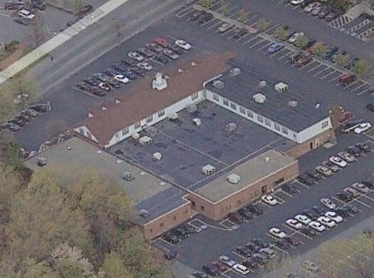

Prepared by:
Massachusetts Department of Public Health
Bureau of Environmental Health
Indoor Air Quality Program
July 2012

Background/Introduction
In response to a request from Bruce Tebo, Project Manager, Division of Capital Asset Management (DCAM), the Massachusetts Department of Public Health (MDPH), Bureau of Environmental Health (BEH) conducted a pre-lease renewal indoor air quality (IAQ) assessment at 21 Spring Street, Taunton, Massachusetts. This evaluation was conducted as part of enhanced efforts to ensure acceptable indoor the air quality of office space leased by Massachusetts state agencies. On May 25, 2012, a visit to conduct a post-occupancy IAQ assessment was made by Cory Holmes, Environmental Analyst/Inspector for BEH’s IAQ Program.
The building is a multi-level structure consisting of office space, open work areas and conference/meeting rooms. State tenants have occupied the building for over 20 years and include MassHealth (Office of Medicaid), the Massachusetts Rehabilitation Commission (MRC), the Department of Transitional Assistance (DTA) and the Massachusetts Department of Developmental Services (DDS). Each office space has separate heating, ventilation and air conditioning (HVAC) equipment. Windows are openable in some areas of the building.

Methods
Air tests for carbon monoxide, carbon dioxide, temperature and relative humidity were taken with the TSI, Q-Trak, IAQ Monitor 7565. Air tests for airborne particle matter with a diameter less than 2.5 micrometers were taken with the TSI, DUSTTRAK™ Aerosol Monitor Model 8520. BEH staff also performed visual inspection of building materials for water damage and/or microbial growth and other conditions that may potentially impact IAQ.

Results
The offices have a combined employee population of approximately 125 with several hundred members of the public conducting business at the offices daily. Test results appear in Table 1 and are listed by function, occupants’ last name(s) or office numerical designation (where available).

Discussion

Ventilation
It can be seen from Table 1 that carbon dioxide levels were below 800 parts per million (ppm) in all areas tested at the time of assessment, indicating good air exchange throughout the building. Fresh air is provided by rooftop air-handling units (AHUs) (Picture 1). Fresh air is drawn into the AHUs through a bank of high efficiency pleated air filters, heated or cooled and delivered to occupied areas via ducted air diffusers (Picture 2). Return air is drawn into ceiling or wall-mounted vents and ducted back to the rooftop AHUs (Pictures 3 and 4).
The HVAC system is controlled by digital thermostats. Thermostats examined had a fan switch with two settings, on and auto (Picture 5). When the fan is set to on, the system provides a continuous source of air circulation and filtration. The automatic setting on the thermostat activates the HVAC system at a preset temperature. Once the preset temperature is reached, the HVAC system is deactivated. Therefore, no mechanical ventilation is provided until the thermostat re-activates the system. The MDPH typically recommends that thermostats be set to the fan on setting during occupied hours to provide continuous air circulation. Most of the thermostats throughout the building were set to the fan on setting. The thermostat in the MRC conference room had a “check filter” message indicating, that the filter for that AHU may be in need of changing (Picture 5).
In order to have proper ventilation with a mechanical supply and exhaust system, the systems must be balanced to provide an adequate amount of fresh air to the interior of a room while removing stale air from the room. It is recommended that HVAC systems be re-balanced every five years to ensure adequate air systems function (SMACNA, 1994).
The Massachusetts Building Code requires a minimum ventilation rate of 20 cubic feet per minute (cfm) per occupant of fresh outside air or openable windows (SBBRS, 1997; BOCA, 1993). The ventilation must be on at all times that the room is occupied. Providing adequate fresh air ventilation with open windows and maintaining the temperature in the comfort range during the cold weather season is impractical. Mechanical ventilation is usually required to provide adequate fresh air ventilation.
Carbon dioxide is not a problem in and of itself. It is used as an indicator of the adequacy of the fresh air ventilation. As carbon dioxide levels rise, it indicates that the ventilating system is malfunctioning or the design occupancy of the room is being exceeded. When this happens, a buildup of common indoor air pollutants can occur, leading to discomfort or health complaints. The Occupational Safety and Health Administration (OSHA) standard for carbon dioxide is 5,000 parts per million parts of air (ppm). Workers may be exposed to this level for 40 hours/week, based on a time-weighted average (OSHA, 1997).
The MDPH uses a guideline of 800 ppm for publicly occupied buildings. A guideline of 600 ppm or less is preferred in schools due to the fact that the majority of occupants are young and considered to be a more sensitive population in the evaluation of environmental health status. Inadequate ventilation and/or elevated temperatures are major causes of complaints such as respiratory, eye, nose and throat irritation, lethargy and headaches. For more information concerning carbon dioxide, please see Appendix A.
Indoor temperatures ranged from 71°F to 77 °F (Table 1), which were within the MDPH recommended comfort range at the time of the assessment. The MDPH recommends that indoor air temperatures be maintained in a range of 70 °F to 78 °F in order to provide for the comfort of building occupants. In many cases concerning indoor air quality, fluctuations of temperature in occupied spaces are typically experienced, even in a building with an adequate fresh air supply.
Relative humidity measurements ranged from 44 to 67 percent (Table 1), which were within or close to the MDPH recommended comfort range in the majority of areas surveyed. The MDPH recommends a comfort range of 40 to 60 percent for indoor air relative humidity. Several building occupants expressed that the building air felt dry. The sensation of dryness and irritation is common in a low relative humidity environment. Low relative humidity is a very common problem during the heating season in the northeast part of the United States.

Microbial/Moisture Concerns
In order for building materials to support mold growth, a source of water exposure is necessary. Water-damaged ceiling tiles were observed in a few areas (Table 1), which indicate current/historic plumbing or roof leaks. Water-damaged ceiling tiles can provide a source of mold and should be replaced after a water leak is discovered and repaired. Occasional leaks were reported by occupants directly inside the 2nd floor entrance of the MRC. At the time of the assessment, water-damaged ceiling tiles had been changed. However water-damaged fiberglass insulation located above the ceiling was observed in this area (Picture 6). The US Environmental Protection Agency (US EPA) and the American Conference of Governmental Industrial Hygienists (ACGIH) recommend that porous materials (e.g., carpeting, fiberglass insulation) be dried with fans and heating within 24 to 48 hours of becoming wet (US EPA, 2001; ACGIH, 1989). If not dried within this time frame, mold growth may occur. Once mold has colonized porous materials, they are difficult to clean and should be removed/discarded.
Plants were observed in several areas. Plants, soil and drip pans can serve as sources of mold/bacterial growth. Plants should be properly maintained, over-watering of plants should be avoided and drip pans should be inspected periodically for mold growth. Mold growth/water damage was observed on shelving in the 2nd floor of the MRC as a result of over-watering or leaking drip pans (Picture 7).
Accumulated debris was observed on floor tiles in the MassHealth break room (102) on the 1st floor (Picture 8). Occupants and building management could not recall issues with water penetration, therefore it could not be concluded if this material was mastic around floor tiles that had become softened by water infiltration or material stuck to the floor from stored items (e.g., cardboard boxes).

Other IAQ Evaluations
Indoor air quality can be negatively influenced by the presence of respiratory irritants, such as products of combustion. The process of combustion produces a number of pollutants. Common combustion emissions include carbon monoxide, carbon dioxide, water vapor, and smoke (fine airborne particle material). Of these materials, exposure to carbon monoxide and particulate matter with a diameter of 2.5 micrometers (μm) or less (PM2.5) can produce immediate, acute health effects upon exposure. To determine whether combustion products were present in the indoor environment, BEH staff obtained measurements for carbon monoxide and PM2.5.

Carbon Monoxide
Carbon monoxide is a by-product of incomplete combustion of organic matter (e.g., gasoline, wood and tobacco). Exposure to carbon monoxide can produce immediate and acute health affects. Several air quality standards have been established to address carbon monoxide and prevent symptoms from exposure to these substances. The MDPH established a corrective action level concerning carbon monoxide in ice skating rinks that use fossil-fueled ice resurfacing equipment. If an operator of an indoor ice rink measures a carbon monoxide level over 30 ppm, taken 20 minutes after resurfacing within a rink, that operator must take actions to reduce carbon monoxide levels (MDPH, 1997).
The American Society of Heating Refrigeration and Air-Conditioning Engineers (ASHRAE) has adopted the National Ambient Air Quality Standards (NAAQS) as one set of criteria for assessing indoor air quality and monitoring of fresh air introduced by HVAC systems (ASHRAE, 1989). The NAAQS are standards established by the US EPA to protect the public health from six criteria pollutants, including carbon monoxide and particulate matter (US EPA, 2006). As recommended by ASHRAE, pollutant levels of fresh air introduced to a building should not exceed the NAAQS levels (ASHRAE, 1989). The NAAQS were adopted by reference in the Building Officials & Code Administrators (BOCA) National Mechanical Code of 1993 (BOCA, 1993), which is now an HVAC standard included in the Massachusetts State Building Code (SBBRS, 1997). According to the NAAQS, carbon monoxide levels in outdoor air should not exceed 9 ppm in an eight-hour average (US EPA, 2006).
Carbon monoxide should not be present in a typical, indoor environment. If it is present, indoor carbon monoxide levels should be less than or equal to outdoor levels. Outdoor carbon monoxide concentrations were non-detect the day of the assessment (Table 1). No measureable levels of carbon monoxide were detected in the building during the assessment (Table 1).

Particulate Matter
The US EPA has established NAAQS limits for exposure to particulate matter. Particulate matter is airborne solids that can be irritating to the eyes, nose and throat. The NAAQS originally established exposure limits to particulate matter with a diameter of 10 μm or less (PM10). According to the NAAQS, PM10 levels should not exceed 150 micrograms per cubic meter (μg/m³) in a 24-hour average (US EPA, 2006). These standards were adopted by both ASHRAE and BOCA. Since the issuance of the ASHRAE standard and BOCA Code, US EPA established a more protective standard for fine airborne particles. This more stringent PM2.5 standard requires outdoor air particle levels be maintained below 35 μg/m³ over a 24-hour average (US EPA, 2006). Although both the ASHRAE standard and BOCA Code adopted the PM10 standard for evaluating air quality, MDPH uses the more protective PM2.5 standard for evaluating airborne particulate matter concentrations in the indoor environment.
Outdoor PM2.5 was measured at 12 μg/m³ (Table 1). PM2.5 levels measured indoors ranged from 7 to 11 μg/m³ (Table 1), which were below the NAAQS PM2.5 level of 35 μg/m³. Frequently, indoor air levels of particulates (including PM2.5) can be at higher levels than those measured outdoors. A number of mechanical devices and/or activities that occur in buildings can generate particulate during normal operations. Sources of indoor airborne particulates may include but are not limited to particles generated during the operation of fan belts in the HVAC system, use of stoves and/or microwave ovens in kitchen areas; use of photocopiers, fax machines and computer printing devices; operation of an ordinary vacuum cleaner and heavy foot traffic indoors.

Conclusions/Recommendations
In view of the findings at the time of the visit, the following recommendations are made:
- Ensure that all thermostats are set to the fan “on” position to operate the ventilation system continuously in occupied areas during business hours.
- Change filters for air handling equipment as per the manufacturers’ instructions or more frequently if needed.
- Adjust HVAC system settings to provide comfort and reduce relative humidity conditions as needed.
- Ensure roof/plumbing leaks are repaired once discovered. Replace any remaining water-damaged ceiling tiles and fiberglass insulation (e.g., MRC). Monitor for further leaks. If wetting of ceiling tiles recurs, report to building management for prompt remediation.
- Avoid over watering of plants. Ensure flat surfaces around plants are free of potting soil and other plant debris. Examine drip pans periodically for mold growth and disinfect with an appropriate antimicrobial where necessary. Do not place plants on porous materials (e.g., paper/cardboard).
- Make repairs/refinish water-damaged shelving in the MRC (Picture 7).
- Clean black debris from floor tiles in MassHealth break room (102). Monitor for further accumulation and/or water penetration.
- For buildings in New England, periods of low relative humidity during the winter are often unavoidable. Therefore, scrupulous cleaning practices should be adopted to minimize common indoor air contaminants whose irritant effects can be enhanced when the relative humidity is low. To control for dusts, a high efficiency particulate arrestance (HEPA) filter equipped vacuum cleaner in conjunction with wet wiping of all surfaces is recommended. Avoid the use of feather dusters. Drinking water during the day can help ease some symptoms associated with a dry environment (throat and sinus irritations).
- Consider adopting a balancing schedule of every 5 years for all mechanical ventilation systems, as recommended by ventilation industrial standards (SMACNA, 1994).
- Refer to resource manual and other related indoor air quality documents located on the MDPH’s website for further building-wide evaluations and advice on maintaining public buildings. These documents are available at: http://mass.gov/dph/iaq.

References
ACGIH. 1989. Guidelines for the Assessment of Bioaerosols in the Indoor Environment. American Conference of Governmental Industrial Hygienists, Cincinnati, OH.
ASHRAE. 1989. Ventilation for Acceptable Indoor Air Quality. American Society of Heating, Refrigeration and Air Conditioning Engineers. ANSI/ASHRAE 62-1989.
BOCA. 1993. The BOCA National Mechanical Code/1993. 8th ed. Building Officials and Code Administrators International, Inc., Country Club Hill, IL.
MDPH. 1997. Requirements to Maintain Air Quality in Indoor Skating Rinks (State Sanitary Code, Chapter XI). 105 CMR 675.000. Massachusetts Department of Public Health, Boston, MA.
OSHA. 1997. Limits for Air Contaminants. Occupational Safety and Health Administration. Code of Federal Regulations. 29 C.F.R 1910.1000 Table Z-1-A
SBBRS. 1997. Mechanical Ventilation. State Board of Building Regulations and Standards. Code of Massachusetts Regulations. 780 CMR 1209.0
SMACNA. 1994. HVAC Systems Commissioning Manual. 1st ed. Sheet Metal and Air Conditioning Contractors’ National Association, Inc., Chantilly, VA.
US EPA. 2001. “Mold Remediation in Schools and Commercial Buildings”. Office of Air and Radiation, Indoor Environments Division, Washington, DC. EPA 402-K-01-001. March 2001. Available at: http://www.epa.gov/iaq/molds/mold_remediation.html
US EPA. 2006. National Ambient Air Quality Standards (NAAQS). US Environmental Protection Agency, Office of Air Quality Planning and Standards, Washington, DC. http://www.epa.gov/air/criteria.html
Picture 1

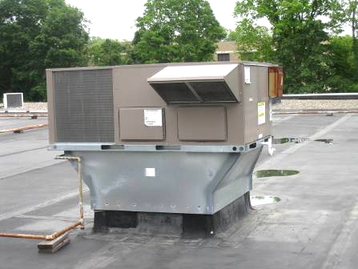

One of Several Rooftop Air Handling Units

Picture 2

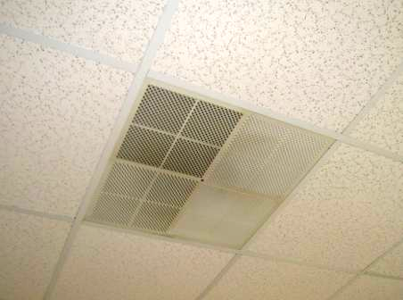

Ceiling-Mounted Air Diffuser

Picture 3

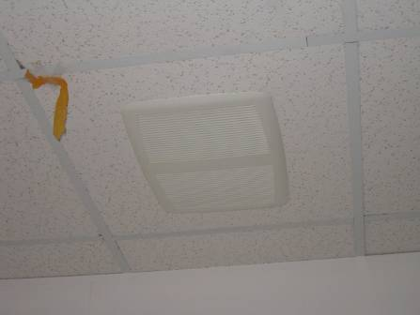

Ceiling-Mounted Return Vent

Picture 4

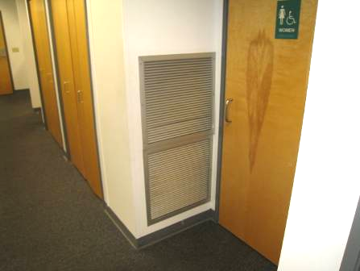

Wall-Mounted Return Vent

Picture 5

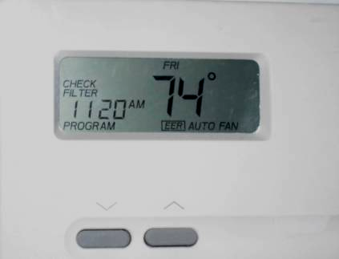

Digital Wall Thermostat in MRC Conference Room, Note Fan in Auto
and Check Filter Message

Picture 6

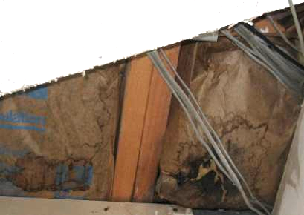

Water-Damaged Fiberglass Insulation above Ceiling 2nd Floor MRC Entrance

Picture 7

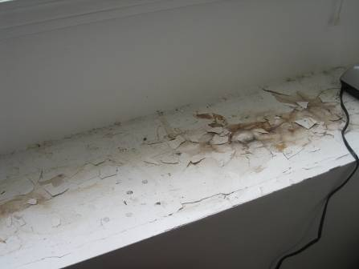

Water-Damaged Shelving near Window 2nd Floor MRC

Picture 8

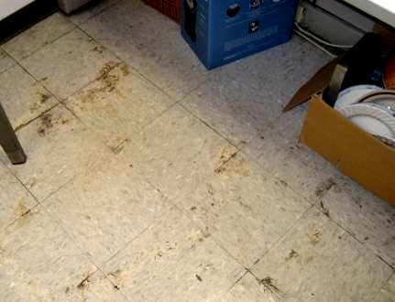

Accumulated Debris on Floor Tiles in 1st Floor MassHealth Break Room (102)
Location | Carbon  Dioxide  (*ppm) | Temp  (°F) | Relative  Humidity  (%) | Carbon  Monoxide  (*ppm) | PM2.5  (µg/m³) | Occupants  in Room | Windows  Openable | Ventilation
Background | 396 | 72 | 67 | ND | 12 |  |  |  |  | Overcast, humid
MA Health
Reception Area | 504 | 75 | 60 | ND | 9 | 3 | N | Y | Y
101 | 545 | 76 | 57 | ND | 9 | 1 | N | Y | N
102 breakroom | 511 | 77 | 54 | ND | 9 | 0 | Y | Y | Y | Black material on tile (mastic/water damage?)
103-108 | 518 | 77 | 53 | ND | 10 | 1 | N | Y | Y
109-110 | 501 | 77 | 53 | ND | 8 | 0 | Y | Y | Y
112-119 | 503 | 77 | 53 | ND | 8 | 0 | N | Y | Y
114-117 | 512 | 76 | 52 | ND | 7 | 1 | N | Y | Y
120 | 577 | 72 | 50 | ND | 7 | 2 | Y | Y | Y | DO
126-136 | 573 | 75 | 48 | ND | 7 | 4 | N | Y | Y
127-131 | 574 | 73 | 48 | ND | 7 | 3 | Y | Y | Y
132-134 | 581 | 74 | 49 | ND | 7 | 2 | Y | Y | Y
138-142 | 646 | 73 | 49 | ND | 7 | 2 | N | Y | Y
144 | 556 | 74 | 46 | ND | 7 | 0 | N | Y | Y | DO
145 | 603 | 76 | 51 | ND | 7 | 0 | N | Y | N
200 | 513 | 74 | 55 | ND | 8 | 0 | Y | Y | Y | Plants
201 Conference Room | 390 | 73 | 55 | ND | 9 | 0 | Y | Y | Y
206 | 398 | 73 | 59 | ND | 9 | 1 | N | Y | Y
207 | 423 | 73 | 60 | ND | 8 | 0 | Y | Y | Y | DO
209-212 | 421 | 73 | 63 | ND | 8 | 1 | Y | Y | Y | Photocopier
213-221 | 405 | 73 | 62 | ND | 8 | 4 | N | Y | Y
217 | 415 | 73 | 61 | ND | 8 | 0 | Y | Y | N
218 | 447 | 73 | 61 | ND | 8 | 2 | y | Y | N | Plants
227 Training Room | 409 | 73 | 61 | ND | 8 | 0 | Y | Y | Y
231-238 | 410 | 73 | 62 | ND | 8 | 2 | Y | Y | Y
239-247 | 408 | 74 | 61 | ND | 9 | 3 | Y | Y | Y
248 | 430 | 73 | 61 | ND | 7 | 0 | Y | Y | Y
250 Lounge | 396 | 73 | 59 | ND | 8 | 1 | N | Y | Y
251 | 441 | 74 | 55 | ND | 8 | 0 | Y | Y | Y | DO
MRC
Reception Area | 409 | 75 | 56 | ND | 9 | 2 | N | Y | Y | Photocopier
Callahan | 431 | 74 | 57 | ND | 10 | 1 | N | Y | N | DO
Ellis | 413 | 74 | 57 | ND | 10 | 1 | N | Y | N | DO
Childers | 403 | 74 | 57 | ND | 10 | 0 | N | Y | N
Olivier | 442 | 74 | 57 | ND | 9 | 1 | N | Y | N | DO
Sarkady | 503 | 74 | 53 | ND | 9 | 1 | N | Y | N | DO, plants
Silva | 493 | 73 | 53 | ND | 9 | 0 | N | Y | N | DO
Ahearn | 426 | 73 | 53 | ND | 10 | 0 | N | Y | Y | DO
Tilden | 450 | 73 | 55 | ND | 9 | 1 | N | Y | N | DO
Lounge | 514 | 74 | 58 | ND | 10 | 0 | N | Y | Y
Woman’s Restroom |  |  |  |  |  |  | N | Y | Y | 1 WD CT
Interpreter’s Office | 406 | 74 | 65 | ND | 11 | 1 | N | Y | N
Caprio | 724 | 76 | 51 | ND | 8 | 2 | N | Y | N
Conference Room | 553 | 75 | 47 | ND | 7 | 0 | Y | Y | Y | Check filter message on thermostat, fan auto
Rautiainen | 546 | 74 | 46 | ND | 9 | 1 | N | Y | N | DO
Monroe | 556 | 74 | 45 | ND | 7 | 1 | N | Y | N | DO
Igreja | 533 | 74 | 45 | ND | 7 | 1 | N | Y | N | DO
Midura | 448 | 74 | 44 | ND | 8 | 0 | Y | Y | N | DO
Cazeau-Class | 521 | 75 | 46 | ND | 7 | 1 | Y | Y | N | Plants
Botellho | 687 | 75 | 47 | ND | 7 | 1 | N | Y | N | DO
DTA
Lobby | 716 | 75 | 67 | ND | 11 | 20 | N | Y | Y
Lounge | 549 | 71 | 57 | ND | 7 | 3 | N | Y | Y | Plants
Large Conference Room | 542 | 72 | 57 | ND | 7 | 0 | N | Y | Y | WD CT-corner
Raposo | 575 | 71 | 53 | ND | 8 | 1 | N | Y | Y | Plants
Common Work Area (Rear) | 603 | 71 | 60 | ND | 8 | 4 | N | Y | Y
Common Work Area (Center) | 617 | 72 | 60 | ND | 9 | 5 | N | Y | Y
Common Work Area (Center-Right) | 639 | 73 | 66 | ND | 9 | 5 | N | Y | Y
Common Work Area (Maloney) | 648 | 73 | 67 | ND | 9 | 2 | N | Y | Y | DO
Common Work Area (Front) | 612 | 73 | 61 | ND | 9 | 6 | N | Y | Y
Reception | 706 | 74 | 60 | ND | 9 | 2 | N | Y | Y
Bertoldo | 542 | 74 | 60 | ND | 8 | 0 | N | Y | Y | DO
Computer Lab | 375 | 74 | 67 | ND | 9 | 0 | N | Y | Y | Only used periodically, building management contacted to adjust HVAC when in use
DDS
Reception | 392 | 74 | 61 | ND | 10 | 1 | N | Y | Y
Curley | 379 | 73 | 62 | ND | 10 | 0 | N | Y | Y | DO
Griffin | 402 | 73 | 64 | ND | 10 | 1 | N | Y | N | DO
Voyer | 392 | 73 | 64 | ND | 10 | 0 | N | Y | N | DO
Vought | 387 | 73 | 64 | ND | 10 | 0 | N | Y | N
Break Room | 456 | 73 | 67 | ND | 10 | 2 | N | Y | N
Open Work Area (Rear) | 413 | 74 | 66 | ND | 10 | 2 | N | Y | Y
Houston | 378 | 75 | 65 | ND | 10 | 0 | N | Y | N
Conference Room | 606 | 74 | 64 | ND | 10 | 8 | N | Y | Y

