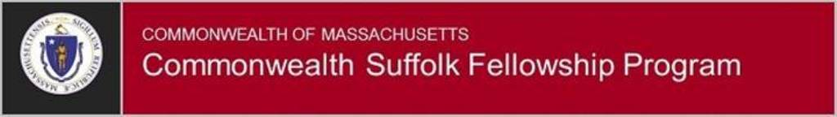

Leadership Commitment (Approval) Form
As part of the Commonwealth Suffolk Fellowship Program application, this form must be signed and submitted by 4:00PM, May 23, 2019 to the following address. NOTE: the form submission must include all original (wet) signatures.
Commonwealth Suffolk Fellowship Program Manager
100 Cambridge Street, Suite 600
Boston, MA 02114
Commonwealth Suffolk Fellowship Program Applicant: Complete the Applicant Information and obtain the requested signatures for their approval..
Applicant’s full name:
Job title:
Employee ID#:
Agency:
Signature of Applicant: | Date:
Supervisor Information
I certify that all the information provided above is correct.
Supervisor’s Full Name:
Supervisor’s Job Title:
Supervisor’s Work Address:
Supervisor’s Signature: |  | Date:
HR Director Information
By signing this form, I grant approval for the employee listed above to participate in the Commonwealth Suffolk Fellowship Program, and agree that I have read and understood the program requirements.
HR Director’s full name:
HR Director signature: |  | Date:
Agency Head (or designee) Information
By signing this form, I grant approval for the employee listed above to participate in the Commonwealth Suffolk Fellowship Program, and agree that I have read and understood the program requirements.
Agency Head’s full name:
Agency Head signature: |  | Date:

