Community Engagement Materials

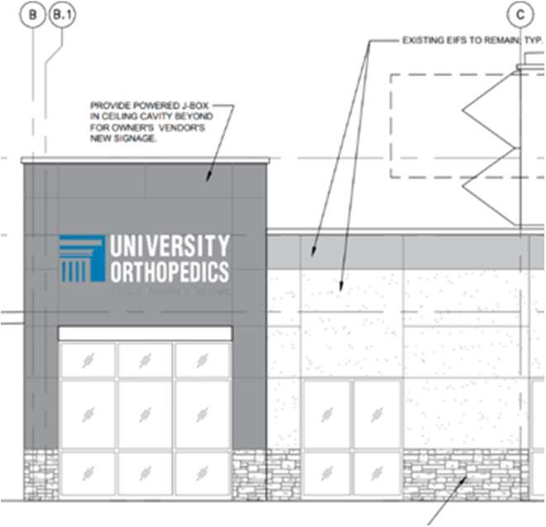

Coming in 2027:
Sturdy Hospital-University Orthopedics Center for Orthopedic Surgery

Sturdy Hospital-University Orthopedics Center for Orthopedic Surgery
- Ambulatory surgery center with four operating rooms available in 2027.

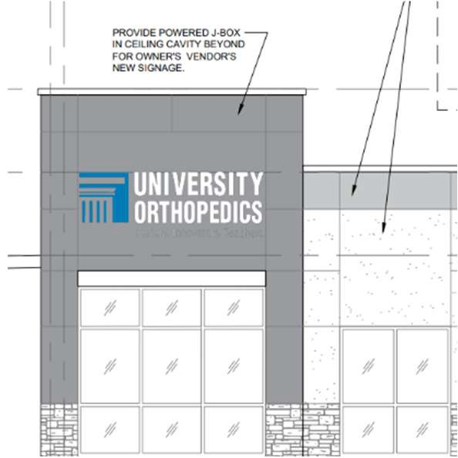
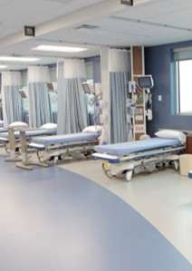


- Increased access to surgery leads to shortened wait times for procedures.

- Offers specialized orthopedic care for outpatient-specific cases ranging from hand, sports, spine, and total joint surgery.

- Creates a highly specialized environment providing patients with access to high-quality, specialized care, similar to the University Orthopedics East Bay Surgery Center.

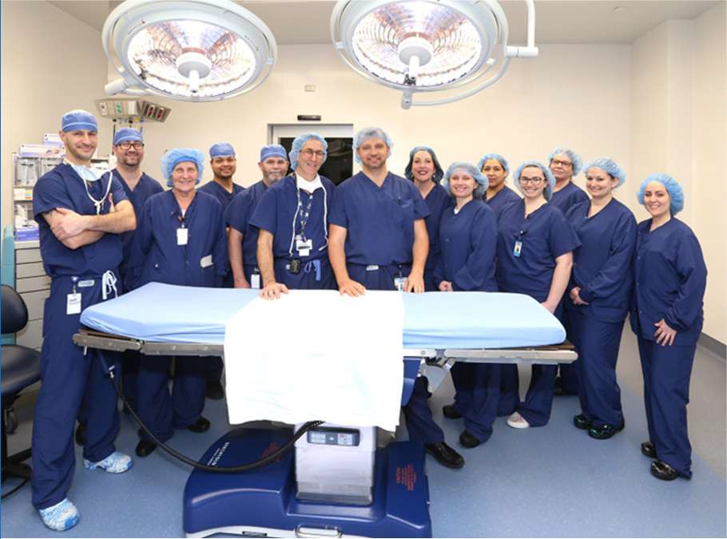





Objectives

Make surgery as stress free as possible.

Create environment that makes patients feel more comfortable during stay.

Ensure patients know what to expect during recovery.

Help patients prepare themselves and their living space before surgery.

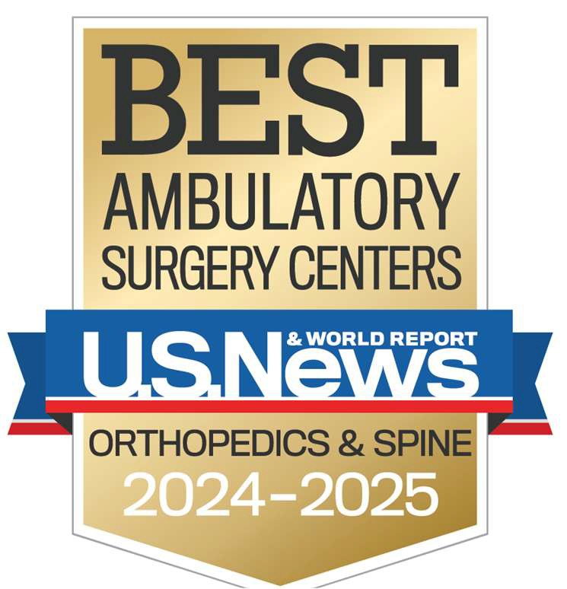

University Orthopedics East Bay Surgery Total Joint Program

- Personalized educational program designed with an in-person class to ensure that patients are fully prepared for their experience.

- Integrated support and evaluation from our dedicated program educator, skilled physical therapists, anesthesiologists specializing in advanced pain management, and the experienced staff at our surgery center—working together to deliver comprehensive, high-quality care.

- Concierge-style care includes private transportation home and in-home support from a certified nursing assistant and physical therapist to guide patients through recovery.


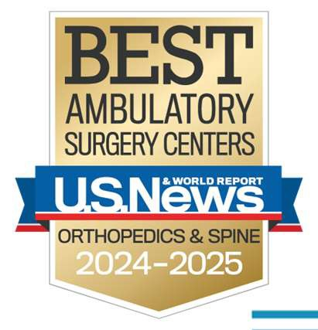

University Orthopedics East Bay Surgery Center
Quality Measures 2025
- Press Ganey Patient Satisfaction: Average 92%
- Infection Rates: 0.1%
- Complications: 0.1%
- Hospital Transfers: 0.08%
- Patient Falls: 0%
- Patient Wrongs: 0%
- Patient Burns: 0%

Ambulatory Surgery Center
Joint Venture with University Orthopedics

Wayne Gietz | Chief Operating Officer

PFAC Meeting -- December 2, 2025

Agenda
  - Welcome and Introductions
  - Need for Ambulatory Surgery Center
  - Current State and Proposed State
  - Financials
  - Location and Details
  - Project Timeline
  - Community Health Initiative/Benefits
  - Q&A, Feedback

Sturdy Health




Executive Summary
Key Points
- Surgery Services Growth
- Patient Experience & Access Improvement
- Cost-Effectiveness
- Lower Capital Requirements
- Orthopedic Services Strategic Partnership

Summary
Ambulatory surgery centers (“ASC”) are industry-standard facilities for patient-centered, cost-effective and convenient care. In today’s healthcare market, they are a must-have in order to grow outpatient elective surgical services in a lower cost setting. ASCs can improve access, patient experience, and profitability. They help hospital systems to improve their main OR capacity for complex, inpatient, surgical services by redirecting outpatient surgeries to a more convenient and lower cost venue. ASCs are a key part of an integrated healthcare system.



Why Choose an ASC?

ASCs’ value is a combination of cost and quality

ASCs are highly specialized (outpatient elective surgeries only)

They function on a much lower overhead than hospitals

Because of high specialization, ASCs can focus on quality and patient experience

The lower overhead/high efficiency allows ASCs to provide surgical care at much lower cost than hospital-based ORs

ASCs help create more OR capacity at the hospital for more complex, impatient and emergent surgeries by moving outpatient surgeries to ASCs

ASCs have proven to be a successful venue for Joint Ventures between health systems and physician groups




5

Current State at Sturdy

All surgeries are performed in the hospital’s OR
Issues:

  - Limited capacity and growth potential due to OR space limitations
  - Difficult to add new or grow existing services without access to an ASC
  - Difficult to recruit new surgeons without ASC access
  - Cancelations or delays due to more urgent cases taking priority over electives ones
  - Higher cost for outpatient surgeries (higher overhead and variable expenses)

6

Proposed State

Build a new ASC in a joint venture partnership with University of Orthopedics (“UO”)

- 50/50% share (Sturdy/UO) JV ownership between the parties
- UO is a leader in orthopedic surgeries in our region
- Sturdy already has a great partnership with UO staffing our Orthopedic services with surgeons and PAs
- UO currently owns and operates surgery centers in the region

- Oncological surgeries: Gynecology, Thoracic, Breast & Plastics, Colorectal
Relocate appropriate Sturdy orthopedic outpatient surgical cases to ASC
UO to direct surgeries from their other clinic locations
Create OR capacity at Sturdy Memorial Hospital OR for new surgical volume:
- Vascular
- Urology

7

8

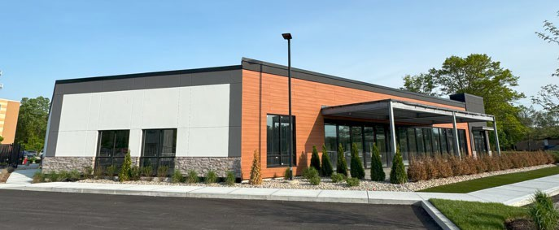

Target Location – 30 Reservoir St, Mansfield

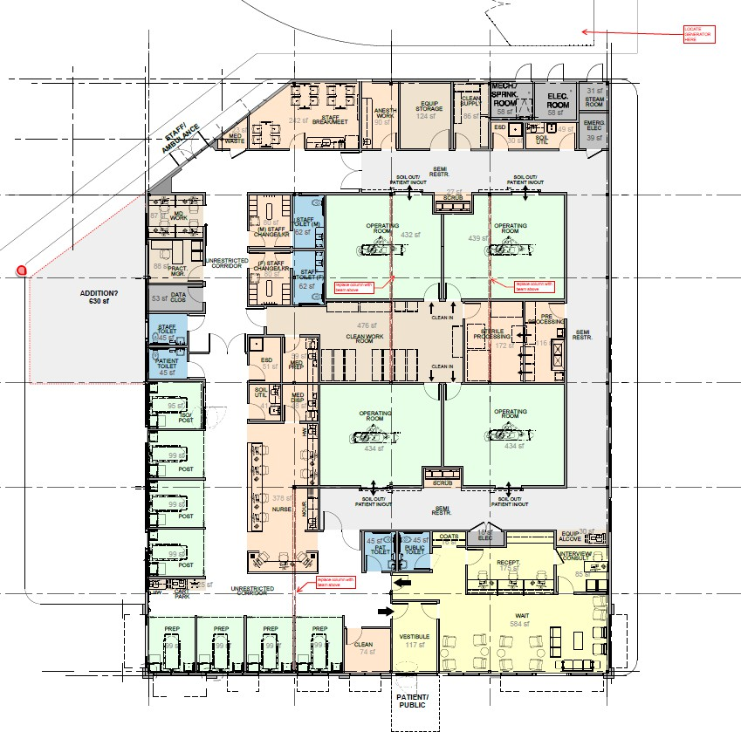
Target Location – Floor Plan Design
9

Project Timeline
File DoN and Notice of Material Change: Winter 2025
Review and approval received: Mid 2026
Plan review: Two months following DoN Approval
Construction Begins: Upon Plan Review approval
Opening Estimated: Mid-2027

10

Benefits to the Community / Patients
11

More convenient access to surgical services which can safely be provided in an ASC

Increase surgical specialties available at the hospital

Potentially lower beneficiary cost share

Access to same orthopedic surgeons currently practicing only at the hospital

Community Health Initiative

DPH requires DoN Holders to distribute funding equal to 5% of the approved project’s cost through local initiatives

This will result in an additional $500,000 being awarded to benefit Sturdy’s communities. This money will be combined with the CHI from Sturdy’s recent emergency department DoN.






Questions? Feedback?

13

