ODOR ASSESSMENT

Community Enterprises
287 High Street
Holyoke, Massachusetts



Prepared by:
Massachusetts Department of Public Health
Bureau of Environmental Health
Indoor Air Quality Program
September 2015

Background
Building: | Community Enterprises (CE)
Address: | 287 High Street, Holyoke, MA
Assessment Requested by: | Katie Gallagher, Assistant Director, Holyoke Health Department (HHD)
Date of Assessment: | July 17, 2015
BEH/IAQ Staff Conducting Assessment: | Michael Feeney, Director  Stefanie Santora
Date of Building Construction: | Pre 1900s
Reason for Request: | Mold concerns and odors in first floor offices

Building Description
The CE consists of two adjoining four-story stone buildings in downtown Holyoke (Picture 1). Subsequent renovations joined the two buildings together as a single office space. Windows do not open in the CE space. Similarly-sized buildings adjoin the CE on the block.

Methods/Results
Air tests for carbon dioxide, carbon monoxide, temperature and relative humidity were taken with the TSI, Q-Trak, IAQ Monitor 7565. Tests for airborne particle matter with a diameter less than 2.5 micrometers were taken with the TSI, DUSTTRAK™ Aerosol Monitor Model 8520. Screening for volatile organic compounds was conducted using a RAE Systems, Mini-RAE 2000 Photo Ionization Detector. BEH/IAQ staff also performed a visual inspection of building materials for water damage and/or microbial growth. Results appear in Table 1.

Discussion

Ventilation
It can be seen from Table 1 that carbon dioxide levels were above 800 parts per million (ppm) in occupied areas on the second floor of CE offices and below 800 ppm on the first floor. Fresh air is provided by a rooftop air-handling unit (AHU). Once air is filtered, it is heated or cooled and delivered to occupied areas via ducted supply diffusers. Return air is drawn into a combination of plenum and ducted ceiling-mounted vents and returned back to rooftop AHUs.
To maximize air exchange, the MDPH recommends that both supply and exhaust ventilation operate continuously during periods of occupancy. In order to have proper ventilation with a mechanical supply and exhaust system, the systems must be balanced to provide an adequate amount of fresh air to the interior of a room while removing stale air from the room. It is recommended that HVAC systems be re-balanced every five years to ensure adequate air systems function (SMACNA, 1994). The date of the last balancing of these systems was not available at the time of the assessment.
The MDPH uses a guideline of 800 ppm for publicly occupied buildings. Inadequate ventilation and/or elevated temperatures are major causes of complaints such as respiratory, eye, nose and throat irritation, lethargy and headaches. For more information concerning carbon dioxide, please see Appendix A.

Temperature and Relative Humidity
Indoor temperature measurements at the time of the assessment ranged from 70°F to 76°F (Table 1), which were within the MDPH recommended comfort range. The MDPH recommends that indoor air temperatures be maintained in a range of 70°F to 78°F in order to provide for the comfort of building occupants. In many cases concerning indoor air quality, fluctuations of temperature in occupied spaces are typically experienced, even in a building with an adequate fresh air supply.
Indoor relative humidity at the time of the assessment ranged from 40 to 58 percent (Table 1), which was within the MDPH recommended comfort range in all areas tested. The MDPH recommends a comfort range of 40 to 60 percent for indoor air relative humidity. The elevated relative humidity measurements were reflective of outdoor conditions. Relative humidity levels in the building would be expected to drop during winter months due to heating. The sensation of dryness and irritation is common in a low relative humidity environment. Low relative humidity is a very common problem during the heating season in the northeast part of the United States.

Microbial/Moisture Concerns
Mold concerns initiated the request for assessment. Of note was the condition of the basement floor. The rear half of the basement contains the furnace and water heater installed on a dirt floor (Picture 2). The front part of the basement has a concrete floor. Installed over the concrete is a tongue-in-groove wooden floor, which appears to be rotting (Pictures 3 and 4). Either rotting wood or the dirt floor can be ready sources of mold. Of note is the presence of a passive vent in the basement door that leads to CE first floor offices (Picture 5). Basement odors were detected outside this door when it was closed. It is likely that mold spores and other odors are entering the CE through the passive door vent.

Other IAQ Evaluations
Indoor air quality can be negatively influenced by the presence of respiratory irritants, such as products of combustion. The process of combustion produces a number of pollutants. Common combustion emissions include carbon monoxide, carbon dioxide, water vapor, and smoke (fine airborne particle material). Of these materials, exposure to carbon monoxide and particulate matter with a diameter of 2.5 micrometers (μm) or less (PM2.5) can produce immediate, acute health effects upon exposure. To determine whether combustion products were present in the indoor environment, BEH/IAQ staff obtained measurements for carbon monoxide and PM2.5.

Carbon Monoxide
Carbon monoxide is a by-product of incomplete combustion of organic matter (e.g., gasoline, wood and tobacco). Exposure to carbon monoxide can produce immediate and acute health effects. Several air quality standards have been established to address carbon monoxide and prevent symptoms from exposure to these substances. The MDPH established a corrective action level concerning carbon monoxide in ice skating rinks that use fossil-fueled ice resurfacing equipment. If an operator of an indoor ice rink measures a carbon monoxide level over 30 ppm, taken 20 minutes after resurfacing within a rink, that operator must take actions to reduce carbon monoxide levels (MDPH, 1997).
The American Society of Heating Refrigeration and Air-Conditioning Engineers (ASHRAE) has adopted the National Ambient Air Quality Standards (NAAQS) as one set of criteria for assessing indoor air quality and monitoring of fresh air introduced by HVAC systems (ASHRAE, 1989). The NAAQS are standards established by the US EPA to protect the public health from six criteria pollutants, including carbon monoxide and particulate matter (US EPA, 2006). As recommended by ASHRAE, pollutant levels of fresh air introduced to a building should not exceed the NAAQS levels (ASHRAE, 1989). The NAAQS were adopted by reference in the Building Officials & Code Administrators (BOCA) National Mechanical Code of 1993 (BOCA, 1993), which is now an HVAC standard included in the Massachusetts State Building Code (SBBRS, 2011). According to the NAAQS, carbon monoxide levels in outdoor air should not exceed 9 ppm in an eight-hour average (US EPA, 2006).
Carbon monoxide should not be present in a typical, indoor environment. If it is present, indoor carbon monoxide levels should be less than or equal to outdoor levels. No carbon monoxide was detected in any indoor or outdoor measurements.

Particulate Matter
Particulate matter is airborne solids that can be irritating to the eyes, nose and throat. The NAAQS originally established exposure limits to particulate matter with a diameter of 10 μm or less (PM10). According to the NAAQS, PM10 levels should not exceed 150 microgram per cubic meter (μg/m³) in a 24-hour average (US EPA, 2006). These standards were adopted by both ASHRAE and BOCA. Since the issuance of the ASHRAE standard and BOCA Code, US EPA established a more protective standard for fine airborne particles. This more stringent PM2.5 standard requires outdoor air particle levels be maintained below 35 μg/m³ over a 24-hour average (US EPA, 2006). Although both the ASHRAE standard and BOCA Code adopted the PM10 standard for evaluating air quality, MDPH uses the more protective PM2.5 standard for evaluating airborne particulate matter concentrations in the indoor environment.
Outdoor PM2.5 concentrations were 18 μg/m³ (Table 1). PM2.5 concentrations inside CE were measured in a range of 4 to 31 μg/m³ (Table 1) in occupied space. PM2.5 levels in the CE basement were 58 μg/m³, in excess of the 35 μg/m³ EPA standard. Frequently, indoor air levels of particulate matter (including PM2.5) can be at higher levels than those measured outdoors. As noted previously, the basement has a wood floor that is rotting in sections installed over a cement foundation. Walking on this floor by BEH/HHD staff likely increased PM2.5 concentrations.

Volatile Organic Compounds (VOCs)
VOCs are carbon-containing substances that have the ability to evaporate at room temperature. Frequently, exposure to low levels of total VOCs (TVOCs) may produce eye, nose, throat and/or respiratory irritation in some sensitive individuals. In an effort to determine whether VOCs were present in CE, BEH/IAQ staff conducted TVOC screening. Outdoor air samples were also taken for comparison.
TVOCs were not detected (ND) outdoors or inside the occupied second floor of the CE offices (Table 1). Upon entering the first floor CE offices, a lacquer/chemical odor was noted; TVOCs measured 0.2 ppm throughout the floor (Table 1). VOC concentrations in the basement were in a range of 0.3 to 1.4 ppm, with the highest measurement next to the basement wall where water service pipes penetrated into an adjoining building (Picture 6). HHD staff reported that an operating nail salon used the adjoining basement for storage. While accompanying HHD staff, BEH/IAQ staff conducted TVOC measurement in the first floor and basement of the nail salon. VOC measurements within the nail salon were measured in a range of 6 to 14.9 ppm (Table 1). It is likely that the operation of the nail salon HVAC system creates air pressure, which then forces air and TVOCs/odors into the CE building through cracks/crevices and holes that exist in the shared/adjoining walls. It is likely the HVAC system on the CE first floor is drawing basement TVOCs and other odors into occupied areas through the passive vent in the CE basement door (Picture 5).

Other Concerns
As noted, the door leading to the basement on the CE first floor contains a passive door vent. The presence of this vent is unusual, since basement doors are used as a barrier to separate the basement and associated moisture/odors from occupied space. The CE has a gas-fired furnace and water heater. In order to combust gas, a source of oxygen is needed, which is usually provided by a vent that is open to the outdoors. BEH/IAQ staff could not identify any other combustion vent so it appears that the passive vent in the basement door was installed as the source of combustion air. Passive door vents are not allowed under various versions of the fire code because the vent breaches the fire integrity of the basement door. Internal doors in buildings are designed to contain a fire in a room by being solid and constructed to resist burning for a set period of time. Fire will follow its oxygen source and readily pass through a passive door vent. In addition, the passive door vent appears to be the pathway for VOCs, mold spores and other odors from the basement to readily enter CE first floor offices.

Conclusions/Recommendations
The conditions of the CE building are of two origins: the basement of the CE building and the penetration of VOCs into the CE building from operation of the nail salon in the adjoining building. The following recommendations are made regarding each building:

CE Building
- Install a combustion air vent for the furnace and water heater to provide outdoor air to these devices. Once completed, seal the basement passive door vent shown in Picture 5 with an appropriate material, or replace the door with a solid one.
- Install weather-stripping and a door sweep on the basement door to render it as airtight as possible.
- Seal any openings in the shared wall on the CE side with an appropriate fire-rated sealant.
- Remove water-damaged/rotted floor materials in the basement.
- Refer to resource manuals and other related indoor air quality documents for further building-wide evaluations and advice on maintaining public buildings. Copies of these materials are located on the MDPH’s website: http://mass.gov/dph/iaq.

Nail Salon Building
- Consider having the nail salon consult with a Certified Industrial Hygienist (CIH) regarding the best ventilation methods to properly vent nail salon emission from their building.
- At minimum, the following activities should be done to decrease the migration of nail salon pollutants into the CE building:
  - Increase exhaust ventilation for the nail salon to render the building depressurized with regards to the CE building.
  - Seal all visible cracks, crevices and holes in the adjoining wall between the buildings.

References
ASHRAE. 1989. Ventilation for Acceptable Indoor Air Quality. American Society of Heating, Refrigeration and Air Conditioning Engineers. ANSI/ASHRAE 62-1989.
BOCA. 1993. The BOCA National Mechanical Code/1993. 8th ed. Building Officials and Code Administrators International, Inc., Country Club Hill, IL.
MDPH. 1997. Requirements to Maintain Air Quality in Indoor Skating Rinks (State Sanitary Code, Chapter XI). 105 CMR 675.000. Massachusetts Department of Public Health, Boston, MA.
SBBRS. 2011. Mechanical Ventilation. State Board of Building Regulations and Standards. Code of Massachusetts Regulations. 780 CMR 1209.0.
SMACNA. 1994. HVAC Systems Commissioning Manual. 1st ed. Sheet Metal and Air Conditioning Contractors’ National Association, Inc., Chantilly, VA.
US EPA. 2006. National Ambient Air Quality Standards (NAAQS). US Environmental Protection Agency, Office of Air Quality Planning and Standards, Washington, DC. http://www.epa.gov/air/criteria.html
Picture 1

Community Enterprises Building (Arrow is the location of the nail salon)
Picture 2
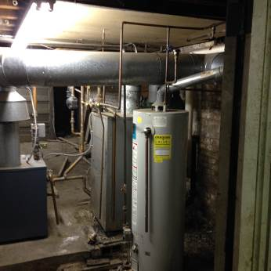
Rear half of the basement with furnace and water heat installed on a dirt floor
Picture 3
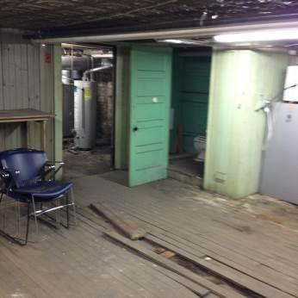
Rotting tongue-in-groove floor
Picture 4
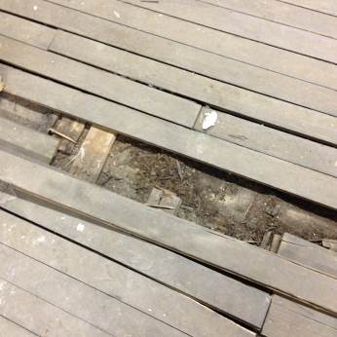
Close-up of rotting tongue-in-groove floor
Picture 5
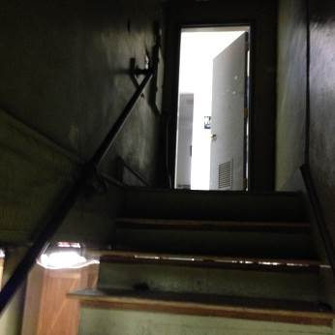
Basement view of passive vent in the basement door of the CE offices
Picture 6
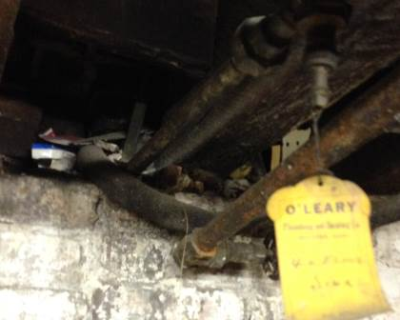
Location of highest VOC measurement in the CE basement
Location | Carbon  Dioxide  (ppm) | Carbon Monoxide  (ppm) | Temp  (°F) | Relative  Humidity  (%) | TVOCs  (ppm) | PM2.5  (µg/m³) | Occupants  in Room | Windows  Openable | Ventilation |  |  | Remarks
 |  |  |  |  |  |  |  |  | Intake | Exhaust |  | Remarks
Background (outdoors) | 272 | ND | 84 | 37 | ND | 18
Community Enterprises Second Floor
209 | 964 | ND | 75 | 46 | ND | 4 | 4 | Y | Y |  | Y
217 | 1018 | ND | 72 | 40 | ND | 7 | 2 | N | Y |  | Y
218 | 916 | ND | 70 | 41 | ND | 7 | 0 | N | Y |  | Y
Elevator lobby | 1090 | ND | 70 | 55 | ND | 31 | 4 | N | N |  | N
Community Enterprises First Floor
Career Center reception | 572 | ND | 76 | 41 | 0.2 | 15 | 0 | N | Y |  | N
1 | 535 | ND | 75 | 40 | 0.2 | 11 | 0 | N | Y |  | Y
2 | 533 | ND | 73 | 44 | 0.2 | 9 | 0 | N | Y |  | Y
3 | 527 | ND | 72 | 43 | 0.2 | 9 | 0 | N | Y |  | Y
4 | 552 | ND | 72 | 45 | 0.3 | 9 | 0 | N | Y |  | Y | Door open
5 | 529 | ND | 71 | 47 | 0.2 | 10 | 0 | N | Y |  | Y | Door open
Basement | 565 | ND | 74 | 58 | 0.3-1.4 | 58 | 0 | N | N |  | N | VOC reading highest at hole in shared wall at water supply pipe
Nail Salon
Nail Salon first floor |  |  |  |  | 14.9 |  |  |  |  |  |  | VOC sampling only
Nail Salon basement |  |  |  |  | 6 |  |  |  |  |  |  | VOC sampling only

