ODOR REASSESSMENT

Community Enterprises
287 High Street
Holyoke, Massachusetts



Prepared by:
Massachusetts Department of Public Health
Bureau of Environmental Health
Indoor Air Quality Program
January 2016

Background
Building: | Community Enterprises (CE)
Address: | 287 High Street, Holyoke, MA
Assessment Requested by: | Pam Zagorski, Vice President/CFO  Community Enterprises, Inc.
Date of Assessment: | December 11, 2015
Bureau of Environmental Health/Indoor Air Quality (BEH/IAQ) Program Staff Conducting Assessment: | Michael Feeney, Director
Date of Building Construction: | Pre 1900s
Reason for Request: | Mold concerns and odors in first floor offices

Building Description
The CE consists of two adjoining four-story stone buildings in downtown Holyoke. Subsequent renovations joined the two buildings together as a single office space. Windows do not open in the CE space. Similarly-sized buildings adjoin the CE on the block.

Methods/Results
BEH/IAQ staff performed a visual inspection of remediation activities made in response to the previous assessment conducted on July 17, 2015. A report from that assessment was issued in September of 2015.

Discussion
The following remediation efforts were completed in response to the July 17, 2015 assessment.
- Recommendation: Install a combustion air vent for the furnace and water heater to provide outdoor air to these devices.
- Action: A combustion air vent was installed in the basement (Pictures 1 and 2).
- Recommendation: Seal the basement passive door vent with an appropriate material, or replace the door with a solid one.
- Action: The passive door vent was sealed (Picture 3).
- Recommendation: Seal any openings in the shared wall on the CE side with an appropriate fire-rated sealant.
- Action: Openings were sealed using spray-foam insulation (Picture 4).
- Recommendation: Remove water-damaged/rotted floor materials in the basement.
- Action: The entire wooden floor in the basement was removed (Picture 5).

Conclusions/Recommendations
The remediation efforts removed the source of mold contamination in the basement as well as the pathway for basement odors entering the occupied space on the CE first floor. Based on these efforts, IAQ staff recommended to CE management that the first floor can be used for normal activities.
Picture 1
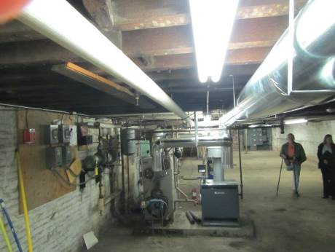
New combustion air vent
Picture 2
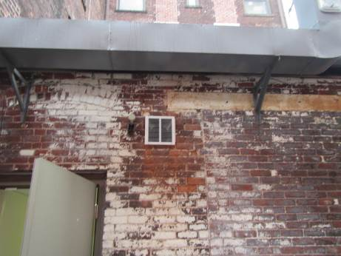
Opening for new air vent
Picture 3
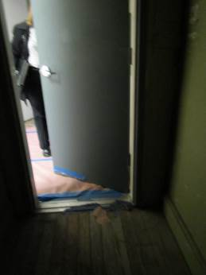
New basement door without passive air vent
Picture 4
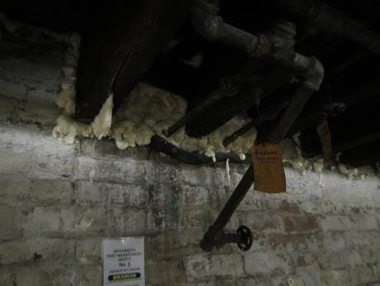
Example of wall opening sealed with spray foam insulation
Picture 5
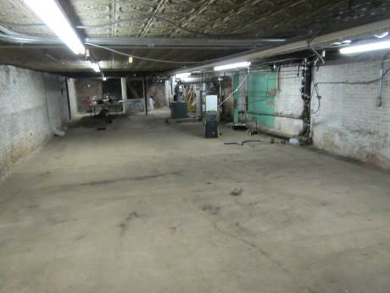
False wood floor and walls completely removed from the basement

