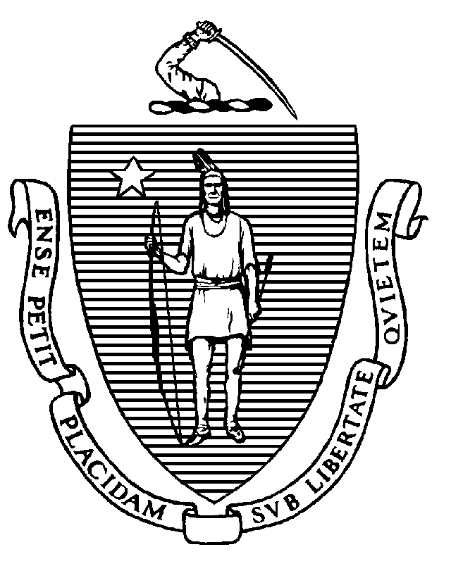

CHARLES D. BAKER
Governor
KARYN E. POLITO
Lieutenant Governor
The Commonwealth of Massachusetts
Executive Office of Health and Human Services
Department of Public Health
Bureau of Health Professions Licensure
239 Causeway Street, Suite 500, Boston, MA 02114

MARYLOU SUDDERS
Secretary
MONICA BHAREL, MD, MPH Commissioner

Tel: 617-973-0800
TTY : 617-973-0988
www.mass.gov/dph/boards
Community Health Workers:
Certification in Massachusetts

The Important Role of CHWs

Community Health Workers (CHWs):

- Are frontline public health workers
- Are hired primarily for their understanding of the communities they serve
- Build individual and community capacity by increasing health knowledge and self-sufficiency
- Provide a range of services such as outreach, community education, informal counseling, social support and advocacy

Why Certify CHWs?

- The purpose of certification is to create a better understanding and recognition of the value of community health workers.
- It is a competency-based certification that defines the CHW scope of practice in order to promote effective integration of CHWs into public health and health care.
- Certification legislation resulted from planning and advocacy by CHWs and CHW advocates.
- The State does not require certification of CHWs. CHWs do not need to be certified to work or to continue working as a CHW.
- The Board of Certification of Community Health Workers (the Board) also establishes standards for core CHW Education and Training Programs.
- New bullet to list the value of the core competency.

How Do I Apply for Certification?

To qualify for certification, you must:

- Be 18 years of age or older
- Be competent in each of the 10 core competencies
- Satisfy the work and training requirements
- Provide at least 3 professional references
- Be able to demonstrate “Suitability for Certification” (see link below)
- View the application https://www.mass.gov/community-health-worker-certification.

Two Pathways to Certification

Pathway | Eligibility Criteria
Work Experience Only | 4000 hours CHW work experience over 10 years  * This option is only available for the first 3 years of certification
Combined Training & Work Experience | 80 hours of a board approved core competency training program  2000 hours of CHW work experience over 10 years  * Will become available when the Board begins to approve CHW Training Programs.

Guidelines for CHW Training Programs to Gain Board Approval
- Training programs must provide 80 hours of core training:
  - 80% core competencies (64 hours)
  - 20% special health topics (16 hours)
- 40% of the training must be taught or co-taught by CHWs
- Training methodology is inclusive, accessible and culturally competent
For More Information
- Board of Certification of Community Health Workers
https://www.mass.gov/orgs/board-of-certification-of-community-health-workers
- The Office of Community Health Workers at the Massachusetts Department of Public Health https://www.mass.gov/community-health-workers
- Contact us via email at chwinfo@state.ma.us

