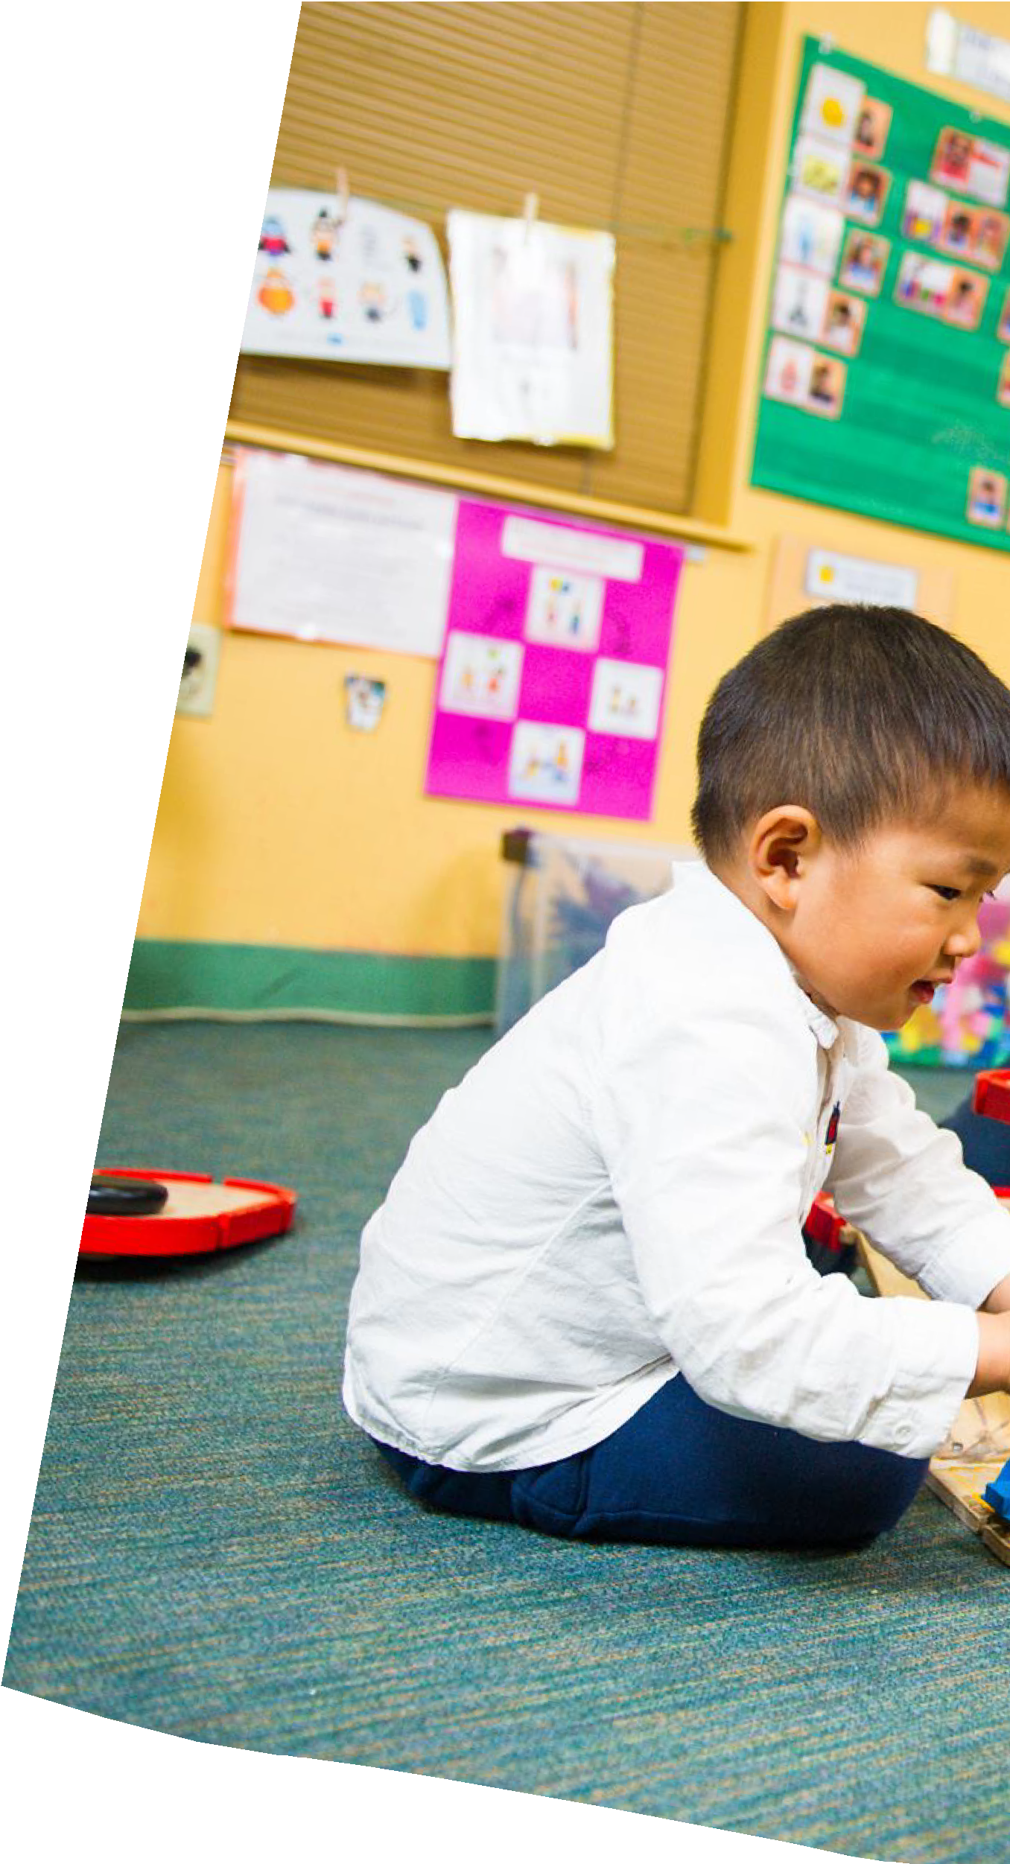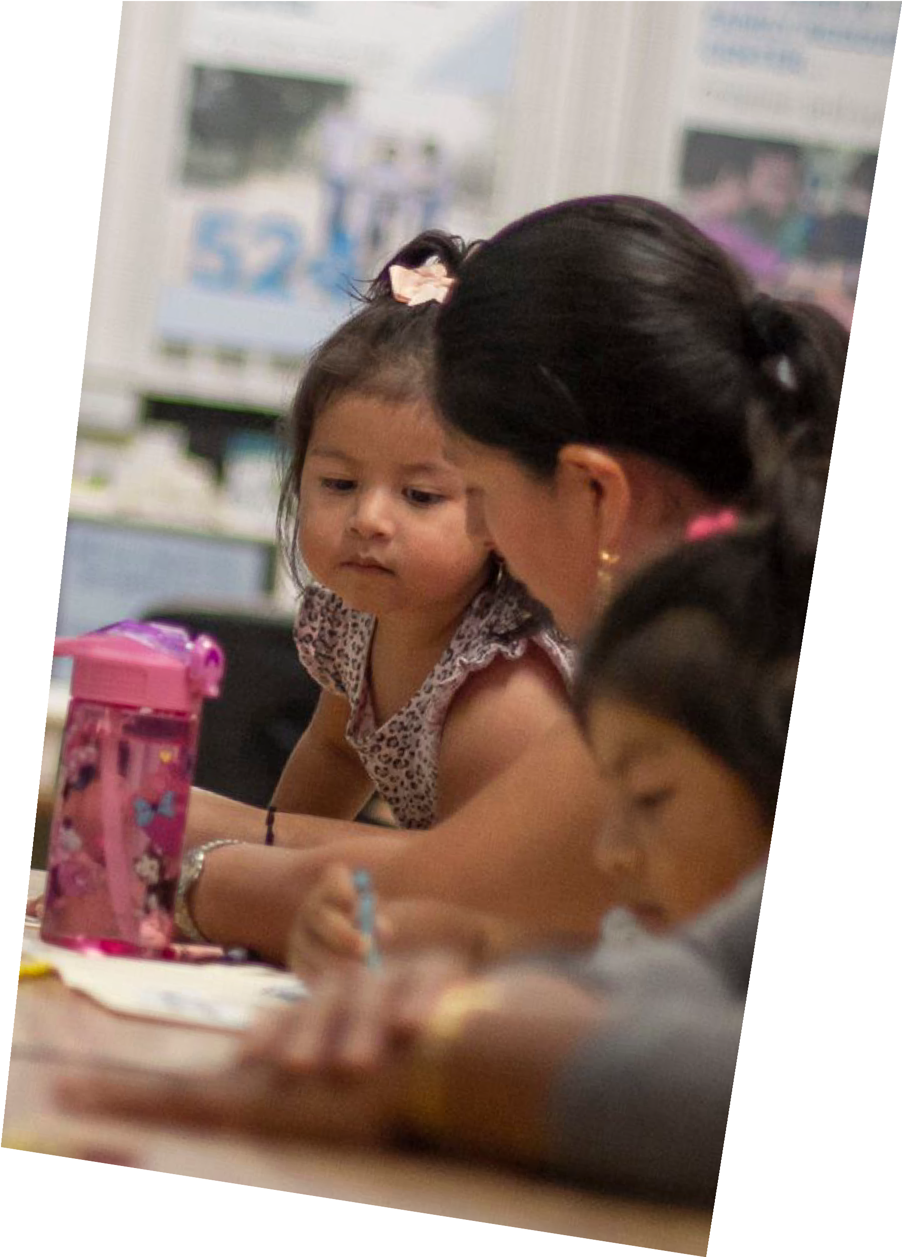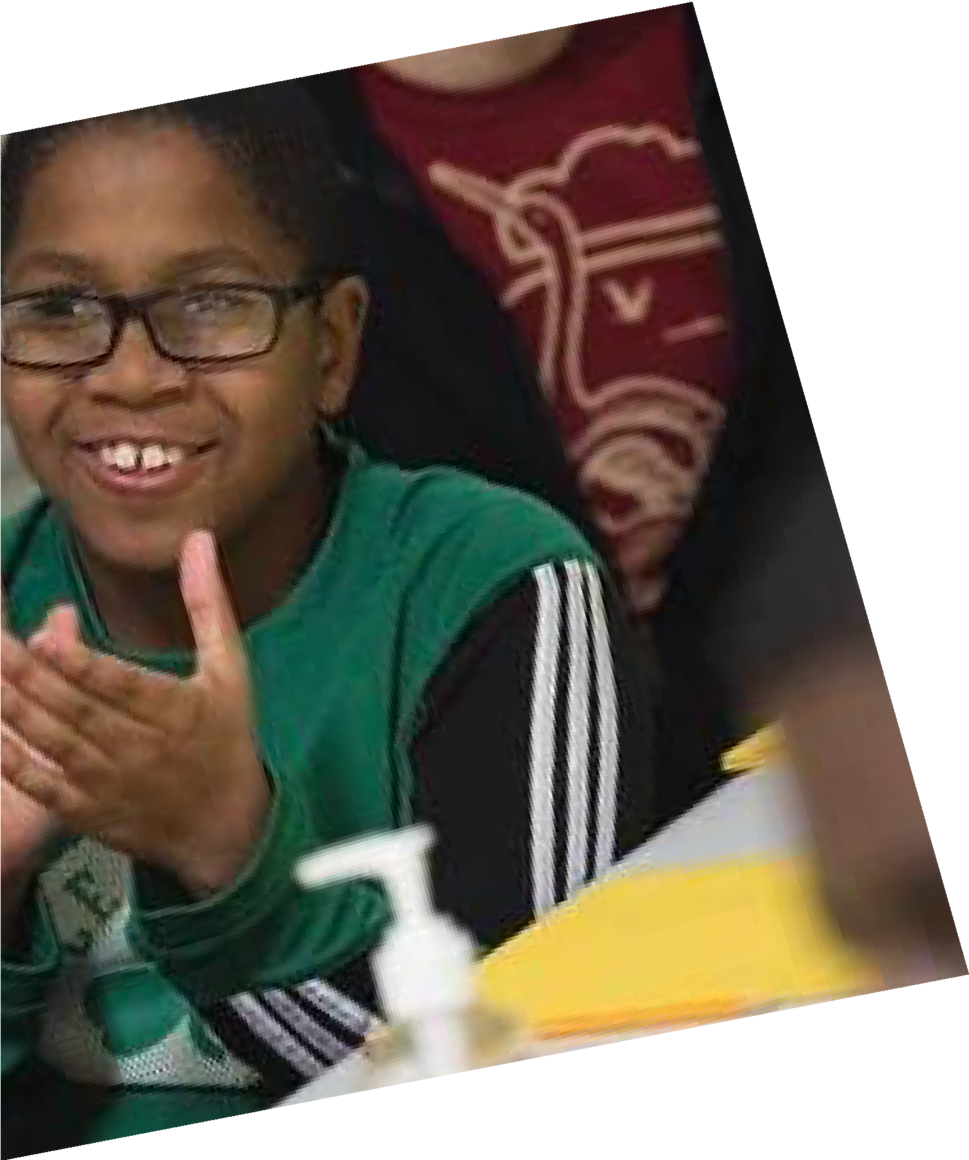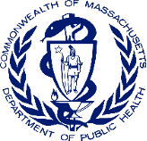

EVERETT, MASSACHUSETTS

C O M M U N I T Y L E V E L H E A L T H P R O J E C T

P L A N N I N G Y E A R R E P O R T

J U N E 2 0 2 1

M A S S A C H U S E T T S D E P A R T M E N T O F P U B L I C H E A L T H
O F F I C E O F P R O B L E M G A M B L I N G S E R V I C E S

Table of Contents
Executive Summary 2
Introduction 3
Identification of Priority Areas and Findings 7
Assessment of Existing Data 8
Identification of Priority Areas and Expert Panels 9
Expert Panels 9
Behavioral Health 10
Racial Equity 13
Access to Culturally Appropriate Services 14
Process and Methodology for Community Engagement 16
Findings from the Community Engagement Process 18
Demographic Information 18
Chosen Priority Area: Integration 20
Community Findings 21
Community-based Intervention: Project RISE 24
Central Tenets of the Intervention 25
Theory of Change 25
Project RISE: Capacity Building and Community Intervention 27
Rationale for Two-phased Intervention 27
Phase One: Capacity Building 28
Phase Two: Intervention 31
Monitoring and Evaluation: Participatory evaluation 32
Appendix 1: Proposed Timeline 34
Appendix 2: Proposed Budget 35
Appendix 3: Logic Models 36
Appendix 4: Demographic Information from Community Engagement Sessions 38
Works Cited 41

Executive Summary
This report details the partnership planning process, community engagement work, and resulting proposed intervention of the Everett Community Level Health Project (CLHP) which took place over 14- months via Zoom. This initiative was funded by the Office of Problem Gambling Services at the Massachusetts Department of Public Health (MDPH), administered by the Boston Chinatown Neighborhood Center, and facilitated by two independent consultants.

The Everett CLHP was comprised of a diverse group of stakeholders from the catchment area of the Everett casino which included community-based agencies, community health centers, and a regional planning agency. Using the two frameworks of the social determinants of health and community engagement, the goal of the CLHP was to identify a health priority concern for the catchment area and make a data-driven and community-prioritized recommendation to MDPH for how to address gambling- related problems. The CLHP looked at existing needs assessments, convened experts on behavioral health, racial equity and access to culturally appropriate services, conducted 10 community engagement sessions which engaged 148 members of the catchment area representing residents, youth, service providers, health care providers, community and faith-based leaders, and small business owners. The catchment area overwhelmingly called for an intervention that integrated behavioral health, racial equity, and access to culturally appropriate services.

Project RISE (Resilient Immigrants Striving for Equity) is a result of this work that seeks to provide services within a framework for immigrants that is caring, just, and humanitarian. The CLHP proposes a two-phased intervention that addresses behavioral health for immigrant communities using a racial equity and access to culturally appropriate services lens. Rooted in theories of power sharing, cultural brokers, and community agencies as safety nets, this intervention centers the critical and central role that community agencies play in supporting vulnerable immigrant communities. As a behavioral intervention, Project RISE recognizes that serving this population well, so they feel respected, listened to, and have a sense of belonging requires new innovative, creative thinking that brings together the best of community-based and clinical care.

The first phase of Project RISE is capacity-building that involves ample and adequate time for planning and preparation, workforce development of bilingual/bicultural cultural brokers, asset mapping, and community design workshops for wellness and resilience. During this phase, community agencies will ensure they have the internal and external infrastructure in place to provide peer support and wrap around services and use innovative tools like asset mapping and design thinking to engage the community in developing new, innovative services and programs. The second phase of Project RISE is the intervention stage that involves services and programs that address all four levels of the social ecological model: individual peer support, support for families, community level programs, and a systems-wide coalition. The programs and activities of phase two will be based on best practices as well as what emerges from Phase One.

Together the community agencies in Project RISE will work and learn together in a community of practice over the three years of the intervention, facilitated by two independent community engagement consultants, as they develop, implement, and evaluate new models for serving vulnerable immigrant communities, thereby making new inroads on the intractable challenge of behavioral health.

Introduction
The passing of the Massachusetts Expanding Gaming Act of in 2011 allowed for the creation of three casinos and one slot parlor in Massachusetts. Currently, there is a slot parlor in Plainville and two regional casinos– one in Springfield and another in Everett. A Public Health Trust Fund (PHTF) was created with the purpose of mitigating negative health effects of gambling on communities due to the opening of the casinos. The strategic plan adopted by the PHTF Executive Committee in 2016 is implemented by the MDPH and the Massachusetts Gaming Commission (MGC).

The MDPH promotes the health and well-being of all residents by ensuring access to high-quality public health and healthcare services, and by focusing on prevention, wellness, and health equity for all people. Within MDPH, the Office of Problem Gambling Services (OPGS) ensures a comprehensive and integrated public health response to problem gambling by using data and community engagement to inform initiatives, priorities, and ensuring racial equity and access to culturally appropriate services.
Critical to the work of MDPH and OPGS is community-driven data, the social determinants of health, and community engagement, with a vision of eradicating health disparities.

Existing Research
In Massachusetts, the 2015 Social and Economic Impacts of Gambling in Massachusetts (SEIGMA) study, updated in 2017, found a prevalence of 2.0% for problem gamblers and 8.4% for at-risk gamblers (Volberg et al., 2017). The prevalence of problem gamblers accounts for approximately 83,000-135,000 Massachusetts residents. The study found that problem gamblers were significantly more likely to be male, Black, and have a high school education or less. At-risk gamblers were significantly more likely than recreational gamblers to be male, unemployed or retired, have an annual household income under
$15,000, and have a high school education or less. Additionally, people of color had higher rates of problem gambling than the general population, with Black and Hispanic prevalence rates of 6.1% and 2.3% respectively (Volberg et al., 2017). While the SEIGMA report notes that the Asian subgroup data was unreliable due to inadequate sample size, other studies have shown problem gambling is an issue within the Asian community (Petry, Stinson, & Grant, 2005; Wong & Li, 2020). The SEIGMA study notes its limitations which include: the questionnaire was translated into Spanish but not other languages; several subgroup sizes were small leading to prevalence rates with large confidence intervals; and the sample did not include individuals who are incarcerated, people experiencing homelessness, or those living in group quarters (Volberg et al., 2017).

The field of gambling has been historically disconnected from the community experience of gambling. Existing research captured by large, state-wide, epidemiological studies is not often able to discern the subtle, nuanced, and everyday impacts on communities that are linguistically and culturally isolated.
MDPH and OPGS target upstream causes that manifest in gambling-related problems. OPGS recognizes the centrality of community voices and honoring the lived experiences of practitioners, providers, policymakers, and the public in the communities impacted by the casinos and gambling overall. Those impacted include those who live near, work at, and use casinos and other forms of gambling.

Everett Community Level Health Project
The purpose of the Everett Community Level Health Project (CLHP) was to bring together key stakeholders representing those impacted by casino gambling, particularly those who are racial minorities and linguistically and culturally isolated. This group met regularly over 14 months to develop, propose, and recommend a community-level plan that would identify and address a critical aspect of the social determinants of health that would mitigate and prevent gambling-related health concerns.

Key partners: The Advisory Group (described below) was led by two community engagement consultants whose roles were to shepherd and steward this process. The lead community engagement consultant, Dr. Heang Rubin EdD, MA, is a national expert on stakeholder and community engagement. Community engagement principles are woven into her research which has focused on community- identified priorities in Chinatown, her applied and field-based teaching, and her advocacy work in Boston Chinatown. The junior community engagement consultant, Mia Colby, MPH, provided key project management, data collection and analysis, and social media skills.

The Advisory Group met on a monthly basis and included the following core partners:

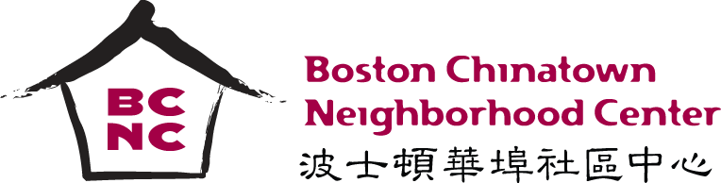
- Boston Chinatown Neighborhood Center (BCNC): BCNC was the lead agency for this project. Established in 1969, BCNC is a multi-service organization serving Greater Boston with the aim of
empowering Asians and new immigrants. BCNC has locations in Boston’s Chinatown and Quincy as well as Pao Arts Center in downtown Boston. Their mission is to ensure that children, youth, and families served have the resources and supports needed to achieve greater economic success and social well-being. The organization provides a range of programs and services from education to family support services to arts and culture. BCNC reaches more than 13,000 individuals a year.

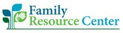
- Family Resource Center (FRC): FRC is based in Everett and is a part of Eliot Community Human Services, an organization committed to serving the most vulnerable populations. FRC is designed to help

families find emotional support and practical assistance with everything from housing, education, utility assistance, and legal help to summer camps and sports leagues. Their work also extends to having school liaisons and supporting families with youth at-risk for needing court involvement. Additionally, FRC runs a food pantry in Eliot which serves a diverse population.

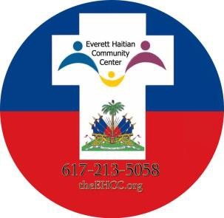
- Everett Haitian Community Center (EHCC): EHCC is the first volunteer social welfare/social justice faith-based human rights, civil rights, and anti-poverty Haitian American organization in Massachusetts. Their mission is to empower, educate, and provide culturally appropriate resources to individuals and families in order to integrate in the local society and attain self-sustainability for a better future. EHCC has been serving immigrants of all faiths in Everett, Malden, Medford, Chelsea, Revere, East Boston, and other Greater Boston areas since 2015. They provide advocacy, services,
classes, programs, and resources to those in need including programming in community outreach and civic engagement, community health literacy and advocacy, and youth programs such as the Emerging Bright Stars Academy.

- Cambridge Health Alliance (CHA): CHA is a health system and safety net hospital serving the Boston metro-north region. The Health Improvement Team (HIT) is a department of CHA which works with healthcare providers, the
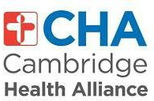
community, and city officials/leaders to assess health, determine health priorities, and develop plans regarding health issues in the community. HIT aims to bring partners from the community together to identify factors influencing health and build programs that are data-driven. CHA is community driven and provides many programs and services to
better serve the needs of the community. CHA has HIT teams dedicated to working specifically with the communities in Everett, Chelsea, Revere, Somerville, Malden, and Medford.

- Metropolitan Area Planning Council (MAPC): MAPC is a regional planning agency that serves people in the Metropolitan Boston area. The
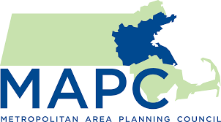
mission of MAPC is to promote smart growth and regional collaboration. MAPC encompasses 101 cities and towns and is governed by representatives from the towns in their region. MAPC focuses on a wide range of issues including municipal management, sustainable land use, protection of public resources, transportation, public safety,

economic development, healthy communities, ensuring that the public is informed, and providing equity and opportunity for people of all backgrounds.

This was a strategic partnership that represented stakeholders who work at multiple levels of the social ecological model (Figure 1). This partnership included key community-based organizations with deep roots in immigrant communities, community health centers with a history of successful service delivery, and a regional planning agency who works on regional collaboration in the region.

Partnership phase: In this partnership phase, the Advisory Group identified priorities that address specific health concerns which have arisen and/or been exacerbated by casino gambling in the Everett region. For the Advisory Group,
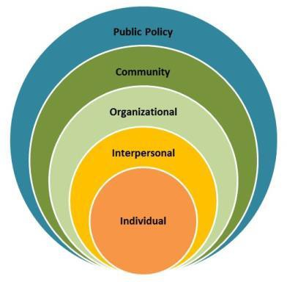
immigrants were chosen as the priority population due to the history of racial and ethnic inequities in health (particularly in behavioral health care), the fight for racial equity, and the long- standing struggle for immigrant communities who lack access to basic services because of linguistic and cultural isolation. This group made decisions based on prior needs assessments, content

expert input, and feedback from stakeholders across the catchment area.
Figure 1. The Social Economic Framework from the Centers for Disease Control

Guiding frameworks: Two frameworks guided the work of the Advisory Group in the partnership phase. First, the social ecological framework looks at public health concerns that manifest in individual lives as embedded within interpersonal relationships (such as the family), within the organizations and institutions they interact with, within their communities, and within policy at the local, state, and national levels (Figure 1.) The influence and interaction of all these levels shape the individual, families’, and community’s knowledge, attitudes, skills, and sense of self-efficacy. The social ecological framework is often used in public health when designing interventions and is central to OPGS’s work. Second, a stakeholder community engagement (SCE) framework recognizes that involving key stakeholders as equal collaborators is important to address inequities in public health outcomes (McCloskey, Akintobi, Bonham, Cook, & Coyne-Beasley, 2011). SCE framework centers trust building, consensus, and transparency to ensure that concerns and questions are addressed with a spirit of respect, openness, and responsiveness (Israel, Schulz, Parker, & Becker, 1998; Minkler, 2005; Wallerstein, Minkler, Carter- Edwards, Avila, & Sánchez, 2015).

Focus of the Report
This report represents the culmination of the partnership process and provides the theoretical and implementation framework of Project RISE (Resilient Immigrants Striving for Equity), a two-phased intervention that involves 1) capacity-building and 2) delivery of programs, services, and policy work. Project RISE addresses behavioral health, based in community-led and community-based service delivery, such that the implementation of services is caring, flexible, and equitable. According to the community input and content experts, immigrant behavioral health outcomes, such as stress, financial distress, and a sense of otherness or a lack of belonging, are existing health issues of great concern which have been created and/or exacerbated by casino gambling. Central and critical to the design, delivery, and evaluation of Project RISE is the role of community-serving agencies such as community- based organizations, faith-based institutions, and community health centers that are led by, staffed with, and rooted in the racial and ethnic communities impacted by casino gambling.

Because the COVID-19 pandemic has created and exacerbated behavioral health problems, this proposed intervention combines the best of community-based and clinical care and provides the opportunity to re-think and re-imagine existing models of service delivery, thereby making space for more creative, flexible, and adaptive work that centers racial equity and access to culturally appropriate services for immigrant communities in the catchment area.

This report is organized with the following sections:
- Introduction
- Identification of Priority Areas and Findings
- Community engagement process and methodology
- Theory of change for intervention
- Project RISE: Capacity building and Community design
- Monitoring and evaluation
- Timeline
- Appendices: (Proposed Timeline, Proposed Budget, Logic Models, Demographic Information from the Community Engagement Sessions)

Identification of Priority Areas and Findings
The Everett CLHP partnership phase was conducted with a four-step process:

- Assessment of existing data
  - Definition of catchment area for Encore casino
  - Discuss of existing community health level data
- Identification of priority areas and expert panels
- Community feedback from catchment area
- Development and design of intervention

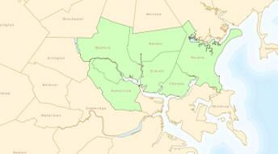Assessment of Existing Data
Somerville
Chelsea
Winthrop
Charlestown
East Boston
Chinatown
Everett

Revere

Medford
Malden

Definition of catchment area: The Everett CLHP first identified the catchment area for the Encore casino (Figure 2). The final decision about the catchment area was based on geography and population impacted by the casino. The catchment area included the Greater Everett region (City of Everett, Chelsea, Medford, Malden, Revere, Somerville, Winthrop) and key neighborhoods in Boston: Charlestown, Chinatown, and East Boston. The population impacted by the casino included those cities and neighborhoods for which public and/or casino transportation make the

Figure 2: Catchment area. Map adapted from the MAPC. (Metropolitan Area Planning Council, 2014)

local casino easily accessible to linguistically and culturally isolated communities and those neighborhoods and cities served by the partners in the Everett CLHP.

Discussion of existing data: Based on the catchment area, the Advisory Group looked at the existing data that existed in Community Health Needs Assessments (CHNAs) that were housed on the websites of local hospitals or public health agencies. Criteria for including the CHNA in the assessment were 1) conducted in the last four years and 2) contains data on city or neighborhood in catchment area. One of the community engagement consultants read through each CHNA, synthesized the findings, and grouped the findings into common themes. These four areas themes were presented to the Everett CLHP for discussion (Figure 3).

Housing
Stability
Affordability
Quality
Gentrification
Behavioral Health
Mental Health
Substance
Abuse
Access
Food Insecurity
Access to
Healthcare
Access to Social
Services
Transportation
Economic
Stability/Mobility
Education
Employment
Poverty

Figure 3: Summary of health disparities in catchment area

Identification of Priority Areas and Expert Panels
The Advisory Group discussed the four areas that emerged most frequently in the CHNAs: housing, behavioral health, access, and economic stability and mobility. Behavioral health emerged immediately as a key area to focus on. Through the discussions of housing and economic stability/mobility, several members of the Advisory Group determined that there were other working groups in the catchment area, and they did not want to be duplicative of other initiatives.

The killing of George Floyd, Brianna Taylor, and Ahmed Aubrey over the summer of 2020 and the local and national protests around racial equity created an opportunity to speak more directly to the issues of systemic racism in this country and how it has impacted the lives and livelihood of Black, Indigenous, and other People of Color (BIPOC) people. Race is a salient and often unacknowledged issue affecting quality of life of the communities served by the partners in the Advisory Group. As a result, the community-based agencies on the Advisory Group felt strongly that racial equity and access to culturally appropriate services be looked at distinctly as a priority issue area.

Expert Panels
Advisory Group members brainstormed local experts for each panel. People with lived and professional experience were all equally considered experts. In putting together each panel, attention was paid to ensure racial and ethnic diversity. Final panel members were chosen by an anonymous vote and the Advisory Group approved the final slate for each panel. Experts were invited to come to the panel via email explaining the intent and goals of the panel. There were prep calls for the racial equity and access to culturally appropriate services panels. The Advisory Group wanted to use the panels to think broadly, deeply, and boldly about how to really address the intractable and painful issue of problem gambling and its relationship with the priority areas.
Panelists represented the following: Behavioral Health
- Haitian community member
- White clinician who works in Everett
- Asian American psychiatrist and researcher

Racial Equity
- Black academic who researches immigrant families
- Latinx civil rights lawyer
- Latinx non-profit leader
- Asian American service provider and community researcher

Access to culturally appropriate services
- Haitian non-profit leader
- Community health worker at community health center
- Asian American domestic violence advocate

Behavioral Health
Demographics of who is impacted: It is not surprising that behavioral health rose to the top of the list of community priorities, as identified by the Advisory Group. According to the Mass Department of Mental Health Annual Report (2020), 25,000+ individuals were served in 2020. Sixty to eighty percent of those served have co-occurring mental health and substance use disorders. Of those served, 56% were White non-Hispanic, 7% White Hispanic, 14% Black non-Hispanic, 1% Black Hispanic, 2% Asian, <1% Native American, and 2% identified as two or more races (Mass Department of Mental Health Annual Report: Fiscal Year 2020, 2020). We know however, that these numbers do not adequately capture the behavioral health needs of immigrant communities who under-report behavioral health.

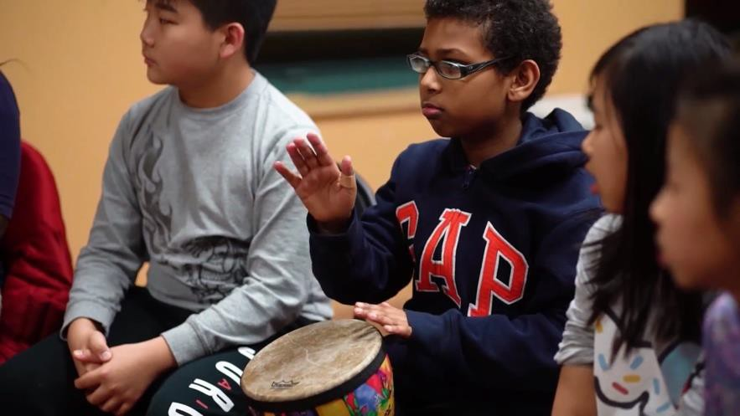
Relevance to the catchment area: In the catchment area, mental health indicators were often higher than for the state. For example, mental health related mortality in Malden was 64.1 as compared to the 60 for the state. When looking at youth, rates for students experiencing depression in the past 12 months or reporting feeling sad/hopeless were higher than the state in Everett, Malden, Chelsea, Revere, and Winthrop (Everett/Malden Collaborative for Community Health Improvement, 2019; North Suffolk Public Health Collaborative, 2019). Somerville has also reported high rates of youth depression and suicidal thoughts (Cambridge Health Alliance & City of Somerville Health and Human Services, 2017;
North Suffolk Public Health Collaborative, 2019). Respondents in some cities of the catchment area stated they had been told they had anxiety and depression (Institute for Community Health, 2019). Chelsea, Revere, and Winthrop also stated that mental health was a top concern(North Suffolk Public Health Collaborative, 2019).

Gaps in mental health services: The CHNAs reviewed also pointed to gaps in the behavioral health care system, a scarcity of needed services for mental health and substance abuse, and a lack of culturally and linguistically appropriate services. The North Suffolk CHNA report summarized the frustration felt by many in the area in concluding: “The care delivery method for mental health resources and services should be reformed in new and alternative ways so that more individuals of all ages, religions, races, ethnic groups, socio-economic backgrounds and sexual orientation who need mental health care are
able to receive quality and affordable care quickly” (North Suffolk Public Health Collaborative, 2019). Access to care can be particularly challenging for immigrant communities: “The effect of perceived discrimination and language proficiency on service use indicates a need for more bilingual services and more collaborations between formal service systems and community resources.” (Spencer, Chen, Gee, Fabian, & Takeuchi, 2010).

Expert testimonies
The testimonies from experts on the behavioral health panel deepened the understanding of the issue, providing texture, nuance, and real-life experiences to complement the data from the needs assessments and peer-review literature. The Haitian expert indicated there are historical, systemic health and social inequalities that disproportionately impact those particularly from immigrant backgrounds. In the Haitian community, for example, the community struggled with the behavioral impact of the Haitian earthquake in 2010. Furthermore, she explained that those who are undocumented fared even worse under COVID. The fear of their immigration status being discovered made some not seek services during this critical time. Some key points expressed by the panelists are listed below:

New behavioral health challenges presented by COVID-19: Providing clinical services for behavioral health and particularly gambling addiction has always been a challenge. People with behavioral health problems do not usually come in to a clinic initially to address this problem. Because gambling is comorbid with other health problems, clients usually come to the clinic, presenting with other conditions, such as alcoholism.

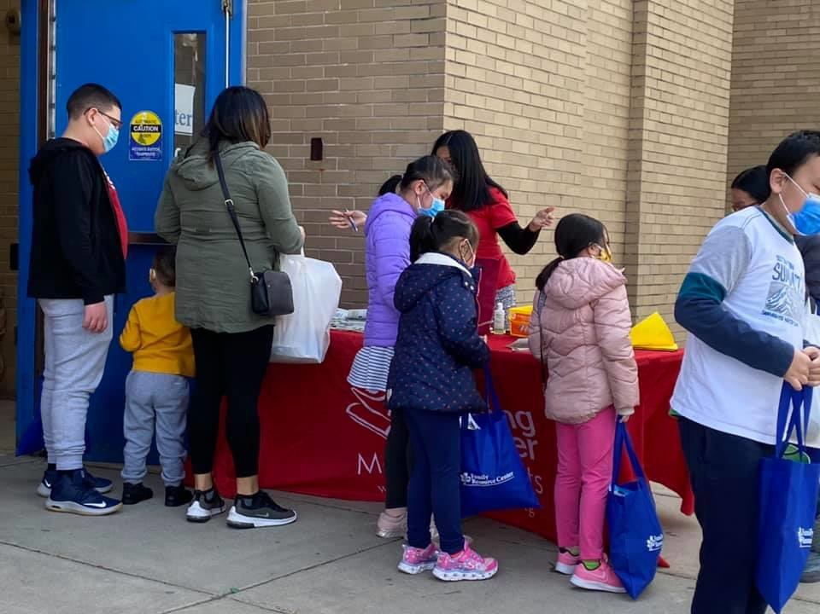
Under COVID, people lost many of their typical coping skills, such as exercise or social relationships. One expert expressed that many clinicians providing behavioral health care found themselves providing trauma-informed care, because clients were in “flight, fright, or freeze.” Clinics had to quickly adapt to telehealth and many clients found it difficult to adapt to telehealth. Many clinicians found themselves also needing to provide basic resources that clients were in need of, such as food, utility, and access to other resources.

“Double trauma” of living under COVID-19:
Like so many other inequities, behavioral health was exacerbated by COVID, according to the behavioral health experts. One expert likened dealing with the inequities under COVID and racism as a “double trauma.” Living with COVID caused more stress among certain communities. For example, in the Haitian community, many are nurses who take public transportation to work. Therefore, taking public transportation exacerbated stress levels. These needs further exposed the gaps in the system. A clinician indicated that
there has been an uptick in suicidality and “the increase in suicide attempts has really been a concern of [theirs].” People struggling with behavioral health also find themselves struggling to maintain their jobs, are at-risk of eviction, and lack access to culturally appropriate foods. The needs of sub-populations, such as students, became more apparent under COVID. One clinician expert expressed that “the most

impacted [are] the people that have been already finding it difficult to find their natural supports and
their way in the world.”

Impact of poverty: Poverty is intimately linked to why people gamble. One expert described that in her community, people are “living paycheck to paycheck” and use gambling to supplement their income. This can be particularly acute for some communities in which people are sending money back to their home country to support family members abroad. For those who struggle with poverty and financial inequities, there are not adequate services for them, and this large part of the population does not make it to the clinic. Because of the link to poverty, there is an urgent need to help families with financial literacy and planning. Working-class families have not had access to knowledge about how to build wealth in this country.

Stigma: Stigma is complicated and difficult to disentangle. “Mental illness” in this country is pathologized; many internalize it and isolate when diagnosed, causing some to suffer in silence and others to engage in even more toxic behaviors. In some immigrant communities, there is a “taboo” of speaking about behavioral health and it may be seen as a “spiritual attack”. The Haitian expert
expressed that in her community, mental illness is something “you go to your church members to help you pray through [...] as opposed to seeing it as something that can be treated medically or through health professionals.” Because of this, some look to prayer and faith leaders to help them with behavioral health issues; however, COVID has made it difficult to access one’s faith community. Those who seek out traditional behavioral health services may find themselves minimized, misunderstood, or
dismissed in their own communities. For example, an expert from the Asian community stated: “Mental
health is not a culturally accepted script [...] if you are struggling it’s not because you might be depressed, it’s probably because you are lazy or some other issue.”

Challenge of serving a different cultural group: Culture can be difficult to navigate. Providers without the lived experience often find themselves limited in what they can provide if they are only working through a translator, and they do not know how to navigate in communities with cultural nuances. Therefore, all experts recommended that there is a strong need to develop culturally appropriate interventions outside of the traditional, clinical encounter.

The urgent need for “out of the box” solutions: All three experts pointed to the need for addressing the emotional needs of clients outside of formal talk therapy. What’s most important is getting someone in the door and providing services. They all called “out-of-the-box” ways to address behavioral health. One of the clinicians found that in her practice with youth, some of the most effective programs have been meditation groups, arts, and expressive music. Outreach and messaging to immigrant communities can be done through everyday institutions such as laundries, grocery stores, and public transportation.
There also need to be ways to talk about behavioral health in ways that are not stigmatizing. Conversations in a community setting can lead to opening up and the opportunity to normalize the issue. Bilingual/bicultural workers such as family partners can run ongoing support groups in which people have their feelings validated which leads to normalization. During these sessions, community agencies can give clients information and support them and how to connect and trust. The

reimbursement system, which is two-tiered, must also be reviewed. For those on MassHealth, there is often a long-wait period. For those with disposable income, they can often pay out of pocket for services and wait to be reimbursed.

Racial Equity
Scholars and practitioners alike point to the COVID-19 pandemic as exacerbating existing racial and ethnic inequalities. The Center for Disease Control recognizes that racial and ethnic minorities are disproportionately impacted by the COVID-19 pandemic (CDC, 2020). The World Economic Forum cited that the COVID-19 pandemic revealed inequalities are most pronounced for racial and ethnic minorities and people with disabilities related to access to green space, health care access and outcomes, access to technology, employment and accessibility for people with disabilities (Myers, 2020). The COVID-19 pandemic demonstrated and exacerbated existing racial and ethnic inequalities in the US related to employment, family life, and health (Abedi et al., 2020; Blundell, Costa Dias, Joyce, & Xu, 2020). The killing of George Floyd in May 2020, the upsurge of anti-Asian sentiment, and the killing of six women of Asian descent in March 2021 has re-invigorated local and national discussions about racial equity in the US. The COVID-19 pandemic and the racial violence of the past year built on existing racial and ethnic disparities in health care related to patient-provider communication, access to services, and health literacy (Howard, Sentell, & Gazmararian, 2006; Schut, 2021; Sentell & Halpin, 2006; Shen et al., 2018; Yearby, 2011, 2018). Due to all these dynamics, the Advisory Group felt strongly that experts on racial equity provide testimony during this process.

Expert testimonies
Being actively anti-racist: All panelists agreed that it is important to recognize the intersectionality of race with other areas of inequality such as poverty and national origin. No racial group has a homogeneous experience. There were strong feelings among the panelists that everyone in this country can be complicit in perpetuating systemic racism, as one panelist argued, “We must be actively anti-
racist.” Panelists recognized that being anti-racist must
go beyond workshops on implicit bias training. No

panelist was surprised at the recent events, recognizing that social media has made many more people aware of systemic racism, its implications on people’s lives, and the ways in which many of us have
turned a blind eye to its effects. Systemic racism can be explicit, such as police brutality, or subtle, such as the questioning of a BIPOC’s person’s intelligence in meetings (which many of the panelists had experienced). One panelist made explicit that we must all face the “myth of Massachusetts is progressive.”

“I think it is important for us not to pat

ourselves on the back because we didn't actively discriminate somebody today or because we didn’t actively hate crime somebody today. It is incredibly important for us to be thinking about our active role, not just as bystanders of the inequity, but as people who are committed to being actively anti-racist and to dismantle the structural inequities that we're talking about.”

-Expert Panelist

Link between racial equity and the casinos: Three of the four panelists explicitly linked racial equity to
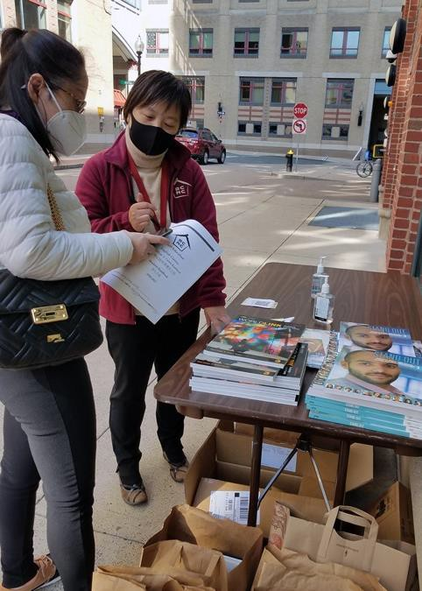
the casinos. For the experts, the Everett community in which the casino was built and the targeting of certain communities, such as working-class Chinese Americans, clearly point to a racial equity piece of casino gambling. One expert pointed to the buses sent by the casinos to Chinatown. She observed that the buses are
“purposefully sent by the casinos” to pick up restaurant workers at the end of their shifts who are in need of stress relief. One panelist noted that “casinos prey upon Asian Americans in dire economic situations” adding later “profit seeking agencies hijack one’s need to socialize and then make money off of people.” Another expert said that casinos actively create addiction and in doing so, one’s “basic needs and human rights are being exploited.” To better understand how casinos create situations conducive to addiction, one expert advocated that it is important to look more into casino advertising and know who’s using the casino, how often, and how much they are spending. “What are people missing in their lives”
this expert wondered, calling for “alternative recreational opportunities” that are healthier.

Power and resources: Panelists comments pointed to how working-class communities that feel invisible and excluded from the political process, making some afraid to make demands to the government. One expert panelist questioned whether community partners had been at the table when the decision was made to open the casino in Everett and advocated that community partners be at the table when discussing mitigation. This expert echoed a theme among many experts from all three panels that community partners, because of their lived experience and direct experience in working with clients and their families, be seen and treated as experts in their own right. Community partners are key in holding large institutions, like casinos, accountable for their work.

Need for wrap-around services: Echoing the behavioral health panel, two experts in this panel pointed to the need for wrap-around services for families and the need for linking emotional wellness with economic health of a family. One expert also questioned the role that casinos play in tipping a recreational gambler into a problem gambler. One expert specially called for an “equity audit” in which the casinos hire a third party to look at their advertising, marketing, hiring, implicit bias, and outreach.

Access to Culturally Appropriate Services
It is well documented that immigrant and refugee communities face significant barriers in accessing care in the behavioral health system due to linguistic and cultural barriers. These barriers include differences in how Western trained providers and immigrant communities think about, understand, and access behavioral health. Mistrust in the system, feeling disrespected, poor communication, culturally inappropriate interventions, and poor outcomes (even misdiagnosis) for those needing support

exacerbate inequities has been well documented (Leong & Kalibatseva, 2011; Ngo-Metzger et al., 2003; Snyder, Cunningham, Nakazono, & Hays, 2000).

The Advisory Group voiced that the immigrant communities they work with long to feel welcomed, loved, heard, respected, and a sense of belonging. Too often, when interacting with government systems this sense of being valued and heard is not part of their experiences and these communities do not feel integrated into these systems because they face such challenges in access and navigation.

Expert testimonies
Spaces of belonging: The experts told stories about how government systems may have a translator on hand when an immigrant or refugee walks through the door, but it is not the same as going to a trusted community-based agency. The experts emphasized that community-based agencies are places where immigrant and refugee communities go to be heard, understood, and treated with a sense of dignity.
One expert stated the importance of “understanding their [the client’s] background, their aspirations, so that by the time you serve them you show them the respect that they deserve, you give them the
dignity that they deserve.” Community-based agencies are usually staffed by people who look like the client, share the same background, and speak the language. Just as important as the cultural and linguistic congruence, is the sense that immigrants and refugees feel cared for in these agencies. They know that staff of these agencies will “give them what it takes” and there is a mutual feeling of “we are with you.”

The need for remuneration when providing linguistic and culturally appropriate services: Two of the experts pointed to the glaring fact that too often, community-based agencies find themselves providing cultural and linguistic specific services for government and health care systems without adequate compensation and remuneration. One expert who works with victims of domestic violence estimated that her staff provide close to $8,000 worth of linguistic and culturally competent services for each client while helping them navigate across systems such as housing, law enforcement, and the courts. She
stated that “all those [government services] are inaccessible to somebody who has cultural and linguistic barriers, so our advocates come in […] and they are providing that service on behalf of the clients.” Seventy percent of their referrals come from providers who are in critical need for their services. She argued that her staff should be seen as “specialists” in their own right, just as those with advanced degrees in medicine are treated as experts and compensated as such. The other experts on the panel agreed that their staff should be seen as experts for the skills and experiences that they bring.

Cultural humility: One expert described providers adopting cultural humility can help with systemic barriers to care when the providers in a system do not share the cultural and linguistic background of the public. An expert stated: “We define cultural humility as a lifelong process of self-reflection and self- critique where you not only learn about another culture, but start by examining your own culture, your own beliefs, and your own cultural identities.” Cultural humility involves the recognition that all of us occupy multiple cultural identities and occupy different spaces of privilege as well. Working with people of different backgrounds requires that one understand that one can only be the expert of one’s life

experience and that one can help create the conditions so that others can feel supported and can flourish.

The importance of having community leaders at the table: The experts observed that there are resources available to serve linguistic minority populations; however, there are multiple barriers that prevent this population from having their needs met. Like the other panels, the experts on this panel believe that leaders like themselves, who are “on the ground”, need to be at the table where and when
decisions are made about the community. One expert stated: “We know that for changes to happen, we
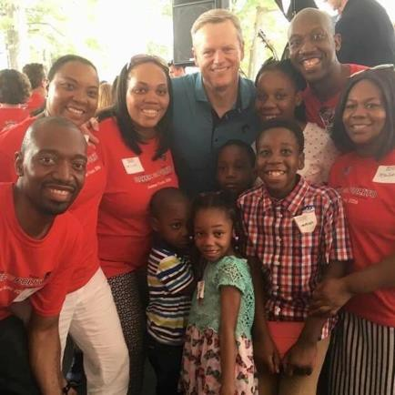
need to be present, we need to be at the table advocating for
these changes.” The statement was echoed and supported by
other experts present, one of whom felt “we need to have these leaders at the ground level from planning on.” The experts also felt strongly that it is important to continue to hear the stories of the people they work with so that the “conversation continues to be in the spotlight,” even if it makes those in positions of decision-making uncomfortable with what is being said or what is being asked of them. As leaders, they can exercise their privilege in a way that can push for equity, unity, and coalition-building thereby ensuring their concerns are heard by those in leadership.

Process and Methodology for Community Engagement
Community engagement sessions across the catchment area were conducted by Advisory Group members. The purpose of the community engagement sessions was to present the findings from the expert panels, engage in discussion with the community, and have individuals vote for their preferred focus area for an intervention which would address upstream factors influencing gambling related problems and behaviors. The Advisory Group decided to add one additional voting preference: integration of all three areas, thereby incorporating behavioral health, racial equity, and access to culturally appropriate services. Getting feedback from across the catchment area on the priority area they would like to see funded was central to this engagement process.

Design of community engagement sessions: Members of the Advisory Group, in collaboration with the community engagement consultants, conducted the community engagement sessions. The Advisory Group strove to have a representative segment of the community that included providers, community leaders, and residents. Careful attention was paid to piggy-back off of existing meetings to avoid overburdening the community during COVID-19, especially as the workload has increased for many who serve the catchment area.

Preparation for community engagement sessions: The community engagement consultants created a PowerPoint that was used across all community engagement meetings. This PowerPoint was presented to the Advisory Group, feedback was received, changes were made, and then approved by the Advisory Group and MDPH. The PowerPoint included the goals and purpose of the meeting, the goals of the

project, a list of partners in the Everett CLHP, a map of the catchment area, salient quotes and findings from each of the expert panels, discussion questions, and discussion of the voting process. During this discussion, a suggestion was made that there be a fourth option presented to the community: integration of all three priority areas.

Discussion of data collection tool for community engagement sessions: A survey was created to gather accurate, representative demographic information about participants at the community engagement session. Data was collected using a standard Qualtrics survey that enabled ranked choice preference (first and second choice) and an open comment box to indicate why they chose this option. Advisory board members also wanted information about national origin, language, and existing assets and strengths to build upon.

Delivery of community engagement sessions: All meetings were done over Zoom and were attended by the community engagement consultants. The lead community engagement consultant ensured that consistent information was presented, though some sessions were tailored depending on the audience. For example, the meeting with youth used a more conversational meeting style with more icebreakers and getting-to-know-you questions. The junior consultant helped people through the logistics and technical aspects of the survey.

Monitoring of community engagement sessions: Community engagement sessions were done over the month of March 2021. In mid-March, the Everett Executive Team (consisting of BCNC, MDPH, and the two consultants) met to look at the progress. This enabled the team to look at the number of meetings and the sample. Extra effort was made to ensure that community members representing immigrant communities were engaged and represented at the meetings.

List of the community engagement meetings and the CLHP partner(s) that facilitated them:
- Everett Youth Network Meeting (Cambridge Health Alliance, Family Resource Center, & Everett Haitian Community Center)
- The Chinatown Coalition Meeting (Boston Chinatown Neighborhood Center)
- Chinese Cultural Connection Meeting (Boston Chinatown Neighborhood Center)
- Greater Malden Asian American Community Coalition Meeting (Boston Chinatown Neighborhood Center)
- Association of Haitian Pastors Meeting (Everett Haitian Community Center)
- Teens in Everett Against Substance Abuse Meeting (Cambridge Health Alliance)
- North Suffolk CHIP Behavioral Health Meeting (Metropolitan Area Planning Council)
- VHA Meeting (Everett Haitian Community Center)
- Hispanic Mothers Meeting (Family Resource Center)
- Parent Group Meeting (Boston Chinatown Neighborhood Center)

Findings from the Community Engagement Process

Demographic Information
A total of 148 participants responded to the survey. The demographic information for the community feedback was separated based on whether the respondent was a member of the community or a service provider. On the whole, the respondents represented the diverse immigrant community of the catchment area. Both the cities served by the service providers (Figure 4) and the cities the community respondents live in (Figure 5) demonstrate strong representation of the catchment population.

As can be seen in Figures 6 and 7, the distribution of languages spoken indicates many individuals who do not speak English as their first language. The service providers participating in the community engagement sessions provided services in a wide range of languages.

12%

4%

4%
17%

6%

5%

8%

7%
20%
17%

Boston Cambridge Chelsea Everett Malden Medford Quincy Revere Somerville Other

Figure 4: Cities served by the service provider respondents. The other category encompasses all cities with 2 or fewer respondents and includes the following cities Billerica, Brockton, East Boston, Lowell, Lynn, Melrose, Winthrop, Worcester (N=89)

21
16%
%
21%
26%

10%

6%

Boston Chelsea Everett Malden Quincy Other

Figure 5: Cities community respondents live. The other category encompasses all cities with 2 or fewer respondents and includes the following cities Billerica, Brockton, East Boston, Lowell, Lynn, Melrose, Winthrop, Worcester. (N=62)

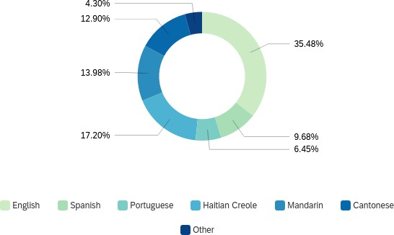
Figure 6: Languages services are offered in as reported by service providers in the catchment area (N=93)

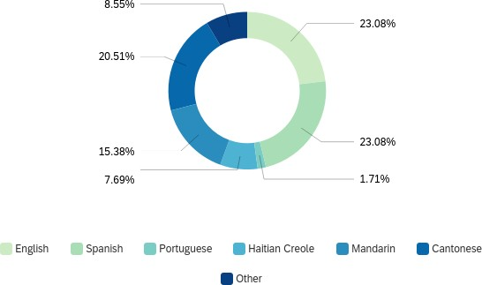

Figure 7: Languages spoken by community respondents (N=116)
The most represented age group was 31-40 years (36.1%); however, the ages between 21 years to 60 years were generally well represented. The service providers were relatively even in the distribution of ages for the populations they serve, with each age group making up around 15% of the surveyed population. The races and ethnicities of the service providers were quite diverse with 31% Asian service providers, 23% Black or African American, 18% White, and 16% of service providers

identifying as of Hispanic, Latino, or Spanish origin. The race breakdown of the community respondents leaned heavily towards those of Asian origin (68%), followed by Black or African American (18%). It is important to note that the respondents who identified as of Hispanic, Latino, or Spanish origin (37%) are not represented in the race data as they left the question on race blank. The race and ethnicity demographics from the community respondents is very representative of the immigrant populations the project was hoping to receive feedback from. Please see Appendix 4 for more detailed information on the demographic information from the community engagement sessions.

Chosen Priority Area: Integration
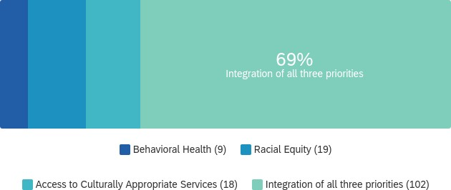
Integration of all three priority areas was the most chosen priority area across the catchment area.

There was clear consensus about the need for integrating, because residents, community leaders, and service and health care providers all agreed that addressing behavioral health without addressing racial equity and access to culturally appropriate services is not possible. These quotes illustrate why people across the catchment

Figure 8: Vote for most important priority area from the community engagement sessions (N=148)

area called for integration of all three priority areas.

“This was difficult to choose, but I think supporting the emotional wellness of the population through making mental health treatment accessible and destigmatized would do a lot to address gambling.” (Provider in Everett)

“All three findings are so important because they are all so interrelated. For me in the service sector, they come to me in my office on a daily basis. The community needs wrap-around services. They have a certain problem which is very difficult to disclose somewhere else. So, the pastors can’t disclose the information. If we can have access to the funding, we can hire a young Haitian with the ability to help and can work with the pastor to provide help. We can offer wrap- around service to deal with racial inequity and help them with their problems.” (Haitian pastor)

“The integration of priorities would be critical in truly addressing problem gambling in a diverse Asian population and providing equitable care. There are no culturally and linguistically appropriate services for Asian problem gamblers and their families that are affected. No prevention services, no intervention services, no behavioral health services and very limited funds invested into this hyper-vulnerable community.” (Chinatown service provider)

In addition to calling for integration of all three services, like the experts, those who voted felt the urgency of addressing behavioral health in ways that were community-based and community-centered. One community member said, “We need to allocate the resources to the people who know the communities best. That is the only way to meet these issues.” Like the experts, there was caution against a “one size fits all” model. Instead, one health provider said, “We need to get people what they need.” Community-based agencies can help to fill this critical gap.

Community Findings
The community engagement sessions also provided more nuance and texture to the priority areas.

Everett Youth: There was some ambivalence about the impact the casino has had on the community. One youth wondered, “Was it intentional that the casino was placed in a city where there are certain races? Why are minorities more affected? Are we targeted or is it because of where we live?”

The relationship between gambling and poverty: While one youth remembered the promise of jobs from the casino, many youths were skeptical about its impact and role in the community. Like the experts, the youth saw the connection between gambling and poverty:

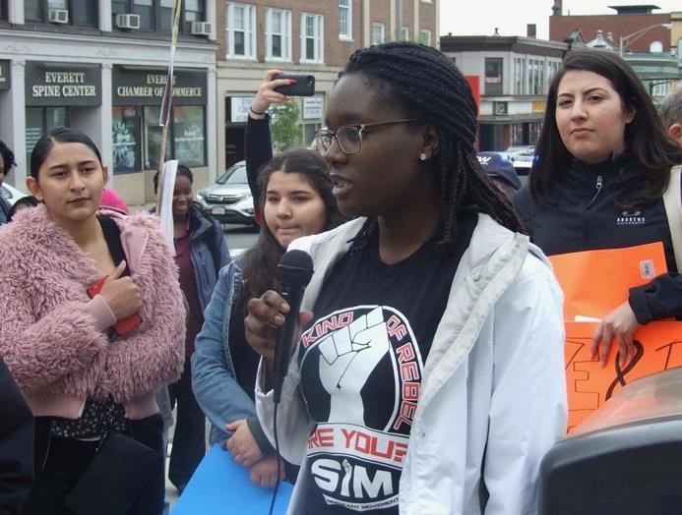
“People get mistreated because of their job. As a janitor, one doesn’t get the respect they deserve, and people are mean to them. People who are lower working class, have no college degree, and are immigrants, don’t always get the respect they deserve.”

“They probably gamble because they don’t make
enough”

“The casino brings you in to get money and then they get you addicted. Some lose their cars, their homes, they start drinking. Their family life is
ruined.”

The disconnect between what the casino promised and what they delivered: A few of the youth felt betrayed by what the community had been promised and what the reality was. One youth clearly saw the connection to racial equity:

“Minorities are targeted because we are disadvantaged and lower-income. Immigrants are targeted because they live in low-income areas and are stressed. People who are of lower income have a bigger chance of losing everything. There is the promise of high reward, but it comes with a high risk.”

Another youth expressed his anger at the casino noting, “They need people to get addicted. It’s dishonest and immoral.” Young people see a link between gambling and vices, with one noting,
“Gambling is also associated with other vices like smoking, drinking, vaping which makes things worse.” One youth voiced, “It seems immoral to put a casino near a school.”

Impact on quality of life in Everett: In addition to impacting family life and one’s finances, one youth
mourned the loss of a sense of community and the negative impact on quality of life:

“Since the casino has come, we don’t feel safe. We feel safe in places where there are other people who look like us in term of race, gender, and culture. When you take a walk at night and see all this light and chaos, it feels weird. The casino took the serenity out of tight-knit
community.”

The Everett Community: Among Latinx mothers, Haitian pastors, health care providers, small business owners, and government officials, there is also a strong sentiment of ambivalence about the casino and frustration about its impacts.

Link between gambling and behavioral health: The Everett community also sees the impact of the behavioral health in the community. The impact that gambling addiction has on the family is not lost on the community.

“It creates problems for the family. People think they are going to win and then they end up not having the rent for the month. Sometimes they win, but when they don’t it becomes a question of where is the money – how to pay bills and rent.” (Provider)

“Empty promises”: Like the youth, several Latinx mothers expressed the sentiment of feeling betrayed by the promise of the casino. As immigrants they receive the message of “this is the best you can get.” They wonder, how do they weigh the pros/cons of the casino? A few Latinx mothers felt as though they “deserve better” and instead they were given “empty promises.” Some Latinx mothers recounted that they were led to believe the casinos would provide entertainment, yet most of the women at the meeting have not gone to the casino because they cannot afford to go and they have to be careful about their living expenses.

Lack of transparency about jobs: The community is unclear whether the jobs from the casino have been given to local residents and whether these jobs are stable with good wages and benefits. Some Latinx mothers wondered whether the jobs that the Latinx community were given (restaurant, food court, or parking lot) were cut the most during the pandemic.

Multiple reasons for gambling behavior: A few community members recounted stories of family members gambling. One woman talked about a family member who gambled because of anxiety. One community member observed co-workers getting addicted because of the “adrenaline” or promise of winning. At the same time, this person wanted to know what causes addiction.

Link between gambling and poverty: Several community members and providers agreed that many people gamble in order to supplement income. One person observed: “It [gambling] is their only hope for overcoming their economic condition”. A Haitian pastor observed that one of his congregants lost
$1000 in one day. The following quote illustrates the observed connection between poverty and how that can lead to addiction:

“They buy a lot of scratch tickets because of anxiety. They feel that they will win. As they start to win more, they keep playing. They will ask you to save the ticket for them and then come back with money they get from others.” (Convenience store owner)

Chinatown: There is a common sentiment in Chinatown that casinos are specifically targeting Asians, and in particular those in the service industry who are low income and limited-English-proficient like the restaurant workers. These immigrants are more likely to become problem gamblers and to bring their problems, anger, stress, and financial issues into the home. These issues lead to problems such as family violence, strained family situations, and dangerous financial situations. Service providers are worried that restaurant workers finish work late at night when spouses and children are asleep. A Chinese pastor,
whose church has thought about opening up at midnight to provide alternatives for the service workers, noted:

“They have money, and they end up going to the casinos and gamble and get a free meal. Shuttles are just waiting outside of their workplace to bring them to the casinos.”

Service providers in Chinatown, who have been concerned about this issue for many years yet lacked an avenue for effecting change, advocated for more positive alternative activities to encourage those likely to gamble to focus on their kids. One service provider suggested:

“To prevent families from gambling, we need to have more family life enrichment programs.”

There are ways to engage parents into more events and ways to help and educate their children. Family nights (dinner, game nights) attract the parents.

Community Assets: Advisory Group members wanted to capture feedback on community assets in the region. This would give the community the opportunity to identify existing assets that could be built upon, which is in alignment with the strengths-based approach that public health takes. Throughout the expert panels and community engagement sessions across the catchment area, everyone pointed to the

central and critical role that community-based agencies have played in addressing gambling-related problems as indicated in the following quotes:

  - “There are already well-established organizations rooted in the organization and I think involving and engaging them in the planning and implementation would be very beneficial and can make reaching community members easier.” (Service provider)

  - “Culturally and linguistically specific community-based organizations have [been] built and designed to serve their respective programs and have been providing access to services for decades, and have a wealth of institutional knowledge, expertise, best practices that do work. We don't need to reinvent the wheel.” (Asian American service provider)

  - “One aspect that worked well was when one church in our community designed services to be delivered when certain populations were just getting off work. In this case, these were restaurant workers getting off work at midnight who had cash in their pockets after just getting paid. One church would hold services and programs on Sundays at midnight because Sunday evening is the start of the "weekend" for this group of workers, as many of them did not work on Mondays. Offering services and a space during that day and time was effective while it lasted. But it takes significant resources and energy to maintain.” (Chinatown community leader)

In conclusion, it is important to note the three central threads across all three priority areas emphasized by the experts and the community. First, providers and community members alike echoed the need for developing programs and services that were community-based and community-centered, as an
alternative to a “one-size-fits-all” model. Because the clinical encounter is based on an individualized Western model of treatment, it is not surprising that these immigrant communities, which bring collectivist cultural values, are calling for intervention ideas that respect, honor, and build on this important cultural value (Leong & Kalibatseva, 2011). Creative, out-of-the-box solutions, provided by bilingual/bicultural workers in community-based settings can help address this intractable problem that is hurting communities in the catchment area. Second, racial equity and access to culturally appropriate services underlie this yearning for better services. Finally, community leaders who understand their clients need to continue to be at the table as decisions are made so that community voice, perspective, and lived experience is valued, respected, and honored.

Community-based Intervention: Project RISE
The Advisory Group strongly proposes a two-phase intervention that builds capacity in community- based agencies, providing culturally and linguistically appropriate services using a racial equity lens to address behavioral health. This intervention weaves together the lived experiences and expertise of members of the Advisory Group, the testimonies from the three expert panels, and the feedback from the ten community engagement sessions. Central to this intervention is the critical and vital role that community-based agencies play and can continue to play with a greater investment of resources. This investment will help build capacity allowing them to better serve the behavioral health needs of the population as an upstream prevention strategy so that immigrant communities can to heal, transform, and flourish.

Central Tenets of the Intervention
The central tenets of this two-phase intervention are grounded in the knowledge and expertise of the expert panels and the community engagement sessions.

- Community-based agencies provide a critical complement to the existing behavioral health system, which primarily resides in clinical and Western model of intervention, such as talk therapy.

- Community-based agencies, such as community-based organizations or faith-based institutions, can be a viable alternative to existing models because immigrants find these community-based environments welcoming, trusting, and respectful, where they feel a sense of dignity and respect because they are served by people who look like them, speak their language, and understand them implicitly.

- Building resilience and wellness in community-based agencies can help to de-stigmatize mental health and behavioral health and get more people the help, services, and resources that they need.

- “Out-of-the-box”, creative, and untested interventions can combine the best of clinical care and community-based care. There are helpful healing modalities known to practitioners and the public which are uncovered by insurance. Ideas of how best to heal and transform the pain of affected communities can come from the communities themselves.

- Behavioral health, including problem gambling, must continue to be addressed holistically, upstream, at the prevention level, and involve stakeholders from multiple sectors. Connecting to other sectors such as economic development and violence prevention are necessary to develop future partnerships.

- Community-based organizations must be at the table and present to advocate for changes and treated as experts for their lived and practice-based experience.

- For community-based agencies to do this work, it is imperative that these agencies are compensated fairly for the work that they do. Fair compensation keeps this bilingual/bicultural workforce sustainable.

Theory of Change
The theory of change for Project RISE emerged organically from a deliberate and intentional community engagement approach which respects the lived experiences of multiple stakeholders and centers listening, learning, and being responsive. Three salient, enduring, fundamental ideas in public health underlie this intervention: cultural brokering, power sharing, and community design. These three ideas serve as the foundation for this intervention and integrate racial equity and access to culturally appropriate services throughout the proposed three-year period.

Power sharing
Some public health researchers and practitioners have long advocated that public health adopt a
“power with” approach to working with underserved and vulnerable communities. “Power with”
involves community building, capacity building, and empowerment-oriented social action (Wallerstein et

al., 2015). Operationalizing power sharing in today’s world, where the conversation around racial equity is more salient, necessitates that affected communities be at the decision-making table instead of having decisions made for them. Power sharing works to equalize relationships between underserved and vulnerable communities, -- whose power lies in their lived experience -- and health care institutions which have access to financial and political power (Farhang & Gaydos, n.d.; Fleurant, 2021).

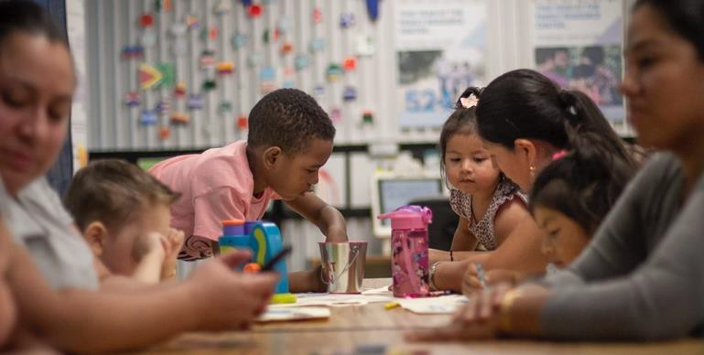
Cultural brokering
Cultural brokering is the “the act of bridging, linking, or mediating between groups or persons of different cultural backgrounds for the purpose of reducing conflict or producing change” (Jezewski, 1990, 2001). Cultural brokering is fundamental to creating a linguistic and culturally appropriate workforce and organization.
Cultural brokers are recognized throughout a variety of fields -- family support people in family services work, peer support specialists in behavioral health, parent mentors in education, and community health workers in public health. Cultural brokers offer an alternative structure and system for those who feel left out, unheard, and marginalized. According to the National Center for Cultural Competence (2021), cultural brokers work as the go-between, often advocating for an individual or a group on their behalf (“National Center for Cultural Competence,” 2021). They can be a liaison, a cultural guide, bridging the personal level community with the professional level of providers and services, because they understand the strengths and needs of community and the structures and functions of health care setting. Cultural brokers serve as a mediator helping to ease historical and inherent distrust towards healthcare
organizations and at best, a catalyst for change as they “initiate the transformation of a health-care setting by creating an inclusive and collaborative environment for providers and patients/consumers alike” (“National Center for Cultural Competence,” 2021).

Community-based agencies as safety net
Community-based agencies serve as a safety net and bridge for these communities who lack access to resources and the knowledge to navigate health care and governmental systems (Adams & McDaniel, 2012; Oberlin & Pizmony-Levy, 2016; Tsega, Giantris, & Shah, 2020). As mentioned, these agencies provide needed services in linguistically and culturally appropriate ways. The COVID-19 pandemic has also illustrated that these agencies serve as “first responders” for linguistically and culturally isolated communities. Because they are on-the-ground, listening, and being responsive to isolated communities, they can quickly adapt and can respond in real-time to emergent issues.

Project RISE: Capacity Building and Community Intervention

Rationale for Two-phased Intervention

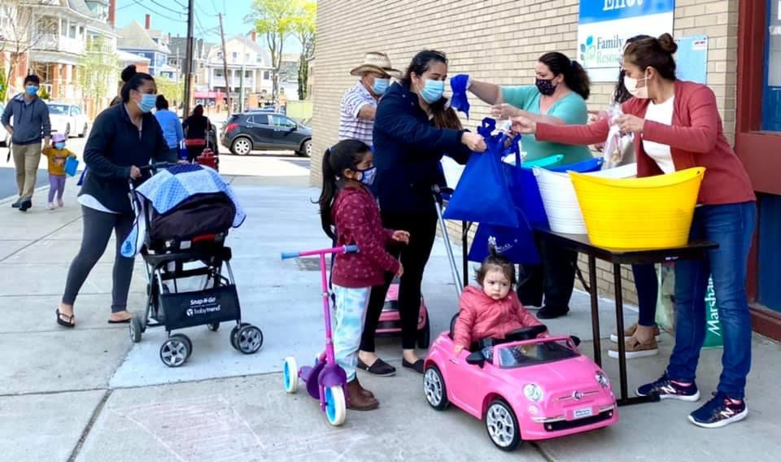

Project RISE targets behavioral health for immigrant communities with a racial equity lens and access to culturally appropriate service through the creation of community-based strategies. The immigrant communities targeted for this intervention include the Asian American, Haitian, and Latinx immigrant communities in the catchment area defined in Assessment of Existing Data. The

intervention includes the following phases: 1) capacity-building and 2) direct services and prevention programs for behavioral health. Logic models for each phase are included in Appendix 3.

Phase One of the intervention involves capacity-building, the process where organizations obtain, improve, and retain skills, knowledge, tools, and other resources to perform their jobs well and to accomplish the objectives of this project (Jacobs et al., 2014; Leeman et al., 2015, 2017; Ramanadhan et al., 2021). In this phase, communities will be actively engaged to design interventions that are centered in racial equity and access to culturally appropriate services. Because of the central role that community-based agencies have in this intervention, a capacity-building phase will ensure that community-based agencies have the resources and time to adequately and appropriately plan and prepare for direct services and prevention program implementation. Additionally, capacity-building ensures that community-based agencies have the time to build the internal infrastructure, staff, and external partnerships necessary to design, deliver, and evaluate services and determine how best to deliver these services. This report reiterates what we heard from the experts and the community engagement sessions: there is no one-size fits all for addressing behavioral health for the affected population. The literature is also limited on promising practices and evidence-based programs on how best to serve those who are most affected in the catchment area. We also know that mere adoption of
existing evidence-based practices is not always the most appropriate path for communities that differ by language, history, and culture (Castro, Barrera, & Holleran Steiker, 2010; Morrison et al., 2009; Sue et al., 2006).

The second phase of this intervention addresses four levels of the socio-ecological model (individual, intrapersonal, community, and policy) with targeted and community-based direct services and programs, prevention, and policy work. The underlying assumption of this intervention is that racial equity and access to culturally and linguistically appropriate services are integrated throughout the planning, design, delivery, and evaluation of programs, services, and policy work.

Recommended Organizations
The following three community-based organizations are recommended as the sites to house the cultural brokers and provide linguistically and culturally competent behavioral health services with a racial equity lens. All the following organizations will also be involved in the systems-level coalition described in Phase Two.
- Boston Chinatown Neighborhood Center
- Everett Haitian Community Center
- Family Resource Center

The following organizations may provide training on identifying behavioral health issues that should be addressed by a licensed clinician and be partners with the above agencies in providing wrap-around services for immigrant families
- Cambridge Health Alliance
- Eliot Health Center
- South Cove Community Health Center

Metropolitan Area Planning Council will participate in the systems-wide coalition and help to make the linkage with local Public Health Departments.

A learning community, or community of practice, will be established to thread together the two phases of this intervention. A community of practice is a facilitated learning community that allows for peer- learning across agencies for shared best practices, on-going professional development, and learning across communities (Pyrko, Dörfler, & Eden, 2017; Wenger, 1999, 2000). At the end of the behavioral health expert panel, all the members of the Advisory Group were struck by the similarities across their respective ethnic communities, and everyone called for collaboration. The sense of working together and continuing on-going collaboration has been palpable throughout the partnership progress of the Advisory Group.

The community engagement consultants will be retained to work with the community agencies in the capacity-building and intervention stages and convene the community of practice.

Phase One: Capacity Building
We anticipate that the capacity-building phase will happen over 6 - 9 months in Year One. Capacity- building will ensure that community-serving agencies have the internal infrastructure in place (staffing, funding, space, financial capacity, etc) and external partnerships necessary to execute this intervention. Capacity-building also ensures adequate planning time so that local communities have the tools and resources needed to determine the “out-of-the-box” creative solutions to address behavioral health. For example, the Asian CARES research group, in its assessment of existing programs to address gambling- related problems for the Asian American community, found that there are only two such programs in the United States that address problem gambling and the Asian community. Both programs are rooted in local experiences, resources, and expertise. Adequate planning time is necessary in order to

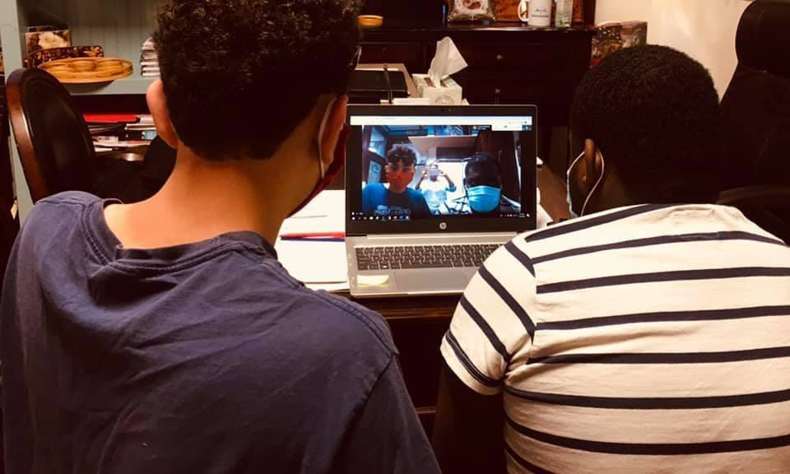
authentically engage affected communities in identifying appropriate programs and services. More detail is included in the Proposed Timeline (Appendix 1).

There are four key elements of this capacity building model: planning and preparation, workforce development, asset mapping, and community design strategies. There are ample toolkits that will be adapted for each respective
community agency. Below is a description of each of these key elements:

Planning and Preparation: The community engagement consultants will work with each respective community-based agency to first identify if they have the existing internal infrastructure to deliver on the intervention and assess issues such as staffing, funding, space, financial capacity, etc. Next, the community engagement consultants will develop tailored, linguistically and culturally specific training on behavioral health, financial literacy, and racial equity. The training for cultural brokers will be developed in collaboration with community-based, non-clinical experts as well as clinical providers from organizations such as Cambridge Health Alliance and South Cove Community Health Center. Workshops and training on financial literacy, a key recommendation of many of the experts, will also be developed. Racial equity training will be tailored for each specific organization depending on the history of their target population. The consultants will also look into identifying tools for asset mapping and community design, working with the staff and cultural broker of each respective agency to design and implement these processes for their respective communities. The consultants will also work with each community serving agency to develop a timeline for workforce development, asset mapping, and community design.

Workforce Development: Community-serving agencies will recruit, hire, and train 1 - 2 part-time bilingual/bicultural cultural brokers to conduct the capacity-building activities in Year One and intervention services in Years Two and Three. Training will ensure that cultural brokers have the skills, knowledge, and attitudes to plan, deliver, and modify the programs and services. For the capacity- building phase, the consultants will support and train the cultural brokers as part of the community of practice to facilitate asset mapping and community design workshops. In the intervention phase, cultural brokers will be trained to provide peer support for the behavioral health needs of individuals and families in community-based settings and to know how to identify when an individual needs to be referred to a licensed provider for clinical support.

Asset Mapping: This project takes a strength-based approach, which is fundamental to public health practice. Asset mapping is a method for assessing what unique resources exist in communities that can be built upon and leveraged in order to maximize partnership and avoid duplication of services (Baker, 2014; Lightfoot, McCleary, & Lum, 2014; Morgan & Ziglio, 2007). Asset mapping will be used to determine the strengths and resources of the community agency and build upon and leveraged in order to design, deliver, and evaluate the intervention in Phase Two. Asset mapping includes an environmental scan of the external resources that the community agency can leverage. Central to this scan is identifying the strategic partnerships that are needed to support the design and delivery of programs and services. Identifying external resources will help with developing wrap-around services for the individuals and families who present with behavioral health challenges. The cultural broker, in partnership with the consultants, will conduct the asset mapping. Current toolkits that we will draw upon and adapt include:
  - Participatory Asset Mapping Toolkit from Community Science
  - Toolkit for Stakeholder Asset Mapping from NCCAPPS

Community Design for Resilience and Wellness: Community design strategies, such as equitable participatory design, agile thinking, and others, focus on drawing out innovative and creative ideas from community members that are community-based and user-centered (Ivey et al., 2007; Meléndez & Martinez-Cosio, 2019). Each community will have the opportunity to design strategies that build resilience and improve behavioral health and community wellness. We will explore a partnership with the MITD-Lab (https://d-lab.mit.edu/) to learn the tools of participatory design that involve co-creation with the users. Together the cultural broker and consultants will plan community design strategies for each respective community. These community design workshops will utilize creative, interactive, participatory strategies for unearthing new, innovative, community-based activities for supporting resilience and wellness. These community design workshops seek to draw upon and honor the lived experience of the public and providers in order to develop resilience and wellness strategies that are relevant for each respective community. While much of design thinking is rooted in community development, there is emerging work combining design thinking with behavioral health. Much of the current resources have focused on youth. The cultural broker and consultants will work to adapt these resources to adult and elderly immigrant adults. An equity framework will be built into the fabric of community design strategies. Some current on-line resources include:
- Young and Well - Participatory design of on-line youth mental health intervention, promotion, and treatment
- GovLab and UNICEF - A collaboration between GovLab and UNICEF to design a new methodology around participatory mapping of issues related to adolescent mental health.
- Enterprise Community - A toolkit designed to help facilitate a process of community engagement in the design process.

Phase Two: Intervention
Project RISE addresses four levels of the socio-ecological model. See below for a social ecological model that illustrates our intervention.

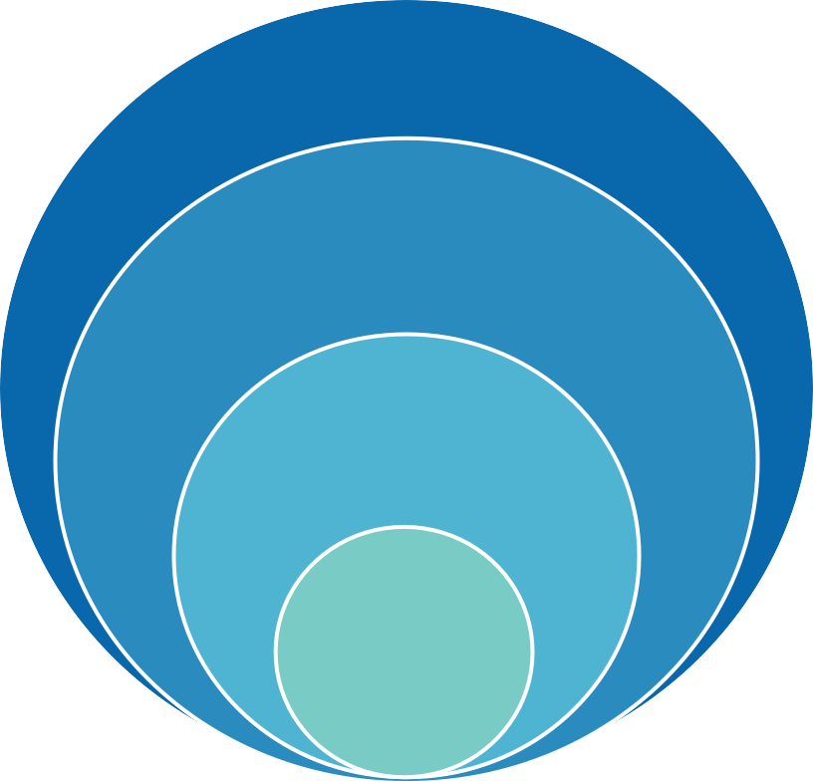In Year One, Project RISE will target immigrant Asian American, Haitian, and Latinx communities in the catchment area. In the middle of Year Two, the key organizations will begin working on how to expand the intervention to a broader immigrant population
Societal
- Systems wide coalition

Community
- Community workshops
- Recreational activities
Interpersonal
- Intake process
- Family support groups/workshops

Individual
- Non-clinical peer support
  - Referrals to outside clinician
- Support groups
Figure 9: Social ecological model for Project RISE.

Individual: The cultural broker will provide individual, community-based peer support services for community members in the community agency, centering racial equity and culturally appropriate services. This may include services such as:
- Peer support for non-clinical behavioral health issues.
- Identification and referrals to outside clinicians when a client needs clinical behavioral health services (telehealth phone calls, video, or in-person).
- Peer support groups for individuals that promote wellness and resilience

Interpersonal: Interpersonal support focus on meeting families’ immediate needs, strengthening the family, and building resilience through respect, listening, and guidance. Through peer navigation, the cultural broker will help to identify a holistic plan for each family that includes wrap-around services to

ensure that immigrant families have access to the services and resources that they need. Examples of activities to address this level include:
- Intake process to identify and understand family needs using a social determinants of health framework
- Family support groups and workshops for promoting wellness and resilience and financial literacy

Community: For the community level, the cultural broker will implement a variety of prevention activities as informed by the community design processes. The community design process during the capacity-building stage will inform how to design and deliver community-level programs that address behavioral health. Examples of activities to address this level include:
- Workshops on racial equity
- Recreational activities that promote social support among immigrant communities

Societal: Behavioral health problems are indicative of larger societal issues such as poverty and lack of opportunity for immigrant communities to find gainful employment. Starting in Year Two, Project RISE will establish a systems-level coalition that builds off the current Advisory Group. This coalition will meet quarterly across stakeholders and sectors to brainstorm and strategize on how to address other upstream factors. These upstream factors primarily include employment for the affected communities and the social impact for immigrant communities due to a lack of recreational activities and spaces of belonging. Project RISE will follow best practices in coalition-building drawing upon sources such as:
- The Prevention Institute
- The Campaign Workshop
- The Commons Social Change Library

Monitoring and Evaluation: Participatory evaluation
Project RISE will involve both process and outcome evaluation. During the first few months of the project, a more detailed evaluation plan for both phases of the intervention, including indicators and data collection tools and methods, will be developed. Evaluation will be conducted by the consultants and be an on-going, iterative process with each community agency. The evaluation will be implemented according to the following guide:

Process Evaluation:
Phase One: Capacity-building
During the capacity building phase of Project RISE, the following questions will be used to help guide the process evaluation:

- How many cultural brokers were trained and how satisfied were they with the trainings?
- Did the community-based agencies use asset mapping to conduct an inventory of services, assess existing and external partnerships and design wrap-around services?

- How many stakeholders participated in the community design workshops? How many new ideas were generated from these workshops?

Potential data collection tools include pre/post surveys and satisfaction surveys to monitor the progress of the trainings, workshops, inventory of services, and other activities. Additionally, outputs will be documented during the process to create a clear picture of what has been accomplished. Outputs and process measures can be seen in Appendix 3.

Phase Two: Intervention
The intervention stage of the project will again be assessed through satisfaction surveys and pre/post surveys. Other metrics specific to certain activities such as the number of issues identified for family support groups will be developed and measured by activity. Outputs such as how many meetings were attended, and numbers of individuals reached or helped will also be included. A list of process measures can be seen in Appendix 3.

Potential guiding questions for the initial evaluation of the intervention phase are:

- How many individuals received in-house support? How many individuals were referred to outside clinicians for more intensive counseling?
- How many families participated in case management? What types of programs and services were recommended for the families?
- How many family support groups were implemented? What topics did these family support groups cover? Were the support groups culturally responsive?
- Did the individuals receiving educational materials feel they were relevant and useful?
- What type of community-level interventions were implemented in each community? How many people attended each program/service?
- How many groups participate in the system-wide coalition? How many meetings do they have?

Outcome Evaluation:
The following outcomes can be used to guide the outcome evaluation for Project RISE:

Short term Outcomes:
- Increase availability and access to behavioral health services for racial/ethnic groups
- Increase individuals and families’ ability to access culturally appropriate services
- Reduce barriers to access to care in community-based care and clinical care
- Strengthen and stabilize families using racial equity and access to culturally appropriate services
- Strengthen community resilience around behavioral health
- Build a viable statewide coalition that involves different sectors to address this issue more holistically

Long term Outcomes:
- Reduce acculturation stress related to behavioral health
- Increase funding for community-based agencies addressing behavioral health
- Reduce racial inequity regarding behavioral health
- Improve psychosocial well-being of immigrant communities
- Develop and evaluate new programs and services to address behavioral health in immigrant communities

Appendix 1: Proposed Timeline

 | FY  Oct 2021-  2022 | FY 2022-2023 | FY 2023-2024
CAPACITY BUILDING
Planning and preparation
Develop training materials
Adapt tools on asset mapping and community design

Workforce development
Recruit cultural brokers
Hire and on-board cultural brokers Train cultural brokers

Asset mapping Environmental scan Partnership development

Community Design Workshops
Identification of populations to target Implementation of community design workshops Analysis of data and results from workshops

Learning Community
Monthly meeting
INTERVENTION
Development of outreach and recruitment materials

Individual Level
Peer support for non-clinical behavioral health issues Identification and referrals to outside clinicians
Peer support groups

Interpersonal Level
Intake process to identify family needs Family support groups and workshops

Community Level
Community activities (ie - workshops, recreational activities)

Societal Level
Systems-wide coalition meeting

Appendix 2: Proposed Budget

FY22 Draft Everett Community Level Health Project Budget Narrative (October 2021-June 2022)

Lead Agency: $61,000

- Program Manager ($19,845): Coordination of project including management of executive team and leadership of the working groups as well as the coordination and submission of monthly program and budget update reports to MDPH.
- Program Director ($11,520): Staff time to oversee day-to-day program activities and manage the cultural broker(s).
- Cultural Broker ($22,275): Providing peer support services, identifying holistic family plans and coordinating support groups, and implementing prevention activities. Responsibilities will include working with the program director and consultants on asset mapping and community design planning.
- Fringe Benefit ($7,360)

Consultant: $65,000
- Lead Independent Consultant ($30,000): Will develop the framework of capacity building and program evaluation and design strategies appropriate for each respective community. Work will include accessing organizational capacity, developing tailored trainings, plan community design strategies, developing the evaluation framework, monitoring data collections and analyzing data, as well as facilitating community-based organizations and learning community meetings.
- Junior Independent Consultant ($35,000): Will be responsible for helping lead consultant’s work and collecting data from community-based organizations. Responsibilities will include mapping out capacity assessment, helping community-based organizations to identify measurement tools, aiding in training development and implementation, planning community design strategies, and supporting data collection and analyzation as well as coordinating community- based organizations and learning community meetings.

Staff training: $6000 (Cultural broker training)

Subcontract: $168,000
The amounts set aside for community-based organizations and coalition members:
- Latinx serving community-based agency: $82,000 (capacity building and program implementation)
- Haitian serving community-based agency: $82,000 (capacity building and program implementation)
- Two additional community-centered agencies to take part in the coalition: $2,000 each (quarterly meeting)

Appendix 3: Logic Models
Phase One: Capacity Building Logic Model

Inputs: | Activities: | Outputs: | Process measures: | Short term outcomes: | Long term outcomes:
Staff Volunteers  Youth, adults, caregivers, families  Community partners such as schools, community health center, services providers | Workforce Development |  |  | Increase knowledge of staff regarding problem gambling, behavioral health, and racial equity  Increase skills of staff in identifying gambling related problems | Strengthen capacity of CBOs in order to better serve their communities  Long-term partnerships designed to fill gaps and provide needed culturally appropriate services to diverse immigrant communities
 | Trainings/ workshops on building capacity | # of workshops  # of individuals attending workshops | Pre/post workshop survey
 | Hire and train staff on problem gambling, behavioral health, and racial equity | # of workers hired # of trainings  # of workers attending the trainings  # of workers certified | Pre/post training survey
Funding | Asset Mapping
Facility | Inventory of services  and capabilities | # of current services identified | Pre/post satisfaction  survey
Department of Public Health |  | List of gaps in service
 |  | SWOT analysis
Massachusetts Gaming Commission  Evidence based programs  Consultant | Build and evaluate partnerships (ex: faith based institutions) | # of partners identified  # of partnerships established | Develop community designed strategies for wellness and resilience
 | Referral assessment (discussion with clinical care providers) | # of identified clinics for referral
 | Community Designed Wellness Strategies
 | Trainings on Process Methods (community engagement, design charettes, etc) | # of trainings | Satisfaction survey
 | Participatory processes (design thinking, equitable community design) | # of participatory process events  # of attendees/ participants | # of ideas generated/ identified

Phase Two: Intervention Logic Model

Inputs: | Activities: | Outputs: | Process measures: | Short term outcomes: | Long term outcomes: | Impact:
Staff Volunteers  Youth, adults, caregivers, families  Community partners such as schools, community health center, services providers  Funding Facility  Department of Public Health  Massachusetts Gaming Commission  Trainings Curricula  Evidence based programs  Evaluations Consultant  Coalition meetings | Individual Level Intervention |  |  | Increase availability and access to behavioral health services for racial/ethnic groups  Increase individuals and families’ ability to access culturally appropriate services  Reduce barriers to access to care in community-based care and clinical care  Strengthen and stabilize families using racial equity and access to culturally appropriate services  Strengthen community resilience around behavioral health  Build a viable statewide coalition that involves different sectors to address this issue more holistically | Reduce acculturation stress related to behavioral health  Increase funding for community- based agencies addressing behavioral health  Reduce racial inequity regarding behavioral health  Improve psychosocial well- being of immigrant communities  Develop and evaluate new programs and services to address behavioral health in immigrant communities | Improve the emotional well-being of immigrant families in the catchment area by reducing behavioral health issues in the community
 | Non-clinical peer support (Telehealth and/or In-person) | # of individuals receiving support services | # of individuals meet their goals
 | Train cultural brokers to provide services determined during capacity building | # of individuals attend the training # of trainings | Pre & Post training survey
 | Referrals to psychiatrist  Referrals to emergency room and/or hospital | # of referrals to psychiatrists  # of referrals to emergency room and/or hospital | Referral’s reasons and  issues
 | Interpersonal Level Intervention
 | Intake processing | # of families/ individuals in need of intake  # of services identified for the family # of hours of services  # of referrals
 | Family support groups | # of family members supported  # of families participating | # of issues are identified
 | Community Level Intervention
 | Create community specific public education materials | # of education materials have been created | # of individuals have received the materials  Satisfaction survey
 | Community workshop (PG education, racial equity, Financial management, Stress management) | # of individuals attending the workshops | Satisfaction Survey
 | Community building events determined during the capacity building stage | TBD | TBD
 | Societal Level Intervention
 | Coalition meeting | # of coalition meeting # of sectors reached  # of cross sector events | # of issues are being discussed
 | Advocacy for funding and service | Amount of funding  # of services

Appendix 4: Demographic Information from Community Engagement Sessions

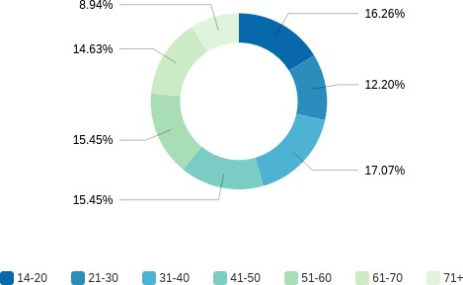
Figure 10: Age distribution of those served by services providers (N=123)

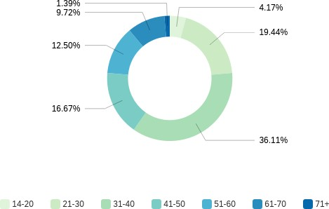
Figure 11: Age distribution of community members (N=72)

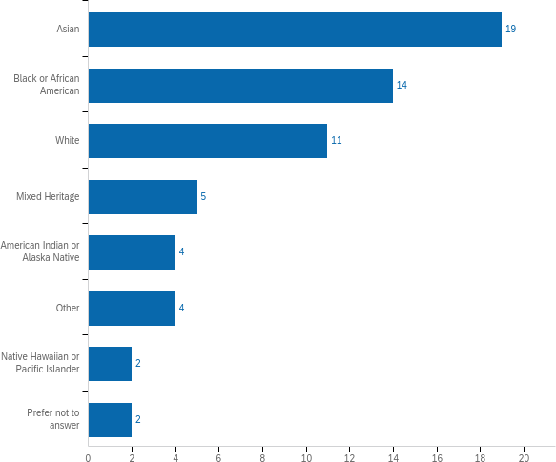
Figure 12: Race of service providers (N=60)
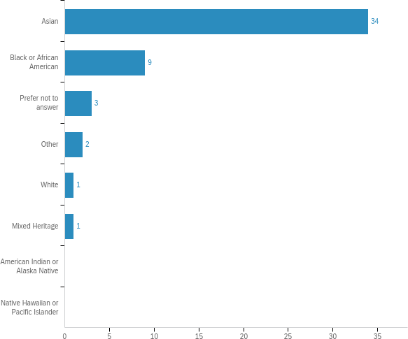

Figure 13: Race of community members (N=50)

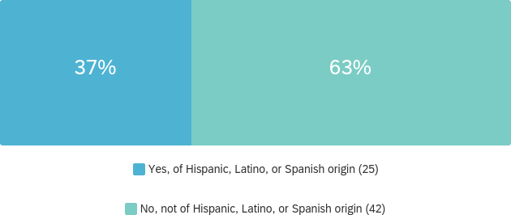
Figure 14: Community respondents who identify as Hispanic, Latino, or Spanish Origin (N=67)

Works Cited
Abedi, V., Olulana, O., Avula, V., Chaudhary, D., Khan, A., Shahjouei, S., … Zand, R. (2020). Racial, Economic, and Health Inequality and COVID-19 Infection in the United States. Journal of Racial and Ethnic Health Disparities, 1–11. https://doi.org/10.1007/s40615- 020-00833-4
Adams, G., & McDaniel, M. (2012). Untapped Potential: Partnering with Community-Based Organizations to Support Participation of Lower-Incidence Immigrant Communities in the Illinois Preschool for All Initiative. 27.
Baker, D. (2014). Developing and implementing a robust asset-based approach to public health.
Perspectives in Public Health, 134(3), 129–130. https://doi.org/10.1177/1757913914530842
Blundell, R., Costa Dias, M., Joyce, R., & Xu, X. (2020). COVID-19 and Inequalities. Fiscal Studies. https://doi.org/10.1111/1475-5890.12232
Cambridge Health Alliance, & City of Somerville Health and Human Services. (2017). The Wellbeing of Somerville Report (p. 180). Retrieved from https://www.challiance.org/uploads/public/documents/community/somerville-wellbeing- report-2017.pdf
Castro, F. G., Barrera, M., & Holleran Steiker, L. K. (2010). Issues and challenges in the design of culturally adapted evidence-based interventions. Annual Review of Clinical Psychology, 6(1), 213–239. https://doi.org/10.1146/annurev-clinpsy-033109-132032
CDC. (2020, December 10). COVID-19 Racial and Ethnic Health Disparities. Retrieved June 17, 2021, from Centers for Disease Control and Prevention website: https://www.cdc.gov/coronavirus/2019-ncov/community/health-equity/racial-ethnic- disparities/index.html
Everett/Malden Collaborative for Community Health Improvement. (2019). Everett-Malden Community Health Needs Assessment (p. 68). Retrieved from https://www.challiance.org/uploads/public/documents/community/everett-malden-chna- report-final.pdf
Farhang, L., & Gaydos, M. (n.d.). Shifting and Sharing Power: Public Health’s Charge in Building Community Power. Public Health, 6.
Fleurant, S. (2021, March 29). Power Sharing, Capacity Building, and Community Leadership: Common Elements of Public Health Practice and Community Lawyering. Retrieved June 2, 2021, from Network for Public Health Law website: https://www.networkforphl.org/news-insights/power-sharing-capacity-building-and- community-leadership-common-elements-of-public-health-practice-and-community- lawyering/
Howard, D. H., Sentell, T., & Gazmararian, J. A. (2006). Impact of health literacy on socioeconomic and racial differences in health in an elderly population. Journal of General Internal Medicine, 21(8), 857–861. https://doi.org/10.1111/j.1525- 1497.2006.00530.x
Institute for Community Health. (2019). Melrose-Wakefield Healthcare Community Health Needs Assessment 2019 (p. 130). Retrieved from https://www.melrosewakefield.org/wp- content/uploads/2017/07/2019-MWHC-CHNA-report-FINAL-updated.pdf
Israel, B. A., Schulz, A. J., Parker, E. A., & Becker, A. B. (1998). Review of community-based research: Assessing partnership approaches to improve public health. Annual Review of Public Health, 19, 173–202. https://doi.org/10.1146/annurev.publhealth.19.1.173
Ivey, M., Elizabeth, D., Sanders, B. -n, Li, Y., Kirk, E., Ian, P., … Chang, Y. (2007). Giving Voice to Equitable Collaboration in Participatory Design Research. Presented at the European Academy of Design Conference, Izmir, Turkey.

Jacobs, J. A., Duggan, K., Erwin, P., Smith, C., Borawski, E., Compton, J., … Brownson, R. C. (2014). Capacity building for evidence-based decision making in local health departments: Scaling up an effective training approach. Implementation Science, 9(1), 124. https://doi.org/10.1186/s13012-014-0124-x
Jezewski, M. A. (1990). Culture Brokering in Migrant Farmworker Health Care. Western Journal of Nursing Research, 12(4), 497–513. https://doi.org/10.1177/019394599001200406
Jezewski, M. A. (2001). Culture Brokering: Providing Culturally Competent Rehabilitation Services to Foreign-born Persons. Center for International Rehabilitation Research Information and Exchange.
Leeman, J., Calancie, L., Hartman, M. A., Escoffery, C. T., Herrmann, A. K., Tague, L. E., … Samuel-Hodge, C. (2015). What strategies are used to build practitioners’ capacity to implement community-based interventions and are they effective?: A systematic review. Implementation Science, 10(1), 80. https://doi.org/10.1186/s13012-015-0272-7
Leeman, J., Calancie, L., Kegler, M. C., Escoffery, C. T., Herrmann, A. K., Thatcher, E., … Fernandez, M. E. (2017). Developing Theory to Guide Building Practitioners’ Capacity to Implement Evidence-Based Interventions. Health Education & Behavior, 44(1), 59–69. https://doi.org/10.1177/1090198115610572
Leong, F. T. L., & Kalibatseva, Z. (2011). Cross-Cultural Barriers to Mental Health Services in the United States. Cerebrum: The Dana Forum on Brain Science, 2011. Retrieved from https://www.ncbi.nlm.nih.gov/pmc/articles/PMC3574791/
Lightfoot, E., McCleary, J. S., & Lum, T. (2014). Asset Mapping as a Research Tool for Community-Based Participatory Research in Social Work. Social Work Research, 38(1), 59–64. https://doi.org/10.1093/swr/svu001
Mass Department of Mental Health Annual Report: Fiscal Year 2020 (p. 12). (2020). Retrieved from https://www.mass.gov/doc/dmh-fy-2020-annual-report/download
McCloskey, D. J., Akintobi, T. H., Bonham, A., Cook, J., & Coyne-Beasley, T. (2011). Principles of Community Engagement (2nd Edition). NIH.
Meléndez, J. W., & Martinez-Cosio, M. (2019). Designing for equitable civic engagement: Participatory design and discourse in contested spaces. Journal of Civil Society, 15(1), 18–41. https://doi.org/10.1080/17448689.2018.1559471
Minkler, M. (2005). Community-based research partnerships: Challenges and opportunities. Journal of Urban Health : Bulletin of the New York Academy of Medicine, 82(Suppl 2), ii3–ii12. https://doi.org/10.1093/jurban/jti034
Morgan, A., & Ziglio, E. (2007). Revitalising the evidence base for public health: An assets model. Promotion & Education, 14(2_suppl), 17–22. https://doi.org/10.1177/10253823070140020701x
Morrison, D. M., Hoppe, M. J., Gillmore, M. R., Kluver, C., Higa, D., & Wells, E. A. (2009). Replicating an Intervention: The Tension Between Fidelity and Adaptation. AIDS Education and Prevention, 21(2), 128–140. http://dx.doi.org.ezproxy.library.tufts.edu/10.1521/aeap.2009.21.2.128
Myers, J. (2020, August 18). 5 things COVID-19 has taught us about inequality. Retrieved June 17, 2021, from World Economic Forum website: https://www.weforum.org/agenda/2020/08/5-things-covid-19-has-taught-us-about- inequality/
National Center for Cultural Competence. (2021). Retrieved June 2, 2021, from https://nccc.georgetown.edu/culturalbroker/index.html
Ngo-Metzger, Q., Massagli, M. P., Clarridge, B. R., Manocchia, M., Davis, R. B., Iezzoni, L. I., & Phillips, R. S. (2003). Linguistic and cultural barriers to care. Journal of General Internal Medicine, 18(1), 44–52. https://doi.org/10.1046/j.1525-1497.2003.20205.x
North Suffolk Public Health Collaborative. (2019). North Suffolk Community Health Needs Assessment (p. 85). Retrieved from

https://drive.google.com/file/d/1aL3WGqVq6uMe_U7oZezWxJ056x1iCl- u/view?usp=embed_facebook
Oberlin, K., & Pizmony-Levy, O. (2016). Beyond Access: Social Safety Nets and the Use of Free Health Care Services. Sociological Perspectives, 59. https://doi.org/10.1177/0731121416641677
Petry, N. M., Stinson, F. S., & Grant, B. F. (2005). Comorbidity of DSM-IV pathological gambling and other psychiatric disorders: Results from the National Epidemiologic Survey on Alcohol and Related Conditions. The Journal of Clinical Psychiatry, 66(5), 564–574. https://doi.org/10.4088/jcp.v66n0504
Pyrko, I., Dörfler, V., & Eden, C. (2017). Thinking together: What makes Communities of Practice work? Human Relations, 70(4), 389–409. https://doi.org/10.1177/0018726716661040
Ramanadhan, S., Galbraith-Gyan, K., Revette, A., Foti, A., Rackard James, C., Martinez- Dominguez, V., … Viswanath, K. (2021). Key considerations for designing capacity- building interventions to support evidence-based programming in underserved communities: A qualitative exploration. Translational Behavioral Medicine, 11(2), 452–
461. https://doi.org/10.1093/tbm/ibz177
Schut, R. A. (2021). Racial disparities in provider-patient communication of incidental medical findings. Social Science & Medicine (1982), 277, 113901. https://doi.org/10.1016/j.socscimed.2021.113901
Sentell, T. L., & Halpin, H. A. (2006). Importance of adult literacy in understanding health disparities. Journal of General Internal Medicine, 21(8), 862–866. https://doi.org/10.1111/j.1525-1497.2006.00538.x
Shen, M. J., Peterson, E. B., Costas-Muñiz, R., Hernandez, M. H., Jewell, S. T., Matsoukas, K., & Bylund, C. L. (2018). The Effects of Race and Racial Concordance on Patient- Physician Communication: A Systematic Review of the Literature. Journal of Racial and Ethnic Health Disparities, 5(1), 117–140. https://doi.org/10.1007/s40615-017-0350-4
Snyder, R. E., Cunningham, W., Nakazono, T. T., & Hays, R. D. (2000). Access to medical care reported by Asians and Pacific Islanders in a West Coast physician group association.
Medical Care Research and Review: MCRR, 57(2), 196–215. https://doi.org/10.1177/107755870005700204
Spencer, M. S., Chen, J., Gee, G. C., Fabian, C. G., & Takeuchi, D. T. (2010). Discrimination and Mental Health–Related Service Use in a National Study of Asian Americans.
American Journal of Public Health, 100(12), 2410–2417. https://doi.org/10.2105/AJPH.2009.176321
Sue, S., Zane, N., Levant, R., Silverstein, L., Brown, L., Olkin, R., & Taliaferro, G. (2006). How Well Do Both Evidence-Based Practices and Treatment as Usual Satisfactorily Address the Various Dimensions of Diversity? https://doi.org/10.1037/11265-008
Tsega, M., Giantris, K., & Shah, T. (2020, June 1). Essential Social Services Are Struggling to Survive the COVID-19 Crisis [Commonwealth Fund]. https://doi.org/10.26099/d7q2-s993
Volberg, R. A., Williams, R. J., Stanek, E. J., Houpt, A., Zorn, M., & Rodriguez-Monguio, R. (2017). Gambling and Problem Gambling in Massachusetts: Results of a Baseline Population Survey (p. 320). Amherst, MA: University of Massachusetts Amherst School of Public Health and Health Sciences.
Wallerstein, N., Minkler, M., Carter-Edwards, L., Avila, M., & Sánchez, V. (2015). Improving health through community engagement, community organization, and community building. In Health behavior: Theory, research, and practice, 5th ed (pp. 277–300). Hoboken, NJ, US: Jossey-Bass/Wiley.
Wenger, E. (1999). Communities of Practice: Learning, Meaning, and Identity. Cambridge University Press.

Wenger, E. (2000). Communities of Practice and Social Learning Systems. Organization, 7(2), 225–246. https://doi.org/10.1177/135050840072002
Wong, C., & Li, G. (2020). Talking about Casino Gambling: Community Voices from Boston Chinatown. Institute for Asian American Studies Publications. Retrieved from https://scholarworks.umb.edu/iaas_pubs/45
Yearby, R. (2011). Racial Inequities in Mortality and Access to Health Care: The Untold Peril of Rationing Health Care in the United States. The Journal of Legal Medicine, 32, 77–91. https://doi.org/10.1080/01947648.2011.550830
Yearby, R. (2018). Racial Disparities in Health Status and Access to Healthcare: The Continuation of Inequality in the United States Due to Structural Racism. American Journal of Economics and Sociology, 77(3–4), 1113–1152. https://doi.org/10.1111/ajes.12230

