INDOOR AIR QUALITY ASSESSMENT

Community Maintenance & Development Department
7 Butler Street
Sherborn, Massachusetts

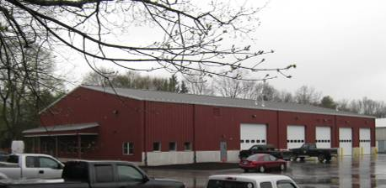

Prepared by:
Massachusetts Department of Public Health
Bureau of Environmental Health
Indoor Air Quality Program
July 2010

Background/Introduction
In response to a request from Edward Wagner, Director, Town of Sherborn, Community Maintenance & Development Department (SCMDD), the Massachusetts Department of Public Health (MDPH), Bureau of Environmental Health (BEH) provided assistance and consultation regarding indoor air quality concerns at the SCMDD facilities located at 7 Butler Street, Sherborn, Massachusetts. The request was prompted by occupant complaints of transient odors in the building. On April 9, 2010, a visit to conduct an indoor air quality assessment was made by Cory Holmes, an Environmental Analyst/Regional Inspector in BEH’s Indoor Air Quality (IAQ) Program.
The SCMDD occupies a cinderblock and metal one-story building completed in February 2010. The building consists of several large concrete-floored vehicle bays and carpeted office space. Windows are openable in the office space.

Methods
Air tests for carbon dioxide, temperature and relative humidity were taken with the TSI, Q-Trak, IAQ Monitor, Model 7565. Air tests for airborne particle matter with a diameter less than 2.5 micrometers were taken with the TSI, DUSTTRAK™ Aerosol Monitor Model 8520. Screening for total volatile organic compounds (TVOCs) was conducted using a Thermo Environmental Instruments Inc., Model 580 Series Photo Ionization Detector (PID). BEH staff also performed a visual inspection of building materials for water damage and/or microbial growth.

Results
The SCMDD has an employee population of approximately 10. Tests were taken during normal operations, and results appear in Table 1.

Discussion

Ventilation
It can be seen from Table 1 that carbon dioxide levels were below 800 parts per million (ppm) in all areas, indicating adequate air exchange at the time of the assessment. Mechanical ventilation is provided by an air-handling unit (AHU) located in a mechanical room (Picture 1). Fresh air is drawn into the AHU (Picture 2) and delivered to occupied areas by ceiling-mounted fresh air diffusers, which are connected to the AHU via ductwork. Return air is drawn into ceiling vents and ducted back to the AHU.
A dedicated, local mechanical exhaust ventilation system is installed in the vehicle bays to remove airborne pollutants (e.g., odors, fumes, carbon monoxide and other products of combustion) generated by activities/vehicles housed in the garage bays. This dedicated system is described in detail under the Other IAQ Evaluations portion of this report.
To maximize air exchange, the MDPH recommends that both supply and exhaust ventilation operate continuously during periods of occupancy. In order to have proper ventilation with a mechanical supply and exhaust system, the systems must be balanced to provide an adequate amount of fresh air to the interior of a room while removing stale air from the room. It is recommended that HVAC systems be re-balanced every five years to ensure adequate air systems function (SMACNA, 1994). The date of the last balancing of these systems occurred prior to occupancy in February 2010.
The Massachusetts Building Code requires that each room in an office have a minimum ventilation rate of 20 cubic feet per minute (cfm) per occupant of fresh outside air or openable windows; 1.5 cfm/ft² is required for repair garages (SBBRS, 1997; BOCA, 1993). The ventilation must be operating at all times that the room is occupied. Providing adequate fresh air ventilation with open windows and maintaining the temperature in the comfort range during the cold weather season is impractical. Mechanical ventilation is usually required to provide adequate fresh air ventilation.
Carbon dioxide is not a problem in and of itself. It is used as an indicator of the adequacy of the fresh air ventilation. As carbon dioxide levels rise, it indicates that the ventilating system is malfunctioning or the design occupancy of the room is being exceeded. When this happens, a buildup of common indoor air pollutants can occur, leading to discomfort or health complaints. The Occupational Safety and Health Administration (OSHA) standard for carbon dioxide is 5,000 parts per million parts of air (ppm). Workers may be exposed to this level for 40 hours/week, based on a time-weighted average (OSHA, 1997).
The MDPH uses a guideline of 800 ppm for publicly occupied buildings. A guideline of 600 ppm or less is preferred in schools due to the fact that the majority of occupants are young and considered to be a more sensitive population in the evaluation of environmental health status. Inadequate ventilation and/or elevated temperatures are major causes of complaints such as respiratory, eye, nose and throat irritation, lethargy and headaches. For more information concerning carbon dioxide, please see Appendix A.
Temperature readings in office areas were measured at 68º F which was close to the lower end of the MDPH recommended comfort guidelines. Temperature measurements in vehicle bays ranged from 60º F to 62º F, reflective of outdoor temperatures due to the opening and closing of vehicle bay doors. The MDPH recommends that indoor air temperatures be maintained in a range of 70 º F to 78 º F in order to provide for the comfort of building occupants. In many cases concerning indoor air quality, fluctuations of temperature in occupied spaces are typically experienced, even in a building with an adequate fresh air supply.
The relative humidity measured during the assessment ranged from 66 to 80 percent, which were above the MDPH recommended comfort range in all areas surveyed the day of the assessment, which occurred on a humid, day with intermediate to heavy rain. As with temperature, relative humidity in the vehicle bays was reflective of outdoor conditions due to opening and closing of bay doors. The MDPH recommends a comfort range of 40 to 60 percent for indoor air relative humidity. Relative humidity levels in the building would be expected to drop during the winter months due to heating. Relative humidity levels in the building would be expected to drop during the heating season.

Microbial/Moisture Concerns
No water damage or visible mold growth were reported or observed during the assessment.

Other IAQ Evaluations
Indoor air quality can be negatively influenced by the presence of respiratory irritants, such as products of combustion. The process of combustion produces a number of pollutants. Common combustion emissions include carbon monoxide, carbon dioxide, water vapor and smoke (fine airborne particle material). Of these materials, exposure to carbon monoxide and particulate matter with a diameter of 2.5 micrometers (μm) or less (PM2.5) can produce immediate, acute health effects upon exposure. To determine whether combustion products were present in the indoor environment, BEH staff obtained measurements for carbon monoxide and PM2.5.

Carbon Monoxide
Carbon monoxide is a by-product of incomplete combustion of organic matter (e.g., gasoline, wood and tobacco). Exposure to carbon monoxide can produce immediate and acute health affects. Several air quality standards have been established to address carbon monoxide and prevent symptoms from exposure to these substances. The MDPH established a corrective action level concerning carbon monoxide in ice skating rinks that use fossil-fueled ice resurfacing equipment. If an operator of an indoor ice rink measures a carbon monoxide level over 30 ppm, taken 20 minutes after resurfacing within a rink, that operator must take actions to reduce carbon monoxide levels (MDPH, 1997).
The American Society of Heating Refrigeration and Air-Conditioning Engineers (ASHRAE) has adopted the National Ambient Air Quality Standards (NAAQS) as one set of criteria for assessing indoor air quality and monitoring of fresh air introduced by HVAC systems (ASHRAE, 1989). The NAAQS are standards established by the US EPA to protect the public health from six criteria pollutants, including carbon monoxide and particulate matter (US EPA, 2006). As recommended by ASHRAE, pollutant levels of fresh air introduced to a building should not exceed the NAAQS levels (ASHRAE, 1989). The NAAQS were adopted by reference in the Building Officials & Code Administrators (BOCA) National Mechanical Code of 1993 (BOCA, 1993), which is now an HVAC standard included in the Massachusetts State Building Code (SBBRS, 1997). According to the NAAQS, carbon monoxide levels in outdoor air should not exceed 9 ppm in an eight-hour average (US EPA, 2006).
Carbon monoxide should not be present in a typical, indoor environment. If it is present, indoor carbon monoxide levels should be less than or equal to outdoor levels. Outdoor carbon monoxide concentrations were non-detect (ND) at the time of the assessment (Table 1). No measureable levels of carbon monoxide were detected inside the building during the assessment (Table 1).
As mentioned previously, the building is equipped with a mechanical exhaust system to remove exhaust emissions and other pollutants from the building. The local exhaust system consists of large exhaust vents located at the front of the vehicle bays and make-up air vents installed on the opposite wall to pressurize the vehicle bays toward the exhaust vents (Pictures 3 and 4). The activation of this system appears to be automatic and dependent on carbon monoxide chemical sensors (Picture 5). These types of sensors are typically designed to trigger the activation and deactivation of mechanical ventilation components. Once a pre-set reading is exceeded, the system is activated to remove pollutants and introduce fresh air. When a second, lower pre-set reading is measured by the sensor, the ventilation system is deactivated. Therefore, no mechanical ventilation is provided until the sensors’ higher pre-set level is reached to re-activate the system. However, the system can also be manually over-ridden and activated as needed using a wall switch (Pictures 5 and 6).
This type of chemical sensor activated system is dependant on accurate measurements of airborne contaminants. It is important to note that any type of chemical sensor requires periodic calibration to maintain proper function. Building occupants could not identify if a calibration program for preventative maintenance was in place for the carbon monoxide sensors.

Particulate Matter (PM2.5)
The US EPA has established NAAQS limits for exposure to particulate matter. Particulate matter is airborne solids that can be irritating to the eyes, nose and throat. The NAAQS originally established exposure limits to particulate matter with a diameter of 10 μm or less (PM10). According to the NAAQS, PM10 levels should not exceed 150 micrograms per cubic meter (μg/m³) in a 24-hour average (US EPA, 2006). These standards were adopted by both ASHRAE and BOCA. Since the issuance of the ASHRAE standard and BOCA Code, US EPA established a more protective standard for fine airborne particles. This more stringent PM2.5 standard requires outdoor air particle levels be maintained below 35 μg/m³ over a 24-hour average (US EPA, 2006). Although both the ASHRAE standard and BOCA Code adopted the PM10 standard for evaluating air quality, MDPH uses the more protective PM2.5 standard for evaluating airborne particulate matter concentrations in the indoor environment.
Outdoor PM2.5 concentrations the day of the assessment were measured at 18 μg/m³. PM2.5 levels measured inside the building ranged from 27 to 28 μg/m³ (Table 1), which were below the NAAQS PM2.5 level of 35 μg/m³. Frequently, indoor air levels of particulates (including PM2.5) can be at higher levels than those measured outdoors. A number of mechanical devices and/or activities that occur indoors can generate particulate during normal operations. Sources of indoor airborne particulates may include but are not limited to particles generated during the operation of fan belts vehicles in enclosed spaces, use of stoves and/or microwave ovens in kitchen areas; use of photocopiers, fax machines and computer printing devices; operation of an ordinary vacuum cleaner and heavy foot traffic indoors.

Volatile Organic Compounds
Indoor air concentrations can be greatly impacted by the use of products containing volatile organic compounds (VOCs). VOCs are carbon-containing substances that have the ability to evaporate at room temperature. Frequently, exposure to low levels of total VOCs (TVOCs) may produce eye, nose, throat and/or respiratory irritation in some sensitive individuals. For example, chemicals evaporating from a paint can stored at room temperature would most likely contain VOCs. In an effort to determine whether VOCs were present in the building, air monitoring for TVOCs was conducted. An outdoor air sample was taken for comparison. Outdoor TVOC concentrations were non-detect or ND. No measurable levels of TVOCs were detected inside the building at the time of the assessment, with the exception of a slight reading (2.5 ppm) directly over the parts washer, which uses solvents/degreasers (Table 1). Please note, TVOC air measurements are only reflective of the indoor air concentrations present at the time of sampling.

Odors
As mentioned, the assessment was prompted by complaints of an odor originating from the vehicle bays. Occupants reported that the odor is intermittent and sometimes occurs after days of heat and humid conditions. The vehicle bays are made of cinderblock and metal walls, which are covered with bats of plastic-covered fiberglass insulation (Pictures 7 and 8). Mr. Wagner reported that the base of the fiberglass insulation along exterior walls became detached in a few areas, which reportedly produced odors (Picture 8). This may indicate that condensation forming on the exterior metal walls is being trapped behind fiberglass bats, creating conditions for odors. In addition, it is possible that heat may be contributing to off-gassing odors associated with plastic covering the fiberglass batts. Odors are often associated with new building components (e.g., carpeting, tile mastic). At the time the assessment occurred, odors were not present. BEH staff offered to conduct a reassessment when/if odors recur. The Town of Sherborn is reportedly working with their builder and architect to further investigate the issue.

Other Conditions
The synthetic fiber filters installed in the AHU offers minimal filtration (Picture 9). The purpose of a filter is to provide filtration of respirable dusts. In order to decrease aerosolized particulates, disposable pleated filters with an increased dust spot efficiency should be installed. The dust spot efficiency is the ability of a filter to remove particulates of a certain diameter from air passing through the filter. Filters that have been determined by ASHRAE to meet its standard for a dust spot efficiency of a minimum of 40 percent (Minimum Efficiency Reporting Value equal to 9) would be sufficient to reduce many airborne particulates (Thornburg, 2000; MEHRC, 1997; ASHRAE, 1992).

Conclusions/Recommendations
In view of the findings at the time of the visit, the following is recommended:
- Continue to work with architect and private contractors to examine building components/structural issues that may be contributing to conditions creating odors.
- Contact BEH/IAQ Program for further investigation if odors recur and/or continue to be an issue.
- Contact the manufacturer and/or installer regarding the operation and calibration of the chemical sensor/local exhaust ventilation system. Maintain and calibrate sensors in accordance with the manufacturer’s instructions.
- Although local exhaust ventilation is set to trigger based on elevated carbon monoxide, all staff should be instructed on how to override the system and operate in manual mode during odor or fume-producing activities.
- Upgrade to more efficient, pleated HVAC filters. Change filters for HVAC equipment as per the manufacturer’s instructions or more frequently if needed.
- Consider adopting a balancing schedule of every 5 years for all mechanical ventilation systems, as recommended by ventilation industrial standards (SMACNA, 1994).
- Refer to resource manuals and other related indoor air quality documents for further building-wide evaluations and advice on maintaining public buildings. Copies of these materials are located on the MDPH’s website: http://mass.gov/dph/indoor_air.

References
ASHRAE. 1992. Gravimetric and Dust-Spot Procedures for Testing Air-Cleaning Devices Used in General Ventilation for Removing Particulate Matter. American Society of Heating, Refrigeration and Air Conditioning Engineers. ANSI/ASHRAE 52.1-1992.
BOCA. 1993. The BOCA National Mechanical Code/1993. 8th ed. Building Officials and Code Administrators International, Inc., Country Club Hill, IL. Section M-308.1.1.
MEHRC. 1997. Indoor Air Quality for HVAC Operators & Contractors Workbook. MidAtlantic Environmental Hygiene Resource Center, Philadelphia, PA.
OSHA. 1997. Limits for Air Contaminants. Occupational Safety and Health Administration. Code of Federal Regulations. 29 C.F.R 1910.1000 Table Z-1-A.
SBBRS. 1997. Mechanical Ventilation. State Board of Building Regulations and Standards. Code of Massachusetts Regulations. 780 CMR 1209.0.
SMACNA. 1994. HVAC Systems Commissioning Manual. 1st ed. Sheet Metal and Air Conditioning Contractors’ National Association, Inc., Chantilly, VA.
Thornburg, D. 2000. Filter Selection: a Standard Solution. Engineering Systems 17:6 pp. 74-80.
Picture 1

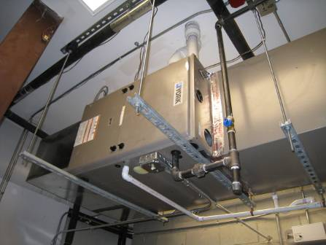

AHU in Mechanical Room

Picture 2

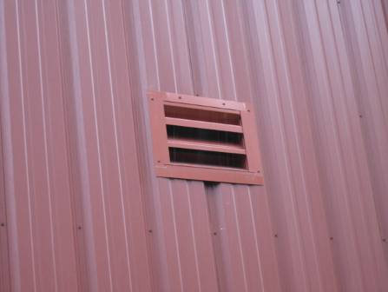

Fresh Air Intake for AHU

Picture 3

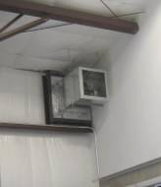

Wall-Mounted Local Exhaust Vent

Picture 4

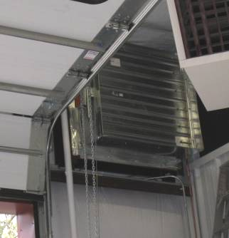

Louvered Supply Vent for Local Exhaust System

Picture 5

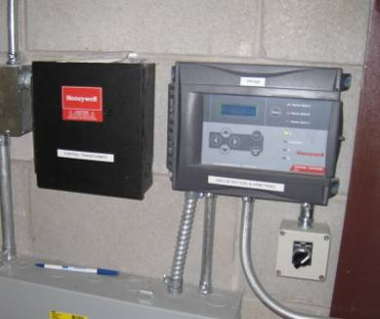

Chemical Sensor and Manual Override Control for Local Exhaust System

Picture 6

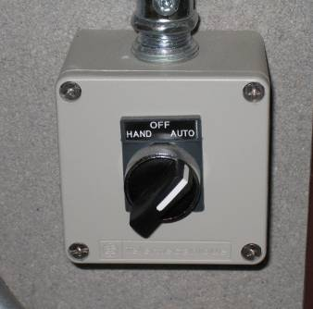

Close-up of Manual Control for Local Exhaust System

Picture 7

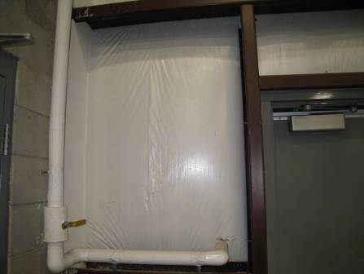

Plastic Covered Fiberglass Batts on Garage/Vehicle Bay Walls (and Ceilings)

Picture 8

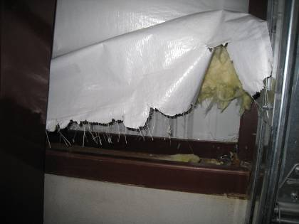

Close-up of Plastic Covered Fiberglass Batts on Garage/Vehicle Bay Walls Removed to Investigate Odors

Picture 9

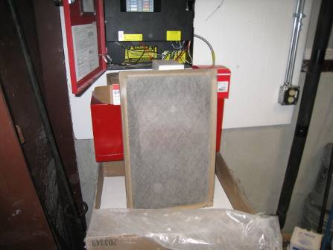

Fibrous Mesh Filters Installed in AHU
Location |  | Occupants  in Room |  | Temp  (°F) |  | Relative  Humidity  (%) |  | Carbon  Dioxide  (ppm) |  | Carbon Monoxide  (ppm) |  | PM2.5 |  | TVOCs  (ppm) |  | Windows  Openable |  | Ventilation |  |  |  | Remarks
 |  |  |  |  |  |  |  |  |  |  |  | (µg/m3) |  |  |  |  |  | Supply |  | Exhaust |  | Remarks
Outside/  Background |  |  | 65 |  | 100 |  | 323 |  | ND |  | 18 |  | ND |  |  |  |  |  |  |  | Moderate to heavy rains
Office Area | 0 |  | 68 |  | 66 |  | 518 |  | ND |  | 18 |  | ND |  | Y |  | Y |  | Y
Garage Work Bay | 0 |  | 60 |  | 84 |  | 324 |  | ND |  | 29 |  | ND |  | N |  | Y |  | Y |  | Tire/battery storage, ceiling fan on
Center Garage Work Bay | 0 |  | 62 |  | 80 |  | 333 |  | ND |  | 28 |  | ND/2.5 near parts washer |  | N |  | Y |  | Y
Vehicle Truck Bay | 0 |  | 62 |  | 75 |  | 343 |  | ND |  | 27 |  | ND |  | N |  | Y |  | Y |  | Tractors, dump truck, gas-fueled hand held equipment

